THE OPEN UNIVERSITY OF SRI LANKA


EEX6373 Performance Modelling

Deliverable 01

Faculty of Engineering Technology
Bachelor of Software Engineering Honours Department of Electrical and Computer Engineering

A.MAHATHIR MOHAMED
S NO : S92066684
REG NO : 121426684

Library Book Borrowing and Management System
1. Introduction
In most university libraries, the process of borrowing and returning books remains partially manual, leading to inefficiencies and performance bottlenecks. Students often experience long queues during peak academic periods, and librarians struggle to maintain accurate, real-time data of book availability and overdue returns.
The Library Book Borrowing and Management System is designed to resolve these challenges by automating and optimizing the core library operations such as catalog management, book issue/return tracking, and user authentication.
This system leverages a centralized database, automated identification mechanisms (such as barcodes or RFID), and real-time performance monitoring to deliver a faster, more reliable, and scalable service to both users and administrators.

2. High-Level Problem Statement
2.1 Problem Context
University libraries serve thousands of users daily. During high-traffic periods, the manual checkout process faces several issues:
- Slow transaction processing due to manual entry
- Lack of real-time availability information for books
- Delays in generating overdue or fine reports
- Limited scalability when user count increases
- Inconsistent performance under heavy loads
The goal is to design a digital Library Book Borrowing and Management System that can handle multiple users simultaneously, maintain consistent performance, and ensure data integrity without service disruption.
2.2 System Objective
To develop a performance-oriented automated system that manages the entire lifecycle of book transactions including issue, renewal, and return while optimizing key performance metrics such as throughput, response time, and resource utilization.

3. System Overview
3.1 System Description
The Library Book Book Borrowing and Management System consists of several interacting components:
Module | Description
User Interface | Provides web and mobile access for users to search books, issue, or return items.
Authentication Module | Validates user credentials and roles (student,librarian).
Book Catalog Management | Stores metadata about each book and updates availability in real-time.
Transaction Processor | Handles checkout, return, and fine calculation requests.
Database System | Maintains structured data of users, books, and transaction history.
Performance Monitor | Logs response time, throughput, and resource utilization for optimization.

3.2 System Architecture Diagram
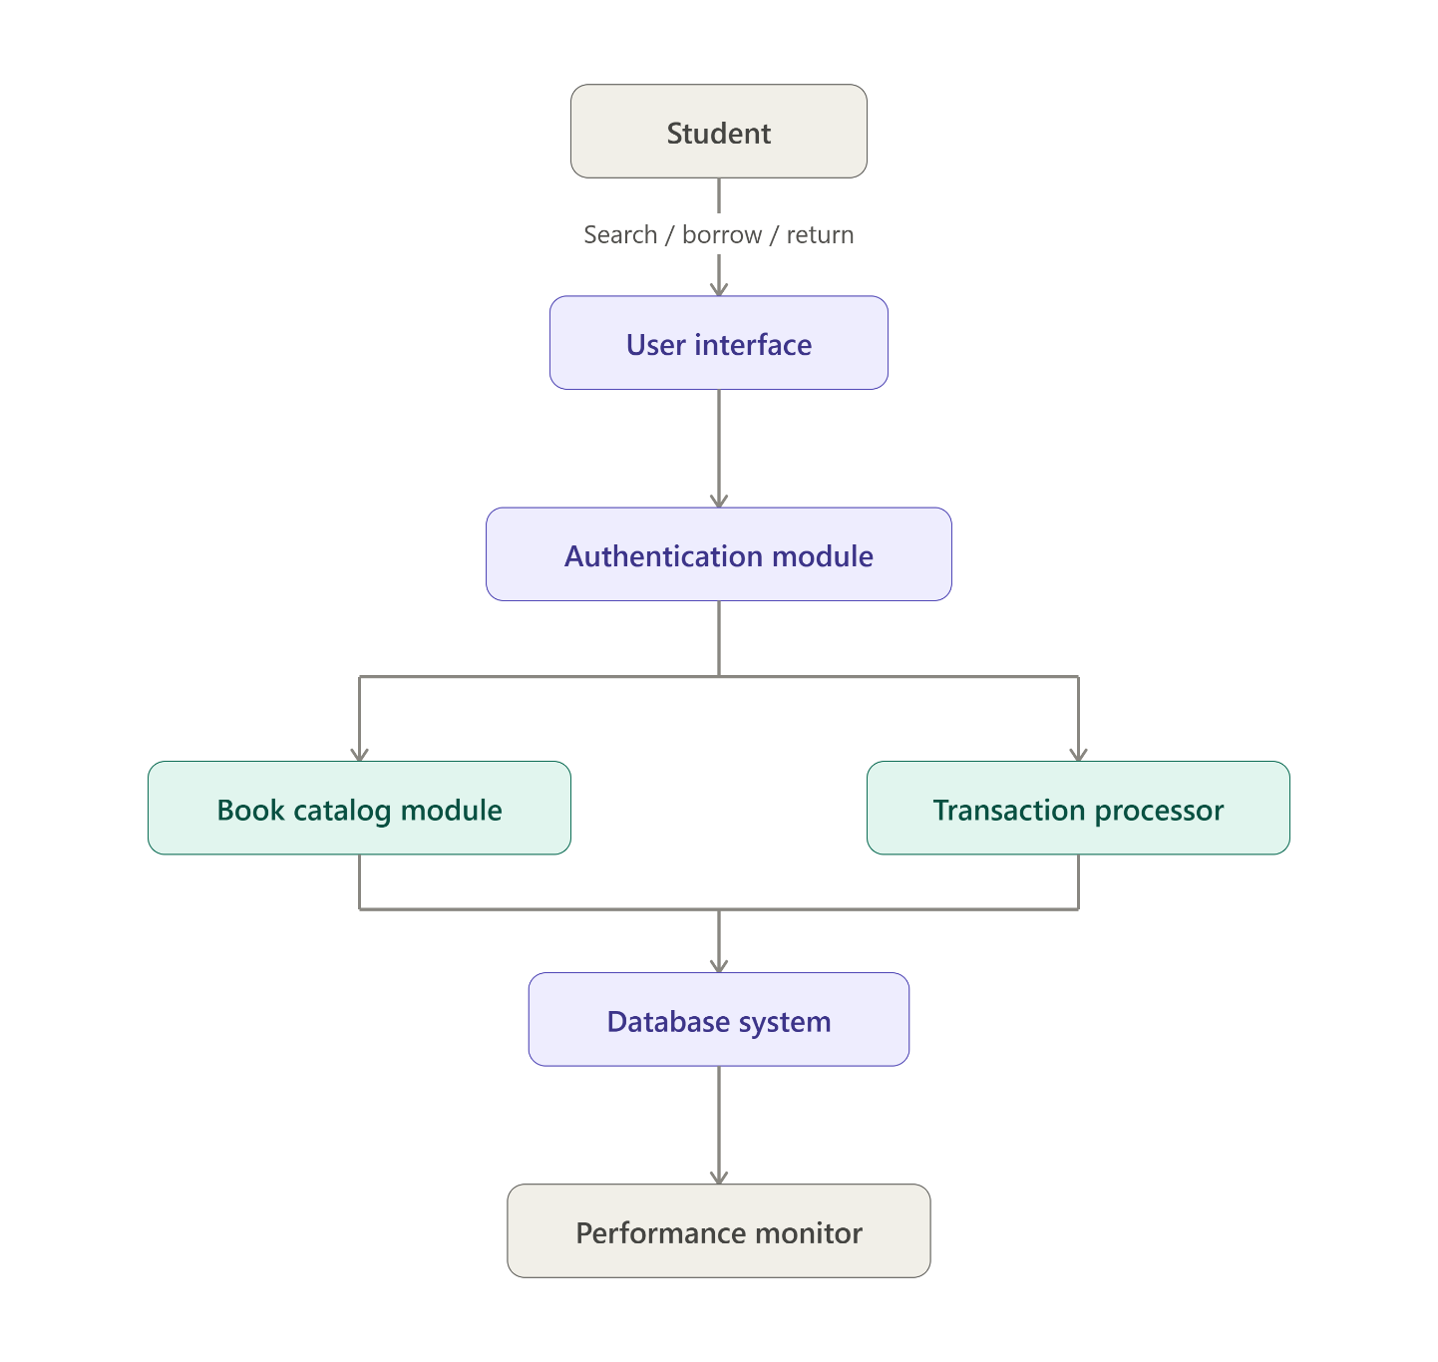

3.3 Workflow
- Book Request Submission:
The student approaches the library counter and provides the book details and student ID to the librarian (admin).
- Verification and Availability Check:
The librarian verifies the student’s credentials and borrowing limit, then checks the system to confirm the availability of the requested book.
- Book Issue Process:
If the book is available, the librarian updates the system by marking the book as “Borrowed”, linking it with the student’s record, and recording the borrow and due dates.
- Student Panel Update:
The student can log in to their student panel to view all currently borrowed books, due dates, and any applicable fines.
- Book Return:
When the student returns the book, the librarian processes the return transaction, and the system automatically calculates any overdue fines (if applicable).
- Status Update:
Upon successful return, the book’s status changes back to “Available”, and the transaction record is archived for reporting and performance monitoring.

4. Dataset Description
To evaluate and improve system performance, a dataset representing real operational data is utilized.
Data Category | Description | Example Fields
User Data | Information about registered members | User_ID, Name, Role, Department, Borrow_Limit
Book Data | Metadata and availability of books | Book_ID, Title, Author, ISBN, Genre, Location, Availability
Transaction Data | Log of issued, renewed, and returned books | Transaction_ID, User_ID, Book_ID, Issue_Date, Due_Date, Return_Date, Fine
System Metrics Data | Real-time system logs used for performance analysis | Request_Time, Response_Time, CPU_Usage, Memory_Utilization, Queue_Length
Error/Exception Logs | System error data for bottleneck identification | Error_Code, Description, Timestamp, Severity
The dataset enables performance modeling through statistical analysis, system simulations, and load testing.

5. Performance Objectives
The performance analysis focuses on measurable goals that ensure efficiency, reliability, and scalability.
Objective | Description | Measurement Metric | Target Value
1. Minimize Response Time | Reduce the average time to process a checkout or return request. | Average response time (seconds) | ≤ 2 seconds
2. Maximize Throughput | Handle multiple user transactions efficiently under high load. | Transactions per second (TPS) | ≥ 100 TPS
3. Optimize Resource Utilization | Ensure balanced use of CPU, memory, and network bandwidth. | CPU/Memory usage (%) | ≤ 80%
4. Improve Scalability | Support future growth in users and book inventory. | Concurrent users handled | Up to 10,000
5. Enhance System Reliability | Maintain uninterrupted service and quick recovery from failure. | System uptime (%) | ≥ 99.5%
6. Identify and Eliminate Bottlenecks | Detect slow database queries, network delays, or hardware constraints. | Bottleneck detection logs | Continuous monitoring

6. Performance Evaluation Approach
To ensure the system meets its objectives, performance will be tested using simulated datasets and real transaction loads. The evaluation includes:
- Load Testing: Using simulated users to determine the maximum number of concurrent requests before latency increases.
- Stress Testing: Measuring how the system behaves under extreme conditions or hardware limitations.
- Scalability Testing: Adding simulated users to analyze horizontal and vertical scalability.
- Bottleneck Analysis: Identifying delays in database queries, server response, or API calls.
- Resource Monitoring: Tracking CPU, memory, and I/O usage through performance monitoring tools.

7. Expected Outcomes
- Faster and more reliable checkout process for library users.
- Reduction in transaction processing delays during peak hours.
- Improved utilization of library resources and reduced administrative workload.
- Scalable design capable of supporting larger datasets and user bases.
- Data-driven insights for continuous performance optimization.

8. Conclusion
The Library Book Book Borrowing and Management System represents a scalable, data-driven digital transformation of traditional library operations. By focusing on key performance objectives response time, throughput, scalability, and reliability the system ensures smooth functioning even under heavy workloads. The implementation of data analytics and monitoring tools further enhances decision-making and supports continuous system improvement.

My Github Repository link :

