Moon - Portfolio
Mishkatuz Zannat Moon · Student ID 385411 · HIT339 Group Project (library management system)

Implementation: API, importer, analytics and export
I added three things to our Assignment 2 library system (ASP.NET Core MVC with SQLite): a public read-only API, an admin CSV importer, and manager reports that can be exported as CSV or PDF. They all use the tables and staff roles we already had, so I didn't need to change the database. All three are merged into main (pull requests #2 to #5).

Read-only public API
- Five read-only GET links under /api/v1: the item list (with paging and category, status and search filters), one item by id, one item by library code, the categories, and a status check.
- The API sends back small, purpose-made objects instead of the database objects, so things like replacement cost, loans, borrowers and fines never show up.
- If someone sends something wrong they get a clear error: 400 for a bad id, page, page size, category or status; 404 if the item doesn't exist; 405 for anything that isn't GET.
- Other websites can read the data (read-only). There is a machine-readable description at /openapi/v1.json and a page you can browse at /api-docs.html (this page needs internet).

CSV importer (Admin only)
- You upload a file, look at the preview, then confirm. Nothing is saved until the admin presses Import, and the server checks the file again at that point.
- Every row is checked with the same rules as the normal admin forms, so the importer and the forms accept the same things.
- Each row is marked Valid, Invalid or Duplicate, with its row number and the reason. A duplicate is a library code that already exists or is repeated in the file.
- Bad files (empty, wrong file type, binary data, missing columns, only a header, an unclosed quote, over 512 KB or over 1,000 rows) give a clear message and import nothing.
- Valid rows are saved in one go, so if saving fails, nothing gets imported.

Manager reports and export (Manager and Admin)
- Three reports: borrowing, fines and inventory. The borrowing and fines reports have a From/To date filter.
- One service works out each report once, and the screen, the CSV and the PDF all use it, so the numbers are the same everywhere.
- CSV files open fine in Excel. Anything that could be read as a spreadsheet formula is made safe.
- PDFs are made with QuestPDF in landscape A4, with a summary, tables and page numbers.

Files
Area | Main files
API | Controllers/Api/CatalogApiController.cs, Models/Api/ApiDtos.cs, wwwroot/api-docs.html
Importer | Controllers/ImportController.cs, Services/CsvImportService.cs, Services/CsvParser.cs, Views/Import/Index.cshtml
Reports and export | Controllers/ReportsController.cs, Services/ReportService.cs, Services/ReportExporter.cs, Services/CsvWriter.cs, Views/Reports/
Shared changes | Program.cs, Bibliotheca.csproj, Views/Shared/_Layout.cshtml, Views/Manager/Index.cshtml

Integration diagram
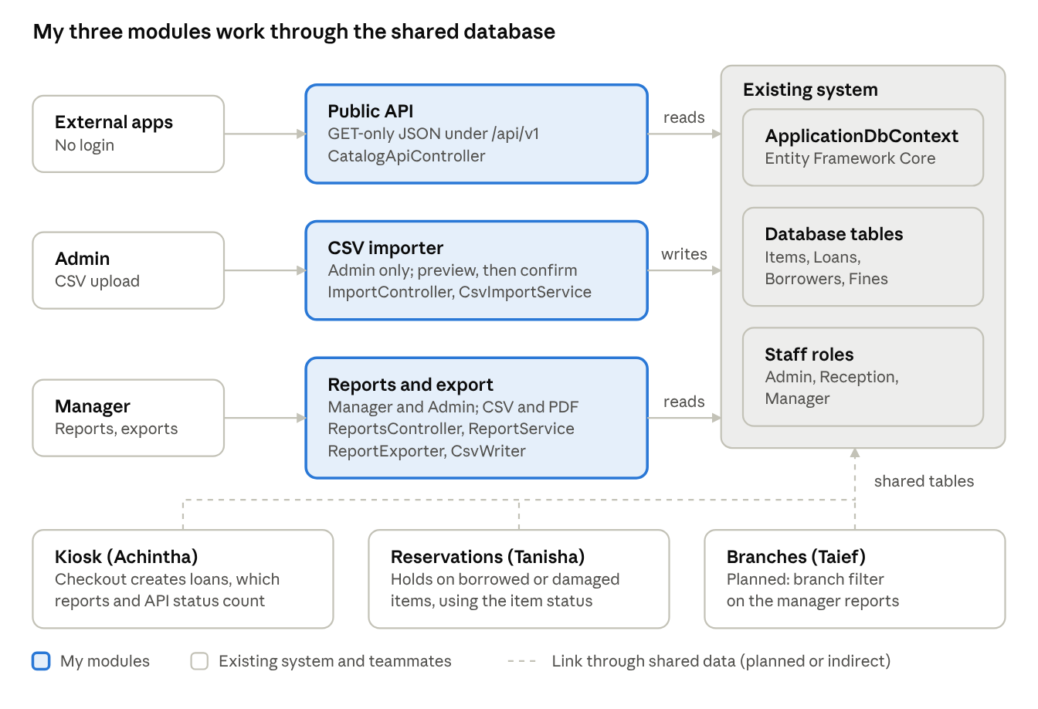
integration view · my 3 modules, the shared database and teammates' modules
My API, importer and reports each reach the existing system through the shared database context, and the kiosk, reservation and branch modules meet them in the same tables.

Integration diagrams and user journeys
These are the integration diagrams and user journeys for my three new modules: the read-only API, the CSV importer, and the manager reports with export. In the integration diagrams, blue boxes are the new parts I built, grey boxes are parts that were already in the library system, and yellow boxes are the people using it. In the journeys, green boxes are the steps a user takes and the red box is what happens if something goes wrong.

Integration diagrams

1.1 Read-only API
Anyone can send a GET request to the API without logging in. The API reads items from the existing library database and sends back only safe details (no replacement cost, loans, borrowers or fines). The OpenAPI file and docs page describe the API.
Outside app or browser
(no login)
Read-only API
/api/v1/* (GET only)
Library database
(items, categories)
request
read items
Safe response shapes
(no private data)
builds reply
sends JSON back
OpenAPI file and
API docs page
describes
Diagram 1. How the read-only API connects to the existing library system.

1.2 CSV importer
Only the Admin can open the Import page. The uploaded file is read, then checked with the same rules as the admin forms. The Admin sees a preview first, and nothing is saved until they press Import. Then all the valid rows are saved in one go.
Admin
(signed in)
Import page
(Admin only)
upload CSV, then confirm
Library database
(items)
save valid rows in one go
CSV reader
Import checker
(same rules as admin forms)
check duplicates
Preview shown:
valid / invalid / duplicate
results
Admin reads it
Diagram 2. How the CSV importer connects to the existing library system.

1.3 Manager reports and export
Only the Manager can open the Reports page. One report calculator reads the loans, fines and items and gives the same figures to the screen, the CSV file and the PDF file. The Manager dashboard uses the same data, so the totals match.
Manager
(signed in)
Reports page
(Manager only)
pick dates
Manager dashboard
(same totals)
Report calculator
(one calculation)
asks for figures
Library database
(loans, fines, items)
reads
same data
CSV and PDF exporters
same data
download file
Diagram 3. How the reports and export connect to the existing library system.

User journeys

2.1 Developer using the API
1. Developer opens /api-docs.html
2. Picks an endpoint (items, categories, status)
3. Sends a GET request
4. Gets JSON with paging and items
Clear error (400 or 404)
if wrong
Diagram 4. A developer looks up library items through the API.

2.2 Admin importing items
1. Admin signs in
2. Opens Import page, downloads template
3. Uploads a CSV file
4. Reads the preview (valid, invalid, duplicate)
5. Presses Import
6. Sees how many items were added
File error, nothing saved
if wrong
Diagram 5. An Admin adds new items from a CSV file.

2.3 Manager exporting a report
1. Manager signs in
2. Opens Reports & Export
3. Sets From and To dates
4. Reads the three reports
5. Presses Export CSV or PDF
6. Opens the downloaded file
Other roles refused or sent to login
if wrong
Diagram 6. A Manager views a report and downloads it.

Requirements and testing
My modules have 29 numbered requirements (22 must-have, 7 should-have) and 33 test cases. Each requirement is linked to the code that does it and the test that checks it. All 33 tests passed when I ran them on the site.
Area | Requirement IDs | Test cases | What the tests check
Public API | REQ-API-01 to 10 | TC-API-01 to 14 | Valid responses, 400 and 404 errors, 405 on write verbs, no private data, documentation page
CSV importer | REQ-IMP-01 to 08 | TC-IMP-01 to 06 (with sub-cases 04a to 04g) | Admin-only access, valid and mixed files, six kinds of bad file, re-upload gives duplicates, template
Analytics | REQ-ANA-01 to 06 | TC-ANA-01 to 03 | Figures match the manager dashboard, date filter, Manager and Admin access only
Export | REQ-EXP-01 to 03 | TC-EXP-01 to 03 | CSV and PDF open for all three reports, including a report with no data
General | REQ-GEN-01 to 02 | TC-GEN-01 | Clean build, existing features unchanged

Test evidence (screenshots)
These are the main screenshots from my testing. The rest are in the appendix at the end, and every screenshot is named after its test ID.
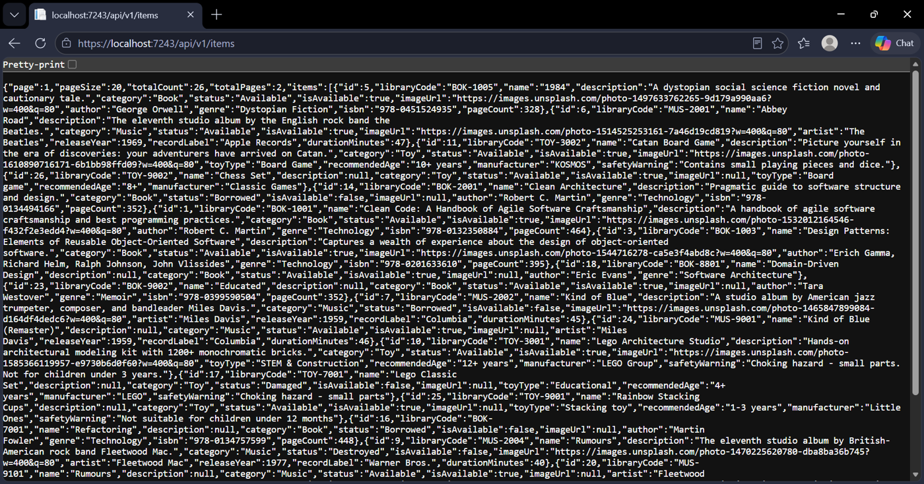
Figure 1. The API item list (TC-API-01). Typing the link into the browser gives the catalogue as JSON, with the paging fields at the top.
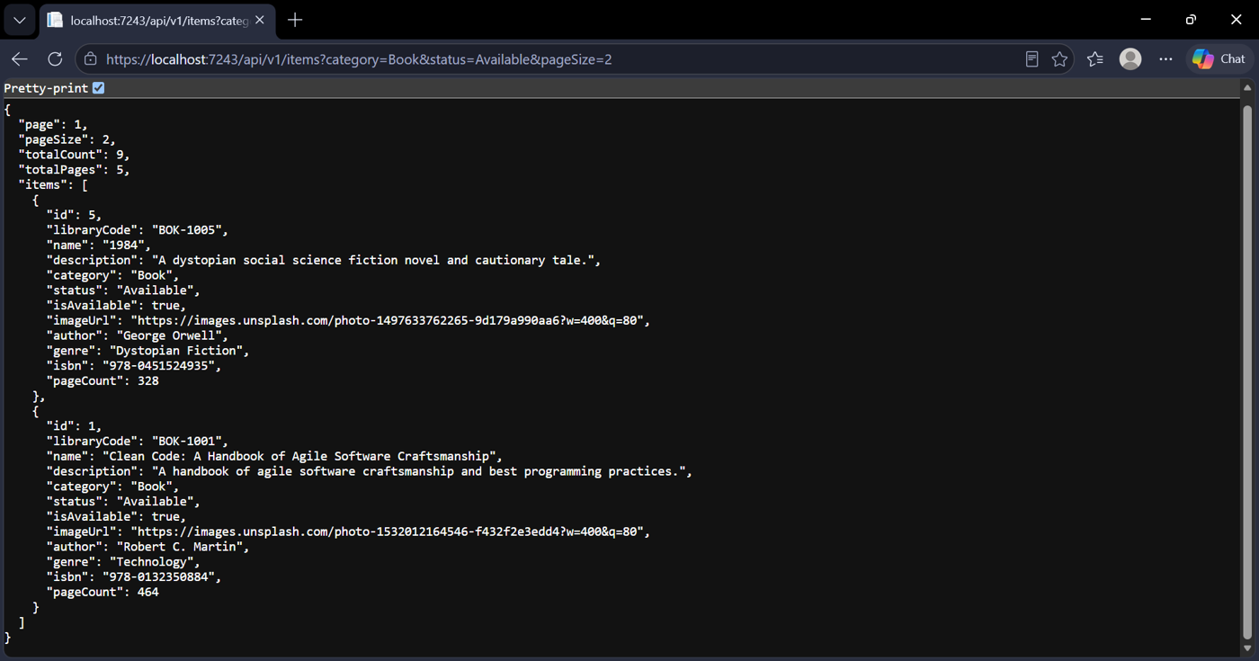
Figure 2. Filtering the item list (TC-API-02). Asking for available books, 2 per page, gives just 2 books and the page counts.
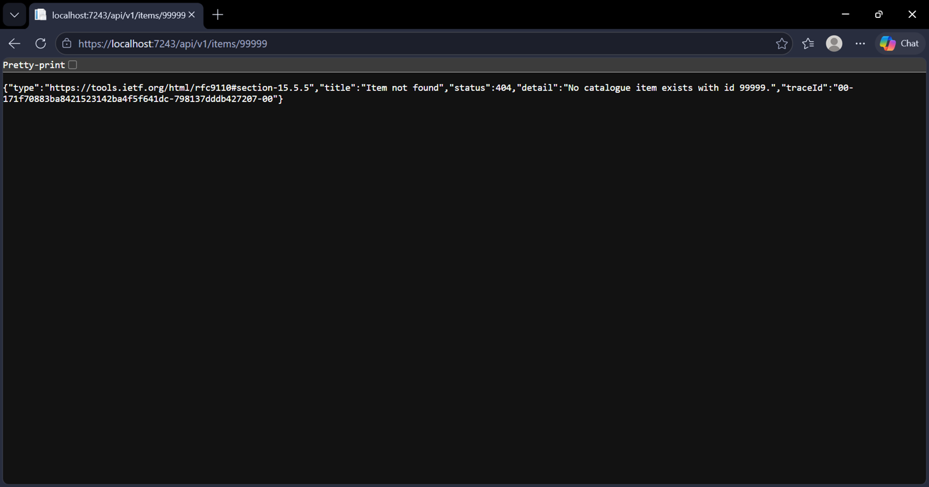
Figure 3. An item that doesn't exist (TC-API-05). The API answers with a 404 "Item not found" message.
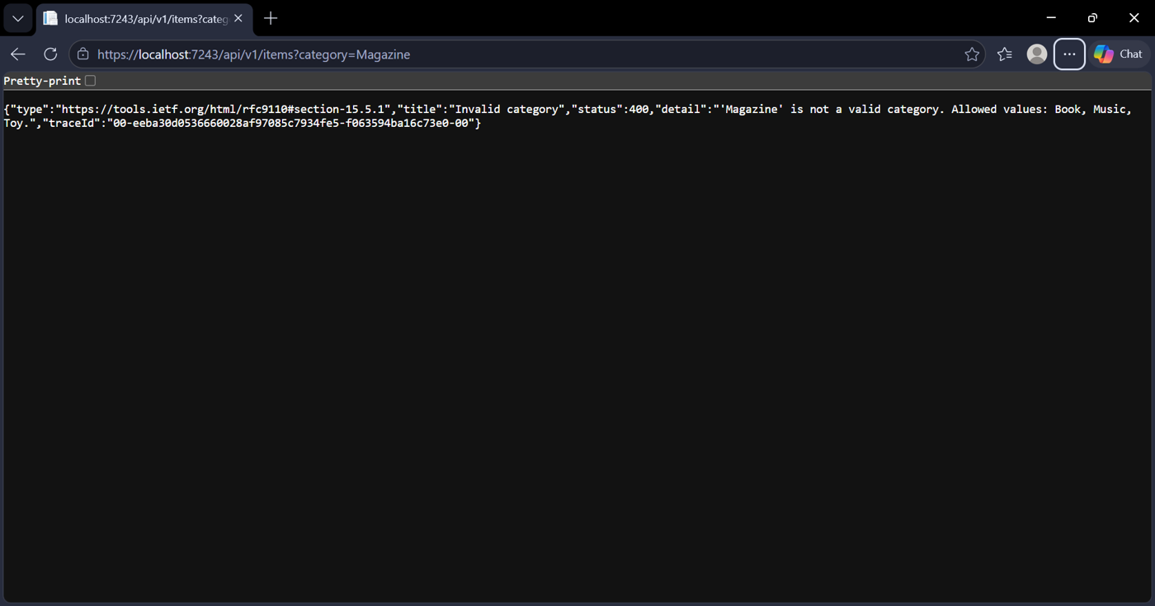
Figure 4. A bad category (TC-API-09). The API says 400 and lists the categories it accepts: Book, Music or Toy.
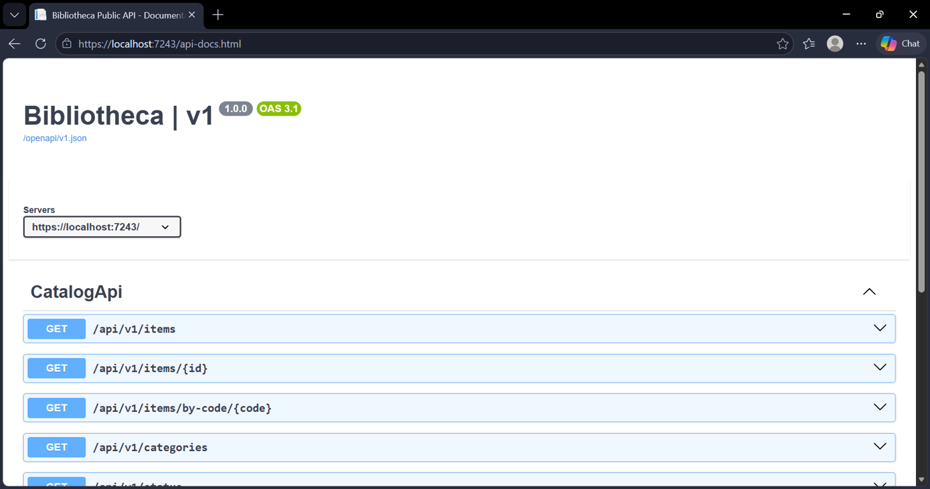
Figure 5. The API docs page (TC-API-14). It lists the five read-only GET links.
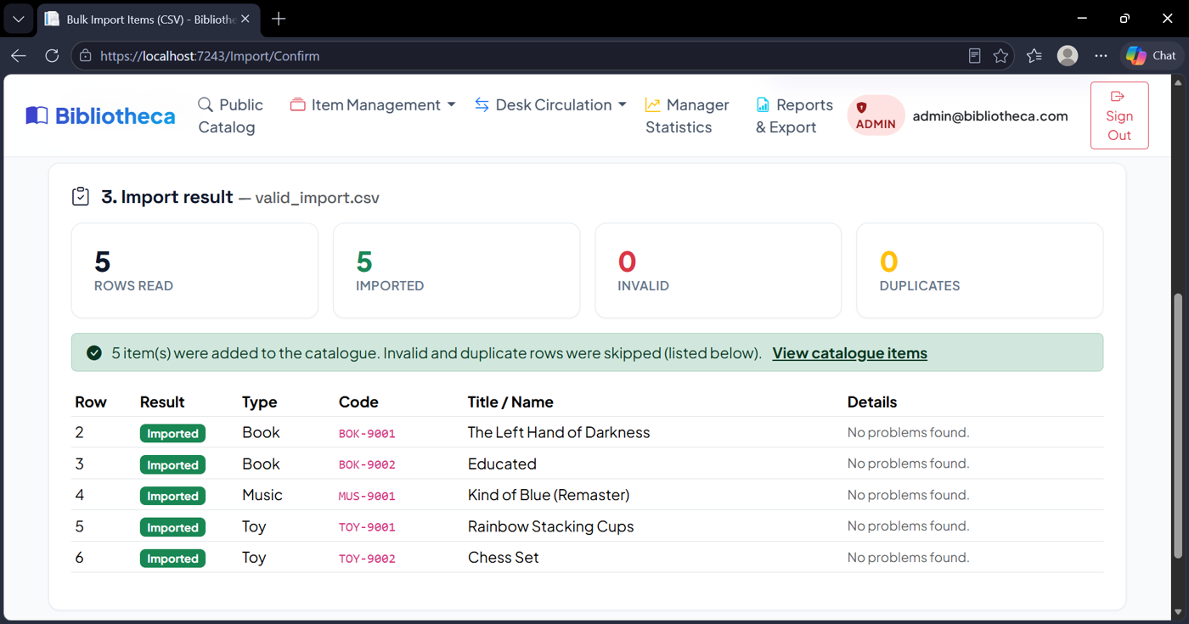
Figure 6. Importing a good file (TC-IMP-02). valid_import.csv added 5 items, and every row is marked Imported.
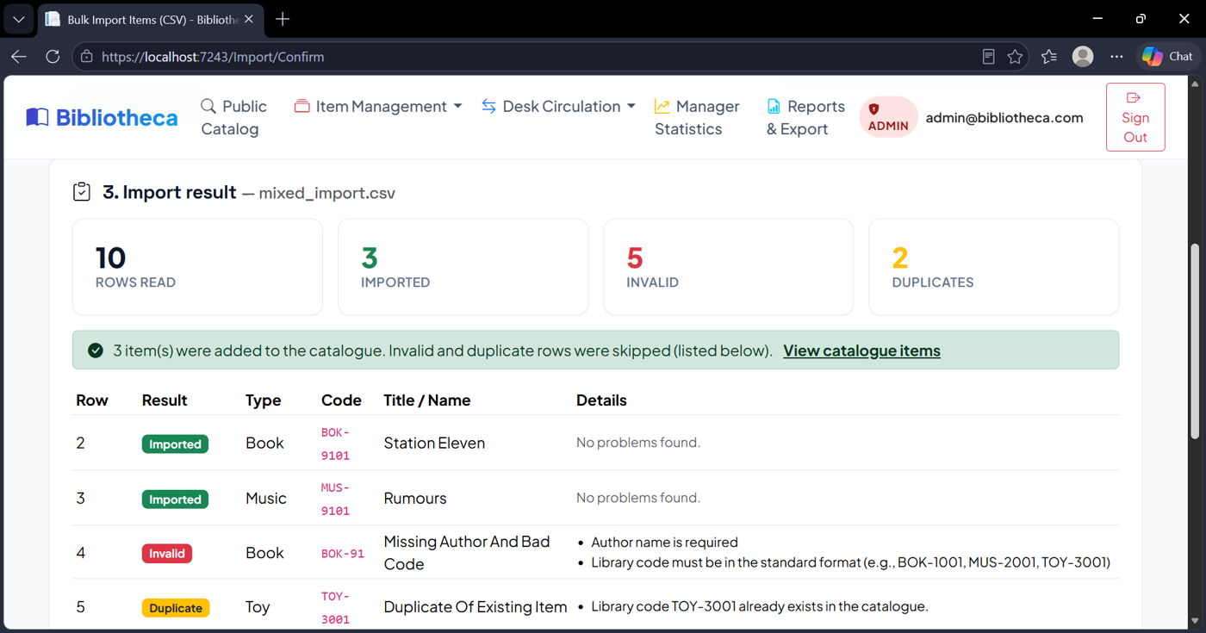
Figure 7. Importing a mixed file (TC-IMP-03). Of 10 rows, 3 were imported, 5 were invalid and 2 were duplicates. The bad rows were skipped.
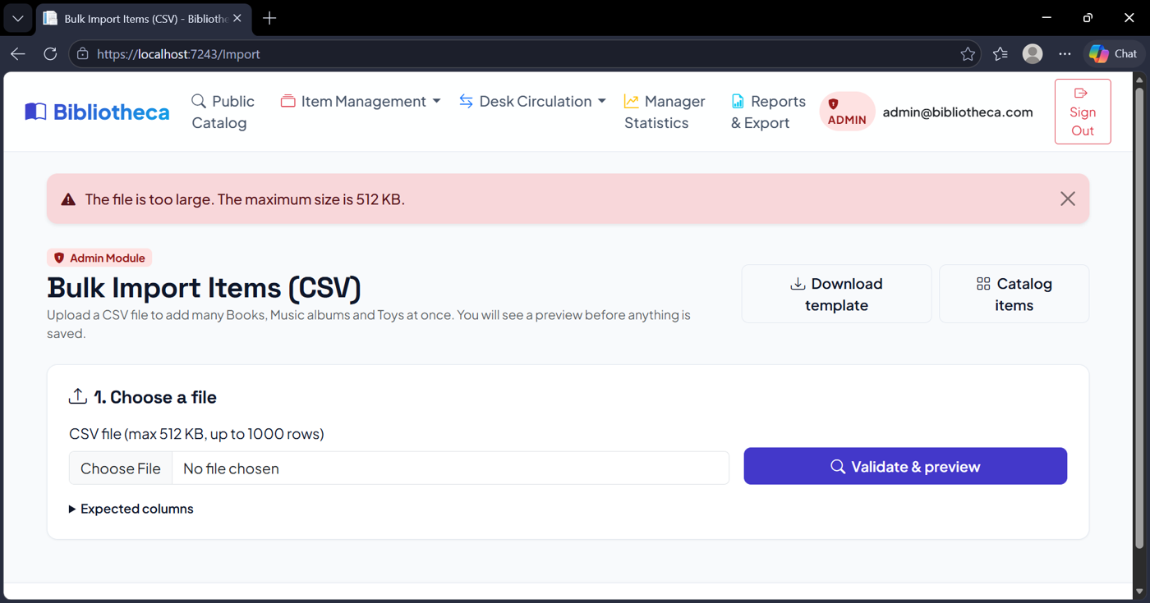
Figure 8. A file that is too big (TC-IMP-04g). A file over 512 KB gets a clear message and nothing is imported.
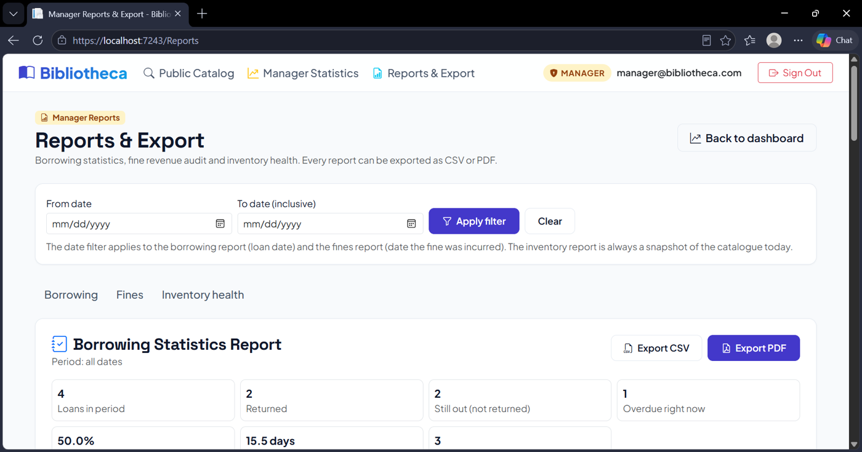
Figure 9. The Reports & Export page (TC-ANA-01). It has the Borrowing, Fines and Inventory reports, the date filter, and the Export CSV and Export PDF buttons.
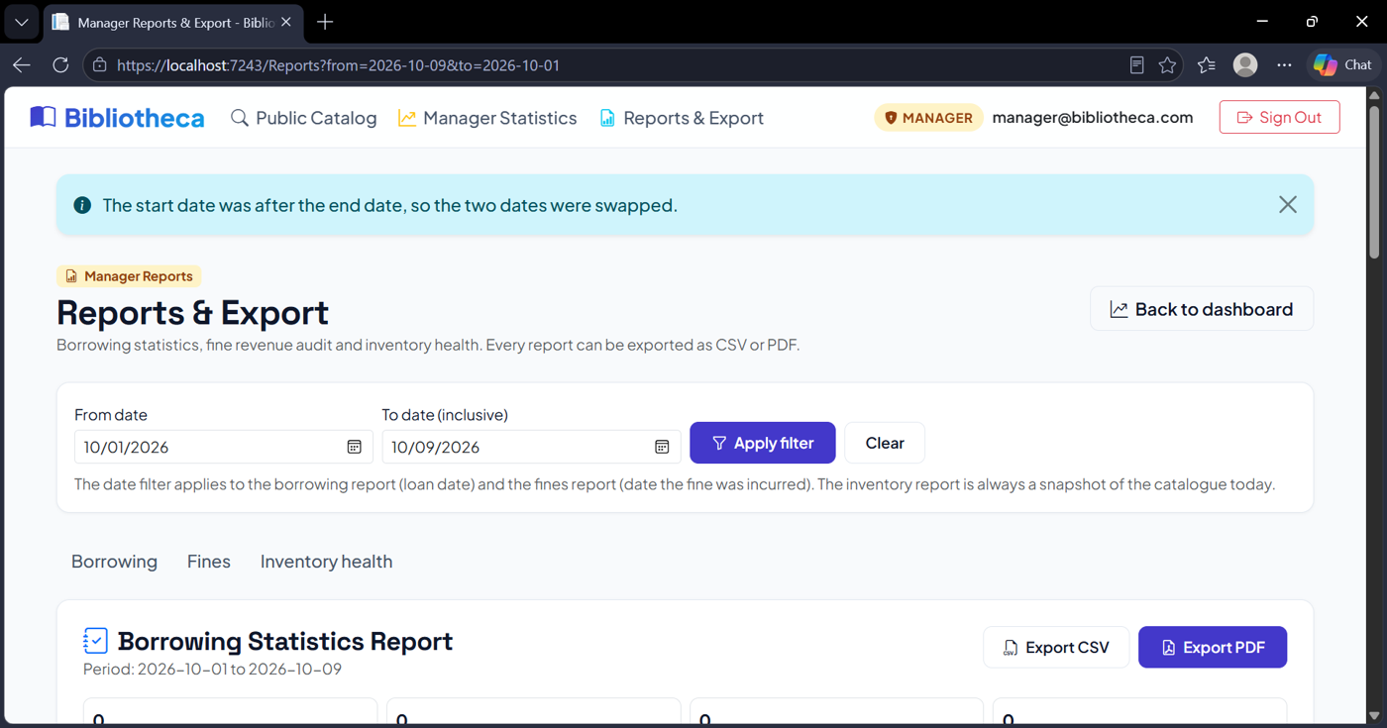
Figure 10. Dates the wrong way round (TC-ANA-02). The page swaps them and shows a message saying so.
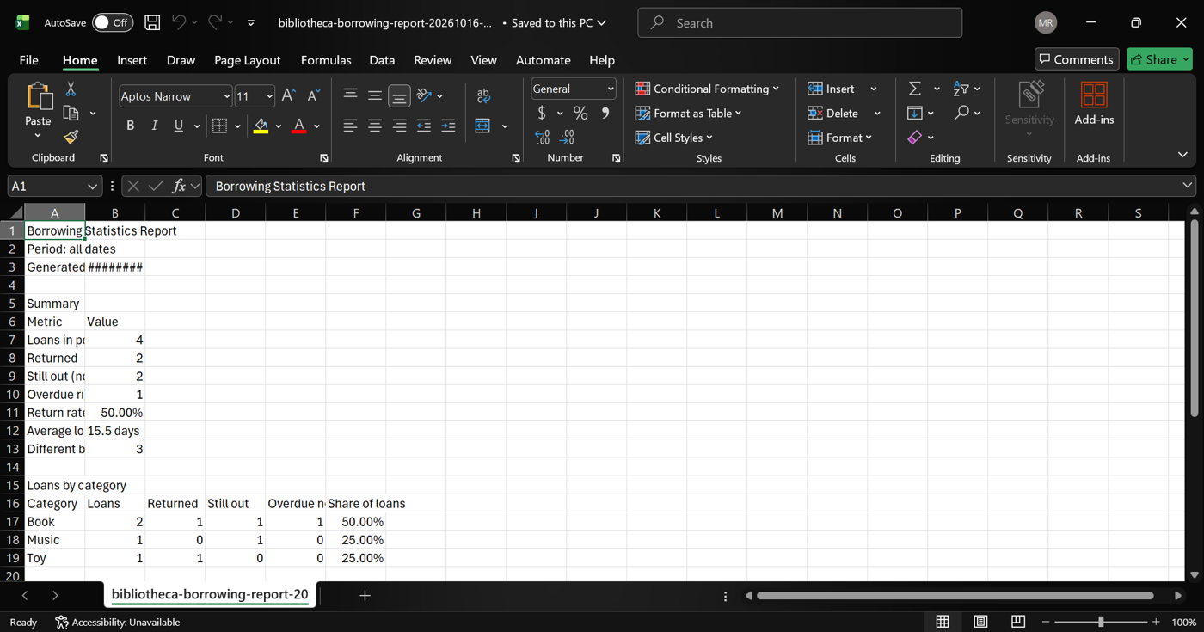
Figure 11. The borrowing report as a CSV in Excel (TC-EXP-01). The summary and tables open cleanly.
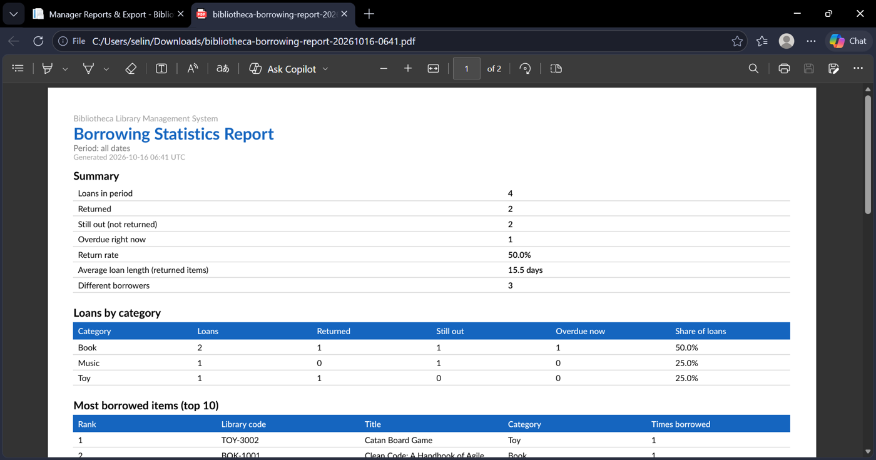
Figure 12. The borrowing report as a PDF (TC-EXP-02). It has a title, a summary, tables and a page number.
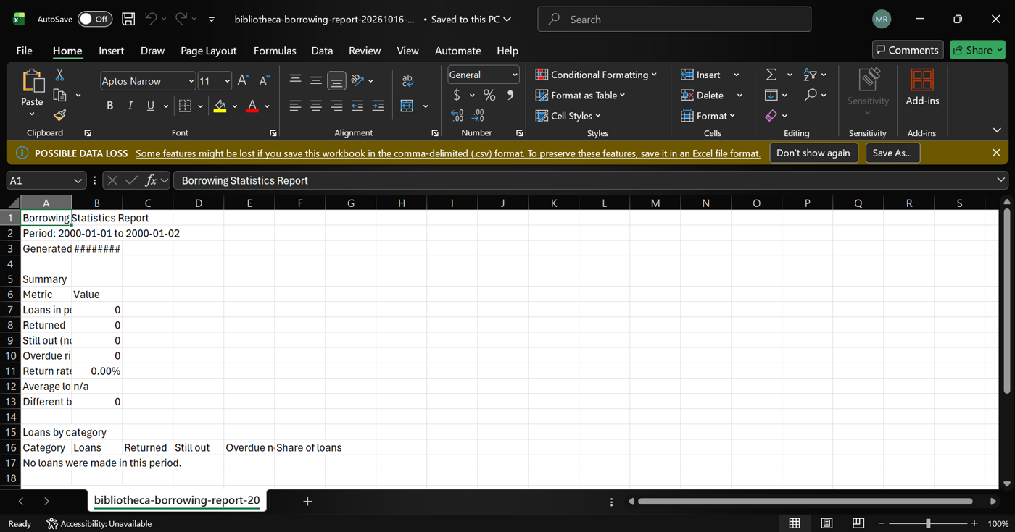
Figure 13. A date range with no data (TC-EXP-03). The export still opens and says no loans were made in this period.
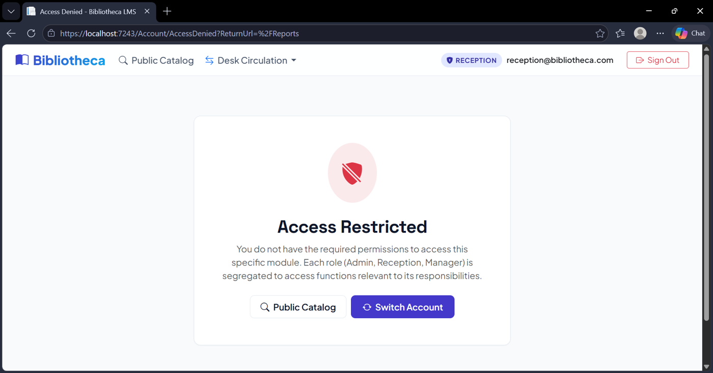
Figure 14. Wrong role (TC-ANA-03). Signed in as Reception, the Reports page says Access Restricted.
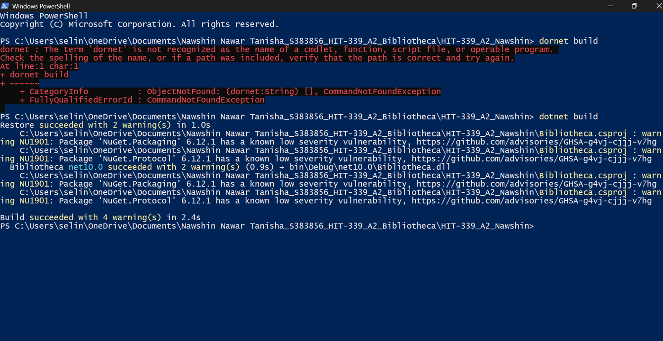
Figure 15. The build check (TC-GEN-01). dotnet build succeeded, with warnings only. My first try failed because the site was still running, so I stopped it and built again.
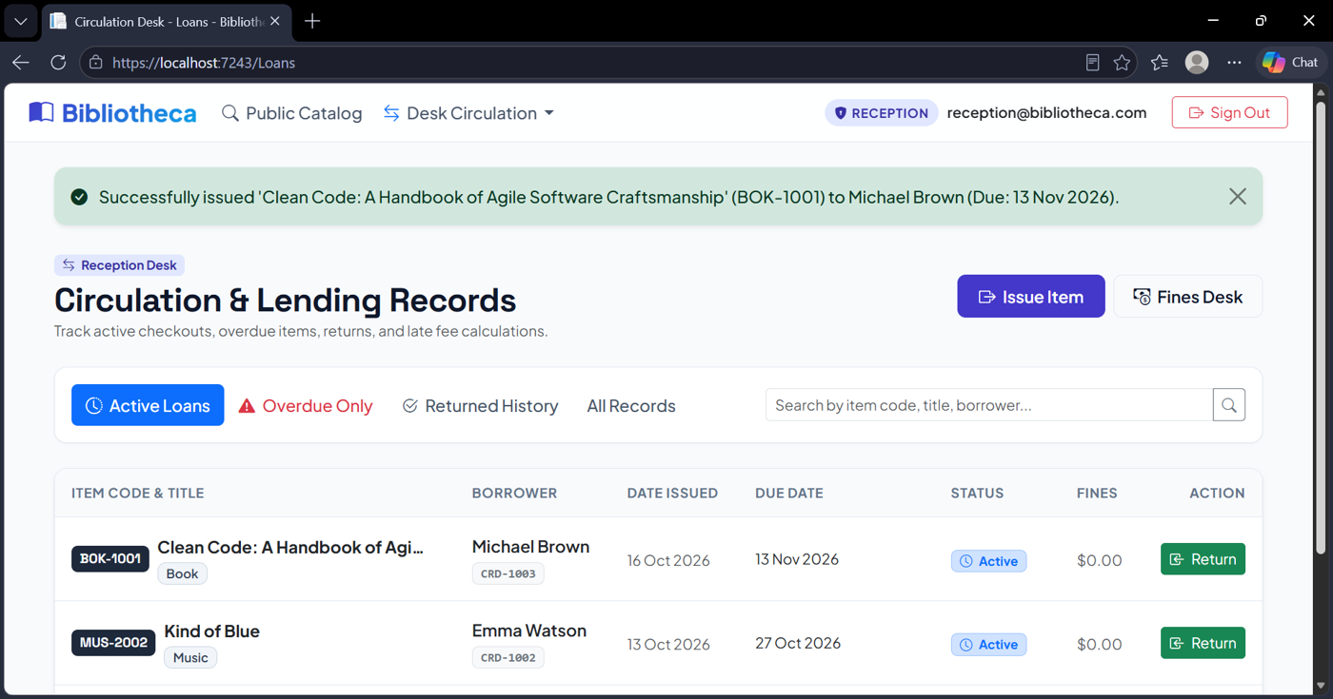
Figure 16. Issuing a loan (TC-GEN-01). BOK-1001 was issued to Michael Brown, so the existing loan feature still works.
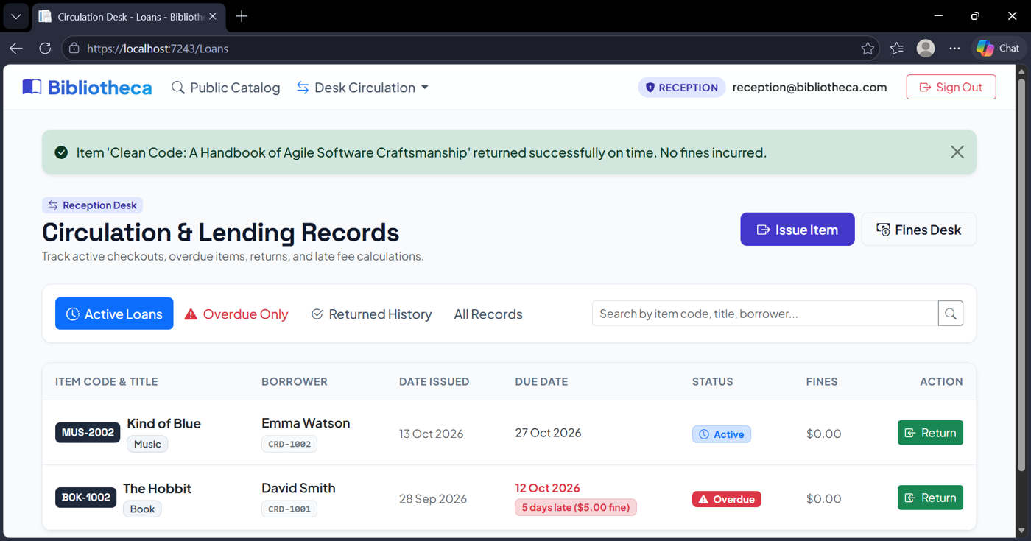
Figure 17. Returning the loan (TC-GEN-01). The item was returned on time with no fine.

Strengths and weaknesses
The best thing about my part is that all three modules reuse the rules and data we already had. The weak spots are that I only tested by hand and left a few things out on purpose.

Strengths
- Reuse, not copy. The importer checks rows with the same rules as the admin forms, and the reports use the tables and roles we already had. I didn't change the database, so it merges with everyone else's work without much trouble.
- One calculation per report. The screen, the CSV and the PDF all come from the same data, so they can't disagree.
- Safe by design. The API is GET only and hides private data. The importer shows a preview first and saves everything in one go. CSV exports make spreadsheet formulas safe.
- Easy to trace. Every requirement has an ID, the code that does it and the test that checks it.

Weaknesses
- Manual testing only. There are no automated tests, so if something breaks later someone has to repeat the tests by hand.
- CSV only. The brief also allows a mock external data source, which I didn't build.
- Reports load data into memory. That's fine for a small library but wouldn't scale to a big one.
- No API key or rate limit. The data is already public in the catalogue, but a real API would need both.
- Third-party PDF library. PDF export depends on QuestPDF and its licence terms.

AI Acknowledgement:
I used Claude to help me with my part of the assignment.

Appendix: Other test screenshots
These are the rest of my test screenshots. The numbered figures in the main part of this document are the ones I picked as examples. Each screenshot here is named by its test ID.
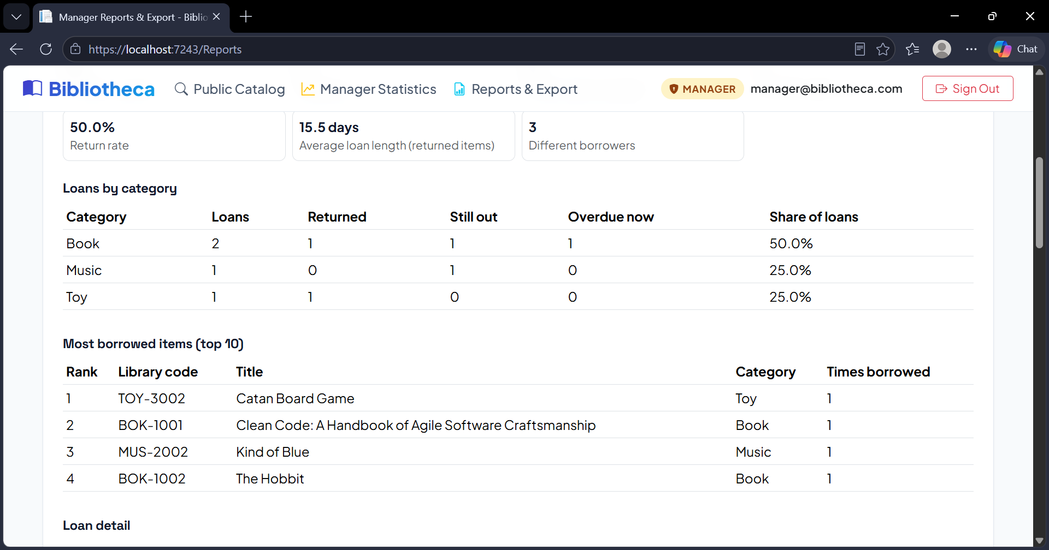
Figure A1. Report figures on the Reports page (1 of 5) (TC-ANA-01).
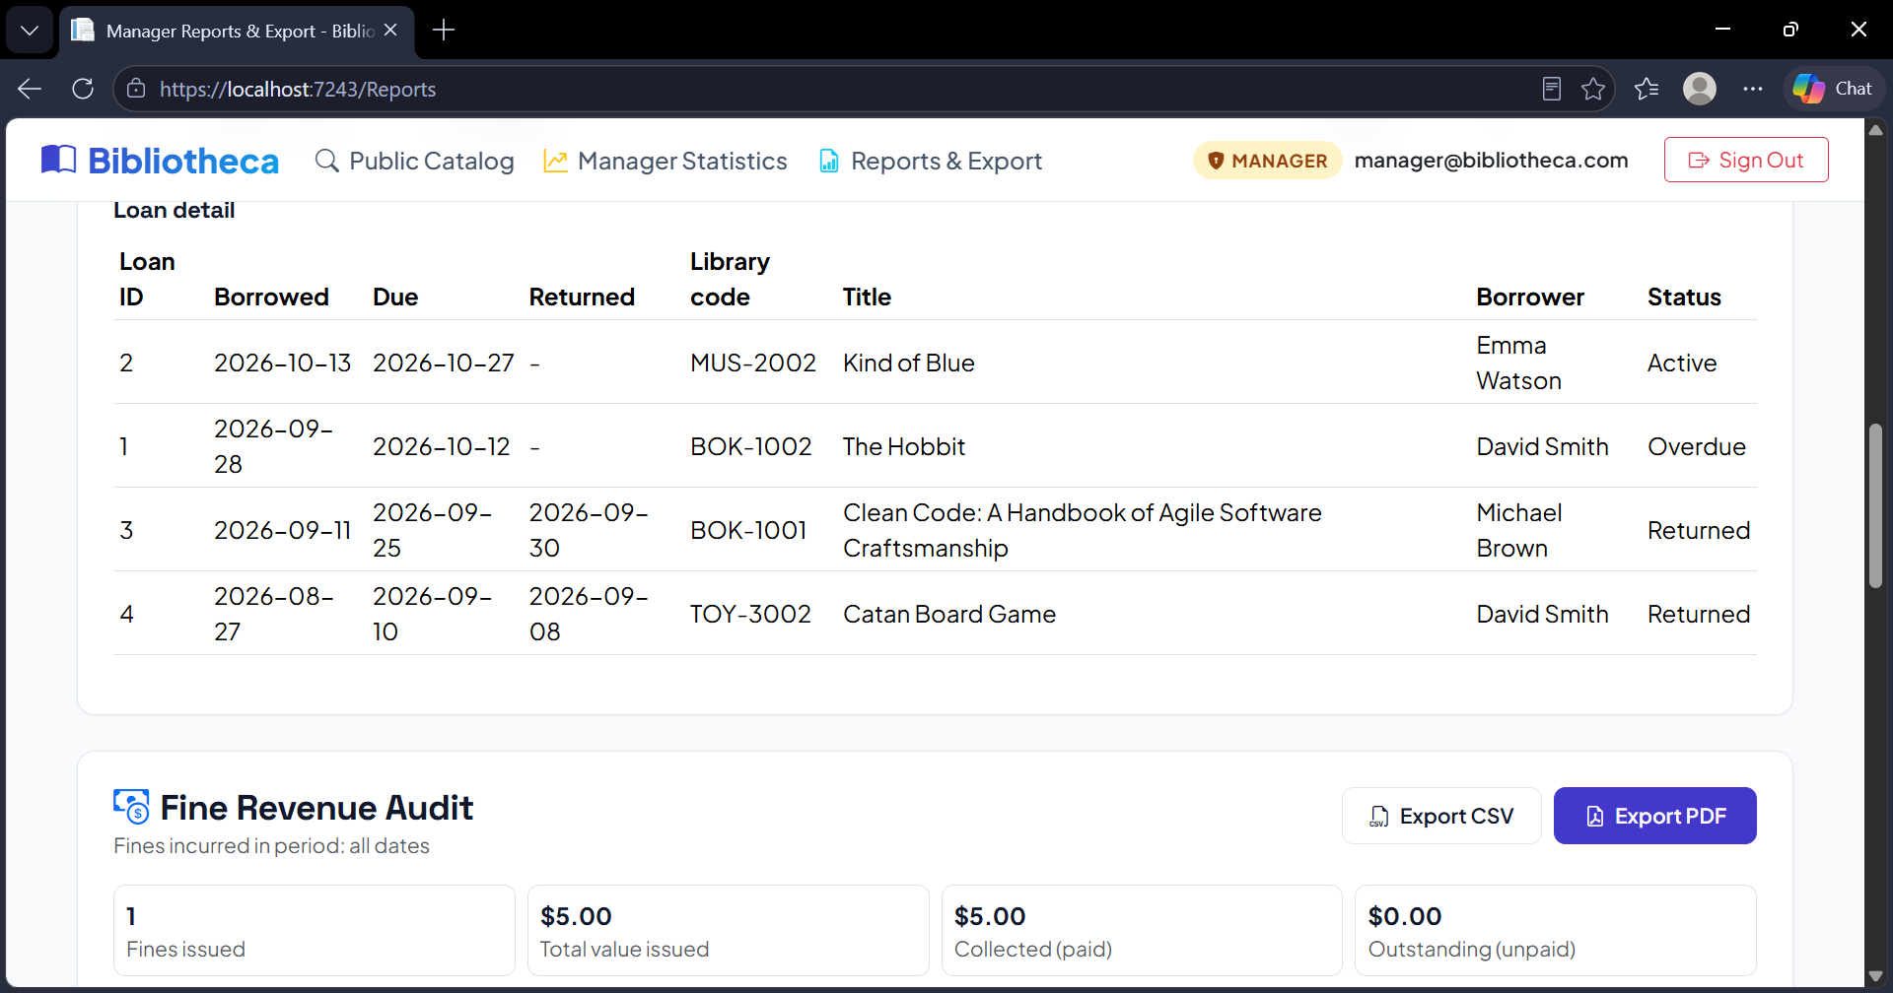
Figure A2. Report figures on the Reports page (2 of 5) (TC-ANA-01).
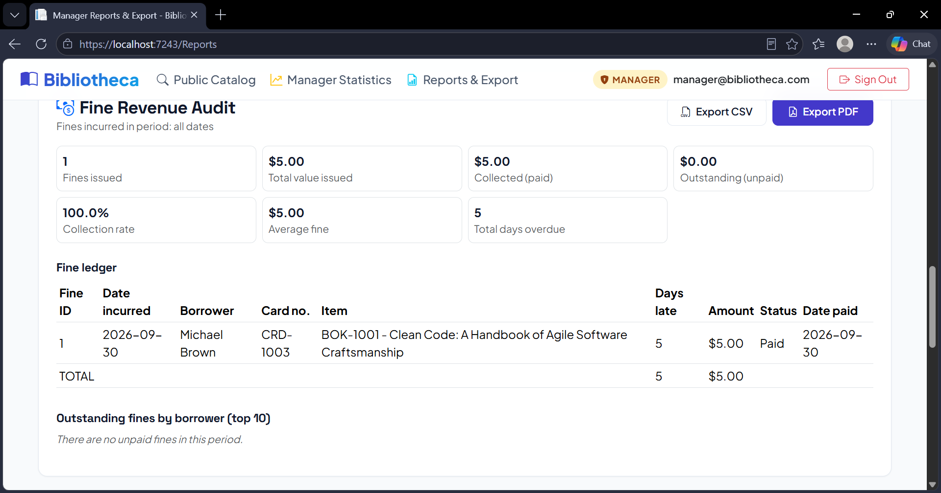
Figure A3. Report figures on the Reports page (3 of 5) (TC-ANA-01).
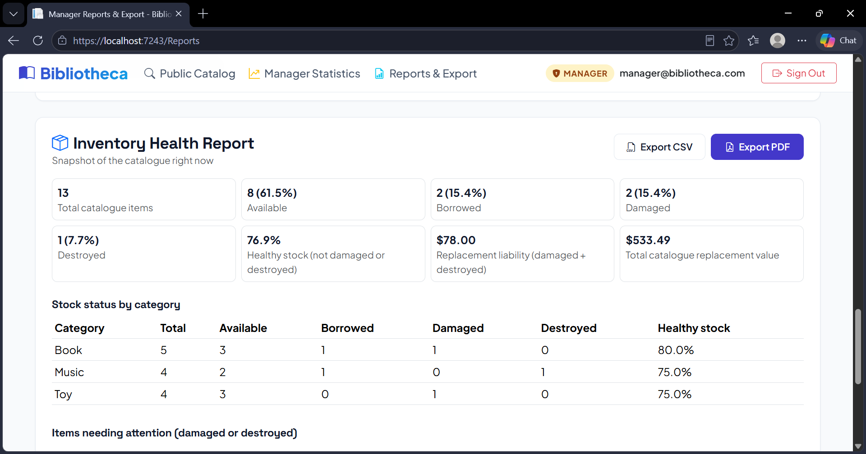
Figure A4. Report figures on the Reports page (4 of 5) (TC-ANA-01).
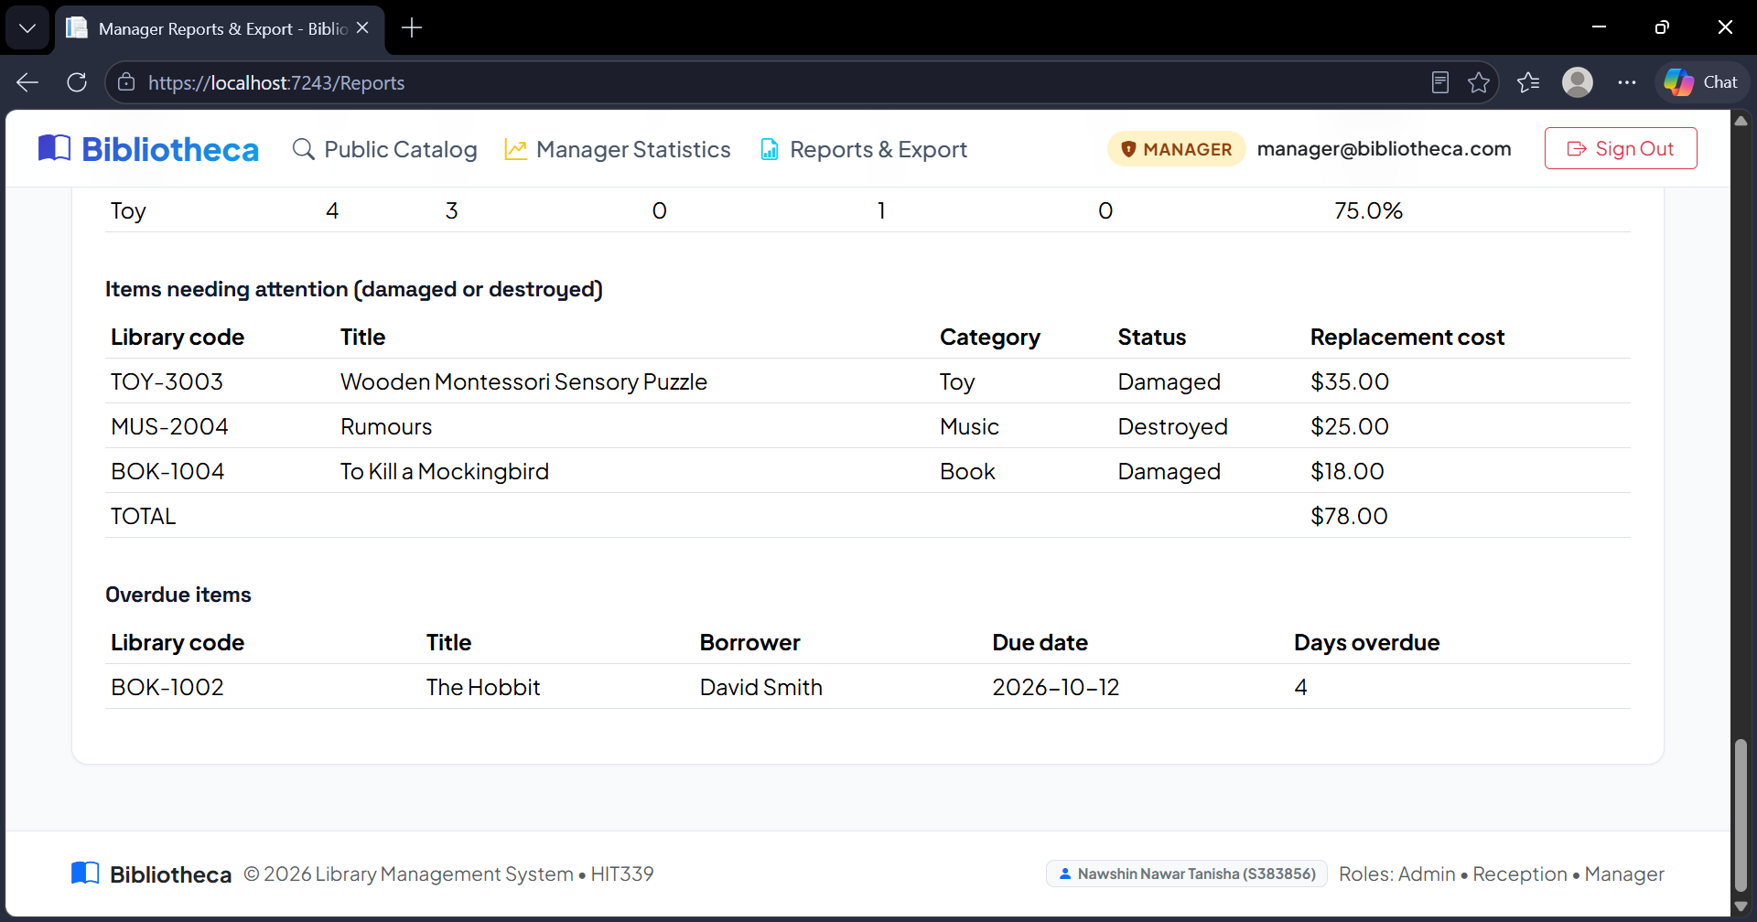
Figure A5. Report figures on the Reports page (5 of 5) (TC-ANA-01).
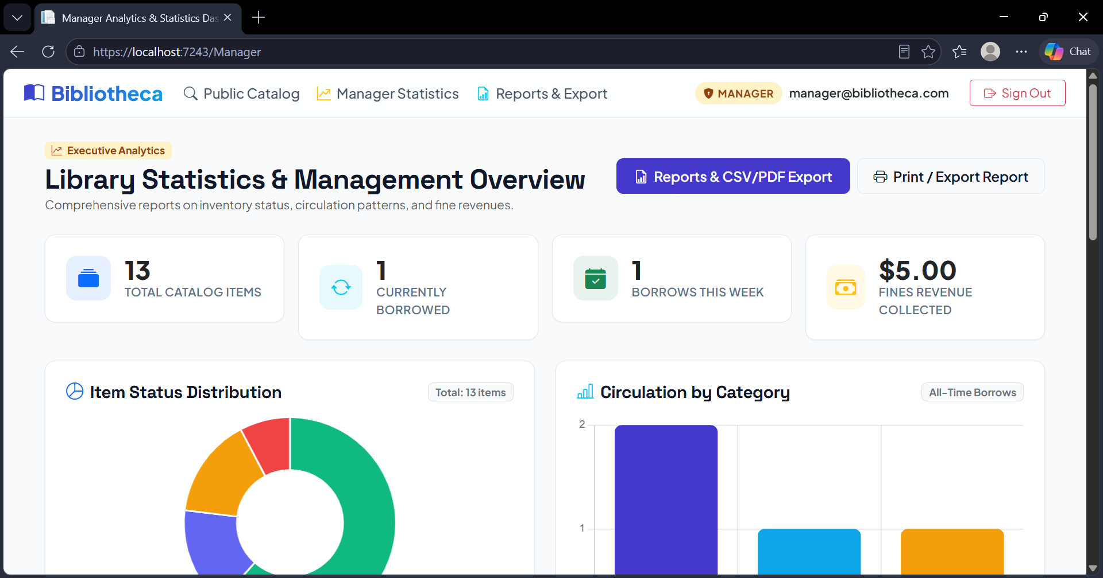
Figure A6. Manager dashboard totals to compare with the reports (1 of 4) (TC-ANA-01).
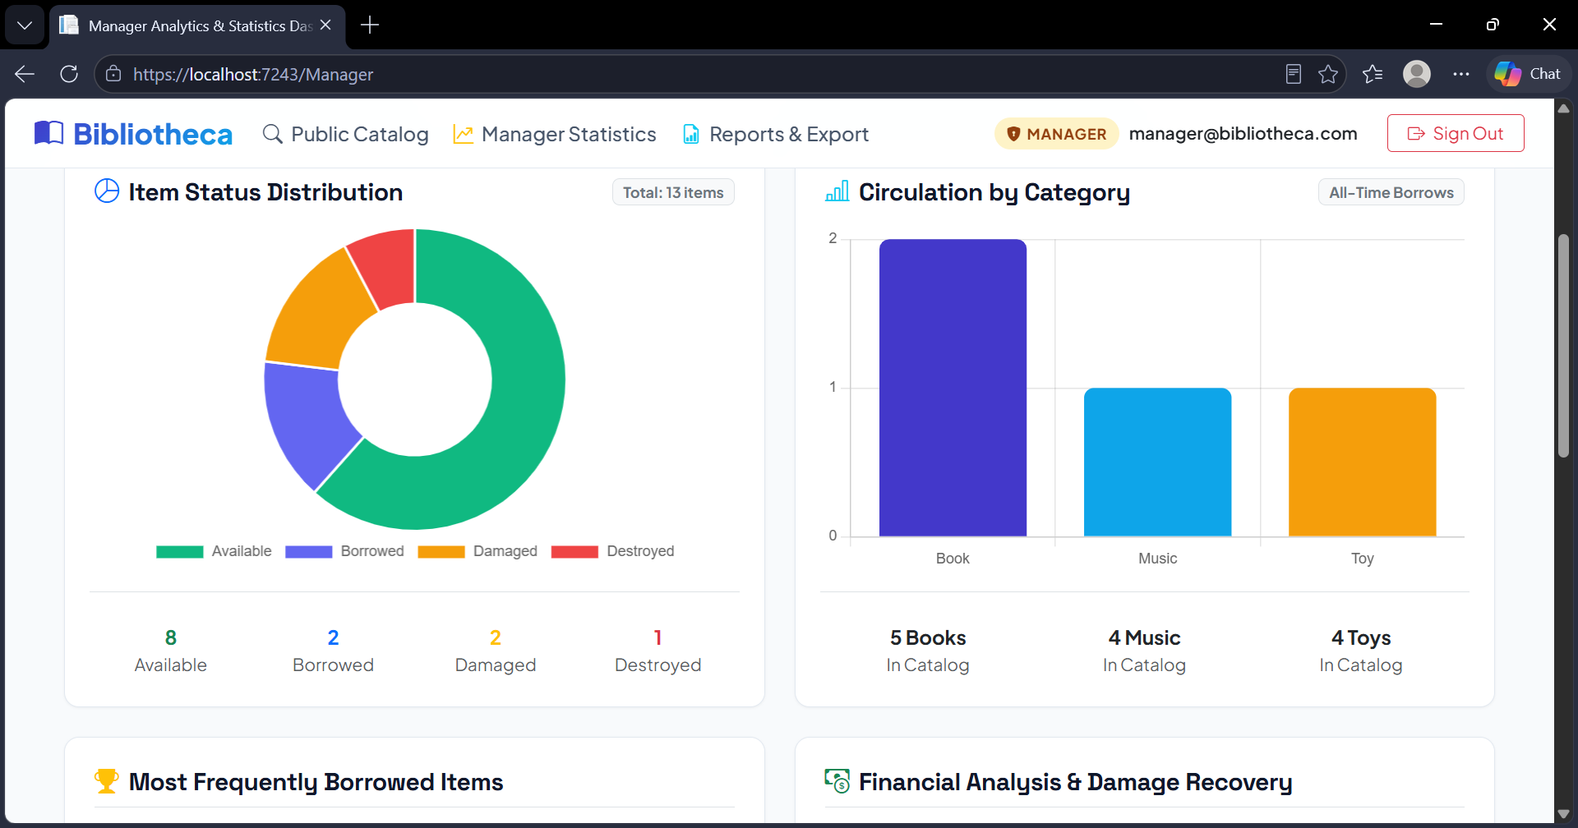
Figure A7. Manager dashboard totals to compare with the reports (2 of 4) (TC-ANA-01).
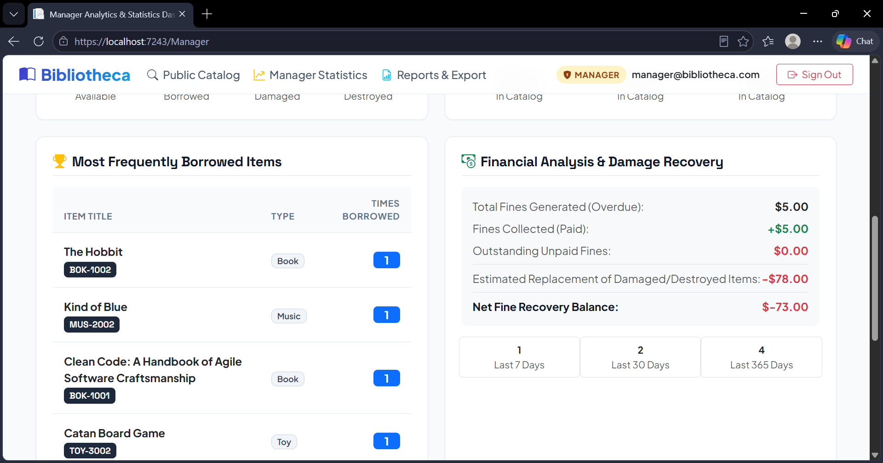
Figure A8. Manager dashboard totals to compare with the reports (3 of 4) (TC-ANA-01).
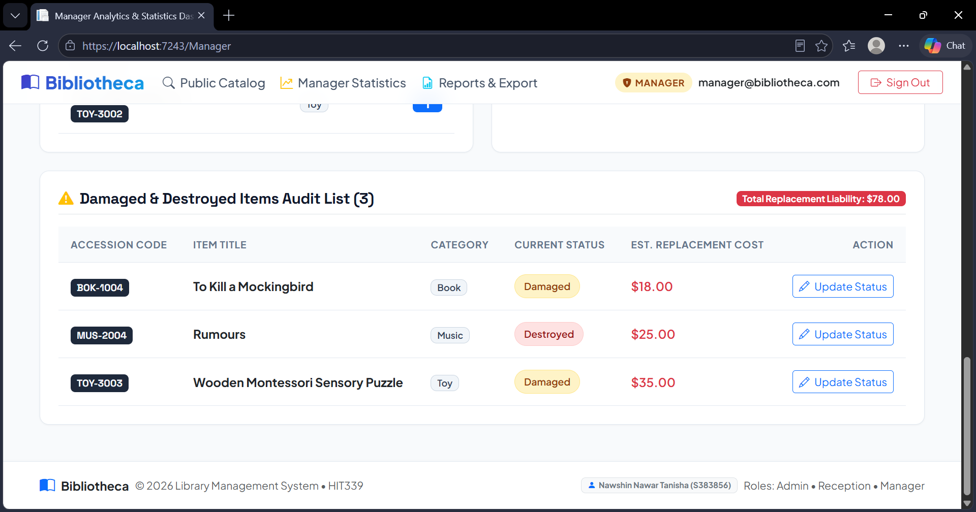
Figure A9. Manager dashboard totals to compare with the reports (4 of 4) (TC-ANA-01).
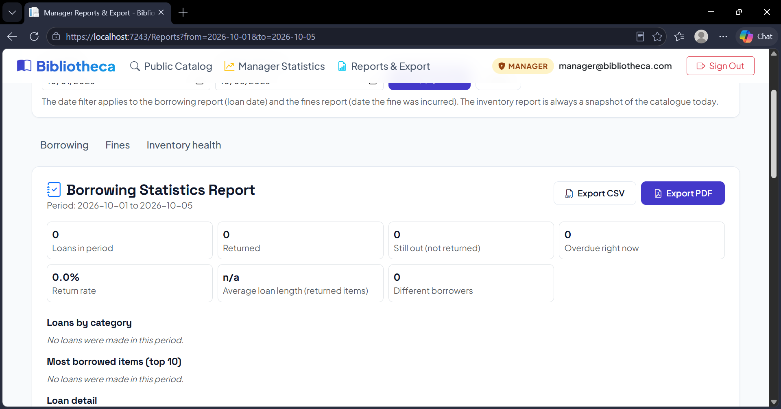
Figure A10. Reports filtered to a narrow date range (1 of 2) (TC-ANA-02).
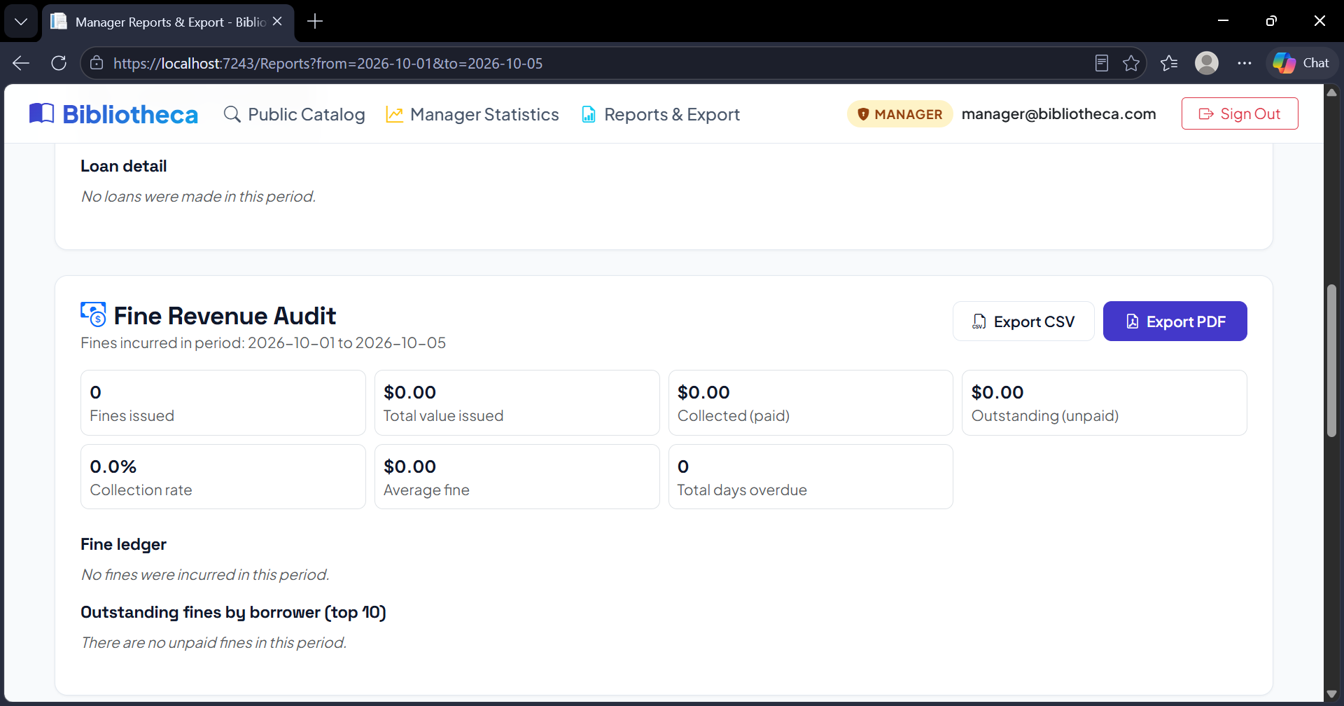
Figure A11. Reports filtered to a narrow date range (2 of 2) (TC-ANA-02).
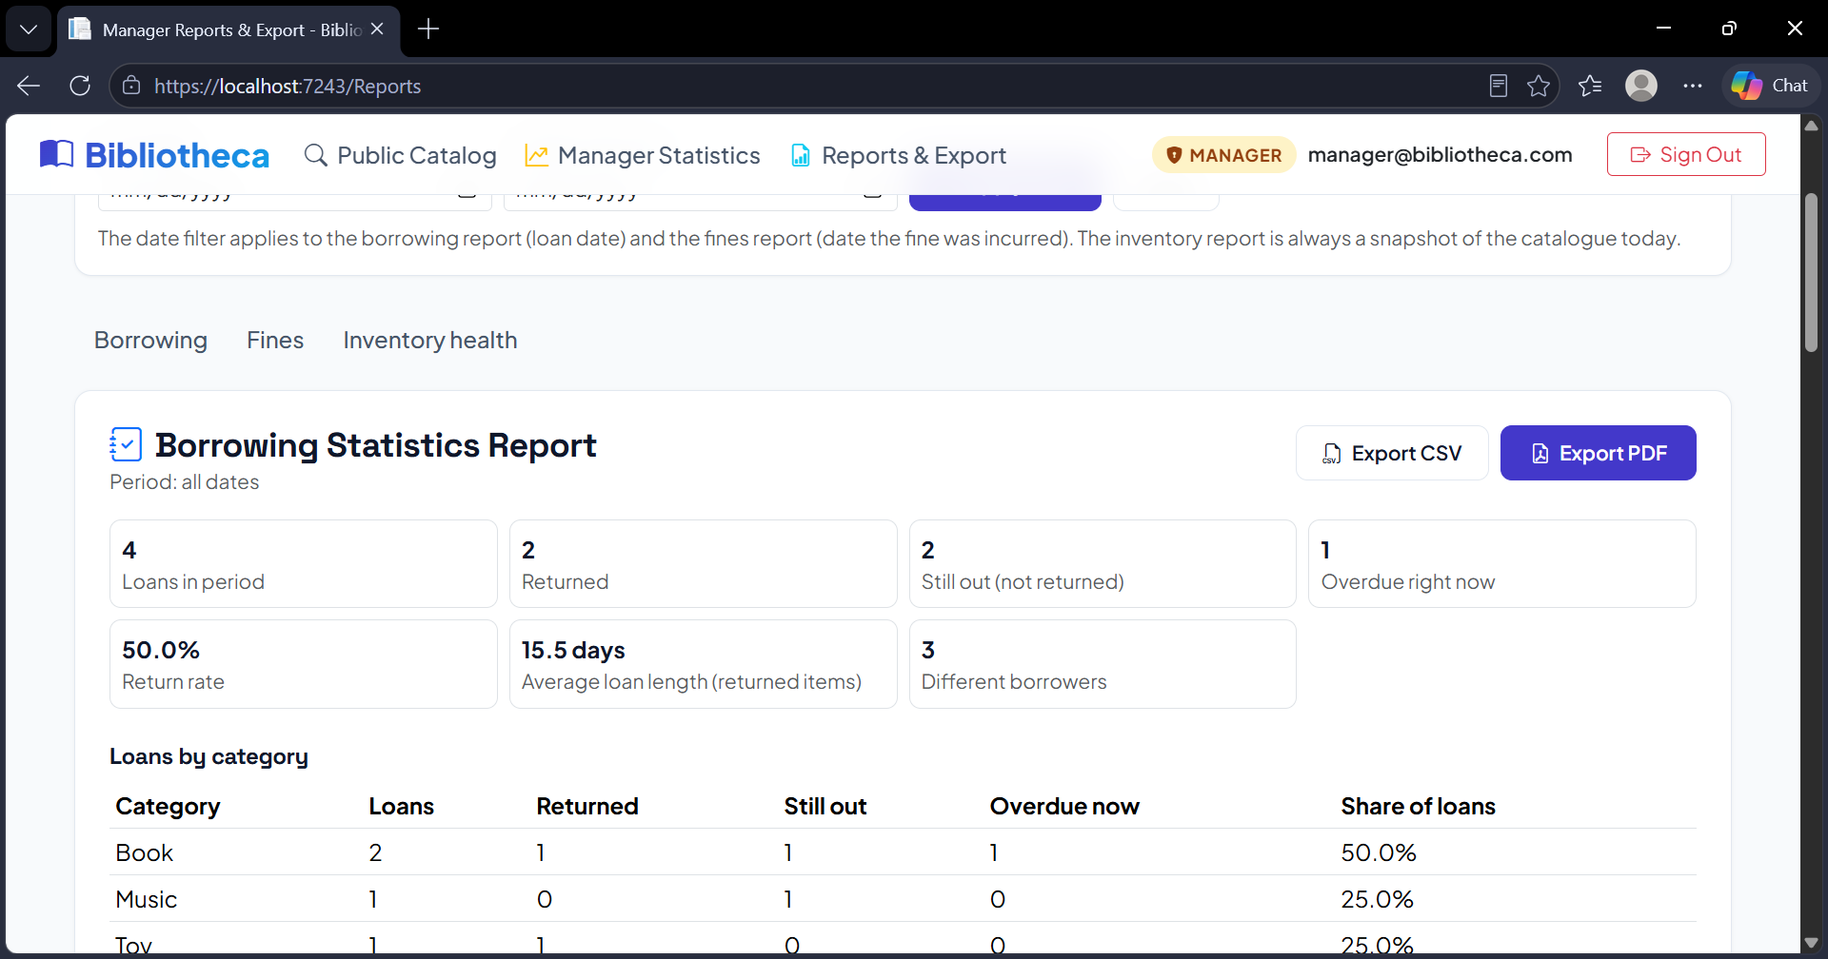
Figure A12. Date filter cleared, figures restored (TC-ANA-02).
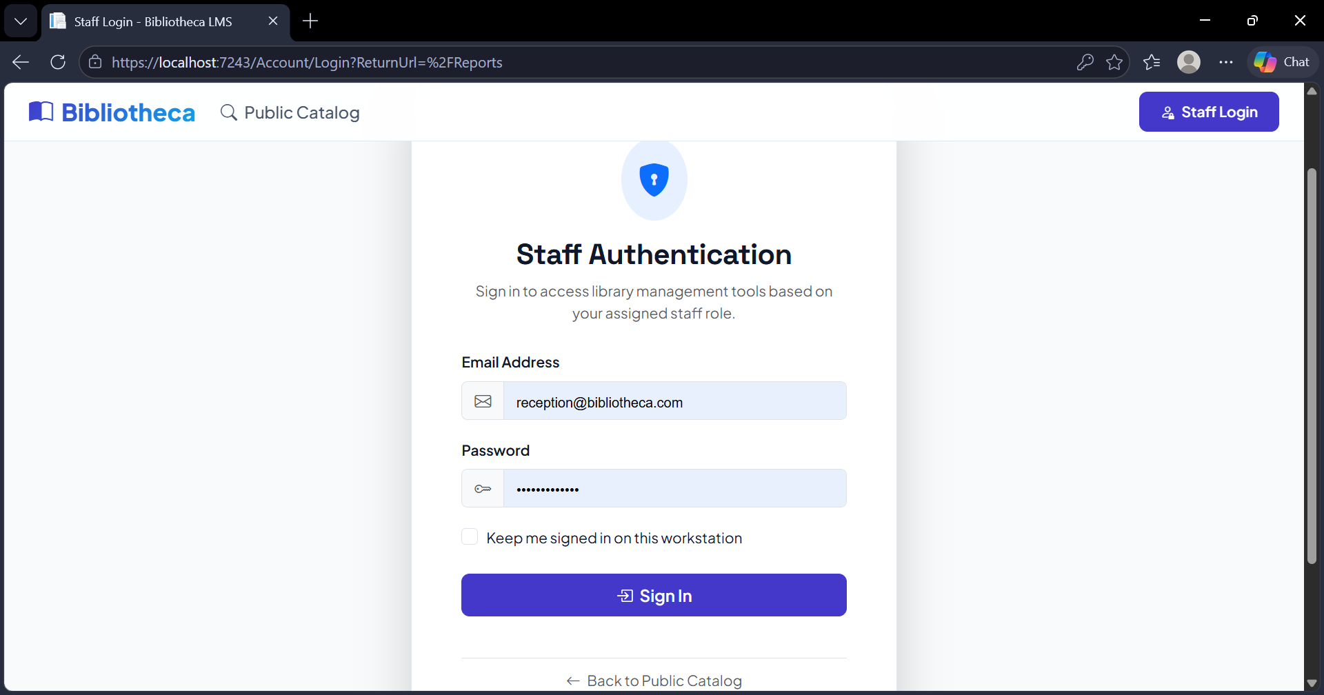
Figure A13. Reports page blocked when signed out (TC-ANA-03).
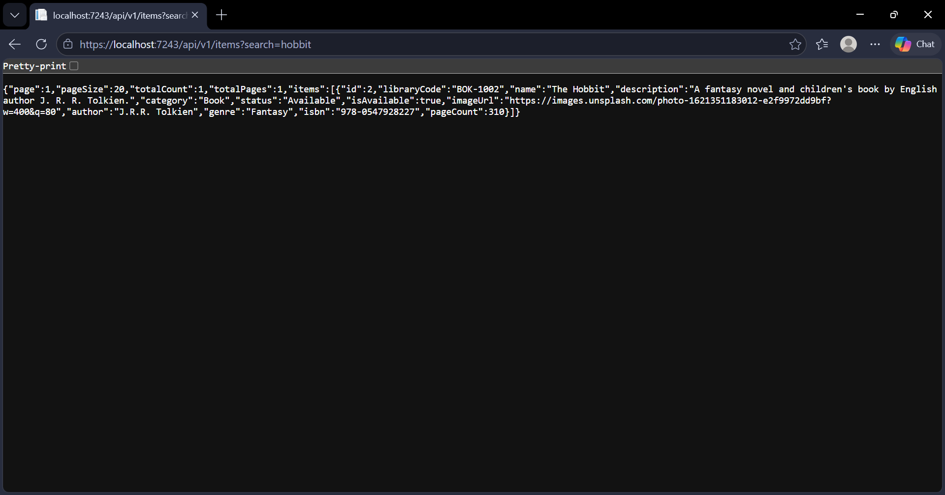
Figure A14. Searching for "hobbit" returns The Hobbit (TC-API-03).
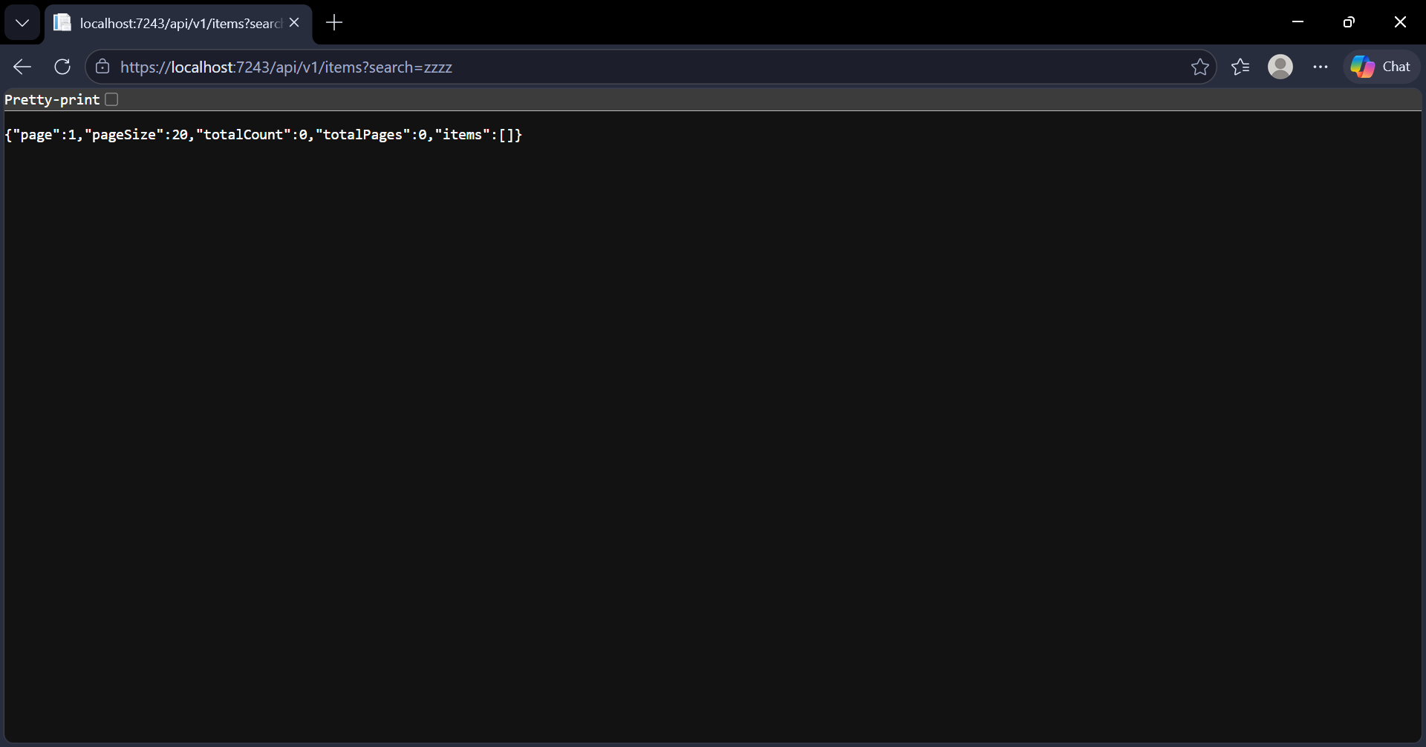
Figure A15. Searching for "zzzz" returns an empty list, not an error (TC-API-03).
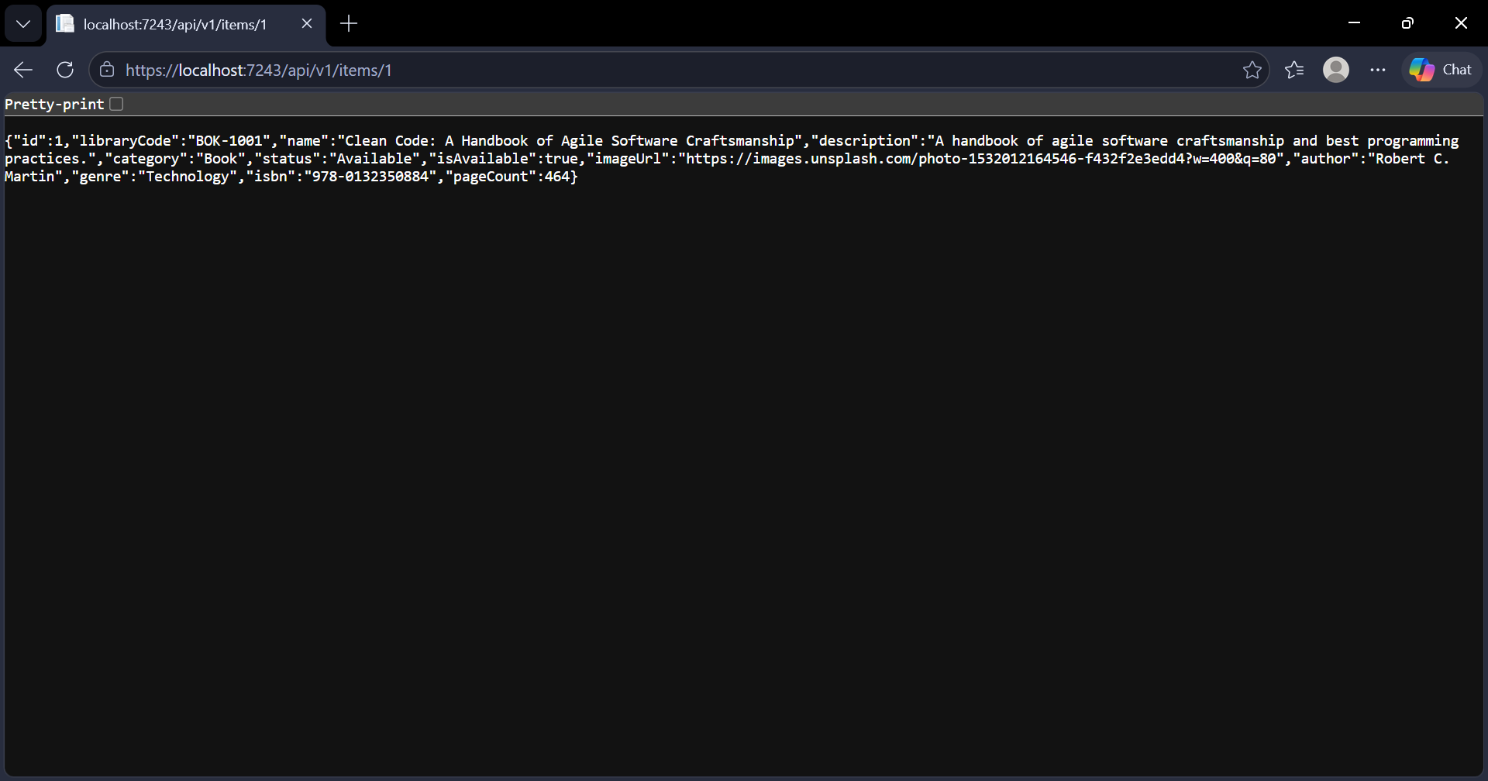
Figure A16. One item by ID, with its type-specific fields (no private data) (TC-API-04).
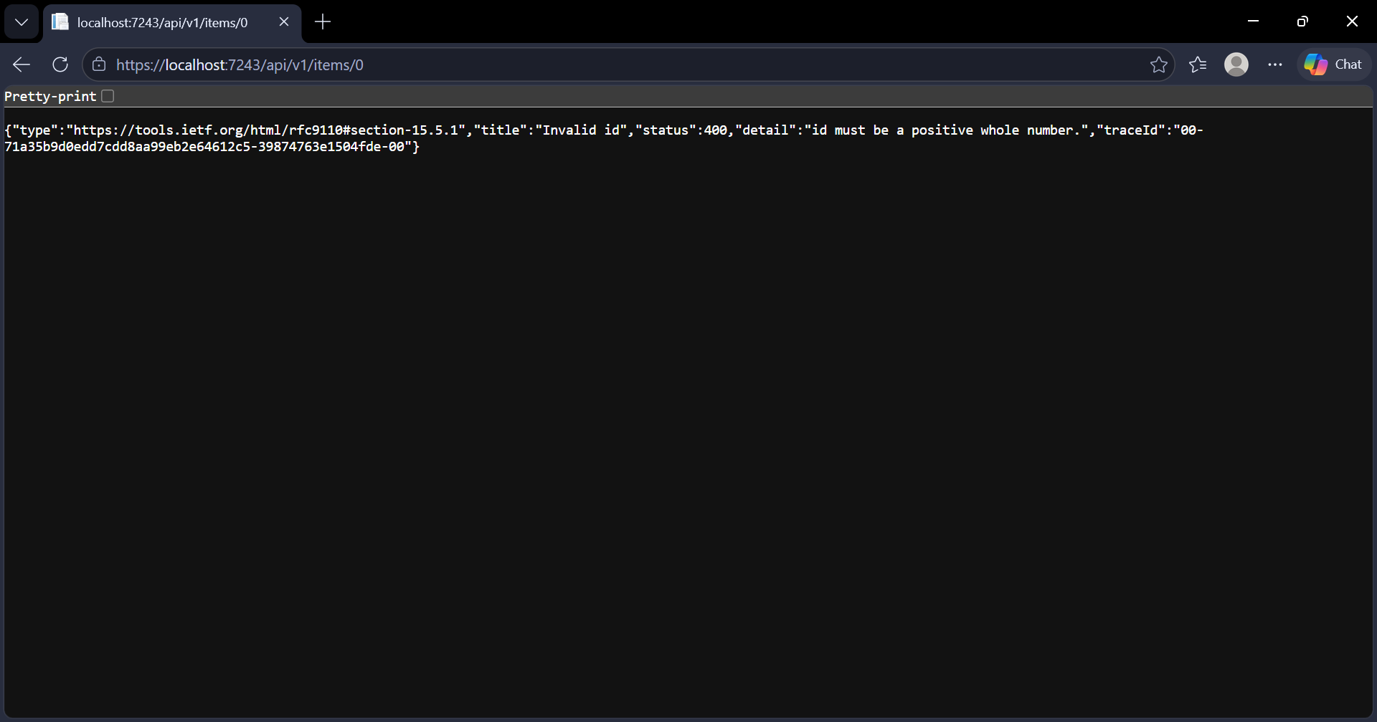
Figure A17. Item ID 0 is refused with a 400 error (TC-API-06).
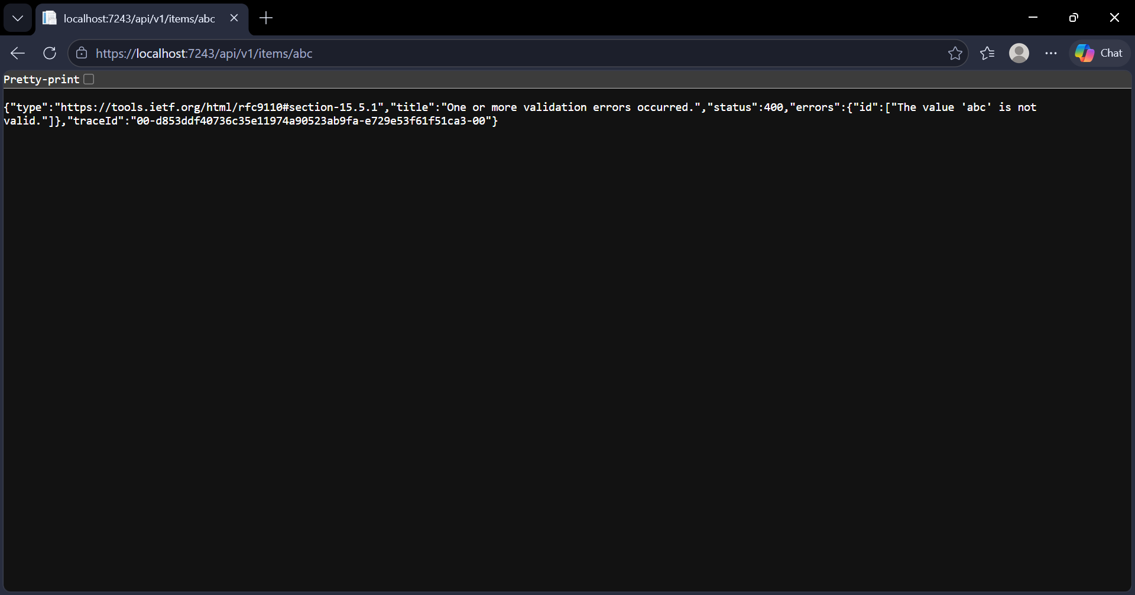
Figure A18. Item ID that is not a number is refused with a 400 error (TC-API-06).
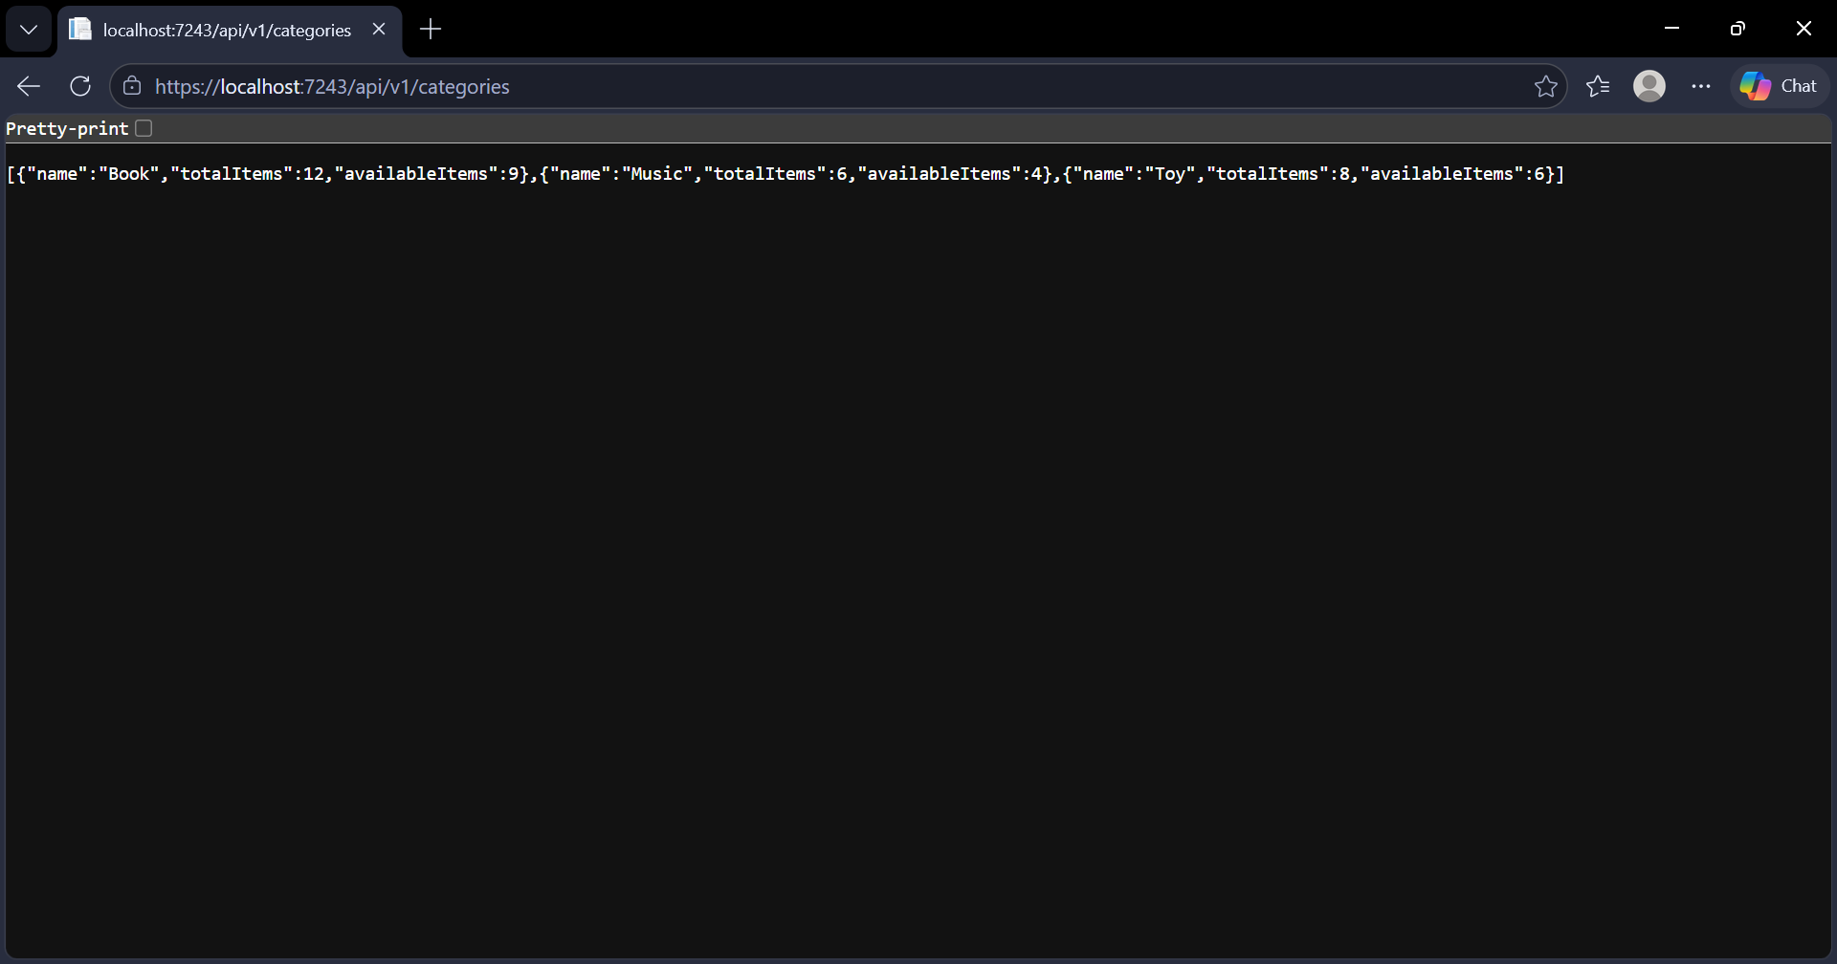
Figure A19. Categories list with item counts (TC-API-07).
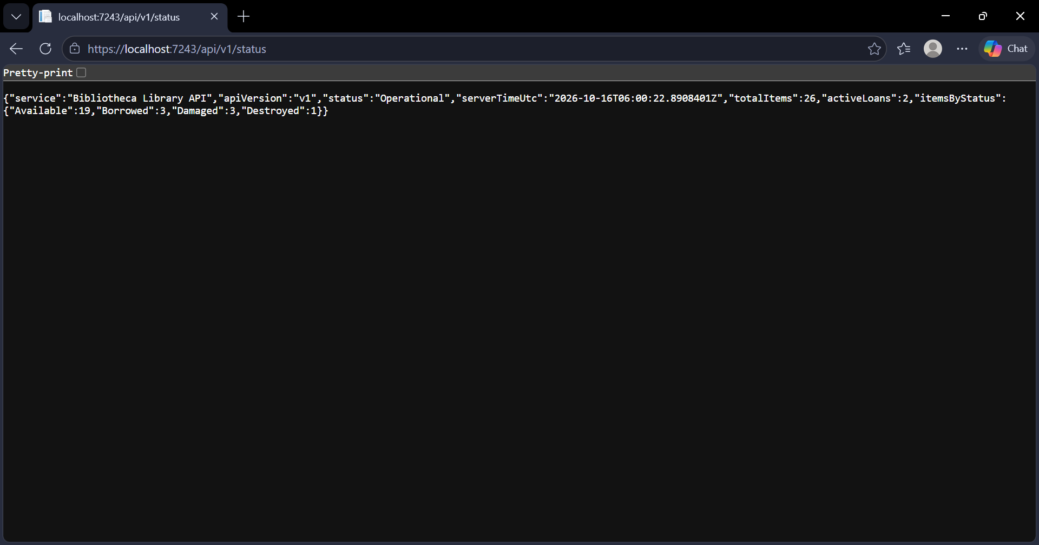
Figure A20. API status page with counts for each item status (TC-API-08).
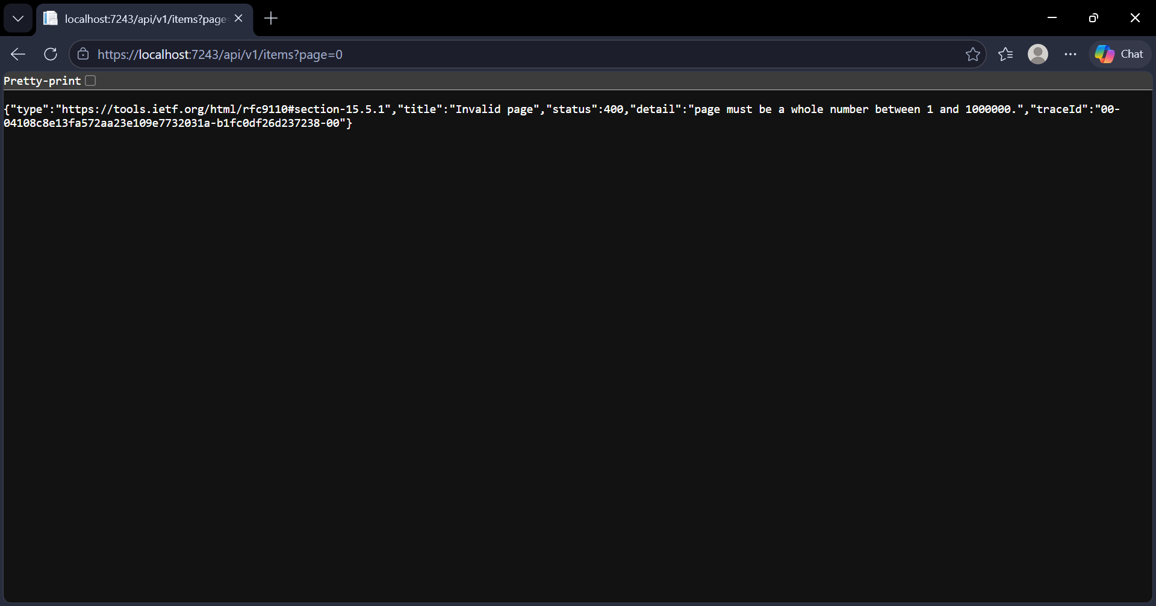
Figure A21. Page 0 is refused with a 400 error (TC-API-10).
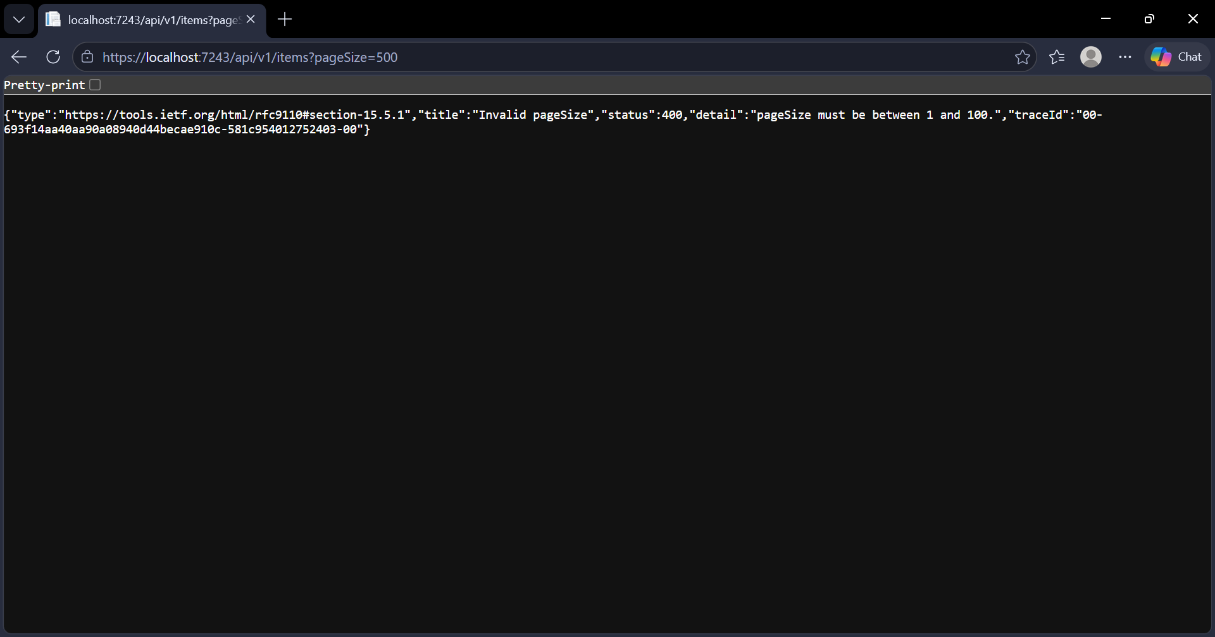
Figure A22. Page size of 500 is refused with a 400 error (TC-API-10).
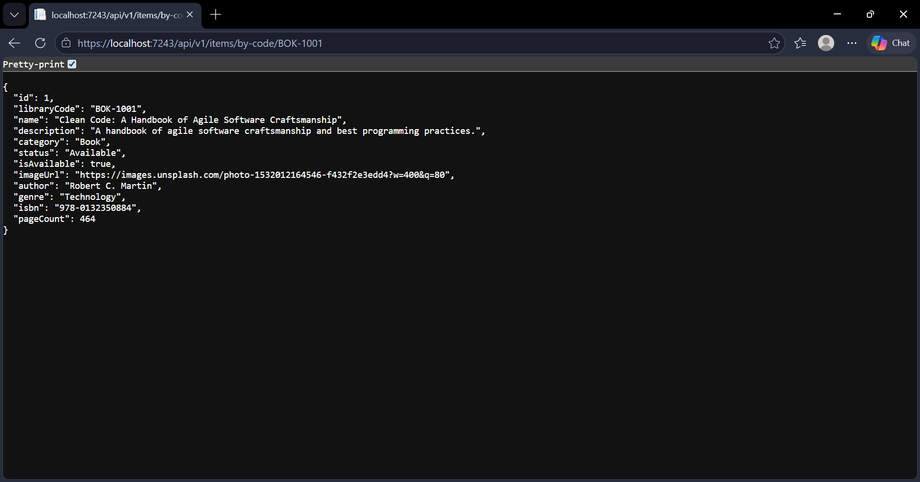
Figure A23. Looking up BOK-1001 by item code works (TC-API-13).
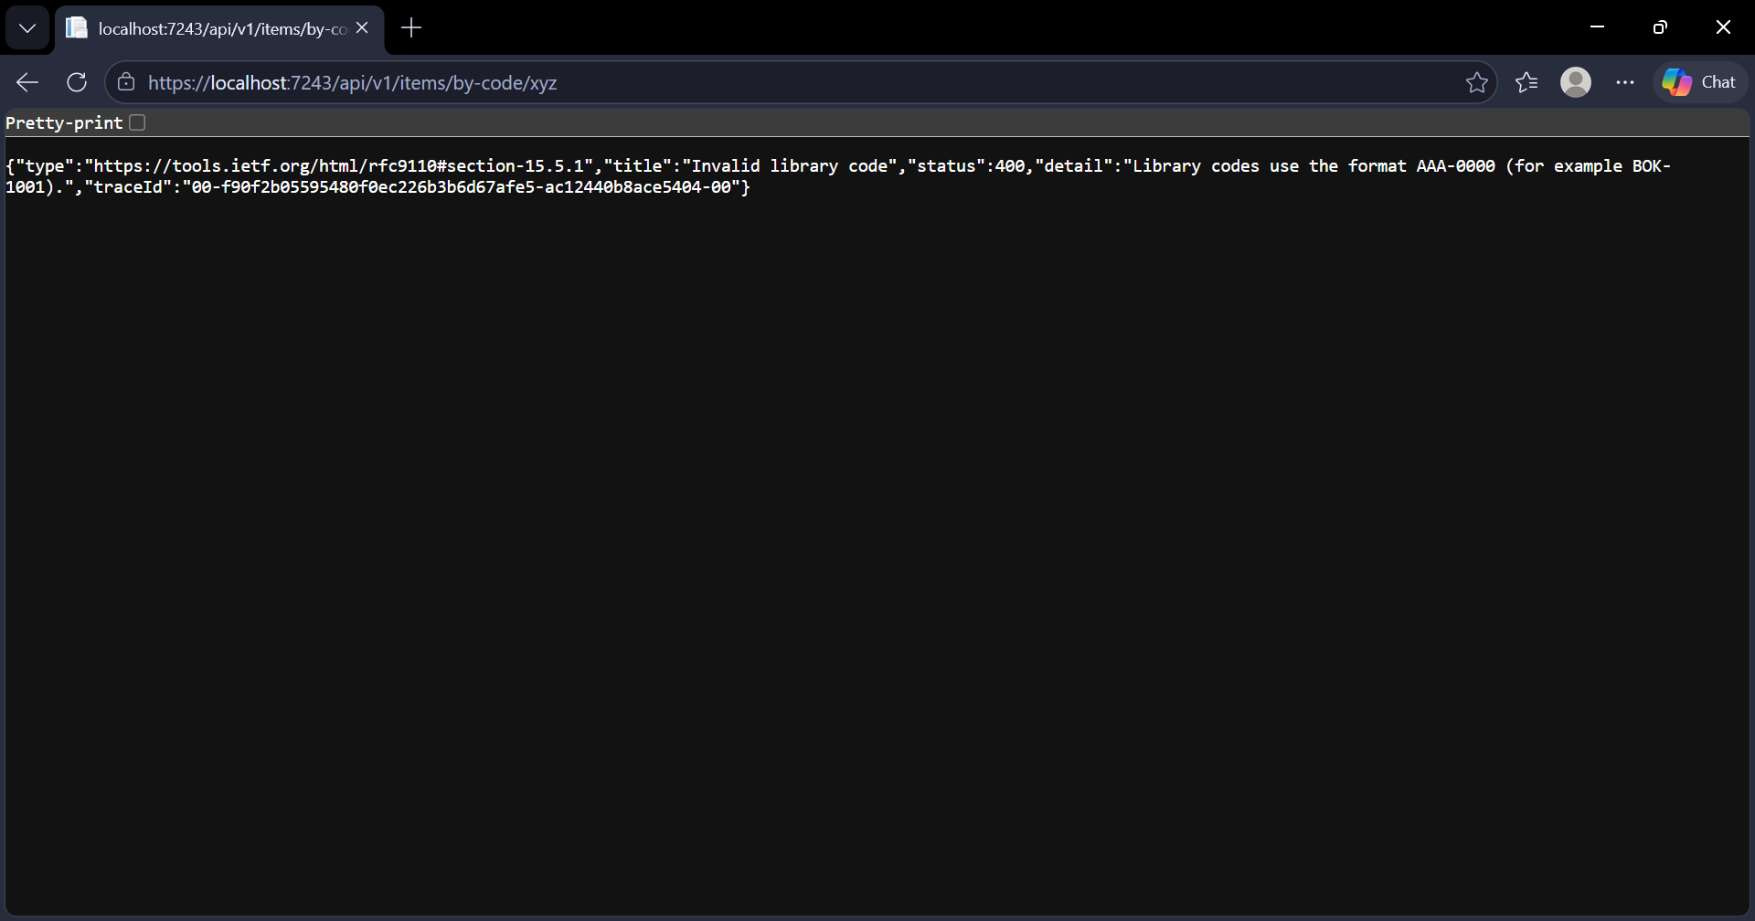
Figure A24. Looking up a badly formed code ("xyz") gives a 400 error (TC-API-13).
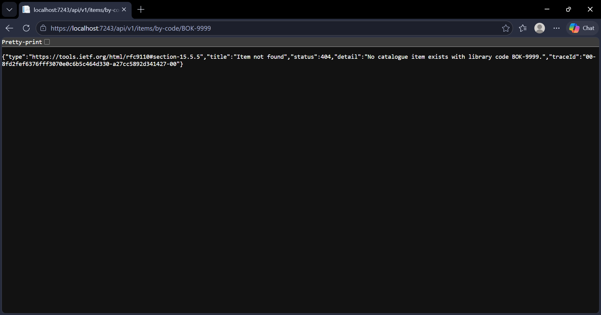
Figure A25. Looking up a code that does not exist (BOK-9999) gives a 404 (TC-API-13).
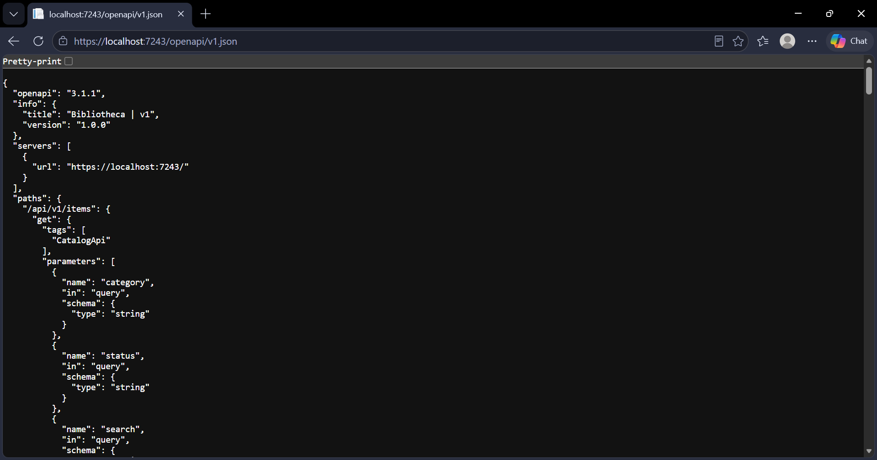
Figure A26. The OpenAPI JSON document loads (TC-API-14).
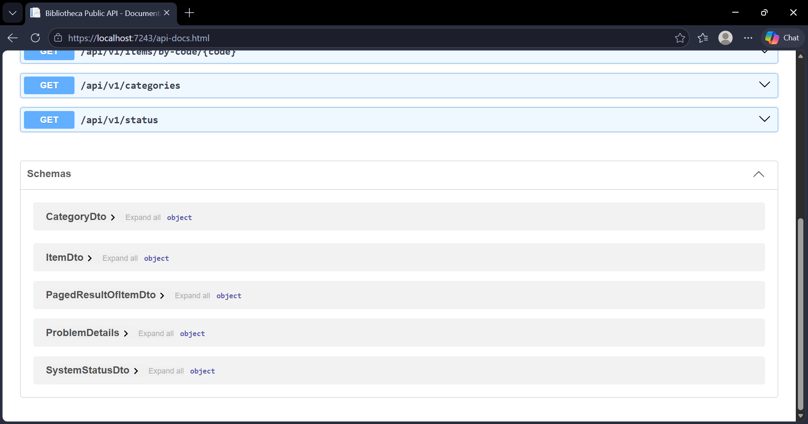
Figure A27. The API docs page lists the endpoints (2 of 2) (TC-API-14).
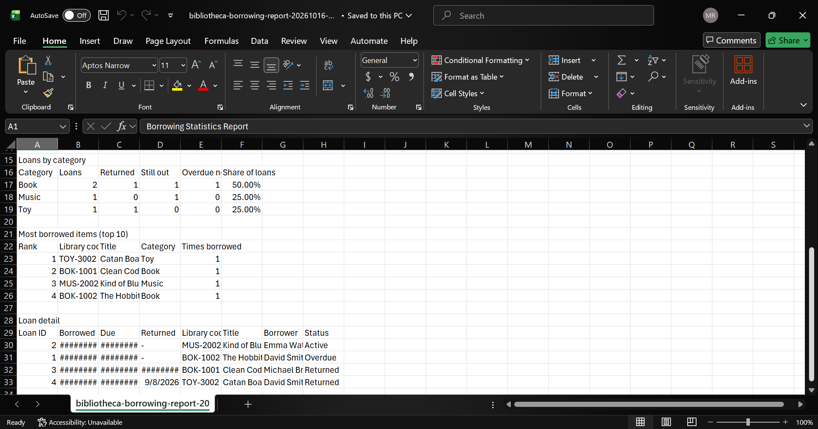
Figure A28. Borrowing report exported as CSV (2 of 2) (TC-EXP-01).
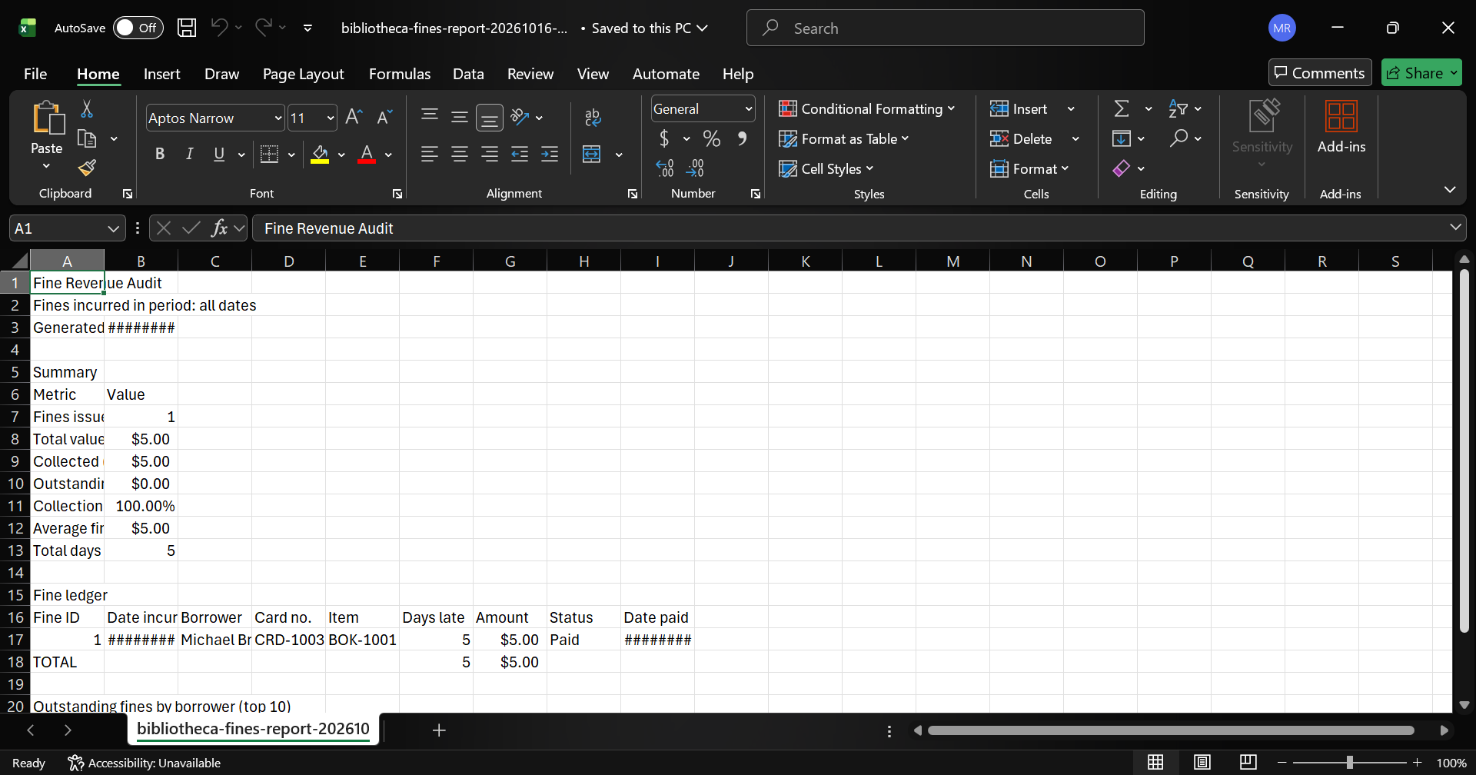
Figure A29. Fines report exported as CSV (1 of 2) (TC-EXP-01).
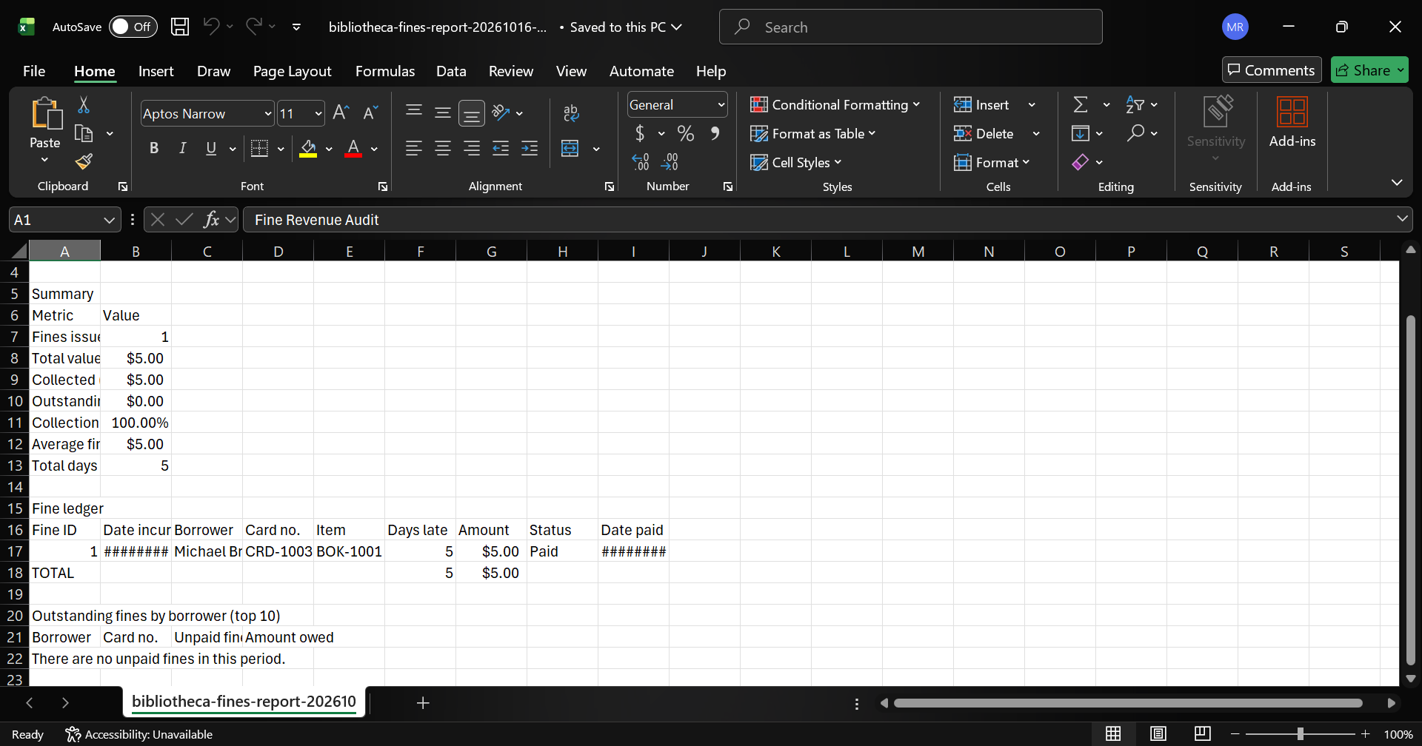
Figure A30. Fines report exported as CSV (2 of 2) (TC-EXP-01).
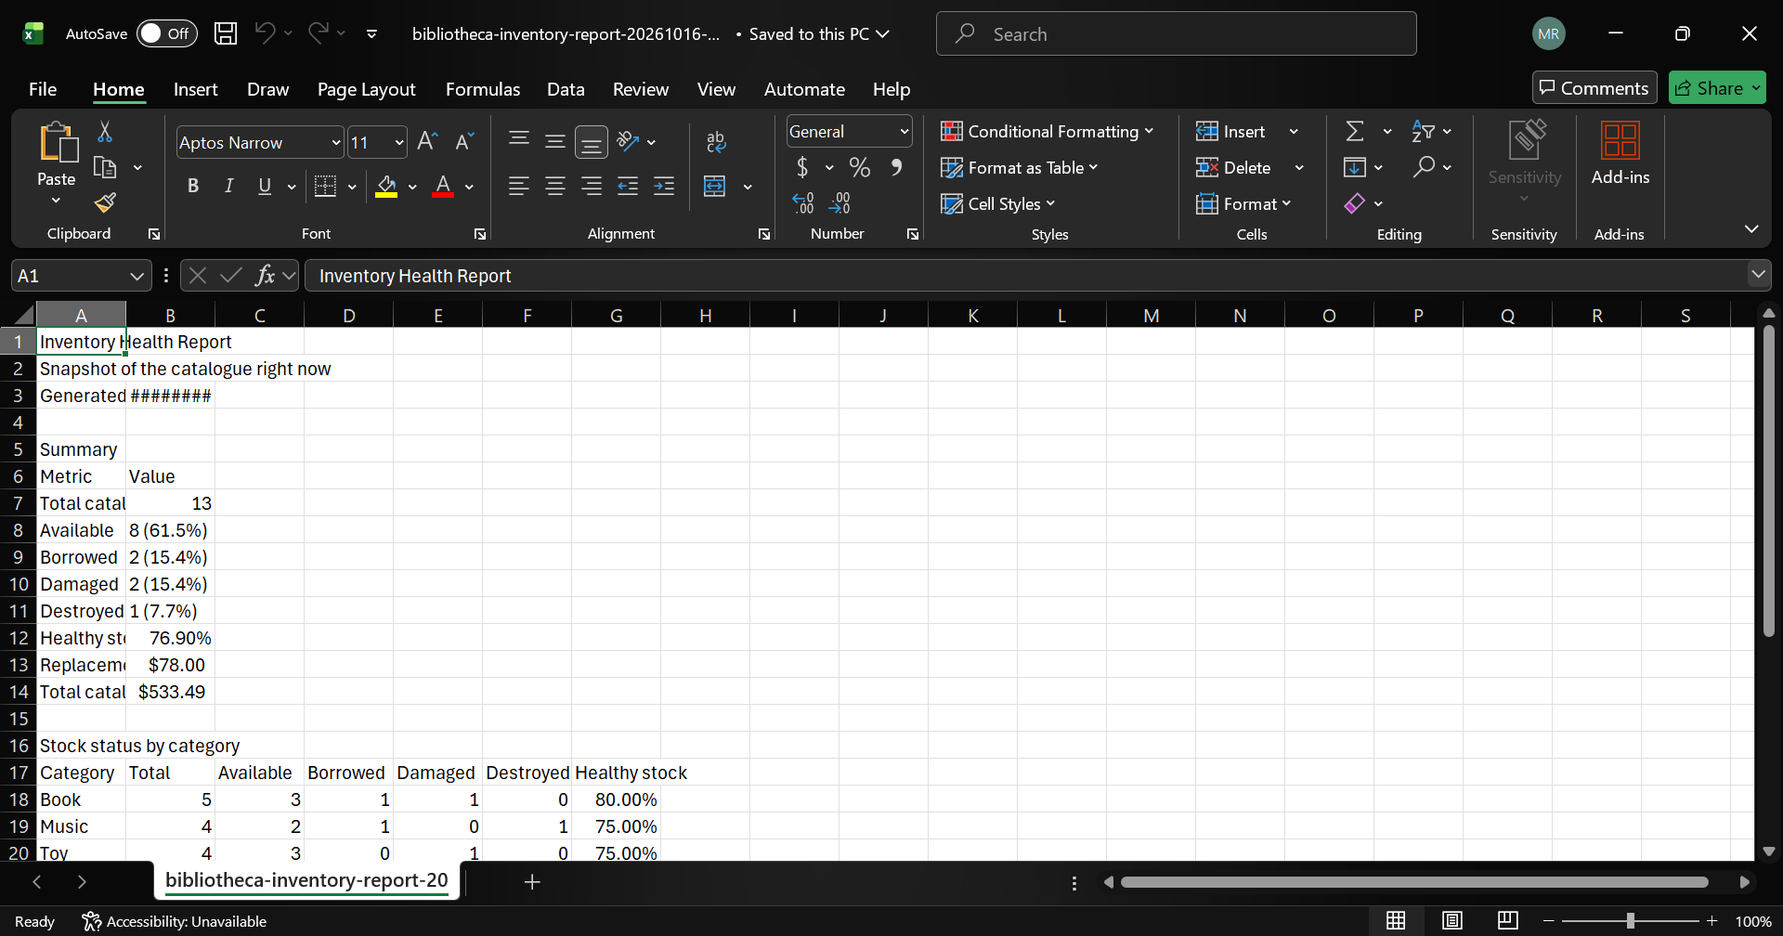
Figure A31. Inventory report exported as CSV (1 of 2) (TC-EXP-01).
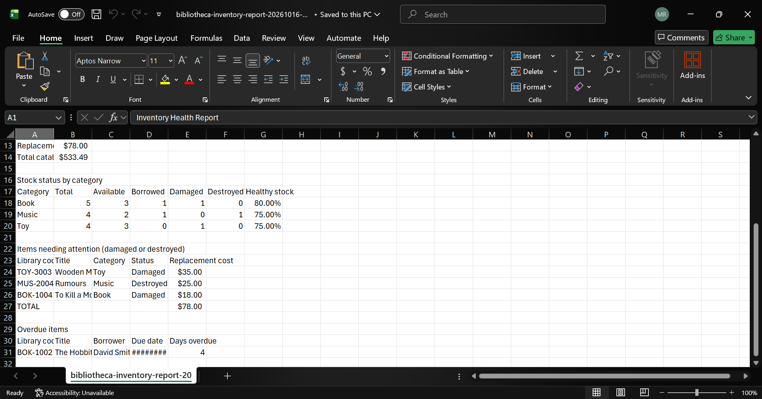
Figure A32. Inventory report exported as CSV (2 of 2) (TC-EXP-01).
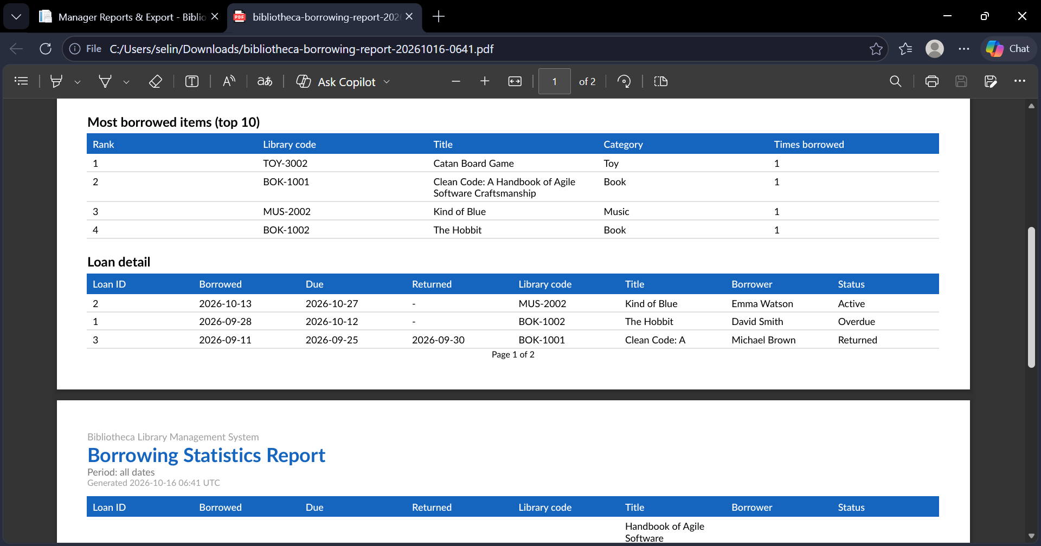
Figure A33. Borrowing report exported as PDF (2 of 3) (TC-EXP-02).
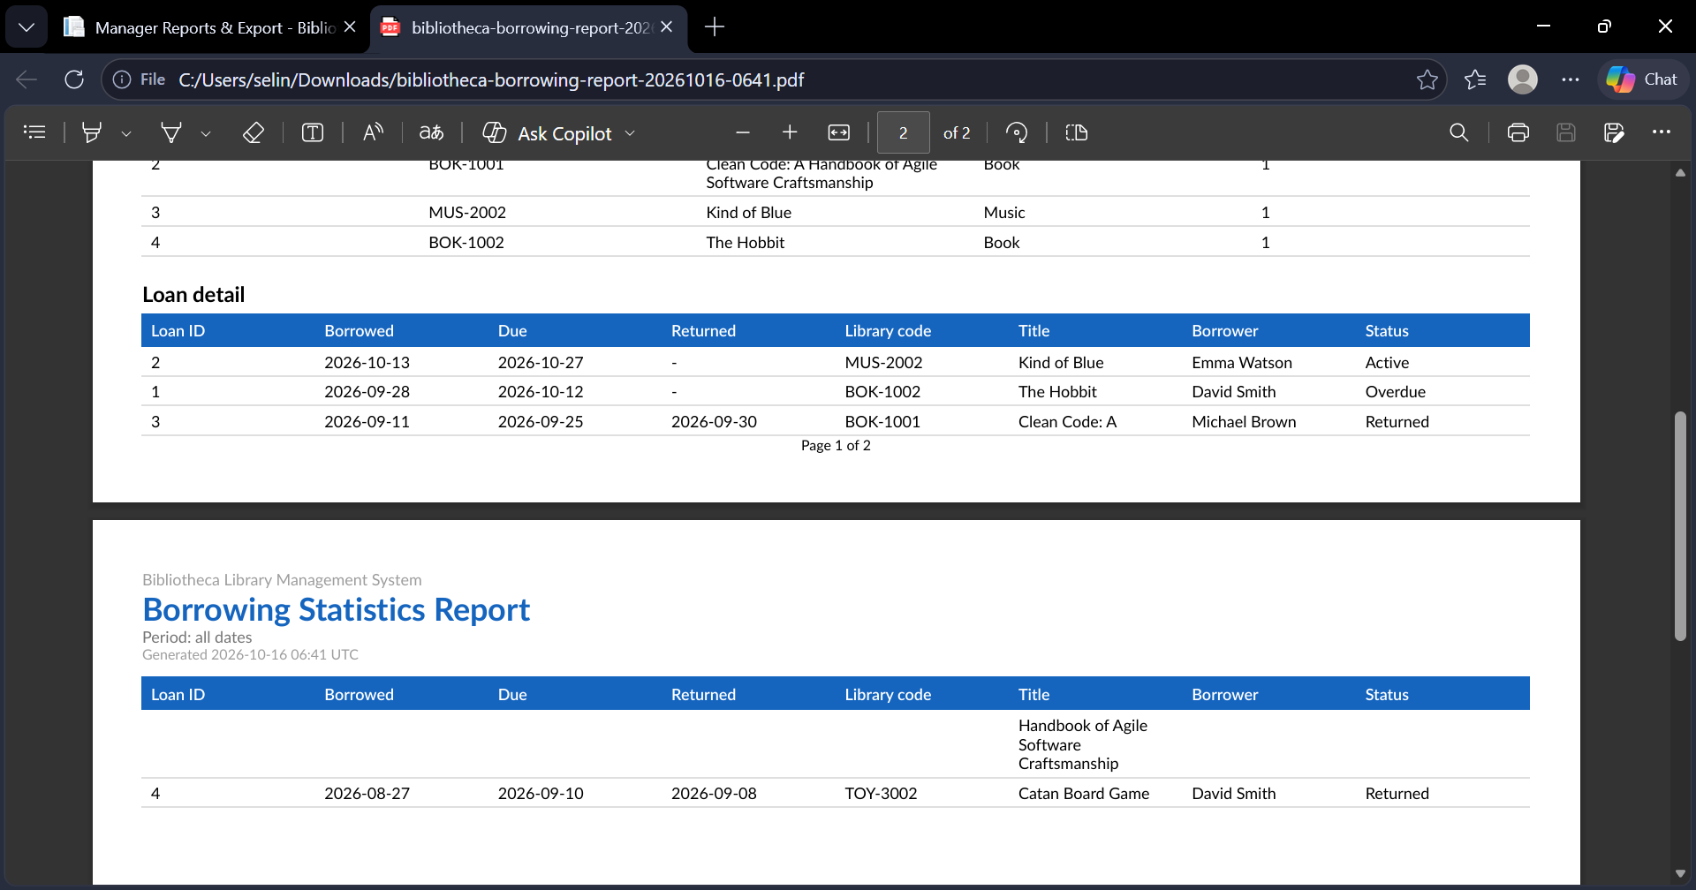
Figure A34. Borrowing report exported as PDF (3 of 3) (TC-EXP-02).
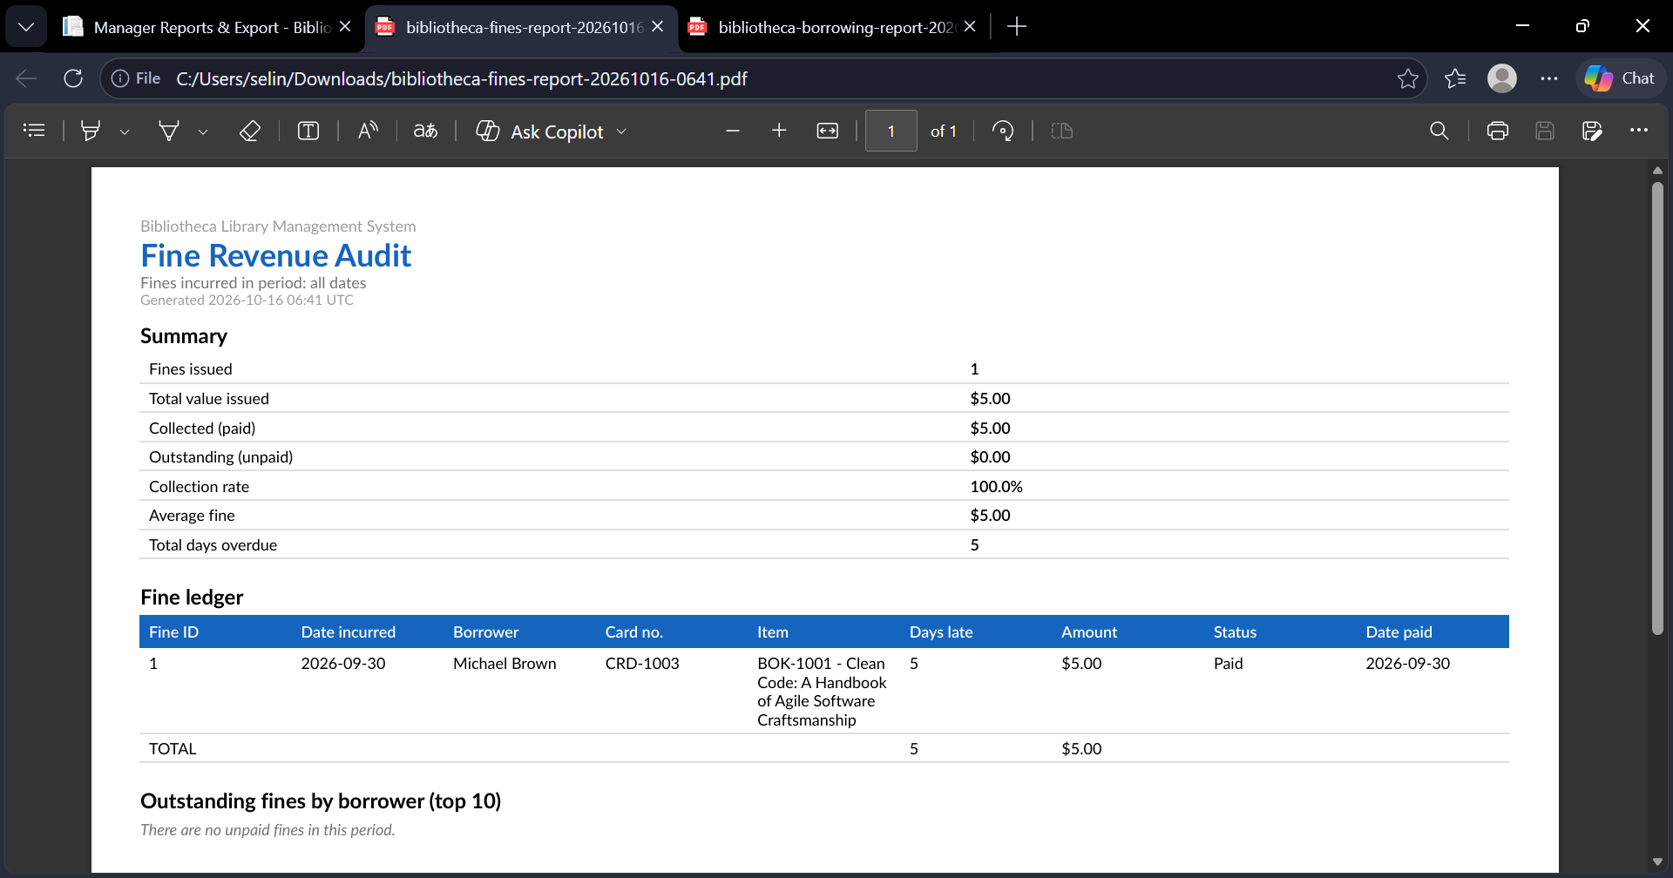
Figure A35. Fines report exported as PDF (TC-EXP-02).
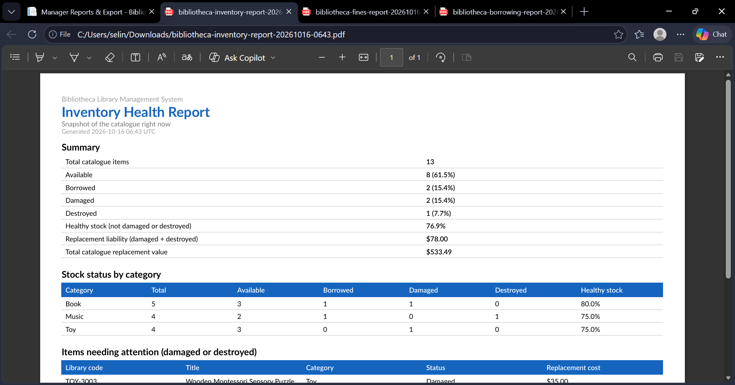
Figure A36. Inventory report exported as PDF (1 of 2) (TC-EXP-02).
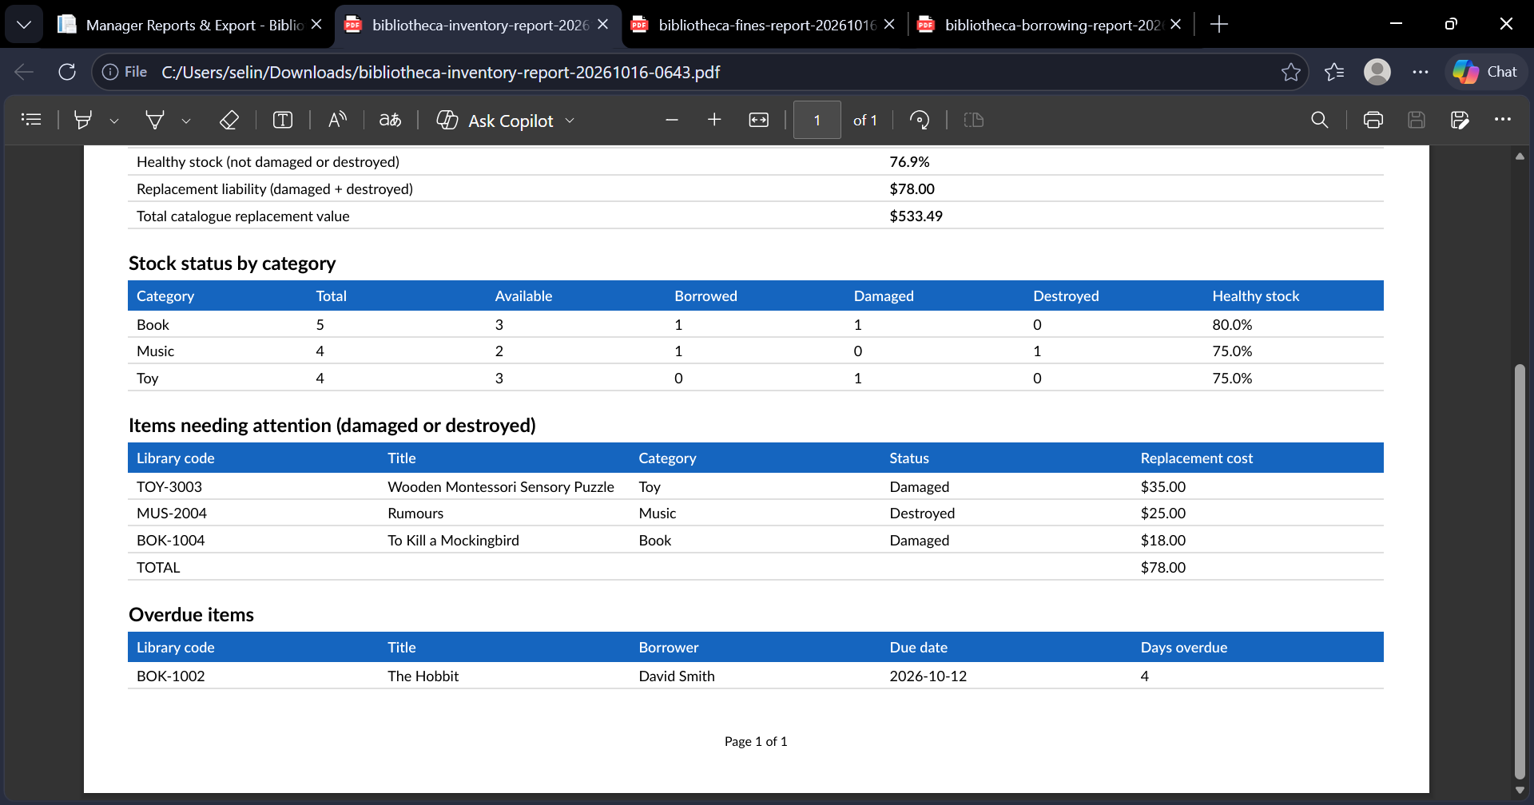
Figure A37. Inventory report exported as PDF (2 of 2) (TC-EXP-02).
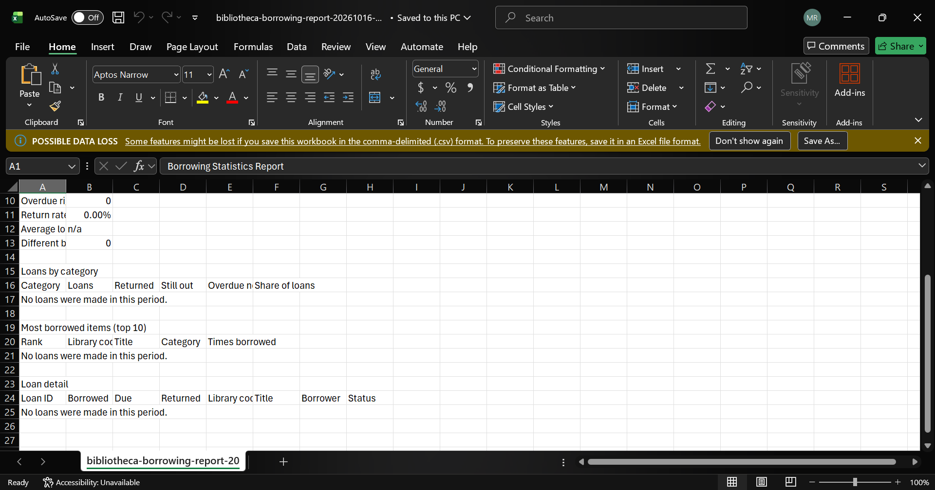
Figure A38. Borrowing CSV for a date range with no data (2 of 2) (TC-EXP-03).
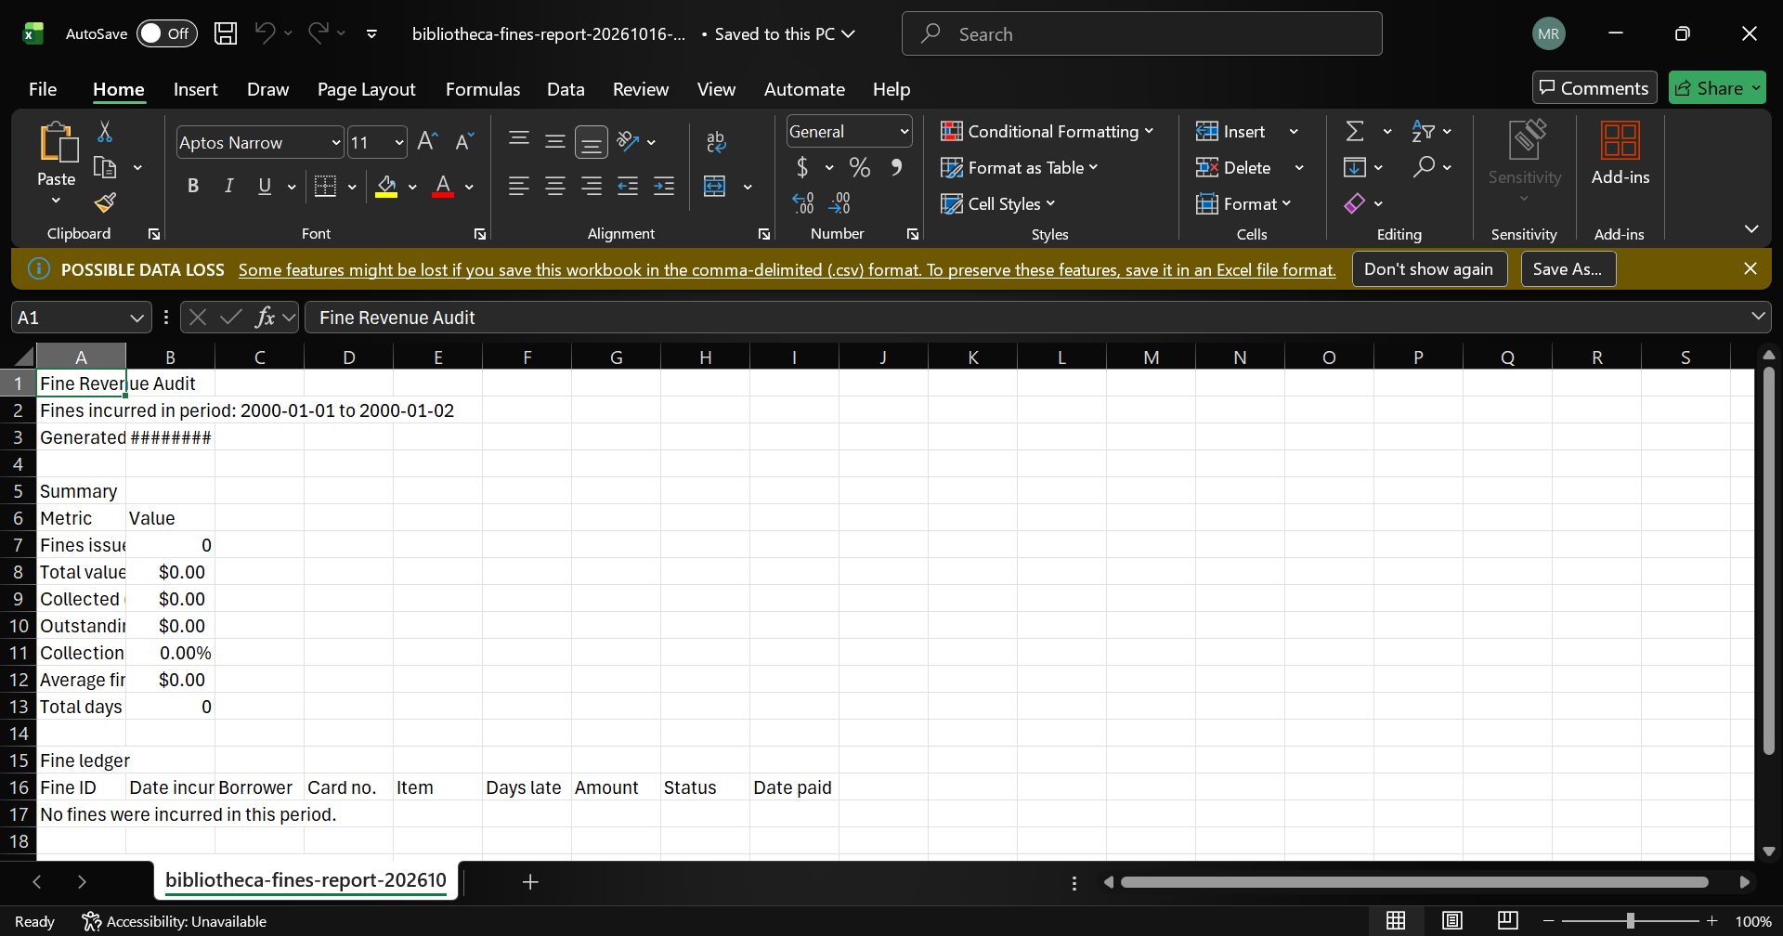
Figure A39. Fines CSV for a date range with no data (1 of 2) (TC-EXP-03).
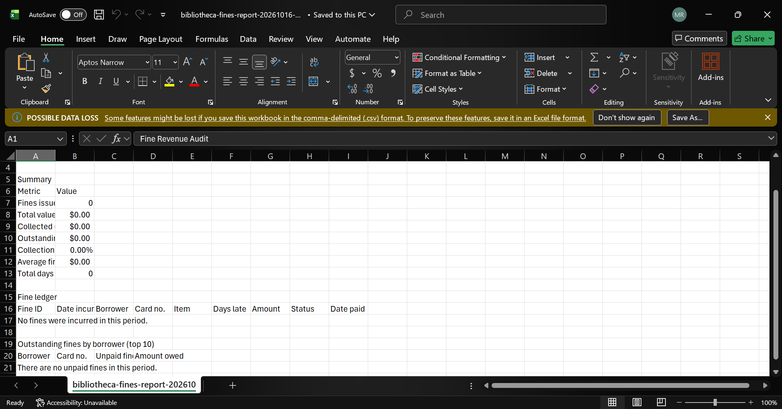
Figure A40. Fines CSV for a date range with no data (2 of 2) (TC-EXP-03).
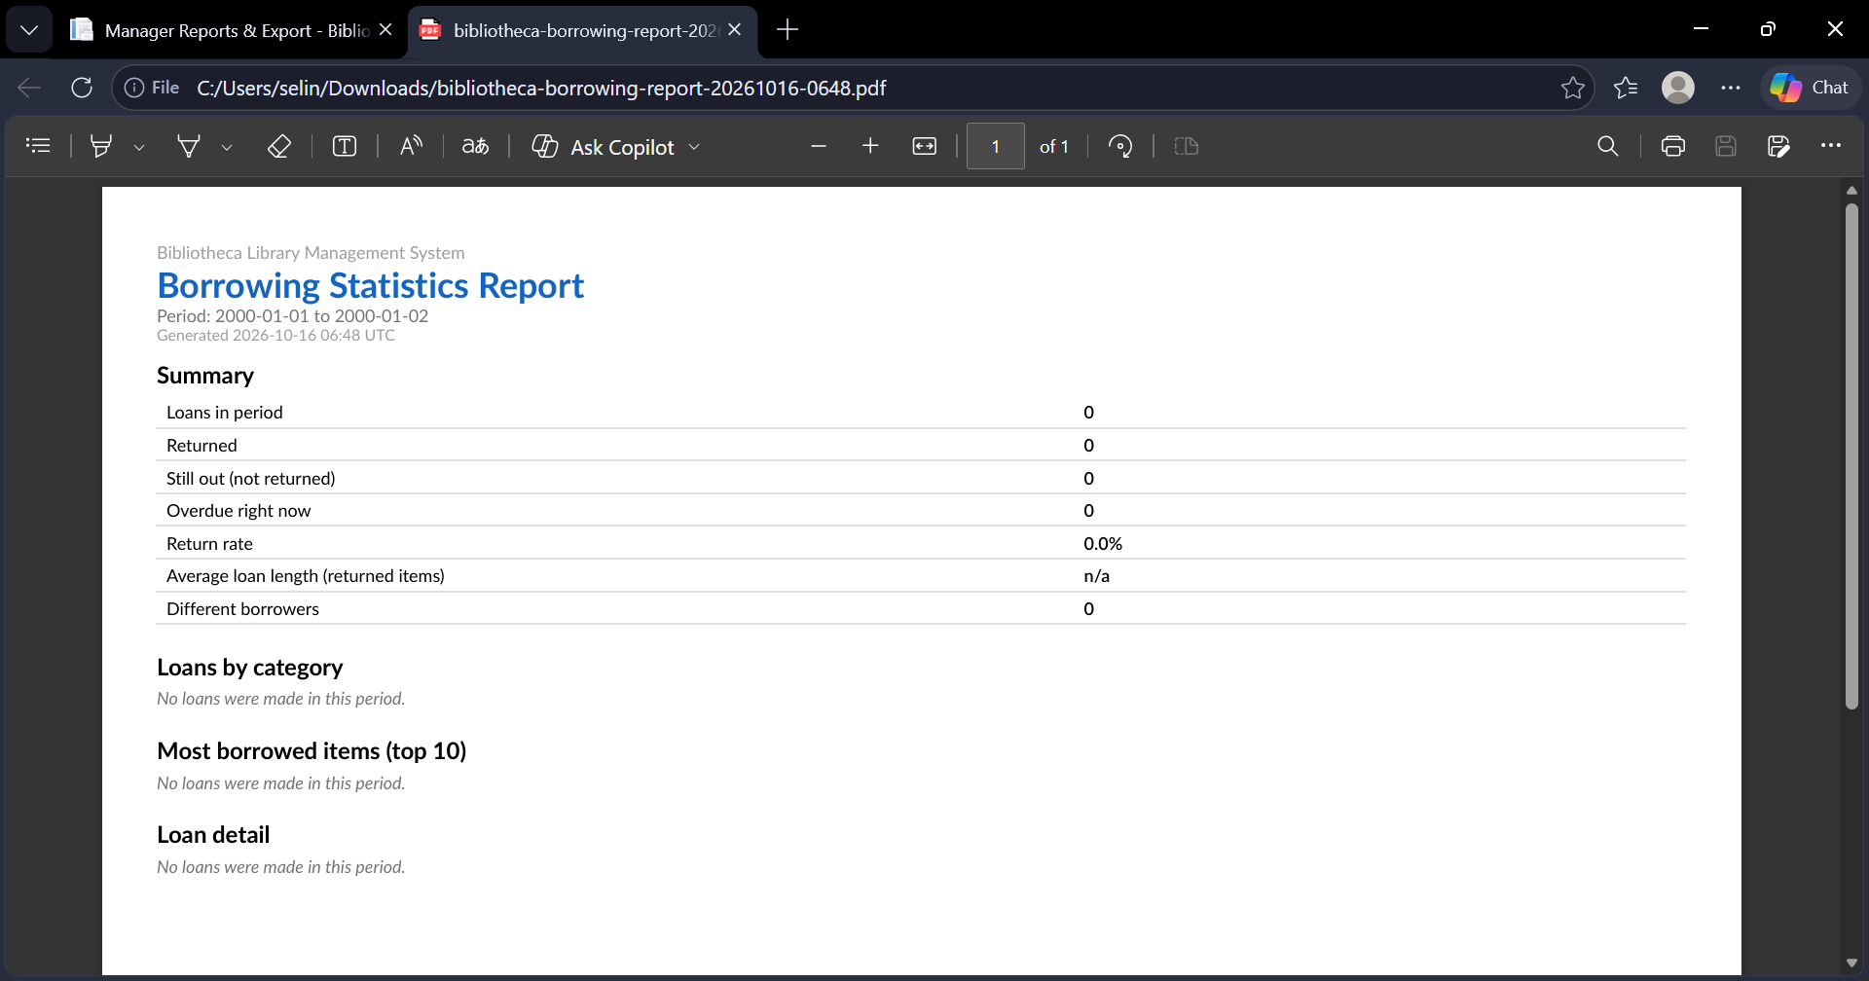
Figure A41. Borrowing PDF for a date range with no data (TC-EXP-03).
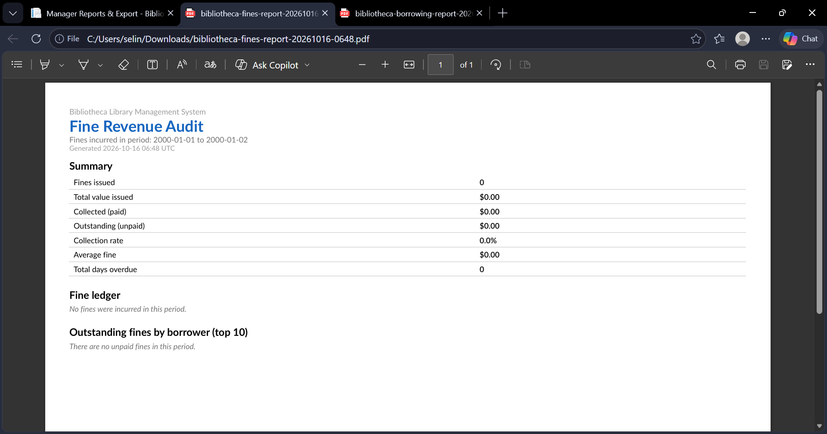
Figure A42. Fines PDF for a date range with no data (TC-EXP-03).
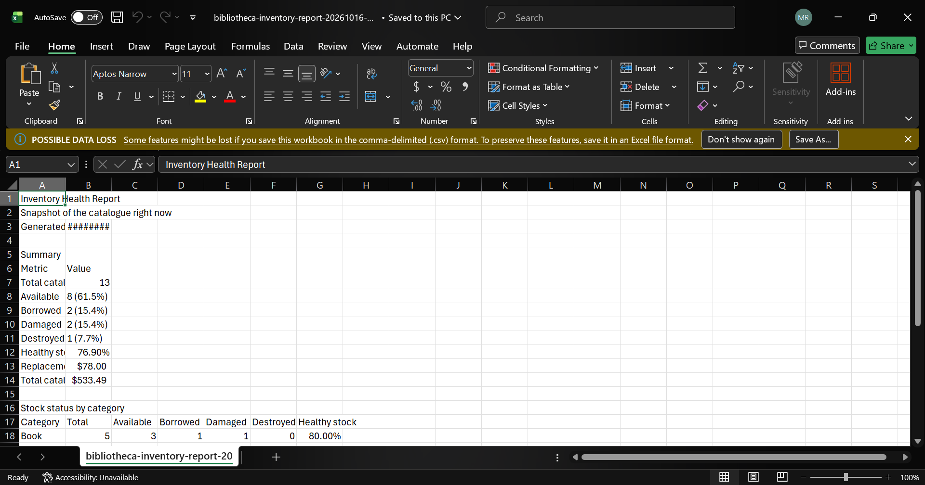
Figure A43. Empty-range export, further view (1 of 2) (TC-EXP-03).
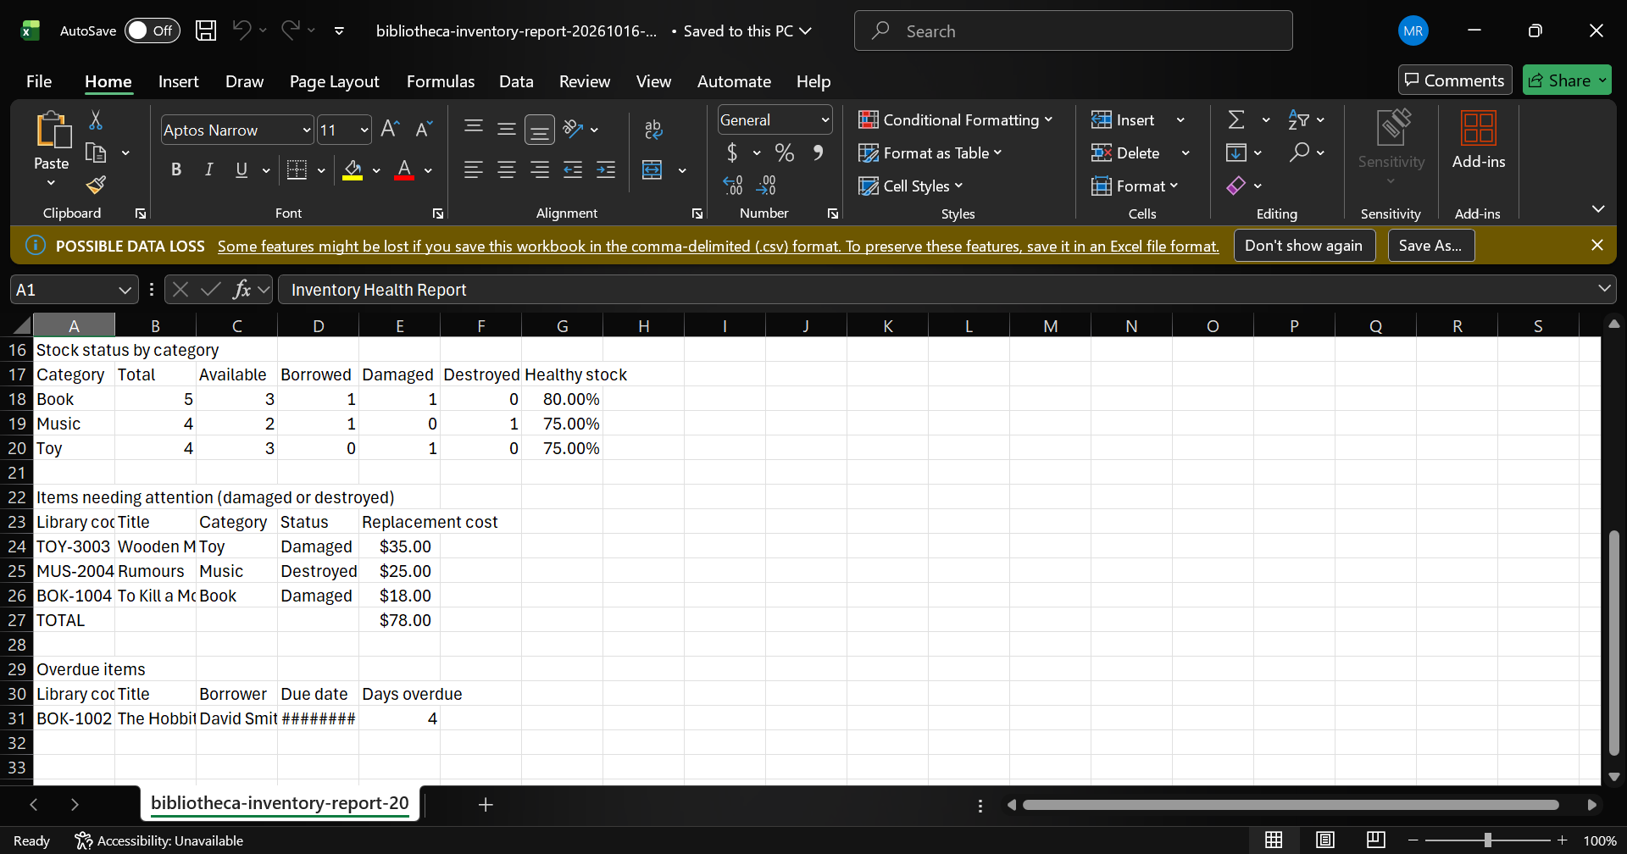
Figure A44. Empty-range export, further view (2 of 2) (TC-EXP-03).
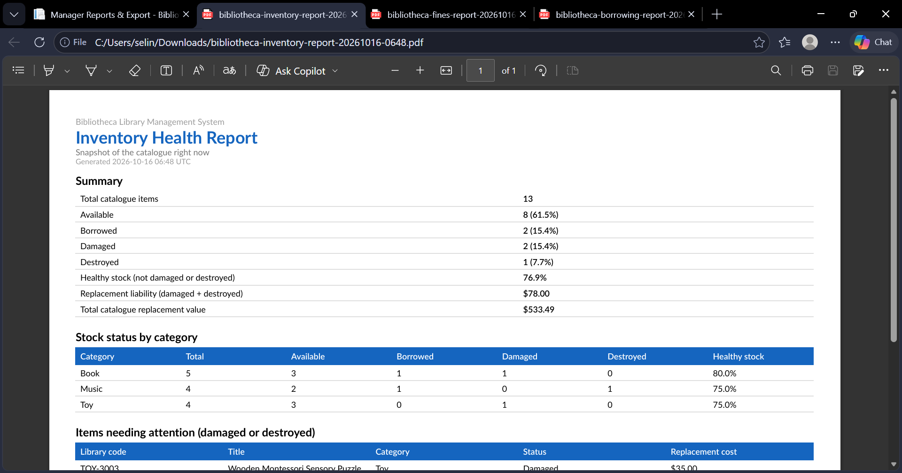
Figure A45. Empty-range export, further view (1 of 2) (TC-EXP-03).
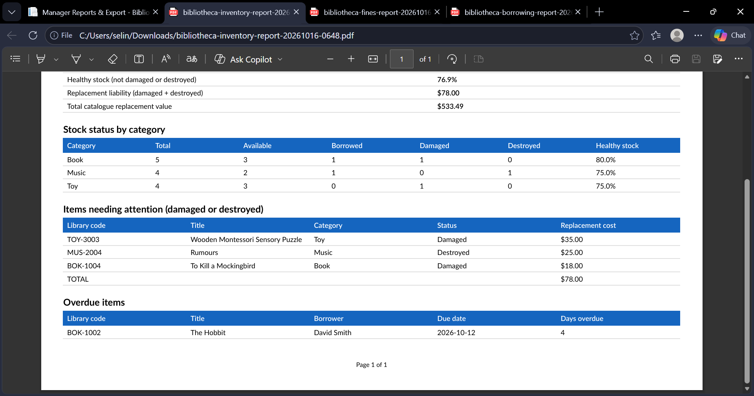
Figure A46. Empty-range export, further view (2 of 2) (TC-EXP-03).
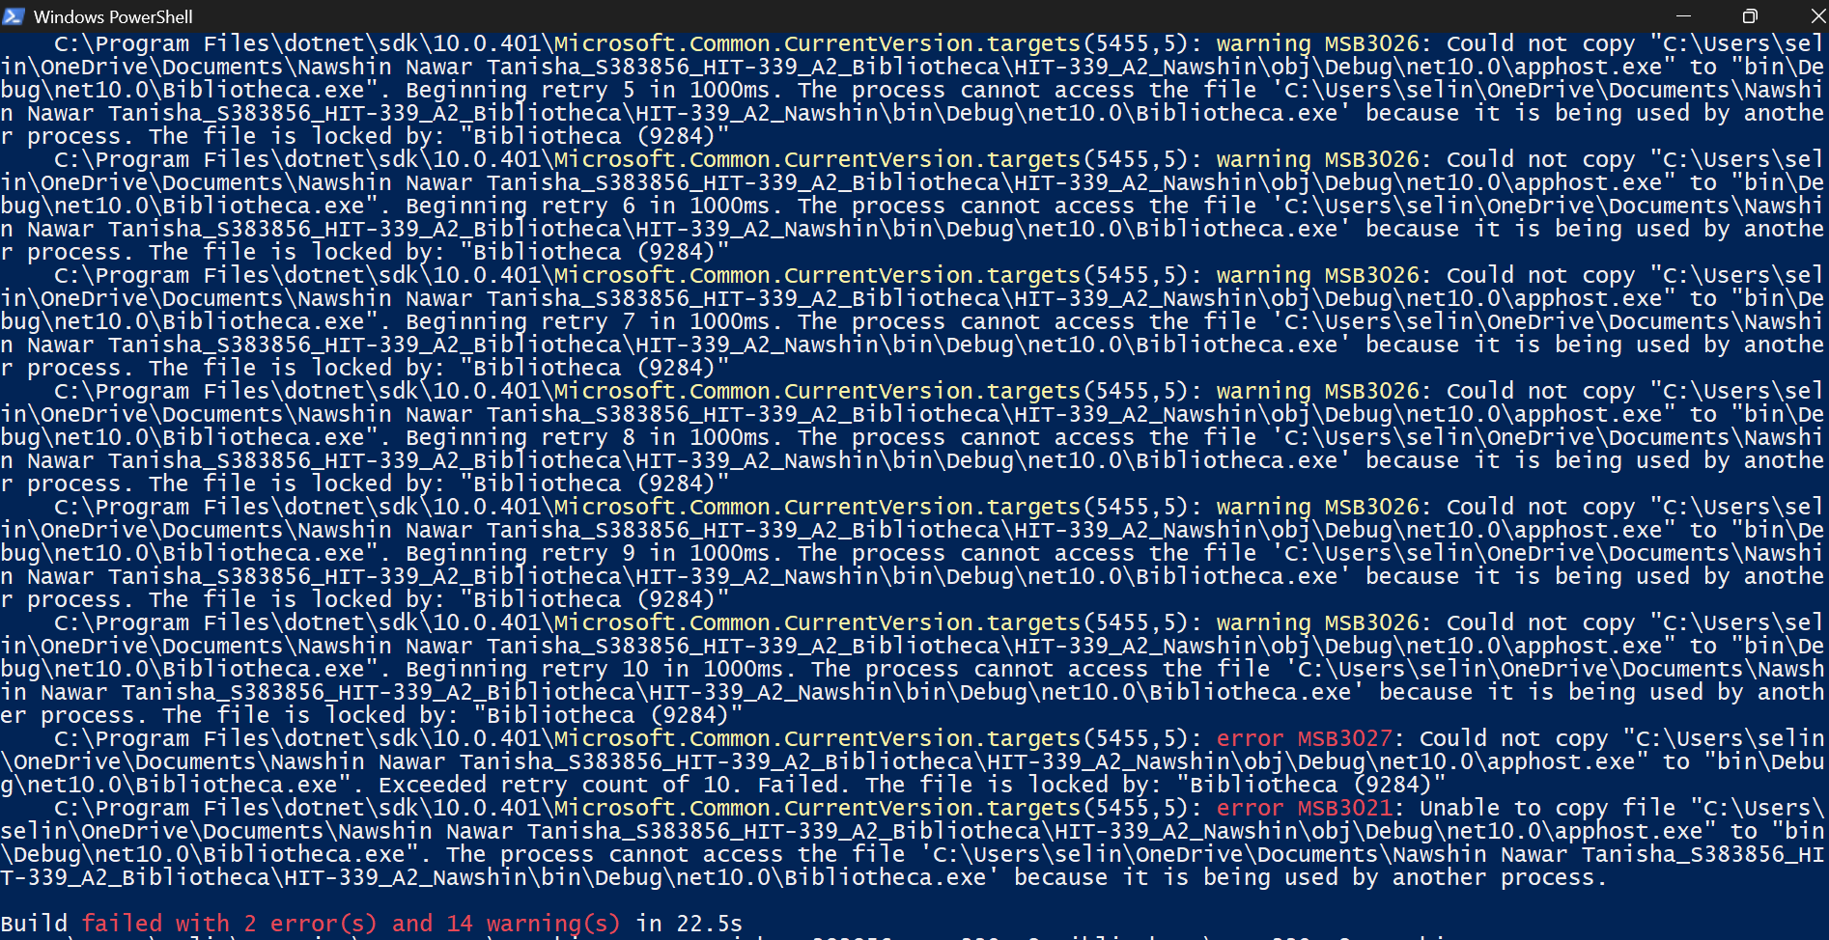
Figure A47. First build attempt failed because the site was still running (TC-GEN-01).
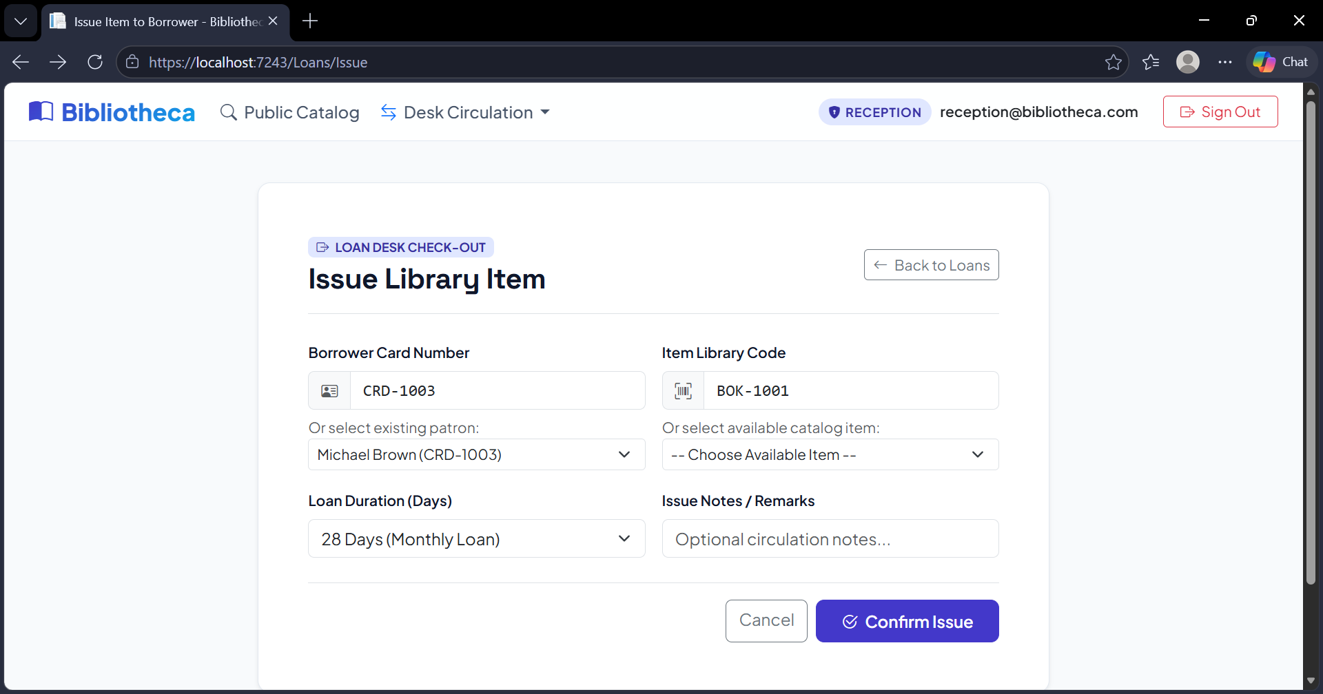
Figure A48. Issue loan form (TC-GEN-01).
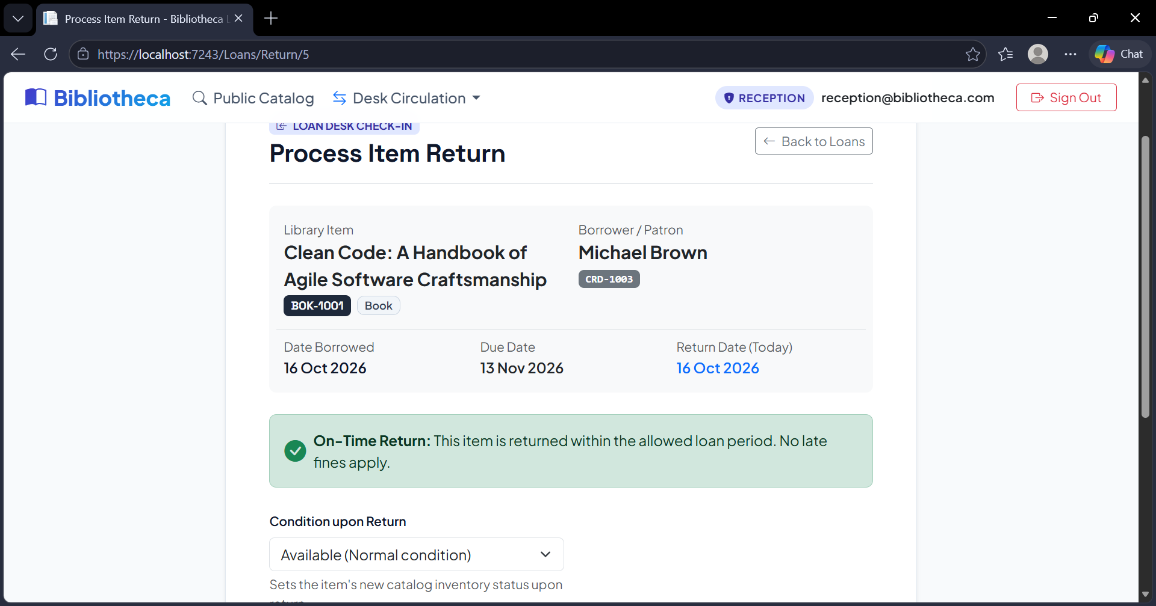
Figure A49. Return loan form (TC-GEN-01).
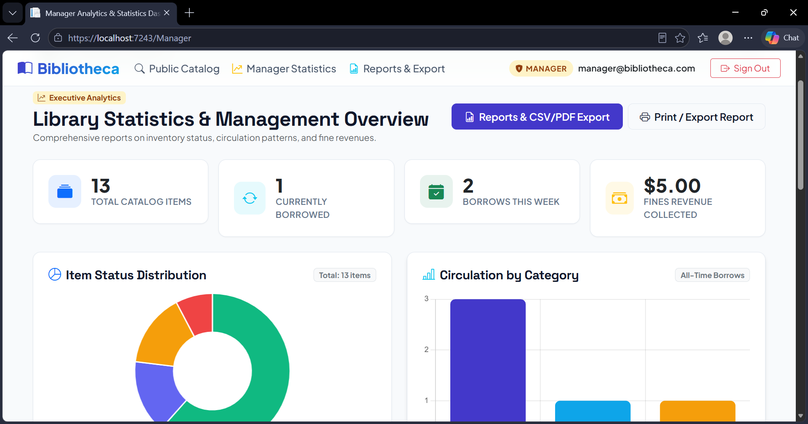
Figure A50. Manager dashboard after the loan was issued and returned (1 of 4) (TC-GEN-01).
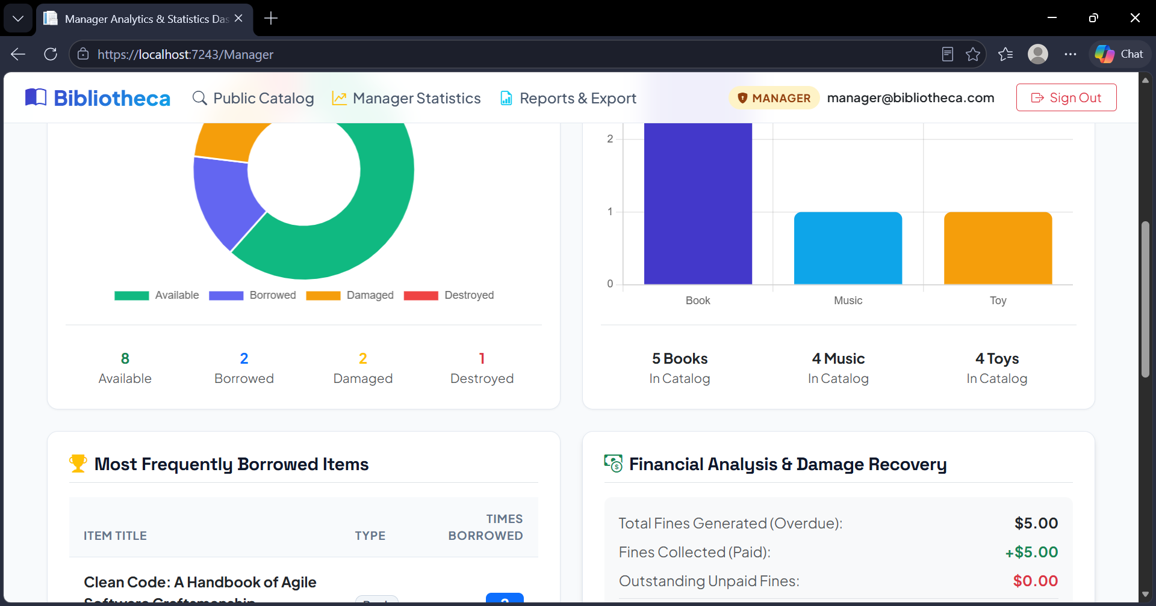
Figure A51. Manager dashboard after the loan was issued and returned (2 of 4) (TC-GEN-01).
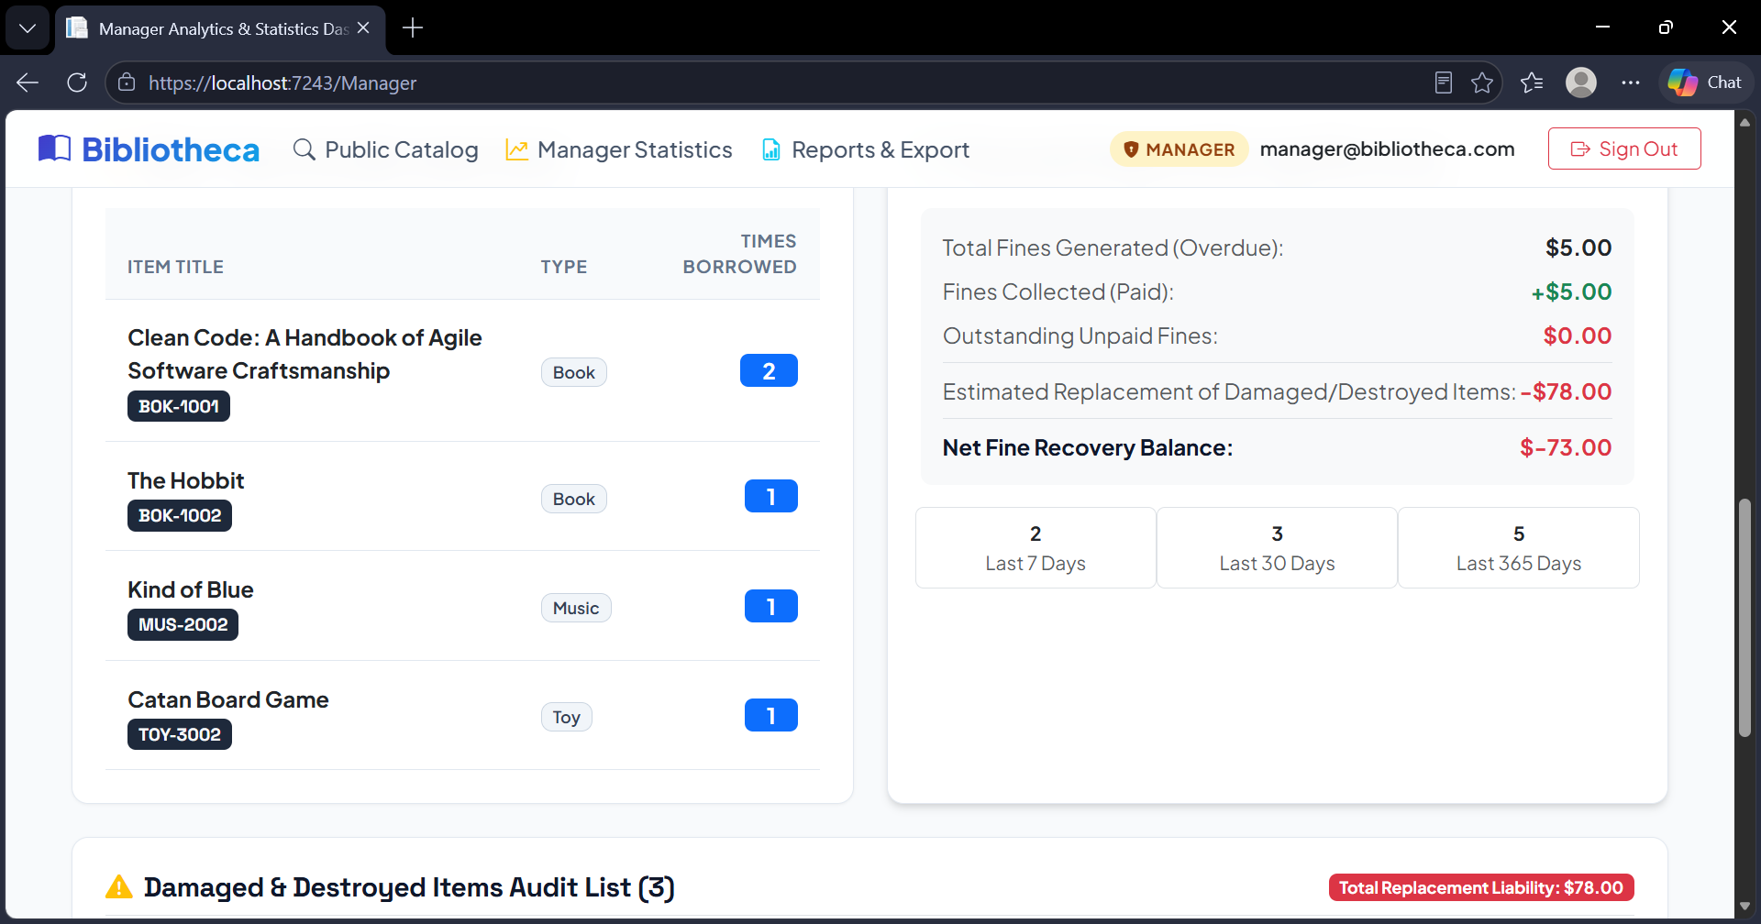
Figure A52. Manager dashboard after the loan was issued and returned (3 of 4) (TC-GEN-01).
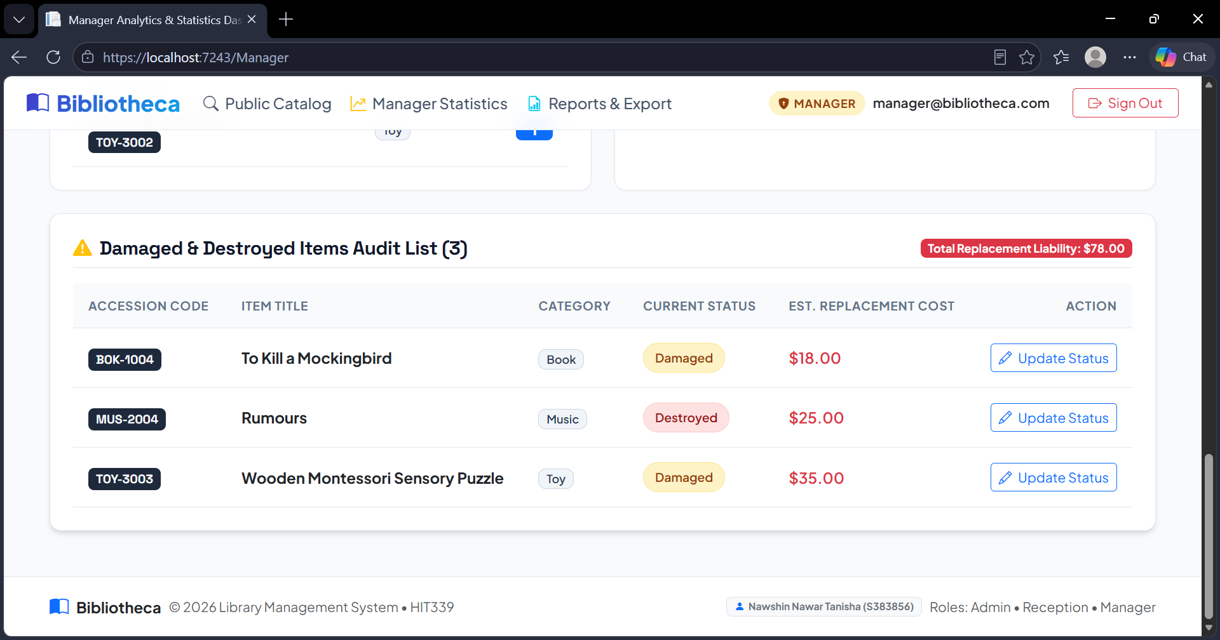
Figure A53. Manager dashboard after the loan was issued and returned (4 of 4) (TC-GEN-01).
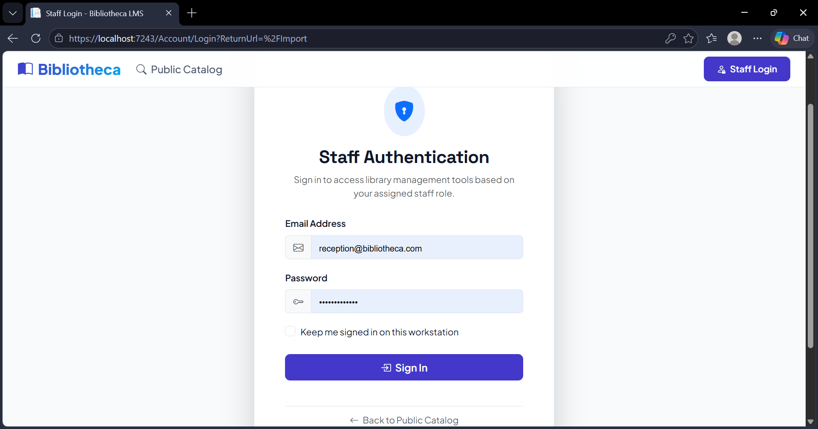
Figure A54. The Import page is open for the Admin (TC-IMP-01).
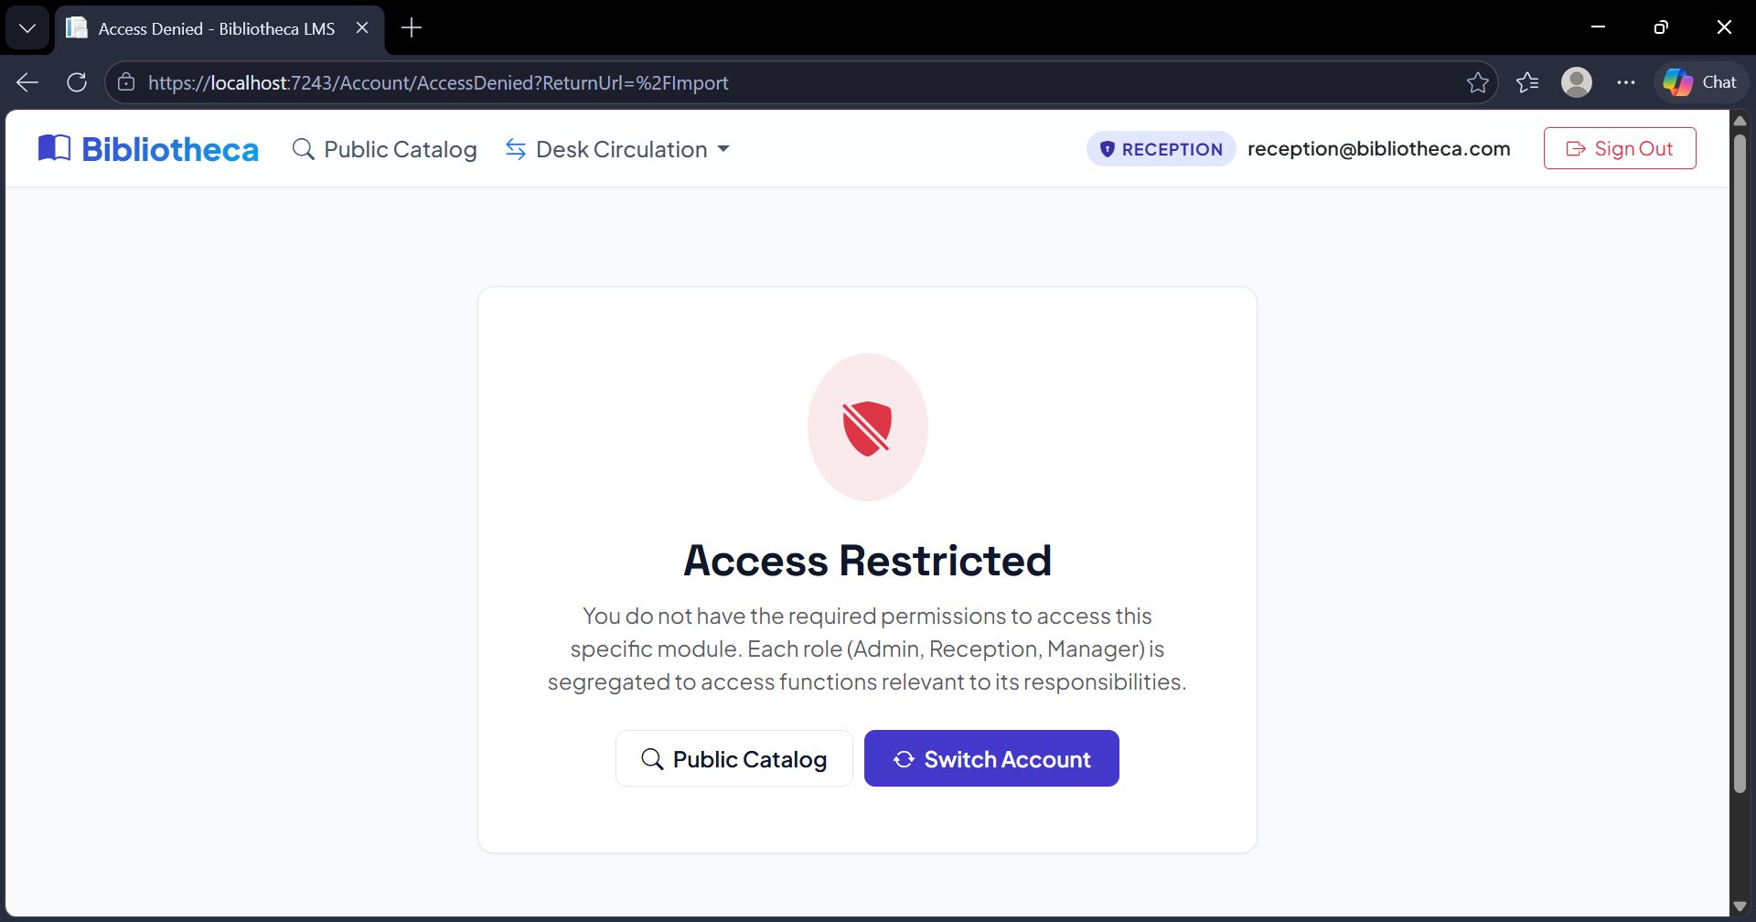
Figure A55. The Import page is blocked for other users (TC-IMP-01).
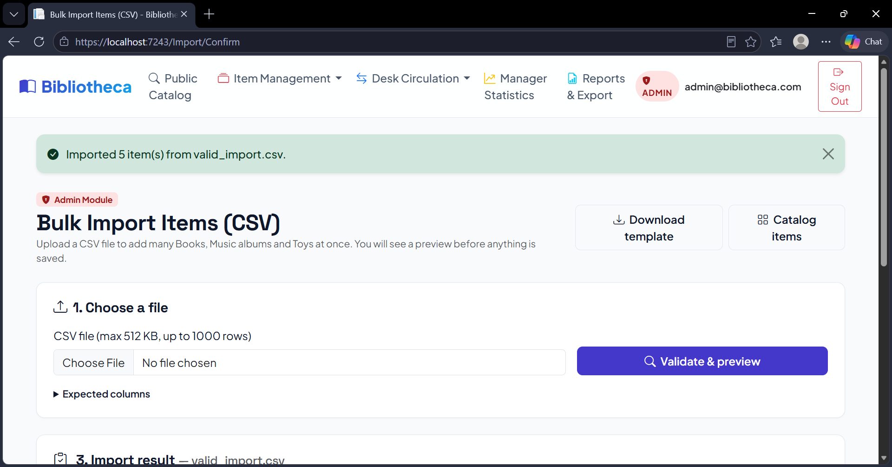
Figure A56. Import preview for valid_import.csv (1 of 2) (TC-IMP-02).
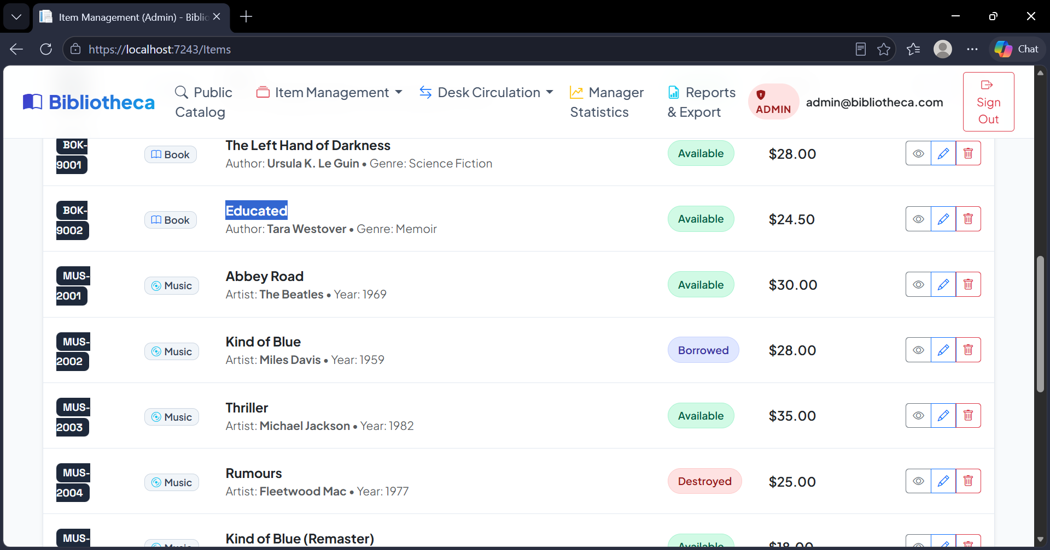
Figure A57. Result after importing the valid rows (1 of 2) (TC-IMP-02).
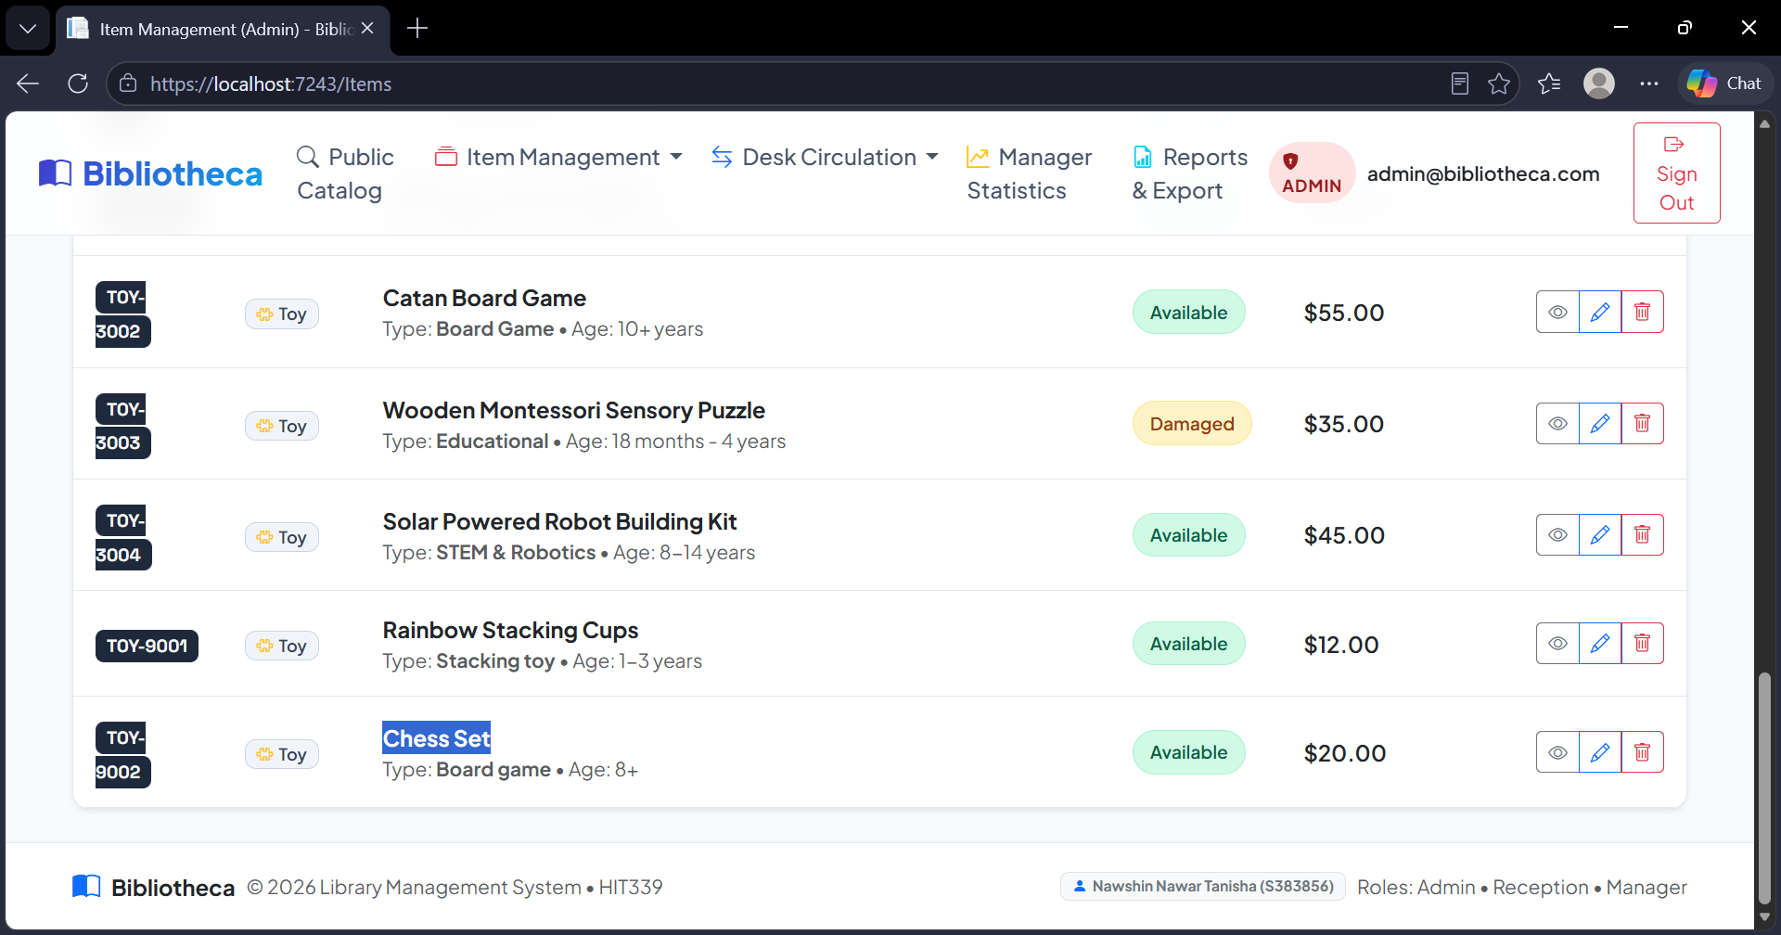
Figure A58. Result after importing the valid rows (2 of 2) (TC-IMP-02).
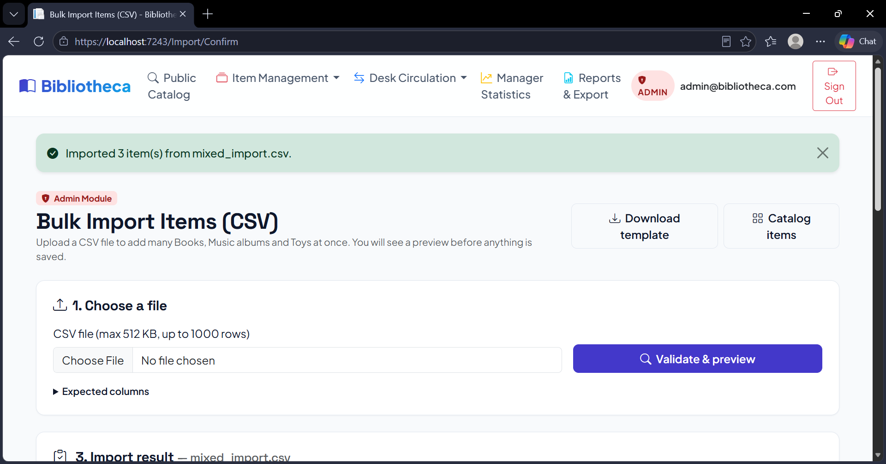
Figure A59. Import preview for mixed_import.csv with valid, invalid and duplicate rows (1 of 3) (TC-IMP-03).
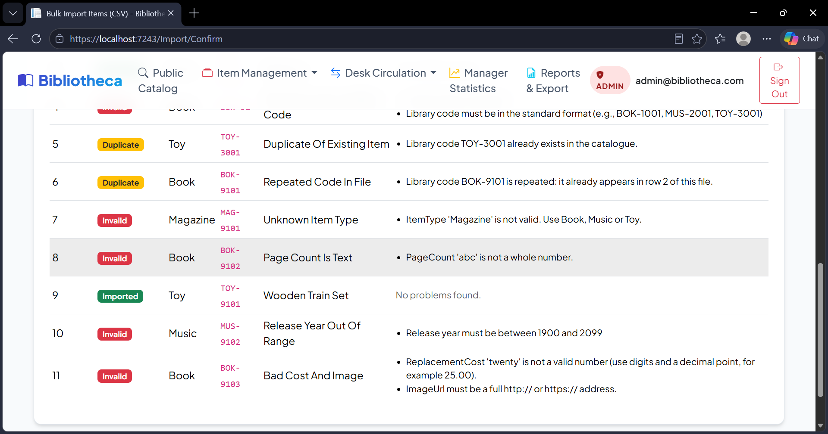
Figure A60. Import preview for mixed_import.csv with valid, invalid and duplicate rows (3 of 3) (TC-IMP-03).
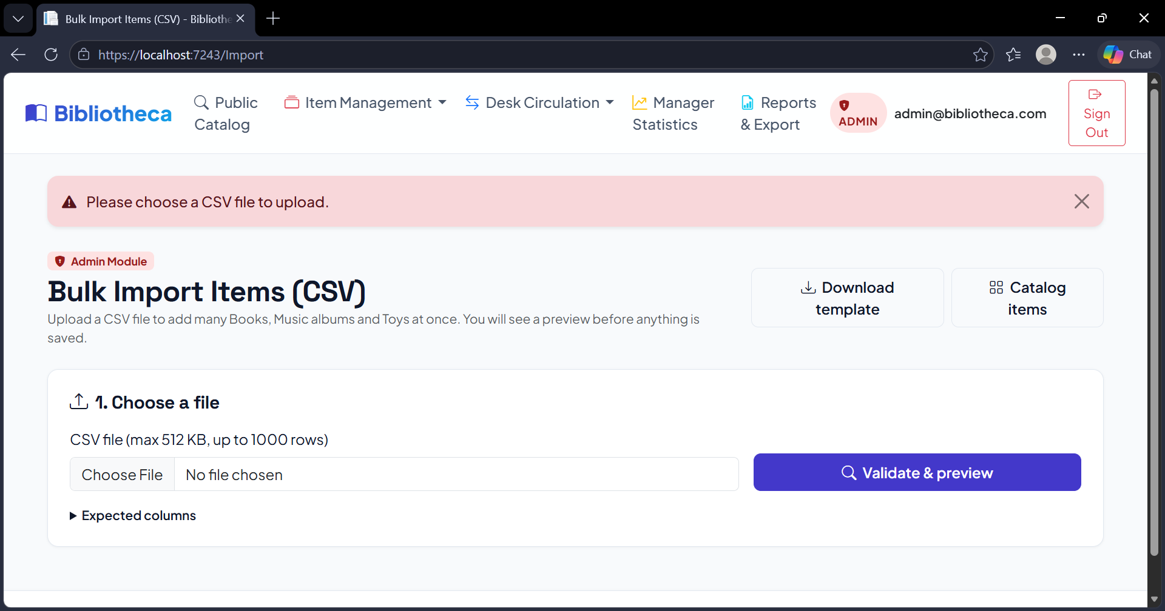
Figure A61. Empty file: a message asks for a file (TC-IMP-04).
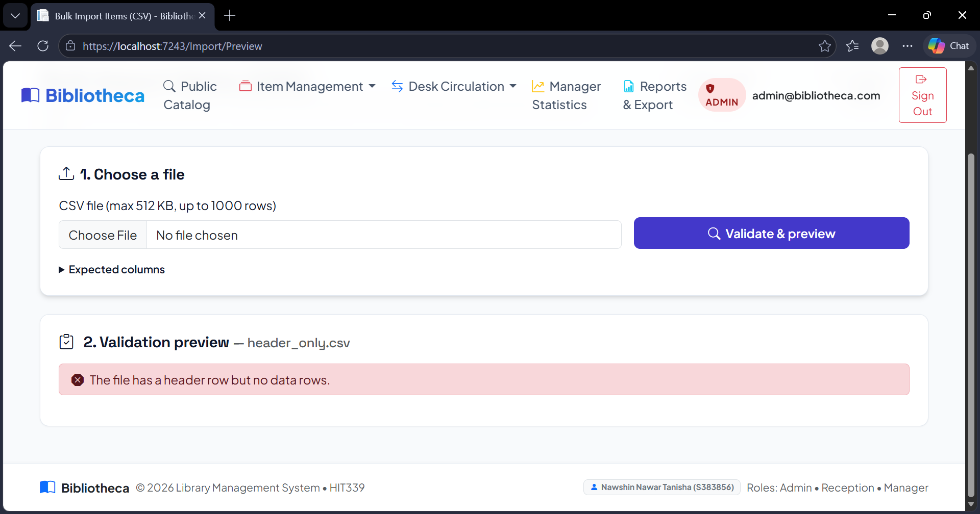
Figure A62. File with only a header row is refused (TC-IMP-04).
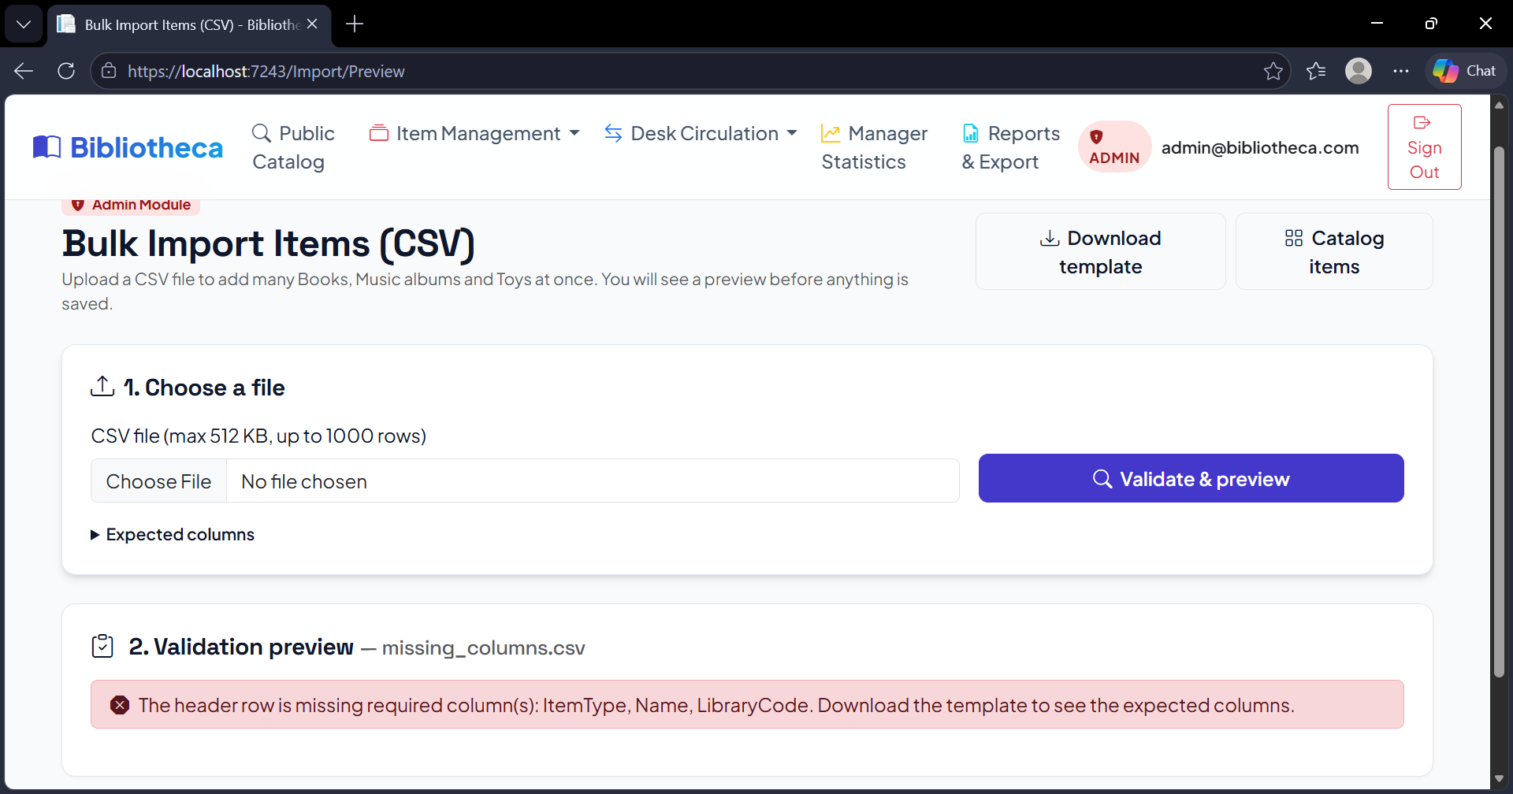
Figure A63. File with missing columns is refused (TC-IMP-04).
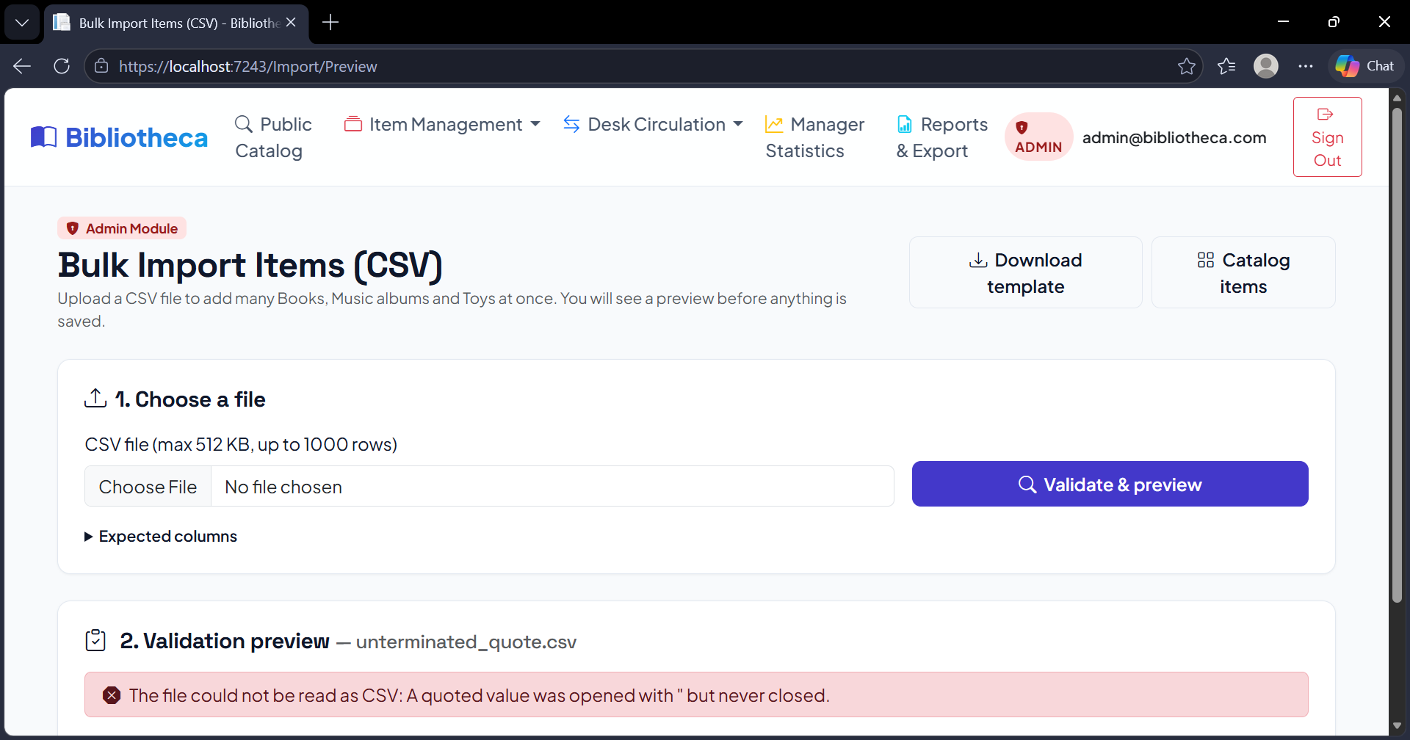
Figure A64. File with an unclosed quote is refused (TC-IMP-04).
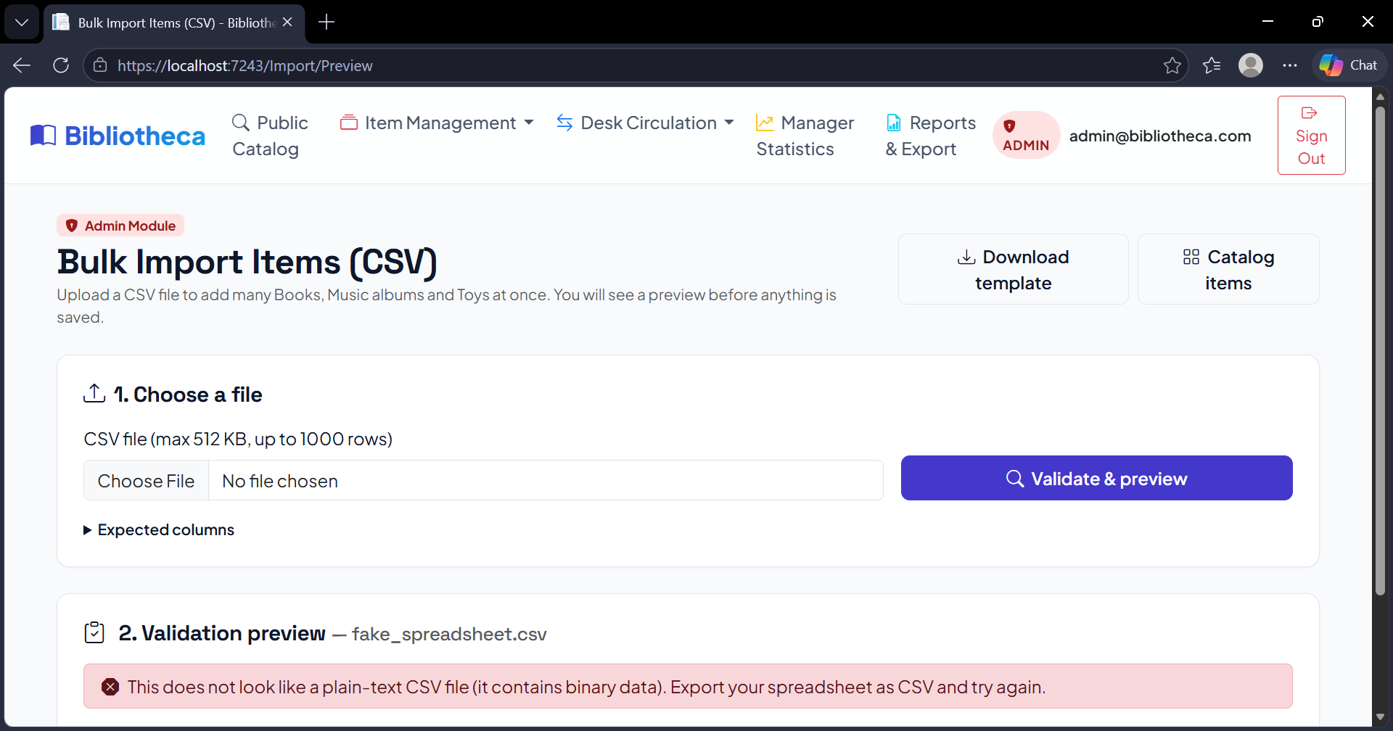
Figure A65. A renamed .xlsx file is refused as binary data (TC-IMP-04).
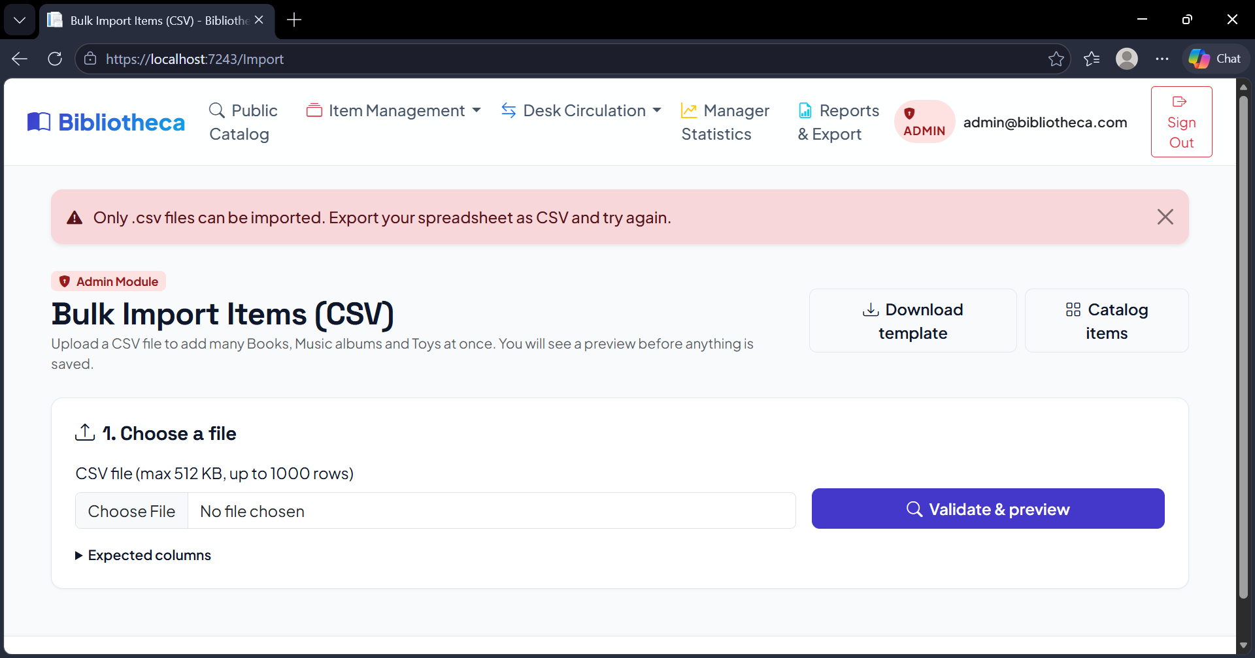
Figure A66. A .txt file is refused (only .csv allowed) (TC-IMP-04).

