**Float:** The float property in CSS is used to place an element to the left or right of its container, allowing text or inline elements to wrap around it.

Syntax: selector {

float: left | right | none | inherit;

}

Values of float:

**Left :** Floats the element to the **left** of its container.

**Right :** Floats the element to the **right** of its container.

**None :** Default value; the element **does not float.**

**Inherit** :Inherits the float value from its parent.

Ex Source Code for float left:

Html:

<div class="box">Floating Box</div>

<p>This text wraps around the floating box.</p>

CSS: .box {

width: 200px;

height: 100px;

float: left;

margin-right: 20px;

background-color: orange;

}

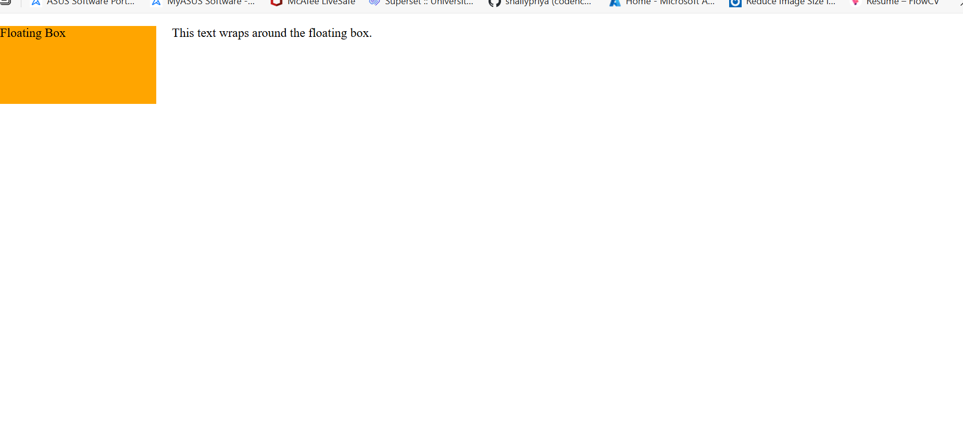output:

Ex source code for float right:

<!DOCTYPE html>

<html>

<head>

<title>Float Right Example</title>

<style>

.float-box {

width: 200px;

height: 100px;

background-color: orange;

float: right;

margin: 10px;

}

.content {

font-family: Arial, sans-serif;

}

</style>

</head>

<body>

<div class="float-box">I'm floated to the right</div>

<div class="content">

<p>

This is some sample content that will wrap around the box which is floated to the right.

You can add more text here to see how the paragraph adjusts around the floated box.

</p>

</div>

</body>

</html>

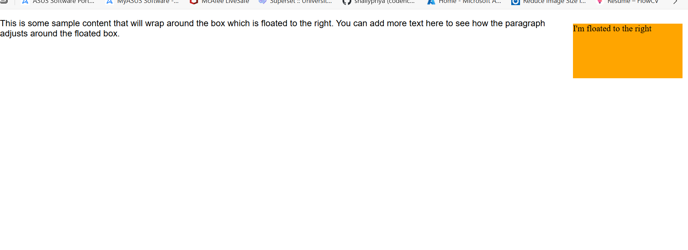output:

**HTML <input> Types:**

1. Text
2. Password
3. Email
4. Number
5. Tel(telephone)
6. url
7. Search
8. Date
9. Time
10. Datetime-local
11. Checkbox
12. Radio
13. Range
14. Color
15. File
16. Hidden
17. Submit
18. Reset
19. Button

**1.Text:** Allows the user to enter plain text.

Code:

<input type="text" placeholder="Enter your name">

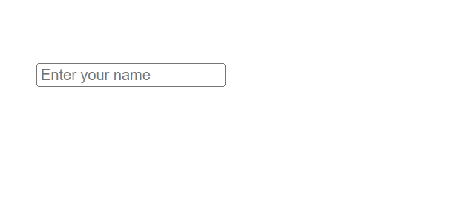Output:

**2.Password:**  Hides input characters; used for passwords.

Code:

<input type="password" placeholder="Enter your password">

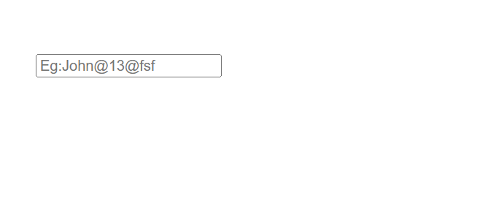Output:

**3.Email:** Validates email format.

Code:

<input type="email" placeholder="Enter your email">

Output:

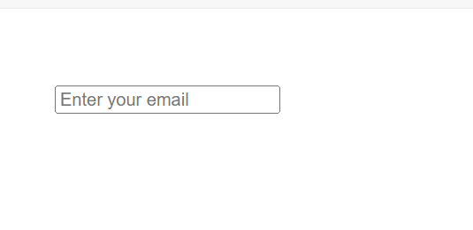

**4. Number:** Allows numeric input only.

Code: <input type="number" min="1" max="100">

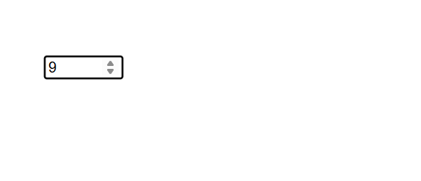Output:

**5. Tel:** Used for telephone numbers(no automatic validation)

Code: <input type="tel" placeholder="Enter phone number">

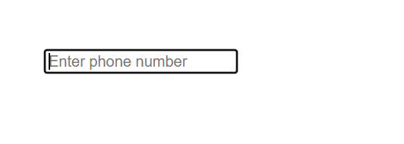Output:

**6. URL:** Validates URL format.

Code: <input type="url" placeholder="https://example.com">

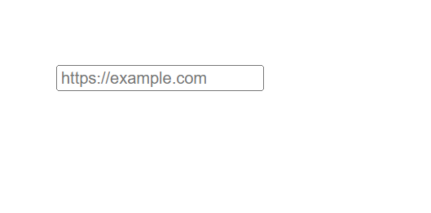 Output:

**7. Search:** Search field input with clear (×) icon in some browsers.

Code: <input type="search" placeholder="Search here">

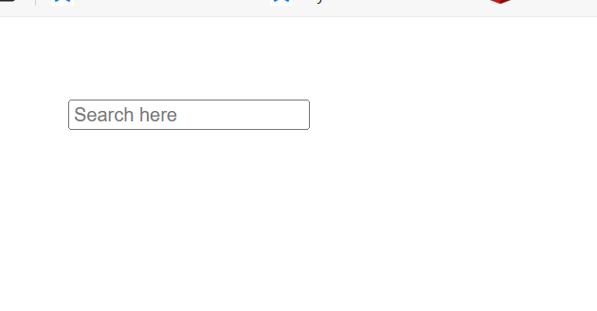 Output:

**8. Date:** Date picker

Code: <input type="date">

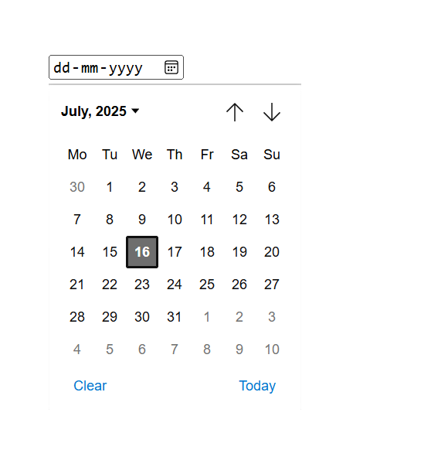 Output:

**9. Time:** Time picker

Code: <input type="time">

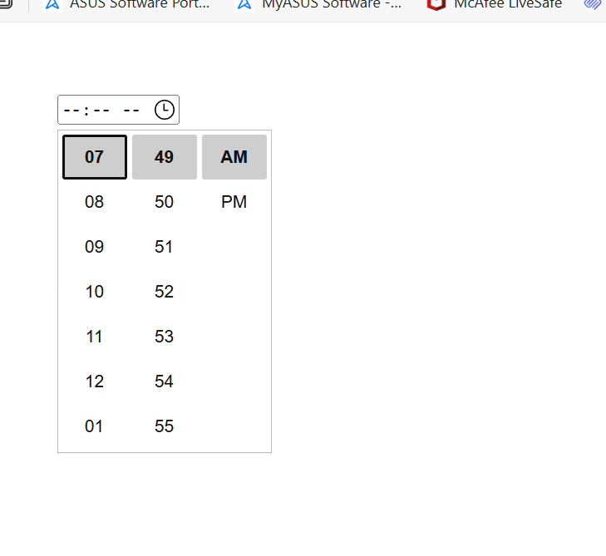 Output:

**10. Datetime-local:** Both date and time input.

Code: <input type="datetime-local">

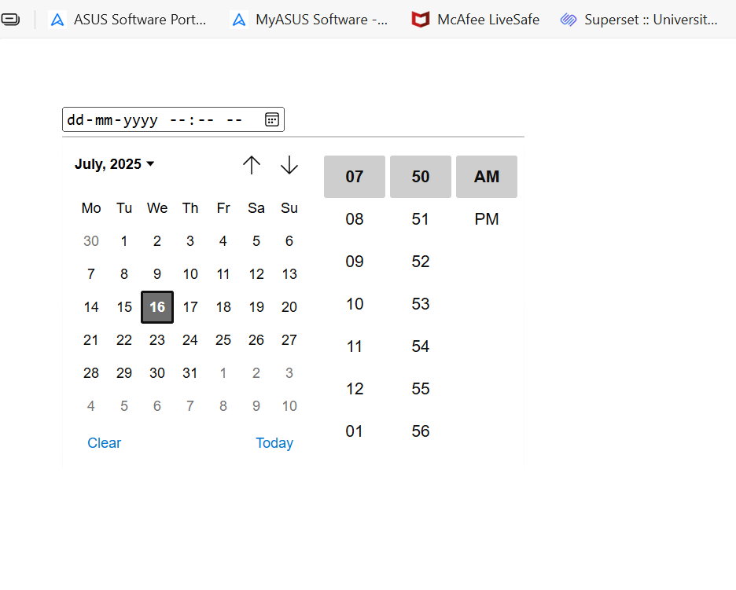 Output:

**11.Checkbox:** Used for multiple selections.

Code: <input type="checkbox" id="bike"> I have a bike

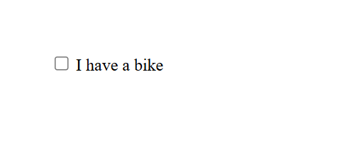 Output:

**12. Radio:** Used for single selection among options.

Code: <input type="radio" name="gender" value="male"> Male

<input type="radio" name="gender" value="female"> Female

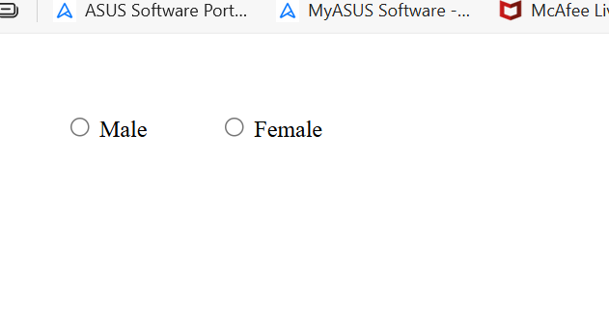 Output:

**13. Range:** Creates a slider.

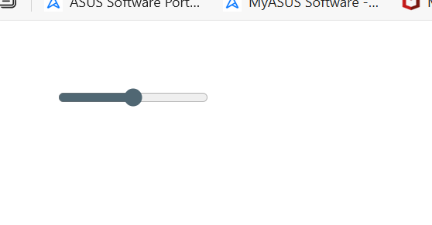 Code: <input type="range" min="0" max="100">

Output:

**14. Color:** Color picker input.

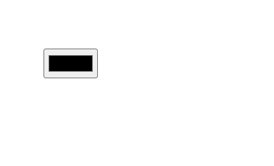 Code: <input type="color">

Output:

**15. File:** Used to upload files.

Code: <input type="file">

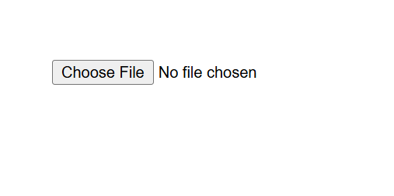 Output:

**16. Hidden:** Stores data without showing it to the user.

Code: <input type="hidden" name="userId" value="12345">

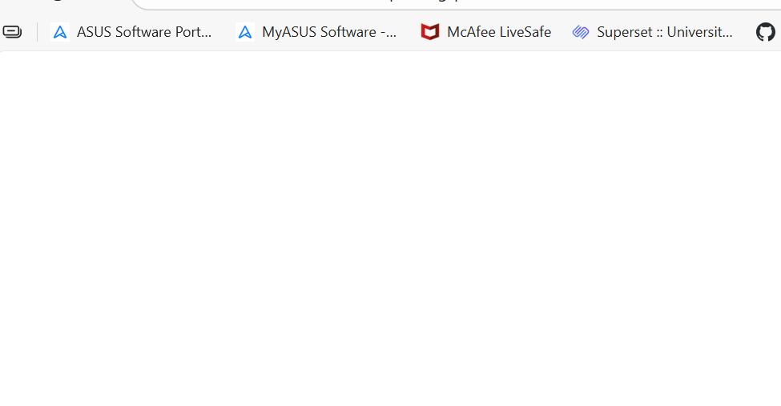 Output:

Here it hides the data

**17. Submit:** Submits the form.

Code: <input type="submit" value="Submit">

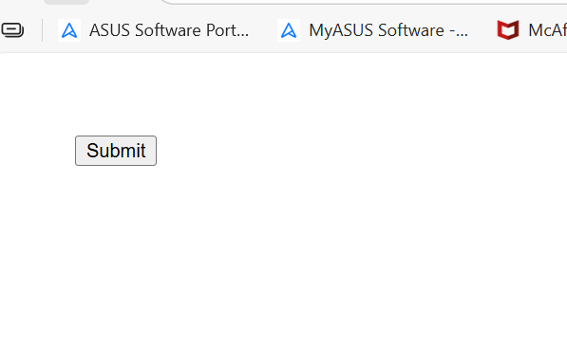 Output:

**18. Reset:** Resets all fields in a form.

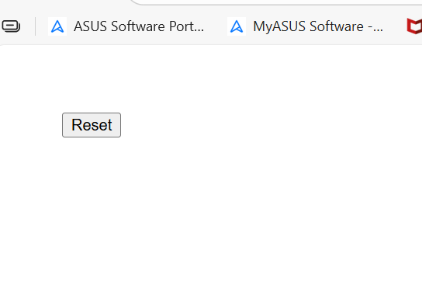 Code: <input type="reset">

Output:

**19. Button:** Regular button (needs JavaScript to function).

Code: <input type="button" value="Click Me">

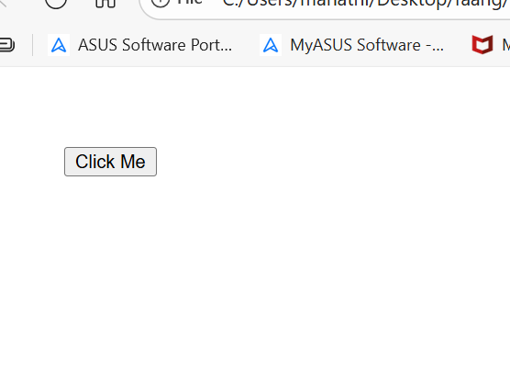 Output: