

PAGE1

E-COMMERCE PLATFORM REPORT
STUDENTS NAME: ASPENOURS MAITEKA
ADMISSION NUMBER: BBIT/2024/73549
LECTURER: MICHAEL NYORO
ACADEMIC YEAR: YEAR 3 SEMESTER 2
UNIT: ADVANCED WEB DESIGN AND DEVELOPMENT
UNIT CODE: BIT3208

PROJECT DEAILS
Technologies;
MongoDB, express.js, Node.js

GITHUB LINK
https://github.com/Mahatma3560/BIT3208-ADVANCED-WEB-PROJECT

PAGE 2
Table of Contents
PAGE1 1
E-COMMERCE PLATFORM REPORT 1
PROJECT DEAILS 1
PAGE 2 2
PAGE 3 4
Week 1: local Environment Setup 4
Installation and testing of local development environment 4
Fig.1; installation of Node.js 4
Fig2.Node.js and MongoDB running 5
Fig.3 installation of XAMPP 6
Fig.5 hello world test 7
WHAT I HAVE LEARNED 10
WEEK 2. WIREFRAME AND GUI DESIGN 11
FIG.1; Hand drawn wireframe and dashboard layout design 11
Fig2.Mobile view mockup 13
Fig3.GUI prototype in canva 14
STUDENTS REFLECTION 16
WEEK3. JAVASCRIPT AND PHP BASICS 17
Fig1.Javascript from validation 17
Fig2.Password strength checker 18
Fig3.database connection script 18
Fig5: Dynamic user input handling 19
WEEK4: SERVER-SIDECOMPONENTS 21
DEPLOYING ASIMPLE PHP/ASP SCRIPT 21
TASK1.Understanding sever-side programming 21
TASK2: HTML forms and PHP integration 21
TASK3: Simple authentication system 22
Task 4.Session 23
Task 5;folder structure 23
WEEK5- ADVANCED WEB DESIGN AND DEVELOPMENT 24
TASK1-INTRODUCTION TO DARABASE 24
TASK 2- CREATE DATABASE 24
TASK3: CREATE TABLE 25
TASK 4: Insert data into the table 25
STEP5-Create PHP database connection 26
STEP 6: FETCHING DATABASE RECORDS 27
UPDATE (edit records) 27
DELETE (remove records) 28

PAGE 3

Week 1: local Environment Setup

Installation and testing of local development environment

Fig.1; installation of Node.js
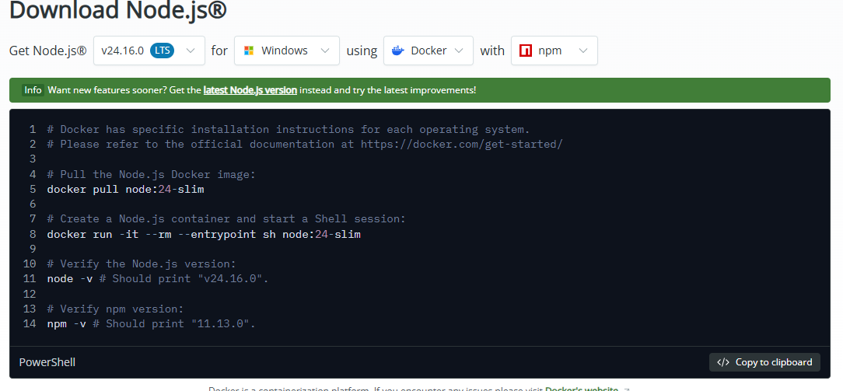
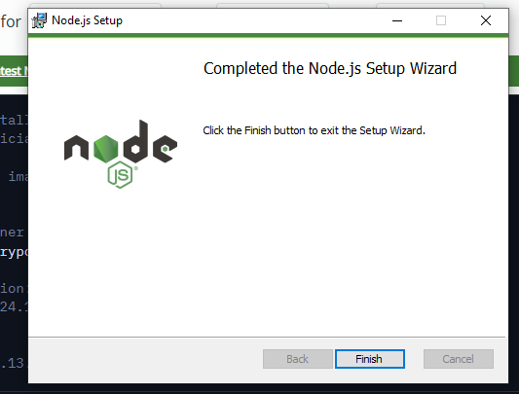

Fig2.Node.js and MongoDB running

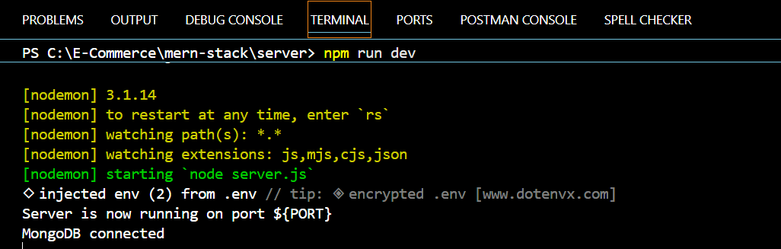

Fig.3 installation of XAMPP
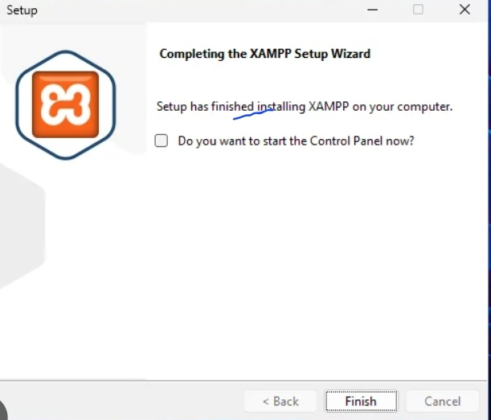

Fig.4 localhost test page
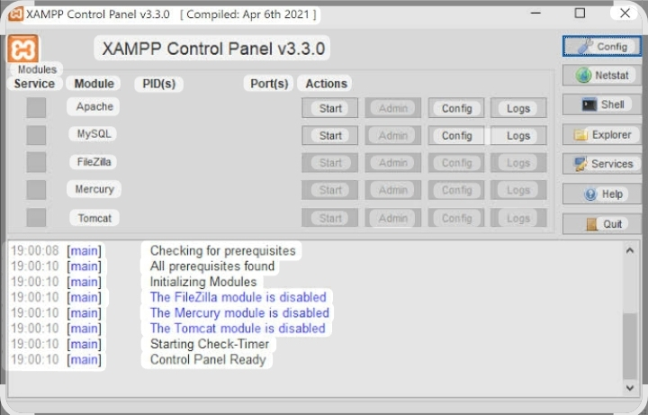

Fig.5 hello world test
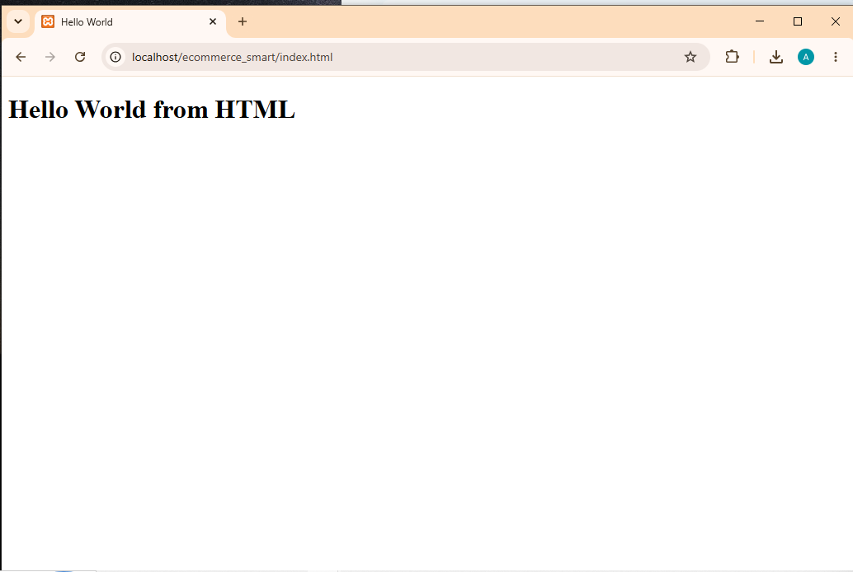
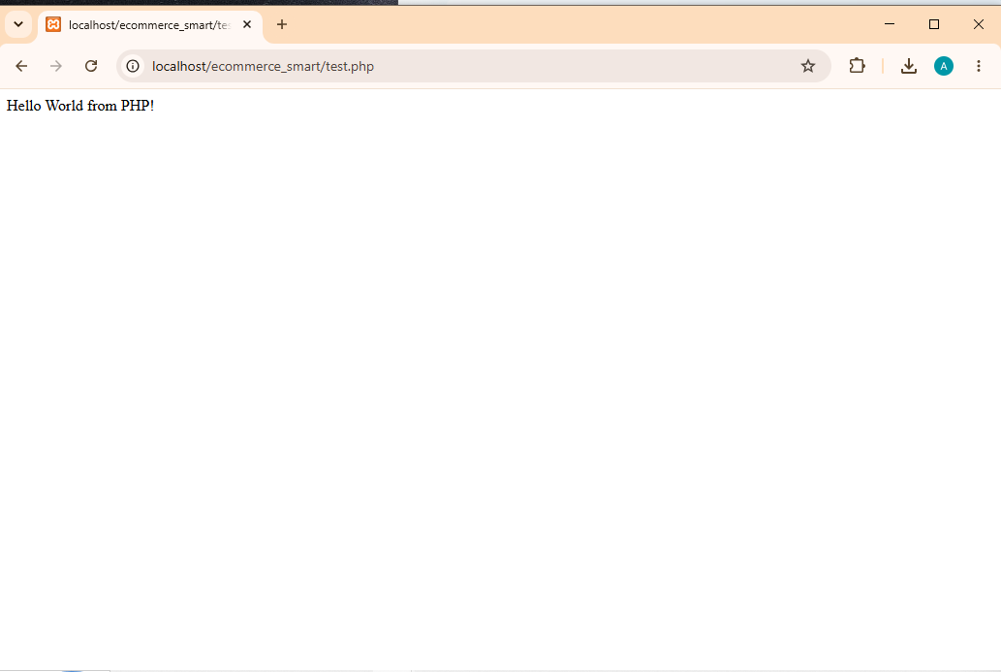

Fig.6 database connection test
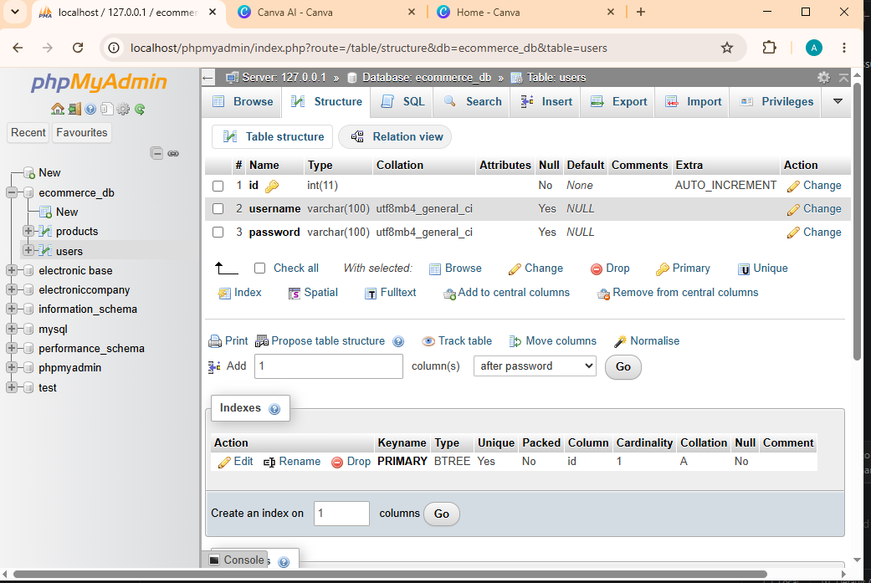

WHAT I HAVE LEARNED
Through this project, I learned how to develop a simple web application using PHP and MySQL. All tools were configured using XAMPP, which was used to run both the web server and database locally. During the connection process, I encountered challenges such as database connection errors and configuration issues. By troubleshooting these problems, I successfully connected PHP to MySQL and gained practical experience in web development and database management.FIG.6 shows a successful connection between PHP and MYSQL using mysql_connect().this confirms that Apache and MYSQL were properly configured in XAMPP.

WEEK 2. WIREFRAME AND GUI DESIGN

FIG.1; Hand drawn wireframe and dashboard layout design
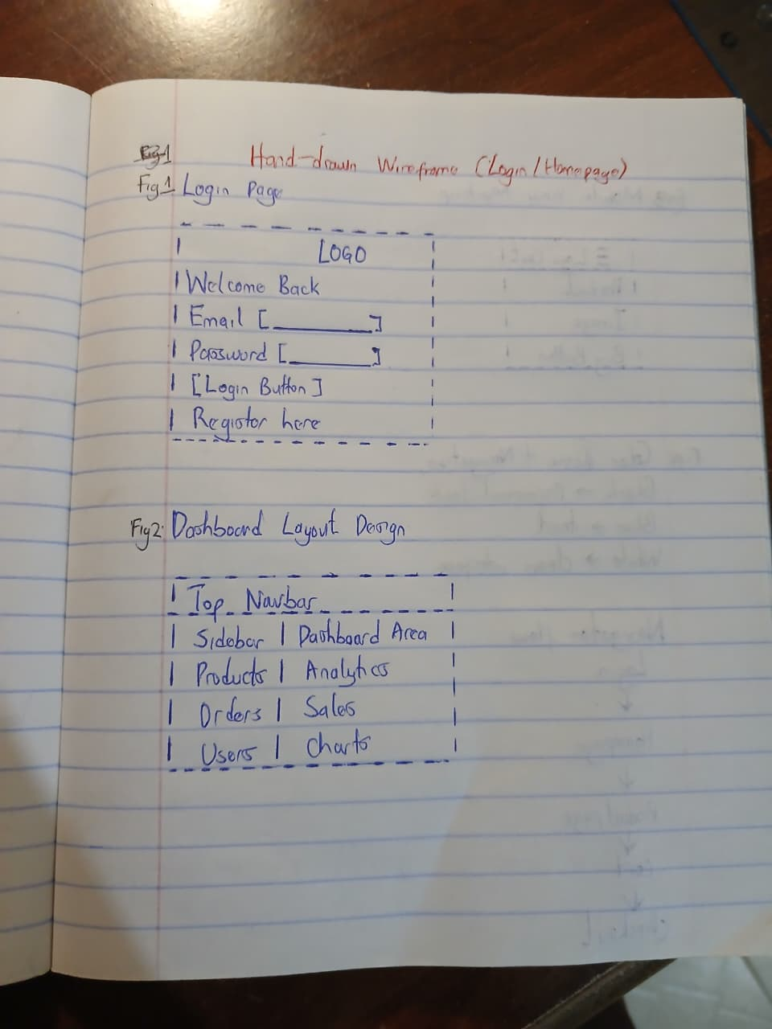

Fig2.Mobile view mockup
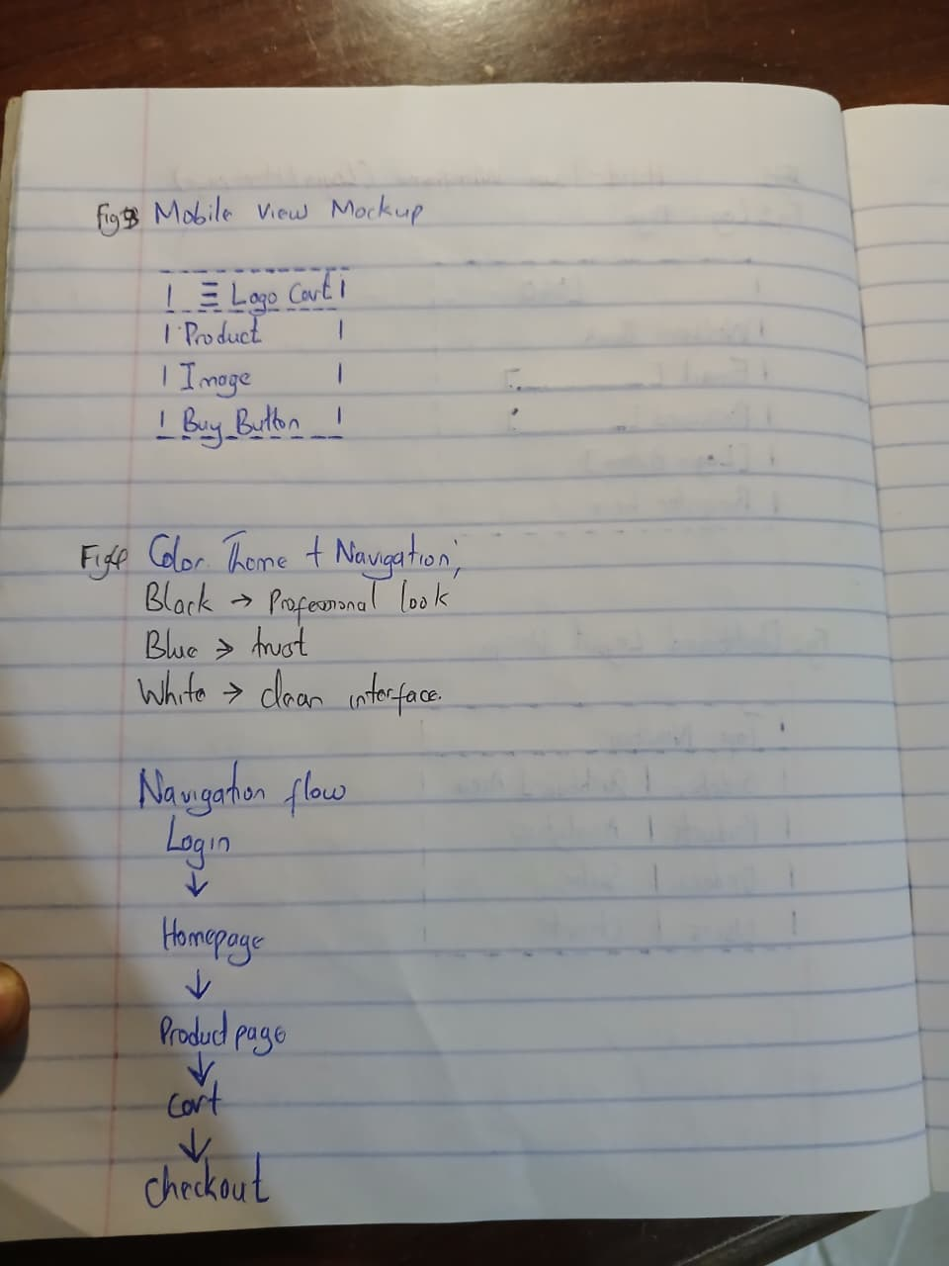

Fig3.GUI prototype in canva
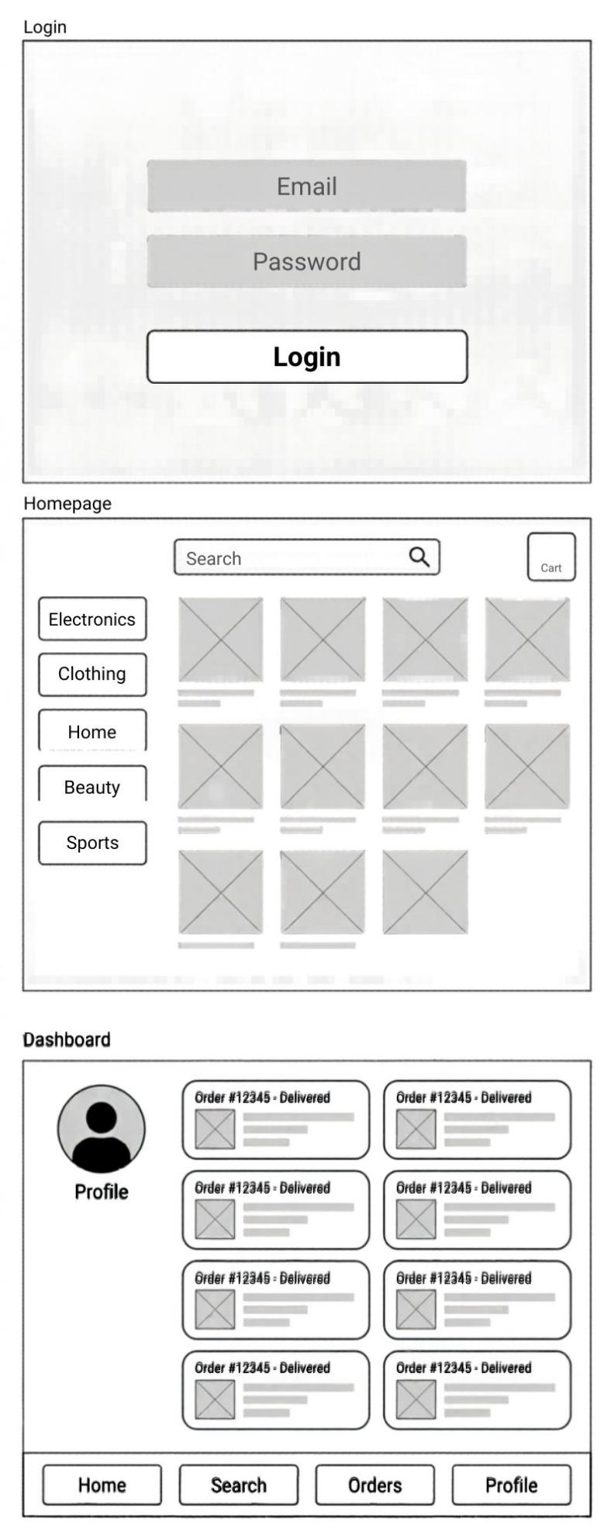

STUDENTS REFLECTION
I chose Canva for wireframe design due to its simplicity and speed. The UI was planned with clarity, consistency, responsiveness, and accessibility in mind. Navigation flow followed a logical hierarchy with clear labels and minimal clicks for efficiency. The intended users are students and professionals seeking a clean, functional, and easy-to-use interface.

WEEK3. JAVASCRIPT AND PHP BASICS
Frontend interaction and backend foundation

Fig1.Javascript from validation
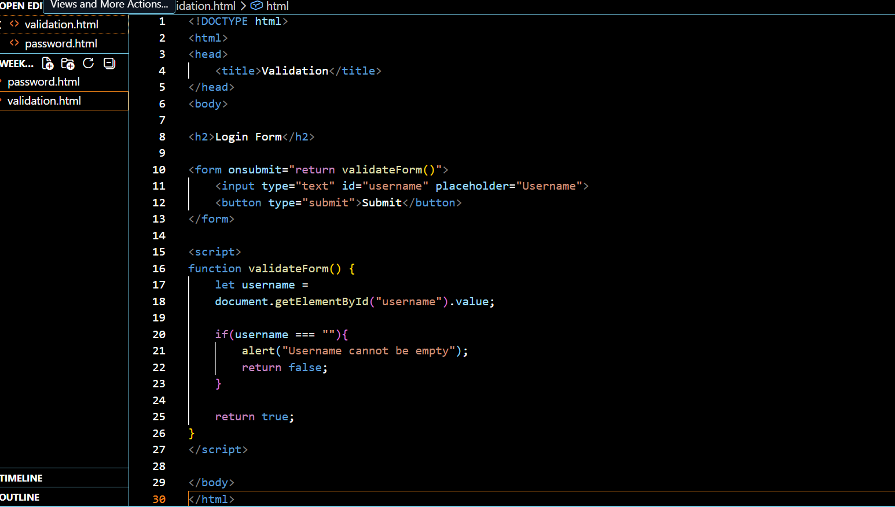
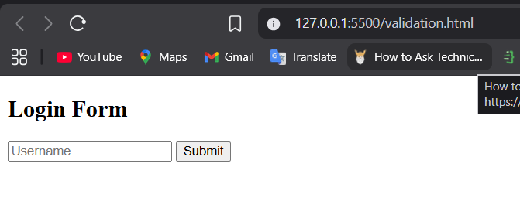

Fig2.Password strength checker
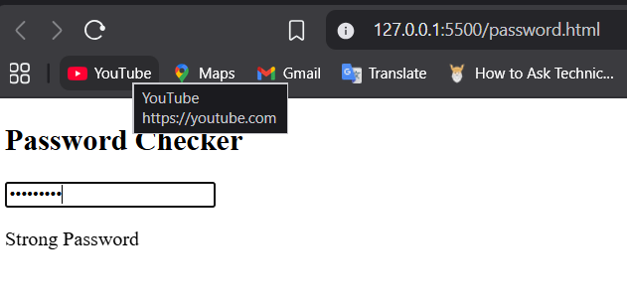

Fig3.database connection script
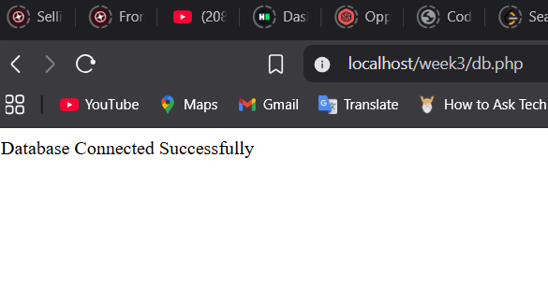
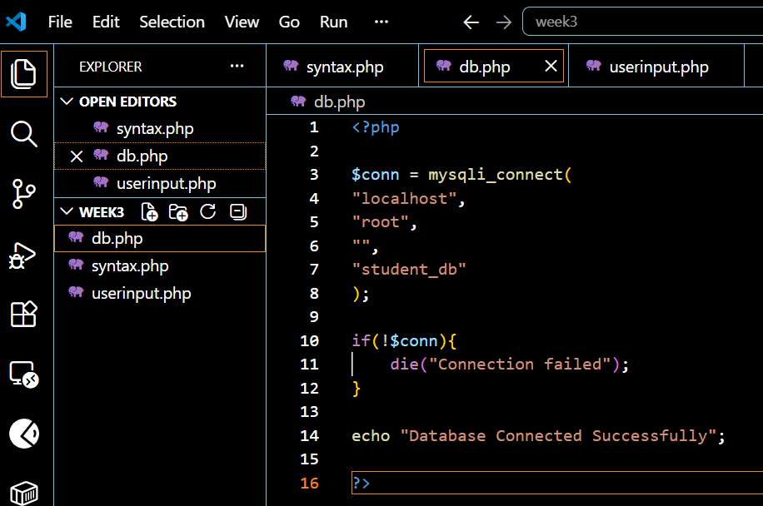

Fig5: Dynamic user input handling
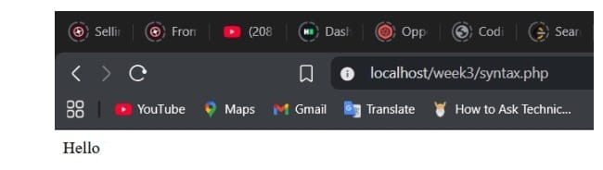

JavaScript was used to improve frontend interaction by validating user input before submission. This prevents empty forms and improves user experience. PHP handled backend processing by receiving form data and interacting with the database. MySQL was used for storing information while database connection ensured communication between the application and stored records. These technologies work together to create an interactive and functional web system.

WEEK4: SERVER-SIDECOMPONENTS

DEPLOYING ASIMPLE PHP/ASP SCRIPT

TASK1.Understanding sever-side programming
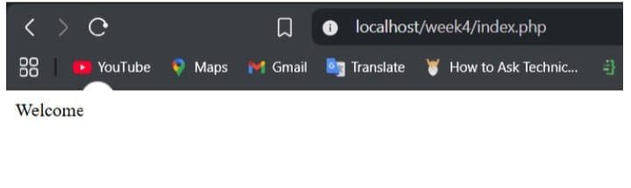

TASK2: HTML forms and PHP integration
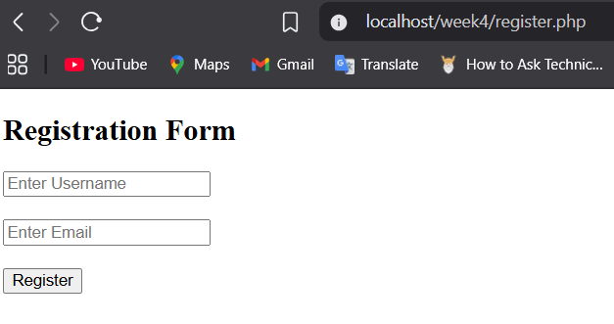

TASK3: Simple authentication system
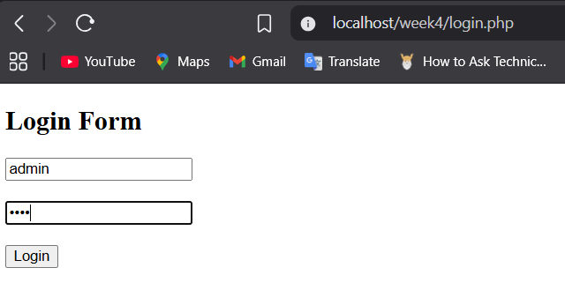
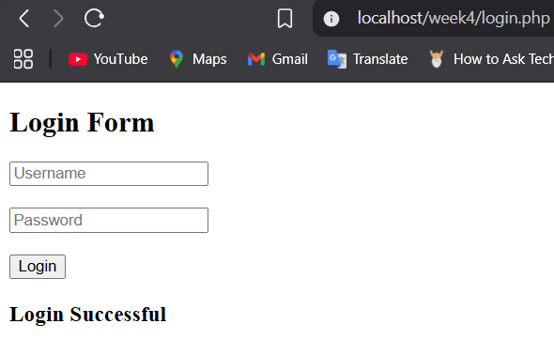

Task 4.Session


Task 5;folder structure
week4
│── index.php
│── login.php
│── register.php
│── welcome.php
│── css
│ └── style.css

WEEK5- ADVANCED WEB DESIGN AND DEVELOPMENT

TASK1-INTRODUCTION TO DARABASE
Create a folder week5 in vs code

TASK 2- CREATE DATABASE


TASK3: CREATE TABLE
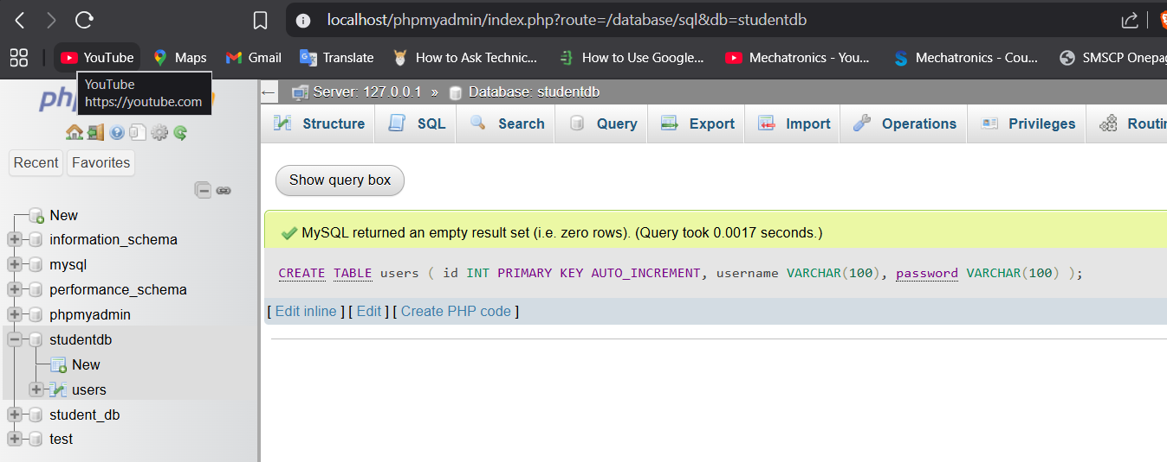

TASK 4: Insert data into the table
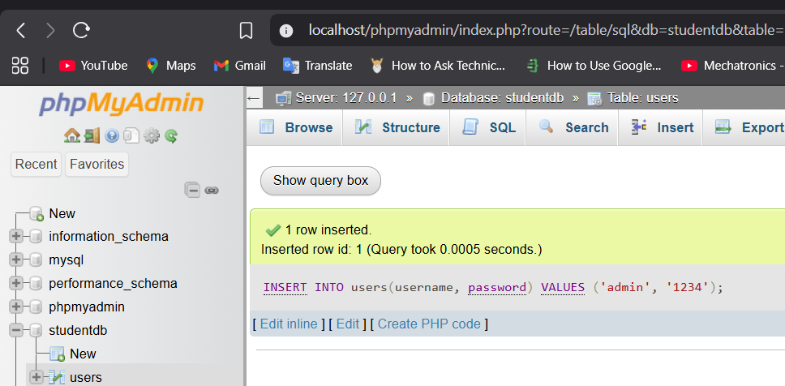
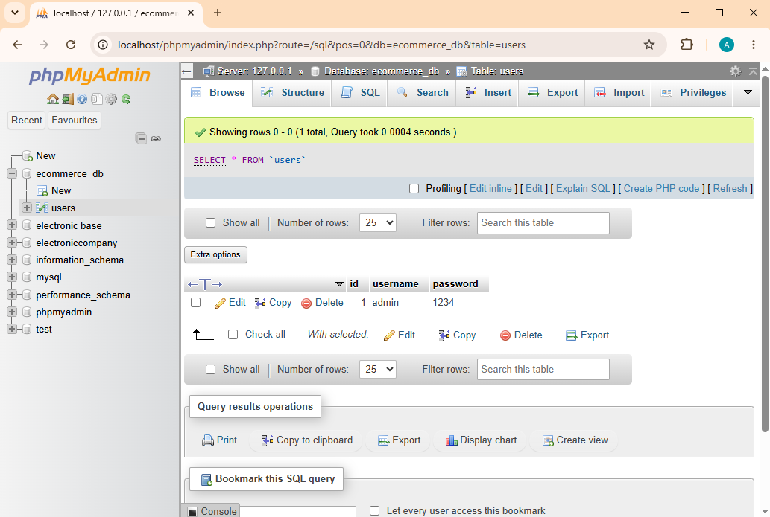

STEP5-Create PHP database connection
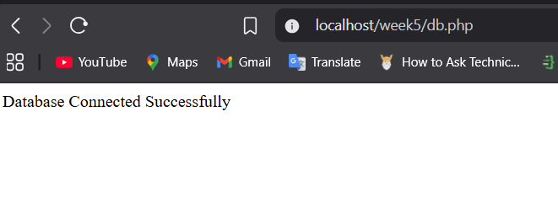

STEP 6: FETCHING DATABASE RECORDS
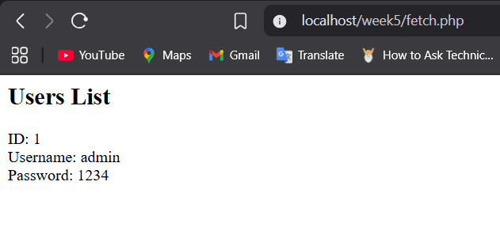
What this code is doing; This line gets data:
SELECT * FROM users
Meaning:
Get all records from users table
Then:
mysqli_fetch_assoc()
reads each row one by one.
Example:
Database:
id | username | password
1 | admin | 1234
PHP displays it in browser.

After it works, we’ll do the last part of CRUD:

UPDATE (edit records)
and

DELETE (remove records)

