ecoVolt-finder
Smart, Green, and True-Cost EV Charging & Load-Balancing Platform
Project Ideation & Technical Design Report
Project Name: | ecoVolt-finder
Team Members: | Mahavir Virda (Backend / API & System Architecture)  Deep (Mobile App & UI/UX Design)  Dhruvin (ML / Grid Forecasting & Routing Engine)
Target Platform: | Mobile (React Native/Android) + Node.js API + Python ML Microservice
Document Type: | Ideation Round Technical Submission Report
1. Executive Summary
ecoVolt-finder is an intelligent, full-stack EV charging ecosystem designed to solve the critical gap between expanding EV adoption and power grid sustainability in India. While traditional EV navigation platforms focus strictly on distance or advertised sticker price per kWh, ecoVolt-finder exposes real-time Grid Greenness (clean renewable generation share vs. fossil fuel intensity) as an actionable metric.
By computing vehicle-aware True Total Cost (Energy Cost + Distance Travel Cost) and automating Smart-Charging Scheduling during renewable supply peaks, the platform establishes a win-win incentive loop: drivers save money and cut carbon emissions, while charging operators lower wholesale electricity costs and mitigate grid peak-demand charges.
2. Problem Statement
- The "Green EV" Irony: EVs in India frequently charge during evening peak demand periods (6 PM - 10 PM) powered by coal-heavy thermal plants, undermining the environmental benefits of electrification and stressing the grid.
- The "Cheaper-But-Farther" Trap: Drivers are often misled by lower sticker prices (e.g. ₹2/kWh cheaper) at distant stations, only to discover that travel battery consumption and round-trip costs erase all financial gains.
- Fragmented Multi-Provider Tariffs: Power distribution companies (Torrent Power, GUVNL, Adani, Tata Power, BSES) operate disparate slab rates and Time-of-Use structures that remain non-transparent to users.
- Operator Demand Charges: Simultaneous multi-vehicle charging spikes substation load during peak hours, triggering punishing demand surcharges for station operators.
3. Proposed Solution & End-to-End Workflow
ecoVolt-finder creates a closed-loop data pipeline bridging drivers, charging station operators, and the regional power grid. The complete 5-step operational workflow is illustrated below:
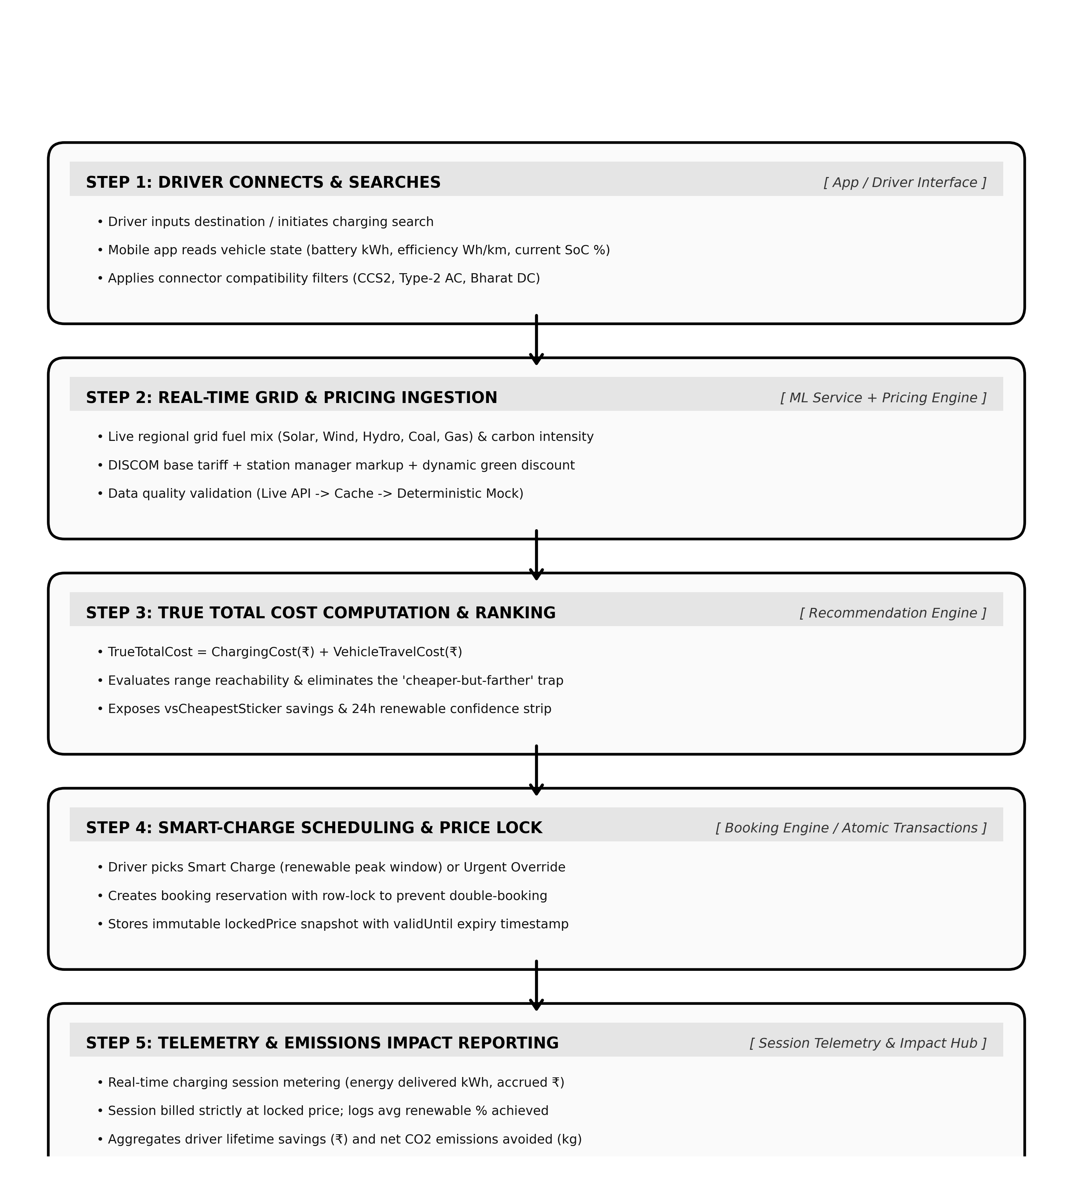
Figure 1: ecoVolt-finder 5-Step Operational Flowchart (Driver Discovery to Telemetry)
4. Key Features by Role
4.1 EV Driver Experience (Mobile App)
- Vehicle-Aware Profiling: Supports cars and bikes with customizable battery capacity (kWh), real-world efficiency (Wh/km), connector types (CCS2, Type-2 AC, Bharat DC), and live SoC %.
- Live Green Map Pins: Charging stations rendered with color-coded greenness badges reflecting real-time renewable abundance.
- 24-Hour Renewable Forecast: Visual sparklines highlighting projected peak green hours with model confidence intervals.
- True-Cost Comparison Card: Transparently breaks down energy vs travel expense and compares it against naive sticker-price alternatives.
- Driver Impact Hub: Lifetime metrics tracking total kWh delivered, total ₹ saved, and aggregate kg of CO2 avoided.
4.2 Station Manager Experience (Web & Operator Portal)
- Multi-Provider Tariff Management: Configure base tariffs for regional power providers (Torrent, GUVNL, Tata, Adani) + station service markups.
- Dynamic Green Discounting: Automated time-of-use pricing discounts during high renewable generation to incentivize customer load shifting.
- Demand-Charge Peak Risk Meter: Live monitoring of station aggregate kW draw to avoid substation demand-charge penalties.
- Connector Status Control: Real-time occupancy management and maintenance controls.
4.3 Grid Operator & Admin Oversight
- Network Load Shifting Analytics: Macro insights into aggregate EV energy consumption shifted away from peak thermal hours.
- Data Reliability Auditing: Monitors telemetry quality across data tiers (Live, Cached, Forecast, and Mock Fallback).
5. Technology Stack & Monorepo Architecture
The project is structured as a conflict-free monorepo divided into three distinct service domains with strict interface contracts:
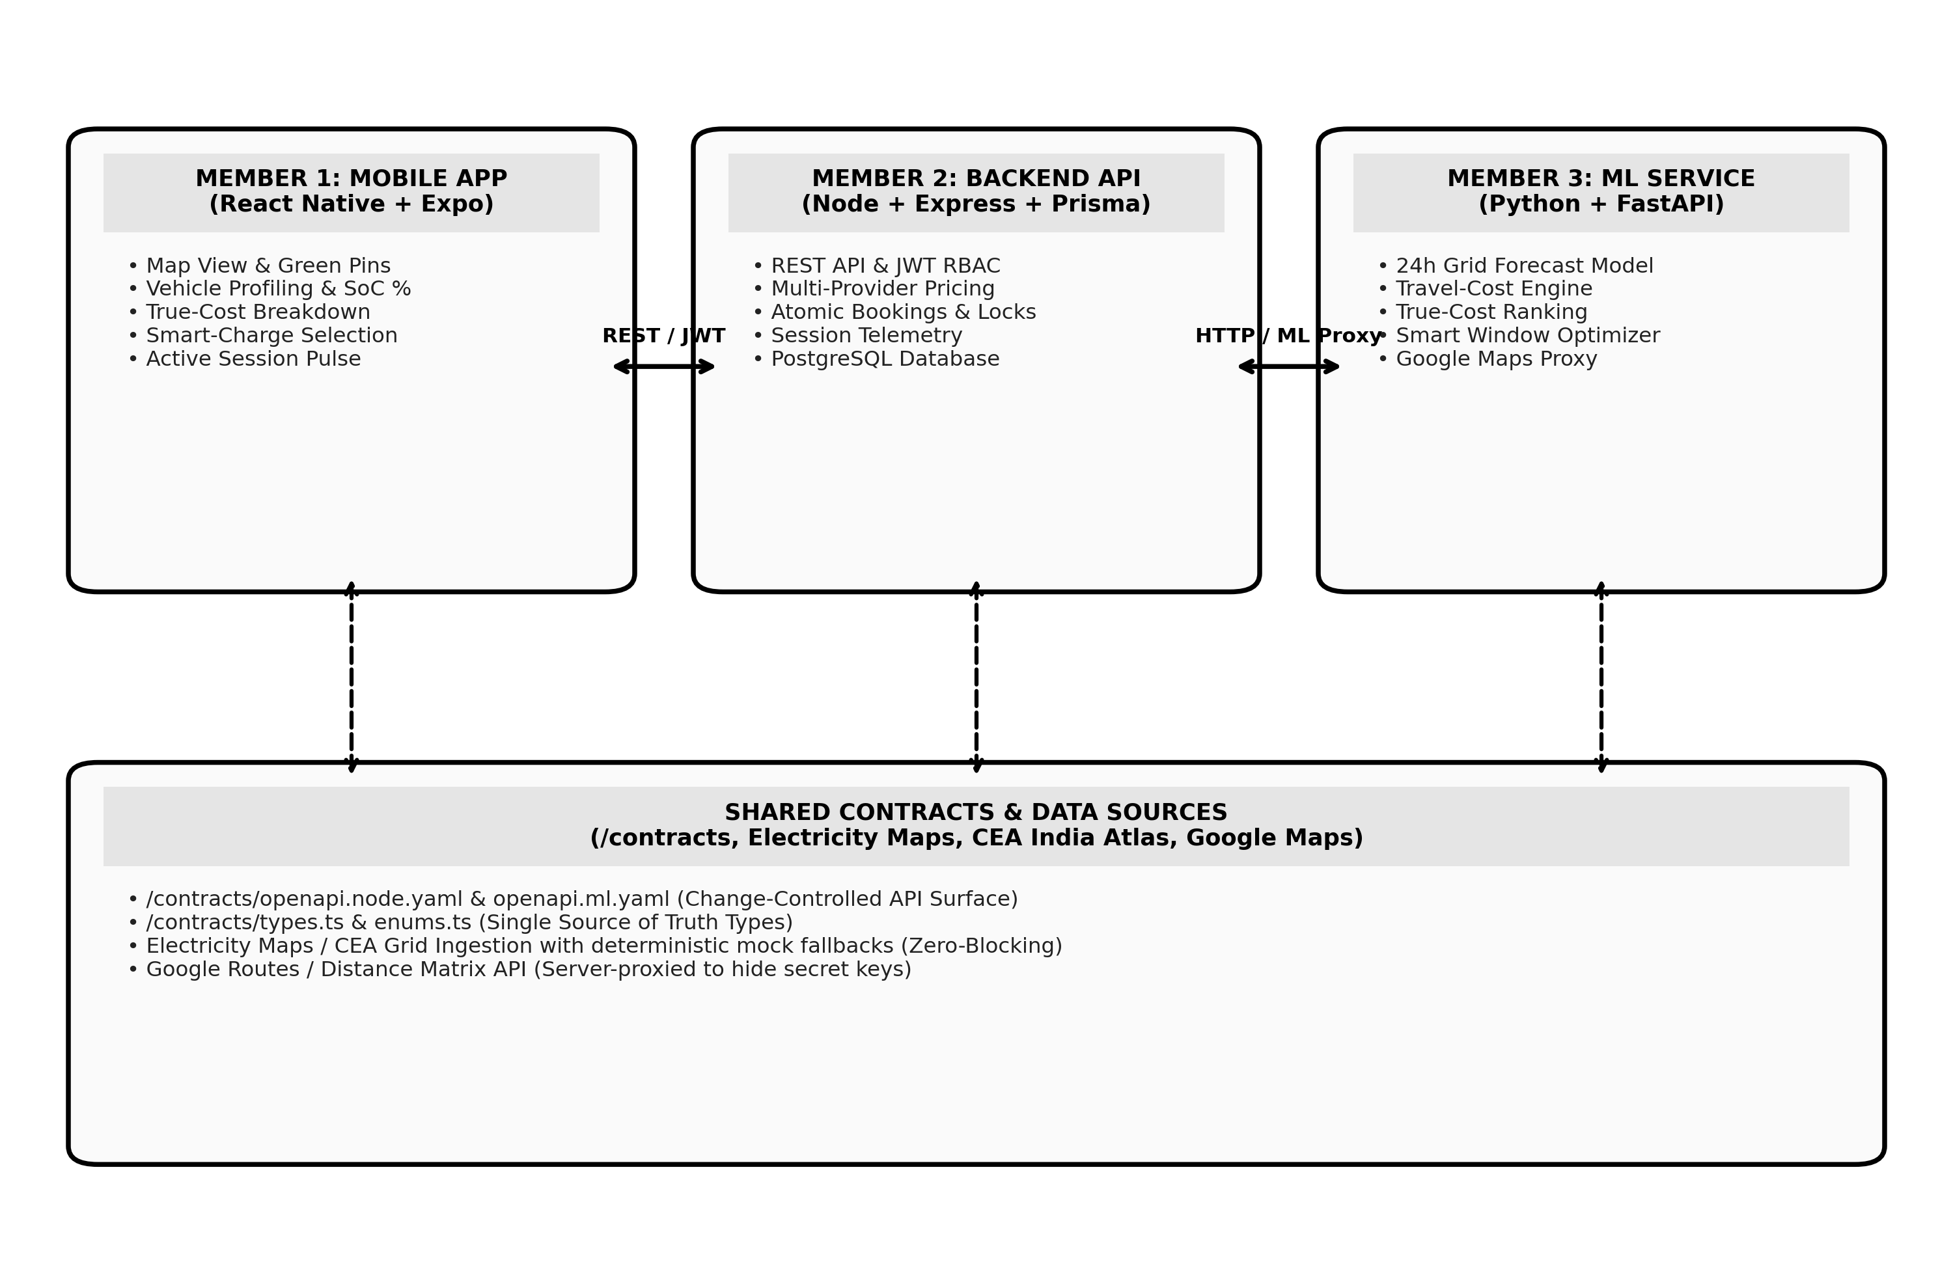
Figure 2: ecoVolt-finder Monorepo Architecture & Cross-Service Data Seams
Layer / Subsystem | Technology Stack | Core Responsibility
Mobile App (Frontend) | React Native, Expo, React Navigation, react-native-maps | Driver map discovery, station cards, vehicle profile, and booking flows.
Backend API | Node.js, Express, TypeScript, Prisma ORM, PostgreSQL | REST endpoints, JWT RBAC, pricing engine, price-lock transactions, and health checks.
ML & Intelligence Service | Python 3.11, FastAPI, Scikit-Learn, Pandas, NumPy | 24h grid greenness forecasting, travel-cost algorithms, and smart-charge planning.
Grid Data & Telemetry | Electricity Maps API, India Energy Atlas + Mock Engine | Zone-level renewable vs thermal generation mix & carbon intensity.
Spatial & Routing Proxy | Google Maps Platform (Routes, Matrix, Geocoding) | Accurate driving distance & duration calculations proxied server-side to secure keys.
6. Edge Cases & Resilience Strategy
- Cheaper-but-Farther Station: Eliminated by evaluating TrueTotalCost = ChargingCost + TravelCost before ranking.
- Different DISCOM Base Tariffs: First-class PowerProvider enum and customizable Tariff entities per zone.
- Grid API Outages / Limits: Three-tier hybrid resilience: Live API -> Database Cache -> Deterministic Mock Generator.
- Double-Booking Contention: Atomic Prisma database transactions with row-level locks and time-window validation.
- Mid-Charge Price Fluctuations: Immutable lockedPrice snapshot stored in Booking; driver is billed quoted rate.
- Google Maps API Key Protection: Client app never holds routing credentials; all route queries proxied server-side.
7. Implementation Roadmap
- Phase 1: Foundation & Monorepo Bootstrap: Contracts definition (OpenAPI 3.1, TypeScript types), PostgreSQL relational schema, Express server, and Expo mobile setup.
- Phase 2: Core Engines & Data Layer: JWT auth, RBAC middleware, spatial station search, Multi-Provider Pricing Engine, and live grid ingestion.
- Phase 3: Machine Learning & Booking: 24-hour renewable forecasting model, travel-cost optimizer, smart-charge scheduler, and atomic price-lock bookings.
- Phase 4: Telemetry & Impact Analytics: Real-time charging session state machine, driver carbon counter, and operator demand-charge monitor.
- Phase 5: Verification & Polish: End-to-end integration tests, offline fallback banner, and final production validation.
8. Conclusion
ecoVolt-finder aligns economic self-interest with environmental responsibility. By transforming grid greenness into actionable charging intelligence and true-cost visibility, the platform empowers EV drivers to charge affordably while assisting grid operators in stabilizing India's clean energy transition.

