**Final Results- Hackit Dataset**

Total Number of Systems=40

Number of Real Systems=10

Number of Honeypot Systems=30

Two simulations each have been performed in both “Subnet” and “Non-Subnet” setting.

**Simulation 1-** Analysis of Human performance for the last 30% of decisions taken by a user

**Simulation 2-** Analysis of IBL theory performance where the IBL theory took 30% of the total decisions taken by a user after 70% of the initial decisions of that user were prepopulated in the memory

Performances of each simulation are compared according to the parameters mentioned below.

1. Parameter 1-Average Number of Real Systems exploited by a user
2. Parameter 2-Average Number of Honeypot Systems exploited by a user
3. Parameter 3-Percentage of Real Systems Exploited [(Parameter 1/10)*100]
4. Parameter 4- Percentage of Honeypot Systems Exploited [(Parameter 2/30)*100]
5. Parameter 5- Percentage of Real Systems Exploited out of total systems [(Parameter 1/40)*100]

**Subnet Setting**

|  |  |  |
| --- | --- | --- |
|  | Simulation 1 (Human Performance) | Simulation 2 (IBL Performance) |
| Parameter 1-Average Number of Real Systems exploited by a user | 0.185 | 0.33318 |
| Parameter 2-Average Number of Honeypot Systems exploited by a user | 5.18181 | 1.75681 |
| Parameter 3-Percentage of Real Systems Exploited [(Parameter 1/10)*100] | 1.84999% | 3.33181% |
| Parameter 4- Percentage of Honeypot Systems Exploited [(Parameter 2/30)*100] | 17.27272% | 5.85606% |
| Parameter 5- Percentage of Real Systems Exploited out of total systems [(Parameter 1/40)*100] | 0.46249% | 0.83295% |

**Non-Subnet Setting**

|  |  |  |
| --- | --- | --- |
|  | Simulation 1 (Human Performance) | Simulation 2 (IBL Performance) |
| Parameter 1-Average Number of Real Systems exploited by a user | 0.23288 | 0.38881 |
| Parameter 2-Average Number of Honeypot Systems exploited by a user | 6.20338 | 2.04915 |
| Parameter 3-Percentage of Real Systems Exploited [(Parameter 1/10)*100] | 2.32881% | 3.88813% |
| Parameter 4- Percentage of Honeypot Systems Exploited [(Parameter 2/30)*100] | 20.67796% | 6.83050% |
| Parameter 5- Percentage of Real Systems Exploited out of total systems [(Parameter 1/40)*100] | 0.58220% | 0.97203% |

**Graphical Analysis of Performance**

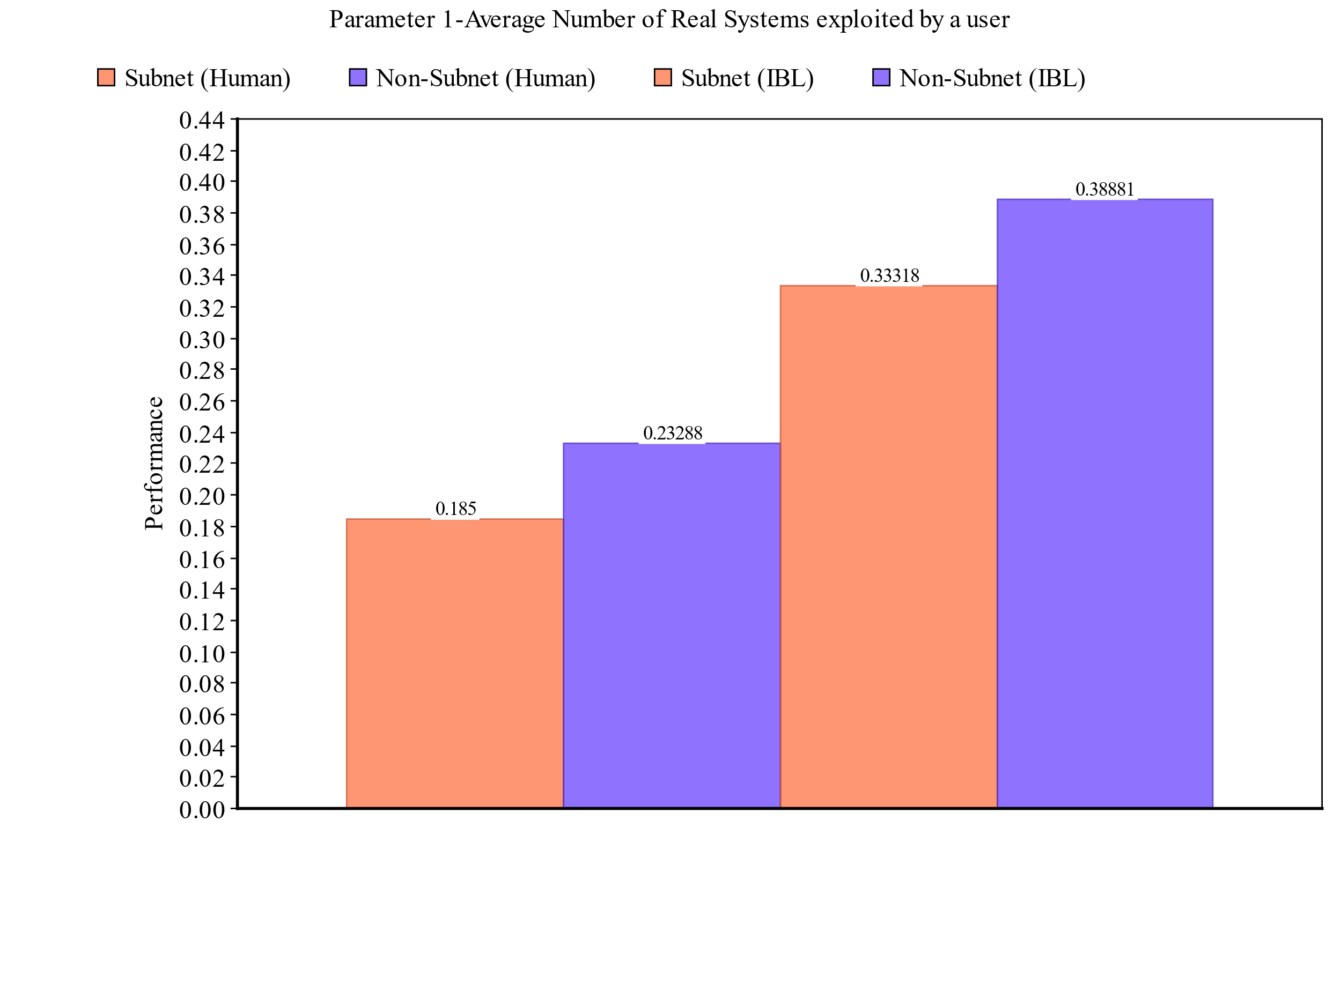

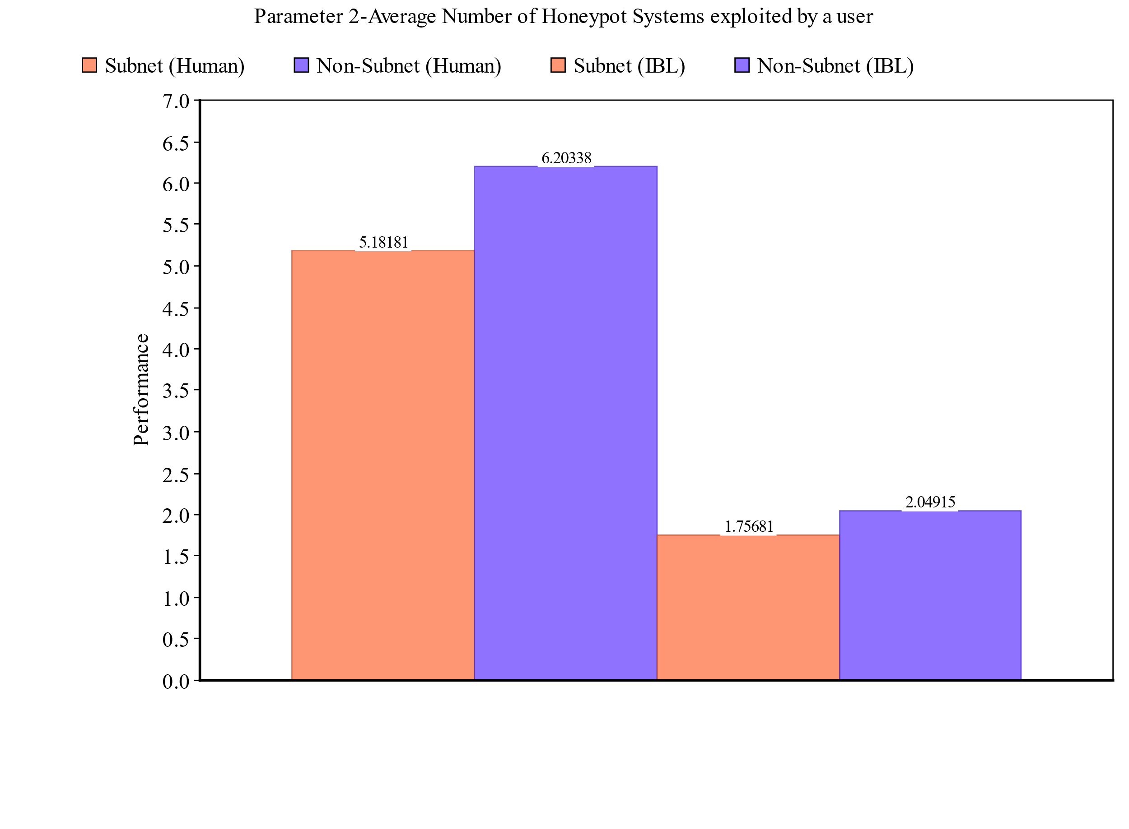

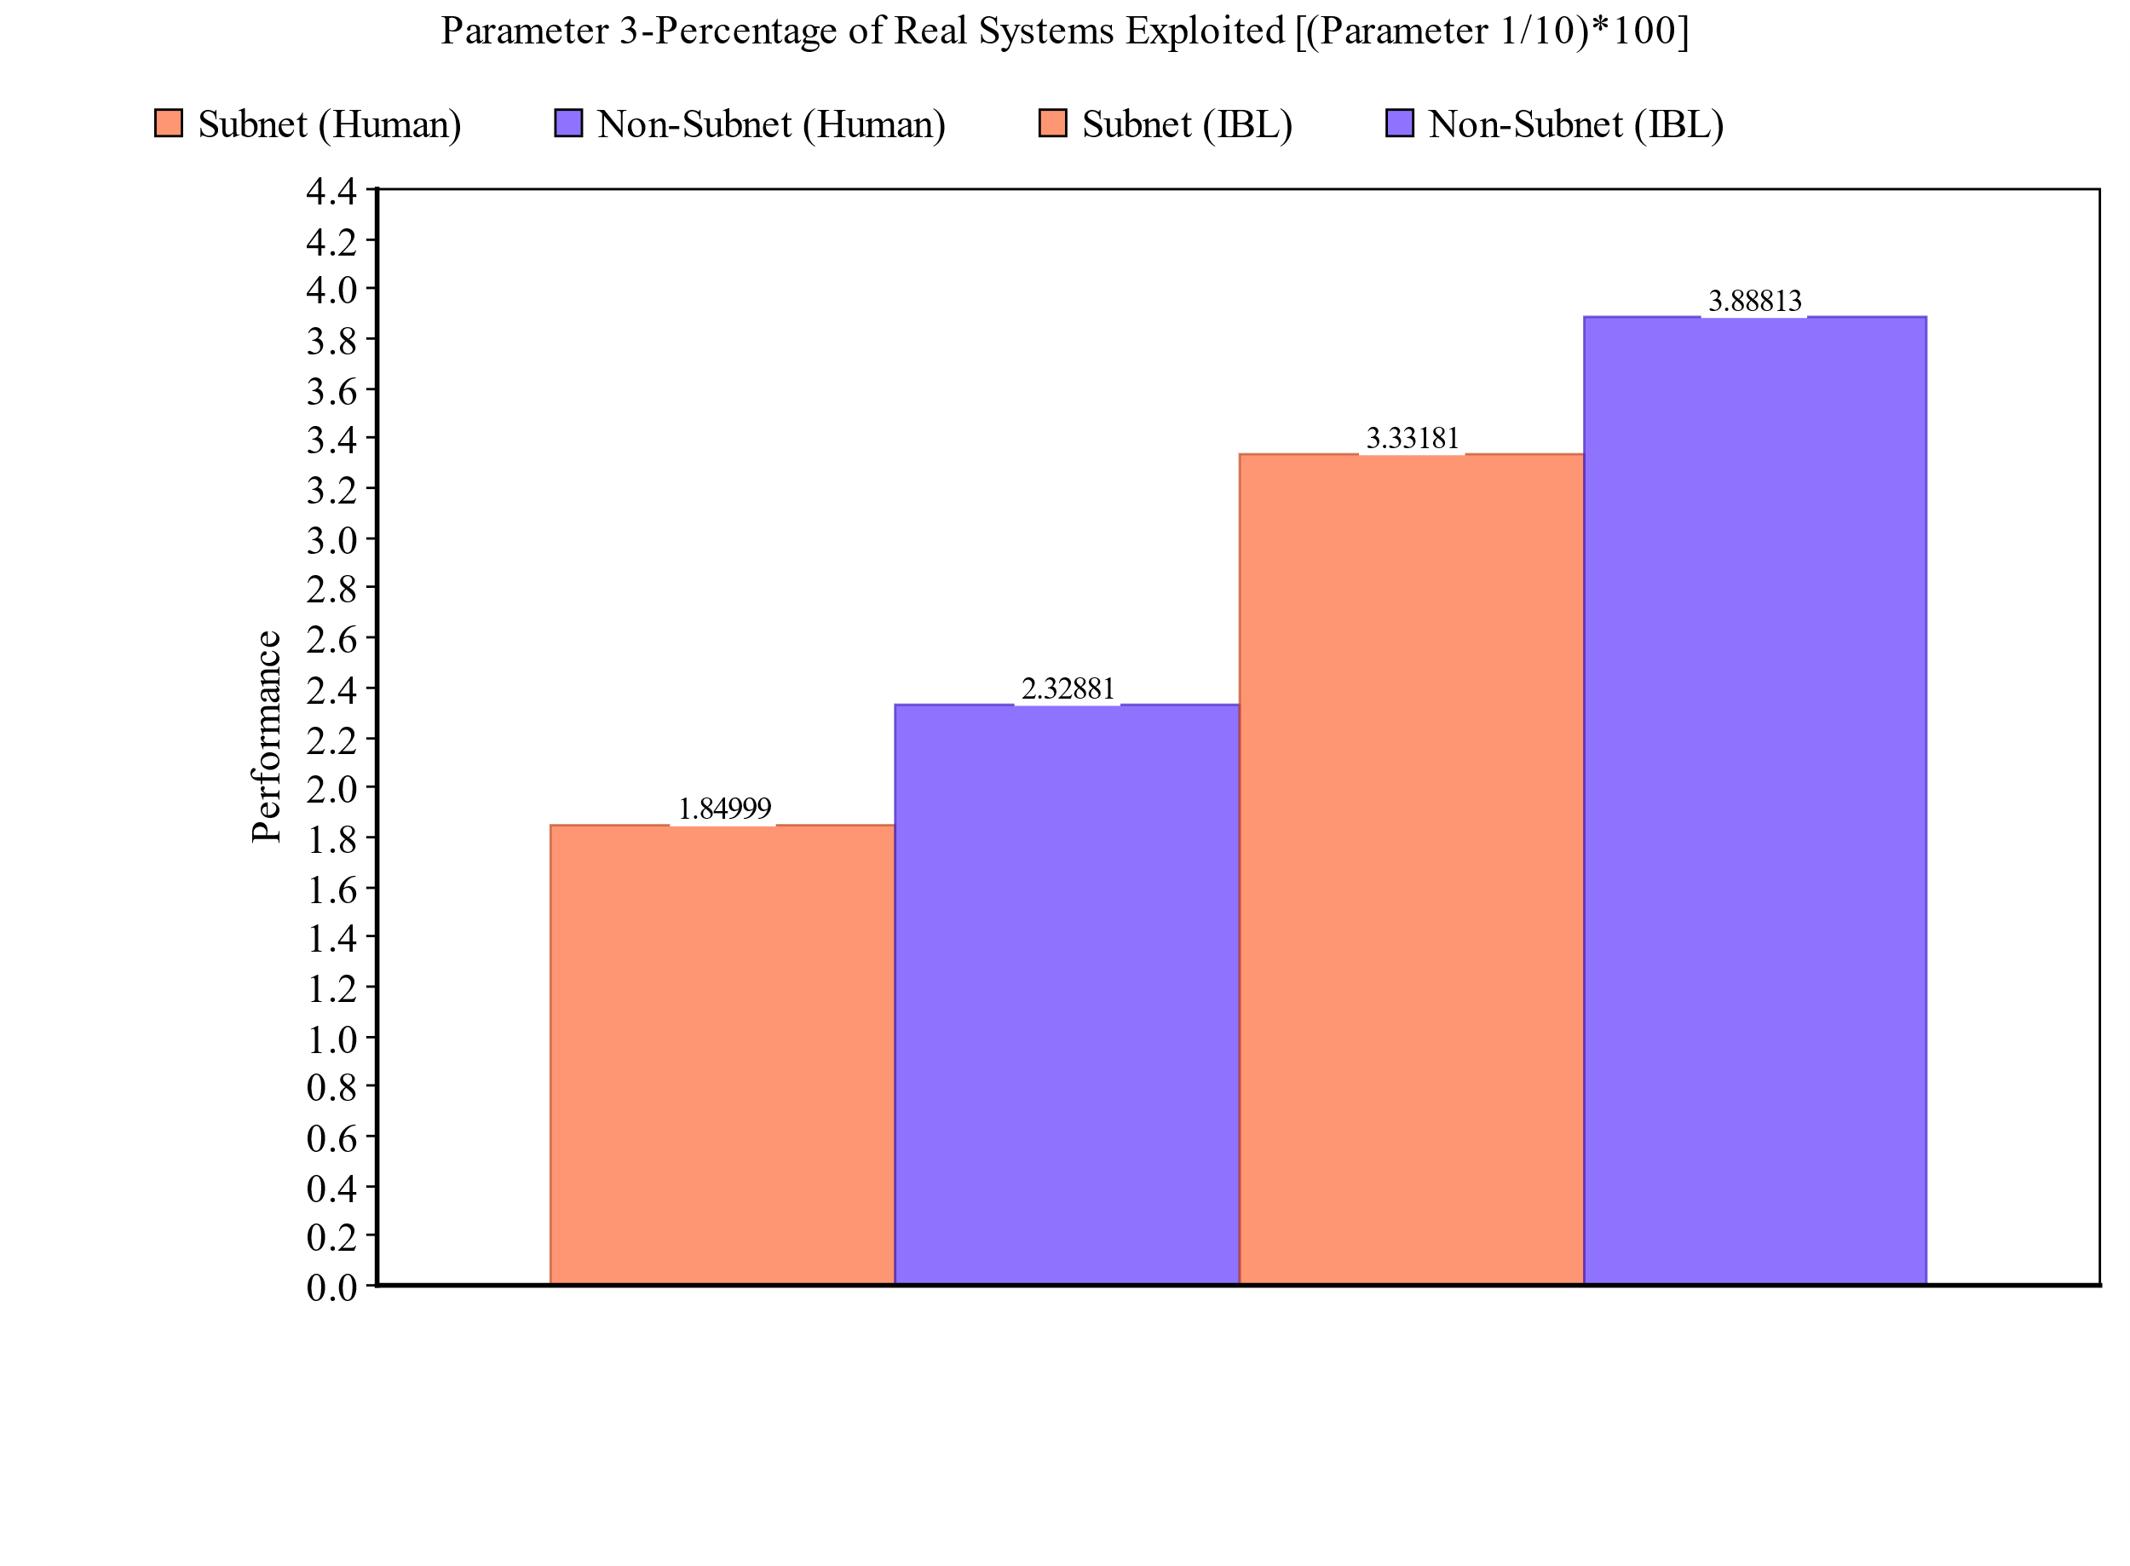

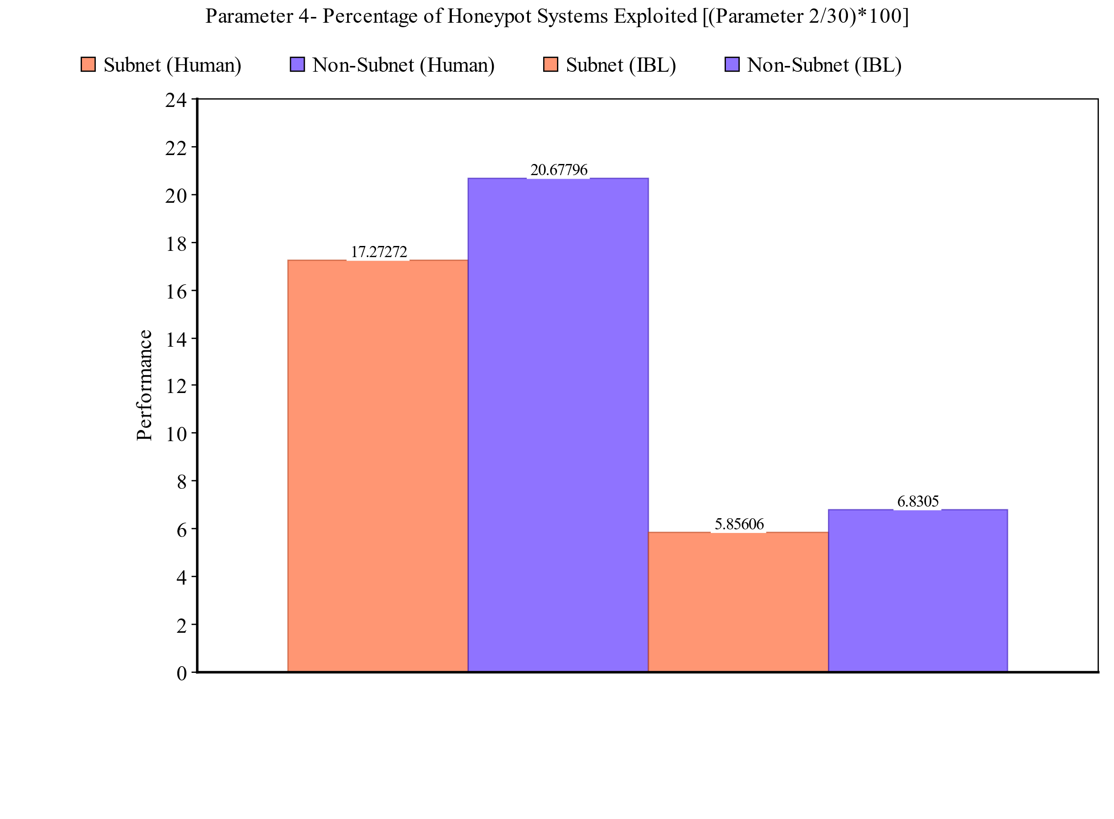

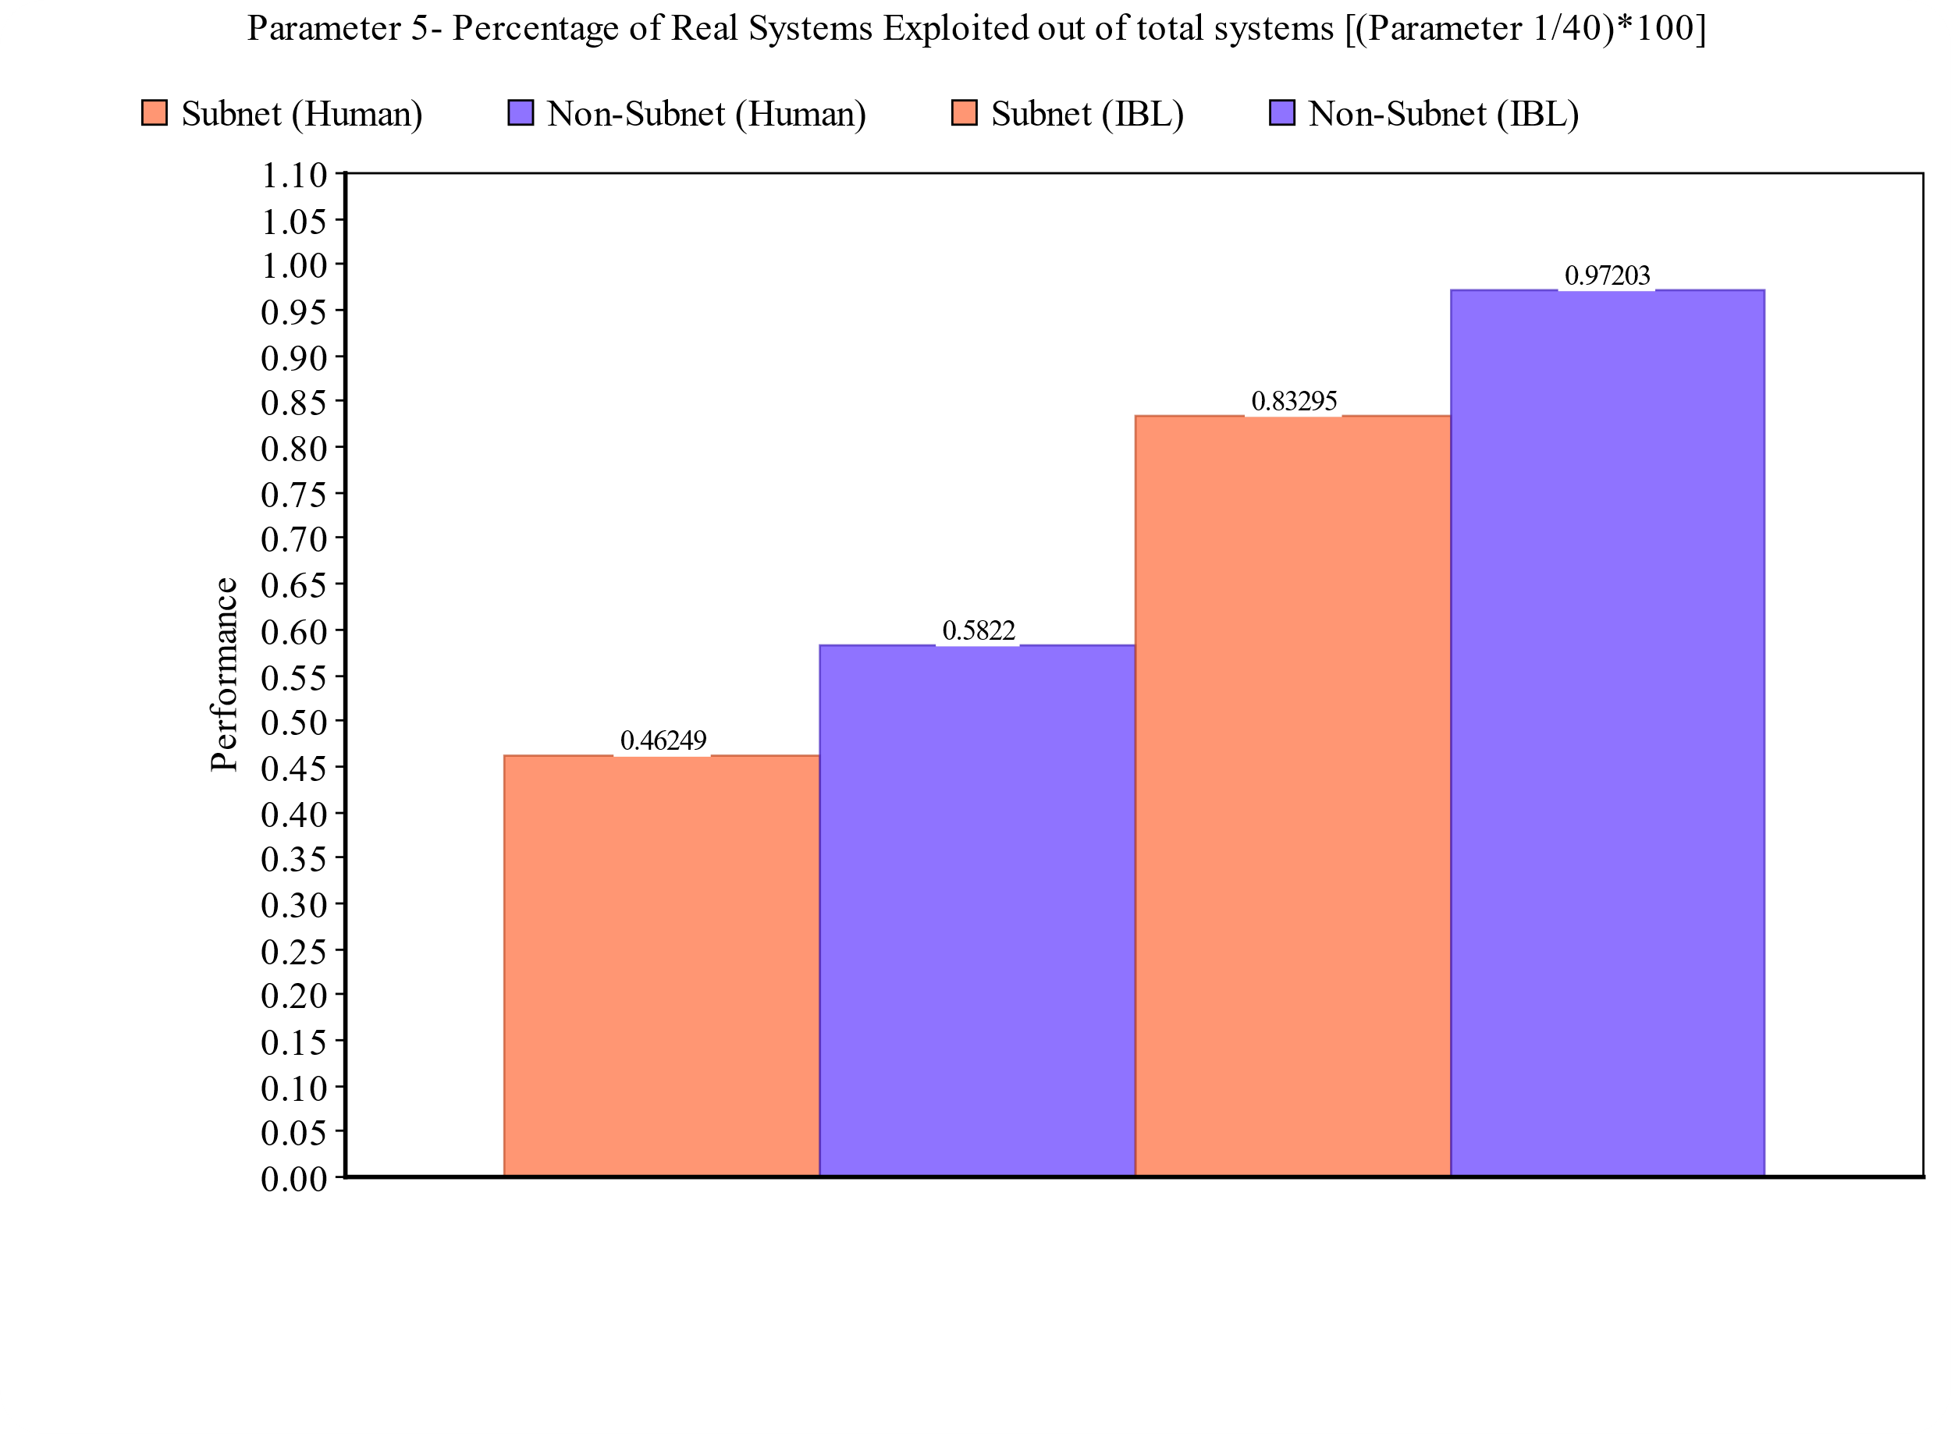

**Results**

1. Performance is increased when the setting is changed from “Subnet” to “Non-Subnet”.
2. IBL theory results in better performance than humans for the final 30% decisions in both “Subnet” and “Non-Subnet” settings.