

B. Tech. Fall Semester 2021-2022

SCHOOL OF COMPUTER SCIENCE ENGINEERING

(SCOPE)

**CUTE FOOD :- “Online Food Ordering System (OFOS)”**

**COURSE: MGT 1027**

**FACULTY: Subhamitra Patra Maam**

**SLOT: B1**

**TEAM MEMBERS:**

**Mahavir lunkad(19bce1774**

**CONTENT TABLE:-**

**• ABSTRACT**

**• INTRODUCTION**

**• OBJECTIVE**

**• LITERATURE SURRVEY**

**• FEASIBILITY STUDY**

**• TECHNOLOGY USED**

**• DESIGN FLOW**

**• IMPLEMENTATION**

**• SCREENSHOT**

**• DISCUSSION**

**• CONCLUSION**

**• REFERENCE**

**ABSTRACT**

This paper proposes an online meal ordering system that streamlines the ordering procedure. The suggested system displays a user interface and updates the menu to include all accessible alternatives, making customer work easier. Customers can place orders for several items and check order details before logging off. The customer receives an order confirmation. The order is queued and updated in the database before being returned in real time. This solution enables employees to review orders in real time and process them efficiently and with little errors. Labor rates are continuously rising year after year, making it tough to hire workers. The food sector is extremely labor-intensive.The cost of hiring the right personnel to execute the job is the highest expense in the food sector. One option to cut costs is to use contemporary technology to automate some of the tasks previously performed by humans. We suggest a "Online Food Ordering System" for fast food restaurants, take-out restaurants, and college cafeterias. The technique can be utilised in any industry that delivers meals. The entire process of taking orders is automated, making meal ordering easier for both the customer and the business.

**1.INTRODUCTION**

The purpose of this project is to develop an Online Food Ordering System. It is a system that enables customer of food to place their order online at any time and any place. The reason to develop the system is due to the issues facing by food industry. These issues are such as peak hour-long queue issues, increase of take away foods than visitors, speed major requisite of food preparation, limited promotion and advertising on current strategy, and quality control of food management issues. Therefore, this system enhances the speed and standardization of taking the order from the customer and displays it to the staff in the kitchen accordingly. Besides that, it provide a user-friendly web pages and effective advertising medium to the new product of the online food restaurant to the customer with cheaper cost.

Furthermore, it extends and delivers client satisfactions, particularly to the busy consumer or to customers who are unable to travel to a restaurant for food. At the same time, enhance the market share of the food restaurant and the investor's return on investment. The Online Food Ordering System was developed using structured approaches.

**2.OBJECTIVE:**

A brand-new free online food ordering system for Restaurants.

This is platform with the following features:

• A login for the customer and admin.

• The customer can order food.

• Tickets are available for conversation and feedback of costumer for admin.

• Admin can able to make food available and unavailable.

• A dashboard for the admin to keep a track on past orders.

• An option to cancel order for customer as well as admin.

• An option to view past orders.

This will ensure social distancing in this pandemic situation and provide a better platform to order

food.

A major advantage of such a platform is that it will make the process of order food easier, more

efficient and safer.

**3. LITERATURE REVIEW**

Various case studies [1–5] have emphasised the difficulties encountered when opening a restaurant. The following are some of the issues discovered during the survey in the existing system:

• To place orders, the customer goes to the restaurant, looks through the menu, and selects the products needed, then places the order and pays. This strategy necessitates the customer's manual labour and time.

• When a customer wants to order over the phone, he or she cannot see a tangible copy of the menu that is available in the restaurant, and there is no way to confirm that the order was placed for the correct menu items.

• Every restaurant requires someone to take the order physically or over the phone, to provide a great experience for the customer, and even to process the order payment.

**4.FEASIBILITY STUDY**

A feasibility study is a simplified version of the System Analysis and Design Process. The investigation begins with a classification of the problem definition. The purpose of feasibility is to see if something is worth trying. The analyst creates a logical model of the system after creating an acceptance problem specification. The hunt for alternatives is thoroughly examined. A feasibility study has three elements.

1) Feasibility of Operation

2) Feasibility of Implementation

3) Financial Possibility

**5.TECHNOLOGY USED**

The technologies which we have used in this project are as follows:

**1.FRONTEND:**

For frontend we have used different technologies which are as follows:

**a. HTML:**

Hypertext Markup Language is the standard markup language for documents designed to be displayed in a web browser. It can be assisted by technologies such as Cascading Style Sheets and scripting languages such as JavaScript.

**b. CSS:**

Cascading Style Sheets is a style sheet language used for describing the presentation of a document written in a markup language like HTML. CSS is a cornerstone technology of the World Wide Web, alongside HTML

and JavaScript.

**c. JAVA SCRIPT:**

JavaScript, often abbreviated as JS, is a programming language that conforms to the ECMAScript specification. JavaScript is high-level, often just-in-time compiled, and multi-paradigm. It has curly-bracket syntax, dynamic typing, prototype-based object-orientation, and first-class functions.

**2.BACKEND:**

For backend the technologies which we have used the languages are mentioned below:

**a. PHP:**

The main backend scripting language will be php. The PHP Hypertext Preprocessor (PHP) is a programming language that allows web developers to create dynamic content that interacts with databases. PHP is basically used for developing web based software applications.

**b. NODE JS**:Node.js is a free, open-sourced, cross-platform JavaScript run-time environment that lets developers write

command line tools and server-side scripts outside of a browser.

**3.DATABASES**:

We will be using 3 databases which are as:

**a. MySQ**L:

MySQL is an open-source relational database management system. Its name is a combination of "My", the name of co-founder Michael Widenius's daughter, and "SQL", the abbreviation for Structured Query

Language.The data in a MySQL database are stored in tables. A table is a collection of related data, and it consists of columns and rows.

**6.DESIGN FLOW AND METHODOLOGY**

The simulation first starts with the customer entering his/her credentials (name, ID and password). Once that has been verified, the customer can place an order specifying the quantity of the food required. Now we get a window that displays the order number, customer ID, food name, price and quantity. Once the customer finalizes his/her order, they are redirected to the payment window where the total price is displayed and the customer can select the payment method of their choice and then the customer gets a message of confirmation of order. The block diagram and the ER Diagram of the proposed Online Food Ordering System is given in Figure 1 (a) and (b). The above mentioned simulation flow is with respect to the customer's point of view. Now if you are an admin, you can select the normal login option and enter the admin credentials (email ID and password). Once you enter the admin portal, you get the option of adding food, deleting food or updating food. Any option of choice leads you to the food menu. Once the selected operation is carried out, the end result, i.e, the added food or the updated food list is displayed and if you have deleted a food, that particular food disappears from the main menu.

Fig. 1 (a) The block diagram of the Online Food Ordering System,

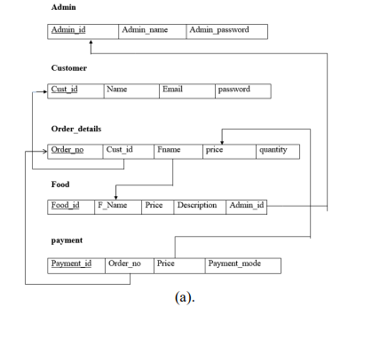

(b) The ER Diagram of the Online Food Ordering System.

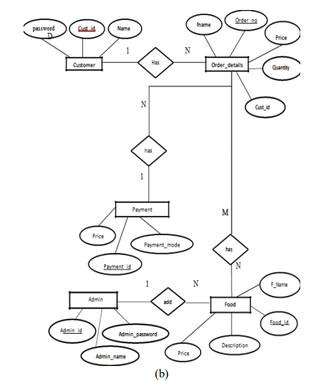

**7.MODULES:-**

In the application there are two main page admin and customer page

Admin :- Admin page is for admin to manage the website like edit menu,verify user,answer of the feedback,and also making system less complex.

Customer:Customer page is for customer to order food make payment and give feedback about the food.

This section presents the identified functional requirements for Online Food Delivery System. There are some general functional requirementsthat need to be overcome. These are:

• A server will host the system and provide system data processing and storage capability.

• A web application shall provide a customer with all customer system functionality. Users of the web ordering system, namely restaurant customers, must be provided the following functionality:

**MODULES A.1**

o Create an account.:- New customer can create their account easily

o Manage their account:- old/new both the customer can manage their account .

o Log in to the system:-people the login directly when account is

created

o Navigate the restaurant’s menu.:- customer can search all the menu

o Select an item from the menu.:- after searching they can select the food they want to eat.

o Customize options for a selected item.Admin can customise the option

o Add an item to their current order.:the item can be added to the cart

o Review their current order.-custimer can review the current order

o Remove an item/remove all items from their current order.-Admin can add and remove the item

o Provide delivery and payment details.-payment option and details are provided in the dashboard

o Place an order.-after selecting order can be placed

o Receive confirmation in the form of an order number.

• The web application will make a customer able to order any type as per their wish and requirements.

• A backend program shall provide a restaurant with all system.

• The backend program enables placing orders and delivery of the product to the customer.

There are some functional customer requirements that need to be overcome. These are:

• A customer shall be able to navigate through the available items in their engaged menu.

• A customer shall be able to remove an item from a pending order.

• A customer shall be able to add an item to an order.

• A customer shall be able to place an order through their engaged menu if it is pending and not empty.

• A customer shall be able to cancel an order through their engaged menu if it is pending and not yet placed.

• Admin can make a food available or not.

• Admin can cancel customer order.

A customer will also be able to choose their payment mode as per their ease of satisfaction.

**8.IMPLEMENTATION**

**CODE :-**

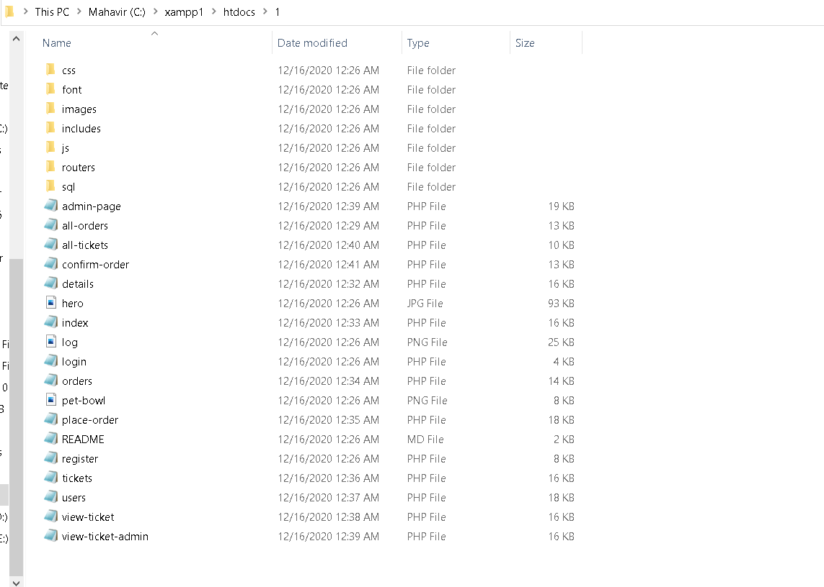

**LINK OF THE CODE :-**

https://drive.google.com/drive/folders/1aDrUKENSQhFQcZDdOdr5MWqU5_fjBu3m?usp=sharing

**9.SCREENSHOT :-**

**CUSTOMER LOGIN PAGE**

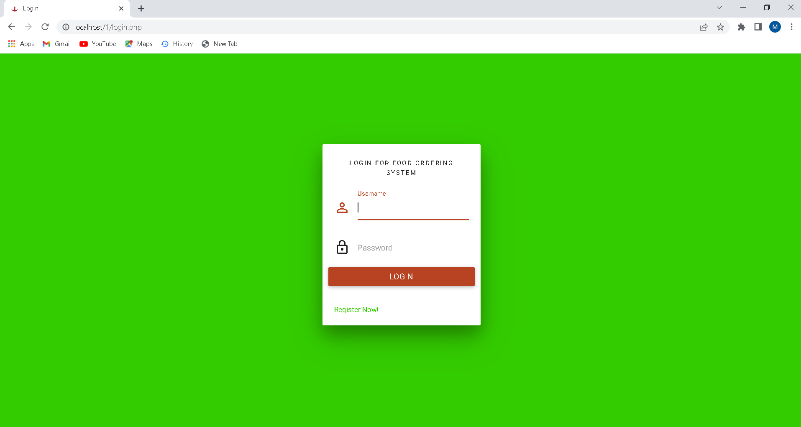

**LOGGING**

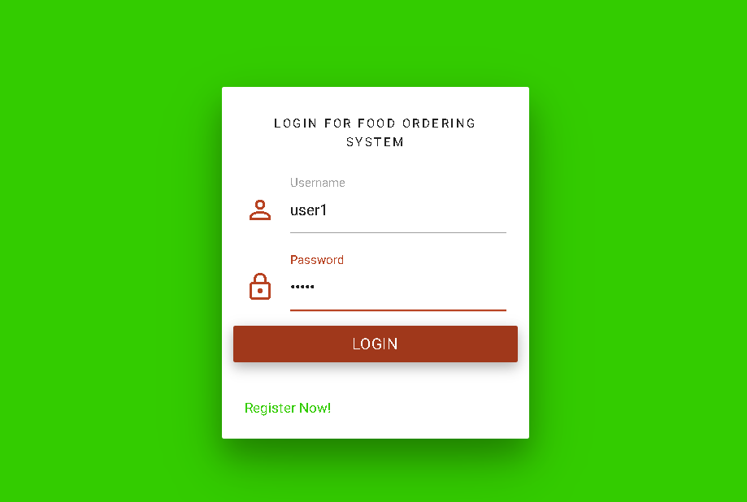

**REGISTERING PAGE**

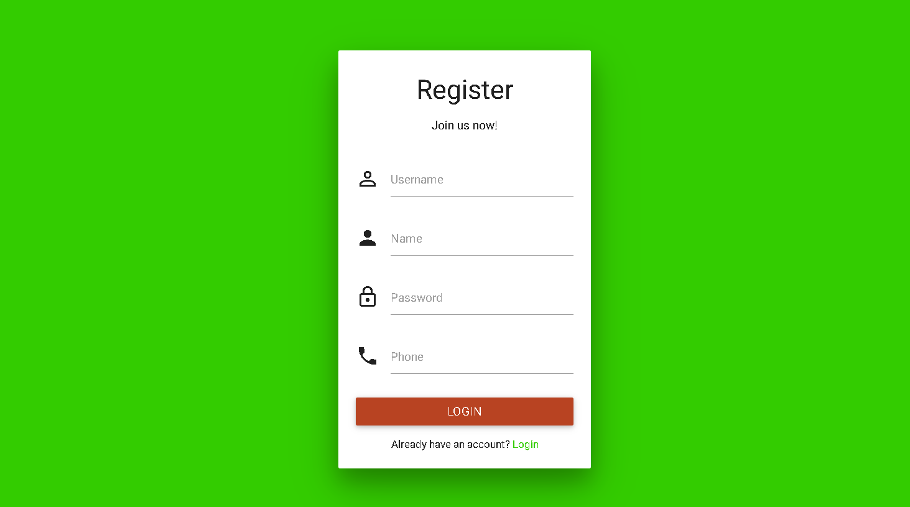

**DASHBOARD FOR CUSTOMER**

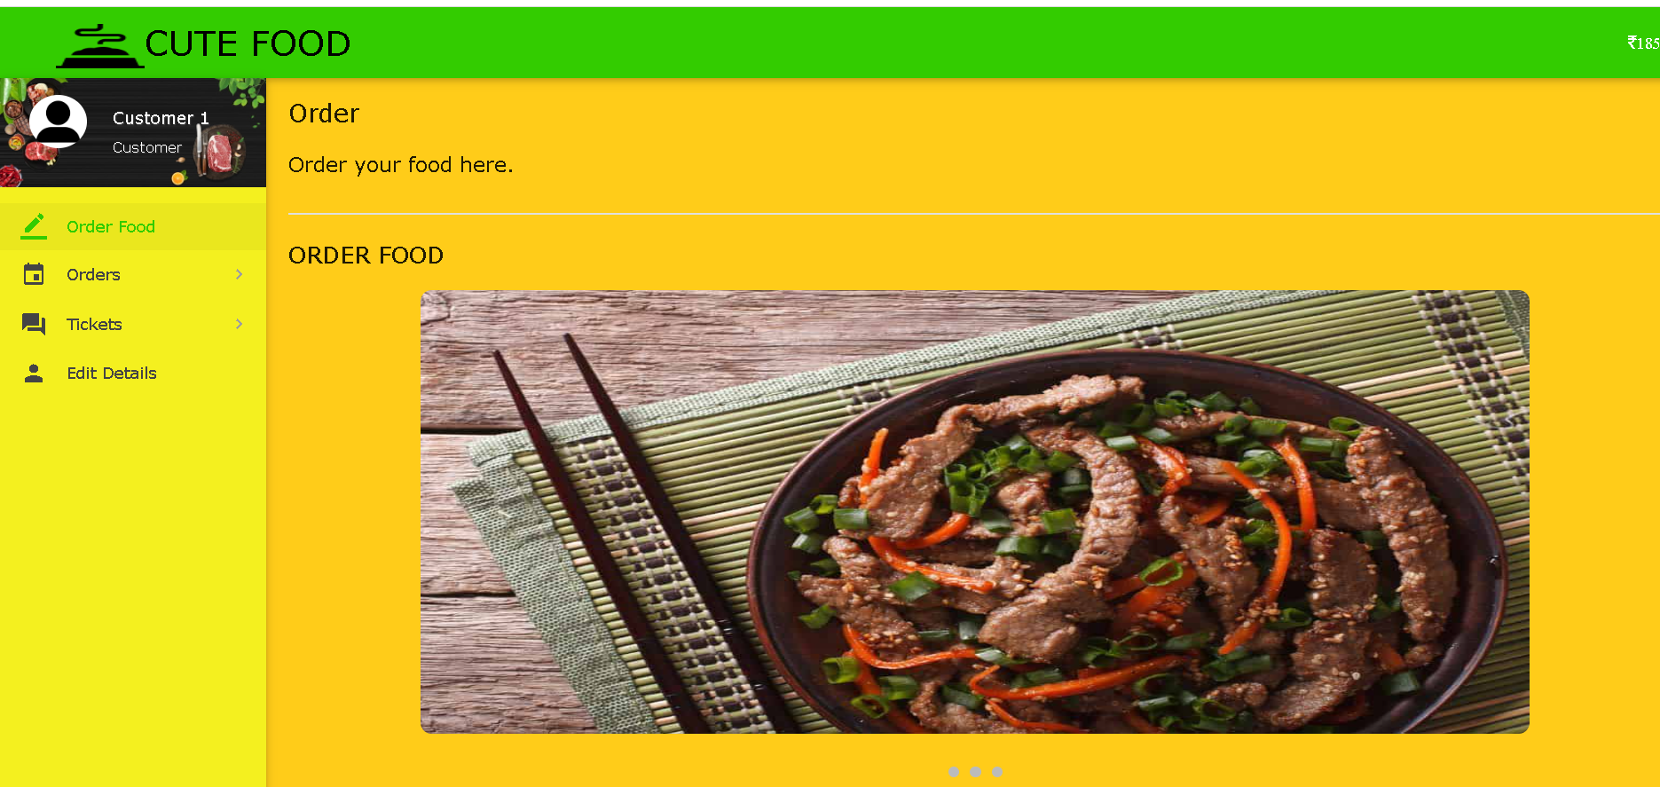

**MENU PAGE FOR CUSTOMER**

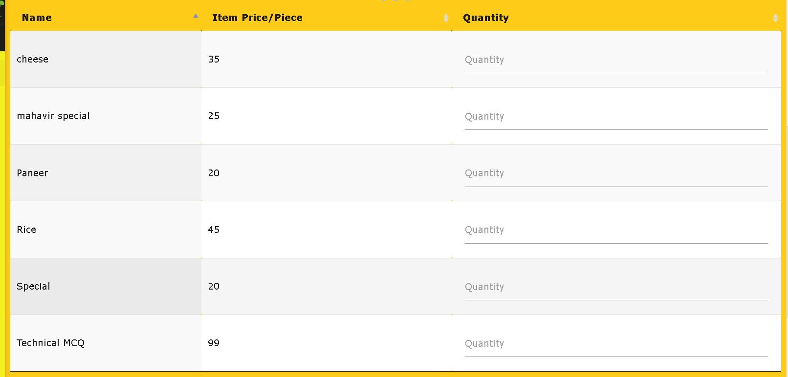

**ORDERING FOOD**

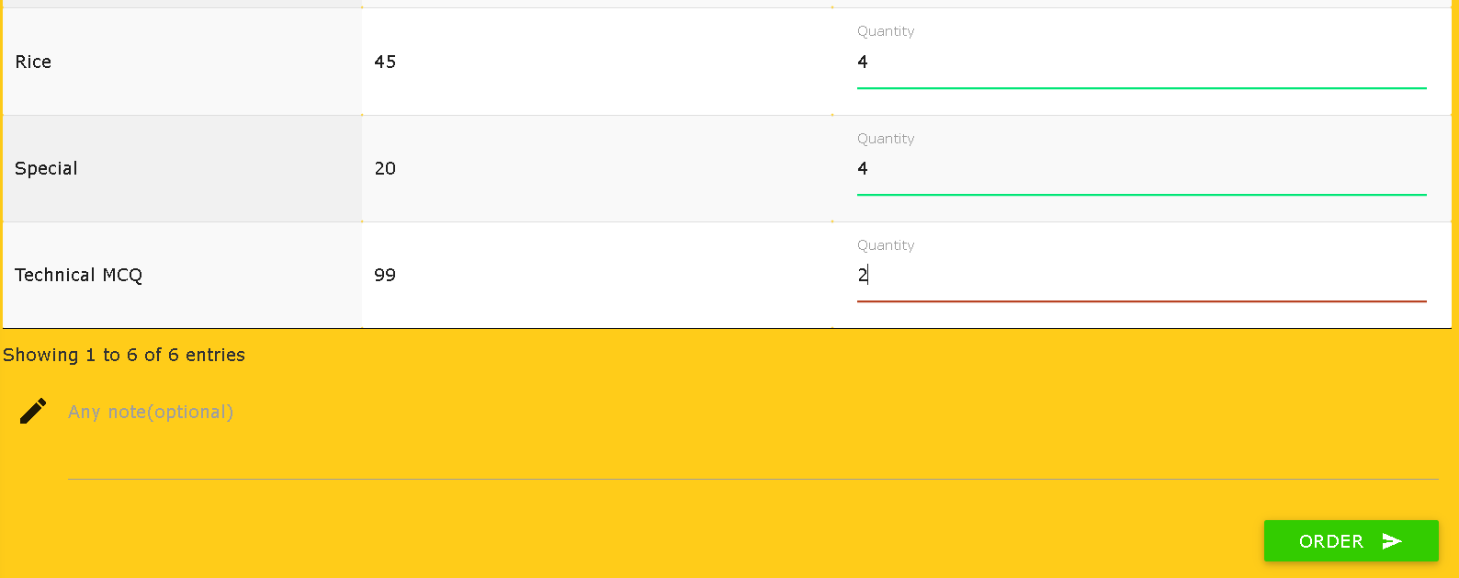

**AFTER ORDERING ADD ADDRESS AND WALLET DETAILS**

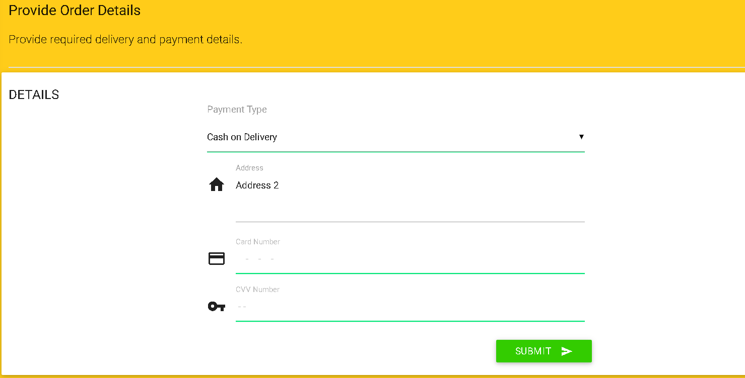

**RECEIPT OF BILL AND ORDER CONFIRMATION**

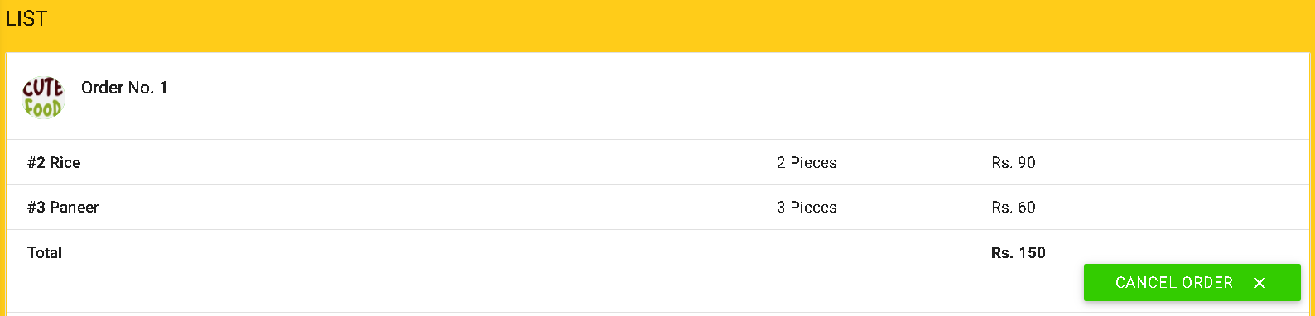

**ALL ORDER PAGES:-**

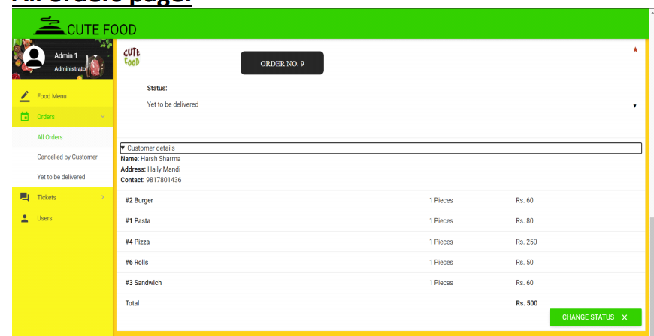

**CONFIRM ORDER PAGE**

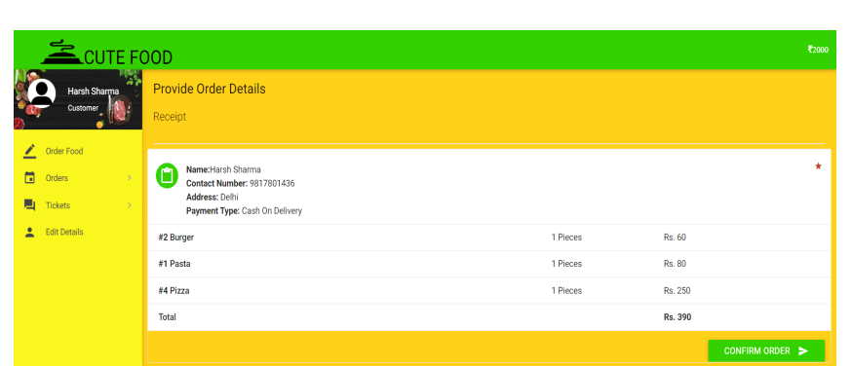

**RECEIPT PAGE :-**

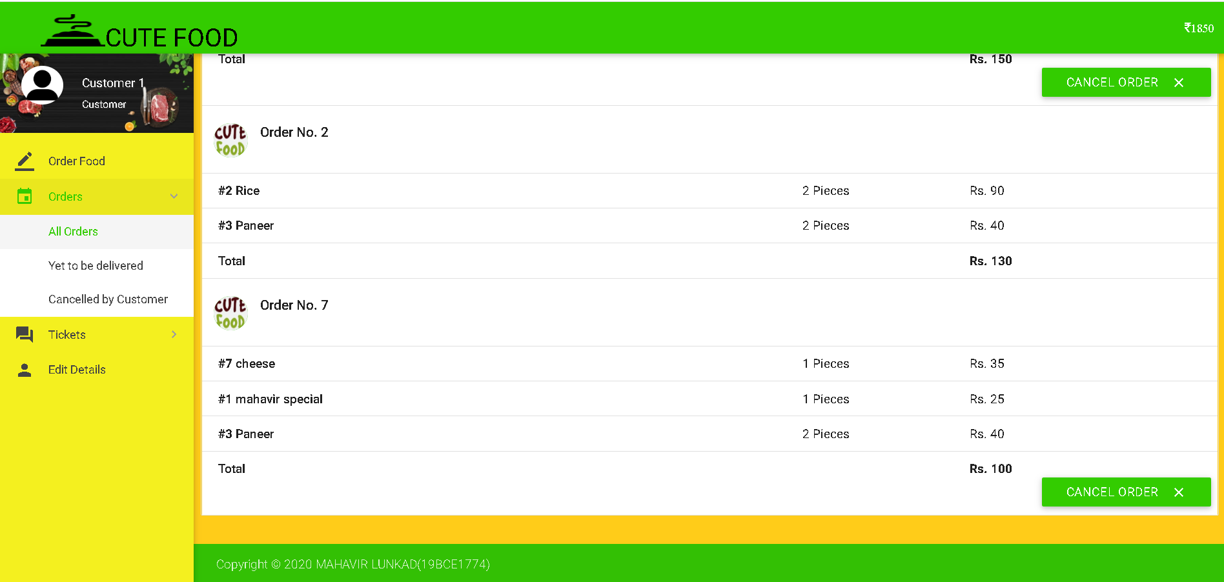

**TICKET PAGE**

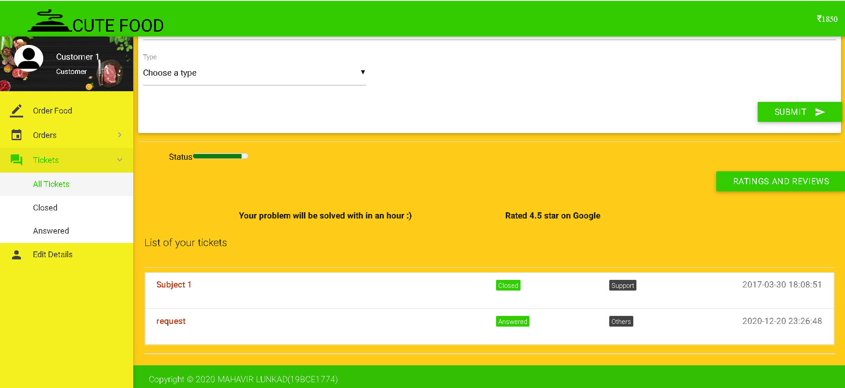

**USER EDIT DETAIL PAGE :-**

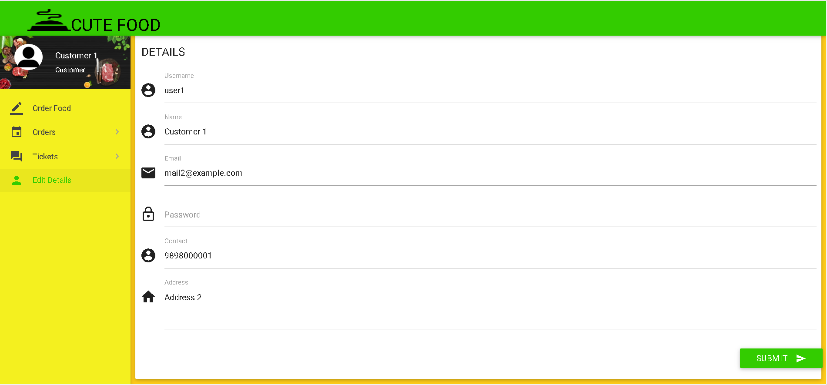

**NOW ADMIN PAGES :-**

**ADMIN DASHBOARD**

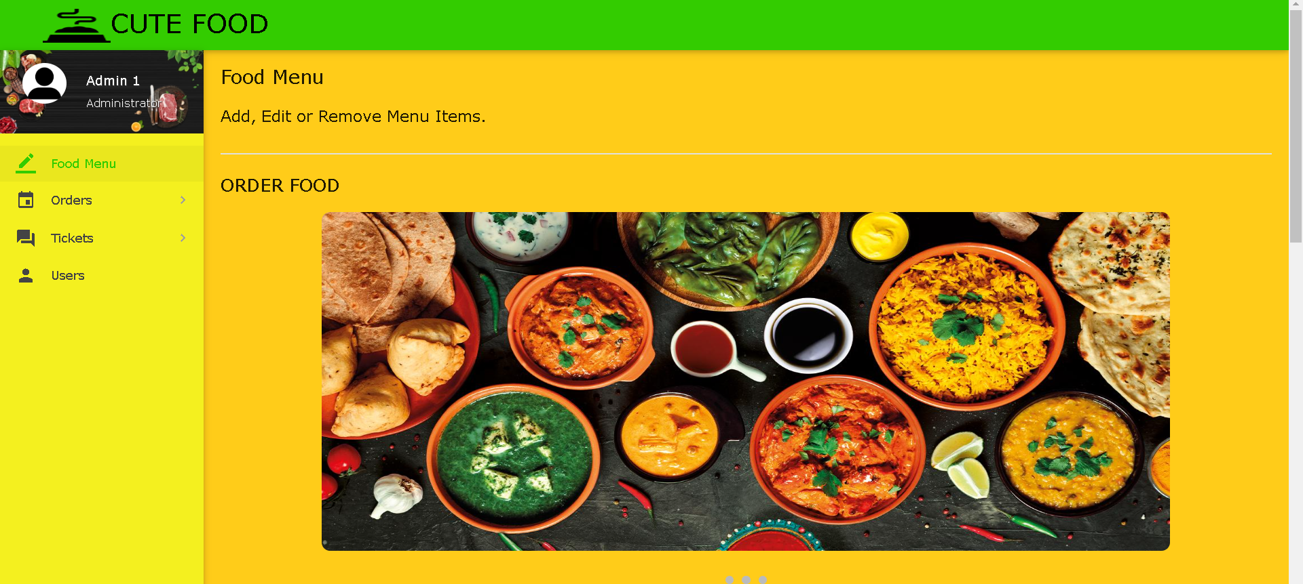

**ADMIN FOOD ITEM EDIT PAGE :-**

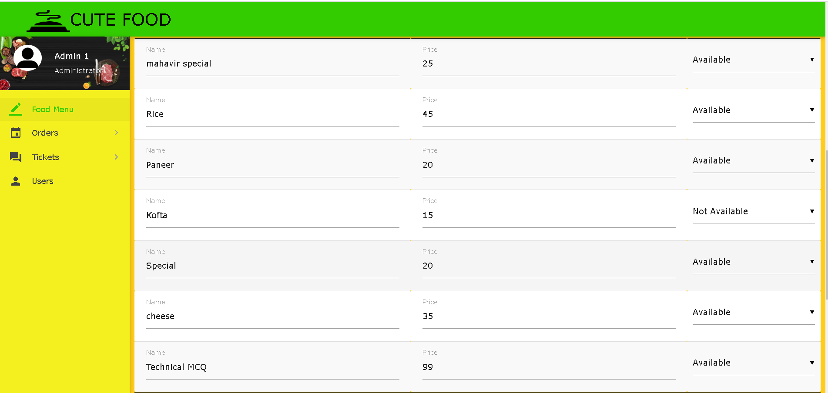

**ADMIN TICKET PAGE :-**

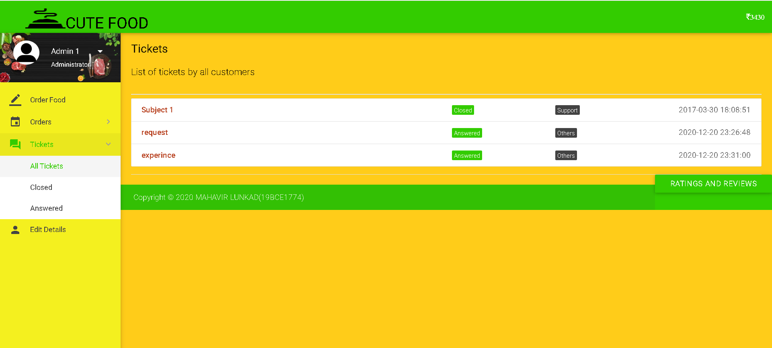

**ADMIN USER EDIT DETAIL FROM HERE ADMIN CAN VERIFY USER**

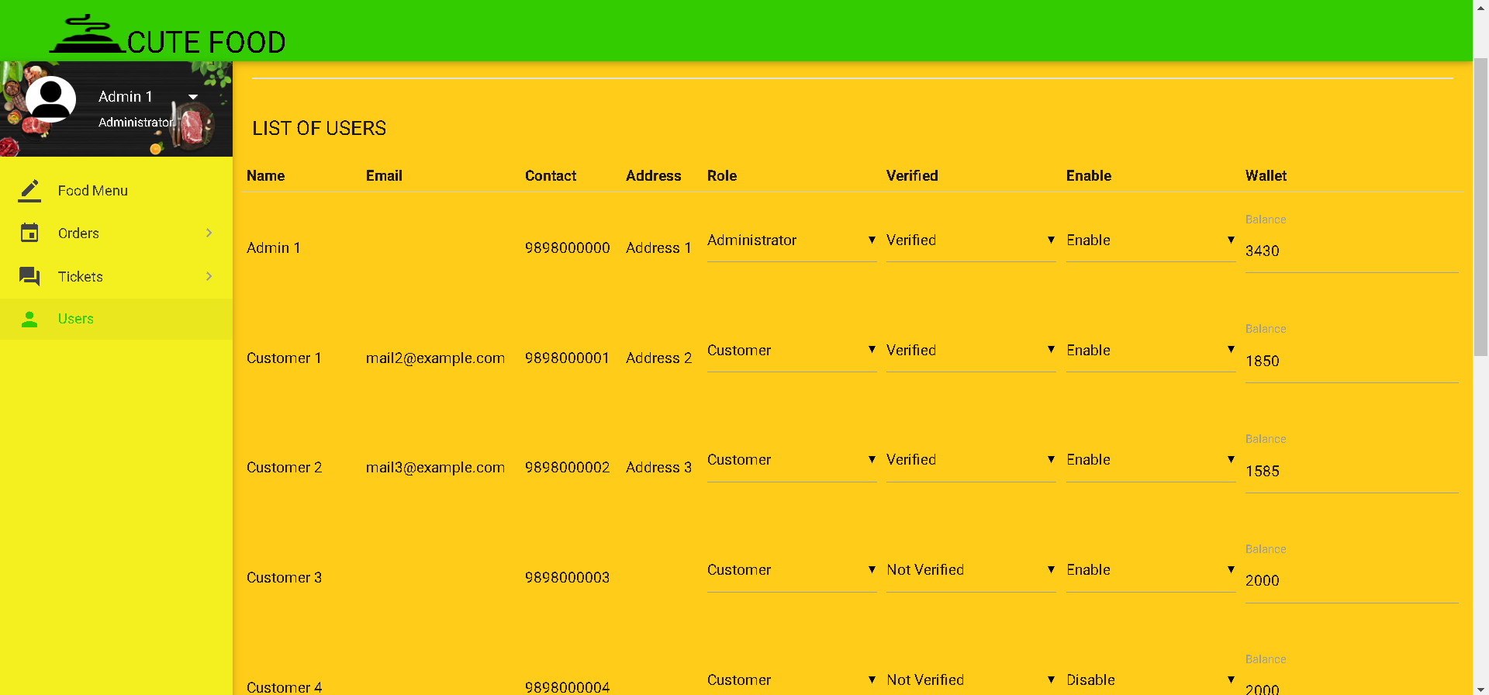

**10.DISCUSSION**

People may effortlessly order food with the help of this technology. It may also ensure that people do not squander their time.valuable time and put it to good use in other ways works. In the long run, this will ensure that it aids in the reduction of pollution. cost of labour This system proves to be more economical. and more dependable than other systems This system is difficult to understand. as compared to other systems in terms of forging or cheating The food was paid for. It is simple to use and has few drawbacks. maintenance. There is no need for human interaction, and

As a result, it can be considered totally automated. There are none.

There are certain limitations to this system, but one must consider them.

Pay attention to the minor details.

**11.CONCLUSION:-**

Customers can place food orders online without of having to wait for a server to accept their order.

End users register online, read the E-menu card, and select food from the E-menu card to order food online using the application. The chef will be able to see the results on the screen and begin processing the food once the customer has selected the appropriate food item. This application eliminates the need for a waiter or decreases the waiter's duty. The advantage is that in a full restaurant, the waiters may become overwhelmed with orders and unable to service the needs of the customers.As a result, consumers can immediately place food orders with the chef through this application.

Finally, an online meal ordering mechanism is suggested.

This is useful in tiny family eateries as well as locations such as college cafeterias. This project can be completed later. enlarged on a grander scale It was created with restaurants in mind. to make ordinary managerial and operational tasks easier for them, and improve the customers' dining experience This is also beneficial. Restaurant owners cultivate a solid client base. By delivering pretty good services, you can build relationships. The method also allows the restaurant to keep track of the items.

available in real time, allowing them to make changes to their diet.

Inventories of beverages based on orders and sales completed orders.

**12.REFERENCE**

1. Awojide, Simon, I. M. Omogbhemhe, O. S. Awe, and T. S. Babatope, “Towards the digitalization of Restaurant Business Process for Food Ordering in Nigeria Private University: The Design Perspective. A Study of Samuel Adegboyega University Edo State Nigeria,” Int. J. Sci. Res. Publ., vol. 8, no. 5, pp. 46–54, 2018.

2. O. I. Mike and A. Simon, “Towards the Digitalization of Hotel Business in Nigeria: The Design Perspective,” vol. 8, no. 2, pp. 1175–1178, 2017.

3. Adithya. R., A. Singh, S. Pathan, and V. Kanade, “Online Food Ordering System,” Int. J. Comput. Appl., vol. 180, no. 6, pp. 22–24, 2017.

4. Varsha Chavan, Priya Jadhav, Snehal Korade, Priyanka Teli, ”Implementing Customizable Online Food Ordering System Using Web Based Application”, International Journal of Innovative Science, Engineering Technology(IJISET) 2015.

5. Patel, Mayurkumar, "Online Food Order System for Restaurants" (2015). Technical Library. Paper 219

6. php code [online] available at www.w3schools.com

7. mysql code [online] available at www.stackoverflow.com