Go to Rahti and start guide tour if you want:
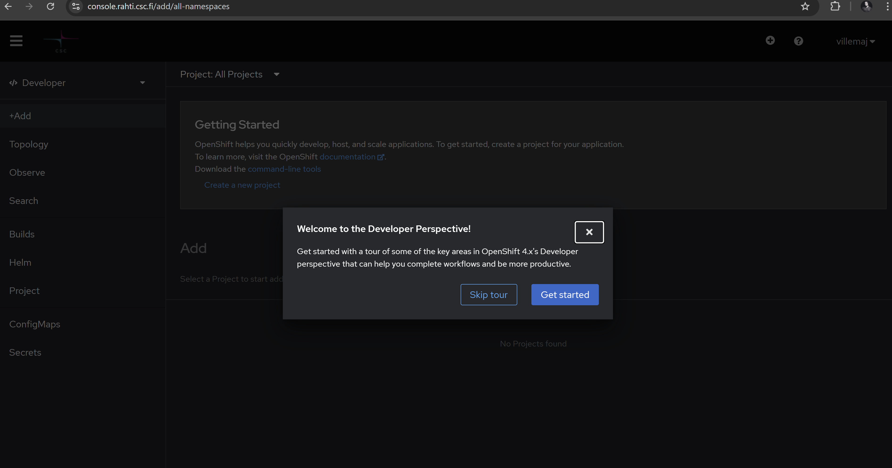
Install OC CLI: https://developers.redhat.com/learn/openshift/download-and-install-red-hat-openshift-cli
Login into Rahti OC:
oc login --web https://api.2.rahti.csc.fi:6443
Or use token:

Check current context
oc whoami
oc project

