

Gaurav Singh

"I've been meaning to tell you how touched I am every time I see you out in the community with your students. You have such a positive impact on the young people who dance alongside you, it's warming to see."



Robert Keosiki

"Mel, thank you so much for being the amazing person you are. You’re always there when your students need you, you’re an inspiration to all of us! I don't know what I would do without you, Melissa Hall and Julie Prévost. "



Dr. R. K. Singh

"Everything about the Melissa Kelly Dance Academy is both educational and fun for my daughters. They improve so much each year and this is evidence of the experienced and dedicated teaching staff. I highly recommend the Melissa Kelly Dance Academy."



Garvita Roy

"Melissa has been great with my daughter and all the children there at the studio. She is very passionate at what she does and portrays it through her classes. My daughter has learned so much from her and has had a very enjoyable experience. She loves the classes!"



Renu Ghosh

"I've been meaning to tell you how touched I am every time I see you out in the community with your students. You have such a positive impact on the young people who dance alongside you, it's warming to see."

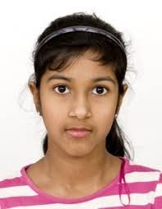

Nimmi Singh

"I've been meaning to tell you how touched I am every time I see you out in the community with your students. You have such a positive impact on the young people who dance alongside you, it's warming to see."