# Department of Computer Applications

# Mini Project Report

# On

# Voting Management System

### Submitted By:

**Mahboob Hasan(200910140032)**



**JSS Academy of Technical Education, NOIDA**

**Dr. APJ Abdul Kalam Technical University, Lucknow, U.P**

**Session 2023-24**

**DECLARATION**

I hereby Declare that the Project Work Entitled "Voting Management System" in partial fulfillment of the need for the reward of the degree of master of computer application, submitted to APJ Abdul kalam Pradesh Technical University Lucknow is the record of an original work by me under the guidance of Shobha G, Head M.C.A. department, JSS Academy of technical education, Noida. Contains no antecedently material printed or written by any other person expect wherever do acknowledgement has been created within the text. The results Embodied in this thesis have not been submitted to any other university or institute for the reward of any degree or diploma.

Signature:

Name: Mahboob Hasan

Roll No: 2200910140032

Date:

Place:

**CERTIFICATE**

This is to certify that project report entitled "Voting Management System" that is submitted by Prashant Singh impartial fulfillment of the necessity for the reward of degree Master of Computer Application of Abdul kalam Technical University, is a record of the candidate's own work disbursed by him under my super intendance. The matter embodied in this project is original and has not been submitted for the reward of other degree.

Date:

Shobha G

Project Guide and Head of Department

**ACKNOWLEDGEMENT**

The satisfaction that accompanies that the successful completion of any task would be incomplete without the mention of people whose ceaseless cooperation made it possible, whose constant guidance and encouragement crown all efforts with success. I am very grateful to my project supervisor Prof, Shoba G for the guidance, inspiration and constructive suggestions that helpful me in the preparation of this project. I won't forget to also mention some sites and Wikipedia pages for their wonderful and skillful guidance in assisting me with the necessary support to ensure that my project is a success. I also thank my parents and family at large for their moral support in the project to ensure successful completion of the project.

Signature:

**ABSTRACT**

The word "vote" means to choose from a list, to elect or to determine. The main goal of voting (in a scenario involving the citizens of a given country) is to come up with leaders of the people's choice, Most countries, India not an exception have problems when it comes to voting. Some of the problems involved include ridging votes during election, Insecure or inaccessible polling stations, inadequate polling materials and also inexperienced personnel. This online voting/polling system seeks to address the above issues. It should be noted that with this system in place, the users, citizens in this case shall be given ample time during the voting period. They shall also be trained on how to vote online before the election time.

**Page Index**

1. INTRODUCTION Topic Page No

1.1 PURPOSE 1

1.2 SCOPE 1

1.3 DEFITIONS, ACRONYMS

AND ABBREVIATIONS 2

2. THE OVERALL DESCRIPTION

2.1 PRODUCT PERSPECTIVE 3

2.1.1 USER INTERFACES 3

2.1.2 HARDWARE INTERFACES 3

2.1.3 SOFTWARE INTERFACES 4

2..1.4 MEMORY CONSTRAINTS 5

2.2 PRODUCT FUNCTIONS 6

2.3 USER CHARACTERISTICS 7

2.4 CONSTRAINTS 7

3. SPECIFIC REQUIREMENTS

3.1 EXTERNAL INTERFACES 8

3.1.1 USER INTERFACE 8

3.1.2 HARDWARE INTERFACE 9

3.1.3 SOFTWARE INTERFACE 9

3.2 SOFTWARE PRODUCT FEATURES 10

3.3 LOGICAL DATABASE REQUIREMENTS 11-12

3.4 SOFTWARE SYSTEM ATTRIBUTES

3.4.1 RELIABILITY 13

3.4.2 AVAILABILITY 14

3.4.3 SECURITY 15-16

3.4.4 MAINTAINABILITY 17-18

3.5 LIST OF DIAGRAMS

3.5.1 DFD 19-21

3.5.2 ER Diagram 22

3.5.3 CLASS DIAGRAM 23-25

4. IMPLEMENTATION RESULTS 26-29

5. Testing 30-31

6. Limitations and Future Enhancements 32-33

7. References 34

**CHAPTER 1**

**INTRODUCTION**

“ONLINE VOTING SYSTEM” is an online voting technique. It is based on the other online services like “ONLINE RESERVATION SYSTEM”. In this system people who have citizenship of INDIA and whose age is above 18 years of any sex can give his\her vote online without going to any polling booth. There is a DATABASE which is maintained by the ELECTION COMMISION OF INDIA in which all the names of voter with complete information is stored.

* 1. **PURPOSE**

In “ONLINE VOTING SYSTEM” a voter can use his\her voting right online without any difficulty. He\She has to fill a registration form to register himself\herself. All the entries is checked by the DATABASE which has already all information about the voter. If all the entries are correct then a USER ID and PASSWORD is given to the voter, by using that ID and PASSWORD he\she can use his\her vote. If conditions are wrong then that entry will be discarded.

* 1. **SCOPE**

The scope of the project that is hosted on the server. There is a DATABASE which is maintained by the ELECTION COMMISION OF INDIA in which all the names of voter with complete information is stored.

* 1. **DEFITIONS, ACRONYMS AND ABBREVIATIONS**

The Voting Management System (VMS) is a comprehensive software application developed in Java to facilitate and streamline the entire electoral process. Here are key definitions, acronyms, and abbreviations integral to its functionality:

**1. VMS: Voting Management System**

- The overarching acronym denoting the software solution that manages voter registration, ballot generation, voting, and result compilation.

**2. IDE: Integrated Development Environment**

- Software tools like NetBeans IDE used for efficient Java programming during the system's development.

**3. DBMS: Database Management System**

- A system facilitating the organized storage, retrieval, and management of voter details, ballots, and election results.

**4. GUI: Graphical User Interface**

- The visual interface allowing users to interact with the VMS, enabling voters to cast ballots and administrators to manage the system.

**5. API: Application Programming Interface**

- Defines the protocols and interactions between different components of the VMS, ensuring seamless communication.

**6. JWT: JSON Web Token**

- A secure authentication mechanism generating digitally signed tokens for authorized access to the VMS.

**7. SQL: Structured Query Language**

- The standard language for managing relational databases, employed for efficient data operations in the VMS.

**8. CRUD: Create, Read, Update, Delete**

- Basic database operations ensuring data integrity and effective management of voter information.

**9. AES: Advanced Encryption Standard**

- A robust symmetric encryption algorithm enhancing the security of sensitive information within the VMS.

**CHAPTER 2**

**THE OVERALL DESCRIPTION**

**2.1 PRODUCT PERSPECTIVE**

The Voting Management System (VMS) operates within a broader product perspective, serving as a pivotal component in the electoral infrastructure. It interfaces with various stakeholders and systems to ensure a comprehensive and seamless electoral process. From a user perspective, the VMS provides an intuitive Graphical User Interface (GUI) for voters to cast their ballots and for administrators to manage the system efficiently. It interacts with a Database Management System (DBMS) to store and retrieve voter information, ballots, and election results securely. Additionally, the VMS may integrate with Optical Character Recognition (OCR) technology for document verification during voter registration. Ensuring compliance with National Institute of Standards and Technology (NIST) guidelines, the VMS contributes to a transparent, secure, and accessible electoral environment, establishing its crucial role in the overall electoral product landscape.

**2.1.1 USER INTERFACES**

The User Interfaces (UI) of the Voting Management System (VMS) are designed to be intuitive and accessible. The VMS features a graphical user interface (GUI) allowing voters to easily cast their ballots, verify their registration status, and view election information. Administrators access a secure dashboard for managing voter registrations, monitoring election progress, and generating comprehensive reports. The UI employs responsive design, ensuring usability across various devices. Elements include interactive forms for voter registration, visually clear ballot displays, and real-time result visualization. User authentication is seamlessly integrated to ensure secure and user-friendly interactions throughout the electoral process.

**2.1.2 HARDWARE INTERFACES**

The hardware interfaces of the Voting Management System (VMS) serve as the bridge between the software and physical components. Key hardware interfaces include:

1. Biometric Devices: Capture and verify voter identity through fingerprint or other biometric data.

2. Card Readers: Authenticate voters using smart cards or ID cards.

3. Printers: Produce physical copies of ballots, receipts, or reports.

4. Barcode Scanners: Read information from printed materials for verification.

5. Touchscreen Kiosks: Enable intuitive voter interaction for casting ballots.

6. Servers: Host the VMS software and manage data storage and processing.

7. Network Devices: Facilitate communication between VMS components and ensure connectivity during elections.

**2.1.3 SOFTWARE INTERFACES**

The Voting Management System (VMS) interfaces with various software components to ensure seamless functionality and communication. These software interfaces play a crucial role in managing different aspects of the electoral process. Here are key software interfaces integrated into the VMS:

**1. Database Interface (DBMS):**

- The VMS interacts with a Database Management System (DBMS) such as MySQL or MongoDB to store, retrieve, and manage voter information, candidate details, and election results.

**2. API (Application Programming Interface):**

- The system employs APIs to establish communication between different modules of the VMS. This includes interfaces for user authentication, ballot generation, and result compilation.

**3. Java EE (Enterprise Edition):**

- The VMS utilizes Java EE for building scalable and enterprise-level applications. It incorporates features like Servlets and JSP for server-side processing and dynamic content generation.

**4. Web Services:**

- SOAP (Simple Object Access Protocol) or RESTful web services are implemented for communication between the VMS and external systems, facilitating data exchange and interoperability.

**5. Security Libraries:**

- Integration with security libraries like Bouncy Castle or Java Cryptography Architecture (JCA) ensures robust encryption and secure communication protocols to safeguard sensitive data.

**6. External Authentication Systems:**

- Interfaces with external authentication systems, such as LDAP (Lightweight Directory Access Protocol) or OAuth, for secure user authentication and authorization.

**7. External Notification Services:**

- Interfaces with external notification services, like SMTP for email notifications or SMS gateways, to inform users about important updates, election schedules, or results.

**8. Logging and Monitoring Tools:**

- Integration with logging tools such as Log4j or monitoring solutions for tracking system activities, identifying issues, and ensuring accountability.

**9. PDF Generation Libraries:**

- Utilizes libraries like Apache PDFBox for generating PDF reports, enabling the creation of comprehensive election reports and result documents.

**10. Frontend Frameworks (React, Angular, or Vue):**

- Implements frontend frameworks to build responsive and interactive user interfaces, allowing voters and administrators to interact seamlessly with the VMS.

**2.1.4 MEMORY CONSTRAINTS**

The Voting Management System (VMS) may face memory constraints based on factors like the scale of the election, the number of registered voters, and data storage requirements. Limited memory may impact the system's ability to efficiently handle concurrent user interactions, process large datasets, and perform real-time computations during the voting process. To address memory constraints, optimization strategies such as efficient database indexing, data compression techniques, and the use of caching mechanisms should be implemented. Additionally, periodic maintenance and data purging may be necessary to prevent memory overload and ensure smooth operation of the VMS.

**2.2 PRODUCT FUNCTIONS**

The Voting Management System (VMS) is designed to execute a range of crucial functions aimed at efficiently managing electoral processes. These product functions are integral to ensuring a seamless, secure, and transparent voting experience for both administrators and voters.

**1. Voter Registration:**

- Enables the registration of eligible voters, capturing and storing their personal details securely in the system.

**2. Ballot Generation:**

- Creates electronic or paper-based ballots representing candidates and issues, ensuring accuracy and clarity.

**3. User Authentication:**

- Implements secure authentication mechanisms to verify the identity of users, preventing unauthorized access to the system.

**4. Vote Casting:**

- Provides a user-friendly interface for voters to cast their votes securely and intuitively.

**5. Vote Counting:**

- Automates the tallying and aggregation of votes, ensuring accurate and efficient determination of election results.

**6. Result Generation:**

- Generates comprehensive and transparent reports, displaying the final results of the election for public scrutiny.

**7. Security Measures:**

- Implements robust security features, including encryption and secure communication protocols, to safeguard the integrity and confidentiality of the voting process.

**8. Database Management:**

- Manages voter information, ballots, and election results in a structured database, ensuring efficient data retrieval and storage.

These product functions collectively contribute to the effectiveness and reliability of the Voting Management System, fostering democratic processes by ensuring fair, secure, and transparent elections.

**2.3 USER CHARACTERISTICS**

User characteristics play a crucial role in shaping the design and functionality of a Voting Management System (VMS). The system caters to a diverse user base, including administrators, election officials, and voters.

**1. Administrators:**

- These users require comprehensive control over the VMS, managing tasks such as user registration, candidate nomination, and result publication. The interface should provide robust security features to safeguard sensitive data.

**2. Election Officials:**

- Responsible for overseeing the election process, election officials need access to real-time data, analytics, and tools for monitoring voter turnout and addressing issues promptly. The system should support efficient collaboration and communication among officials.

**3. Voters:**

- The system should be user-friendly for voters, accommodating individuals with varying levels of technical proficiency. Accessibility features are crucial to ensure inclusivity, allowing all eligible voters to participate easily and securely.

**4. Data Entry Personnel:**

- Individuals responsible for entering and updating voter information. The system should streamline data entry tasks to minimize errors and enhance efficiency.

**2.4 CONSTRAINTS**

The development and implementation of a Voting Management System (VMS) can face various constraints that may impact its functionality, efficiency, and overall success. Here are some common constraints associated with a Voting Management System:

1. Legal and Regulatory Constraints.

2. Security and Privacy Constraints.

3. Budgetary Constraints.

4. Technological Constraints.

5. User Accessibility Constraints.

6. Network Connectivity Constraints.

7. Scalability Constraints.

**CHAPTER 3**

**SPECIFIC REQUIREMENTS**

**3.1 EXTERNAL INTERFACES**

External interfaces of a Voting Management System (VMS) refer to the points of interaction between the system and external entities, including users, hardware, and other systems. Here are key external interfaces typically associated with a VMS:

**1. User Interfaces (UI):**

- Voter Interface: The UI through which eligible voters interact with the system to register, verify their identity, cast votes, and view election results.

- Administrator Interface: A specialized UI for election administrators to manage voter registrations, candidate details, monitor the voting process, and generate reports.

**2. Hardware Interfaces:**

- Biometric Devices: Interfaces with fingerprint scanners or other biometric devices for secure voter authentication during registration and voting.

- Barcode/QR Code Scanners: Used for scanning voter IDs or ballot codes for quick and accurate data entry.

- Printers: Interfaces for generating paper ballots, receipts, or reports.

**3. Network Interfaces:**

- Internet: The VMS may require internet connectivity for online voter registration, result dissemination, and communication between multiple instances of the system.

- Intranet: For internal communication within the election management organization.

**4. External Database Interfaces:**

- Voter Database: Interaction with external databases containing voter information, ensuring synchronization and verification during registration.

- Candidate Database: Accessing external databases containing details of candidates participating in the election.

**3.1.1 USER INTERFACE**

The User Interface (UI) of the Voting Management System (VMS) is designed to be intuitive, user-friendly, and accessible. Voters experience a seamless process for registration, candidate selection, and vote casting through a visually appealing and responsive GUI. Administrators benefit from a well-organized dashboard, facilitating easy management of voter databases, ballot configurations, and result tracking. Clear navigation, informative prompts, and interactive elements ensure a positive user experience. The UI prioritizes simplicity while incorporating advanced features, contributing to efficient electoral management and fostering user confidence in the VMS.

**3.1.2 HARDWARE INTERFACE**

The hardware interface of the Voting Management System (VMS) serves as the bridge between the software application and the physical components. It includes devices such as biometric scanners, card readers, and voting machines. The VMS hardware interface ensures seamless interaction, allowing voters to authenticate their identity, cast votes, and facilitates the integration of peripheral devices. Robust hardware interfaces are essential for the secure and accurate functioning of the VMS, ensuring that the software effectively communicates with the associated hardware components, guaranteeing a smooth and reliable electoral process.

**3.1.3 SOFTWARE INTERFACES**

The software interface of the Voting Management System (VMS) is an intuitive and user-friendly Graphical User Interface (GUI) developed in Java. It allows both voters and administrators to interact seamlessly with the system. Voters can easily navigate through the ballot, cast their votes, and receive confirmation. Administrators have access to a comprehensive dashboard for managing voter registrations, monitoring voting activities, and generating election results. The GUI employs a responsive design, ensuring accessibility across devices. It incorporates elements such as dropdown menus, buttons, and visually organized information, providing a smooth and efficient experience for all users involved in the electoral process.

**3.2 SOFTWARE PRODUCT FEATURES**

The Voting Management System (VMS) is a software product designed to manage the entire electoral process efficiently. Below are key software product features commonly found in a Voting Management System:

**1. Voter Registration:**

- Capture and store voter information, including personal details and identification documents, in a secure database.

**2. Ballot Generation:**

- Create electronic or paper-based ballots that accurately represent the available choices for voters during an election.

**3. User Authentication:**

- Implement secure authentication mechanisms to verify the identity of users, ensuring authorized access to the system.

**4. Graphical User Interface (GUI):**

- Provide an intuitive and user-friendly interface for both voters and administrators to interact with the system.

**5. Candidate Management:**

- Enable the addition, modification, and removal of candidates for different positions in an election.

**6. Vote Casting:**

- Allow voters to cast their votes securely, either electronically or through a traditional paper-based system.

**7. Security Measures:**

- Implement encryption, secure communication protocols, and access controls to protect the integrity and confidentiality of the voting process.

**8. Audit Trail:**

- Maintain a comprehensive record of all activities within the system, promoting transparency and accountability.

**9. Results Compilation:**

- Automatically tally and aggregate votes to generate accurate and timely election results.

**3.3 LOGICAL DATABASE REQUIREMENTS**

The logical database requirements for a Voting Management System (VMS) involve defining the structure and relationships within the database to support the functionalities of the system. Here are key logical database requirements for a VMS:

**1. Voter Information:**

- Store voter details such as name, address, date of birth, and identification information.

- Maintain a unique identifier for each voter to ensure data integrity.

**2. User Authentication:**

- Store login credentials securely, including usernames and hashed passwords.

- Implement tables to manage roles and permissions for different user types (e.g., administrators, election officials).

**3. Election Configuration:**

- Define tables to store information about elections, including election dates, types of elections, and associated parameters.

- Specify tables for political parties, candidates, and their affiliations.

**4. Ballot Management:**

- Design tables to represent the structure of the ballot, including contests, candidates, and voting options.

- Establish relationships to link ballots to specific elections and voter groups.

**5. Vote Casting:**

- Implement tables to record each vote cast, associating it with the voter, the chosen candidates, and the election.

- Ensure data integrity by enforcing constraints to prevent multiple votes from the same voter.

**6. Result Calculation:**

- Define tables and queries to calculate and store election results based on the votes cast.

- Implement mechanisms to handle different types of voting systems (e.g., first-past-the-post, proportional representation).

**7. Audit Trail:**

- Include tables to record audit trail information, logging all significant actions within the system.

- Capture details such as user login/logout, vote submissions, and system configuration changes.

**8. Security Measures:**

- Implement tables to manage security-related information, including tokens for user authentication and authorization.

- Ensure encryption of sensitive data, such as voter identification details.

**9. Historical Data:**

- Include tables to maintain historical data, allowing tracking of changes in voter information over time.

- Preserve historical election results for auditing and analysis purposes.

**10. Database Indexing:**

- Apply indexing to improve query performance, especially for frequently accessed tables and columns.

- Optimize the database schema for efficient data retrieval and manipulation.

**11. Normalization:**

- Normalize the database schema to eliminate redundancy and ensure consistency.

- Use techniques like normalization to organize data into well-structured tables, reducing data anomalies.

**3.4 SOFTWARE SYSTEM ATTRIBUTES**

Software system attributes are characteristics or qualities that define the overall behavior and performance of a system. For a voting management system, various attributes contribute to its effectiveness and user satisfaction. Here are some key software system attributes for a voting management system

**3.4.1 RELIABILITY**

Reliability is a crucial software system attribute that ensures the consistent and trustworthy performance of the application. For a voting management system, reliability is essential to maintain user trust and satisfaction. Here are some key considerations related to the reliability of a voting management system:

**1. Data Integrity:**

- Implement measures to ensure the integrity of voting and user data. This includes proper validation of data inputs, data encryption, and backup mechanisms.

**2. Fault Tolerance:**

- Design the system to be resilient to faults and failures. This could involve redundancy in servers, load balancing, and failover mechanisms to ensure continuous operation.

**3. Error Handling:**

- Implement robust error-handling mechanisms to gracefully manage unexpected errors or exceptions.

- Provide informative error messages for users and log detailed error information for system administrators.

**4. Monitoring and Logging:**

- Implement monitoring tools to track system performance, resource usage, and potential issues.

- Set up detailed logging to capture information about user interactions, system events, and errors for analysis.

**5. User Feedback and Support:**

- Establish channels for users to report issues and provide feedback.

- Have a responsive support system in place to address user concerns promptly.

By focusing on these reliability considerations, a voting management system can deliver a stable and dependable experience for users, minimizing disruptions and instilling confidence in the application's performance. Regular monitoring, testing, and proactive maintenance contribute to the overall reliability of the system.

**3.4.2 AVAILABILITY**

The availability of a voting management system refers to its ability to be consistently accessible and operational for users. Ensuring high availability is crucial for providing a seamless and reliable user experience. Here are some considerations related to the availability of a voting management system:

**1. Uptime:**

- Define and maintain a high level of uptime, indicating the percentage of time the system is operational and accessible to users.

- Implement monitoring tools to track system uptime and quickly identify and address any downtime issues.

**2. Redundancy and Failover:**

- Design the system with redundancy to eliminate single points of failure.

- Implement failover mechanisms to automatically switch to backup servers or components in case of system failures.

**4. Backup and Disaster Recovery:**

- Regularly back up the database and system configuration to prevent data loss.

- Establish a comprehensive disaster recovery plan to quickly recover from unexpected events.

**5. High-Availability Database:**

- Implement a high-availability database configuration with features like replication and failover.

- Ensure data consistency across database replicas.

**6. Response Time Optimization:**

- Optimize system response times to ensure quick access to votings and data.

- Identify and address performance bottlenecks to maintain a responsive user interface.

By addressing these considerations, a voting management system can achieve and maintain high availability, ensuring that users can access and use the system reliably and efficiently.

**3.4.3 SECURITY**

Ensuring the security of a Voting Management System (VMS) developed in Java is crucial to maintain the integrity of the electoral process and protect sensitive voter information. Here are key security considerations for a Java-based VMS:

**1. Authentication and Authorization:**

- Implement strong user authentication mechanisms, including secure password storage and multi-factor authentication (MFA).

- Use role-based access control (RBAC) to enforce appropriate permissions for different user roles (e.g., administrators, election officials).

**2. Secure Communication:**

- Employ HTTPS/SSL/TLS to encrypt data transmitted between clients and the server, preventing eavesdropping and man-in-the-middle attacks.

- Implement secure communication protocols for API endpoints and database connections.

**3. Data Encryption:**

- Encrypt sensitive data, such as voter identification details and election results, both during transmission and storage.

- Use industry-standard encryption algorithms like AES for data protection.

**4. Secure Coding Practices:**

- Adhere to secure coding practices to prevent common vulnerabilities such as SQL injection, cross-site scripting (XSS), and cross-site request forgery (CSRF).

- Regularly update third-party libraries and dependencies to patch known vulnerabilities.

**5. Database Security:**

- Apply the principle of least privilege to database access, ensuring that database users have only the necessary permissions.

- Regularly audit and monitor database access to detect and respond to suspicious activities.

**6. Audit Trail:**

- Implement an audit trail to log significant events, such as user logins, votes cast, and configuration changes.

- Regularly review audit logs to identify and investigate security incidents.

**7. Voter Privacy:**

- Implement measures to ensure the secrecy of votes, preventing unauthorized access to individual voting choices.

- Use techniques like blind signatures or cryptographic protocols to protect voter anonymity.

**8. Input Validation:**

- Validate and sanitize all user inputs to prevent injection attacks and ensure the integrity of data.

- Implement server-side validation and client-side validation to provide an additional layer of security.

**9. Secure Session Management:**

- Use secure session management practices to prevent session hijacking and ensure that session tokens are securely transmitted and stored.

- Implement session timeouts to automatically log out inactive users.

**10. Firewall and Intrusion Detection:**

- Deploy firewalls to restrict unauthorized access to the system.

- Implement intrusion detection and prevention systems to detect and respond to potential security threats.

By implementing these security measures, a Java-based Voting Management System can significantly enhance its resilience against potential threats and vulnerabilities, safeguarding the integrity of the electoral process and protecting voter information.

**3.4.4 MAINTAINABILITY**

Maintaining a Voting Management System (VMS) developed in Java involves ensuring that the system remains adaptable, scalable, and easily modifiable over time. Code modularization and clear documentation facilitate future updates and enhancements. Regular code reviews and adherence to coding standards contribute to maintainability. Employing design patterns and a well-structured architecture promotes code readability and simplifies troubleshooting. Continuous monitoring for performance issues and bug tracking ensures swift resolution. Implementation of version control systems, such as Git, aids in managing code changes systematically. Training and knowledge transfer among development teams further support system maintainability. Overall, a proactive approach to software maintenance, combined with collaborative development practices, enhances the VMS's ability to evolve and meet changing requirements efficiently.

**3.4.5 PORTABILITY**

The portability of a Voting Management System (VMS) developed in Java refers to its ability to run on different platforms and environments without requiring significant modifications. Java, with its "Write Once, Run Anywhere" (WORA) philosophy, facilitates portability through the use of the Java Virtual Machine (JVM). Here are aspects of portability in a Java-based VMS:

**1. Java Virtual Machine (JVM):**

- Java applications, including the VMS, are compiled into bytecode that runs on the JVM. As long as the target environment has a compatible JVM, the application can run seamlessly, promoting cross-platform compatibility.

**2. Operating System Independence:**

- The VMS, being developed in Java, is inherently independent of the underlying operating system. Whether it's Windows, Linux, macOS, or others, the Java application can operate consistently across these platforms.

**3. Hardware Independence:**

- Java's portability extends to various hardware architectures. As long as there is a compatible JVM for a specific hardware platform, the VMS can be deployed without modification.

**4. NetBeans IDE:**

- The use of NetBeans IDE for Java development contributes to portability. Developers using NetBeans can create and manage Java applications on different operating systems, enhancing the collaborative development process.

**5. Jar (Java Archive) Files:**

- The VMS can be packaged into a Java Archive (JAR) file, encapsulating all the necessary components. This JAR file can be easily distributed and executed on any system with a Java Runtime Environment (JRE).

**6. Dependency Management:**

- Java applications typically manage dependencies through tools like Maven or Gradle. This allows for easy inclusion of libraries and ensures that required dependencies are available on different platforms.

**7. Web-Based Architecture:**

- If the VMS has a web-based architecture, it can be accessed through a web browser, further enhancing its portability. Users can interact with the system using a standard web browser regardless of the underlying operating system.

**8. Cross-Browser Compatibility:**

- A Java-based VMS, especially if it involves web-based components, can leverage cross-browser compatibility, allowing users to access and use the system on different web browsers.

**9. Platform-Independent Deployment:**

- With Java Web Start or containerization technologies like Docker, the VMS can be deployed in a platform-independent manner, reducing deployment complexities across diverse environments.

**10. Java Standardization:**

- Java follows established standards, and the language specifications are maintained by organizations like the Java Community Process (JCP). This contributes to the consistency and predictability of Java applications across various platforms.

Ensuring that the Voting Management System adheres to Java best practices, utilizes platform-independent libraries, and is well-packaged for distribution contributes to its high level of portability, making it adaptable to different environments and scenarios.

**3.5 LIST OF DIAGRAMS**

**3.5.1 DFD**

User or Administrator

Output

System

**DFD Level-0**

The above diagram is a 0-level DFD that only shows the flow of data between the various and the system. In online voting system the Administrator is the controller of the system and all the decisions are made by him. The Administrator can handle the entire voter and their details, voting details etc. and view details of them and he can update that detail also.

Login

Process

Voting

Process

Voter information checking process

Voter

Registration

Process

Final

Report

**DFD Level 1**

The above shown diagram is a 1-level Data Flow Diagram for the Online voting system. According to this DFD various process are done after login process. The Administrator can register voter. The ELECTION COMMISION can register the voters and voter can use their voting rights. The voter can view the final report after giving vote.

Administrator

Voter

Final

Result

Voting process

Voter Registration

Information checking

administrators

Login Process

Login

voter data stored data voting data final result

Election Commission

**DFD: Level 2.1**

The above shown diagram is a 2.1 level Data Flow Diagram for the Online voting system. According to this DFD. The Administrator can register the voter information. Administrator can allow or denies the voter. A voter can give vote if all the information filled by him\her are correct.

**3.5.2 Entity Relationship Diagram**

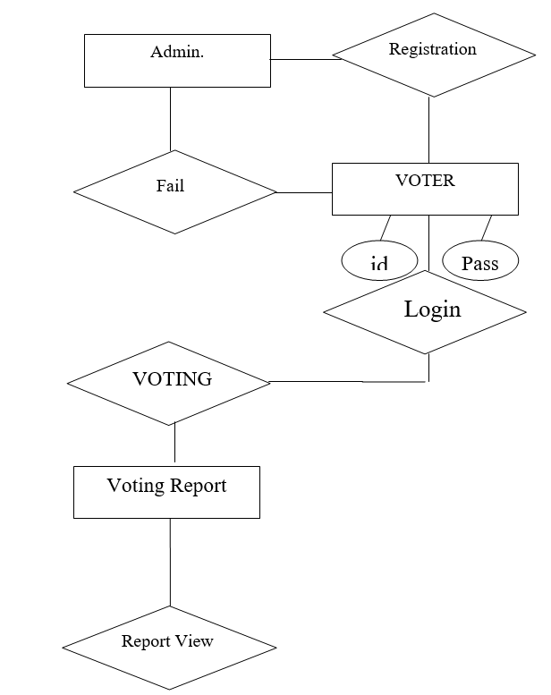

**Fig.- E-R Diagram**

The entity relationship diagram shows the relationship between the various users and their attributes. There is a relationship between the election commission and voter.

The VOTER has different attributes to store their data to data base are follows:-

1. Name-Name contain first name, middle name, last name.

2. Age (should be above 18 years)

3. City

4. State

5. Father’s/Husband Name

6. Address

7. Phone number (Permanent)

8. Phone number (Mobile)

9. Email address

**3.5.3 Class diagram**



***Fig: Relationship between the interface Actor List and its inheriting class***



***Fig: Association between Actor interface and other inheriting classes***

***Registration, login, and logoff modules act as mediator.***



***Fig: Association between Registration, Actor List, Login, Logoff***



***Fig: Association between Election and Ballot (Flyweight, Singleton)***

**CHAPTER 4**

**IMPLEMENTATION RESULTS**

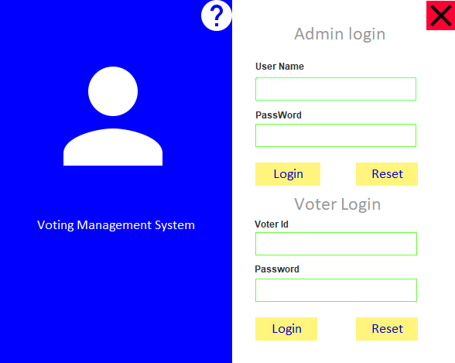

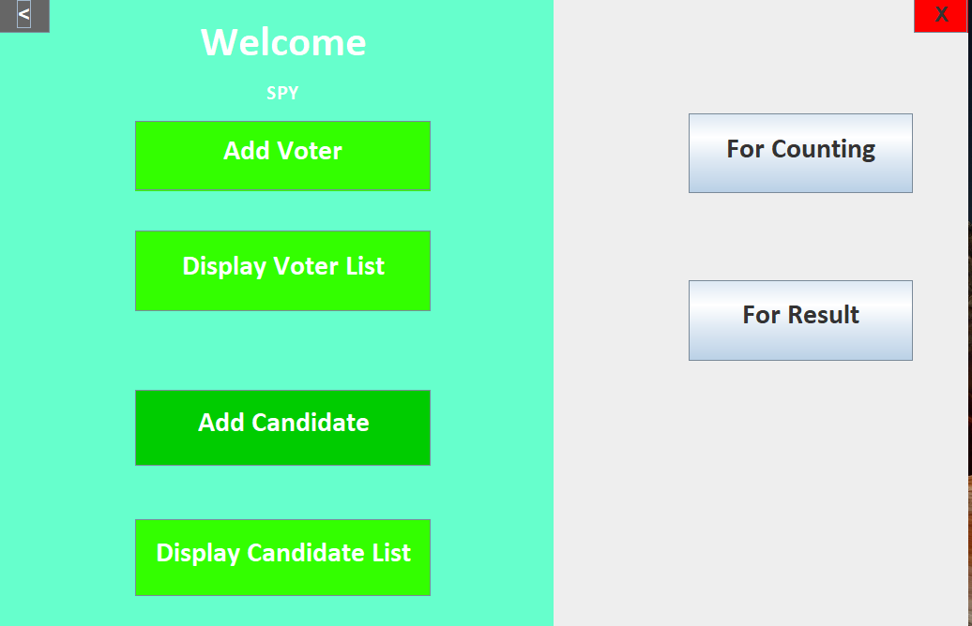

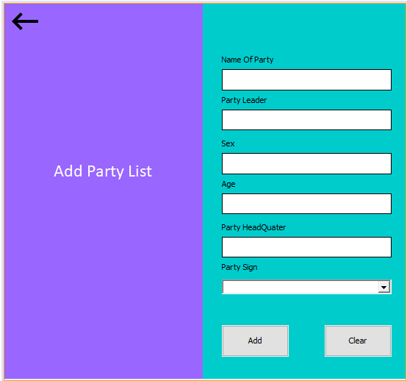

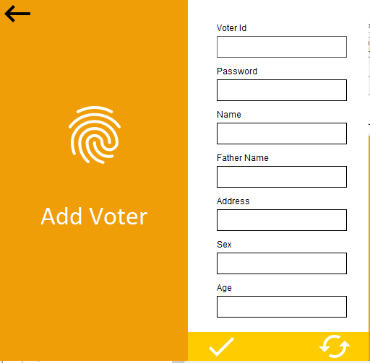

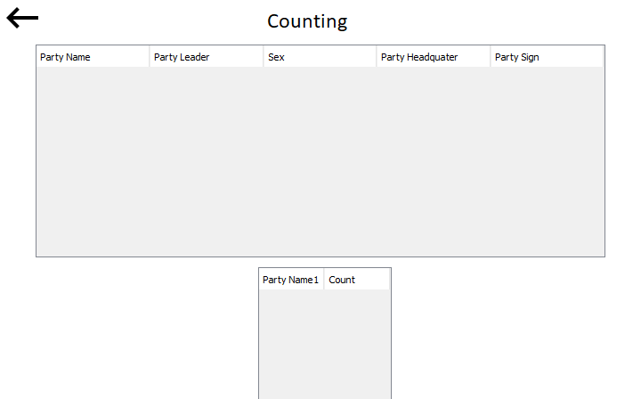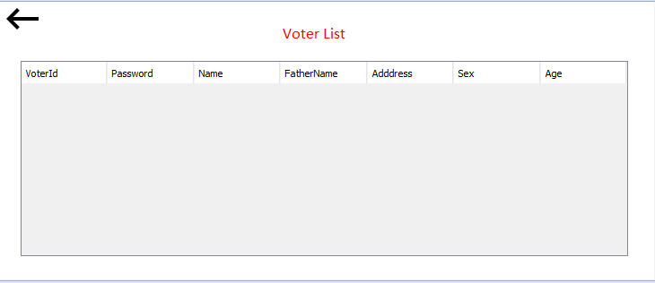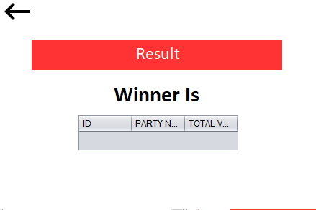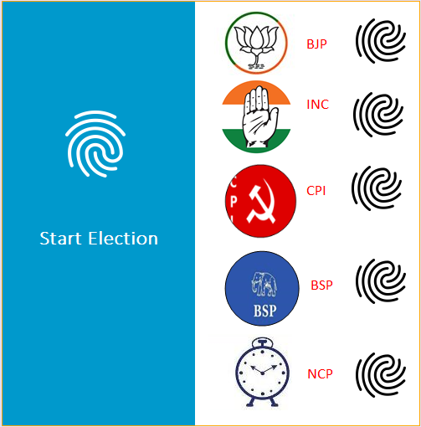

**CHAPTER 6**

**TESTING**

Testing a Voting Management System developed in MERN (MongoDB, Express.js, React, Node.js) involves checking the functionality, performance, and security of the application. Here's a general guide on how to approach testing for each component of the MERN stack:

**1. Unit Testing:**

**- Backend (Node.js/Express):**

- Write unit tests for individual functions and routes using testing frameworks like Mocha, Chai, or Jest.

- Test CRUD operations on votings and ensure proper error handling.

- Check authentication and authorization mechanisms.

- **Frontend (React):**

- Use testing libraries like Jest and Enzyme to write unit tests for React components.

- Test user interactions, state changes, and component rendering.

- Check how the frontend components interact with the backend API.

**2. Integration Testing:**

- **Backend:**

- Test the integration of different backend components.

- Ensure that the API endpoints work together correctly.

- Test database interactions and confirm that data is stored and retrieved accurately.

**- Frontend:**

- Test the integration of React components and how they interact with the backend.

- Confirm that user actions trigger the expected API calls.

- Ensure that data from the backend is displayed correctly in the frontend.

**3. End-to-End Testing:**

- Use tools like Cypress or Selenium for end-to-end testing.

- Simulate user interactions with the application to test the entire flow from UI to backend and back.

- Verify that the voting management system works as expected from the user's perspective.

**4. Performance Testing:**

- Use tools like Artillery, Apache JMeter, or Locust to simulate concurrent user activity and test the system's performance under load.

- Measure response times, throughput, and resource utilization to identify and address performance bottlenecks.

**5. Security Testing:**

- Perform security audits to identify and fix vulnerabilities.

- Check for common security issues such as SQL injection, cross-site scripting (XSS), and cross-site request forgery (CSRF).

- Ensure that authentication and authorization mechanisms are robust.

**6. Usability and User Experience Testing:**

- Test the usability of the application by observing how users interact with it.

- Ensure that the interface is intuitive and user-friendly.

- Check for responsiveness on different devices and screen sizes.

**8. Cross-Browser Testing:**

- Test the application on different web browsers to ensure compatibility.

- Check for and address any browser-specific issues.

**9. Data Backup and Recovery Testing:**

- Test data backup and recovery procedures to ensure that data can be restored in case of system failures.

**10. Documentation Review:**

- Ensure that documentation (code comments, API documentation, user manuals) is accurate and up-to-date.

**CHAPTER 7**

**Limitations and Future Enhancements**

**7.1 Limitations**

**1. Scalability:** Depending on the architecture and database design, a MERN stack application might face scalability challenges as the user base grows. Ensuring that the system can handle a large number of votings, users, and concurrent requests is essential.

**2. Security Concerns:** While MERN provides tools for security, the actual implementation depends on the developers. Security vulnerabilities, such as improper input validation, authentication issues, and inadequate authorization mechanisms, need thorough consideration.

**3. Cross-Browser Compatibility:** Ensuring consistent behavior across various browsers might be challenging. Cross-browser testing is crucial to identify and resolve any compatibility issues.

**4. Mobile Responsiveness:** While React facilitates building responsive web applications, ensuring a seamless user experience across different devices and screen sizes requires extra attention. Mobile optimization might need improvement.

**5. Comprehensive Error Handling:** The system should have robust error handling and logging mechanisms. Insufficient error handling can make it challenging to diagnose and fix issues, leading to a suboptimal user experience.

**6. Lack of Collaboration Features:** Depending on the initial requirements, the system might lack collaborative features, such as real-time editing or sharing votings with other users.

* 1. **Future Enhancements:**

**1.User Authentication Enhancements:** Implementing more advanced authentication features such as two-factor authentication (2FA) for enhanced security.

**2. Social Media Integration:** Allowing users to share their votings on social media platforms or integrate with popular social networks to enhance user engagement.

**3. Advanced Search and Filtering:** Enhancing the search functionality with advanced filters, tags, and categorization options for easier voting discovery.

**4. Voting Ratings and Reviews:** Adding a feature for users to rate and review votings. This could include a comment section for users to share their experiences and tips.

**5. Advanced Notifications:** Implementing notification features to alert users about new votings, comments, or updates related to their saved votings.

**6. Shopping List Integration:** Providing users with the ability to create a shopping list based on the ingredients of selected votings.

**7. Machine Learning Recommendations:** Implementing machine learning algorithms to provide personalized voting recommendations based on user preferences and behavior.

**8. Multilingual Support:** Offering support for multiple languages to make the application more accessible to users from different regions.

**9. Enhanced Data Analytics:** Incorporating analytics tools to gather insights into user behavior, popular votings, and trends, which can help improve the overall user experience.

**10. Offline Mode:** Developing a solution for users to access and modify their votings offline, with changes synchronized once an internet connection is reestablished.

**CHAPTER 8**

**References**

**BIBLIOGRAPHY**

* **Pankaj Jalote**. An Integrated Approach to Software Engineering , Third

Edition, Narosa Publications. A case study approach whereby a project is

Developed through the course of the book, illustrating different activities of

Software development

* **Herbert Schildt** – Java 2: The Complete Reference, Fifth Edition. This book

covers all aspect of java programming language.

* Educational Services Study Guide, Learn the basics of JAVA. Sun Micro

System’s publications.

* **Larne Pekowsky**, Java Server Pages Covers 2.0,Second Edition ,Pearson

Education.-contains all the information necessary to start writing JSP.

* [www.mysql.com](http://www.mysql.com)
* [www.w3schools.com](http://www.w3schools.com)
* [www.google.com](http://www.google.com)
* [www.wikipaedia.com](http://www.wikipaedia.com)
* [www.eci.nic.in](http://www.eci.nic.in)