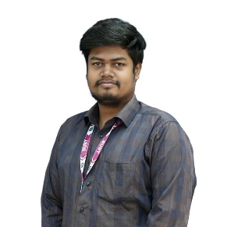
Muhammad Mahbub Sarwar Shafi

Name of Faculty :
Designation : Lecturer
Semester :
Summer 2026

Faculty Code: MMSS

Picture

Class Routine and Weekly Activities

Day/  Time | 08:15 AM  09:45 AM | 09:45 AM  11:15 AM | 11:15 AM  12:45 PM | P&L | 01:15 PM  02:45 PM | 02:45 PM  04:15 PM | 04:15 PM  05:45 PM | 05:45 PM 07:00 PM | 07:00 PM  08:15 PM | 08:15 PM  09:30 PM
Sunday |  | CH | RW |  | OBEI-W
Monday |  |  |  |  | RW | CH | ICT-1101  B4/805  66/7
Tuesday |  | CH | ICT-1102  B4/303  66/7 |  | ICT-1102  B4/303  66/7 | DCW | IS
Wednesday | ICT-1101  B4/704  66/7 | DCW | RW |  | DM | IS | CH | CSE-318  B2/518  48/2 | CSE-318  B2/518  48/2
Thursday |  |  |  |  |  | RW | DCW | CH | CSE-317  B2/708  48/2 | CSE-317  B2/708  48/2
Friday | OFF | OFF | OFF |  | OFF | OFF | OFF | OFF | OFF | OFF

Email: mahbubsarwar@bubt.edu.bd  Phone No: +01341883668  ___________________________  Faculty Signature |  | Teaching Focused Faculty Member
 |  | CH=Counselling Hour (5)
 |  | DM=Departmental Meeting (1)
 |  | DCW= Departmental Committee Work
 |  | IS=Intake Supervision (3)
 |  | OBEI-W= OBE Implementation Work (1)
 |  | P & L = Prayer & Lunch
 |  | RW= Research Work (4)

