**Page Name - Class Doc**

**Class - Saturday 01/15/2021 END WILL July 31th 2021**

Home work → <https://www.google.com/search?q=MS+office+shortcut&rlz=1C5CHFA_enUS806US806&sxsrf=ALeKk036w1GWstSgqovHjW5AimXGXKLgGA:1610678106009&source=lnms&tbm=isch&sa=X&ved=2ahUKEwjXkezC85zuAhU1GVkFHQBAAjwQ_AUoAXoECAoQAw&biw=1397&bih=846&dpr=2#imgrc=of6PTI_ch3onFM>

Computer :

Cache and Cookies → 3

1. Recent file → Enter → ctl a → Shift Delete
2. Prefetch → Enter → ctl a → Shift Delete
3. %temp% → Enter → ctl a → Shift Delete

Incognito (Private mode)

Ctl + Shit + N

Regular Browser mode

Ctl + Shift + Delete → Select Advance + Select all item from drop downlist → Clear Data

Password Bold

LastPass

**Class - Saturday 01/16/2021**

Remember Password Tricks → DevTool → Ctl + Option + C

Ms Excel -

* Dropdown list call the data from different Tab (sheet)
* How to create a dashboard
* How to apply logics
* Data validation
* Hyperlink
* Define Name
* Page/Cell/Columns hyperlink
* Freeze panes
* How customize bookmarks bar
* LIst of shortcuts
* MS Word panels
* Password retriveation (LassPass)
* Cell customization
* Password Tricks (DevTool)

**Class - Saturday 01/16/2021**

* What did you do throughout the last 5 days
* What’s your plan to do today and next week
* Is there any problem or question or concern

**Class - Friday 01/22/2021**

Basic Computer:

* How to customize port
* How to customise disk
* How to see the windows logs for failure
* What is Agile and Benefits of Agile Methodologies (Interview Question)

**Class - Saturday 01/23/2021**

* What is scrum framework and how to use it?
* **What is your involvement in agile-scrum? (Interview Question)**
* **Are you familiar with JIRA?**

What is Scrum?

Scrum Framework: Based on Empiricism | Empirical

Scrum Value: Course, Focus, Respect, Openness

Scrum Rules: Product Owner,, Development Team (Developer, SQA, DevOps) |

3 - Amigo (Developer + SQA + Product Owner)

Scrum Events: Sprint

Scrum Artifacts: Backlog, Sprint Backlog

Application = 1 year

Scrum Master = Process Owner

Stakeholder = Requirements (User story) = Product Owner + Designer = Backlog

Sprint = Timebox (1 to 4 max) 2 weeks (10 days)

========Project Start from here=========

1. Project KickOff meeting: (One time in a project) - Stakeholder + entire project team member
2. Team norms: Setting up ground common roles for the entire team member. (One time in a project) - Entire project team member)
3. Backlog Grooming: (Prior sprint started)

===========Sprint 1=========

Sprint (10 days) - timebox

Day 1

1. First hour (Sprint planning: Story point (Favonoci number))

Day2

1. Daily Scrum Meeting (Daily Standup) (15 minute max)

Day 10

1. Sprint review meeting (Demo meeting/Presentation meeting to Stakeholder + entire project team member)
2. Sprint retrospective - Entire project team member
3. What went well?
4. What needs to be improved?

========End=======

===========Sprint 2=========

-----------Impediment / Blocker / Problem / Issues-------

DevOps:

Dev Environment -

QA Environment - https://www.google.com.qa

Staging Environment -

Production Environment - https://www.google.com

**Class - Tuesday 01/28/2021**

JIRA | BackLog | Scrum Board:

JIRA = Project Management tool

**Class - Friday 02/05/2021**

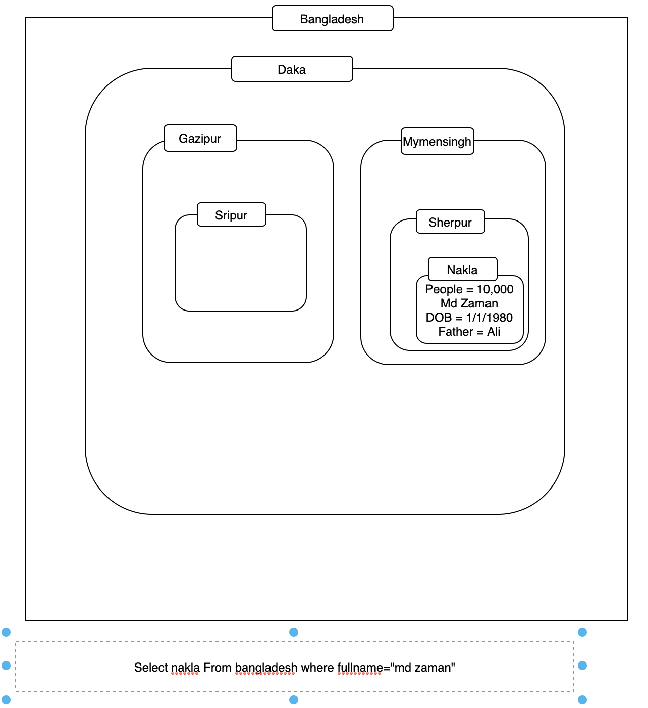

Database:

1. MySQL
2. Oracle
3. Postgres

**Class - Saturday 02/06/2021**

**PostGreSQL**

SQL Statement

**SELECT, SELECT DISTRICT, WHERE, AND OR NOT, Order By, Insert Into, Update, Delete, Select Top, Min & Max, Count, Avg, Sum, Like, Wildcards, In,** Between, Aliases, Joins, InnerJoin, Left Join, Right Join, full Join, Group By, Having, Comments, Operators

**Class - Tuesday 02/12/2021**

SQL Statement

Interview Question:

1. How/When should you use HAVING Clause
2. how /When should you use JOINS
3. how /When should you use LIKE
4. What is the different between Primary Key & Foreign Key

**Class - Tuesday 02/13/2021**

SDLC

STLC

User story + Design

Test Cases

Bug/Defect

**Class - Tuesday 02/19/2021**

JIRA

Interview Question:

1. Difference between Scrum Framework (Board) and Kanban Framework (board)

Requirements → Developer + QA

Sprint - 1 Start (02/18/2021) → (10 to 11) Sprint planning meeting

TO DO LIST

User story (Combine Frontend + Backend Acceptance Criteria)

Front Developer -> Subtask

Back Developer -> Subtask

QA > Subtask

1. Trucking my works in jira scrum board

**Class - Tuesday 02/26/2021**

JIRA = Project management & Defect management tool

Xray = Test Case management JIRA plugin

Test Case management JIRA plugin

Zephyr, Adaptivist,

HP Quality Center -

ALM (Application lifecycle Management)

Defect Management Tool - BugZilla (Open source)

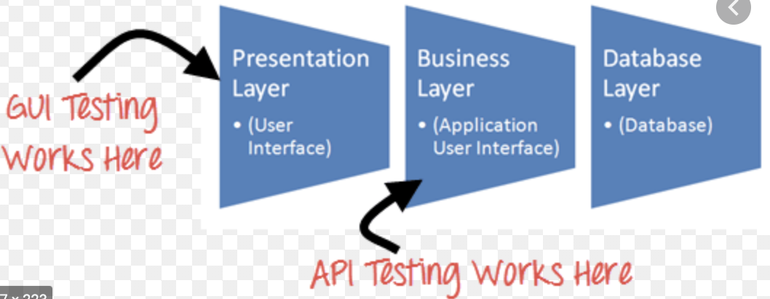

**Cross - Browser testing:**

Chrome, Firefox, Safari, IE, Edge

**Class - Tuesday 02/27/2021**

* Testing Types - Done
* Bug Report - Done
* Test plan
* Test strategies
* Bugzilla/JIRA (Defect Management tool) - Done
* Test case management tool (Xray | ALM)
* SDLC & STLC

Production Environment: <https://www.google.com/>

QA/Staging Environment: <https://www.qa.google.com/>

Dev Environment: [https://www.dev.google.com/](https://www.qa.google.com/)

Sprint 1:

1. Smoke Test = Testing happy path of the application of a specific requirement.
2. Integrated Functional Test (IFT) = Click (UI Perspective)

API Test (Manual) + Automation - Integration

Sprint 2:

1. Smoke Test = Testing happy path of the application of a specific requirement.
2. Integration Functional Test (IFT) = Click
3. Regression Test

API Test (Manual) + Automation - Integration

What is a traceability matrix?

Testing Pyramid

Dev = Unit

QA = API Test

QA = UI Test

**Class - Tuesday 03/05/2021**

Test Plan

Test Strategy

SDLC

STLC

IFT = UI Test

API = Application Program Interface (Integration)

The Test Plan is a document. A Test Plan defines and provides a layout of how and what to test. The Test Plan is a document describing the scope, approach, resources, and schedule of intended testing activities. It identifies test items, the features to be tested, the testing tasks and who will do each task (roles and responsibilities) and any risks and its solutions.

============================================

Project Name

IFT Test Plan

Test Plan Type: Integrated Functional Testing & Regression

Status: Draft

Version: 1.03

Prepared by: Md Zaman

Project Sponsor: HR

Project Manager: Tex Boxer

Project ID: P0503040

Release#: TBD

Date Created: 02/10/2021

Date Last Modified: 02/10/2021

Table Of Contents

Documents Purpose

Approvals

Contributors

Reviewers

Version History

Glossary Of Terms

1. Testing Approach
2. Impacted Areas
3. Testing Assumptions, Constraints, Dependencies, and Risks
4. Testing Details
   1. Integrated Functional Testing
   2. Automated Regression
   3. Manual Regression
5. Impacted Applications
6. Requirement Traceability
7. Testing Control Procedures
8. Test tools and repository
9. Project Documents Reference

**Class - Tuesday 03/06/2021**

Test Strategy

SDLC

STLC

### What is Test Strategy?

A test strategy is an outline that describes the testing portion of the software development cycle. It is created to: inform project managers, testers, and developers about some key issues of the testing process.

### What is included in Test strategy?

The testing objective, methods of testing new functions, total time and resources required for the project, and the testing environment? It also describes how the product risks of the stakeholders are mitigated at the test level, which types of test are to be performed, and which entry and exit criteria apply. The test strategy is created based on development design documents. It is written by the Test Manager or Lead.

It includes introduction, scope, resource and schedule for test activities, acceptance criteria, test environment, test tools, test priorities, test planning, executing a test pass and types of test to be performed, Roles and Responsibilities, Test Status Collections and Reporting, Test Records Maintenance, Test Summary

Table Of Contents

Project Name: FieldNation

Customer Vision & Problem Statement & Solution:

In order to make the customers easy to get the Office Operating Management & Office Related and House Related solution we need to developed a software that can sale as Service (SAAS)

Office Operating Management

Office Related and House Related solution

Listed all the important features to be test

1. [INW-13](https://ittraining.atlassian.net/browse/INW-13) All the list of nav bar will be under this Epic
2. [INW-14](https://ittraining.atlassian.net/browse/INW-14) All the list of conf nav bar will under this epic

Scope Of Testing

* Xray | Excel | ALM: Test Management tool including RTM link (Test Case Coverage)

Testing types includes:

|  |  |  |  |
| --- | --- | --- | --- |
| Types of Testing | Status | Testing Approach and Tools | Comments |
| IFT | YES | Manual (Xary) & Automation (Selenium) |  |
| Integration Test | YES | Manual (POSTMAN) & Automation (RestAssured) |  |
| Regression | YES | Manual (Xary) & Automation (Selenium)  Manual (POSTMAN) & Automation (RestAssured) |  |
| Performance | YES | JMeter |  |
| Compatibility | YES | Chrome, FrieFox |  |
| Accessibility | YES | Chrome, FrieFox |  |
| Localization & Globalization | YES | Translation, Date time format |  |
| Security | NO | Cyber Security Team (BashTool) |  |

Bug/Defect Tracking :

* JIRA

Success / Exit Criteria:

1. Verify if All tests planned have been run
2. Verify if the level of requirement coverage has been met
3. Verify if there are NO Critical or high severity defects that are left outstanding
4. Verify if all high-risk areas are completely tested
5. Verify if software development activities are completed at the projected cost
6. Verify if software development activities are completed within the projected timelines

Phase sign-off Responsibility:

|  |  |  |  |
| --- | --- | --- | --- |
| Role | Location | Name |  |
| Full Stack QA Engineer | Dhaka | [asifiqbalbd345@gmail.com](mailto:asifiqbalbd345@gmail.com) |  |
| Product Owner/P.M | Gulsha | [md.zaman@rtx.com](mailto:md.zaman@rtx.com) |  |
|  |  |  |  |

Tracking testing progress:

* Manul (Xray) - Link
* Automation (UI & API) - GitHub Link

Task Distribution:

* [asifiqbalbd345@gmail.com](mailto:asifiqbalbd345@gmail.com) (100%) - QA Full Stack Engineer

Testing Report:

* Manul (Xray) - Link
* Automation (UI & API) - GitHub Link

All the list of Risk during the test completion

* Delay of the Test Environment setup & issues (QA/Stage)
* Delay of the Test Environment FOR Mobile APK / IPA
* Delay of specific device for QA test
* Delay of the Lockdown functionally
* Dedicated resources unavailable (Not enough resources)
* Delay of Service Account (Test account)

Test Environment:

* QA: Link

Exclusion:

|  |  |  |
| --- | --- | --- |
| Browser/Devices | OS/Browser Version | Android Version |
| Chrome | Latest | N/A |
| FireFox | Latest | N/A |
| IE | Latest | N/A |

**Class - Tuesday 03/11/2021**

Unix/Linux

Git/GitHub

Unix/Linux Navigation Command:

Start or Window (keyboard button) > Type CMD on the search box > Enter

Ls mac

dir (Windosw)