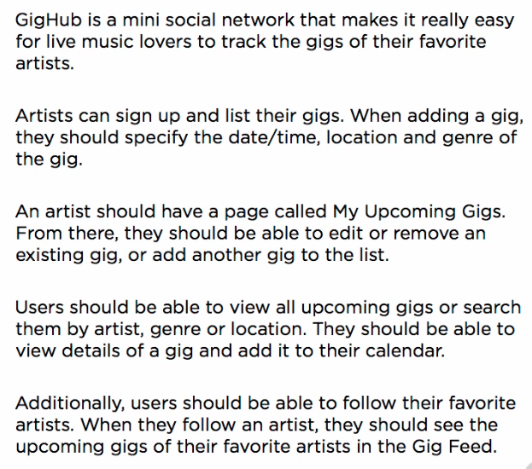

Use case

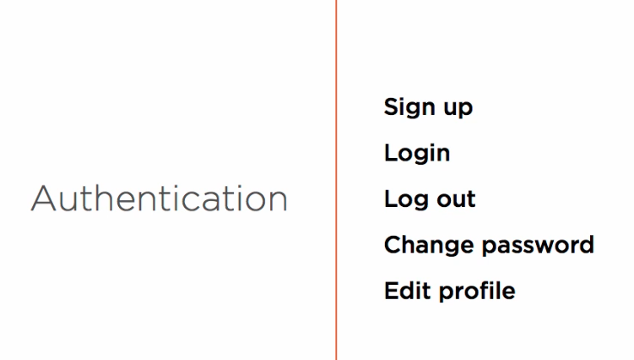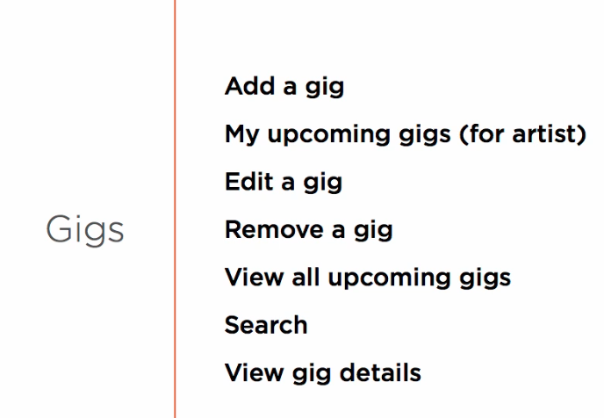

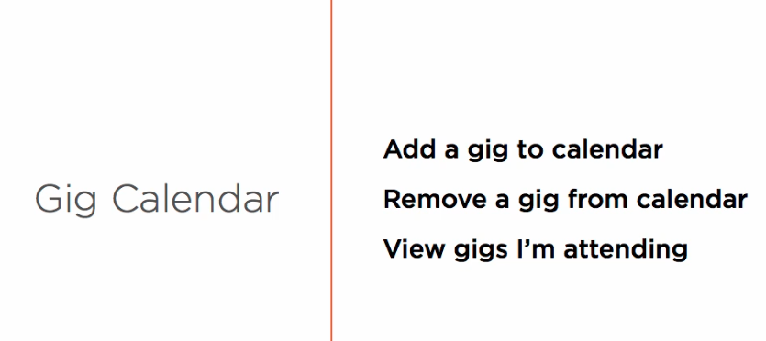

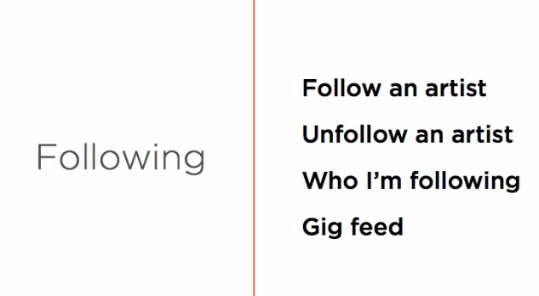

Class/ Model

|  |  |
| --- | --- |
| **Gig** |  |
| id | Int (primary key) |
| Artist | ApplicationUser |
| DateTime | Datetime |
| Venue | string |
| Genre | Genre |
| (foreign key) | Artistid, Genreid |
| Attendances | ICollection<Attendance> |

|  |  |
| --- | --- |
| **Genre / type** |  |
| id | Byte (primary key) |
| name | string |
|  |  |

|  |  |
| --- | --- |
| **Attendance** | (many to many relation) |
| GIg | Gig |
| Attendee | ApplicationUser |
| GigId [key] | Int (Foreign Key) |
| AttendeeId [key] | String (Foreign Key) |
| 2 composit key  Combine as primary key |  |

|  |  |
| --- | --- |
| **Following** | (many to many relation) |
| Follower | ApplicationUser |
| Followee | ApplicationUser |
| FollowerID |  |
| FolloweeId |  |
|  |  |

|  |  |
| --- | --- |
| Notiffication |  |
| id | Int |
| DateTime | DateTime |
| type | NotificationType Enum |
| OriginalDateTime | DateTime ? null able |
| Gig | Gig |

|  |  |
| --- | --- |
| UserNotification |  |
| UserId | String |
| NotificationId | int |
| User | ApplicationUser |
| Notification | Notification |
| Isread | bool |

viweModel

|  |  |
| --- | --- |
| GigFromViewModel |  |
| vanue | string |
| Date | string |
| time | String |
| Genre | byte |
| genres | List // source of dropdown |

|  |  |
| --- | --- |
| Home view model |  |
| Upcomming Gig | Ienumarable<Gig> |
| ShowActions (follow, going) | bool |

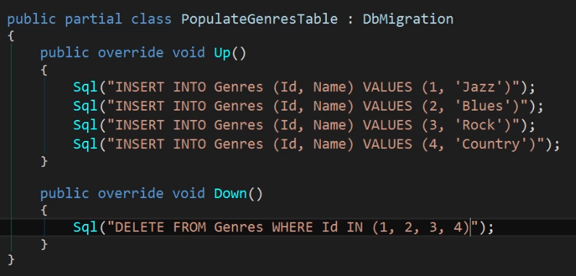

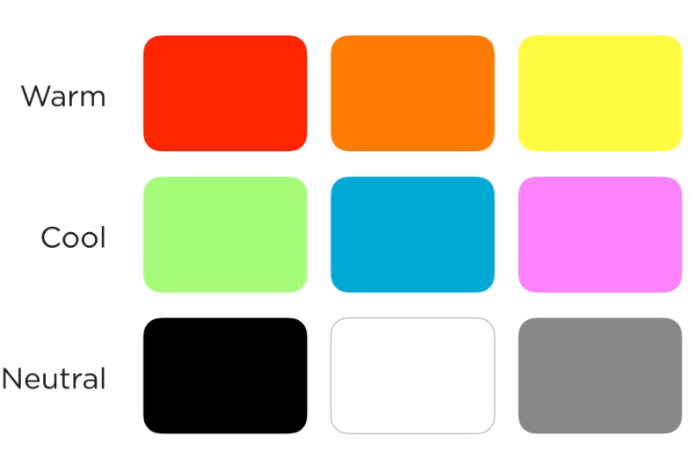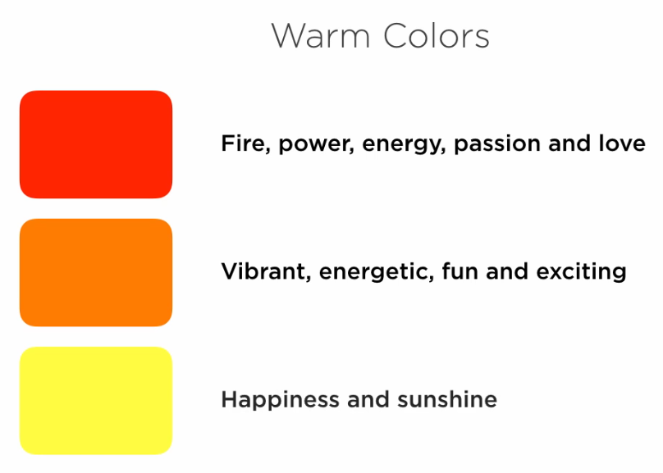

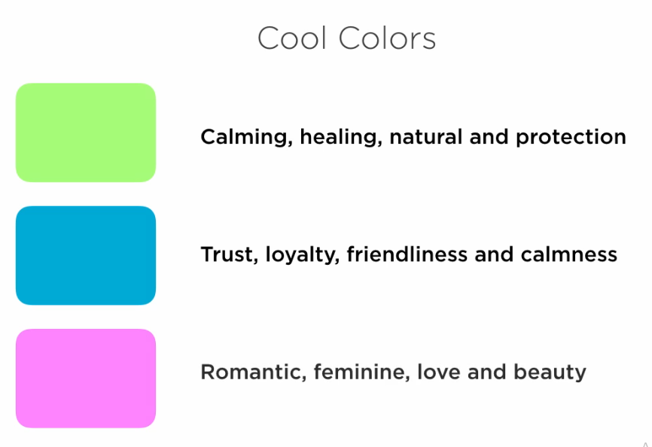

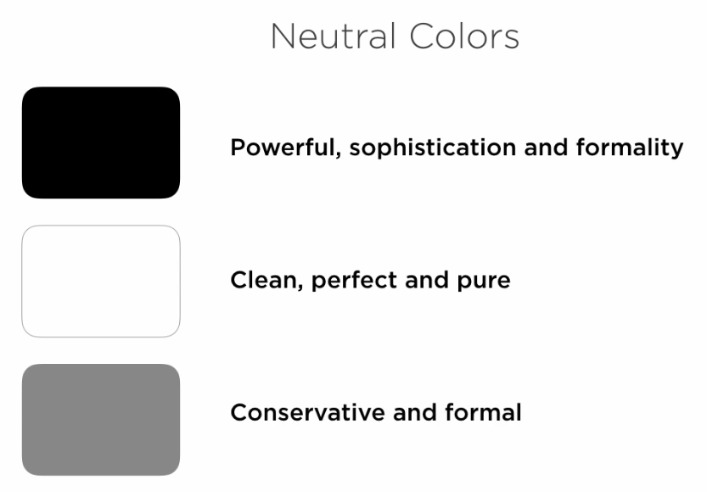

**ZenCoding : home-indexview**

