Software Requirements Specifications

For

Chemistry Calculator

|  |  |
| --- | --- |
| Submitted to | Submitted by |
| Dipok Chandra Das  Assistant Professor, IIT, NSTU | Md.Mahbub Alam (ASH1825003M)  Md.Abrar Hossain Asif (ASH1825005M)  Nishat Tasnim Tamanna (BKH1825006F)  Md.Faisal Ahammed (ASH1825015M)  Moon Moon Das (BKH1825027F) |

Contents

1 Introduction 4

2 Requirement Specification 4

3 Functional Requirements 4

Table 01: User can get balanced equation from unbalanced equation 4

Table 02: User can see the history of Equation Balance 4

Table 03: User can get Concentration in the format of Molarity, Molality and Normality 5

Table 04: User can get atomic profile 5

Table 05: User can get Molar mass 5

Table 06: User can get percent of completion 5

Table 07: User can see the percent of completion pie chart 6

4 Performance Requirements 6

5 Precision & Accuracy Requirements 6

Table 08: Calculate result must be accurate 6

6 Dependability Requirements 6

7 Robustness or Fault-Tolerance Requirements 7

Table 09: The system handles all user access without system errors 7

8 Safety-Critical Requirements 7

9 Supportability Requirements 7

10 Usability and Human-Interaction Requirement 7

11 Ease of Use Requirements 7

Table 10: Application must be usable for the end users 7

12 Personalization and Internationalization Requirements 8

13 Understand ability and Politeness Requirements 8

14 Accessibility Requirements 8

15 User Documentation Requirements 8

Table 11: The system engineer documentation 8

16 Training Requirements 8

17 Look and Feel Requirements 8

17.1 Appearance Requirements 8

Table 12: Labels of mandatory fields must be bold 9

17.2 Style Requirements 9

Table 13: The appearance must be controllable using stylesheet file 9

18 Operational and Environmental Requirements 9

18.1 Expected Physical Requirements 9

18.2 Requirements for Interfacing with Adjacent Systems 9

19 Release Requirements 9

20 Legal Requirements 9

21 Compliance Requirements 9

22 Standards Requirements 10

23 Use case diagram 10

Fig 1: Use Case diagram for Chemistry Calculator 10

24 Use Case Description 11

Table 24.1: Use Case Description of Balance Equation 11

Table 24.2: Use Case Description of Concentration 12

Table 24.3: Use Case Description of Electron Config 13

Table 24.4: Use Case Description of Get Molar Mass 14

Table 24.5: Use Case Description of Get Percent of Completion. 15

Table 24.6: Use Case Description of Get Unknown Value in Titration 16

25 Activity Diagram 17

Fig 2: Activity Diagram of Get Molar Mass 17

Fig 3: Activity Diagram of Get Percent of Completion 18

Fig 4: Activity Diagram of Get Unknown Value in Titration 19

Fig 5: Activity Diagram of balance equation 20

# 1 Introduction

Chemistry Calculator project uses mathematical algorithms and formulas to calculate different parameters such as molarity, molality, balance equation, concentration, molar mass, percent of completion, titration. Additionally, this calculator can help to minimize errors and improve the accuracy of calculation. Chemistry calculator is a valuable tool for student, teacher and professional to analyze and calculate.

This document contains the reverse engineered Software Requirement Specification for Chemistry Calculator project.

# 2 Requirement Specification

Before a system is designed and implemented, the requirements have to be specified in enough detail to make analysis and design possible. This is a big part of software engineering, especially for larger systems.The complete requirement specification based on the elicitation process is described in this section.

# 3 Functional Requirements

Every system must have some functional requirements.  Functional requirement defines a system or its component. It describes the functions a software must perform. A function is nothing but inputs, its behavior, and outputs. It can be a calculation, data manipulation, business process, user interaction, or any other specific functionality which defines what function a system is likely to perform. Functional software requirements help to capture the intended behavior of the system. Now, we are going to mention functional requirements associating Chemistry Calculator.

### Table 01: User can get balanced equation from unbalanced equation

|  |  |
| --- | --- |
| **FR** | **User can get balanced equation from unbalanced equation.** |
| **Description** | If user write any unbalanced Reactants and Products name, they can get easily balanced equation by clicking on Balance button. |
| **Stakeholders** | Teacher, student |
| **Priority** | High |

### Table 02: User can see the history of Equation Balance

|  |  |
| --- | --- |
| **FR** | **User can see the history of Equation Balance** |
| **Description** | After balancing the equation, if any user want to see the history of this balance equation, he/she can see it by clicking on History button. |
| **Stakeholders** | Teacher, student |
| **Priority** | Low |

### T**able 03: User can get Concentration in the format of Molarity, Molality and Normality**

|  |  |
| --- | --- |
| **FR** | **User can get Concentration in the format of Molarity, Molality and Normality** |
| **Description** | If any user write the Compound, Compound’s mass (by kilogram/gram/milligram/pound), Volume of solution (by deciliters, milliliters, centiliters, cubic_decimeters, cubic_millimeters cubic_centimeters) and Equivalent Number, system can calculate concentration in the format of Molarity, Molality and Normality. |
| **Stakeholders** | Teacher, student |
| **Priority** | High |

### Table 04: User can get atomic profile

|  |  |
| --- | --- |
| **FR** | **User can get atomic profile** |
| **Description** | User can get atomic profile by entering atomic number or symbol. If they click on Get Config. Button, they can get the atomic profile. |
| **Stakeholders** | Teacher, student |
| **Priority** | High |

### Table 05: User can get Molar mass

|  |  |
| --- | --- |
| **FR** | **User can get Molar mass** |
| **Description** | User can get Molar mass value by entering compound and they can also see the details of individual chemical elements atomic mass. |
| **Stakeholders** | Teacher, student |
| **Priority** | High |

### Table 06: User can get percent of completion

|  |  |
| --- | --- |
| **FR** | **User can get percent of completion** |
| **Description** | User can get the percent of completion by entering compound. They can see the compound name, symbol, total atoms, atomic mass and percentage. |
| **Stakeholders** | Teacher, student |
| **Priority** | High |

### Table 07: User can see the percent of completion pie chart

|  |  |
| --- | --- |
| **FR** | **User can see the percent of completion pie chart** |
| **Description** | After getting the percent of completion, If user want they can see the pie chart of the percent of completion. |
| **Stakeholders** | Teacher, student |
| **Priority** | Low |

# 4 Performance Requirements

It is very important to maintain performance of any software system. To ensure performance, we need to maintain some steps. Now, I will explain some perspective by which we are going to enhance the performance of this project.

# 5 Precision & Accuracy Requirements

Result that is to be shown to the end user is need to be accurate. Because, wrong information might be ruined the whole business process.

### Table 08: Calculate result must be accurate

|  |  |
| --- | --- |
| **PAR-1** | **Calculate result must be accurate** |
| **Description** | When user enter the compound to see the result, then the calculate result must be according to the input value given by user. |
| **Stakeholders** | Teacher, student |
| **Priority** | High |

# 6 Dependability Requirements

The term dependability is measured based on four dimensions. Such as:

* Availability
* Reliability
* Safety
* Security

If we want to say that this application system is dependable then it must fulfil the four dimensions. But there are other tasks. Like there is no way to make mistakes or this system should have the ability to detect and then remove errors. Besides that, it is also very important to limit the damage which might be caused by system failure.

# 7 Robustness or Fault-Tolerance Requirements

To ensure robustness and fault-tolerance facilities to the end users, it is urgent to ensure 0% crush. Moreover, it must show accurate results.

### Table 09: The system handles all user access without system errors

|  |  |
| --- | --- |
| **RFT-1** | **The system handles all user access without system errors** |
| **Description** | Thousands of users might hit this application system at a time. All their requests must be handled without any fault. |
| **Stakeholders** | N/A |
| **Priority** | High |

# 8 Safety-Critical Requirements

There are no safety-critical requirements in this project.

# 9 Supportability Requirements

Supportability requirements may have related to some extends. Like:

* Testability
* Extensibility
* Adaptability
* Maintainability
* Compatibility
* Configurability
* Serviceability
* Install ability

This application meets all of the above requirements related to supportability.

# 10 Usability and Human-Interaction Requirement

The main target of developing any system is to make the system user friendly and easy to usable for the end users.

# 11 Ease of Use Requirements

This application is easy to use and also easily understandable.

### Table 10: Application must be usable for the end users

|  |  |
| --- | --- |
| **EUR-1** | **Application must be usable for the end users** |
| **Description** | This app is enough usable to the end user by which they can operate this system easily. |
| **Stakeholders** | Teacher, student |
| **Priority** | High |

# 12 Personalization and Internationalization Requirements

There are not any personalization and internationalization requirements to this system. This maiden version of this application is only be operated in Bangladesh.

# 13 Understand ability and Politeness Requirements

It is already said that the application which we are going to develop, is understandable enough. The system provides hints to users whether any error occurred or wrong. By reading those errors users can be able to operate the system easily.

# 14 Accessibility Requirements

There are no specific accessibility requirements associated to this system yet.

# 15 User Documentation Requirements

Documentation are mainly two types. One is internal documentation which is generally written by the application engineers. It is prepared to make development life cycle easier for the system engineers or system analysts.

### Table 11: The system engineer documentation

|  |  |
| --- | --- |
| **UDR-1** | **The system engineer documentation** |
| **Description** | To develop this application named Chemistry Calculator, firstly we have made a system analysis team as well as documentation team. |
| **Stakeholders** | System analysts or software developers |
| **Priority** | Medium |

# 16 Training Requirements

Training requirements involved in after service of any application. It is very necessary to properly train up end users to the system so that they would be capable to operate easily. After launching the full package to the market, firstly we provide training to the different end users like teachers and students.

# 17 Look and Feel Requirements

Look and feel requirements mainly refers how the system will look like and how the user interface or graphical user interface of this system will display to the user.

## 17.1 Appearance Requirements

Patients, doctors and all other user must know which input fields are required and which are not. For that reason, we will use labels for all input fields. Input fields might be text type, radio, checkbox, spinner etc.

### Table 12: Labels of mandatory fields must be bold

|  |  |
| --- | --- |
| **AR-1** | **Labels of mandatory fields must be bold** |
| **Description** | The mandatory field’s label must be bold and all input fields must have placeholder to make it easier for the users. |
| **Stakeholders** | Teacher, student |
| **Priority** | Medium |

## 17.2 Style Requirements

After keeping all contents, it is very essential to load stylesheet to the application. For desktop application like desktop system, extensive mark-up language. It is to be said that we are going to develop this system at desktop platform. Style makes the system lucrative.

### Table 13: The appearance must be controllable using stylesheet file

|  |  |
| --- | --- |
| **SR-1** | **The appearance must be controllable using stylesheet file** |
| **Description** | For desktop application style sheet files are xml. So, all stylesheet must be controllable by the xml file. |
| **Stakeholders** | Software developer |
| **Priority** | High |

# 18 Operational and Environmental Requirements

Operational and environmental requirement refers to the capabilities, performance measurements, process, measurements of effectiveness, measurements of performance, measures of sustainability, measurements of technical performances etc.

## 18.1 Expected Physical Requirements

There are no expected physical requirements in this system.

## 18.2 Requirements for Interfacing with Adjacent Systems

There are no requirements for interfacing with adjacent system for this project.

# 19 Release Requirements

There are no specific release requirements in this system.

# 20 Legal Requirements

Legal requirements normally refer to the terms and conditions or privacy policy of any organizations. The terms and condition of this application is that, no third-party software or person are allowed to engage to use the data for their business purpose.

# 21 Compliance Requirements

There are no specific compliance requirements for this system.

# 22 Standards Requirements

There are no specific standards requirements for this system.

# 23 Use case diagram

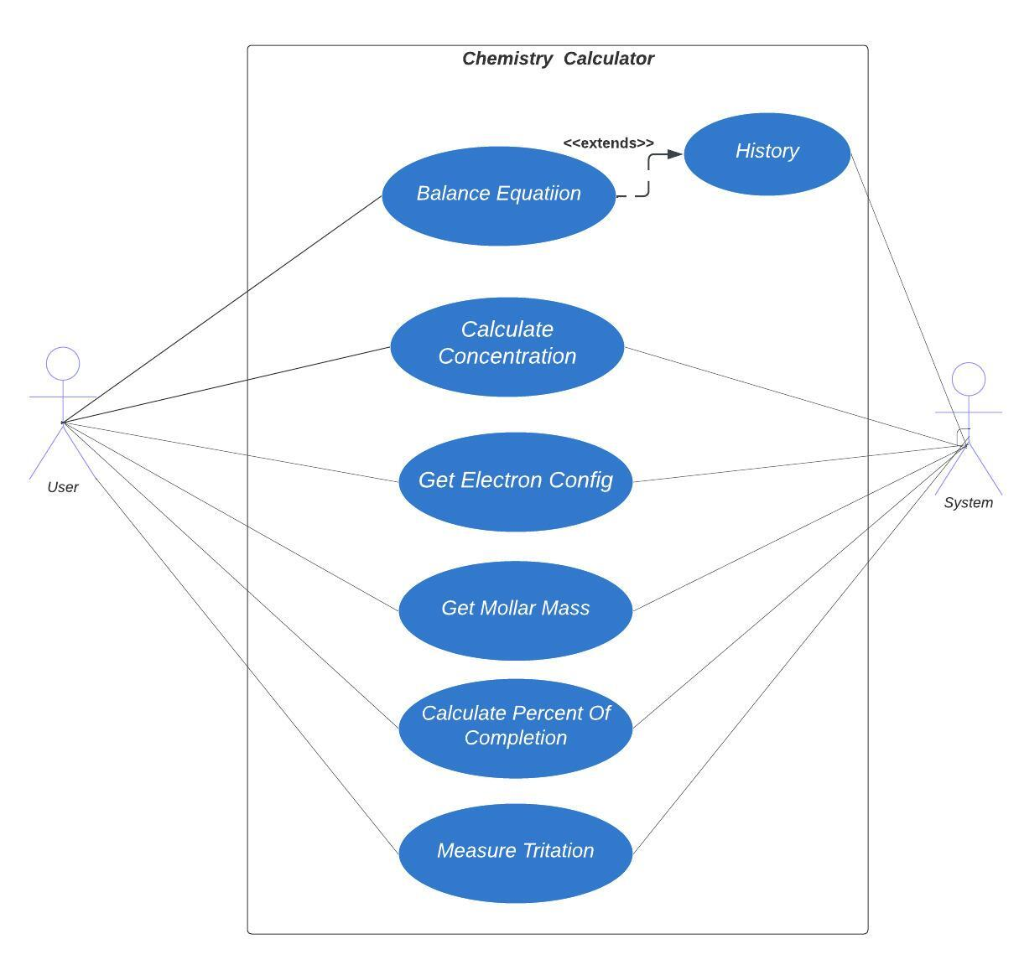

## Fig 1: Use Case diagram for Chemistry Calculator

# 24 Use Case Description

### Table 24.1: Use Case Description of Balance Equation

|  |  |  |
| --- | --- | --- |
| **Use Case ID** | 01 | |
| **Use Case Name** | Balance Equation | |
| **Goal** | Balance equation between Reactants and Products | |
| **Preconditions** | Not Applicable | |
| **Success End Condition** | The equation is balanced successfully between Reactants and Products | |
| **Failed End Condition** | The equation is balanced successfully between Reactants and Products | |
| **Primary Actors:**  **Secondary Actors:** | Teacher, student  Not Applicable | |
| **Trigger** | Click on the Equation Balance option from side bar menu | |
| **Main Success Flows** | **Step** | **Action** |
| 1 | The user input reactants |
| 2 | The user input products |
| 3 | Click balance button |
| 4 | System provides given equation and balanced equation |
| 5 | The user clicks on the clear button to clear input |
| **Alternative Flows** | **Step** | **Branching Action** |
| 1a | The user input incorrect reactants |
| 2a | The user input incorrect products |
| 3 | Show an error |
| **Quality Requirements** | **Step** | **Requirement** |
|  | Not Applicable |

### Table 24.2: Use Case Description of Concentration

|  |  |  |
| --- | --- | --- |
| **Use Case ID** | 02 | |
| **Use Case Name** | Concentration | |
| **Goal** | Calculate Molarity ,Molality and Normality | |
| **Preconditions** | Not Applicable | |
| **Success End condition** | Show Molarity, Molality, Normality Successfully | |
| **Failed End Condition** | Compound not valid | |
| **Primary Actors:**  **Secondary Actors:** | Teacher, student  Not Applicable | |
| **Trigger** | Click on the Concentration option from side bar menu | |
| **Main Success Flows** | **Step** | **Action** |
| 1 | The user input compound |
| 2 | The user input compound’s mass |
| 3 | The user input volume of solution |
| 4 | System provides concentration based on input |
| 5 | The user clicks on the clear button to clear input |
| **Alternative Flows** | **Step** | **Branching Action** |
| 1a | The user input incorrect compound |
| 2a | The user input incorrect product compound’s mass |
| 3a | The user input incorrect volume of solution |
| **Quality Requirements** | **Step** | **Requirement** |
|  | Not Applicable |

### Table 24.3: Use Case Description of Electron Config

|  |  |  |
| --- | --- | --- |
| **Use Case ID** | 03 | |
| **Use Case Name** | Electron Config | |
| **Goal** | Provide Electron configuration of atomic symbol | |
| **Preconditions** | Not Applicable | |
| **Success End Condition** | Show electronics configuration successfully | |
| **Failed End Condition** | Symbol is not valid | |
| **Primary Actors:**  **Secondary Actors:** | Teacher, student  Not Applicable | |
| **Trigger** | Click on the Electron config option from side bar menu | |
| **Main Success Flows** | **Step** | **Action** |
| 1 | The user input Atomic number or symbol |
| 2 | Click Get config button |
| 3 | System provides given equation and balanced equation |
| 4 | The user clicks on the clear button to clear input |
| **Alternative Flows** | **Step** | **Branching Action** |
| 1a | The user input incorrect atomic number or symbol |
| 2 | Show an error |
| **Quality Requirements** | **Step** | **Requirement** |
|  | **Not Applicable** |

### Table 24.4: Use Case Description of Get Molar Mass

|  |  |  |
| --- | --- | --- |
| **Use Case ID** | 04 | |
| **Use Case Name** | Get Molar Mass | |
| **Goal** | Get Molar Mass of a compound. | |
| **Preconditions** | Not Applicable | |
| **Success End Condition** | Molar Mass is displayed successfully | |
| **Failed End Condition** | The system shows an error message | |
| **Primary Actors:**  **Secondary Actors:** | Teacher, student  System | |
| **Trigger** | Click on the “Molar mass” from the sidebar menu | |
| **Main Success Flows** | **Step** | **Action** |
| 1 | The user enters compound in the input box. |
| 2 | The user clicks on the “Get Molar Mass” button |
| 3 | The system displays Molar Mass of the given compound and listed each element of the compound and their respective Atomic Mass |
| 4 | The user clicks on the clear button to clear input box. |
| **Alternative Flows** | **Step** | **Branching Action** |
| 1a | The user enters wrong compound in the input box |
| 3a | The system displays an error message |
| **Quality Requirements** | **Step** | **Requirement** |
|  | Not Applicable |

### Table 24.5: Use Case Description of Get Percent of Completion.

|  |  |  |
| --- | --- | --- |
| **Use Case ID** | 05 | |
| **Use Case Name** | Get Percent of Completion | |
| **Goal** | To get the total percentage of completion for each element in the compound. | |
| **Preconditions** | Not Applicable | |
| **Success End Condition** | Percentage of completion is displayed successfully. | |
| **Failed End Condition** | The system displays an error message. | |
| **Primary Actors:**  **Secondary Actors:** | Teacher, student  System | |
| **Trigger** | Click on the “Percent of completion” from the sidebar menu | |
| **Main Success Flows** | **Step** | **Action** |
| 1 | The user enters compound in the input box. |
| 2 | The user clicks on the “Percent of completion” button |
| 3 | The system displays Name of the elements and their Symbols, Total Atoms, Atomic Mass, and Percentage of Completion |
| 4 | The user clicks on the clear button to clear input box. |
| **Alternative Flows** | 1a | The user enters wrong compound |
| 3a | The system displays an error message |
| **Quality Requirements** | **Step** | **Requirement** |
|  | Not Applicable |

### Table 24.6: Use Case Description of Get Unknown Value in Titration

|  |  |  |
| --- | --- | --- |
| **Use Case ID** | 06 | |
| **Use Case Name** | Get Unknown Value in Titration | |
| **Goal** | To get the unknown value in a titration | |
| **Preconditions** | Not Applicable | |
| **Success End Condition** | The system displays unknown value successfully | |
| **Failed End Condition** | The system displays an error message | |
| **Primary Actors:**  **Secondary Actors:** | Teacher, student  System | |
| **Trigger** | Click on the “Titration” button from the sidebar menu. | |
| **Main Success Flows** | **Step** | **Action** |
| 1 | The user enters five known values in the input box among six. |
| 2 | The user selects units from dropdown of Molarity and Volume values. |
| 3 | The user keeps empty the input box of unknown value |
| 4 | The user clicks on the Get unknown value |
| 5 | The system displays the unknown value in the input box of unknown value. |
| 6 | The user clicks on the clear button to clear input box. |
| **Alternative Flows** | **Step** | **Branching Action** |
| 1a | The user enters less than five known values in the input box |
| 1b | The user enters wrong values in the input box |
| 5a | The system displays a message “Fill up any 5 fields to get unknown value” |
| 5b | The system displays an error message “Only numbers are allowed” |
| **Quality Requirements** |  | Not applicable |

# 25 Activity Diagram

### 

### Fig 2: Activity Diagram of Get Molar Mass

### Fig 3: Activity Diagram of Get Percent of Completion

### Fig 4: Activity Diagram of Get Unknown Value in Titration

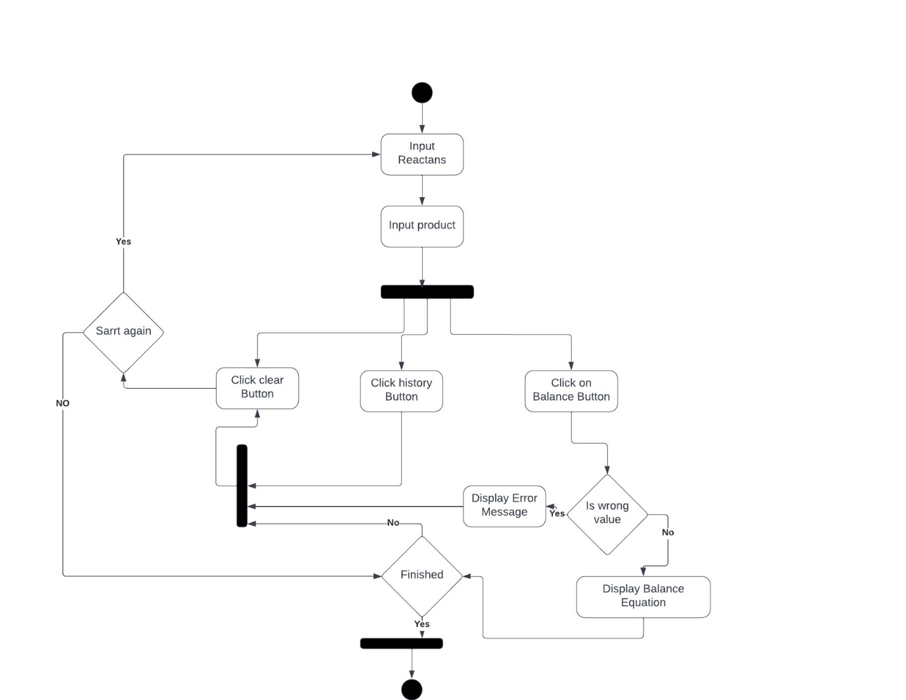

### Fig 5: Activity Diagram of balance equation