**Table 11: Use Case Description of Get Molar Mass**

|  |  |  |
| --- | --- | --- |
| **Use Case ID** | 04 | |
| **Use Case Name** | Get Molar Mass | |
| **Goal** | Get Molar Mass of a compound. | |
| **Preconditions** | Not Applicable | |
| **Success End Condition** | Molar Mass is displayed successfully | |
| **Failed End Condition** | The system shows an error message | |
| **Primary Actors:**  **Secondary Actors:** | End User  System | |
| **Trigger** | Click on the “Molar mass” from the sidebar menu | |
| **Main Success Flows** | **Step** | **Action** |
| 1 | The user enters compound in the input box. |
| 2 | The user clicks on the “Get Molar Mass” button |
| 3 | The system displays Molar Mass of the given compound and listed each element of the compound and their respective Atomic Mass |
| 4 | The user clicks on the clear button to clear input box. |
| **Alternative Flows** | **Step** | **Branching Action** |
| 1a | The user enters wrong compound in the input box |
| 3a | The system displays an error message |
| **Quality Requirements** | **Step** | **Requirement** |
|  | Not Applicable |

**Table 12: Use Case Description of Get Percent of Completion.**

|  |  |  |
| --- | --- | --- |
| **Use Case ID** | 05 | |
| **Use Case Name** | Get Percent of Completion | |
| **Goal** | To get the total percentage of completion for each element in the compound. | |
| **Preconditions** | Not Applicable | |
| **Success End Condition** | Percentage of completion is displayed successfully. | |
| **Failed End Condition** | The system displays an error message. | |
| **Primary Actors:**  **Secondary Actors:** | End Users  System | |
| **Trigger** | Click on the “Percent of completion” from the sidebar menu | |
| **Main Success Flows** | **Step** | **Action** |
| 1 | The user enters compound in the input box. |
| 2 | The user clicks on the “Percent of completion” button |
| 3 | The system displays Name of the elements and their Symbols, Total Atoms, Atomic Mass, and Percentage of Completion |
| 4 | The user clicks on the clear button to clear input box. |
| **Alternative Flows** | **Step** | **Branching Action** |
| 1a | The user enters wrong compound |
| 3a | The system displays an error message |
| **Quality Requirements** | **Step** | **Requirement** |
|  | Not Applicable |

**Table 13: Use Case Description of See Pie Chart for Percentage of Completion.**

|  |  |  |
| --- | --- | --- |
| **Use Case ID** | 06 | |
| **Use Case Name** | See Pie Chart for Percentage of Completion | |
| **Goal** | To display the total percentage of completion for each element in the compound. | |
| **Preconditions** | Need to find Percentage of Completion | |
| **Success End Condition** | Pie Chart is displayed successfully. | |
| **Failed End Condition** | The system displays an error message. | |
| **Primary Actors:**  **Secondary Actors:** | End Users  System | |
| **Trigger** | Click on the “Percent of completion” from the sidebar menu | |
| **Main Success Flows** | **Step** | **Action** |
| 1 | The user clicks on the “See Pie Chart” button |
| 2 | The system displays a pie chart of percentage of completion in a pop-up window |
| **Alternative Flows** | **Step** | **Branching Action** |
|  | Not Applicable |
| **Quality Requirements** | **Step** | **Requirement** |
|  | Not Applicable |

**Table 14: Use Case Description of Get Unknown Value in Titration**

|  |  |  |
| --- | --- | --- |
| **Use Case ID** | 07 | |
| **Use Case Name** | Get Unknown Value in Titration | |
| **Goal** | To get the unknown value in a titration | |
| **Preconditions** | Not Applicable | |
| **Success End Condition** | The system displays unknown value successfully | |
| **Failed End Condition** | The system displays an error message | |
| **Primary Actors:**  **Secondary Actors:** | End Users  System | |
| **Trigger** | Click on the “Titration” button from the sidebar menu. | |
| **Main Success Flows** | **Step** | **Action** |
| 1 | The user enters five known values in the input box among six. |
| 2 | The user selects units from dropdown of Molarity and Volume values. |
| 3 | The user keeps empty the input box of unknown value |
| 4 | The user clicks on the Get unknown value |
| 5 | The system displays the unknown value in the input box of unknown value. |
| 6 | The user clicks on the clear button to clear input box. |
| **Alternative Flows** | **Step** | **Branching Action** |
| 1a | The user enters less than five known values in the input box |
| 1b | The user enters wrong values in the input box |
| 5a | The system displays a message “Fill up any 5 fields to get unknown value” |
| 5b | The system displays an error message “Only numbers are allowed” |
| **Quality Requirements** | **Step** | **Requirement** |
|  | Not Applicable |

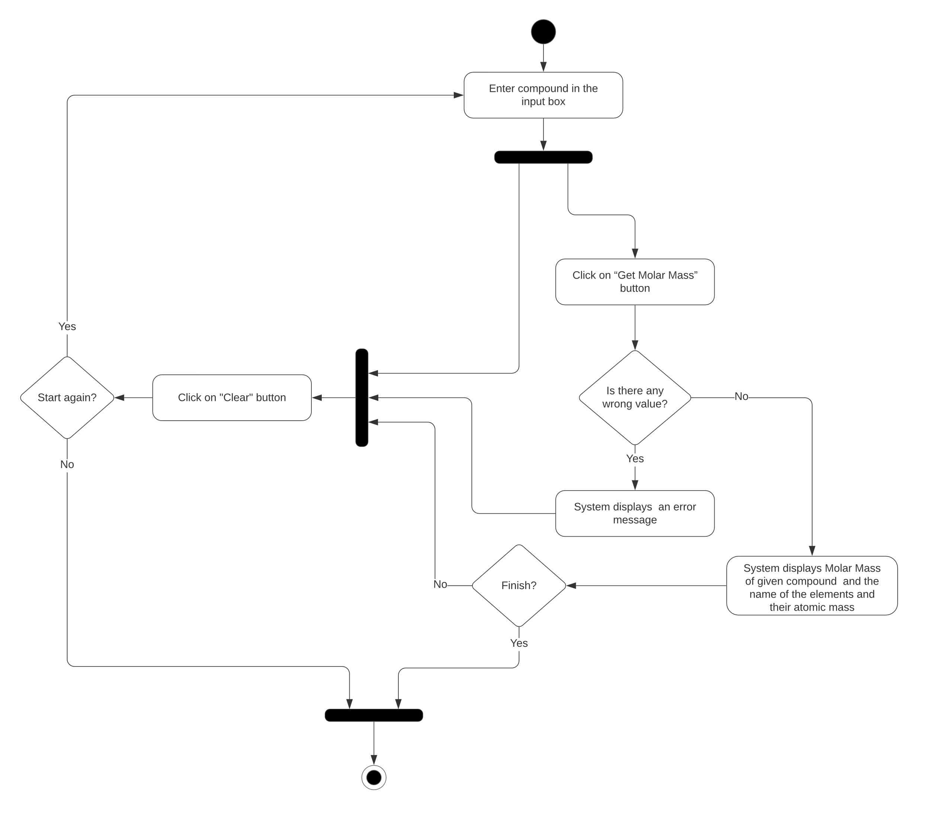

Figure : Activity Diagram of Get Molar Mass

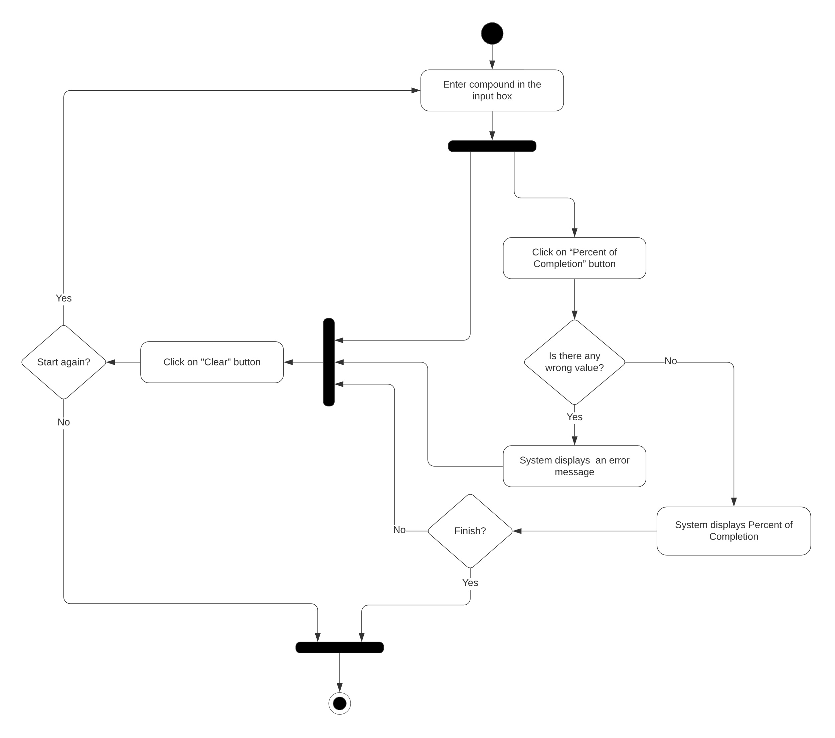

Figure : Activity Diagram of Get Percent of Completion

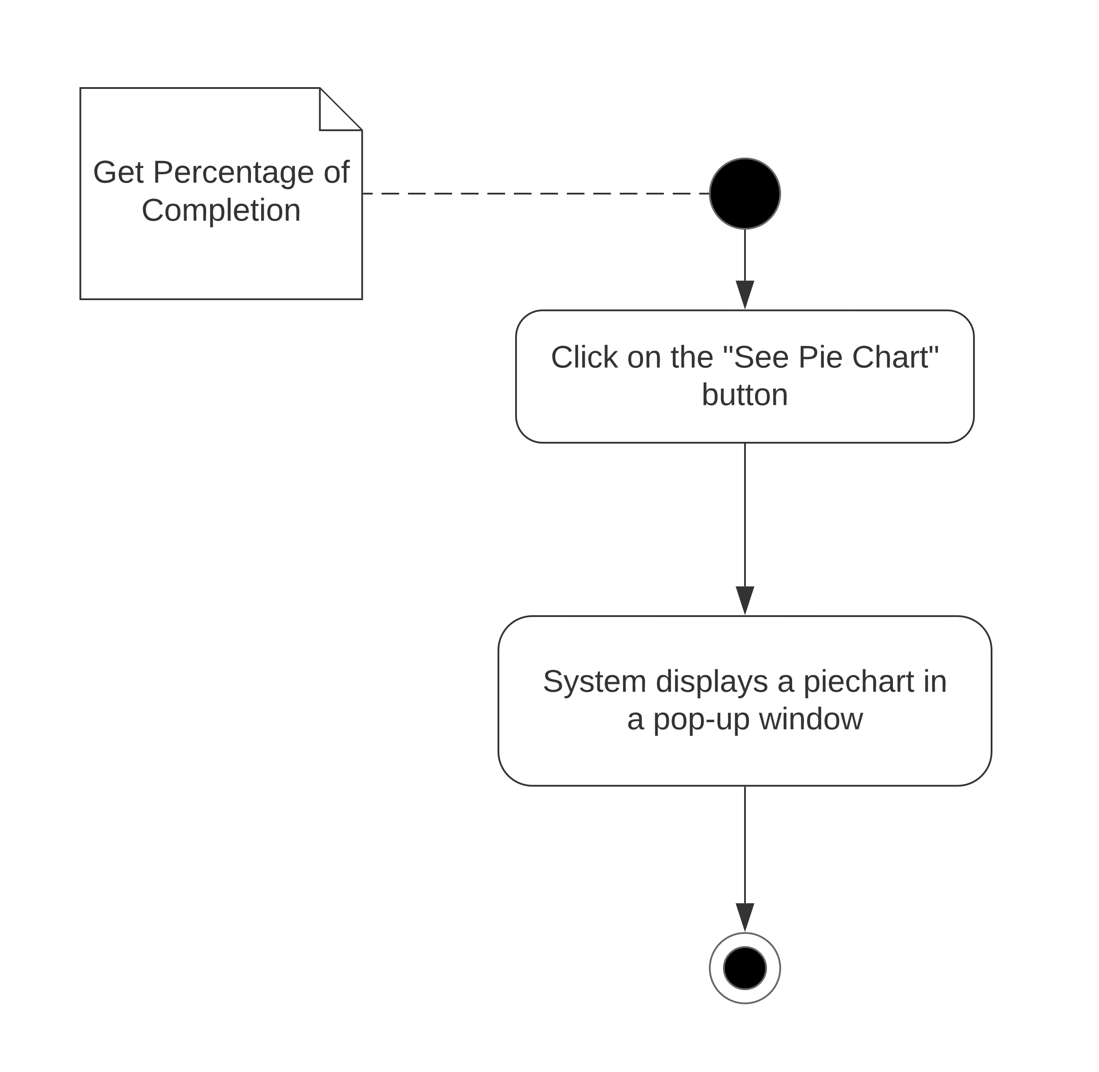

Figure : Activity Diagram of See Pie Chart of Percentage of Completion

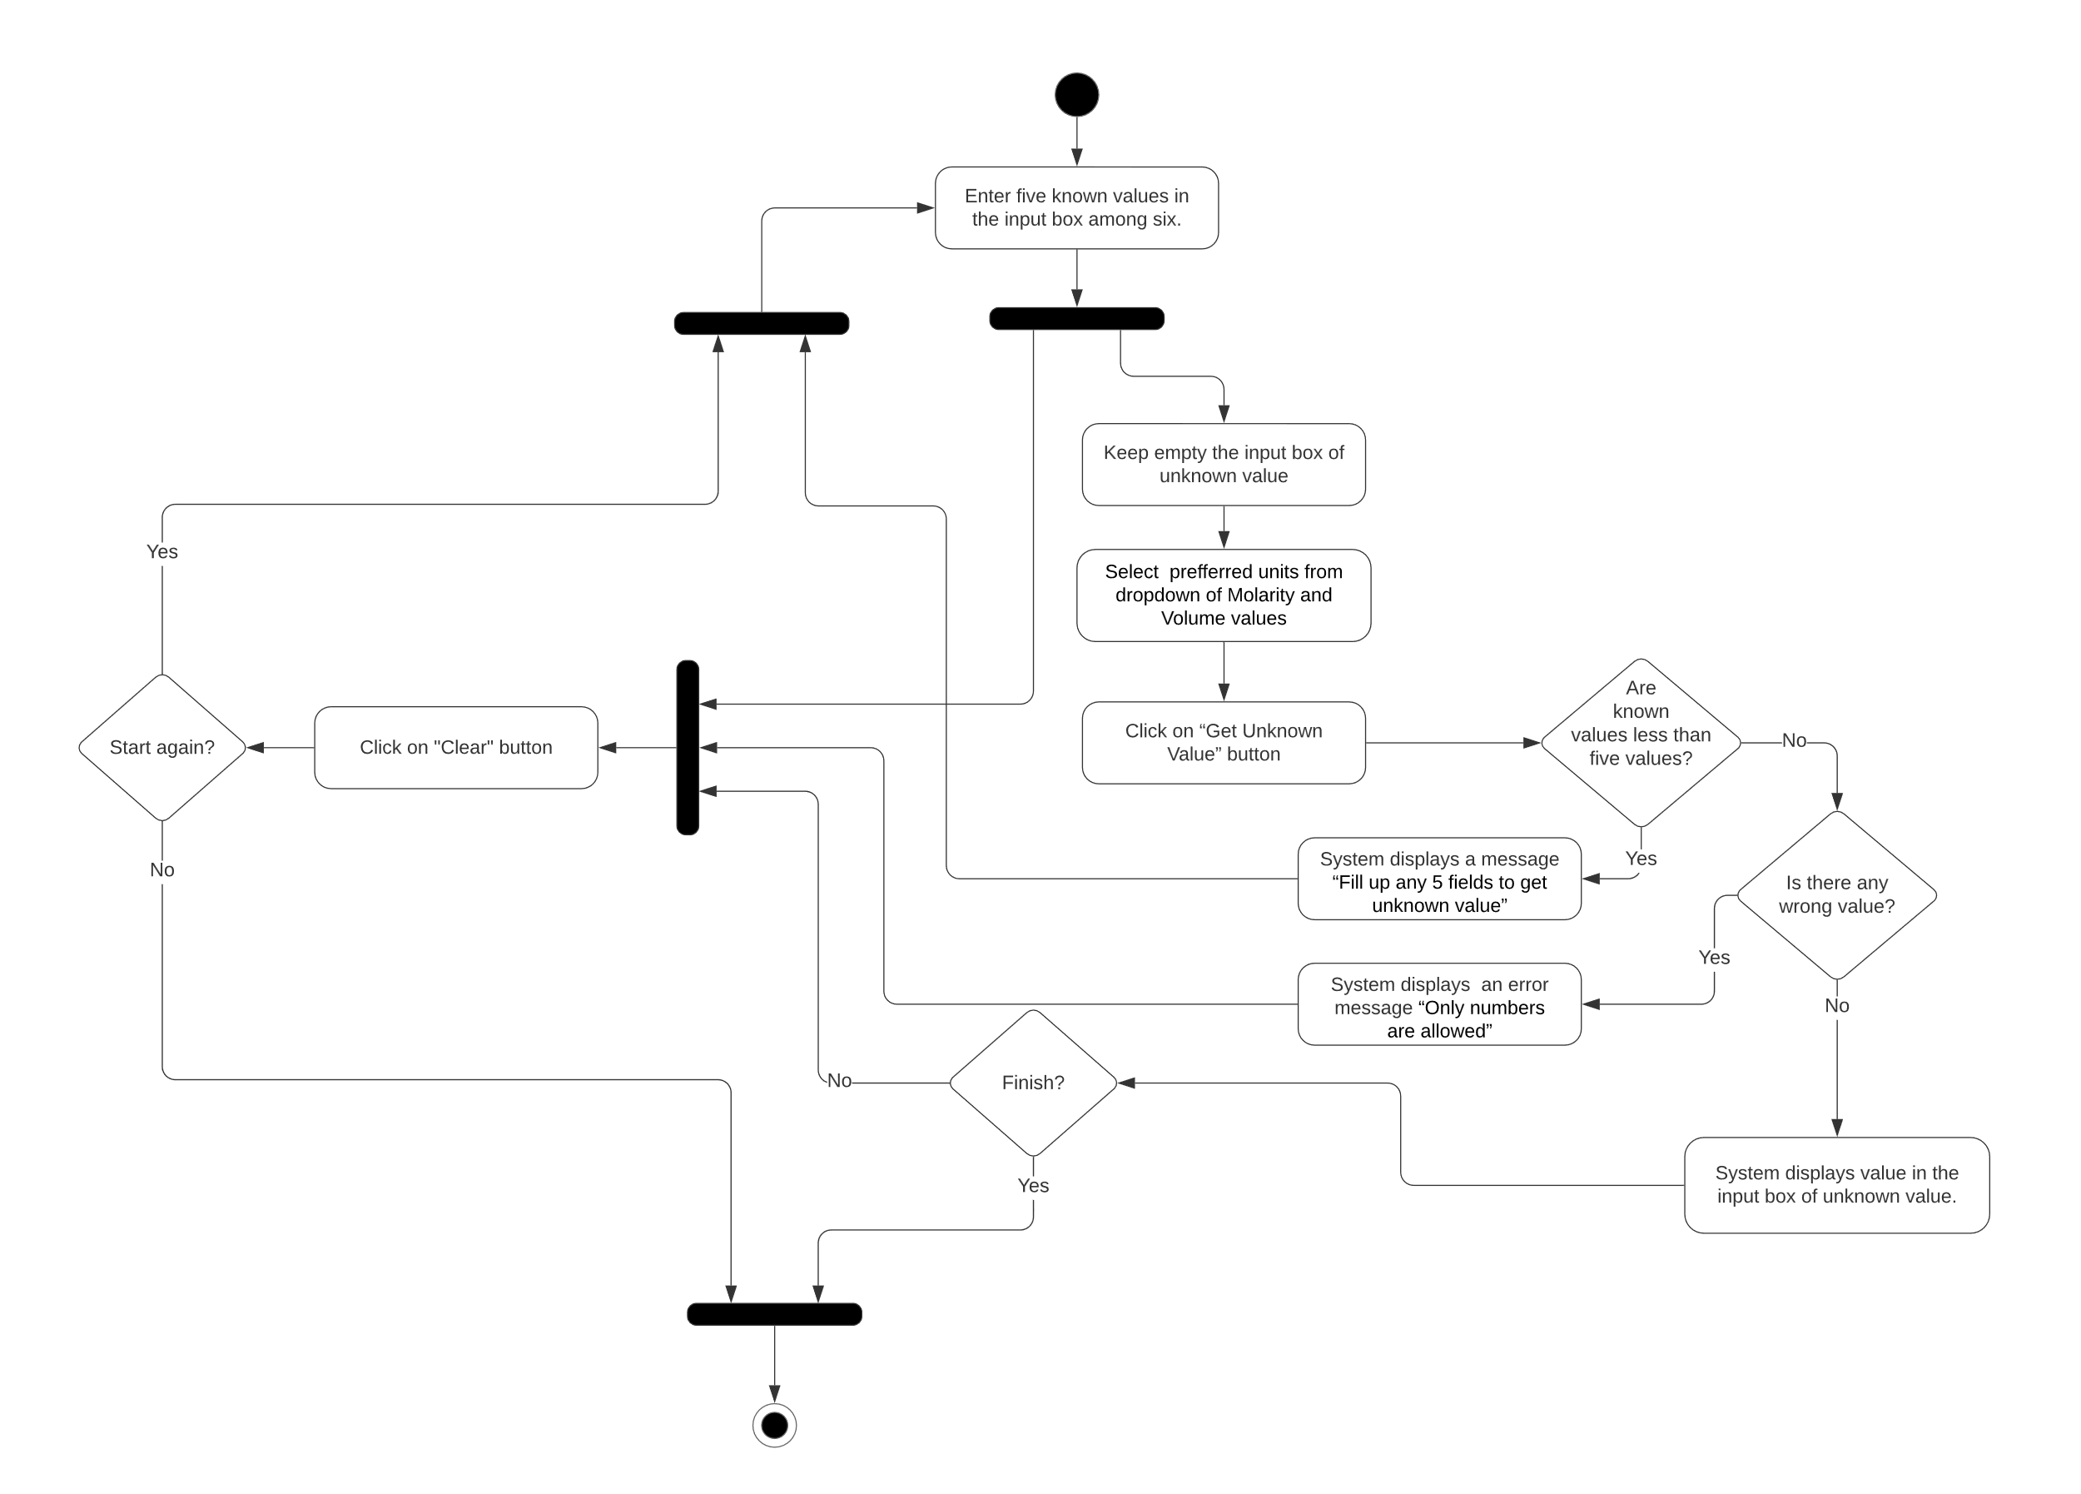

Figure : Activity Diagram of Get Unknown Value in Titration