Report

on

Refactoring project

Chemistry Calculator

Submitted to | Submitted by
Dipok Chandra Das  Assistant Professor, IIT, NSTU | Md. Mahabub Alam (ASH1825003M)  Abrar Hossain (ASH1825005M)  Nishat Tasnim Tamanna (BKH1825006F)  Md. Faisal Ahmed (ASH1825015M)  Moon Moon Das (BKH1825027F)

Introduction
Refactoring is the process of restructuring and improving the design of an existing codebase without changing its external behavior. The goal of the refactoring process is to improve the readability, maintainability, and extensibility of the codebase, making it easier for developers to understand and modify the code.
In this report, we will discuss the refactoring of a project named Chemistry Calculator, which provides many functionalities like-
- Equation balancing
- Electron configuration
- Molar msss
- Calculations of concentration and titration
In this document the refactoring process are performed by following these steps-
- Identification
- Selection
- Application
- Evaluation

Identification
The Chemistry Calculator project was identified as a potential candidate for refactoring due to several factors, including the size of the codebase, the complexity of the calculations, and the lack of clear structure in the code. The code was difficult to maintain, with many redundant and unnecessary statements that made it challenging to understand and modify the code. The code has several issues, such as poor naming conventions, lack of modularity, and duplicate code. The project also lacked proper documentation and testing, making it challenging to verify the accuracy of the calculations.

Selection
To begin the refactoring process, a thorough analysis of the existing codebase was conducted, and a list of potential areas for improvement was identified. The focus was on removing redundant code, simplifying complex calculations, and improving the structure and organization of the code. The selected approach for refactoring was a gradual refactoring process, where changes were made incrementally, ensuring that the code remained functional and accurate throughout the process.
Below are the code smells that are found in the project codebase-
- Remove Unused Imports
- Primitive Obsession
- Long Method
- Long Parameter List
- Large Class
- Comments
- Duplicated Code
- Inappropriate Naming
- Divergent Change
- Speculative Generality
- Dead Code
- Shotgun Surgery
- Inappropriate Intimacy

Class Name | Code Smell
Atom | Primitive Obsession, Inappropriate Naming, Shotgun Surgery
Compound | Long Method
CompoundManager | Long Method
Concentration
Converter
Database | Divergent Change, Speculative Generality, Shotgun Surgery
DatabaseSerializer | Long Method, Divergent Change, Speculative Generality
EquationBalancer | Long Method, Comments
Fraction
History | Inappropriate Naming, Speculative Generality, Inappropriate Intimacy
InsufficientDataException
InvalidAtomException
InvalidEquationException
Matrix | Inappropriate Naming
Titration | Long Parameter List, Inappropriate Naming
ConcentrationPanel | Long Method, Large Class, Inappropriate Naming
ElectronConfigPanel | Long Method, Inappropriate Naming, Large Class
EquationBalancePanel | Long Method, Inappropriate Naming, Large Class
Formater | Long Method, Inappropriate Naming
FxPieChart
HistoryFrame | Long Method, Comments
Home | Long Method, Inappropriate Naming, Shotgun Surgery
MolarMassPanel | Primitive Obsession, Long Method, Inappropriate Naming, Large Class, Comments
NeedHelpPanel | Long Method, Inappropriate Naming
PercentOfCompletionPanel | Primitive Obsession, Long Method, Inappropriate Naming, Large Class, Comments
Sidebar | Long Method, Comments, Shotgun Surgery
TitrationPanel | Long Method, Large Class, Comments
Table 1: Code smell found for each class

Application
The refactoring process involved several steps, starting with
- Restructuring each and every file with proper indentation and removing blank lines to make it more readable
- Removing redundant code (code that were commented to debug certain portion of the code)
- Performing remedy for each and every code smell that are found in the Selection process
Class Name | Remedy Applied
Atom | Replace array with object, Extract method, Move Method, Move Field
Compound | Extract Method
CompoundManager | Extract Method
Database → AtomDatabase | Extract Class, Extract Method, Inline method, Move Method, Move Field
EquationBalancer | Extract Method
History → HistoryManager | Inline method
Matrix | Extract Method
Titration | Extract Method
ConcentrationPanel | Extract Method, Extract Class
ElectronConfigPanel | Extract Method, Extract Class
EquationBalancePanel | Extract Method, Extract Class
Formater | Extract Method
HistoryFrame | Extract Method, Move method
Home | Extract Method, Move Method, Move Field
MolarMassPanel | Replace array with object, Extract Method, Extract Class
NeedHelpPanel | Extract Method
PercentOfCompletionPanel | Replace array with object, Extract Method, Extract Class
Sidebar | Extract Method, Move Method, Move Field
TitrationPanel | Extract Method, Extract Class
Table 2: Code smell remedy for each class

Evaluation
To evaluate whether refactored code improves maintainability, readability and modularity some of the techniques are-
- Code Quality Metrics
- Peer Review
- Unit Testing
- User Feedback
For Chemistry Calculator project evaluation we performed code quality metrics.

Code Quality Metrics
Code quality metrics are used to measure the quality of software code. Some commonly used code quality metrics that we used for Chemistry Calculator project:
- Weighted Methods per Class (WMC): WMC is a software metric that measures the complexity of a class in object-oriented programming. WMC is calculated by counting the number of methods in a class and assigning a weight to each method based on its complexity.
- Cyclomatic complexity: Measures the complexity of a program by counting the number of decision points in the code.
- Lines of code (LOC): Measures the number of lines of code in a program.
These quality metrics performed with MetricesReloaded plugin from Intellij Idea (Community Edition) software.

Before refactoring the lines of code per class is shown below
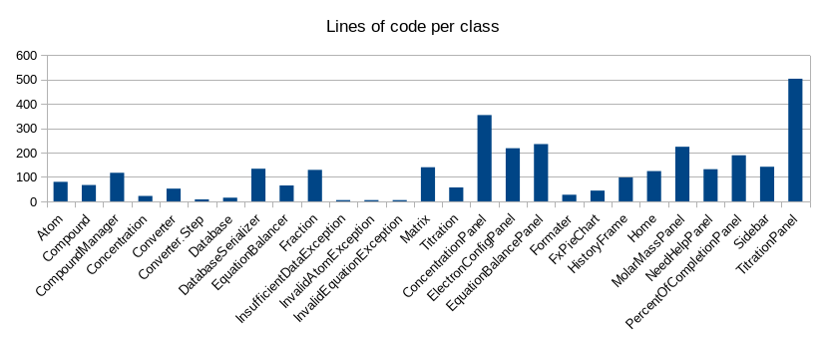
After refactoring the lines of code per class is
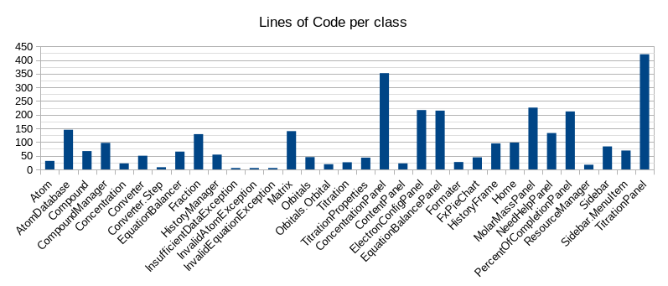

Before refactoring the weighted method per class is
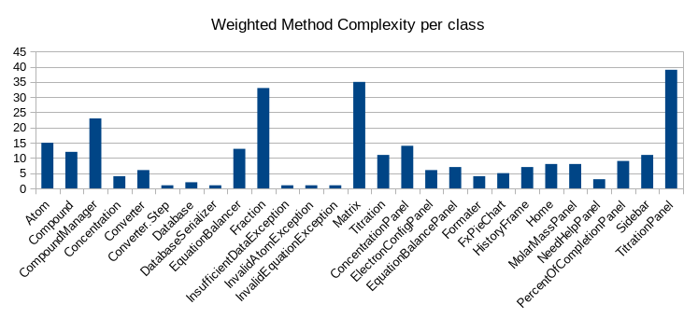
After refactoring the weighted method per class is
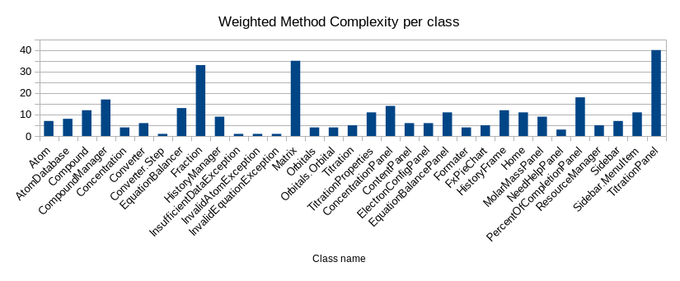

Conclusion
In conclusion, the refactoring process of the Chemistry Calculator project was successful in improving the readability, maintainability, and extensibility of the codebase. The approach used was a gradual refactoring process, ensuring that the code remained functional and accurate throughout the process. The refactored code was evaluated and found to be more readable, maintainable, and extensible than the original code. Overall, the refactoring process resulted in a more reliable and maintainable project that will be easier to modify and extend in the future.

