# Ssccoorriinngg – update 04 / 05/ 20

* Dataset: 40 healthy subjects (LORETA data)
* Leave-one-out CV
* Single channel EEG (F4 – M1)
* Time-dependency added (these results are based on adding 6 preceding and proceeding epochs)
* Changes in feature extraction: Wavelet decomposition up to level 4.
* Current results:

|  |  |  |  |  |  |
| --- | --- | --- | --- | --- | --- |
|  | Wake | N1 | N2 | SWS | REM |
| Accuracy (%) | 96.65 | 88.67 | 82.94 | 93.43 | 89.66 |
| Precision (%) | 90.05 | 84.18 | 83.35 | 89.19 | 72.14 |
| Recall (%) | 63.28 | 07.81 | 79.33 | 71.57 | 52.52 |
| F1-score (%) | 71.46 | 14.79 | 79.19 | 76.22 | 60.25 |

* Example of an acceptable prediction:

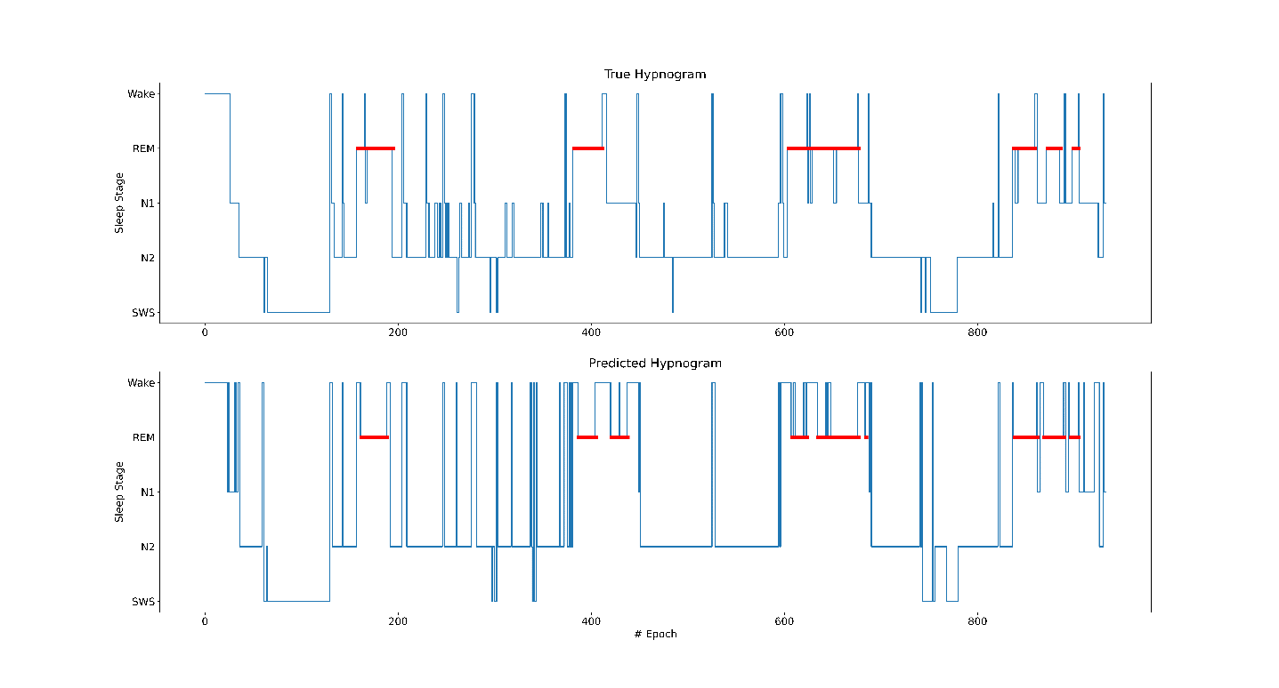

Plans for this week:

* Add features from EMG, EOG, ECG.
* Look up for methods how to improve N1 detection metrics.