Multi-route human health risk assessment of metals and metalloids: a systematic review, meta-analysis of edible aquatic tissue, and an integrated aggregate-exposure equation
Author list and affiliations to be inserted
Corresponding author: to be inserted

Highlights
- Twelve studies were synthesised; two measured a metal in water and in fish at the same site, but none combined media into one human intake.
- Random-effects meta-analysis of edible aquatic tissue (k = 5) gave pooled geometric means of 57 µg/kg for Pb and 7.6 µg/kg for Cd, with I² > 99%.
- Prediction intervals spanning three to six orders of magnitude show that pooled literature values cannot substitute for local measurements.
- An aggregate-exposure equation adds water, diet and air per metal, nests the EPA and REACH approaches, and returns an empirical source contribution.
- Toxicity values changed recently: the 2025 IRIS oral RfD for inorganic arsenic is fivefold lower and its slope factor 21-fold higher.

Abstract
Human exposure to metals and metalloids occurs simultaneously through drinking water, food and inhaled air, yet published risk assessments almost always treat one medium at a time. This review set out to synthesise the multi-route evidence and to derive from it a single equation that combines all media. PubMed, Web of Science, Embase and Scopus were searched to 30 November 2024 (5,499 records); 12 studies with full text met the eligibility criteria and one further study awaits verification. Data were re-extracted with explicit unit, matrix and wet/dry basis provenance, risk of bias was assessed in six domains, and every toxicity value was checked against the issuing agency. Two studies measured metals in water and in fish at the same site, but no study measured ambient air and none combined media into one human intake. A random-effects meta-analysis was feasible for one comparable stratum, edible aquatic animal tissue on a wet-weight basis (k = 5; 1,232 samples or composites). Pooled geometric means were 57.4 µg/kg (95% CI 11.7–282) for lead, 7.55 µg/kg (0.83–68.9) for cadmium and 72.0 µg/kg (1.72–3,016) for total arsenic, with I² of 99.4–99.9% and 95% prediction intervals spanning three to six orders of magnitude, so that a pooled value cannot represent the exposure of any particular population. Reference values were heterogeneous and, in several studies, outdated or applied to the wrong route; in 2024–2025 the US EPA revised the oral values for hexavalent chromium and inorganic arsenic, the latter to an RfD of 0.06 µg/kg bw/day and a slope factor of 32 per mg/kg-day. Building on the WHO allocation procedure, US EPA guidance and the REACH route-summation approach, we propose an integrated equation that converts water, food and air to a common dose scale, sums route-specific hazard quotients into an aggregate hazard index for threshold agents, uses a margin of exposure for lead and inorganic arsenic, adds route-specific cancer risks, and returns the empirical contribution of each medium in place of the default 20% relative source contribution. An illustration with co-located lake-water and fish data showed that the dominant medium differed by metal, that chromium speciation changed the conclusion by three orders of magnitude, and that an unmeasured air pathway could raise the hazard index thirtyfold. The equation is intended for, and requires, co-located measurements in one population.

Keywords
Heavy metals; aggregate exposure; multi-route risk assessment; hazard index; margin of exposure; relative source contribution; meta-analysis; systematic review

1. Introduction
Metals and metalloids are among the most persistent contaminants in the human environment. Cadmium, chromium, mercury, lead and nickel are metals; arsenic is a metalloid; all of them occur together in soil, water, air and the food chain, several accumulate in the body over decades, and their toxicity spans neurotoxicity, nephrotoxicity, cardiovascular disease and cancer. Human health risk assessment is the principal quantitative tool for translating measured environmental concentrations into statements about population risk and for setting the limits that follow from them [1].
The architecture of the method is well established. Hazard identification, dose–response assessment, exposure assessment and risk characterisation are applied in sequence; non-carcinogenic risk is expressed as a hazard quotient or hazard index and carcinogenic risk as an incremental lifetime cancer risk [1, 2]. What varies enormously is the scope of the exposure assessment. Most published assessments consider a single medium: drinking water, ambient air, settled dust or a defined set of foods.
People do not encounter metals one medium at a time. A population drinking water from a contaminated aquifer usually also eats crops irrigated with it and breathes dust derived from the same geology. Assessing each pathway in isolation can only underestimate the total, and the size of the underestimate depends on how the pathways covary within individuals.
Regulators have handled this problem in two ways. The WHO and the US EPA allocate a fixed fraction of the tolerable intake to the medium being regulated, by default 20% for drinking water, bounded between 20% and 80% when data allow [3–5]. The European approach under REACH estimates exposure separately for each route, divides each by a route-specific derived no-effect level and sums the resulting risk characterisation ratios [6]. The first is a device for setting a single-medium standard when only one medium has been measured; the second is a procedure for judging total exposure when all of it has been. Which is more protective in a given setting is an empirical question that requires measurements of the same metal in every relevant medium, in the same population, at the same time.
This review had three objectives: (i) to characterise the media, metals, methods and reference values used in the eligible literature, including its risk of bias; (ii) to determine quantitatively, by meta-analysis where a comparable stratum exists, how far that literature can be pooled; and (iii) to derive, from authoritative guidance rather than from the pooled data, an integrated equation that combines water, food and air for one metal and one population, and to specify the data it requires.

2. Materials and methods

2.1 Protocol and reporting
The review follows the PRISMA 2020 statement [7]. A written protocol specifying the search, eligibility criteria, extraction template and synthesis rules was agreed before extraction began; it was not registered prospectively, which is acknowledged as a limitation. The amendments made at revision (the restricted meta-analytic stratum of Section 2.7, the risk-of-bias assessment and the verification of toxicity values) are reported as protocol deviations. The review question was framed with the PICOS structure (Table S1).

2.2 Search strategy
PubMed, Web of Science Core Collection, Embase and Scopus were searched to 30 November 2024. Search terms combined the target analytes (aluminium, arsenic, cadmium, chromium, mercury, lead, nickel and synonyms, assembled from MeSH headings) with terms for human health risk assessment, exposure route and environmental medium, joined with the Boolean operators AND and OR. The complete string for each database is given in Table S2. Reference lists of included studies were hand-searched.

2.3 Eligibility criteria
Inclusion. Peer-reviewed primary studies published from 2000 onwards that reported measured concentrations of at least one target element in drinking water, food as consumed or ambient air, and that either reported a quantitative human health risk metric (hazard quotient, hazard index, target hazard quotient, cancer risk) or provided every parameter needed to derive one, using a validated analytical method with quality assurance and quality control.
Exclusion. Studies were excluded if they: (a) reported no human exposure scenario (population, intake rate or body weight); (b) were analytical-method or instrument-validation studies; (c) were spiking, greenhouse or pot experiments in which concentrations are set by the investigator; (d) examined biological matrices alone (blood, urine, hair); (e) relied solely on modelling without measured concentrations; or (f) were short reports or conference abstracts. Criteria (b) and (c) were made explicit at revision and removed two studies at re-screening (Section 3.1).

2.4 Study selection and data extraction
Records were de-duplicated in EndNote X8 and screened on title and abstract in Rayyan by two reviewers independently, with disagreements resolved by consensus and a third reviewer adjudicating. Full texts were assessed by the same procedure. Data were extracted into a long-format template with one row per study, matrix and metal, carrying for every value the medium and matrix, the basis (wet, dry or as consumed), the reported and harmonised unit, the statistic (mean, median, single value), the routes assessed, the reference dose used and its cited source, and the source table (Table S3). Concentrations, daily intakes and average daily doses were held in separate fields. Values below the limit of detection were recorded as such and never entered as zero.

2.5 Data quality control
Every extraction round passed an automated gate of fourteen checks before analysis (Table S4; File S1), which rejects values outside a medium-specific plausibility envelope, cancer risks outside [0, 1], incompatible units within one medium, food values without a declared basis, reference doses departing more than threefold from the issuing agency value or lacking a citation, standard deviations more than ten times the mean, means outside the reported range, non-intake matrices and censored values entered as zero. Every revision made against the source PDFs is listed in Table S11.

2.6 Risk of bias
Risk of bias was assessed for each study in six domains adapted for environmental monitoring studies: (1) sampling design and representativeness; (2) analytical method suitability for the matrix and concentration range; (3) analytical quality control (certified reference materials, recovery, limits of detection); (4) completeness and population-specificity of exposure parameters; (5) handling of values below the detection limit; and (6) chemical speciation where the toxicity value depends on it, together with internal consistency of reported results. Each domain was rated low, some concerns or high (Table S5).

2.7 Meta-analysis
Pooling was pre-specified for strata containing at least five independent studies (gate 1) with a comparable matrix on a single wet- or dry-weight basis (gate 2). The original stratification by metal and medium (“food”) mixed cereals, vegetables, seaweed and animal tissue and failed gate 2. At revision a single biologically and analytically coherent stratum was defined: edible aquatic animal tissue (fish, crustacean and mollusc muscle or whole edible portion, including canned fish) on a wet-weight basis. Hepatopancreas, liver, gills and seaweed were excluded. Five studies qualified [8–12]. The Persian Gulf study was excluded because its reported means lie outside its own ranges and its units cannot be reconciled (Section 3.4) [13].
For each study one summary per metal was derived. Where a study reported several species or product groups, these were combined into a single study-level mean and SD with the standard formula for combining groups [14]; for canned fish the mean and SD were computed across the 34 reported products; for crayfish the authors’ dry-to-wet factor of 5.75 was applied to the muscle values [9]. Because concentrations are right-skewed, each arithmetic mean and SD was converted to the mean and variance of the log concentration under a log-normal assumption, σ² = ln(1 + SD²/mean²), μ = ln(mean) − σ²/2, var(μ) = σ²/n [15]. Log-scale estimates were pooled with a random-effects model, τ² estimated by restricted maximum likelihood [16], and the confidence interval computed with the Hartung–Knapp–Sidik–Jonkman method (with the variance multiplier truncated at 1), which is recommended when studies are few and heterogeneous [17]. Heterogeneity is reported as τ², Q and I² [18], together with the 95% prediction interval (t distribution, k − 2 df) [19]. Results are back-transformed to geometric means in µg/kg wet weight. Leave-one-out analysis assessed the influence of each study. Mercury, methylmercury, chromium and copper had fewer than five studies in the stratum and are reported descriptively.
The analysis was programmed in Python 3 (NumPy, SciPy) and validated against the metafor package for R [20] on the standard BCG-vaccine dataset, reproducing the REML estimate (−0.7145), its standard error (0.1798), τ² (0.3132) and Q (152.23) to four decimal places. Code and input data are provided as File S3 and Table S12.

2.8 Verification of toxicity reference values
Every reference value used by a source study was compared with the current value of the agency it cited. Current oral and inhalation values were taken from the US EPA Integrated Risk Information System (IRIS) [21–24], ATSDR minimal risk levels [25, 26], California OEHHA [27], EFSA and JECFA opinions [28–34] and the WHO Guidelines for Drinking-water Quality [3] (accessed October 2026).

2.9 Derivation of the integrated equation
The integrated equation (Section 4) was derived from the WHO procedure for threshold chemicals and allocation factors [3], US EPA guidance for oral, inhalation, probabilistic and mixture assessment [1, 2, 35, 36], the EPA methodology for relative source contribution [4] and ECHA guidance on derived no-effect levels and route-to-route extrapolation [6]. It was applied to the one co-located dataset in the review as an illustration (Section 4.9).

3. Results

3.1 Study selection
The search returned 5,499 records. After removal of 1,880 duplicates, 3,619 records were screened and 3,534 excluded; 85 full texts were assessed and 70 excluded (reasons in Table S6), leaving 15 studies. Two were removed at re-screening under criteria (b) and (c): an evaluation of a spark-induced breakdown spectroscopy analyser for airborne particulate metals, which reports no exposure scenario or risk metric, and a greenhouse pot experiment in which arsenic was added to soil. Of the remaining 13, the full text of one (a survey of drinking-water treatment plants in Nanjing) could not be retrieved; it is listed as awaiting verification. Twelve studies entered the synthesis and five the meta-analysis (Figure 1).
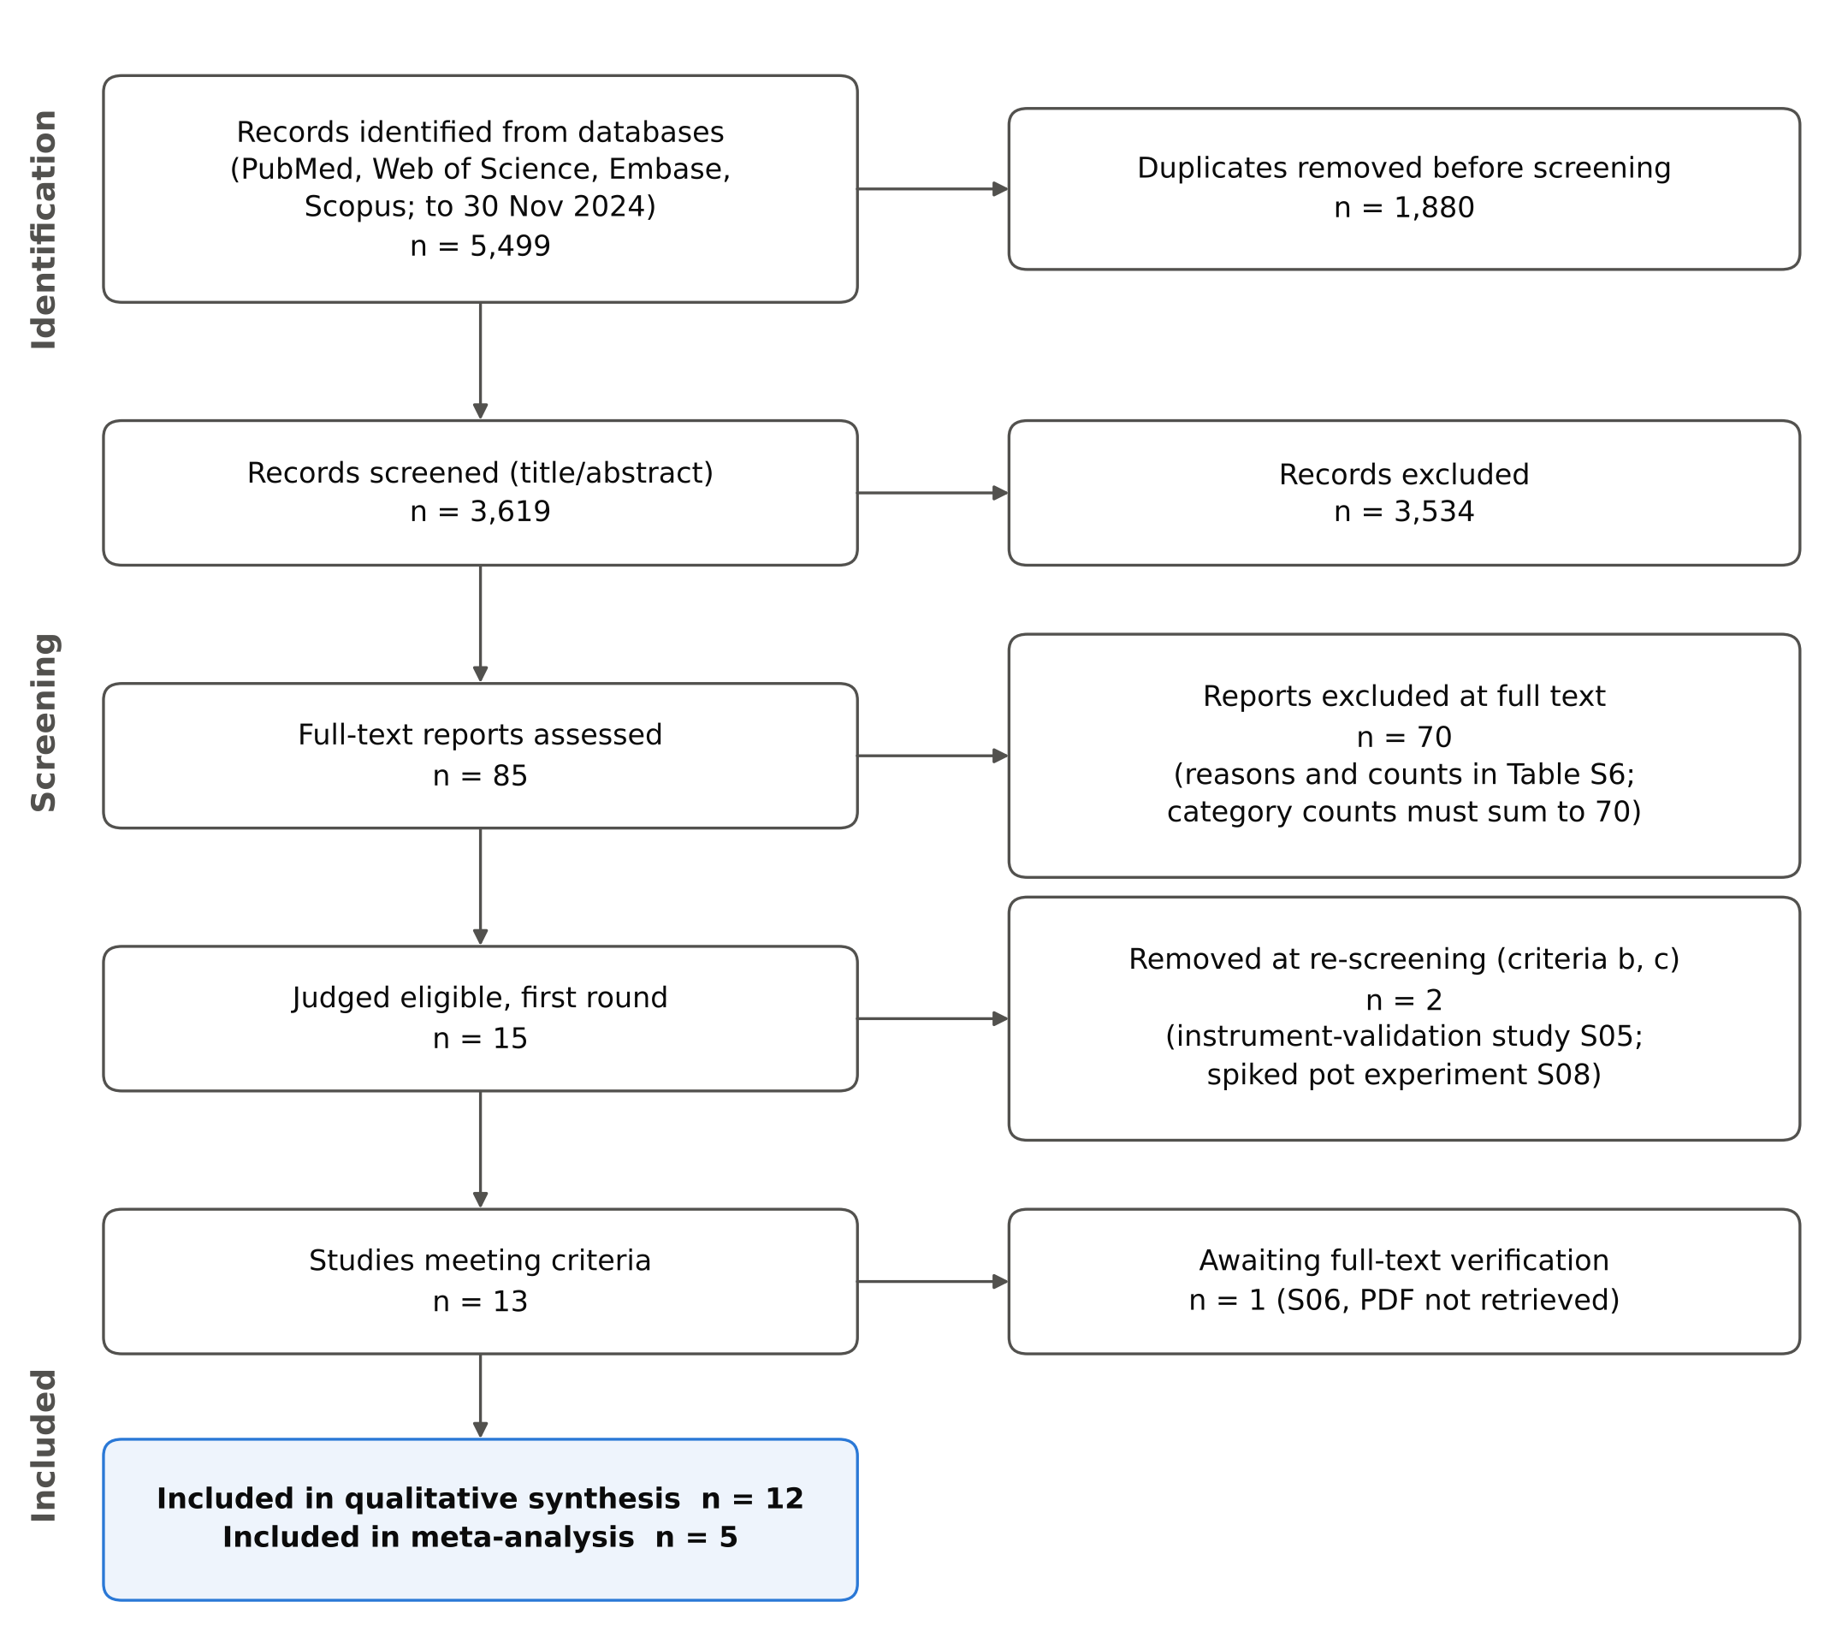
Figure 1. PRISMA 2020 flow diagram of study selection.

3.2 Characteristics of the included studies
The 12 studies were published between 2017 and 2024 in China (four), Bangladesh (two), the Philippines (two), Iran, Türkiye, the Republic of Korea and the United Arab Emirates (one each). Seven assessed food, three drinking or domestic water and two settled street dust; none measured ambient air. Three incorporated Monte Carlo exposure modelling [8, 37, 38] and one measured matrix-specific bioaccessibility [8]. Characteristics are summarised in Table 1.
Table 1. Characteristics of the 12 included studies.
ID | Study | Country, setting | Medium · matrix (n) | Metals | Risk metrics | Media measured at the same site
S01 | Wang 2024 [8] | China, smelting city (NW) | Food · 6 groups incl. carp (8 markets) | As Cd Cr Cu Ni Pb | HQ, HI, CR; MC; bioaccessibility | Food only
S02 | Zhang 2023 [9] | China, Qianjiang | Food · crayfish muscle, hepatopancreas (38 sites) | As Cd Cu Hg Pb | THQ, TTHQ, CR | Food only
S03 | Torabi 2023 [13] | Iran, NW Persian Gulf | Food · 3 marine fish species | Cd Cu Ni Pb Zn | EDI, THQ, CR | Food only
S04 | Semerjian 2024 [39] | UAE, Sharjah | Street dust (68 sites) | 9 elements | HI by ingestion, dermal, inhalation; CR | Dust only
S07 | Hoque 2024 [40] | Bangladesh, Chattogram | Groundwater (117 wells) | As Cd Cr Cu Fe Mn Zn | HQ, HI, CR | Water only
S09 | Rahman 2022 [41] | Bangladesh, Jessore | Chicken and fish tissues (5 farms) | As Cr Pb | THQ, TTHQ, CR | Pond water, sediment, feed, droppings, chicken, fish
S10 | Kosker 2023 [10] | Türkiye, national retail | Canned fish (34 products) | Al As Cd Cr Cu Fe Pb Se Zn | EWI, THQ, CR | Food only
S11 | Kim 2023 [11] | Korea, national | Fishery products (1,186 samples; 7 categories) | As Cd Hg MeHg Pb | EDI, HI | Food only
S12 | Senoro 2022 [37] | Philippines, Marinduque | Domestic water (100 points) | As Ba Cu Fe Mn Ni Pb Zn | HQ, HI, TCR; MC | Water only
S13 | Zhang 2019 [42] | China, 58 cities | Street dust (secondary data, 2000–2018) | 10 elements | HQ, HI by route; CR | Dust only
S14 | Senoro 2023 [38] | Philippines, Occidental Mindoro | Drinking water (71) and groundwater (33) | 9 elements | HI, CR; MC | Water only
S15 | Zhang 2017 [12] | China, Honghu Lake | Fish muscle and organs, 6 species (72) | As Cd Cr Cu Pb Zn | THQ, CR, EWI; BCF | Lake water (20 sites) and fish
BCF, bioconcentration factor; CR, cancer risk; EDI/EWI, estimated daily/weekly intake; HI, hazard index; HQ, hazard quotient; MC, Monte Carlo simulation; TCR, total cancer risk; THQ/TTHQ, (total) target hazard quotient. Study S06 (Nanjing water treatment plants) awaits full-text verification and is not included.

3.3 Multi-route coverage
No study measured ambient air, and no study combined the media it measured into a single human intake. Two studies did, however, measure the same metals in more than one environmental compartment at the same site (Figure 2). Rahman et al. analysed arsenic, lead and chromium in pond water, sediment, chicken feed, droppings, chicken and fish at the same five integrated farms [41]; Zhang et al. measured arsenic, cadmium, chromium, copper, lead and zinc in Honghu Lake water at 20 sites and in the fish caught there, and reported bioconcentration factors [12]. In both, the water was surface or pond water used for aquaculture rather than drinking water, and it was used to explain accumulation in the food, not as a second exposure route. The statement in the previous version of this review that no study measured any metal in more than one medium is therefore corrected: co-located data exist, but not co-located human intake from more than one route.
Summing concentrations from different studies would construct a hypothetical individual who eats in one country, drinks in a second and breathes in a third. The relative contribution of each medium derived from such a sum is determined by which studies the search retrieved, not by human exposure.
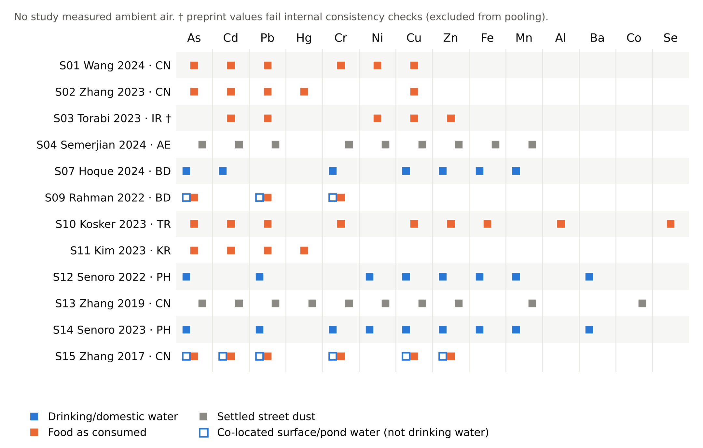
Figure 2. Evidence map. Each marker is a metal measured by a study in a given medium. Open markers show surface or pond water measured at the same site as the food but not used as drinking water. No study measured ambient air.

3.4 Risk of bias
Risk of bias is summarised in Table S5. Three findings bear directly on the use of the data. First, both Philippine water studies measured metals with a field-portable X-ray fluorescence analyser and an electrochemical metals analysis system [37, 38]; these instruments are designed for solids and screening, and their detection limits are poorly matched to the µg/L range relevant to drinking water. The resulting mean concentrations in drinking water, 1.152 mg/L for lead and 0.792 mg/L for arsenic in one study [38], exceed the WHO guideline values by factors of about 115 and 80 [3] and drive the hazard index of 86 reported there; they were rated high risk of bias for analytical suitability and are not carried into any quantitative synthesis. Second, the Persian Gulf study reports means that lie outside its own minimum–maximum ranges (for example, nickel mean 80.3 with range 0.39–1.83), SDs of exactly zero, and units printed as mg/g that are physically impossible for fish muscle [13]; it was rated high risk for internal consistency, and values should be re-extracted from the version of record. Third, speciation was measured only for mercury (methylmercury in Korean fishery products) [11]; arsenic and chromium were reported as totals in every study.

3.5 Meta-analysis of edible aquatic tissue
Five studies contributed to the edible-aquatic-tissue stratum, representing 1,232 samples or composites for lead (Figure 3, Table 2). The pooled geometric mean concentration was 57.4 µg/kg wet weight for lead (95% CI 11.7–282), 7.55 µg/kg for cadmium (0.83–68.9) and 72.0 µg/kg for total arsenic (1.72–3016). Heterogeneity was extreme for all three metals (I² 99.4–99.9%), and the 95% prediction intervals, 0.66–4970 µg/kg for lead and 0.016–3665 µg/kg for cadmium, span between three and six orders of magnitude. Study weights were almost equal (19.9–20.1%) because between-study variance dwarfed within-study sampling error; the pooled mean is therefore close to the unweighted geometric mean of five very different products.
The pooled values were not driven by any single study for lead (leave-one-out range 40.2–84.9 µg/kg) or cadmium (5.18–15.7 µg/kg). For arsenic, omitting the Honghu Lake study, in which five of six species were below detection and recorded as zero, raised the pooled mean from 72.0 to 244 µg/kg. The arsenic analysis combines freshwater fish, in which inorganic arsenic forms a larger share of a small total, with marine crustaceans and molluscs, in which most arsenic is arsenobetaine of low toxicity; the pooled total-arsenic value has no toxicological interpretation and is shown only to document heterogeneity. Of the metals with fewer than five studies, mercury averaged 86.9 µg/kg in crayfish muscle [9] and 119 µg/kg in Korean fishery products, of which methylmercury was 23.3 µg/kg [11].
The practical meaning of the prediction interval is easily shown. At a fish intake of 54 g/d and a body weight of 61.6 kg [12], the pooled lead concentration corresponds to a dose of 50.6 ng/kg bw/day and an MOE of 12.5 against the EFSA BMDL for kidney disease; across the prediction interval the MOE ranges from 0.14 to 1079. The same literature therefore supports any conclusion from serious concern to none, depending on which population is meant. A pooled literature value is no substitute for a local measurement, and this is the quantitative basis of the central argument of this review.
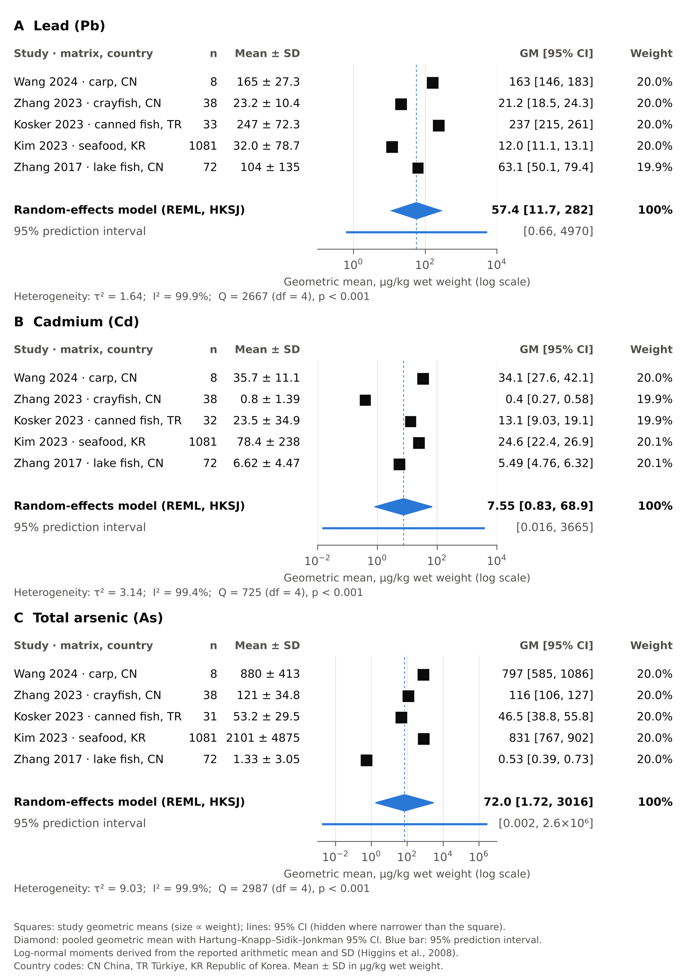
Figure 3. Forest plots of metal concentrations in edible aquatic animal tissue (wet weight): (A) lead, (B) cadmium, (C) total arsenic. Random-effects model on the log scale (REML, Hartung–Knapp–Sidik–Jonkman confidence interval); geometric means in µg/kg.
Table 2. Random-effects meta-analysis of metal concentrations in edible aquatic animal tissue (µg/kg wet weight).
Metal | k | n | Pooled GM (95% CI) | 95% PI | τ² | I² (%) | Q (p) | Leave-one-out GM range
Lead | 5 | 1,232 | 57.4 (11.7–282) | 0.66–4970 | 1.64 | 99.9 | 2667 (<0.001) | 40.2–84.9
Cadmium | 5 | 1,231 | 7.55 (0.83–68.9) | 0.016–3665 | 3.14 | 99.4 | 725 (<0.001) | 5.18–15.7
Total arsenic | 5 | 1,230 | 72.0 (1.72–3016) | 0.0020–2.6×10⁶ | 9.03 | 99.9 | 2987 (<0.001) | 39.0–244
k, studies; n, samples or composites; GM, geometric mean; CI, Hartung–Knapp–Sidik–Jonkman confidence interval; PI, prediction interval. Descriptive only (k < 5): Hg (S02 86.9; S11 118.8 µg/kg), MeHg (S11 23.3), Cr (S01 207; S10 413; S15 1,013) and Cu (S01 268; S02 2,782; S10 4,454; S15 879 µg/kg).

3.6 Methodological heterogeneity

3.6.1 Exposure parameters
Body weights of 15 to 70 kg, water ingestion rates of 1.0 to 2.2 L/d, fish consumption rates of 10.5 to 54.3 g/d, exposure durations of 6 to 72 years and averaging times of 3,650 to 25,550 days were applied. One study measured bioaccessibility [8]; the others assumed complete absorption. Parameters by study are in Table S8.

3.6.2 Reference values
The same metal was assessed against different reference values in different studies, and three systematic errors were found. (i) Outdated values. Every study whose reference values could be extracted used the inorganic-arsenic oral RfD of 0.3 µg/kg bw/day [9–12, 38–41], with the slope factor of 1.5 per mg/kg-day where cancer risk was computed; in January 2025 the US EPA replaced them with 0.06 µg/kg bw/day and 32 per mg/kg-day [21]. Hexavalent chromium assessments used the 1998 RfD of 3 µg/kg bw/day, revised to 0.9 in August 2024 [22]. Results computed with the older values are not wrong for their date, but they understate the arsenic hazard fivefold and the cancer risk 21-fold relative to current values. (ii) Wrong route. One dust study used oral reference doses as “inhalation RfDs” for arsenic, cadmium, chromium and copper [39]; inhalation should be assessed against an RfC or IUR applied to an air concentration [2]. (iii) Wrong species or form. Hazard quotients for mercury in fishery products used the inorganic-mercury RfD (0.3 µg/kg bw/day) for total mercury [11], although the same study measured methylmercury, for which the relevant value is 0.1 [24]; two studies assessed chromium against the Cr(III) RfD of 1,500 µg/kg bw/day [12, 41] while others used the Cr(VI) value, a 500- to 1,700-fold difference for the same total-chromium measurement, and one of them combined the Cr(III) RfD for the hazard quotient with a Cr(VI) slope factor for cancer risk on the same data [41]; lead was assessed against RfDs ranging fourteenfold, from 1.4 [40] through 3.5 [11, 38, 39] and 4 [10, 12, 41] to 20 µg/kg bw/day [9], although the US EPA publishes no lead RfD and EFSA and JECFA have withdrawn the tolerable weekly intake [28]. Weekly intakes in the Honghu Lake study were likewise compared with the JECFA provisional tolerable weekly intakes for lead (25 µg/kg) and cadmium (7 µg/kg), both withdrawn in 2010–2011 [12, 34]. For lead and inorganic arsenic a margin of exposure against a benchmark dose is required [28, 30, 43]. Reference values used by each study are compared with current values in Table S9, and current values are given in Table 3.
Table 3. Current health-based reference values for the priority metals (verified October 2026). Oral values in µg/kg bw/day; inhalation in µg/m³.
Element | Oral threshold value | Non-threshold reference point (MOE) | Oral cancer slope factor | Inhalation (RfC; IUR) | WHO drinking water (allocation)
Inorganic As | RfD 0.06 (IRIS 2025; was 0.3) [21] | BMDL₀₅ 0.06, skin cancer (EFSA 2024) [30] | 32 per mg/kg-day (IRIS 2025; was 1.5); linear < 0.2 µg/kg/d | RfC 0.015 (OEHHA) [27]; IUR 4.3×10⁻³ [24] | 10 µg/L, provisional (achievability)
Cd | RfD 0.5 water, 1.0 food (IRIS) [23]; MRL 0.1 (ATSDR) [25]; TWI 2.5 µg/kg/wk (EFSA) [29]; PTMI 25 µg/kg/month (JECFA) [34] | – | – | MRL 0.01 (ATSDR); IUR 1.8×10⁻³ (IRIS) | 3 µg/L (10% of PTMI)
Pb | None: no RfD (EPA); PTWI withdrawn (EFSA, JECFA) | BMDL₀₁ 0.50 neurodevelopment, 1.50 SBP; BMDL₁₀ 0.63 CKD (EFSA 2010) [28] | 8.5×10⁻³ per mg/kg-day (OEHHA) | IUR 1.2×10⁻⁵ (OEHHA); EU limit 0.5 µg/m³ [44] | 10 µg/L, provisional (achievability)
Cr(VI) | RfD 0.9 (IRIS 2024; was 3) [22] | – | 0.26 per mg/kg-day lifetime with ADAFs (adult 0.16) | RfC 0.03; IUR 1.8×10⁻² (IRIS 2024) | 50 µg/L total Cr (achievability)
Cr(III) | RfD 1,500 (IRIS) | – | – | – | as total Cr
Hg | MeHg RfD 0.1 (IRIS); TWI MeHg 1.3, inorganic Hg 4 µg/kg/wk (EFSA) [32]; HgCl₂ RfD 0.3 | – | – | Elemental Hg RfC 0.3 (IRIS) | 6 µg/L inorganic Hg (10% of TDI 2)
Ni | RfD 20 soluble salts (IRIS); TDI 13 (EFSA 2020) [31] | – | – | MRL 0.09 (ATSDR); IUR 2.4×10⁻⁴ refinery dust (IRIS) | 70 µg/L (20% of TDI 13)
Cu | RfD 40 (HEAST); ADI 70 (EFSA 2023) [33] | – | – | – | 2,000 µg/L
ADAF, age-dependent adjustment factor; BMDL, benchmark-dose lower confidence limit; CKD, chronic kidney disease; HEAST, EPA Health Effects Assessment Summary Tables; IUR, inhalation unit risk (per µg/m³); MRL, ATSDR minimal risk level; PTMI/PTWI, provisional tolerable monthly/weekly intake; RfC, reference concentration; RfD, reference dose; SBP, systolic blood pressure; TDI, tolerable daily intake. Values change; the live agency entry must be checked at the time of use. WHO guideline values and allocations from [3].

3.6.3 Speciation
The highest dietary arsenic concentration in the evidence base, 3.6 mg/kg, is a total-arsenic measurement in seaweed, in which arsenic is dominated by arsenosugars of low toxicity; the source study computed cancer risk on the inorganic fraction only [11]. Total chromium may be trivalent, for which the RfD is 1,500 µg/kg bw/day, or hexavalent, for which it is 0.9; a hazard quotient from total chromium against the Cr(VI) value is an upper bound of unknown tightness. The illustration in Section 4.9 shows that this choice alone moves the aggregate chromium hazard index across the value of 1.

3.7 Reported risk metrics
Most source studies concluded that the exposures they measured were acceptable: weekly intakes below the provisional tolerable weekly intake for canned fish [10]; hazard indices of 1.36×10⁻³ to 1.45×10⁻¹ for Korean fishery products [11]; target hazard quotients below one and cancer risks below 10⁻⁶ for crayfish [9]. Exceedances occurred at integrated chicken–fish farms in Bangladesh (total target hazard quotients 1.47 in chicken flesh to 4.30 in liver for adults and 10.5 for children consuming fish) [41]; in street dust across 58 Chinese cities [42] and in Sharjah (hazard index 3.73 for children by incidental ingestion) [39]; and in domestic water in Occidental Mindoro (hazard index 86, 88% from arsenic) [38], a figure whose analytical basis is questioned in Section 3.4. Several of these conclusions would change under current toxicity values: every arsenic hazard quotient in the evidence base increases fivefold under the 2025 RfD.

4. An integrated aggregate-exposure equation for metals
The meta-analysis shows that a pooled concentration from heterogeneous single-medium studies cannot stand in for the exposure of any real population, and Section 3.3 shows that none of the included studies combined the media it measured into one intake. What the literature can supply is the structure of the calculation. This section assembles that structure from the WHO drinking-water allocation procedure [3], US EPA risk-assessment guidance for oral, inhalation and probabilistic assessment [1, 2, 35], the EPA relative-source-contribution methodology [4] and the REACH route-summation approach [6] into a single per-metal equation that adds water, diet and air on a common scale. It is a framework derived from guidance, not an empirical model fitted to the reviewed data, and it is intended to be applied to co-located measurements in one population.

4.1 Design principles
- One population, one place, one period. Every concentration entering the equation describes the same people, so that the covariance between media is preserved rather than assumed away [45].
- A common dose scale before any comparison. Media are compared only after conversion to µg/kg bw/day (oral) or to a time-weighted air concentration (inhalation), never on their reported units.
- Route-specific toxicity values. Oral doses are divided by oral values and air concentrations by inhalation values; an oral RfD is never applied to an inhalation exposure (the error found in one included study, Section 3.6.2).
- The index follows the mode of action. Threshold agents are summed as hazard quotients; agents without an identifiable threshold (Pb, inorganic As) are characterised by a margin of exposure; carcinogens by an incremental lifetime cancer risk.
- Toxicologically relevant form only. Concentrations are reduced to the species to which the toxicity value refers (inorganic As, Cr(VI), methylmercury) and, where measured, to the relatively bioavailable fraction.

4.2 Route-specific doses
For metal j, the average daily dose from drinking water and from the diet, and the time-weighted exposure concentration in air, are:
$D_{w,j} = \frac{C_{w,j}·{IR}_{w}·EF·ED}{BW·AT}$ (1)
$D_{f,j} = \sum_{k}{\frac{C_{k,j}·S_{k,j}·{RBA}_{k,j}·{IR}_{k}·EF·ED}{BW·AT}}$ (2)
${EC}_{a,j} = \frac{C_{a,j}·ET·EF·ED}{AT}$ (3)
where C_{w,j} is the concentration in treated drinking water at the tap (µg/L) and IR_{w} the daily water intake (L/d); C_{k,j} the concentration in food group k as eaten, on a wet-weight basis (µg/kg; dry-weight values are converted with the measured moisture fraction, C_{ww} = C_{dw}·(1 − M_{k})), and IR_{k} its intake (kg/d); S_{k,j} the fraction of the total element present as the species to which the toxicity value refers; RBA_{k,j} the bioavailability of the metal in that food relative to the vehicle of the critical toxicity study (1 when not measured); C_{a,j} the concentration in ambient PM₁₀ (µg/m³); ET the fraction of the day spent in the exposure setting; EF (d/y), ED (y), BW (kg) and AT (d) the exposure frequency, duration, body weight and averaging time [1, 2, 46]. Equation 3 follows the concentration-based inhalation methodology of RAGS Part F, which removes the inhalation rate and body weight because RfC and IUR values are already expressed per unit air concentration [2].
Two cautions apply to RBA. First, toxicity values are derived from administered doses, so the correction must be the bioavailability relative to that in the critical study, not the absolute bioaccessible fraction measured by an in-vitro extraction [47]; an in-vitro value should be converted with an in-vivo calibration before use. Second, RBA = 1 is the protective default and should be retained when the matrix has not been tested. Wang et al. measured matrix-specific bioaccessibility for six food groups and showed that it changes the dietary risk materially [8]; that dataset is the template for this parameter.

4.3 Aggregate hazard index for threshold agents
${HI}_{agg,j} = \frac{D_{w,j}}{{RfD}_{w,j}} + \frac{D_{f,j}}{{RfD}_{f,j}} + \frac{{EC}_{a,j}}{{RfC}_{j}}$ (4)
Each term is a route-specific hazard quotient HQ_{m,j}. The water and food reference doses are written separately because some agencies distinguish them: the US EPA oral RfD for cadmium is 0.5 µg/kg bw/day in water and 1.0 in food [23]. For most metals the two are identical. HI_{agg,j} > 1 indicates that the combined exposure exceeds the tolerable level. Under REACH the same expression, with derived no-effect levels in place of RfD and RfC, is the summed risk characterisation ratio [6]; Equation 4 therefore contains the European approach as a special case, which allows the two frameworks to be compared on identical exposures.

4.4 Margin of exposure for agents without a threshold
${MOE}_{j} = \frac{{BMDL}_{j}}{D_{w,j} + D_{f,j} + D_{a,j}^eq}$ (5)
$D_{a,j}^eq = \frac{C_{a,j}·InhR·EF·ED}{BW·AT}·\frac{F_{inh}}{F_{oral}}$ (6)
For lead the reference points are the EFSA BMDL₀₁ of 0.50 µg/kg bw/day for developmental neurotoxicity in children, the BMDL₀₁ of 1.50 for systolic blood pressure and the BMDL₁₀ of 0.63 for chronic kidney disease in adults [28]; for inorganic arsenic the BMDL₀₅ of 0.06 µg/kg bw/day for skin cancer [30]. An MOE of 1 or less signals concern; for the adult lead end-points EFSA regarded an MOE of 10 or more as sufficient to exclude an appreciable risk [28, 43]. Because the reference points are external oral doses, the inhaled dose is converted to an oral-equivalent dose with the ratio of absorbed fractions (Equation 6); in the absence of metal-specific data the ECHA default for route-to-route extrapolation, F_{inh}/F_{oral} = 2, is used [6]. For lead in children a biokinetic model that integrates air, water, diet and soil into a predicted blood lead concentration (IEUBK) is the more complete implementation of the same idea and should be preferred where its inputs are available [48].

4.5 Aggregate incremental lifetime cancer risk
${ILCR}_{j} = (D_{w,j} + D_{f,j})·{CSF}_{o,j}·ADAF + {EC}_{a,j}·{IUR}_{j}$ (7)
Doses in Equation 7 are averaged over a lifetime (AT = 70 y × 365 d). Age-dependent adjustment factors apply to agents with a mutagenic mode of action, among them Cr(VI) [22, 49]. For inorganic arsenic the 2025 IRIS oral slope factor (32 per mg/kg-day) is valid only in the low-dose region below about 0.2 µg/kg bw/day; above it the IRIS dose-response equations must be used instead of the linear factor [21]. Cancer risks are additive across routes and, as a screening assumption, across metals.

4.6 Empirical source contribution and context-specific guideline values
Once Equation 4 has been evaluated, the contribution of each medium is measured rather than assumed:
$f_{m,j} = \frac{{HQ}_{m,j}}{{HI}_{agg,j}}, m ∈ \{water, food, air\}$ (8)
f_{w,j} is the empirical counterpart of the relative source contribution, which the EPA sets at 20% by default when the other sources are unknown [4], and of the WHO allocation factor P in GV = TDI·BW·P/C [3]. Equation 8 can also be run in reverse to give a drinking-water value that is consistent with the exposure the population actually receives from its food and air, using the subtraction method bounded by the WHO and EPA floor and ceiling of 20% and 80% [3–5]:
$C_{w,j}^{∗} = \frac{{RfD}_{w,j}·BW·P_{w,j}}{{IR}_{w}}, P_{w,j} = min\{0.8, max[0.2, 1 − {HQ}_{f,j} − {HQ}_{a,j}]\}$ (9)

4.7 Cumulative risk across metals
${HI}_{o} = \sum_{j ∈ o}{{HI}_{agg,j}}$ (10)
Hazard indices are summed across metals only within a target organ o (kidney for Cd, inorganic Hg and Pb; nervous system for MeHg and Pb; the gastrointestinal tract for Cr(VI) and Cu), as recommended for mixtures with common target organs [3, 36]. A sum across all metals regardless of organ is a screening upper bound only.

4.8 Probabilistic implementation
The deterministic equations become a population model when each input is replaced by a distribution and Equations 1–10 are evaluated for every simulated individual [35]. Concentrations are described as log-normal (geometric mean and geometric SD from the measured data, with non-detects handled by Kaplan–Meier or regression-on-order-statistics estimation rather than substitution when they exceed about 15% of results [50]); intake rates as log-normal or empirical distributions from a dietary survey of the same population; and body weight as normal or empirical. Water and food concentrations are drawn jointly with a rank correlation ρ, induced by a Gaussian copula or the Iman–Conover method [51], so that a household with contaminated water is more likely also to eat contaminated produce. The outputs are the 50th and 95th percentiles and the exceedance probability Pr(HI_{agg} > 1) or Pr(MOE < 1). The 95th percentile of the aggregate must be computed from the joint simulation; adding route-specific 95th percentiles describes no individual and overstates the tail when routes are independent.
Table 4. Parameters of the integrated equation, with the recommended source and default for the applied (second) study.
Symbol | Definition (unit) | Recommended source / default | Distribution for Monte Carlo
C_{w} | Metal in treated tap water (µg/L) | Measured in the study households; total and, for As/Cr, speciated | Log-normal (GM, GSD); ND by KM/ROS
IR_{w} | Drinking-water intake (L/d) | Population survey; WHO default 2 L/d [3] | Log-normal / empirical
C_{k} | Metal in food group k as eaten (µg/kg ww) | Market-basket or duplicate-diet samples from the same area | Log-normal per food group
M_{k} | Moisture fraction of food k (–) | Measured with the concentration | Fixed
IR_{k} | Intake of food group k (kg/d) | National dietary survey (24-h recall / FFQ) for the same population | Log-normal / empirical
S_{k,j} | Fraction present as the toxic species (–) | Measured (iAs/tAs, Cr(VI)/Cr, MeHg/THg); default 1 | Uniform or beta over measured range
RBA_{k,j} | Relative bioavailability (–) | In-vitro test calibrated to in-vivo RBA [8, 47]; default 1 | Uniform over measured range
C_{a} | Metal in ambient PM₁₀ (µg/m³) | Filter samples at the residential sites, same period | Log-normal
ET | Fraction of day exposed (–) | 1 for residential (24 h/24 h) [2] | Fixed or time-activity survey
InhR | Inhalation rate (m³/d), MOE only | 20 m³/d adult default; EFH age-specific values [46] | Log-normal
F_{inh}/F_{oral} | Route-to-route absorption ratio (–) | Metal-specific; ECHA default 2 [6] | Sensitivity 1–5
BW | Body weight (kg) | Measured in the population; WHO default 60, EPA 80 [3, 52] | Normal / empirical
EF | Exposure frequency (d/y) | 350 (EPA residential) or 365 [52] | Fixed
ED | Exposure duration (y) | Study-specific; EPA residential 26 [52] | Fixed
AT | Averaging time (d) | ED×365 for threshold effects; 70×365 for cancer [1] | Fixed
ρ | Rank correlation of log C_{w} and log C_{k} | Estimated from paired household data; sensitivity 0–0.8 | –
RfD, RfC, CSF, IUR, BMDL | Toxicity values | Table 3 (verified agency values) | Fixed (state source and date)
ND, non-detect; KM, Kaplan–Meier; ROS, regression on order statistics; FFQ, food-frequency questionnaire; GM/GSD, geometric mean/standard deviation.

4.9 Illustrative application
The equations were applied to the only dataset in the review in which water and an exposure food were measured at the same place: Honghu Lake, China, where Zhang et al. analysed lake water at 20 sites and the muscle of six fish species [12]. Scenario A combines the measured lake-water concentrations (assuming, for illustration only, that untreated lake water were drunk at 2 L/d) with fish intake at the authors’ consumption rate of 54.3 g/d and body weight of 61.6 kg. No air was measured; scenario B adds ambient air at the EU target or limit value (As 6, Cd 5 ng/m³; Pb 0.5 µg/m³) [44] to show how far an unmeasured medium could move the result. Fish total arsenic, below detection in five of six species, was treated as wholly inorganic, and total chromium was bounded by assuming it to be entirely Cr(III) or entirely Cr(VI). Results are in Table 5 and Figure 5.
Table 5. Illustrative aggregate assessment for Honghu Lake (data from Zhang et al. 2017 [12]). Doses in ng/kg bw/day.
Metal | D_{w} | D_{f} | HI_{agg} (A) | Water / fish share (A) | MOE (A) | ILCR (A) | HI_{agg} (B) | MOE (B) | Air share (B)
Inorganic As | 32.1 | 1.18 | 0.56 | 96% / 4% | 1.80 | 4.6×10⁻⁴ | 0.96 | 1.61 | 42%
Cd | 4.55 | 5.84 | 0.015 | 61% / 39% | – | 0 | 0.51 | – | 97%
Cr as Cr(III) | 52.9 | 893 | 0.00063 | 6% / 94% | – | – | 0.00063 | – | –
Cr as Cr(VI) | 52.9 | 893 | 1.05 | 6% / 94% | – | 1.1×10⁻⁴ | 1.05 | – | –
Cu | 100 | 775 | 0.022 | 11% / 89% | – | – | 0.022 | – | –
Pb | 111 | 91.3 | – | 55% / 45% | 7.41 / 3.11 | 7.4×10⁻⁷ | – | 2.85 / 1.20 | 62%
A: lake water + fish (co-located, measured). B: A + air at EU target/limit values (scenario). MOE for Pb is given as SBP / CKD (BMDL 1.50 / 0.63 µg/kg bw/day); MOE for As uses BMDL₀₅ 0.06 µg/kg bw/day. Pb air share is of total oral-equivalent dose (Equation 6, F_{inh}/F_{oral} = 2). The developmental BMDL for Pb (0.50) applies to children and is not used for this adult scenario.
Four results illustrate what the aggregate equation adds. First, the medium that dominates differs by metal within one population: water supplied 96% of the inorganic-arsenic hazard and 61% of the cadmium hazard, whereas fish supplied 89% of the copper hazard and 94% of the chromium hazard. No single default allocation fits all four. Second, speciation decides the conclusion for chromium: the same measurements give an aggregate HI of 0.00063 if the metal is trivalent and 1.05 if it is hexavalent. Third, the unmeasured medium matters: adding air at the EU target value raised the cadmium HI from 0.015 to 0.51 and reduced the lead MOE for kidney disease from 3.11 to 1.20, so a study that omits air cannot be assumed conservative. Fourth, under the 2025 IRIS slope factor the aggregate cancer risk from inorganic arsenic at a water concentration below 1 µg/L was 4.6×10⁻⁴, already above the 10⁻⁴ upper bound of the conventional acceptable range, which indicates how strongly the revised toxicity value changes the interpretation of earlier studies [21].
The Monte Carlo analysis (100,000 iterations; coefficient of variation 1.0 assumed for water, for which the source reports no SD) gave a 95th-percentile lead dose of 568 ng/kg bw/day with independent media and 616 with a water–fish correlation of 0.6, against a deterministic mean of 202; the corresponding MOE for kidney disease at the 95th percentile fell to 1.11 and 1.02. Summing the route-specific 95th percentiles instead gave 675 ng/kg bw/day, a value that corresponds to no simulated individual. For cadmium the context-specific drinking-water value from Equation 9 was 12.3 µg/L (allocation bounded at 80% because the diet used only 1% of the RfD), compared with the WHO guideline value of 3 µg/L derived from a default 10% allocation [3]; for inorganic arsenic the same calculation with the 2025 RfD gave 1.48 µg/L, well below the provisional WHO value of 10 µg/L, which is set on analytical and treatment achievability rather than on health grounds [3].
These numbers are an illustration of the method on real co-located data, not a risk assessment of Honghu Lake residents: lake water is not the drinking-water supply, air was not measured, and arsenic and chromium were not speciated. Each of these gaps is a design requirement for the applied study (Section 5.6).
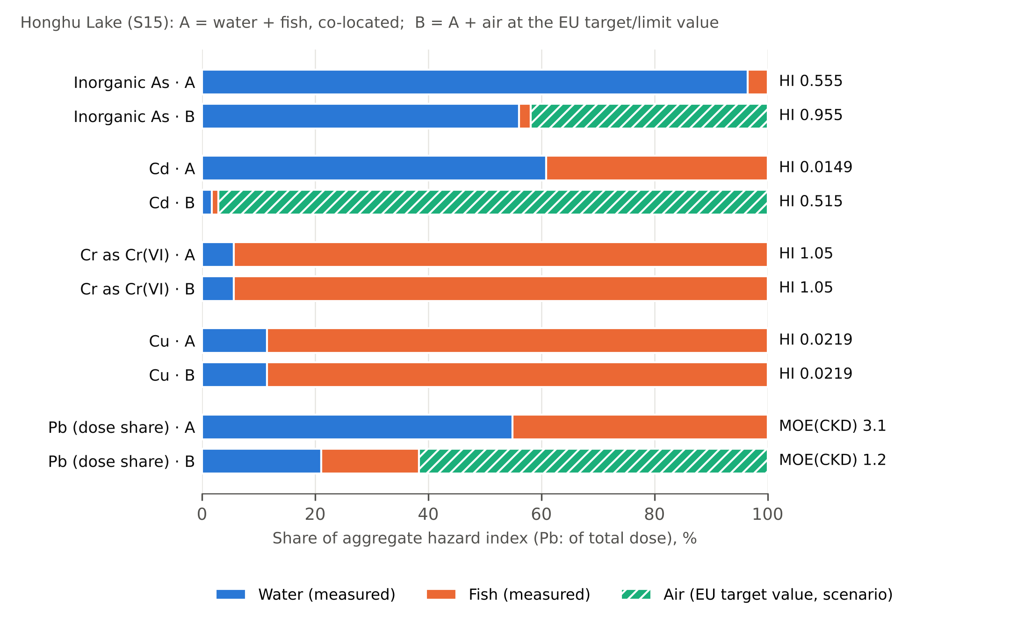
Figure 5. Contribution of each medium to the aggregate hazard index (Pb: to the total oral-equivalent dose) in the Honghu Lake illustration. A, measured water and fish; B, with air at the EU target or limit value. The index value is given at the right of each bar.
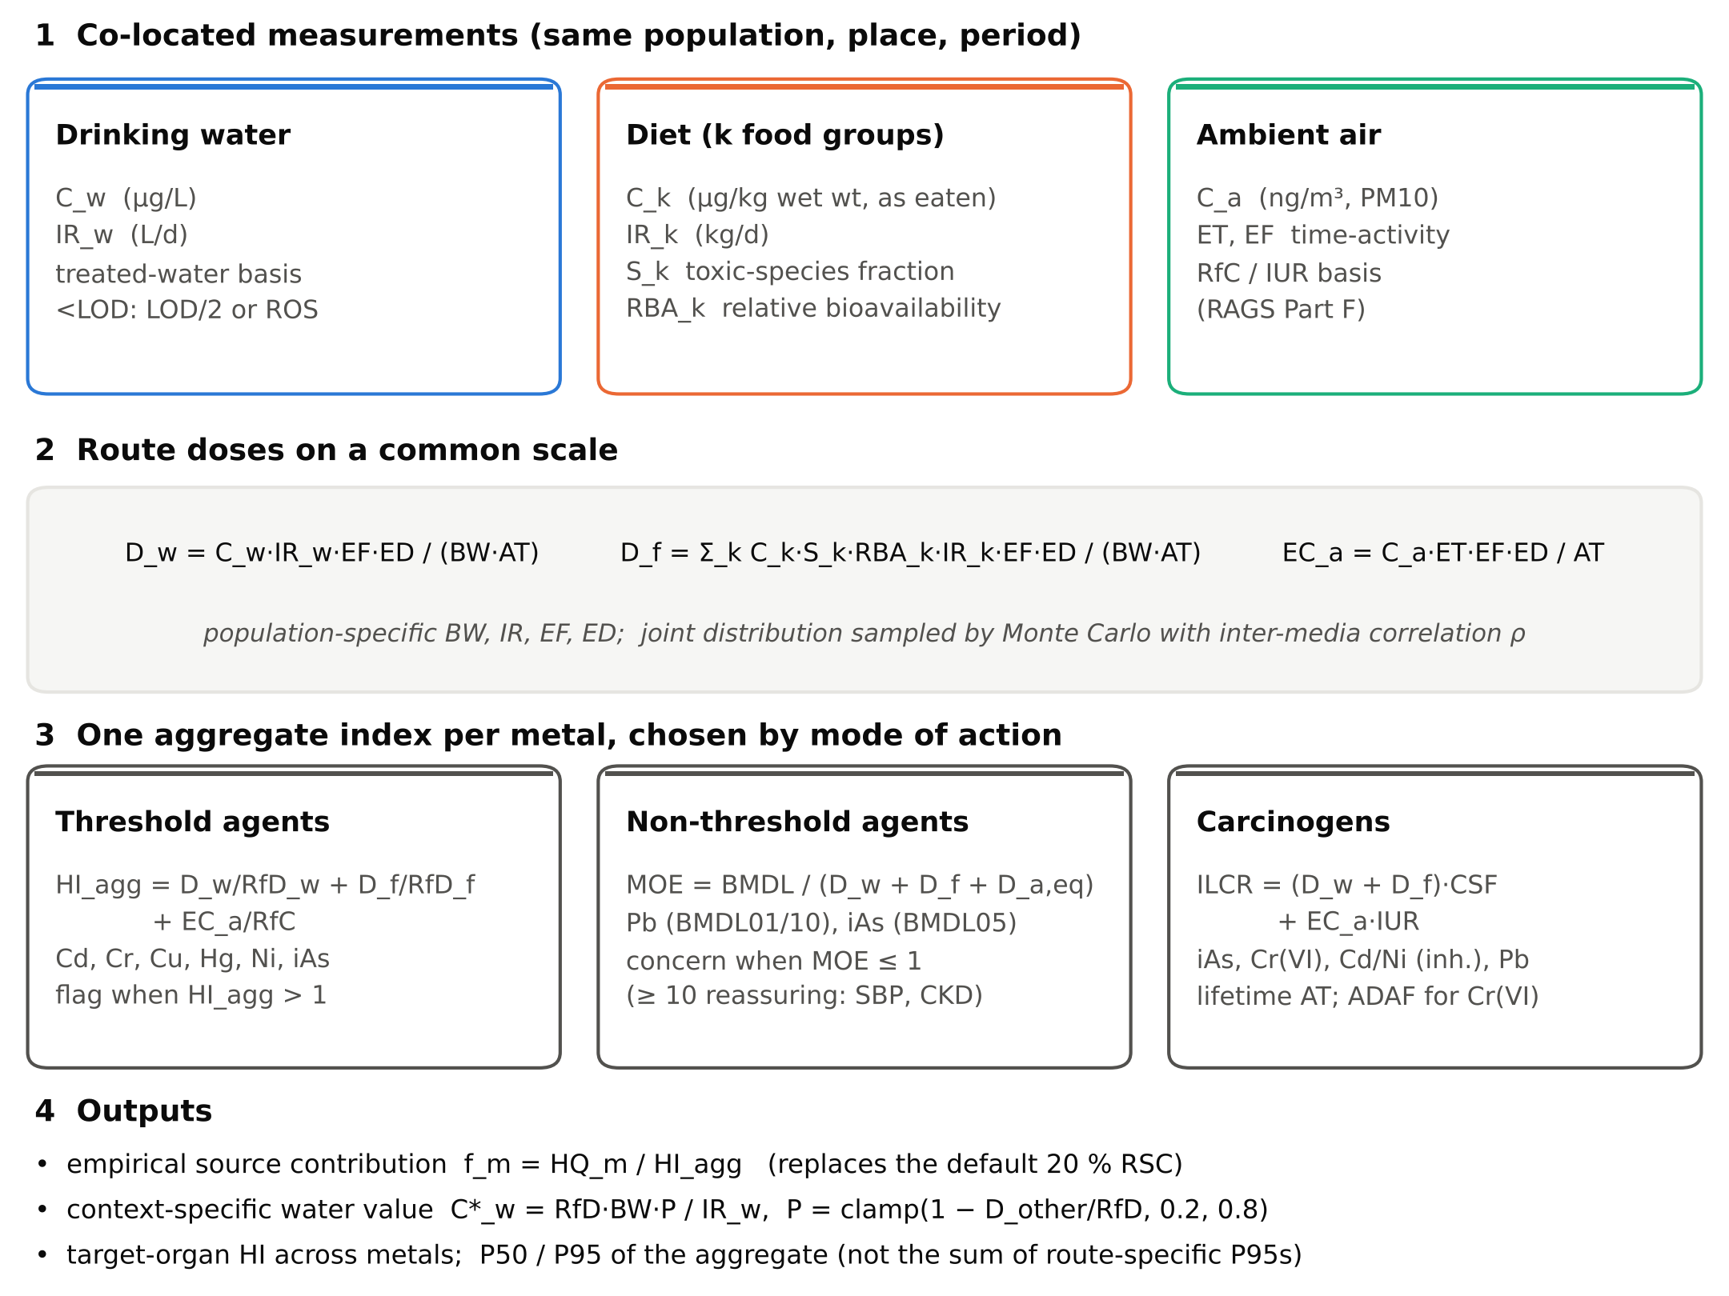
Figure 4. Structure of the integrated aggregate-exposure equation: co-located measurements in three media are converted to route doses on a common scale and combined into one index per metal according to its mode of action.

5. Discussion

5.1 What the meta-analysis shows
The restricted meta-analysis answers a question the previous version of this review left open: how far can the published single-medium literature be pooled? For lead and cadmium in edible aquatic tissue it can be pooled in the statistical sense, but the prediction intervals show that the pooled value describes no particular population. An I² above 99% means that almost all of the variation between studies is real variation between products, species and places rather than sampling error [18]. The appropriate use of these results is as a range against which a new local measurement can be placed, not as a default input to a risk assessment.

5.2 Why single-medium studies cannot be aggregated
Aggregating studies of different media from different populations commits what is in epidemiological terms an ecological fallacy [45]. Total exposure depends on how concentrations covary within a person; summing group means from unrelated groups discards that covariance and replaces it with an assumption of independence. Where a common geological or industrial source contaminates water, crops and dust together, the media are positively correlated and the sum of independent means understates the upper tail, which is where regulatory decisions are made. The illustration in Section 4.9 quantifies the effect: a water–fish correlation of 0.6 raised the 95th-percentile lead dose by about 9% even with only two media.
The unit problem compounds this. Concentrations per litre, per kilogram of food and per kilogram of settled dust cannot be ranked without conversion to a common dose, which requires intake rates for the same population. A conclusion that one medium dominates, drawn from unconverted concentrations, reflects the choice of units.

5.3 Two frameworks, one equation
The EPA relative source contribution and the REACH route summation have been presented as alternatives. The integrated equation shows that they are two special cases of one calculation. When the contributions of food and air are unknown, Equation 9 with P fixed at 20% is the EPA percentage method [4] and the WHO default allocation [3]; when they are measured, P = 1 − HQ_{f} − HQ_{a} is the EPA subtraction method, and Equation 4 with DNELs in place of RfD and RfC is the REACH risk characterisation ratio [6]. The default allocation is a regulatory convention chosen to be protective when data are missing, not a description of how exposure is distributed, and the empirical f_{m} of Equation 8 can be compared with it directly. In the illustration water supplied between 6% and 96% of the hazard depending on the metal, so a single default would have been inappropriate for most of them. An allocation of 20% to water, 50% to food and 30% to air presented in an earlier draft of this work was an assumption, not a finding, and has been withdrawn.

5.4 Agents without a threshold
For lead and inorganic arsenic a hazard quotient is not an approximation of an uncertain threshold but a comparison with a value that the issuing agencies no longer recognise [28, 30]. The margin of exposure is the defensible alternative, and Equation 5 extends it to aggregate exposure. The recent IRIS reassessment of inorganic arsenic illustrates why the reference values in a review must be verified at the time of writing: under the 2025 values an arsenic concentration in water below 1 µg/L, a tenth of the WHO provisional guideline value, corresponds to a lifetime cancer risk above 10⁻⁴ for an adult drinking 2 L/d [3, 21].

5.5 Speciation and bioavailability are not refinements
For arsenic, chromium and mercury the species determines whether a measurement means anything. Total arsenic in seafood and seaweed is dominated by organic species of low toxicity; total chromium may be trivalent or hexavalent, with reference doses differing more than a thousandfold; and the toxicity of mercury in fish is that of methylmercury. Bioavailability matters in the same way for food: matrix-specific bioaccessibility measured in one included study changed the dietary risk materially [8]. Both enter the integrated equation explicitly through S_{k} and RBA_{k}, so that their effect is visible rather than hidden in a default of 1.

5.6 Requirements for an applied multi-route study
The design implied by this review is specific and, in a national monitoring context, achievable:
- the same metals measured in treated drinking water at the tap, in the diet as consumed and in ambient PM₁₀;
- in the same households or communities within the same period, so that inter-media covariance is preserved and can be estimated;
- speciation of arsenic (inorganic fraction) and chromium (Cr(VI)), and methylmercury in fish;
- bioaccessibility measured, or applied from the literature, per food matrix, with conversion to relative bioavailability;
- body weight, water and food intake, and time-activity data from the population itself rather than from handbooks;
- analytical methods suited to each matrix and concentration range (ICP-MS or equivalent for water at µg/L), with certified reference materials, recovery and limits of detection reported, and non-detects handled by censored-data methods;
- risk characterised with current toxicity values, by Equations 4–10, with the EPA and REACH variants computed on the same exposures.

5.7 Limitations
The review was not registered prospectively, and the search, restricted to English-language records in four databases, ends on 30 November 2024; it should be updated before publication. The meta-analysis rests on five studies and on a log-normal conversion of reported means and SDs, which is approximate for small samples and for distributions with non-detects recorded as zero (one study). Study-level SDs for combined groups and for canned products describe between-item variation and may differ from the sampling variation intended by the model; with I² above 99% this does not alter the conclusion. Risk of bias was assessed by one reviewer from the published reports and should be confirmed independently. One eligible study awaits full-text verification. Toxicity values were verified in October 2026 and will continue to change. The integrated equation is derived from guidance; its illustration uses a dataset in which the water was not drinking water and air was not measured, and it is not a risk assessment of that population.

6. Conclusions
The published literature on metal exposure is almost entirely single-medium. Two studies measured water and fish at the same site, none measured air, and none combined media into one human intake. Where a comparable stratum exists, as for lead and cadmium in edible aquatic tissue, the literature can be pooled, but heterogeneity is so large that the pooled value cannot represent any population. Toxicity values in the reviewed studies were frequently outdated, applied to the wrong route or form, or based on thresholds that have been withdrawn, and the 2024–2025 IRIS revisions for inorganic arsenic and hexavalent chromium change the interpretation of earlier work.
The integrated equation proposed here adds water, diet and air for each metal on a common dose scale, uses the index appropriate to the mode of action, and returns the empirical contribution of each medium in place of a default allocation. It contains the WHO, EPA and REACH approaches as special cases, so that their conservatism can be compared on the same data. It is ready to be applied, and requires only what the literature lacks: co-located, speciated measurements of drinking water, diet and air in one population.

Declarations
CRediT author statement. To be completed by the authors. Funding. To be completed. Declaration of competing interest. The authors declare no competing interests (to be confirmed). Data availability. The extraction workbook (Data_Extracted_v2.xlsx), meta-analysis inputs (Table S12), and Python code for the meta-analysis, forest plots and integrated equation (File S3) are provided as supplementary material.

References
1. US EPA. Risk Assessment Guidance for Superfund, Volume I: Human Health Evaluation Manual (Part A). EPA/540/1-89/002. Washington, DC; 1989
2. US EPA. Risk Assessment Guidance for Superfund, Volume I: Human Health Evaluation Manual (Part F, Supplemental Guidance for Inhalation Risk Assessment). EPA-540-R-070-002. Washington, DC; 2009
3. World Health Organization. Guidelines for Drinking-water Quality: Fourth Edition Incorporating the First and Second Addenda. Geneva: WHO; 2022. ISBN 978-92-4-004506-4 (Sections 8.2.2, 8.2.8, 8.2.9 and chemical fact sheets 12.1)
4. US EPA. Methodology for Deriving Ambient Water Quality Criteria for the Protection of Human Health (2000). EPA-822-B-00-004. Washington, DC; 2000
5. Krishnan K, Carrier R. The use of exposure source allocation factor in the risk assessment of drinking-water contaminants. J Toxicol Environ Health B Crit Rev. 2013;16:39–51
6. European Chemicals Agency. Guidance on Information Requirements and Chemical Safety Assessment, Chapter R.8: Characterisation of dose [concentration]-response for human health. Version 2.1. Helsinki: ECHA; 2012
7. Page MJ, McKenzie JE, Bossuyt PM, Boutron I, Hoffmann TC, Mulrow CD, et al. The PRISMA 2020 statement: an updated guideline for reporting systematic reviews. BMJ. 2021;372:n71
8. Wang B, Zhang L, Feng W, Zhang H, Duan X, Qin N. Bioaccessibility-corrected probabilistic health risk assessment of dietary metal(loid) exposure in six major food groups in children from Northwest China. Environ Sci Eur. 2024;36:6. doi:10.1186/s12302-023-00830-4
9. Zhang L, Song Z, Zhou Y, Zhong S, Yu Y, Liu T, et al. The accumulation of toxic elements (Pb, Hg, Cd, As, and Cu) in red swamp crayfish (Procambarus clarkii) in Qianjiang and the associated risks to human health. Toxics. 2023;11:635. doi:10.3390/toxics11070635
10. Kosker AR, Gundogdu S, Esatbeyoglu T, Ayas D, Ozogul F. Metal levels of canned fish sold in Türkiye: health risk assessment. Front Nutr. 2023;10:1255857. doi:10.3389/fnut.2023.1255857
11. Kim DY, Jeon H, Shin HS. Risk assessment and determination of arsenic and heavy metals in fishery products in Korea. Foods. 2023;12:3750. doi:10.3390/foods12203750
12. Zhang J, Zhu L, Li F, Liu C, Yang Z, Qiu Z, Xiao M. Heavy metals and metalloid distribution in different organs and health risk assessment for edible tissues of fish captured from Honghu Lake. Oncotarget. 2017;8(60):101672–101685
13. Torabi S, Gholizadeh M, Yazarlo M, Riahi Z. Health risk assessment of heavy metals in marine fish caught from the northwest Persian Gulf. Research Square [preprint]; 2023. doi:10.21203/rs.3.rs-3257359/v1. Version of record: Biol Trace Elem Res. doi:10.1007/s12011-023-03946-z
14. Higgins JPT, Thomas J, Chandler J, Cumpston M, Li T, Page MJ, Welch VA, editors. Cochrane Handbook for Systematic Reviews of Interventions, version 6.4. Cochrane; 2023 (Section 6.5.2.10, Table 6.5.a)
15. Higgins JPT, White IR, Anzures-Cabrera J. Meta-analysis of skewed data: combining results reported on log-transformed or raw scales. Stat Med. 2008;27:6072–6092
16. Viechtbauer W. Bias and efficiency of meta-analytic variance estimators in the random-effects model. J Educ Behav Stat. 2005;30:261–293
17. IntHout J, Ioannidis JPA, Borm GF. The Hartung-Knapp-Sidik-Jonkman method for random effects meta-analysis is straightforward and considerably outperforms the standard DerSimonian-Laird method. BMC Med Res Methodol. 2014;14:25
18. Higgins JPT, Thompson SG. Quantifying heterogeneity in a meta-analysis. Stat Med. 2002;21:1539–1558
19. Riley RD, Higgins JPT, Deeks JJ. Interpretation of random effects meta-analyses. BMJ. 2011;342:d549
20. Viechtbauer W. Conducting meta-analyses in R with the metafor package. J Stat Softw. 2010;36(3):1–48
21. US EPA. IRIS Toxicological Review of Inorganic Arsenic (Final Report). EPA/635/R-25/005. Washington, DC: Integrated Risk Information System; January 2025
22. US EPA. IRIS Toxicological Review of Hexavalent Chromium [Cr(VI)] (Final Report). Washington, DC: Integrated Risk Information System; August 2024
23. US EPA. Integrated Risk Information System (IRIS) Chemical Assessment Summary: Cadmium (CASRN 7440-43-9). Washington, DC; oral RfD 1989, inhalation unit risk 1992
24. US EPA. Integrated Risk Information System (IRIS) Chemical Assessment Summaries: Chromium(III) insoluble salts; Methylmercury (2001); Mercuric chloride; Elemental mercury; Nickel soluble salts; Nickel refinery dust; Inorganic arsenic inhalation unit risk (1995). Washington, DC
25. Agency for Toxic Substances and Disease Registry. Toxicological Profile for Cadmium. Atlanta, GA: US DHHS; 2012 (chronic oral MRL 0.1 µg/kg/day; chronic inhalation MRL 0.01 µg/m³)
26. Agency for Toxic Substances and Disease Registry. Minimal Risk Levels (MRLs) for Hazardous Substances. Atlanta, GA: ATSDR; list updated December 2025
27. California OEHHA. Air Toxics Hot Spots Program Technical Support Document for Cancer Potency Factors, Appendix B (updated 2011). Sacramento: OEHHA; 2009
28. EFSA CONTAM Panel. Scientific opinion on lead in food. EFSA J. 2010;8(4):1570
29. EFSA CONTAM Panel. Cadmium in food. EFSA J. 2009;980:1–139; and Statement on tolerable weekly intake for cadmium. EFSA J. 2011;9(2):1975
30. EFSA CONTAM Panel. Update of the risk assessment of inorganic arsenic in food. EFSA J. 2024;22(1):e8488
31. EFSA CONTAM Panel. Update of the risk assessment of nickel in food and drinking water. EFSA J. 2020;18(11):e06268
32. EFSA CONTAM Panel. Scientific opinion on the risk for public health related to the presence of mercury and methylmercury in food. EFSA J. 2012;10(12):2985
33. EFSA Scientific Committee. Re-evaluation of the existing health-based guidance values for copper and exposure assessment from all sources. EFSA J. 2023;21(1):7728
34. Joint FAO/WHO Expert Committee on Food Additives. Evaluation of certain food additives and contaminants: seventy-third report (cadmium, PTMI 25 µg/kg bw). WHO Technical Report Series 960. Geneva: WHO; 2011
35. US EPA. Risk Assessment Guidance for Superfund, Volume III Part A: Process for Conducting Probabilistic Risk Assessment. EPA 540-R-02-002. Washington, DC; 2001
36. US EPA. Supplementary Guidance for Conducting Health Risk Assessment of Chemical Mixtures. EPA/630/R-00/002. Washington, DC; 2000
37. Senoro DB, de Jesus KLM, Nolos RC, Lamac MRL, Deseo KM, Tabelin CB. In situ measurements of domestic water quality and health risks by elevated concentration of heavy metals and metalloids using Monte Carlo and MLGI methods. Toxics. 2022;10:342. doi:10.3390/toxics10070342
38. Senoro DB, De Jesus KLM, Monjardin CEF. Pollution and risk evaluation of toxic metals and metalloid in water resources of San Jose, Occidental Mindoro, Philippines. Sustainability. 2023;15:3667. doi:10.3390/su15043667
39. Semerjian L, Adeniji AO, Shanableh A, Semreen MH, Mousa M, Abass K, Okoh A. Assessment of elemental chemistry, spatial distribution, and potential risks of road-deposited dusts in Sharjah, United Arab Emirates. Heliyon. 2024;10:e29088. doi:10.1016/j.heliyon.2024.e29088
40. Hoque MM, Hossen MA, Zuthi MFR, Mullick MRA, Hasan SMF, Khan F, Das T. Exploration of trace elements in groundwater and associated human health risk in Chattogram City of Bangladesh. Heliyon. 2024;10:e35738. doi:10.1016/j.heliyon.2024.e35738
41. Rahman M, Al-Mamun M, Khan AAS, Sarkar OS, et al. Contamination of selected toxic elements in integrated chicken-fish farm settings of Bangladesh and associated human health risk assessments. Biol Trace Elem Res. 2022. doi:10.1007/s12011-022-03244-0
42. Zhang Z, Mamat A, Simayi Z. Pollution assessment and health risks evaluation of (metalloid) heavy metals in urban street dust of 58 cities in China. Environ Sci Pollut Res. 2019;26:126–140. doi:10.1007/s11356-018-3555-0
43. EFSA Scientific Committee. Opinion on a harmonised approach for risk assessment of substances which are both genotoxic and carcinogenic. EFSA J. 2005;282:1–31
44. Directive 2004/107/EC of the European Parliament and of the Council relating to arsenic, cadmium, mercury, nickel and polycyclic aromatic hydrocarbons in ambient air; and Directive 2008/50/EC on ambient air quality and cleaner air for Europe (lead limit value 0.5 µg/m³)
45. Morgenstern H. Ecologic studies in epidemiology: concepts, principles, and methods. Annu Rev Public Health. 1995;16:61–81
46. US EPA. Exposure Factors Handbook: 2011 Edition. EPA/600/R-09/052F. Washington, DC; 2011
47. Ruby MV, Davis A, Schoof R, Eberle S, Sellstone CM. Estimation of lead and arsenic bioavailability using a physiologically based extraction test. Environ Sci Technol. 1996;30:422–430
48. US EPA. Guidance Manual for the Integrated Exposure Uptake Biokinetic Model for Lead in Children. EPA/540/R-93/081. Washington, DC; 1994
49. US EPA. Supplemental Guidance for Assessing Susceptibility from Early-Life Exposure to Carcinogens. EPA/630/R-03/003F. Washington, DC; 2005
50. Helsel DR. Statistics for Censored Environmental Data Using Minitab and R. 2nd ed. Hoboken: Wiley; 2012
51. Iman RL, Conover WJ. A distribution-free approach to inducing rank correlation among input variables. Commun Stat Simul Comput. 1982;11:311–334
52. US EPA. Human Health Evaluation Manual, Supplemental Guidance: Update of Standard Default Exposure Factors. OSWER Directive 9200.1-120. Washington, DC; 2014

Supplementary material
Item | Content | Status
Table S1 | PICOS framework | Provided (Supplementary file)
Table S2 | Full search strings for each database | Authors to insert from the search log
Table S3 | Extraction template: field definitions | Data_Extracted_v2.xlsx, sheet 00_README
Table S4 | Automated quality-control checks | Existing checklist
Table S5 | Risk-of-bias assessment by study and domain | Provided (Supplementary file); confirm by second reviewer
Table S6 | Studies excluded at full text, with reasons | Authors to re-tally so that counts sum to 70
Table S7 | Harmonised concentration dataset | Data_Extracted_v2.xlsx, sheet 02_Concentrations
Table S8 | Exposure parameters by study | Data_Extracted_v2.xlsx
Table S9 | Reference values used by each study vs current agency values | Provided (Supplementary file)
Table S10 | Risk metrics as reported by each study | Extend sheet 03_RiskMetrics (currently 5 of 12 studies)
Table S11 | Record of every value revised during re-extraction | Data_Extracted_v2.xlsx, sheet 07_QC_Flags
Table S12 | Meta-analysis input data and derivations | Provided (Supplementary file)
File S3 | Python code: meta-analysis, forest plots, integrated equation, Monte Carlo | Provided

