Development of a Facial Emotion Recognition Model using HOG
  - Module: CO3519 - Artificial Intelligence

Name: Mahdi Houcine Bouzaher
Student ID: 21065846
Date: 14 December 2025

- Introduction
Emotions are the human control signals; they compress large amounts of internal and external information and have an important role in regulating social interactions and long-term learning through reward and punishment. Recognising these emotions offers leverage in handling different situations. Ko (2018) described FER (Facial Expression Recognition) as a computer vision technique that recognises human emotions from facial images or video. It gained renown in many fields for the real-world value it provides; the security sector uses it to detect micro-expressions associated with high stress, deception, or aggression in public spaces. The healthcare sector uses it to detect early signs of depression, anxiety, and other psychiatric disorders (Lee, et al., 2024) or to monitor patients who cannot verbally communicate to detect signs of pain (Zamzmi, et al., 2018), and in the automotive sector it uses in-cabin cameras to monitor the driver’s face for signs of fatigue. The problem we aim to solve is what approach is best to achieve good accuracy results of FER on 2 different datasets.
This report breaks down the process of building a robust FER system that classifies 6 emotions (Happiness, sadness, fear, surprise, anger, and neutral) using traditional Machine Learning without any use of deep learning. Using 2 datasets (JAFFE and CK+), it systematically compares feature-extraction techniques to find the optimal model. The recorded data provides valuable insight into how each dataset can be used to build robust systems with traditional machine learning models, the shown methodology led to accuracy results as high as 74.55% for JAFFE using extracted HOG features and SVM (RBF), and 77.62% for CK+ using HOG features and Linear SVM, effectively addressing dataset-related issues like class imbalance surpassing raw pixel-based approaches that typically achieve moderate accuracy (~60%).
- Literature Review
After performing cross testing using 6 different models (Random Forest, SVM (Linear), SVM (RBF), KNN (k=3), KNN (k=5), KNN (k=7), Decision Tree, Naive Bayes) and 6 feature extraction methods (Raw Pixels, HOG, LBP, PCA, Gabor Filters, Statistical Features) alone and combined, the results clearly indicated that using extracted HOG features with a linear SVM model is the best approach.

Traditional vs. Deep Learning
CNN, a Deep Learning approach that is considered the state of the art of the FER achieving 95%+ accuracy on static images and 80%+ on videos, an effective yet computationally expensive approach that also lacks Interpretability, here is where the use of traditional machine learning (SVM in particular) is still relevant offering interpretability, lower resource needs, and robustness in specific scenarios like small data, security concerns (Du, 2024).

Feature Extraction Review
To achieve optimal results, machine learning systems rely on 3 types of feature extraction methods to perform facial emotion recognition:
Texture and Pattern Detectors: Focus on the fine details of the skin and pixel arrangements, which allows detection of micro expressions, LBP (Local Binary Patterns) features are a summary of local structures of an image comparing each pixel to its neighbour If a neighbour is brighter, it gets a 1, otherwise 0, it performs best where there is lighting invariance for detecting micro textures like laugh lines (Kaur, Nazir, & Manik, 2021). Gabor Filters on the other hand apply filters at different scales and angles to the image highlighting lines in the face which makes it best for wrinkles and transient features (Kim, Yoon, Lee, & Yoo, 2023).
Shape & Edge Detectors: Capture the geometry behind pixel intensity changes, focusing on contours and gradients of facial features. HOG (Histogram of Oriented Gradients) features are the count of oriented gradients in different portions of the image by dividing an image to cells and calculating the direction of the edges inside each cell to determine the gradients. It then builds a histogram of these directions, it is best for capturing the shape and outline of features, such as the curve of a smiling mouth or the angle of eyebrows (Carcagnì, Del Coco, Leo, & Distante, 2015).
Statistical & Holistic Methods: Analyse the global structure of the face instead of specific local features. PCA (Principal Component Analysis) A dimensionality reduction technique that is used as a feature extractor and called Eigenfaces in this context. PCA capturers the variance of the face and compresses it into a small set of weights that could be used to determine the face’s derivation from the average face (Watson & Johnston, 2022). Statistical features are numerical summaries of pixel intensity distribution, it extracts metrics like the mean, the skewness, and the entropy from specific regions of the image, it’s advantageous with low complexity models as is often used as supplementary features alongside geometric data (Perveen, Gupta, & Verma, 2012).

Hybrid Approaches:
The followed methodology aims to compare handcrafted feature extraction approaches and data augmentation on limited datasets. The work of Salah, Kaya, & Gürpınar (2019) provides a performance baseline comparing LBP, HOG, and Gabor, focusing on deep hybrid networks. This report will revisit these methods to optimise them for a lightweight SVM system, comparing their individual performance and the performance of selected fusion approaches: HOG + SMOTE, HOG + LBP, HOG + LBP + PCA, HOG + Gabor, HOG + Gabor + PCA, HOG + PCA, and HOG + Stat that recent studies experimented with deep learning models, Abdulsattar & Al-Turfi (2022) separately test HOG and LBP comparing their accuracy and confirming an advantage for HOG, they also integrate these 2 feature extraction methods to improve performance by combining gradient-based shape information with texture-based details. Similarly, fusion of HOG with Gabor improves discrimination by combining local edge-orientation with multi-scale, multi-orientation frequency responses (Conde, Moctezuma, Martín De Diego, & Cabello, 2013). After extracting HOG and LBP features, Islam & Hossain (2019) used PCA to reduce the size of the feature vector before classification proving that it is an essential step to prevent the curse of dimensionality especially after fusing large features vectors like HOG+LBP.
- Datasets

Datasets description
Two provided benchmark facial expression datasets were used to train and evaluate multiple models for six emotion categories: Happy, Sad, Angry, Fear, Surprise, and Neutral. The directory structures of both datasets were standardised which allows a single function to load data with a 70% training, 30% testing split.
JAFFE (Japanese Female Facial Expression): A small-scale dataset with 183 images (128 Train, 55 Test) of Japanese female posed subjects. The limited size of 20 images per class training and the single demographic sample can be considered highly deficient risk of overfitting (Kim, Yoon, Lee, & Yoo, 2023). CK+ (Extended Cohn-Kanade) is a larger dataset which contains 484 posed images from 441 Train and 143 Test.
CK+ (Extended Cohn-Kanade): A larger dataset consisting of 484 posed images (341 Train, 143 Test) from diverse subjects. The exploratory analysis of this dataset led to the identification of discrepancies in the labelling of multiple images, where subjects in folders of emotions were visually confirmed to be expressing to be expressing other emotions. These mislabelization was manually corrected to ensure data integrity and correctness before training and testing. (Lucey, et al., 2010)

Preprocessing
To minimize noise and standardize inputs for the classifiers, multiple steps were applied:
Face Detection: Images come with the subject face surrounded by other irrelevant noise such as clothing, hair, background wall. To mitigate this a HAAR Cascade was used via the OpenCV library to detect and crop the faces from the raw images (OpenCV).
Normalization: The cropped faces images were then all converted to Grayscale and resized to 64x64 pixels using cubic interpolation ensuring uniform size across data from the different datasets and uniform feature vector sizes across all models.

The Imbalance Problem
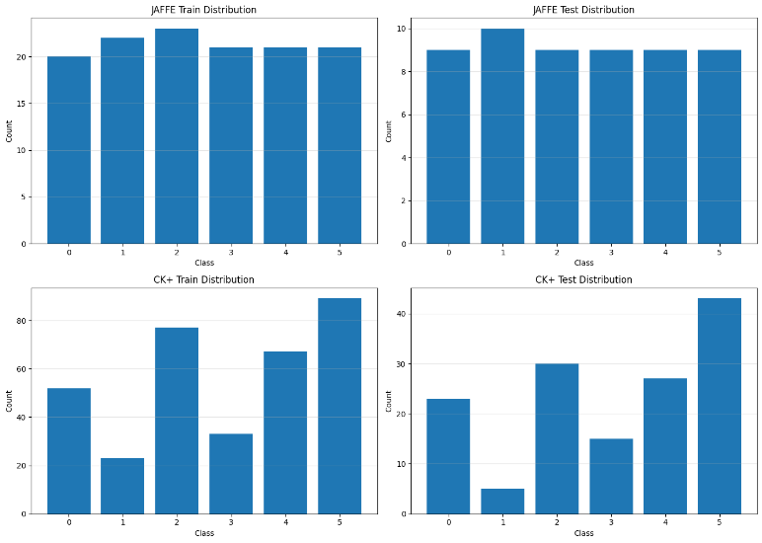
Figure 1: Datasets Distribution Before Augmentation
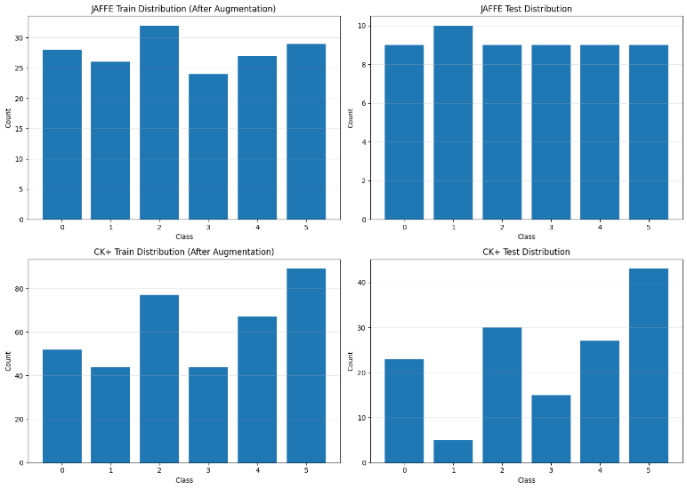
Figure 2: Datasets Distribution Before Augmentation

As illustrated in the Figure 2, JAFFE dataset shows a relative class balance compared to the CK+ that is significantly imbalanced where class 1 constitutes only
6.7% of the data, while Class 5 represents 26.1%. These two tailored strategies were applied to address particular constraints and properties of each dataset.
Solution 1: Albumentations (Applied to both datasets): The Albumentations library was used to apply image-scale augmentation for each dataset. For JAFFE a 30% increase applied with Horizontal Flip, Affine transformations, Random Brightness/Contrast, Gaussian Noise, Motion Blur, CLAHE, and Coarse Dropouts resulted in new training images which required the model to train on variation lightning and geometrics (Buslaev, et al., 2020). The class-specific augmentation approach to CK+ was implemented for the purpose of reducing imbalance by targeting underrepresented classes with horizontal Flip, Shift Scale Rotate, and Random Brightness/Contrast, increasing minority classes with 75% of the median class count.
Solution 2: SMOTE (Evaluated but Not Applied): SMOTE, or Synthetic Minority Over-Sampling Technique, was considered appropriate when the CK+ dataset has sufficient sample images to evaluate directly to the extracted feature vectors. SMOTE produces synthetic minority cases that are not manipulated by augmented image creation (Chawla, Bowyer, Hall, & Kegelmeyer, 2002). However, applying SMOTE to HOG features yielded no performance improvement (77.62% with and without SMOTE), as the interpolation mechanism in high-dimensional feature spaces may generate synthetic samples that do not represent realistic facial expression variations, creating noise in the inputs and affecting models' performance.
As shown in Figure 3, the distributional changes were diverse for each dataset as shown in Figure 3. On JAFFE, the uniform 30% increase for all classes shows a change from 128 to 166 samples with relative class balance. For CK+, class specific augmentation also helped to reduce imbalance by targeting minority classes with Class 1 rising from 23 to 44 samples, Class 3 from 33 to 45 samples, and Class 5 at 90 samples.
- Model Development

Feature Extraction Strategy
At the end of the literature review, the results of a comprehensive comparative analysis were analysed to determine the optimal feature extraction strategies for classifying human emotions:
Local Feature Extraction: methods that extract features from localized regions of the face, capturing fine-grained details:
- Geometric & Shape Features: Human emotion reflects on the face through visible expressions on the landmarks as the mouth, eyes, eyebrows, or the forehead as shapes and edges. HOG (Histogram of Oriented Gradients) is the standard method used for capturing these edge directions by calculating gradient orientations in 4x4 pixel cells and keeping robustness to lighting variations, configured with 9 orientations, 4x4 pixels per cell, and 2x2 cells per block.
- Texture and Pattern Features: Texture and Pattern Features: On top of the change in facial landmarks, textural information in skin details such as wrinkles and furrows can be valuable indicators about the expressed human emotion, this type of extractors uses them as discriminative features. Local Binary Patterns (LBP) translates the micro patterns of the skin to binary patterns that show relationship between each pixel and its neighbours, using 24 sampling points at radius 3 with uniform pattern mapping. GABOR on the other hand analyses frequency and orientation information which makes it useful to detect directional patterns at multiple scales, employing 4 frequencies (0.1, 0.2, 0.3, 0.4) across 4 orientations (0, π/4, π/2, 3π/4) capturing mean and variance responses.
Global Feature Extraction:
- Principal Component Analysis (PCA / Eigenfaces): Principal Component Analysis (PCA / Eigenfaces): Its role is flattening 2-dimensional face images into a long vector which allows the calculation of covariance matrix and extracting the eigenvectors with the largest variance. This compression destroys spatial relationships and all the geometric information with it keeping only intensity patterns, a mechanism that could be perceived as the opposite of HOG that rely on the special information to extract geometric patterns, that is why PCA is usually present as a complementary method to other extraction methods (Islam & Hossain, 2019) reducing dimensionality to 55 components with whitening enabled.
- Statistical Features: Like PCA, statistical features reduce dimensionality by obtaining global summary values from images, from mean intensity, variance, skewness, kurtosis, entropy, or simple histogram counts that delete spatial information that is computed globally and at 44 regional grids for mean, standard deviation, minimum and maximum to measure the spatial information for each region.
Feature Combination Strategy:
- Shape + Texture Combinations: Combining HOG’s ability to extract geometric shape from images with LBP textural micro-patterns would be complementary, and another possibility with a combination HOG + LBP + PCA when applying dimensionality reduction to the concatenated HOG+ LBP vector (Islam & Hossain, 2019)
- Shape + Frequency Combinations: A fusion between HOG and GABOR with its frequency components could improve discrimination (Conde, Moctezuma, Martín De Diego, & Cabello, 2013) by capturing micro-expressions. A dimensionality reduction to the HOG and Gabor feature vectors (which can exceed 1000+ dimensions) using PCA can further improve the discrimination.
- Shape + Dimensionality Reduction: Applies PCA directly to HOG features to compress them while preserving variance. This tests whether reducing HOG's dimensionality improves computational efficiency without sacrificing accuracy.
- Shape + Statistical Moments: Augments HOG with intensity-based statistics (mean, variance, skewness, kurtosis) could provide additional context to the models to learn from.

Classifier Selection & Justification
We test each classifier on eight different algorithms based on eight different models and evaluated them independently in both datasets.
Evaluation Framework: The following classifiers were tested with every feature extraction method:
- Support Vector Machine (Linear Kernel): The optimal theoretical algorithm for large-scale sparse data. Linear SVMs construct a maximal margin hyperplane, where structural risk cannot be considered by the linear SVMs. Hyperparameters: C = 10 (regularisation strength) and probability estimates were used.
- Support Vector Machine (RBF Kernel): tests whether non-linear decision boundaries improve classification when features do not linearly separate emotion classes. The hyperparameters: C = 10, gamma = “scale” (automatically set at 1 / (number of features feature variance)).
- Random Forest: Ensemble baseline for evaluation of bagging and feature randomness for high-dimensional data than just a decision boundary. Import values: 500 trees, max depth = 20. No bootstrapping with small data for the variance.
- k-Nearest Neighbours (k = 3, 5, 7): s emotions defined in separate clusters of feature space? On distance-weighted voting, more close neighbours are prioritized. Three variants testing for sensitivity to neighbourhood size are tested.
- Decision Tree: Single-tree baseline, which can be beneficial to FER but overfitting, was proposed by Jayaswal, Ansari, Dixit, Singh and Ahmad (2025). Hyperparameters: Gini impurity, max depth = 15, pruning rules to avoid overfitting.
- Naive Bayes (Gaussian): Probabilistic baseline. While computationally efficient, it assumes feature independence, known to be violated in correlated features like HOG. Hyperparameters: Variance smoothing = 10⁻¹ to handle zero-variance features.

Implementation & Experimental Rigor
Reproducibility Control: All random processes were controlled using random state=42 for NumPy, Python's random module, classes of SVM, Random Forest, Decision Tree and PCA, and SMOTE so that each run results were matched in the same manner at multiple runs.
Parallel Classifier Testing: Eight different classifiers were evaluated on each feature set by comparison with identical train-test splits to determine the best suitability for optimal features-classifier pairing.
Fixed Hyperparameters Across Comparisons: All classifiers used consistent hyperparameters across all feature extraction methods to ensure that performance differences reflect feature quality and not optimization discrepancies.
Feature Extraction Uniformity: Feature extractors (HOG with 9 orientations, LBP with P=24/R=3, Gabor with 4 frequencies × 4 orientations) applied consistent parameters across both datasets.
StandardScaler Protocol: Feature scaling was only performed by fitting the scaler on training data, then applying the learned transformation to test data. This prevents test set statistics from influencing the scaling parameters.
- Model Evaluation:

Quantitative Analysis
Baseline vs. Best Performance: Raw feature Raw pixels were 32.7-55.45% on JAFFE and 68.5-71.3% on CK+, while HOG features with SVM attained 74.6% (SVM RBF) and 77.6% (SVM Linear) respectively, which suggests that shape-based descriptors can substantially outperform appearance-based raw pixels in facial expression recognition.
Feature Extraction Comparison:
- HOG Superiority: HOG consistently achieved 74-77% in the SVM classifier datasets. This is because HOG captures gradient orientations in the facial muscle movements, raised eyebrows, mouth shapes, that are essential to recognition of expression.
- LBP Failure: LBP was poorly compared with JAFFE by 8-23% and CK+ by 28-43% because it captures texture rather than shape deformations. It is not acceptable to assign LBP as a standalone feature unless facial expressions are structural changes in mouth opening, eyebrow raising, and texture changes.
- Statistical & Gabor Underperformance: Statistical features (29-36% on JAFFE, 44-61% on CK+) and Gabor filters (29-36% on JAFFE, 44-46% on CK+) captured lower-level information that was inaccessible to discrimination for subtle expression differences.

- PCA (Eigenfaces): Achieved 29-40% on JAFFE and 61-68% on CK+, showing that holistic appearance methods struggle with expression variability.
- Hybrid Feature Analysis
The combination of feature extraction methods had decreased effects, with HOG+Gabor being slightly higher (JAFFE 74.6%, CK+ 76.9%) and HOG+LBP, JAFFE 72.7%, CK+ 77.6%, but HOG+LBP making a slight drop (JAFFE 74.6%, CK+ 77.6%) and compared HOG alone (JAFFE 72.7%, CK+ 77.6%) in that the combination of complementary features had reduced noise and redundancy as long as one feature already captures discriminative characteristics effectively, and dimensionality was not significant with meaningful information beyond what HOG provides. The addition of PCA to reduce this dimensionality failed further showing degradation of performance (JAFFE 70.9%, CK+ 73.4%). The fusion HOG+Statistical also did not live to its promises showing no improvement (JAFFE 74.6%, CK+ 77.6%) to the HOG only results, proving that the provided statistical information does not bring any additional insight. (Figure 6 in appendix)
After finding that HOG is the most performant feature extraction method, hyperparamether optimization for both models was peformed (SVM RBF for JAFFE and SVM linear for CK+) to achieve better performance.
The impact of data augmentation: (Figure 5 in appendix)
Improved baseline performance for both datasets, with JAFFE showing an improvement from 54.55% to 56.36% (+1.82%) and CK+ demonstrating a more substantial gain from 68.53% to 71.33% (+2.80%), a modest improvement that suggests that augmentation helped with generalization but didn't solve the fundamental class imbalance (CK+) and scarcity of data (JAFFE) problems.

Qualitative Analysis
JAFFE: Strong Performance: Angry, Happy, and Surprise achieved near perfect or perfect classification (9/9, 9/9, and 8/9 respectively)
Weak Performance: Fear: Only 5/10 correct, confused with Sad, Neutral, and Surprise, Sad: Only 3/9 correct, confused with Happy, Fear, and Neutral, Neutral: 7/9 correct but showed some confusion with Fear and Sad.
Emotions with distinct facial patterns perform well, while subtle emotions cause misclassifications.
CK+: Strong Performance: Happy, Surprise, and Neutral achieved high classification rates (26/30, 24/27, and 36/43 respectively)
Weak Performance: Angry: Only 13/23 correct, heavily confused with Neutral (9 misclassifications), Sad: Only 8/15 correct, confused with Neutral (6 misclassifications), Fear: 4/5 correct but very limited sample size
Emotions with clear facial patterns perform well, while subtle emotions cause misclassifications with Neutral being the dominant confusion category.

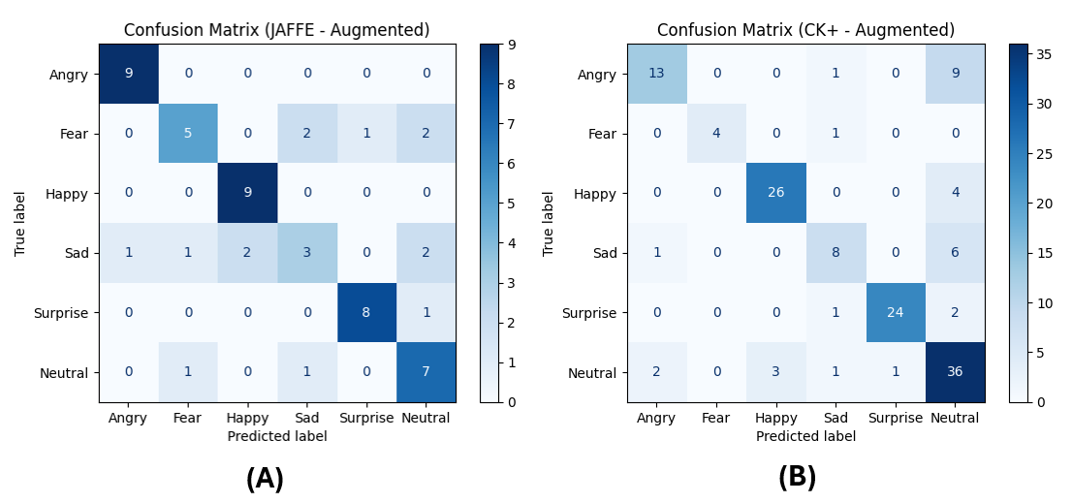
Figure 3: Confusion Matrixs - A: JAFEE, B:CK+
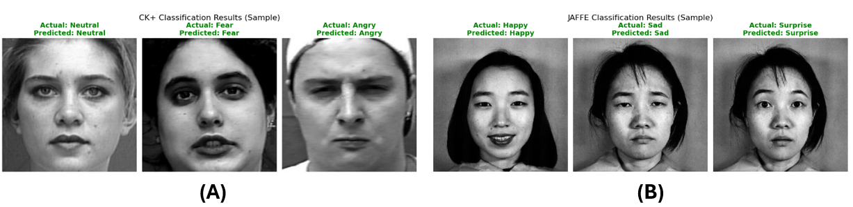
Figure 4: Visual Results - A: CK+, B: JAFFE
CK+ Dataset Results: The model excelled at distinct expressions like Surprise (F1 0.92) and Happy but missed almost half of Sadness cases (Recall 0.53). The high score for Fear is statistically unreliable due to extremely low sample size (5 samples).
JAFFE Dataset Results: Performance was highly polarized, achieving perfect Recall (1.00) for Angry and Happy. However, it failed significantly on Sadness, correctly identifying only 33% of samples, far worse than the CK+ model.
- Conclusion:
Following the performed work during this project, we can conclude that each of the datasets CK+ and JAFFE comes with structural differences that require handling (scarcity or imbalance of data) to achieve optimal results, it was also found that HOG (Geometric shape feature) is the most effective approach when passed through an SVM RBF model for JAFFE and an SVM Linear model for CK+ surpassing textural/pattern features (GABOR and LBP) or global features (PCA, Statistical) and even complementary hybrid approaches.
This assignment helped me develop my research skills and ability to build solutions based on methodically constructed comparisons while documenting my findings and justifying development choices relying on literature or experimentation.

GITHUB Repository link: https://github.com/MahdiBouzaher/Facial_emotion_recognition_with_ML

- References

Abdulsattar, N. S., & Al-Turfi, M. N. (2022). Facial expression recognition using HOG and LBP features with convolutional neural network. Bulletin of Electrical Engineering and Informatics, 11(3), 1350-1357. doi:https://doi.org/10.11591/eei.v11i3.3722.
Buslaev, A., Iglovikov, V. I., Khvedchenya, E., Parinov, A., Druzhinin, M., & Kalinin, A. A. (2020). Albumentations: Fast and Flexible Image Augmentations. Information, 11(2), 125. doi:https://doi.org/10.3390/info11020125
Carcagnì, P., Del Coco, M., Leo, M., & Distante, C. (2015). Facial expression recognition and histograms of oriented gradients: a comprehensive study. SpringerPlus, 4(1), 645. doi:https://doi.org/10.1186/s40064-015-1427-3
Chawla, N. V., Bowyer, K. W., Hall, L. O., & Kegelmeyer, W. P. (2002). SMOTE: Synthetic Minority Over-sampling Technique. Journal of Artificial Intelligence Research, 16, 321-357. doi:https://doi.org/10.1613/jair.953
Conde, C., Moctezuma, D., Martín De Diego, I., & Cabello, E. (2013). HoGG: Gabor and HoG-based human detection for surveillance in non-controlled environments. Neurocomputing, 100, 12-30. doi:https://doi.org/10.1016/j.neucom.2011.12.037
Du, G. (2024). Comparing ML vs. DL for Facial Emotion Recognition (FER). In Y. Wang (Ed.), The 2024 International Conference on Artificial Intelligence and Communication (pp. 373-379). Quanzhou, China: Atlantis Press International BV. Retrieved from https://www.google.co.uk/books/edition/Proceedings_of_the_2024_International_Co/RpUjEQAAQBAJ?hl=en&gbpv=0
Islam, B., & Hossain, A. (2019). Fusion of Features and Extreme Learning Machine for Facial Expression Recognition. Journal of Computer Science, 15(12), 1833-1841. doi:https://doi.org/10.3844/jcssp.2019.1833.1841
Jayaswal, R., Ansari, M., Dixit, M., Singh, D. K., & Ahmad, S. (2025). Advances in facial expression recognition technologies for emotion analysis​. Discover Computing, 28, 203. doi:https://doi.org/10.1007/s10791-025-09699-8
Kaur, N., Nazir, N., & Manik. (2021). A Review of Local Binary Pattern Based texture feature extraction. 2021 9th International Conference on Reliability, Infocom Technologies and Optimization (Trends and Future Directions) (ICRITO) (pp. 1-6). Noida, India: IEEE. doi:https://doi.org/10.1109/ICRITO51393.2021.9596485
Kim, S., Yoon, H., Lee, J., & Yoo, S. (2023). Facial wrinkle segmentation using weighted deep supervision and semi-automatic labeling. Artificial Intelligence in Medicine, 145, 102679. doi:https://doi.org/10.1016/j.artmed.2023.102679
Ko, B. C. (2018). A Brief Review of Facial Emotion Recognition Based on Visual Information. Sensors , 18(2), 401. doi:https://doi.org/10.3390/s18020401
Lee, T., Baek, S., Lee, J., Chung, E. S., Yun, K., Kim, T.-S., & Oh, J. (2024). A Deep Learning Driven Simulation Analysis of the Emotional Profiles of Depression Based on Facial Expression Dynamics. Clinical Psychopharmacology and Neuroscience, 22(1), 87-94. doi:https://doi.org/10.9758/cpn.23.1059
Lucey, P., Cohn, J. F., Kanade, T., Saragih, J., Ambadar, Z., & Matthews, I. (2010). The Extended Cohn-Kanade Dataset (CK+): A complete dataset for action unit and emotion-specified expression. The 2010 IEEE Computer Society Conference on Computer Vision and Pattern Recognition Workshops (CVPRW) (pp. 94-101). San Francisco, CA, USA: IEEE. doi:https://doi.org/10.1109/CVPRW.2010.5543262
OpenCV. (n.d.). Cascade Classifier. Retrieved 10 18, 2025, from OpenCV Documentation: https://docs.opencv.org/3.4/db/d28/tutorial_cascade_classifier.html
Perveen, N., Gupta, S., & Verma, K. (2012). Facial Expression Recognition System using Statistical Feature and Neural Network. International Journal of Computer Applications, 48(18), 17-23. doi:https://doi.org/10.5120/7448-0455
Salah, A. A., Kaya, H., & Gürpınar, F. (2019). Video-Based Emotion Recognition in the Wild. Multimodal Behavior Analysis in the Wild. Academic Press, 369-386. doi:https://doi.org/10.1016/B978-0-12-814601-9.00031-6
Watson, D. M., & Johnston, A. (2022). A PCA-based active appearance model for characterising modes of spatiotemporal variation in dynamic facial behaviours. Frontiers in Psychology, 13, 880548. doi: https://doi.org/10.3389/fpsyg.2022.880548
Zamzmi, G., Kasturi, R., Goldgof, D., Zhi, R., Ashmeade, T., & Sun, Y. (2018). A Review of Automated Pain Assessment in Infants: Features, Classification Tasks, and Databases. IEEE Reviews in Biomedical Engineering, 11, 77-96. doi:https://doi.org/10.1109/RBME.2017.2777907

- Appendix

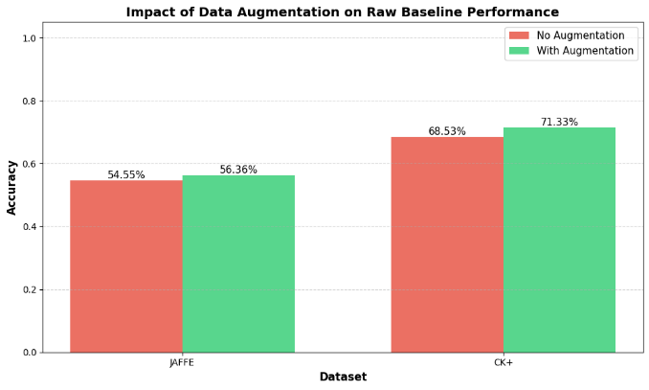
Figure 5: Impact of Augmentation on Accuracy

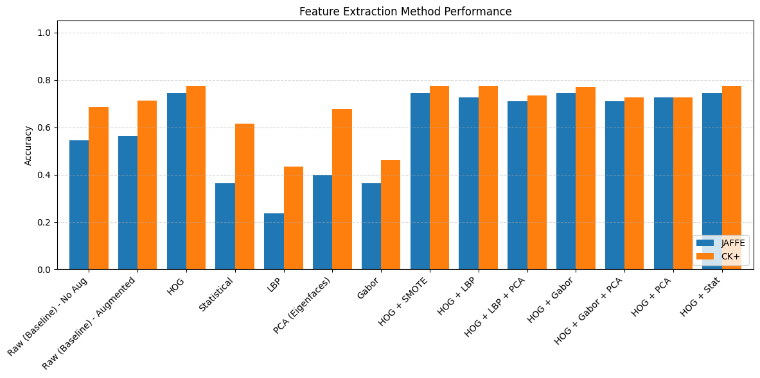
Figure 6: Comparative Performance of Feature Extraction Methods on JAFFE and CK+ Datasets
Emotion | CK+ F1 | JAFFE F1 | Comparison Note
Angry | 0.67 | 0.95 | JAFFE is far superior at detecting Anger ​.
Happy | 0.88 | 0.90 | Both models perform reliably well ​.
Sad | 0.59 | 0.40 | Both struggle, but JAFFE fails significantly ​.
Fear | 0.89 | 0.59 | CK+ numbers are higher but have low support ​.

Table 1: F1 scores between datasets

