SiC Half-Bridge Inverter Leg — Design Calculations
How each governing equation sizes the leg, from first principles to component values
Companion to the Stage-0 design study · Double-Pulse-Test characterization

This document collects every calculation used to model and size the SiC half-bridge leg, and shows how each one feeds the design. The method is deliberate and repeatable: each value is fixed by one governing physical relation and one practical bound. Read that way, none of the numbers are arbitrary — each is the output of a single equation constrained by a single engineering limit, so the same procedure sizes the next design without reference to worked examples.

1. Inputs: operating point and device data
Every calculation below draws on two fixed sets of numbers: the operating point the leg is designed around, and the measured device parameters from the component datasheets.
Quantity | Value
DC bus (validation / design target) | 200 V (800 V-ready)
Test current, I_load | 10 A
Switching frequency | 50 – 100 kHz
Positive gate rail | +18 V
Negative gate rail (turn-off bias) | −4 V
Target current-ramp time, Δt | ≈ 25 µs

Parameter | Symbol | Value | Source
On-resistance | R_ds(on) | 32 mΩ | onsemi NTH4LN032N065M3S
Input capacitance | C_iss | 1410 pF | onsemi datasheet
Gate–drain (Miller) charge | Q_GD | 14 nC | onsemi (at 400 V)
Total gate charge | Q_G | 55 nC | onsemi (−3/18 V)
Internal gate resistance | R_G | 5.0 Ω | onsemi datasheet
Driver peak source / sink | ±I_pk | ±10 A | TI UCC21750
Driver pull-up resistance | R_OH | ≈ 0.7 Ω | TI UCC21750

2. Load inductor
The load inductor acts as a controllable current ramp: with the full bus voltage across it, current rises linearly. Its value is therefore not chosen directly — a comfortable ramp time is selected first, and the inductance follows from the inductor law.
di/dt = V / L → L = V · Δt / ΔI
A ramp time of a few tens of microseconds is the sweet spot: long enough to set precisely on a function generator and resolve on an oscilloscope, short enough to avoid heating and to keep the DC-link charge demand modest. Choosing Δt = 25 µs to reach 10 A at 200 V gives:
L = 200 V × 25 µs / 10 A = 500 µH
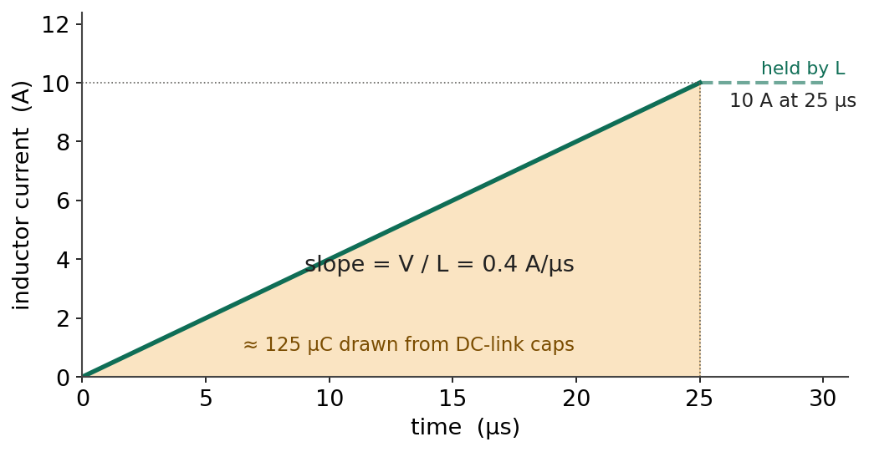
Figure 1 — Inductor current during the on-pulse. The slope is set by V/L; the shaded area is the charge the DC-link must supply.
This yields di/dt = 0.4 A/µs. Two bounds accompany the value: the inductor must not saturate below the test current (rated saturation current with margin above 10 A), and the load inductance must not be confused with the commutation-loop inductance, which is the term that drives turn-off overshoot.

3. DC-link bulk capacitor
During the ramp, current is drawn from the capacitors, not from the distant supply (too slow through its wiring inductance to react over microseconds). The charge delivered is the area under the current ramp of Figure 1:
Q = ½ · I · t = ½ × 10 A × 25 µs = 125 µC
The bus is allowed to sag by a chosen tolerance — here ≤ 1 % of 200 V ≈ 2 V — which sets the minimum capacitance:
C ≥ Q / ΔV = 125 µC / 2 V ≈ 63 µF → round up to ≈ 100 µF
At 100 µF the sag is only ≈ 1.25 V (a conservative worst case, since the supply recharges slightly during the pulse). Two further bounds fix the part: voltage rating uses a 2× derating of the working bus, so 200 V → ≥ 400 V (500–630 V film chosen); and the dielectric is film (polypropylene), not electrolytic, because DC-link duty needs low ESR/ESL and high ripple-current capability.

3.1 Realising 100 µF as a parallel bank
A single 100 µF / 630 V film capacitor is physically large and costly, so the bulk is built as a parallel bank of smaller film parts. Capacitances in parallel add, so:
5 × 22 µF = 110 µF ≈ target
Paralleling also lowers the effective ESR and ESL and lets the caps be distributed along the bus, close to the switches — an electrical improvement, not merely a sourcing workaround.

4. Gate drive rails
The gate is driven between a positive on-rail and a small negative off-rail. The positive value is set by the MOSFET (+18 V for this onsemi part); the negative value (−4 V) holds the switch firmly off and suppresses Miller-induced false turn-on. The drive swing that appears in the gate-current calculations is the difference between them:
V_drive = V_on − V_off = +18 − (−4) = 22 V

5. Gate resistor and peak gate current
The external gate resistor is bounded by a single relation and a single constraint — the driver's peak current rating:
I_peak = V_drive / R_g,total (limit: I_peak ≤ ±10 A)
The total loop resistance is a sum of three series terms, only one of which the designer chooses:
R_g,total = R_driver (≈0.7 Ω) + R_g,ext + R_g,int (5.0 Ω)
The minimum permissible total resistance is:
R_g,total(min) = 22 V / 10 A = 2.2 Ω
But the fixed internal terms already sum to ≈ 5.7 Ω — above the 2.2 Ω floor — so even with R_g,ext = 0 the peak current is only ≈ 22 / 5.7 ≈ 4 A. The current limit is therefore never binding: external R_g stops being a limit-driven choice and becomes purely the switching-speed knob. At the chosen R_g,ext = 5 Ω, R_g,total ≈ 10.7 Ω and I_peak ≈ 22 / 10.7 ≈ 2.1 A — comfortably safe on both edges.

6. Switching dynamics (the Miller plateau)
The switching event does not occur while the gate charges up; it occurs during the flat region of the gate-charge curve — the Miller plateau — where the drain voltage swings while V_GS is held constant and the driver moves the Miller charge Q_GD.
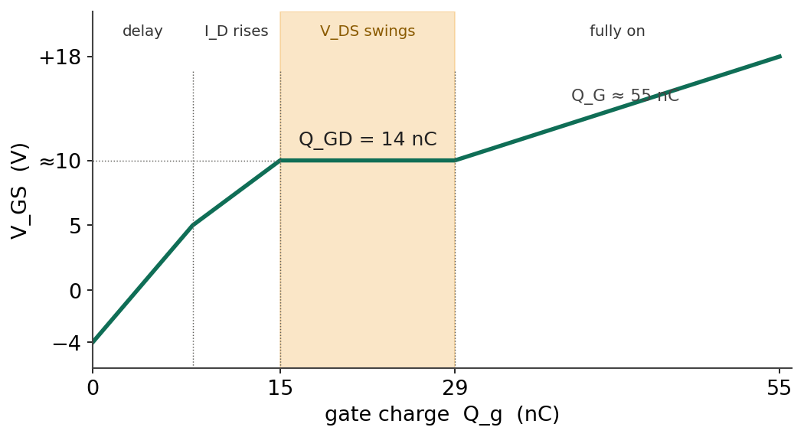
Figure 2 — Gate-source voltage vs gate charge. Switching happens in the shaded plateau, where V_DS swings and the driver moves Q_GD.
During the plateau the gate sits at the plateau voltage (≈ 10 V, read from the gate-charge curve) while the driver rail is at +18 V, so the available current and the resulting plateau duration are:
I_g,plateau = (18 − 10) / R_g,total = 8 / 10.7 ≈ 0.75 A
t_plateau = Q_GD / I_g,plateau = 14 nC / 0.75 A ≈ 19 ns
This ≈ 19 ns is the real V_DS transition time — the honest counterpart of a naïve RC estimate (τ = R_g,total × C_iss ≈ 10.7 Ω × 1410 pF ≈ 15 ns), which ignores that the switching happens at constant V_GS rather than while the gate charges through C_iss.

6.1 R_g as the design lever
Rearranging shows the switching time is directly proportional to the gate resistance:
t_plateau = Q_GD · R_g,total / (V_rail − V_plateau) ∝ R_g,total
Because the turn-on energy scales as E_on ≈ ½ · V_bus · I_load · t_transition, doubling the plateau time roughly doubles the turn-on loss. The trade-off is monotonic and is exactly what the double-pulse test sweeps:
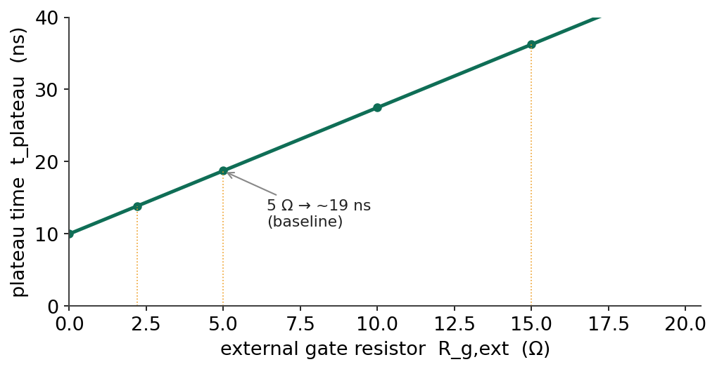
Figure 3 — Switching (plateau) time versus external gate resistor. Larger R_g → slower switching, higher loss, tamer overshoot.
R_g,ext | R_g,total | t_plateau (approx.)
2.2 Ω | ≈ 7.9 Ω | ≈ 14 ns (faster · lower loss · more overshoot)
5 Ω | ≈ 10.7 Ω | ≈ 19 ns (baseline / centre of sweep)
10 Ω | ≈ 15.7 Ω | ≈ 28 ns
15 Ω | ≈ 20.7 Ω | ≈ 37 ns (slower · higher loss · tamer overshoot)

The formula predicts the trend; the exact E_on/E_off and overshoot at each value are obtained by measurement, because at these edge speeds the outcome is dominated by real layout parasitics the equation does not capture. R_g,ext is therefore left provisional at 5 Ω (centre of the sweep) on a swappable footprint.

7. Driver decoupling capacitors
The decoupling capacitors on the driver do not see the 200 V bus — they see only the local supply at their node — so the 2× derating is applied to that voltage, not the bus:
- VDD/VEE decoupling (≈ +18 V node): 18 × 2 = 36 V → 35 V-class ceramic (MLCC).
- VCC decoupling (3.3–5 V logic): a ≥ 25 V ceramic is ample.
These are ceramic MLCCs, not film, because the job is a fast local current burst (low ESL), not bulk energy storage. One correction the calculation must include is the MLCC DC-bias effect: a class-2 (X5R/X7R) capacitor loses capacitance under applied voltage, so a 22 µF/35 V part may deliver only ≈ 10–14 µF at 18 V. The datasheet requires > 10 µF, so the value is chosen with margin (22 µF, or two 15 µF in parallel) to stay above 10 µF after the derating.

8. Bringing it together — the leg model
The calculations interlock into a single, self-consistent model of the leg. The load inductor (500 µH) sets the current slope (0.4 A/µs), which fixes the pulse width (25 µs) needed to reach the 10 A test current. That pulse width, with the test current, sets the charge the DC-link must supply (125 µC), which — under a 1 % sag budget — sizes the bulk capacitance (100 µF). Independently, the gate rails (+18/−4 V) fix the drive swing (22 V), which with the driver's 10 A limit sets the minimum gate resistance (2.2 Ω); the chosen 5 Ω, combined with the device's Miller charge (14 nC), sets the switching time (≈ 19 ns) and hence the turn-on energy the whole experiment exists to measure. Every arrow in that chain is one equation and one bound.
The table below collects the computed quantities in one place.
Quantity | Governing relation | Result
Load inductor | L = V·Δt / ΔI | 500 µH
Current slope | di/dt = V / L | 0.4 A/µs
Charge per pulse | Q = ½·I·t | 125 µC
DC-link bulk cap | C ≥ Q / ΔV | ≈ 100 µF
Gate drive swing | V_drive = V_on − V_off | 22 V
Min. gate resistance | R_g,total ≥ V_drive / I_pk | 2.2 Ω
Peak gate current (R_g,ext=5 Ω) | I_pk = V_drive / R_g,total | ≈ 2.1 A
Plateau (switching) time | t = Q_GD / I_g,plateau | ≈ 19 ns

8.1 Realised component choices
Role | Chosen part / value | Rating
Switches (DUT + high-side) | onsemi NTH4LN032N065M3S | 650 V / 32 mΩ SiC
Gate drivers (×2) | TI UCC21750 | isolated, ±10 A
DC-link bulk | 5 × 22 µF film (TDK B32776) | 630 V, ≈110 µF
DC-link / decoupling voltage | 2× derating of local node | see §4, §8
Driver decoupling (VDD/VEE) | 2 × 15 µF MLCC | 35 V
External gate resistors | R_g(on) / R_g(off), socketed | ≈ 5 Ω start
Load inductor | toroid 500 µH / 15 A (or air coil) | ≥ 15 A

9. Appendix — air-core load inductor (alternative)
If a suitable cored 500 µH / ≥15 A inductor is unavailable, the load can be a hand-wound single-layer air-core coil, which cannot saturate (no core), keeping di/dt perfectly linear at any current. Its inductance is set purely by geometry, via Wheeler's approximation:
L (µH) ≈ d² · N² / (18d + 40ℓ) [d, ℓ in inches]
with d the coil diameter, ℓ the winding length and N the number of turns. The value grows with N² and with diameter, and falls as the coil is stretched. In practice the coil is wound on a rigid non-magnetic form (≈ 30–50 mm diameter) with insulated wire sized for 10 A (≈ 1.5–2.5 mm²), then its inductance is measured with an LCR meter and turns are added or removed until it reads ≈ 500 µH — verification rather than trust, since the formula is accurate only to ≈ ±15 %.
Design calculations — values provisional pending measurement (simulation and/or double-pulse test).

