**TECHNICAL WALKTHROUGH OF PROTRACTOR**

# Installation and Setup

Install Node JS (and NPM)

Node.JS is a runtime of JavaScript built on Chrome’s V8 JS Engine.

NPM is Node’s package manager.

Get the LTS version of Node JS from <https://nodejs.org/en/>

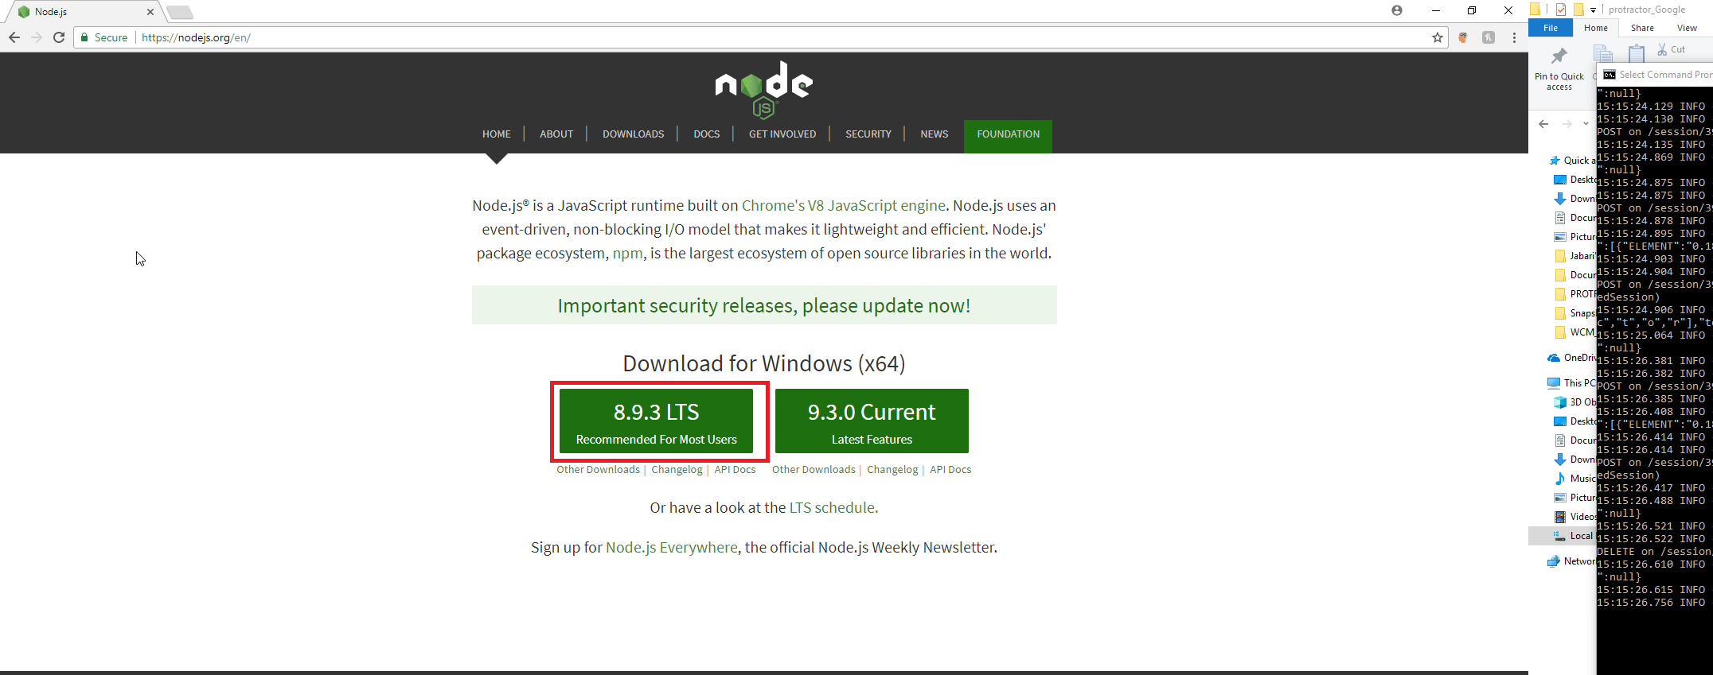

**Verification:**

Run the following command on command line:

node --version



npm --version



Install the Java Development Kit (JDK)

The JDK is necessary to run Selenium Webdriver.

http://www.oracle.com/technetwork/java/javase/downloads/index.html

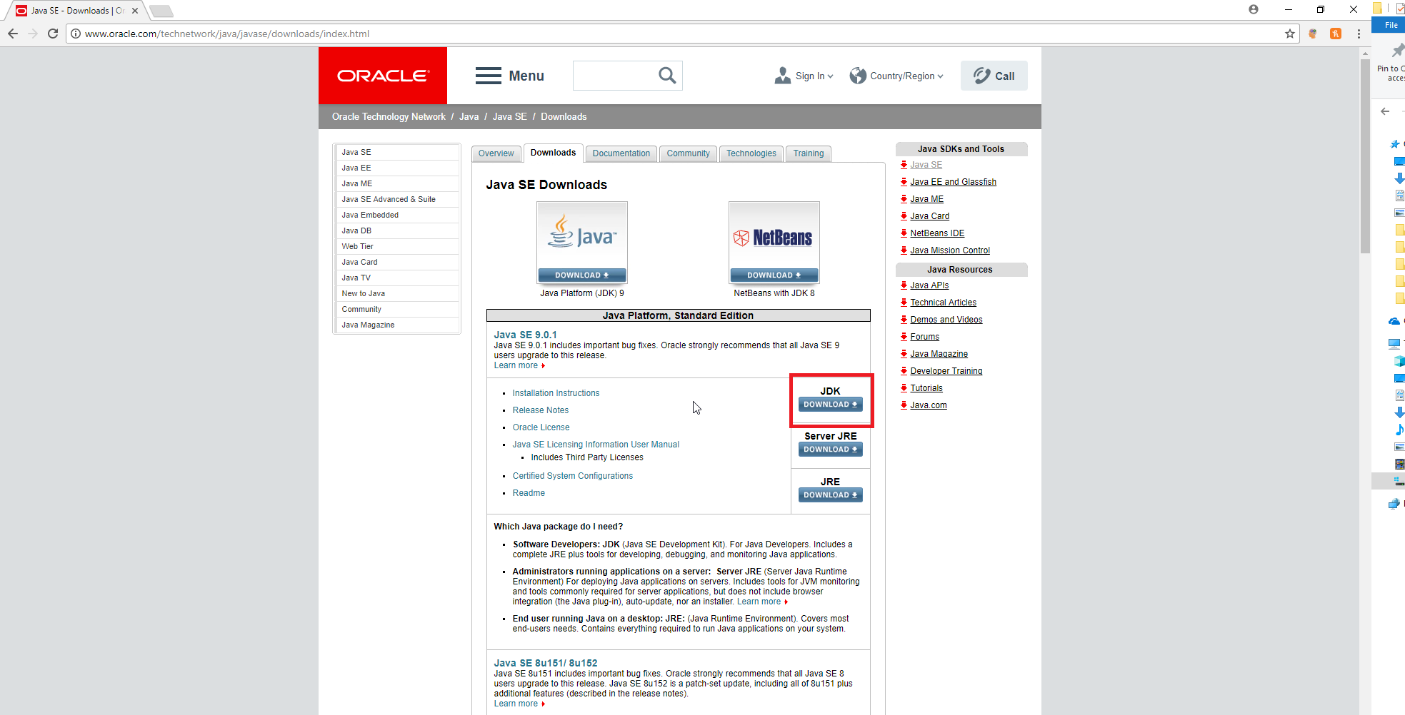

Get the Java Developer’s Kit.

**Verification:**

Run the following command on command line:

java –version

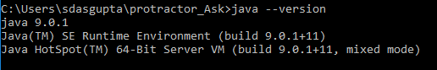

Selenium WebDriver

Selenium Web Driver needs to be installed as well to provide the server upon which the Protractor tests are run.

Run the following command on command line:

webdriver-manager update

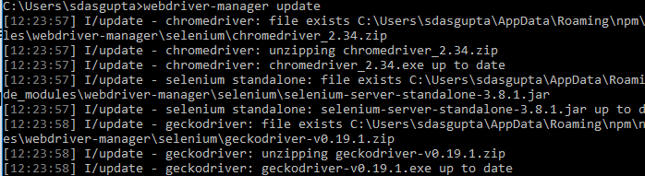

**Verification:**

Run the following command on command line:

webdriver-manager version



Protractor

Now that all the dependencies are setup – it’s finally time to install the End to End testing program. To install it takes:

Run the following command on command line:

npm install –g protractor

The “-g” implies global.

**Verification:**

Run the following command on command line:

Protractor --version



# Sample Run Through: Ask Jeeves Test

In the final suite there are four test cases. Before we run those we will run a sample test to run a simple search on Ask Jeeves.

## Setup Git Repo

Repo Link: <https://github.com/SDasman/Angular_Protractor_End2End_Tests/tree/master/Protractor_Ask>

Run Git Clone command to get the materials.

git clone https://github.com/SDasman/Angular_Protractor_End2End_Tests.git

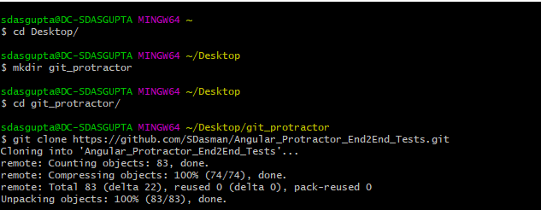

CD to the Angular_Protractor_End2End_Tests Directory and go into the Protractor_Ask folder.

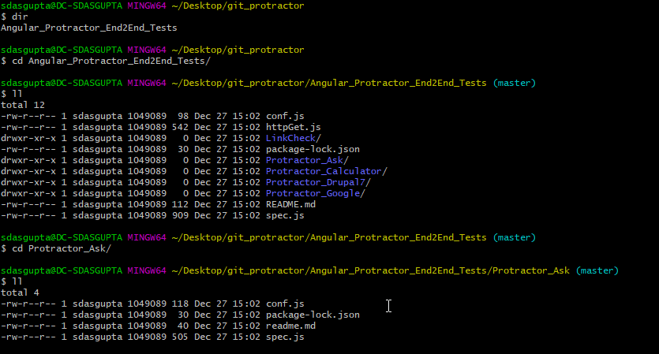

## Sample Run Through of Protractor Test

Launch a command line window. This can be done by entering “cmd” into the start of the document.

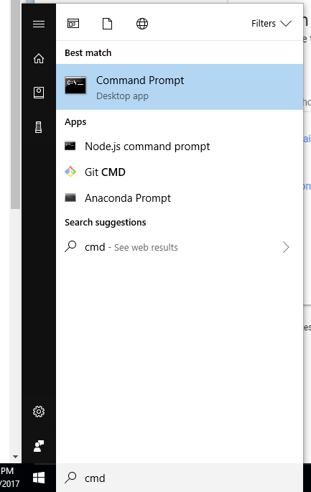

Run a Selenium Server instance with command: webdriver-manager start.

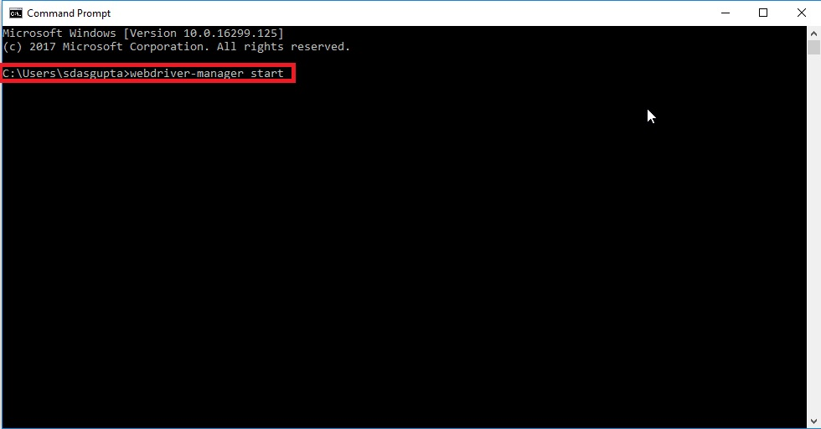

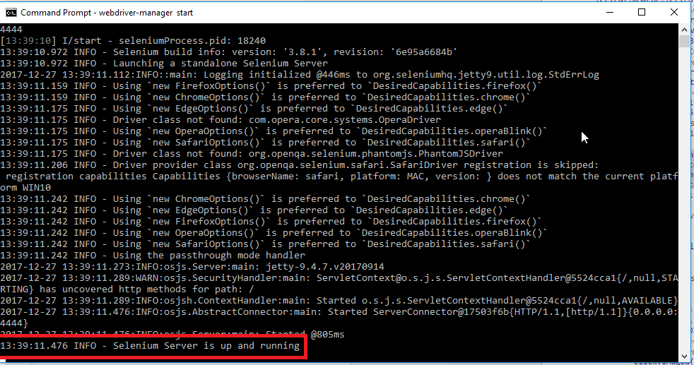

Once you see the success message that a selenium server is running – proceed. If not, run webdriver-manager update.

Launch another command line window.

Through change directory command (cd) navigate to the proper folder location where the protractor test suite is.



Then run the following command to run the test suite:

protractor conf.js --baseUrl=https://ask.com

Note: The URL must be in certain forms for the Protractor Suite to work.

Sample Run Screenshot:

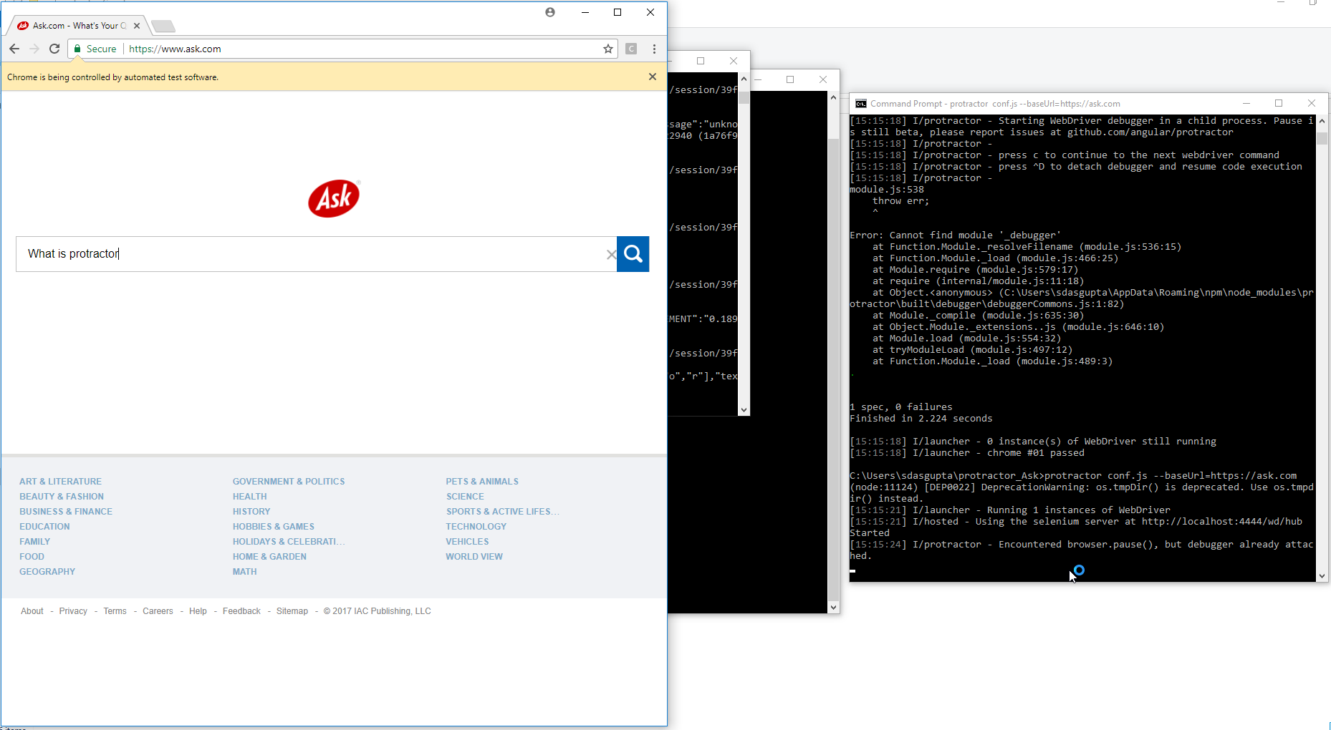

In this test we just run a simple search on Ask Jeeves.

## Reading the Log:

In this log we can see that we ran a test and that it finished in 2.384 seconds and our “1” spec (whether we could enter a search term) worked!

