Highway Cops Game – Mahdiat Khan
INTRODUCTION
This project involves the design and documentation of a procedural highway driving game aimed to be created within Unity 3D. The player will be driving along an endless highway while earning points, points put into a currency system to then buy upgrades or better cars.

GAME OVERVIEW
The game focuses on an endless highway environment where the player must drive for as long as possible to earn more points. The original scope of this project was to make a police pursuit based game in a city environment, but it was far too out of scope to try and learn the new material and resources needed to build a game with that vision, so there was a shift in focus to this highway based game instead, currently lacking any sort of police/pursuit AI, but being a more realistic approach it was chosen as a suitable replacement.

Game Type
Arcade Driving / Endless Runner
Platform
PC
Engine
Unity Game Engine
Programming Language
C#
Target Audience
Casual players who enjoy simple driving games and survival style gameplay mechanics
Core Gameplay Formula
Controlling a vehicle driving along a highway
Avoids collisions with NPC vehicles and the barrier
Earns points based on survival time
Experiences increasing challenge as the game continues
User Story 1
As a player, I want to drive along a highway
User Story 2
As a player, I want to earn points over time so that there is an end goal
User Story 3
I want the road to appear endless so that the gameplay feels continuous
User Story 4
I want the camera to follow my vehicle so that I can see the road ahead clearly

Functional Requirements
Allow the player to control a vehicle.
Generate highway road segments procedurally.
Detect collisions between the vehicle and environment.
Apply damage to the player vehicle.
Track player score over time.

Non-Functional Requirements
Maintain stable performance during gameplay.
Provide responsive player controls.
Present clear visual feedback to the player.
SCRUM TABLE
PRIORITY | FEATURE | DESCRIPTION | RESULT
HIGH | VEHICLE CONTROLLER | A PLAYER WANTS TO CONTROL THE CAR | COMPLETE
HIGH | CHASE CAMERA | ACTIVE CAMERA FOLLOWING VEHICLE | COMPLETE
HIGH | PROCEDURAL HIGHWAY | AUTOMATICALLY GENERATING HIGHWAY | COMPLETE
MEDIUM | COLLISION DETECTION | DETECT HITBOX COLLISIONS | COMPLETE
MEDIUM | POINTS SYSTEM | FUNCTIONING SCORE SYSTEM | COMPLETE
LOW | AI TRAFFIC | A PLAYER WOULD WANT SOME OBSTACLES | COMPLETE

DEVELOPMENT STRATEGY – SCREENSHOTS ATTACHED BELOW
New tasks were broken down into smaller, more manageable tasks. This approach allows complex systems to be developed incrementally while maintaining functional gameplay at each stage of development. References were used, such as youtube tutorials, and third party assets for textures, some controller scripts and models.
PHASES
Initial game concept design (tutorials for inspiration, finding simple car controllers)
Core vehicle movement implementation
Environment and procedural generation development
Gameplay mechanics implementation
Testing and refinement
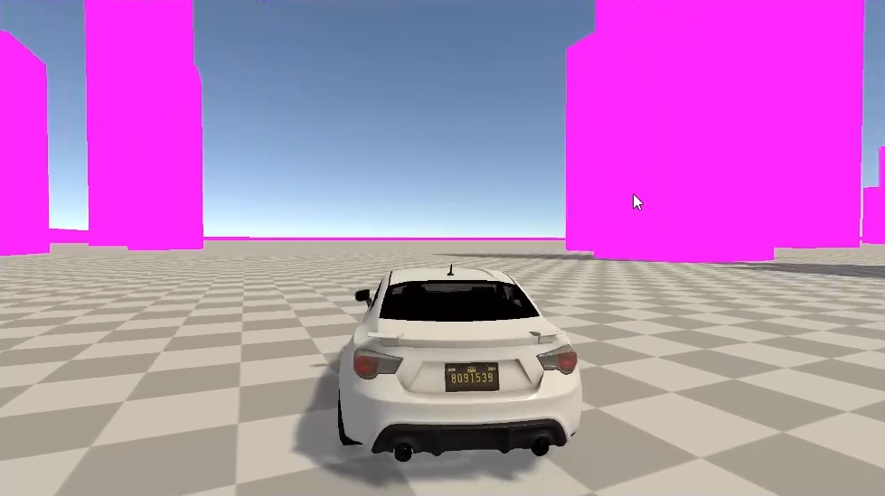
EARLIEST PROTOTYPE – BASIC CAR CONTROLLER IN A FLAT WORLD, MOVEMENT TEST

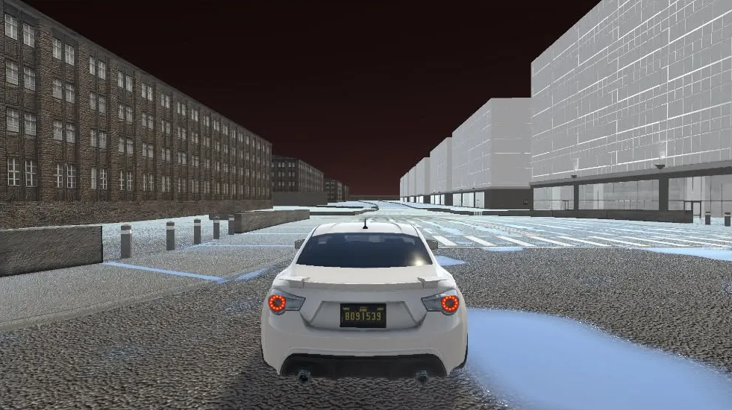
SECOND BUILD - SKYBOX ADDED, CITY ADDED, WITH PROPER MESH AND TEXTURES
SCRAPPED THIS IDEA, PURSUIT AI AROUND A CITY WAS TOO DIFFICULT TO INTEGRATE
TUTORIALS (RESOURCES) USED FOR IN-GAME ELEMENTS SO FAR
https://medium.com/@yadavaman/exploring-procedural- generation-in-unity-tools-and-techniques – PROCEDURAL ROADS
https://www.youtube.com/watch?v=K86JflUmCLY - CONTROLLERS
https://www.youtube.com/watch?v=-Q076-nxRLs – SCENE LIGHTING
https://www.youtube.com/watch?v=gSfdCke3684 – UI BUTTONS
https://www.youtube.com/watch?v=n04QnNf7gfQ – CAMERA INSPO
https://www.youtube.com/watch?v=OJlTY93WLoU – ENGINE SOUNDS

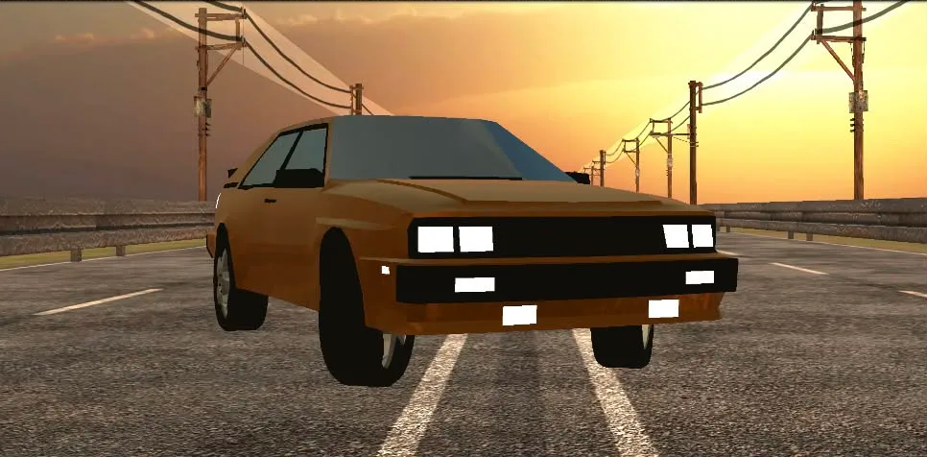
NEW BUILD, WITH PROCEDURAL HIGHWAY AND STARTER SCENE

CURRENT GAME CONCEPT
The player controls a vehicle travelling along a highway environment which appears infinite due to procedural generation of road segments.
Survive for as long as possible, spend points on upgrades.

CHARACTERS
There is no playable character, just a drivable target vehicle
The vehicle includes:
Rigidbody physics
Steering input
Acceleration mechanics
Collision detection
Damage system
The vehicle will act as the player physical interaction with the game world

ENVIRONMENT DESIGN
The game environment consists of a procedurally generated highway system.
Road segments are dynamically spawned as the player moves forward. This allows the game to simulate an endless environment while using a limited number of assets.
Some environmental assets used:
Highway road segments
The side barriers
Skybox environment
Ground terrain textures

GAMEPLAY LOOP

Player begins driving along the highway

New road segments are generated

Player avoids collisions

Player earns points over time

Multipliers added for speed bonus or distance

Game ends when vehicle hits NPC traffic or barrier

MOTIVATION LOOP
Player actively driving
Player wants to survive longer and increase score
Increased score brings increased currency
Easy to gain multipliers by driving on the wrong lane / close calls
Reward scheme, multiplier cashes out bonus points
Player spends points on upgrading parts, or buying new cars
THE GAME TRANSITIONS BETWEEN THESE THREE STATES
GAMEPLAY
GAME OVER
START MENU

PROGRAMMING LANGUAGE AND PLATFORM
The game is developed using the Unity game engine and C#.
Unity handles the particles, scripts, asset management and rendering
C# was used to implement the game logic including:
Vehicle controller scripts
Road generation scripts
Damage and collision logic
Score tracking system
Unity Editor was used for the clickable UI elements within the game viewport, things such as on screen buttons, for options, selecting cars.

KEY | ACTION
W/UP ARROW | ACCELERATE
S/DOWN ARROW | BRAKE
A/LEFT ARROW | STEER LEFT
D/RIGHT ARROW | STEER RIGHT
CONTROL SCHEME (NATIVE KEYBOARD SUPPORT)
CHALLENGES
There were lots of technical shortcomings, mostly Unity having lots of compile errors, or physics bugs whenever loading into game.
Vehicle Physics
Smooth movement needed careful tweaks of the Rigidbody physics system for each car.
Procedural Road Generation
The procedural highway required the implementation of a road spawning system that generates new segments as the player moves forward.
Collision Detection
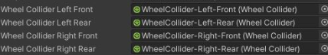
Proper collider setup was required to ensure collisions triggered the damage system correctly, with collider points

CODING TECHNIQUES – TOOLS USED
UNITY ENGINE – GAME DEVELOPMENT VISUAL STUDIO C# - SCRIPTING
GITHUB – DOCUMENTATION AND VERSION CONTROL
Object Oriented Programming
Scripts separated into separate classes and assets
Singleton
Global Management
ISSUE LOGGING
Development Review Logs
Meeting 1 (In class)
Completed: Car movement and camera
Next: Traffic system
Issues: Camera not positioning right in play mode
Meeting 2 (Simulated)
Completed: Traffic AI and pooling
Next: UI and scoring
Issues: Traffic frequency bugging
Session 3 (Simulated)
Completed: UI and game over system
Next: Testing
Issues: Score * Multiplier balancing
Session 4 (Simulated)
Completed: Testing and bug fixes
Issues: UI bugs, sound glitches

SOLUTIONS
Traffic kept overlapping, had to watch some videos on proper collision checking, and update the collision scripts and properties in rigid body.

Camera was always off, had to delete it completely and start fresh with a free controller script and adjust it to my liking.
TEST PLAN
Test 1 — Player Movement
Description: Verify player car movement
Input: WASD/ARROW KEYS
Expected Result: Car moves as it should
Actual Result: Pass
Test 2 — Traffic Spawning
Description: Verify traffic cars actually spawn
Input: Drive forward
Expected Result: Traffic appears ahead of player
Actual Result: Pass
Test 3 — Collision System
Description: Verify collision behaviour
Input: Crash into traffic
Expected Result: Game over triggered
Actual Result: Pass
Test 4 — Game Over UI
Description: Verify game over screen
Input: Crash vehicle
Expected Result: Car crashes, game over screen shown
Actual Result: Pass

COMPLETION – WORKING BUILD, WORKING CARS AND GAMEPLAY LOOP

