Exercise 1 debugging

Mahdis Rezaei Tamijani

Student ID:100381114

Instructor: Chinmaya Mahapatra

First of all, I made a breakpoint on the line 6 and my perspective was on the debugging, so the color of the line was green and the debugging started. It didn’t show any result to me as line 6 was the start of a for loop I guessed that the problem might be an infinite loop, but I needed to make sure. So I used the Step over button to go through lines line-by-line. On the left-hand side of the screen I was able to see the changes in the variables’ values, so by checking the table of the values of the variables on the left I noticed the values of the I is increasing while the values of the j is not increasing and its always 0, so this is why here we have an infinite loop. So. I understood that I need to change the i++ to j++ in the line 7. So now I changed my perspective and I started to run the program and it works correctly and it shows correct result to me.

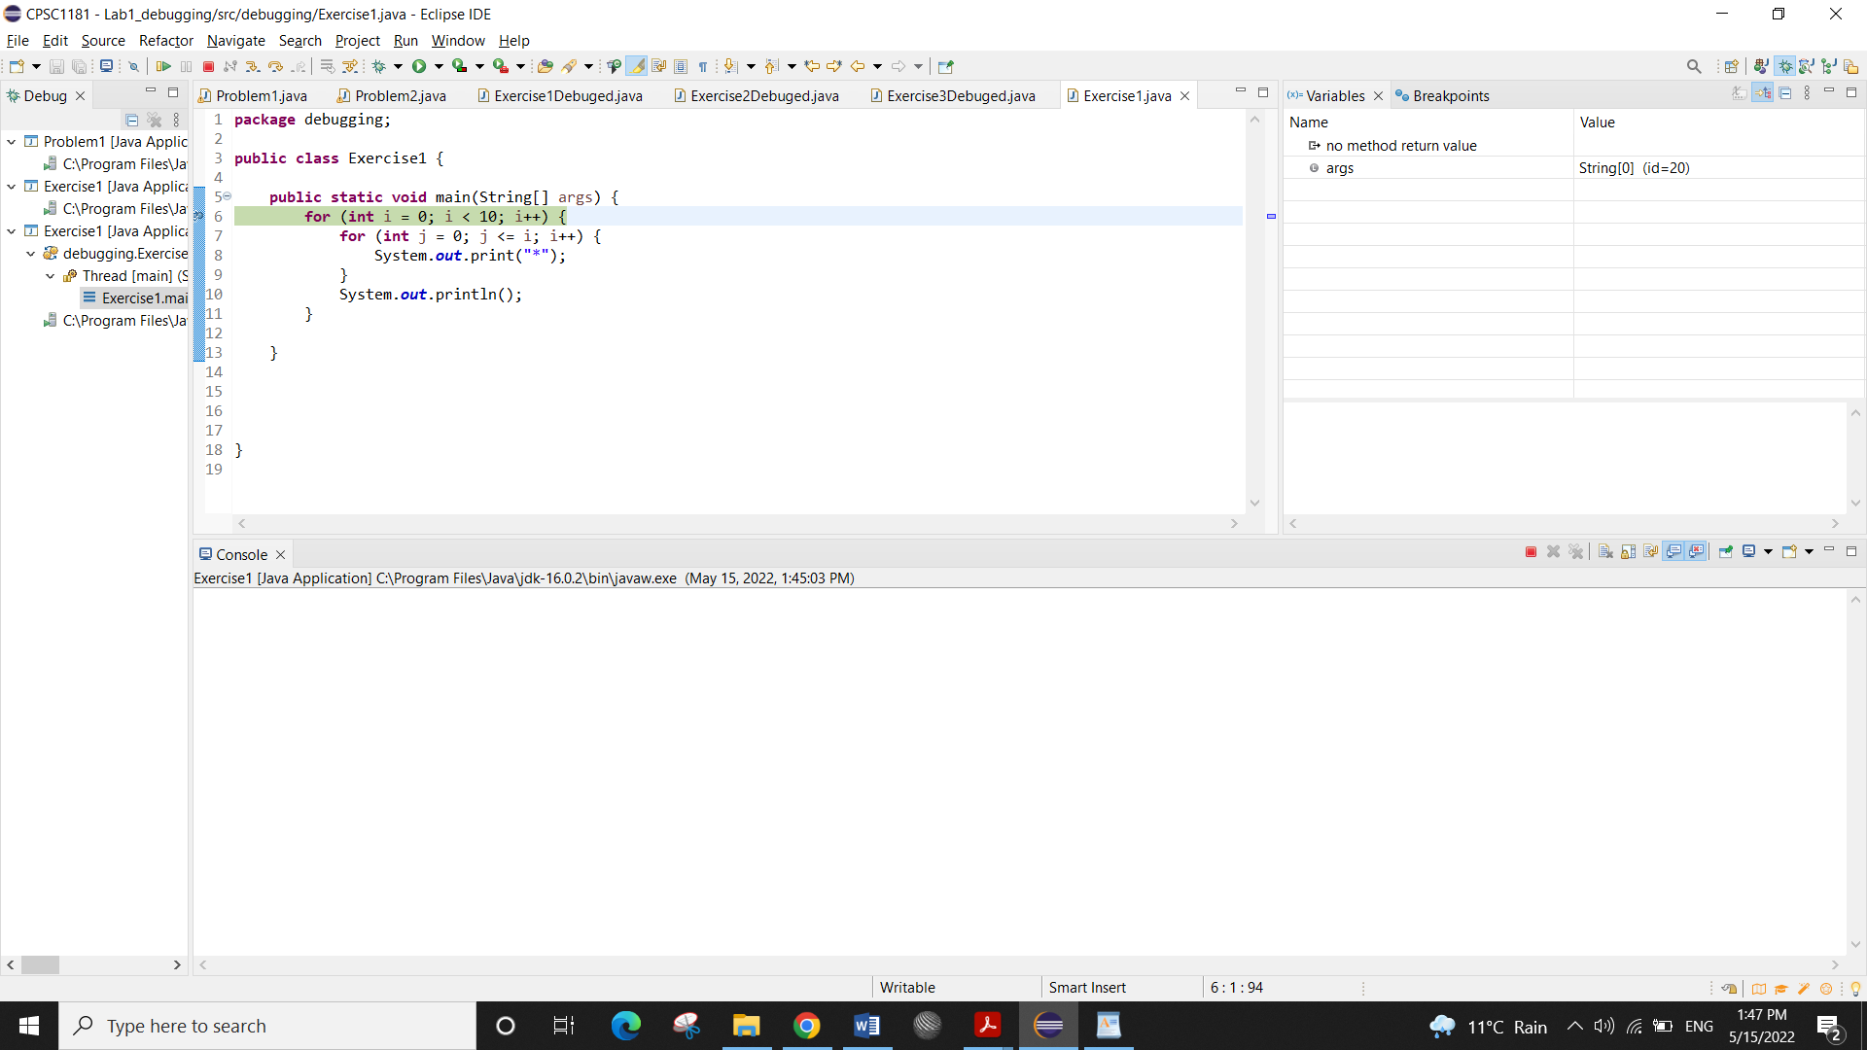

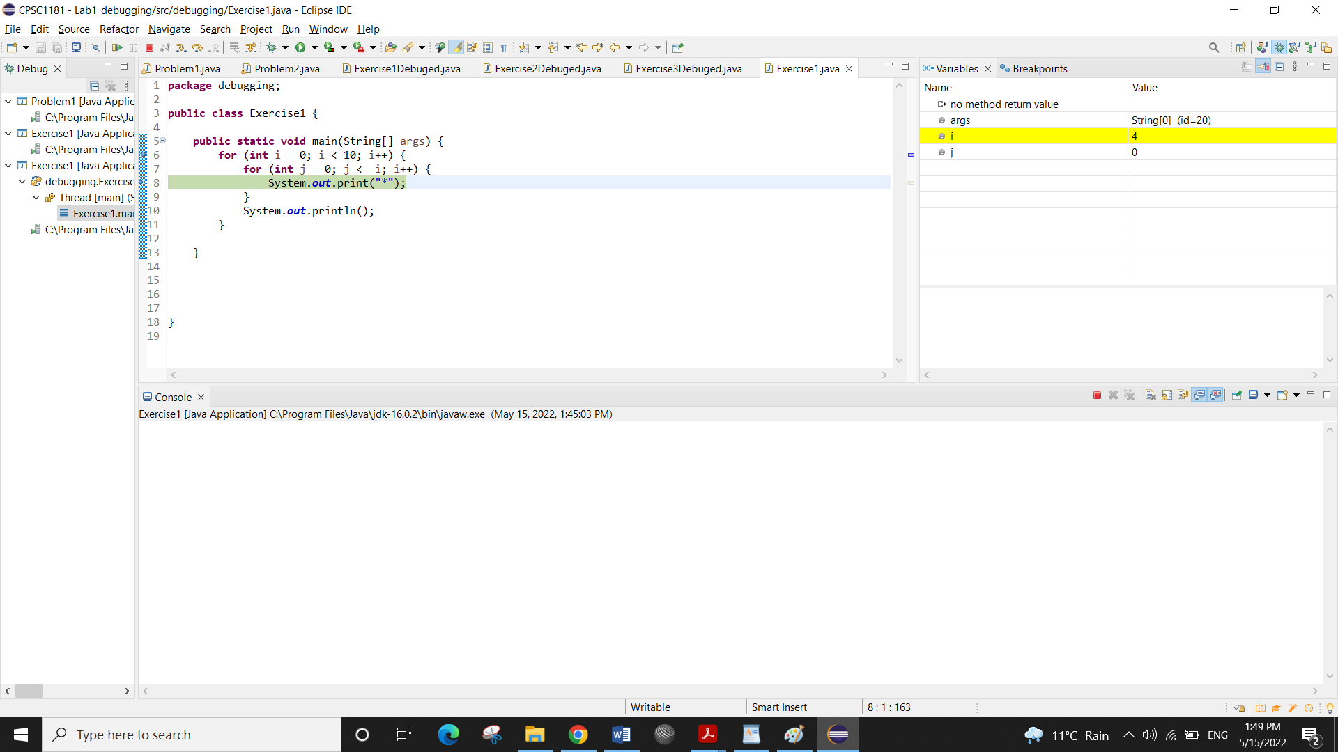

After debugging

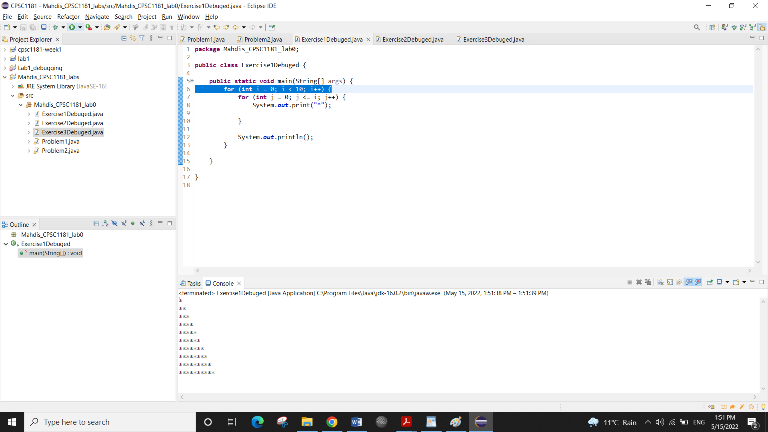

Exercise 2 debugging :

First of all, I run the program and I noticed that the number of cards that program is saying have been drawn correct is not matched with the number of cards are printed; for example, it says 4 cards are drawn in the output, but 6 cards are drawn (6 sentences are printed on the console that the cards are drawn). Also, it sounds that the mistake is more about Jack and Ace. So based on these I putted the break point on the line 21 and 23. And I noticed that the problem is there are no break after lines 21 and 23, so when it prints “ you drew a Jack” it doesn’t break (stop) and it continuous to print “you drew an Ace”. So the mistake was after print in lines 21 and 23 we need break

Before debugging ( the result is not correct)

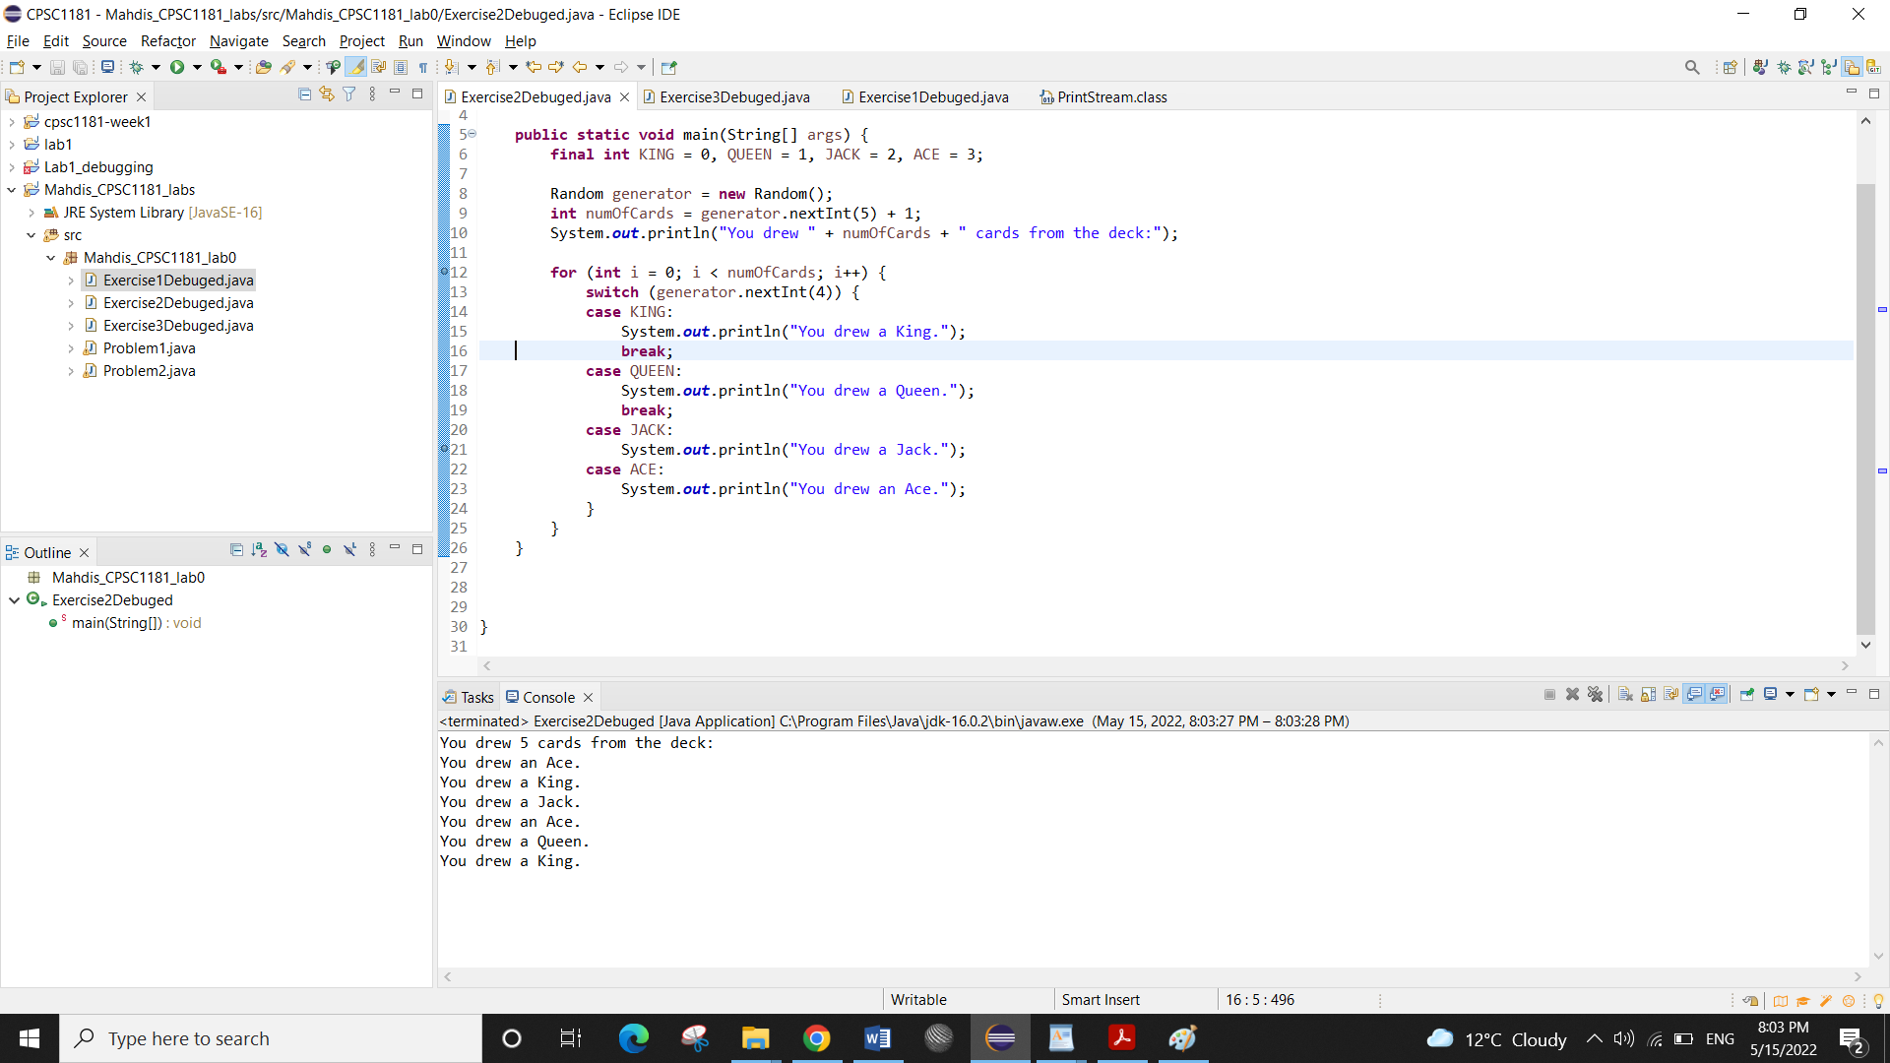

Switching to the debugging perspective; making breakpoints on the lines 21 and 23

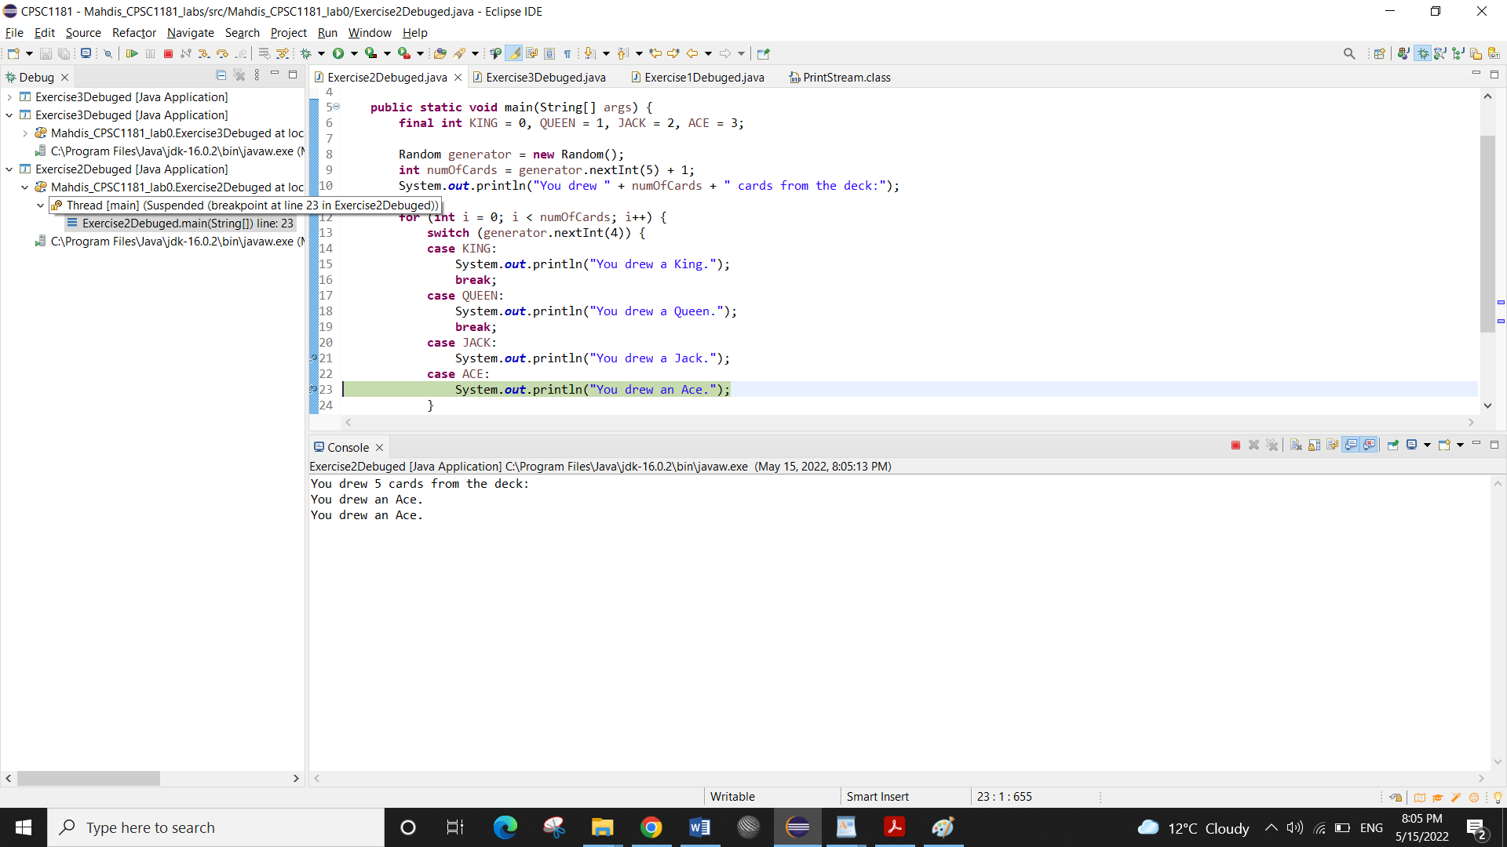

After debugging: adding break

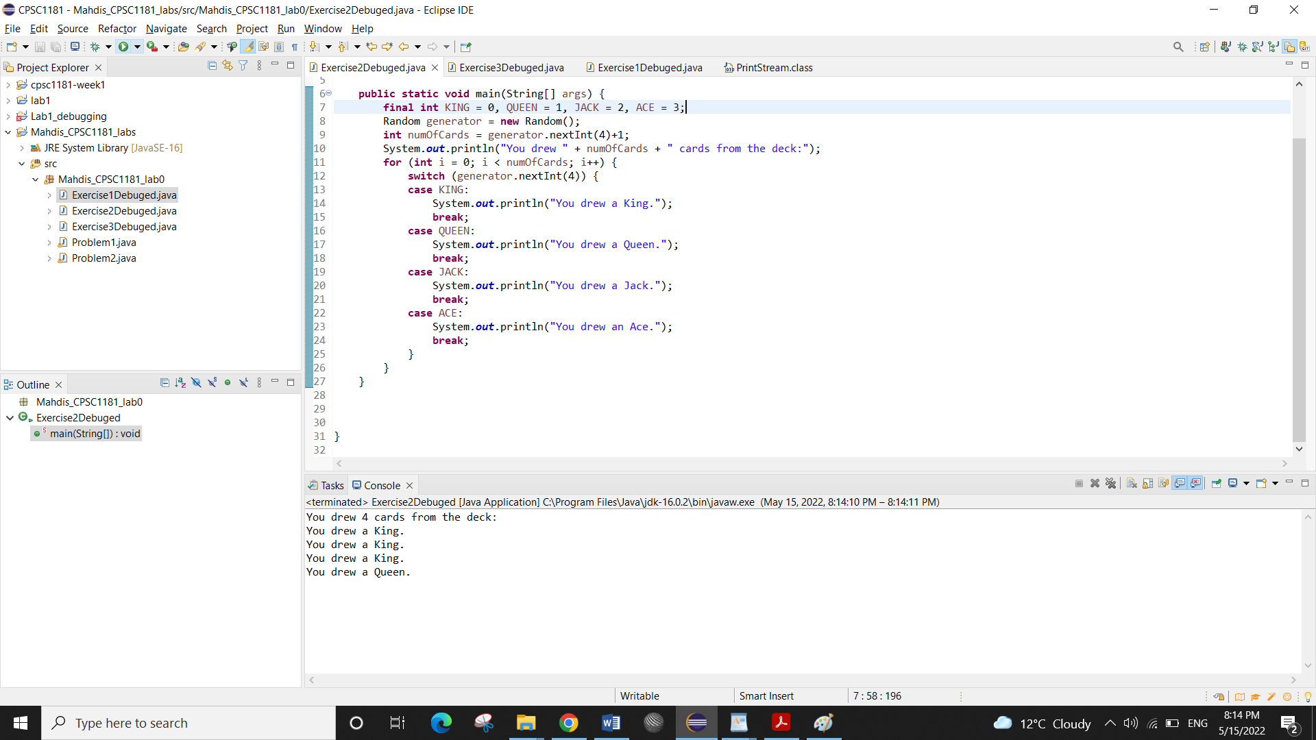

Exercise 3 debugging:

First of all, I run the program and I noticed that the result is not based on what we want because the bug might be about how for loops are nested, it didn’t sound that the other part of the loops like value of the variables be incorrect. So I decided to be focused on the way the loops are nested. Also, one thing that I noticed at first was: in the second for loop for (int i = 1; i <= (value - num); i++); and third for loop for (int i = 1; i <= ((2 \* num) - 1); i++); there is; after the () which is also incorrect, because by this, the computer thinks this is a statement not a loop and the program will not work correctly, so at first, I removed these; from the end of the for loops. To change the way loops are nested, I noticed I need to change the place of the {} in the loops, so I made breakpoint in the lines 7, 8 and 10.

The result of first time running; before debugging.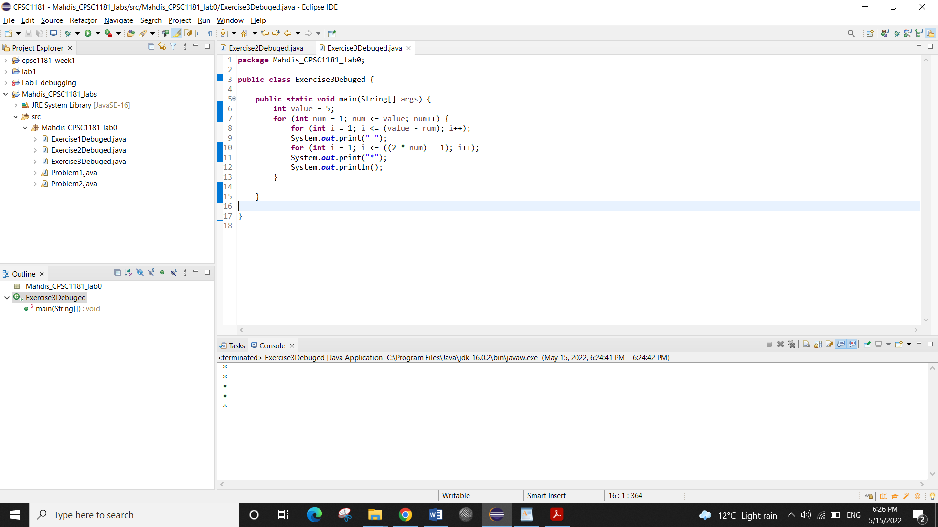

Making break point in the lines 7, 8, 10 and deleting; on the lines 8 and 10 (after for loops)

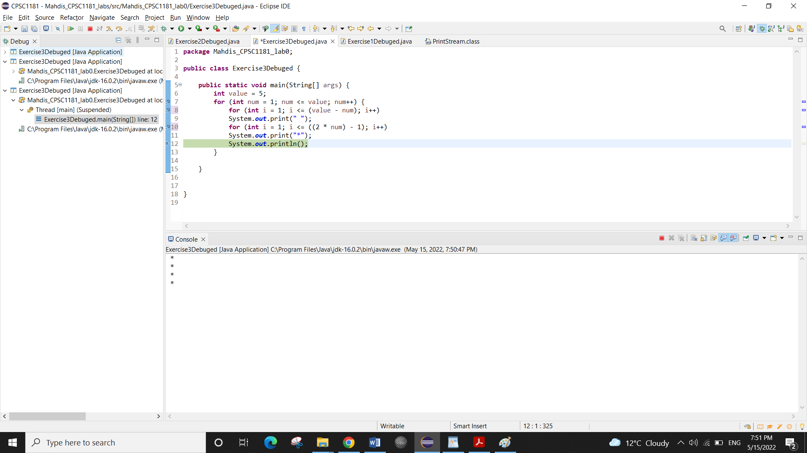

The print in the line 9 should be blocked in the second for loop, the print in the line 13should be blocked in the third block and the last print in the line 16 should be blocked in the largest for loop ( in other words it should be placed after third for loop, but still it is in the largest for loop.

( all the mentioned pointes are accomplished and the debugging is done and the program is run correctly.)

