
FTP & Chat system report
CA1 - Computer Networks

April 8, 2026
mahdy mokhtari - 810101515
https://github.com/MahdyMokh7/computerNetworking-miniProjects/tree/master/CA1-FTPChatProject - 36d733829138af801918d53ac4797a628a531f8c

Introduction

This project implements a simplified version of the File Transfer Protocol (FTP) combined with a group chat system using TCP socket programming in C++. The system follows a client-server architecture where multiple clients can connect simultaneously, exchange messages publicly or privately, and transfer files to/from the server.
Key features implemented:
- Real-time group messaging
- Private messaging between users
- Online user listings
- File upload/download with progress bars
- Concurrent multi-client handling
The communication occurs over a single TCP connection using a custom pipe-delimited protocol for command and data exchange.

System Architecture

Overall Design

The system consists of two main components:

Server
- Listens on port 8888 (configurable)
- Uses select() for I/O multiplexing
- Maintains a list of connected clients
- Stores files in server_files/ directory

Client
- Connects to server via TCP
- Uses select() for concurrent stdin/socket reading
- Stores files in test_files/ directory
- Color-coded terminal output

Client-Server Interaction Flow

┌─────────────┐ ┌─────────────┐
│ CLIENT │ │ SERVER │
└─────────────┘ └─────────────┘
│ │
├────── REGISTER|username ─────────►│
│ ├── Check username
│◄───── SYSTEM|Welcome ─────────────┤
│ │
├────── MSG|Hello ─────────────────►│
│ ├── Broadcast
│◄───── GROUP|user|Hello ───────────┤
│ │
├────── GET|file.txt ──────────────►│
│ ├── Send file size
│◄───── FILE_SIZE|file|size ────────┤
├────── READY ─────────────────────►│
│◄───── [binary file data] ─────────┤
│ │

Concurrency Model

The server uses select() system call to monitor multiple socket descriptors simultaneously. This single-process, single-thread approach eliminates the need for fork() or pthreads while providing efficient concurrent client handling. All clients share the same memory space, making user list management and message broadcasting straightforward.

Advantages of select() over fork():
- Shared memory - all clients visible to each other
- No zombie processes to handle
- Simpler code with fewer synchronization issues
- Lower memory overhead per client

Protocol Design

All communication uses a text-based protocol with pipe (|) delimiters. File transfers use a binary format after the initial handshake.

3.1 Command Format

Client -> Server:
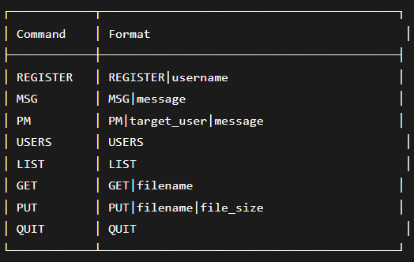
Fig 1. Client to server protocol

Server -> Client:
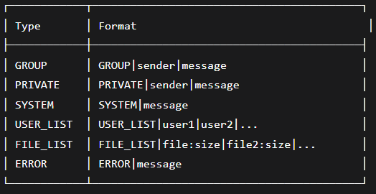
Fig 2. Server to Client protocol

3.2 File Transfer Protocol
File transfer follows a four-step handshake:
1. Client: GET|filename
2. Server: FILE_SIZE|filename|size
3. Client: READY
4. Server: [binary file data]
This ensures both parties are synchronized before binary data transmission.

4. Implementation Details

4.1 Server Implementation (server.cpp)

The server runs an infinite loop with select() monitoring:
• Server socket (for new connections)
• All client sockets (for incoming data) – each client has a socket of itself
Key functions:

Function | Purpose
handle_new_connection | Accepts and registers new client
handle_client_data | Handles client data
broadcast_message | Sends message to all clients
handle_get_command | Sends file to client
handle_put_command | Receives file from client

The server maintains a vector<Client> structure:
struct Client {
int socket_fd;
string username;
bool is_authenticated;
time_t connect_time;
};

4.2 Client Implementation (client.cpp)

The client uses select() to monitor:
• Server socket (for incoming messages)
• STDIN (for user keyboard input)
This allows messages to appear even while the user is typing.
File operations:
• PUT: Reads file from test_files/ directory
• GET: Writes file to test_files/ directory
• Progress bar updates using carriage return (\r)

4.3 Directory Structure

project/
├── server # Server executable
├── client # Client executable
├── server_files/ # Server's file storage
│ └── [uploaded files]
├── test_files/ # Client's file storage
│ └── [local files]
└── server.cpp, client.cpp

4.4 Error Handling

All system calls (socket, connect, send, recv) check return values. Errors are displayed with color-coded messages and do not crash the program.

Available Commands

Command | Usage & Description
MSG | MSG <message>  Broadcast message to all online users
PM | PM <username> <message>  Send private message to specific user
USERS | USERS  Display list of currently online users
LIST | LIST  Show available files on server
GET | GET <filename>  Download file from server to test_files/
PUT | PUT <filename>  Upload file from test_files/ to server
QUIT | QUIT  Disconnect from server and exit
HELP | HELP  Display this command reference

