**Tutorial 2**

**Binary Tree (3/9/2018)**

1. Given the following binary trees: (5m)

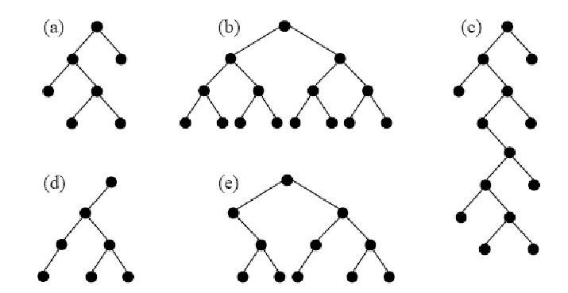

1. Indicate all of the structure properties that apply to each tree: 1. Full or proper, 2. Perfect 3. Complete.
2. Determine the height of each tree.

2. Consider the following code fragment: (2m)

**int Function( BinaryTree T )  
{**

**if( T == NULL )**

**return 0;**

**return ( T->Left != NULL && T->Right != NULL ) + Function(T->Left) + Function(T->Right);**

**}**

What will be returned by Function if we pass a pointer to the root of a binary search tree.

3. Construct a binary tree whose nodes in inorder and preorder are given as follows:(3m) Inorder :10, 15, 17, 18, 20, 25, 30, 35, 38, 40, 50  
Preorder:20, 15, 10, 18, 17, 30, 25, 40, 35, 38, 50

4. Give all the three traversals for the following tree. Also give level order traversal(Level order traversal processes the nodes level by level. It first processes the root, and then its c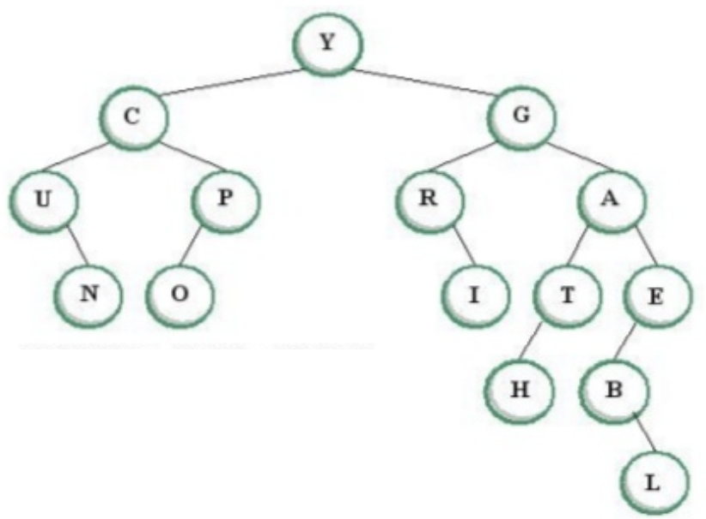hildren, then its grandchildren, and so on.) (4m)

5. Evaluate the following expression tree. For following values U = 2, X = 1, V = 5, Y = 5, Z = 2 (2m)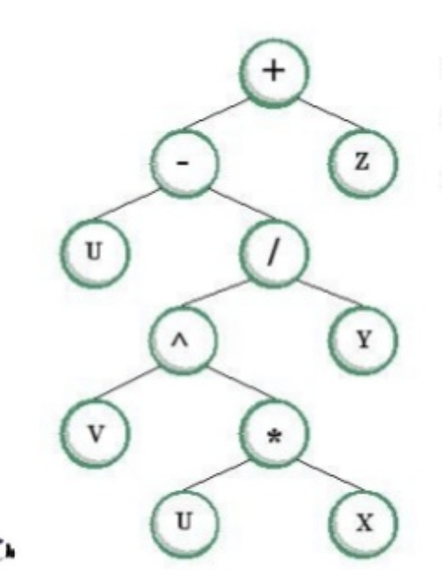

6. A binary tree in which each node has exactly zero or two children is known as a full binary tree. Consider a full binary tree of 500 leaves. Find the number of internal nodes in the tree. Jusify your answer. (1m)

7. Draw a full binary tree of depth 3 with maximum possible number of nodes (2m)

8. The preorder and postorder traversal of a binary tree (with unique elements) generates the same output. The tree can have maximum ................... node(s).(1m)

9. Show that the maximum number of nodes in a binary tree of height h is 2 h+1 − 1.(2m)

10. Eulers Tour: The Euler tour of a tree is the path through the tree that begins at the root and ends at the root, traversing each edge exactly twice — once to enter the subtree, and once to exit it. (3m)

11. Given a sequence of numbers: Draw BST and AVL Tree for the following data.(10m)

11, 6, 8, 19, 4, 10, 5, 17, 43, 49, 31