# Keeping your app responsive

<https://developer.android.com/training/articles/perf-anr>

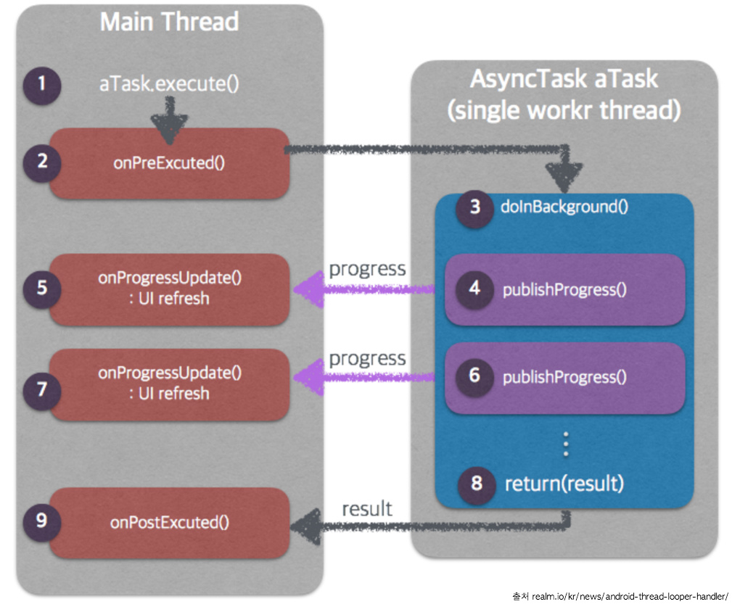

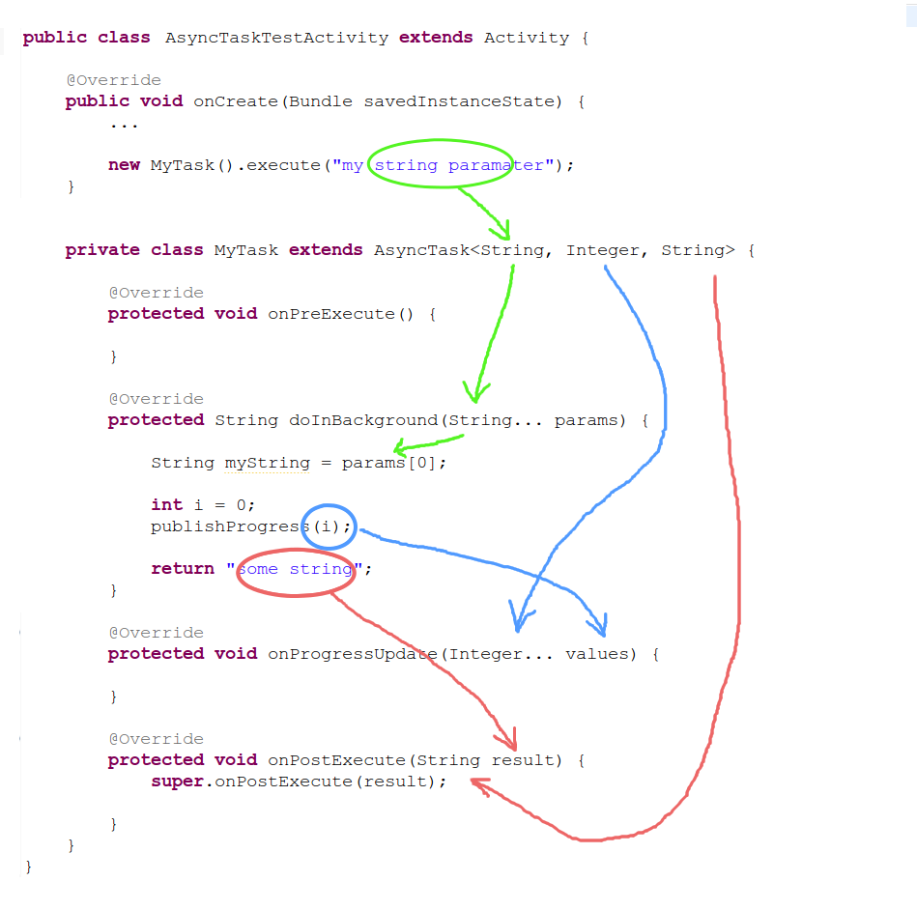

AsyncTask

<https://developer.android.com/reference/android/os/AsyncTask>

*<?***xml version="1.0" encoding="utf-8"***?>*

<**RelativeLayout xmlns:android="http://schemas.android.com/apk/res/android"**

**xmlns:app="http://schemas.android.com/apk/res-auto"**

**xmlns:tools="http://schemas.android.com/tools"**

**android:layout_width="match_parent"**

**android:layout_height="match_parent"**

**tools:context=".MainActivity"**>

<**TextView**

**android:id="@+id/tv_time"**

**android:layout_width="wrap_content"**

**android:layout_height="wrap_content"**

**android:textSize="10pt"**

**android:textColor="#444444"**

**android:layout_alignParentLeft="true"**

**android:layout_marginRight="9dip"**

**android:layout_marginTop="20dip"**

**android:layout_marginLeft="10dip"**

**android:text="Sleep time in Seconds:"**/>

<**EditText**

**android:id="@+id/in_time"**

**android:layout_width="150dip"**

**android:layout_height="wrap_content"**

**android:background="@android:drawable/editbox_background"**

**android:layout_toRightOf="@id/tv_time"**

**android:layout_alignTop="@id/tv_time"**

**android:inputType="number"**

/>

<**TextView**

**android:id="@+id/tv_result"**

**android:layout_width="wrap_content"**

**android:layout_height="wrap_content"**

**android:textSize="20pt"**

**android:textColor="@color/colorAccent"**

**android:layout_below="@+id/in_time"**

**android:layout_centerHorizontal="true"** />

<**Button**

**android:id="@+id/btn_run"**

**android:layout_width="wrap_content"**

**android:layout_height="wrap_content"**

**android:text="Run Async task"**

**android:layout_below="@+id/tv_result"**

**android:layout_centerHorizontal="true"**

**android:layout_marginTop="64dp"** />

</**RelativeLayout**>

**package** com.example.archana.a26_asynctask;

**import** android.widget.Toast;

**import** android.app.ProgressDialog;

**import** android.os.AsyncTask;

**import** android.os.Bundle;

**import** android.support.v7.app.AppCompatActivity;

**import** android.view.View;

**import** android.widget.Button;

**import** android.widget.EditText;

**import** android.widget.TextView;

**import** android.util.Log;

**public class** MainActivity **extends** AppCompatActivity

**implements** View.OnClickListener{

**private** Button **button**;

**private** EditText **time**;

**private** TextView **finalResult**;

@Override

**protected void** onCreate(Bundle savedInstanceState) {

**super**.onCreate(savedInstanceState);

setContentView(R.layout.***activity_main***);

**time** = findViewById(R.id.***in_time***);

**button** = findViewById(R.id.***btn_run***);

**finalResult** = findViewById(R.id.***tv_result***);

**button**.setOnClickListener(**this**);

}

@Override

**public void** onClick(View view) {

AsyncTaskRunner runner = **new** AsyncTaskRunner();

String sleepTime = **time**.getText().toString();

runner.execute(sleepTime);

}

**private class** AsyncTaskRunner

**extends** AsyncTask<String, String, String> {

*/\**

*android.os.AsyncTask<Params, Progress, Result>*

*An asynchronous task is defined by 3 generic types,*

*called Params, Progress and Result,*

*and 4 steps, called onPreExecute,*

*doInBackground, onProgressUpdate and*

*onPostExecute.*

*Params, the type of the parameters sent*

*to the task upon execution.*

*Progress, the type of the progress units*

*published during the background computation.*

*Result, the type of the result of the*

*background computation.*

*\*/*

*/*first generic type comes from execute() method*

*which goes as argument to doInBackground()*

*\*/*

**private** String **resp**;

ProgressDialog **progressDialog**;

@Override

**protected void** onPreExecute() {

Toast.*makeText*(MainActivity.**this**,

**"onPreExecute called"**,

Toast.***LENGTH_SHORT***).show();

Log.*d*(**"AsyncTask"**,**"onPreExecute called"**);

**progressDialog** = ProgressDialog.*show*

(MainActivity.**this**,

**"ProgressDialog"**,

**"Wait for "**+

**time**.getText().toString()+

**" seconds"**);

}

@Override

**protected** String doInBackground(String... params) {

*// NO UI related stuff here*

**try** {

**int** timeinsec = Integer.*parseInt*(params[0]);

**while**(timeinsec>0) {

publishProgress(**"Sleeping for "** +

timeinsec +**" seconds"**);

*// Calls onProgressUpdate()*

*//above string is passed to the*

*//argument text*

Thread.*sleep*(1000);

timeinsec--;

}

**resp** = **"Slept for "** + params[0] + **" seconds"**;

} **catch** (InterruptedException e) {

e.printStackTrace();

**resp** = e.getMessage();

} **catch** (Exception e) {

e.printStackTrace();

**resp** = e.getMessage();

}

**return resp**;

}

@Override

**protected void** onProgressUpdate(String... text) {

Log.*d*(**"AsyncTask"**,**"onProgressUpdate called"**);

Toast.*makeText*(MainActivity.**this**,

**"onProgressUpdate called"**,

Toast.***LENGTH_SHORT***).show();

**finalResult**.setText(text[0]);

}

@Override

**protected void** onPostExecute(String result) {

Toast.*makeText*(MainActivity.**this**,

**"onPostExecute called"**,

Toast.***LENGTH_SHORT***).show();

Log.*d*(**"AsyncTask"**,**"onPostExecute called"**);

*// execution of result of Long time consuming operation*

**progressDialog**.dismiss();

**finalResult**.setText(result);

}

}

}