List_item.xml (To create this app→ res→ layout→ right click→ New→ Layout Resource file →

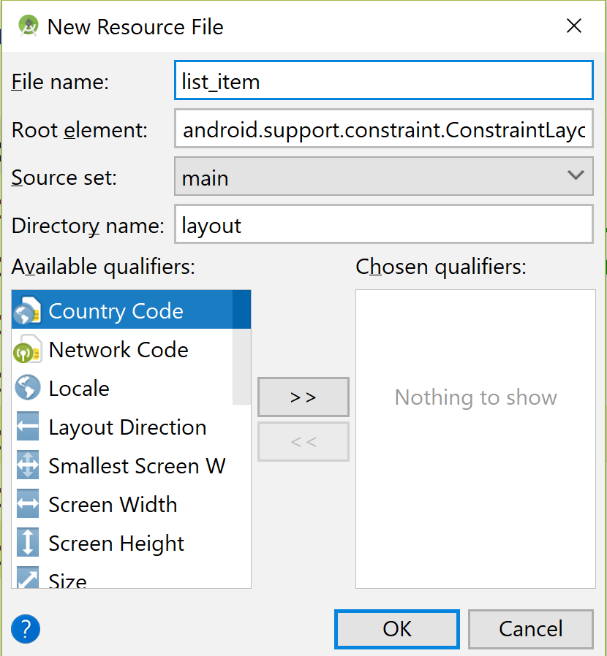

Listitem.xml

*<?***xml version="1.0" encoding="utf-8"***?>*

<**LinearLayout**

**xmlns:android="http://schemas.android.com/apk/res/android" android:layout_width="match_parent"**

**android:layout_height="match_parent"**>

<**TextView android:id="@+id/tv"**

**android:layout_width="match_parent"**

**android:layout_height="wrap_content"**

**android:padding="10dp"**

**android:textSize="16dp"**

**android:textStyle="bold"**

**android:textColor="@color/colorAccent"**/>

</**LinearLayout**>

Activity_main.xml

*<?***xml version="1.0" encoding="utf-8"***?>*

<**RelativeLayout xmlns:android="http://schemas.android.com/apk/res/android"**

**xmlns:app="http://schemas.android.com/apk/res-auto"**

**xmlns:tools="http://schemas.android.com/tools"**

**android:layout_width="match_parent"**

**android:layout_height="match_parent"**

**tools:context=".MainActivity"**>

<**EditText**

**android:layout_width="wrap_content"**

**android:layout_height="wrap_content"**

**android:id="@+id/editText"**

**android:inputType="text"**

**android:hint="Type a fruit name"**

**android:maxLength="50"**

**android:layout_marginLeft="10dp"**

/>

<**ListView**

**android:layout_width="wrap_content"**

**android:layout_height="wrap_content"**

**android:id="@+id/lv"**

**android:layout_below="@id/editText"**

**android:layout_marginLeft="10dp"**

/>

</**RelativeLayout**>

**package** com.example.archana.a6_listview_custom_layout;

**import** android.support.v7.app.AppCompatActivity;

**import** android.os.Bundle;

**import** android.view.View;

**import** android.widget.AdapterView;

**import** android.widget.ArrayAdapter;

**import** android.widget.EditText;

**import** android.widget.ListView;

**import** android.widget.Toast;

**public class** MainActivity **extends** AppCompatActivity

**implements** AdapterView.OnItemClickListener {

String **items**[]=

{**"Apple"**, **"Banana"**, **"Pinapple"**, **"Orange"**,

**"Papaya"**, **"Melon"**, **"Grapes"**,

**"Water Melon"**, **"Lychee"**, **"Guava"**,

**"Mango"**, **"Kivi"**};

EditText **et1**;

ListView **lv**;

ArrayAdapter<String> **ad**;

@Override

**protected void** onCreate(Bundle savedInstanceState) {

**super**.onCreate(savedInstanceState);

setContentView(R.layout.***activity_main***);

**et1** = findViewById(R.id.***editText***);

**lv** = findViewById(R.id.***lv***);

*/\**

*this uses the user defined layout file*

*R.layout.list_item, takes the text view*

*as each element and items are added to them*

*\*/*

**ad** = **new** ArrayAdapter<String>

(**this**,R.layout.***list_item***,

R.id.***tv***,**items**);

**lv**.setAdapter(**ad**);

**lv**.setOnItemClickListener(**this**);

}

@Override

**public void** onItemClick(AdapterView<?> adapterView,

View view, **int** i, **long** l) {

String str = **ad**.getItem(i).toString();

Toast.*makeText*(**this**,**"Item Selected: "**+

str, Toast.***LENGTH_SHORT***).show();

**et1**.setText(**"You have selected "**+ str);

}

}