**Roll No.: _ _ _ _ _ _ _ _ _ _ _ _ _ _ _ _ _ _ _**

Amrita VishwaVidyapeetham

B.Tech. First Assessment –August 2018

Fifth Semester

Computer Science and Engineering

15CSE302 Database Management Systems

**Time: Two hours Maximum: 50 Marks**

**Answer all questions**

**SET 2 Answer Key**

**Part A (30 marks)**

1. What are the advantages of database management system compared to File processing system? . (6 marks)

Advantages:-

a.data inconsistency b. data redundancy c.data isolation is achieved.

d. Integrity problems resolved. e. Automicity of updates.

f. concurrent access. g. security problems resolved

Expln :3 marks

1. Compare and contrast the following terms. (4 marks)
2. Database schema and Database Instance.

Overall design of a database is called database schema, Data stored in the database at any given time is database instance

1. Entity Integrity and Referential Integrity The entity integrity constraints assure that a spesific row in a table can be identified. The entity integrity constraint states that primary keys can't be null.

It states that if a foreign key exists in a relation then either the foreign key value must match a primary key value of some tuple in its home relation or the foreign key value must be null.

1. Consider the following schema and write RELATIONAL ALGEBRA EXPRESSION for the following (10 marks)

**Lives(person-name,street,city)**

**Works(person-name, company-name,salary)**

**Located-in(company-name,city)**

**Manages(person-name,manager-name)**

1. Find the name of all employees (i.e., persons) who work for the City Bank company (which is a specific company in the database).
2. Find the name and city of all employees who work for City Bank.
3. Find the name, street and city of all employees who work for City Bank and earn more than Rs.10,000.
4. Find all employees who live in the same city as the company they work for.
5. Find all employees who live in the same city and on the same street as their manager

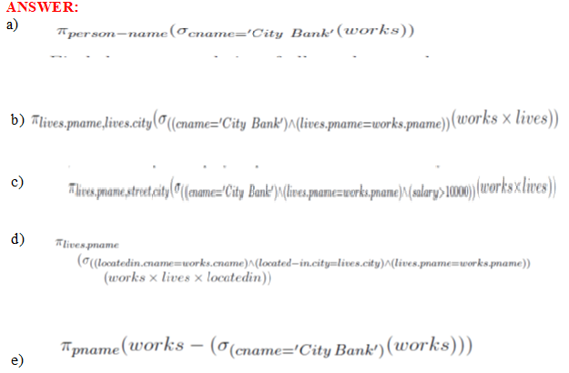

1. The academic world is an interesting example of international cooperation and exchange. This problem is concerned with modeling of a database that contains information on re- searchers, academic institutions, and collaborations among researchers. A researcher can either be employed as a professor or a lab assistant. There are three kinds of professors: Assistant, associate, and full professors. The following should be stored:

* For each researcher, his/her name, year of birth, and current position (if any).
* For each institution, its name, country, and inauguration year.
* For each institution, the names of its schools (e.g. School of Law, School of Business, School of Computer Science,. . .). A school belongs to exactly one institution.
* An employment history, including information on all employments (start and end date, position, and what school).
* Information about co-authorships, i.e., which researchers have co-authored a research paper. The titles of common research papers should also be stored.
* For each researcher, information on his/her highest degree (BSc, MSc or PhD), including who was the main supervisor, and at what school. 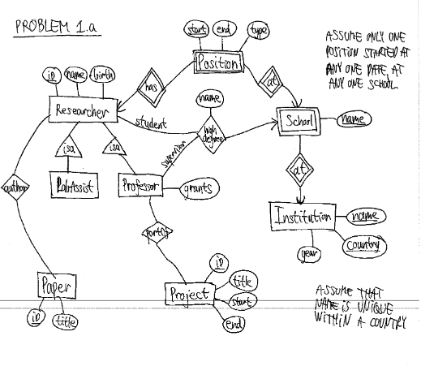
* For each professor, information on what research projects (title, start date, and end date) he/she is involved in, and the total amount of grant money for which he/she was the main applicant.

a. Draw an ER diagram that captures the above information. Identify any constraints that are not captured by the ER diagram.(8 marks)

b. For each of the following concepts give a brief description of what it means, and give an example from your ER diagram for the previous part.(2 marks)

i. Foreign key ii. Derived Attribute