**Roll No.: _ _ _ _ _ _ _ _ _ _ _ _ _ _ _ _ _ _ _**

Amrita VishwaVidyapeetham

B.Tech. First Assessment –August 2018

Fifth Semester

Computer Science and Engineering

15CSE320 Database Management Systems

**Time: Two hours Maximum: 50 Marks**

**Answer all questions**

**SET 3 Answer Key**

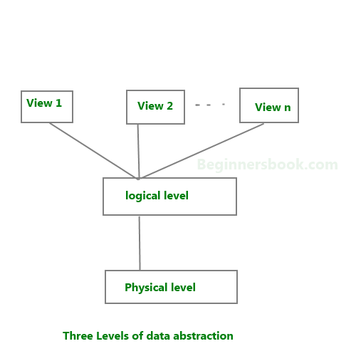**Part A (30 marks)**

1. Explain three levels of Data Abstraction (6 marks)

**Physical,Logical,View 3 marks,Expln 2 marks,Diagram 1 mark**

1. Briefly explain the constraints. (4 marks)

**Key constraints and Domain constraints**

**Primary key Foreign key UNIQUE,NULL,CHECK,DEFAULT**

**Expln 2 marks**

1. Consider a database with the following schema:

|  |  |
| --- | --- |
| *Person* ( name, age, gender ) | name is a key |
| *Frequents* ( name, pizzeria ) | (name, pizzeria) is a key |
| *Eats* ( name, pizza ) | (name, pizza) is a key |
| *Serves* ( pizzeria, pizza, price ) | (pizzeria, pizza) is a key |

**Write relational algebra expressions for the following**

|  |  |
| --- | --- |
| a. | Find all pizzerias frequented by at least one person under the age of 18. |
| b. | Find the names of all females who eat either mushroom or pepperoni pizza (or both). |
| c. | Find the names of all females who eat both mushroom and pepperoni pizza. |
| d. | Find all pizzerias that serve at least one pizza that Amy eats for less than $10.00. |
| e. | For each person, find all pizzas the person eats that are not served by any pizzeria the person frequents. Return all such person (name) / pizza pairs.  Answers |

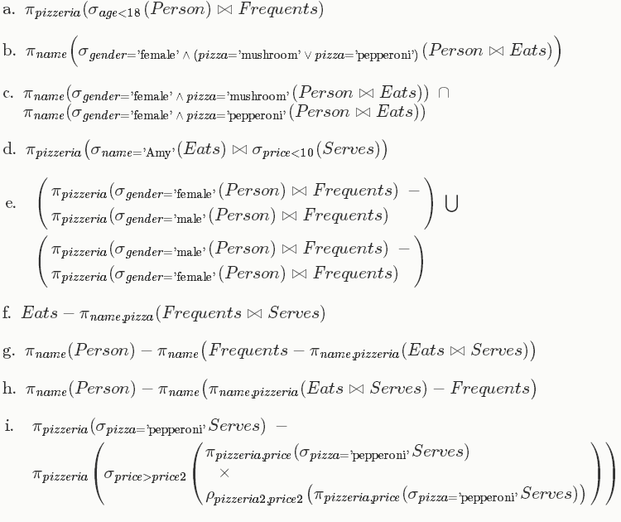

e.

4 Assume that the following application that models soccer teams, the games they play, and the

players in each team. In the design, we want to capture the following

• A set of teams, each team has an ID (unique identifier), name, main stadium, and to

which city this team belongs.

• Each team has many players, and each player belongs to one team. Each player has a number

(unique identifier), name, DoB, start year, and shirt number that he uses.

• Teams play matches, in each match there is a host team and a guest team. The match takes place in the stadium of the host team.

• For each match we need to keep track of the following:

* The date on which the game is played
* The final result of the match
* The players participated in the match. For each player, how many goals he scored,

whether or not he took yellow card, and whether or not he took red card.

* During the match, one player may substitute another player. We want to capture this

substitution and the time at which it took place.

• Each match has exactly three referees. For each referee we have an ID (unique identifier),

name, DoB, years of experience. One referee is the main referee and the other two are

assistant referee.

1. Design an ER diagram to capture the above requirements. State any assumptions you have that affects your design Make sure cardinalities and primary keys are marked.(8 marks)
2. Is there any weak entity? Differentiate weak entity and strong entity.(2 marks)



a.Total 8 marks

Entities:3marks Relationships 2 marks Attributes 2 marks cardinality and multiplicity 1 marks

b.The weak entity always depends on the strong entity for its existence.

|  |  |
| --- | --- |
| The Strong entity has a primary key. | The weak entity has a partial discriminator key. |

