1. **employee (name, salary, deptno) and  
   department (deptno, deptname, address)**

**Which of the following queries cannot be expressed using the basic relational algebra . Justify  
operations (U, -, x, π, σ, p)?**   
(a) Department address of every employee  
(b) Employees whose name is the same as their department name  
(c) The sum of all employees’ salaries  
(d) All employees of a given department

1. **Given the following relation instance.**

**x y z**

**1 4 2**

**1 5 3**

**1 6 3**

**3 2 2**

**Which of the following functional dependencies are satisfied by the instance? Justify**   
(a) XY -> Z and Z -> Y  
(b) YZ -> X and Y -> Z  
(c) YZ -> X and X -> Z  
(d) XZ -> Y and Y -> X

1. **Given relations r(w, x) and s(y, z), the result of  
   select distinct w, xfrom r, s  
   is guaranteed to be same as r, provided**   
   (a) r has no duplicates and s is non-empty  
   (b) r and s have no duplicates  
   (c) s has no duplicates and r is non-empty  
   (d) r and s have the same number of tuples
2. **Consider a schema R(A, B, C, D) and functional dependencies A -> B and C -> D. Then the decomposition of R into R1 (A, B) and R2(C, D) is (GATE CS 2001)**  
   a) dependency preserving and loss less join  
   b) loss less join but not dependency preserving  
   c) dependency preserving but not loss less join  
   d) not dependency preserving and not loss less join
3. **Consider a relation- R ( V , W , X , Y , Z ) with functional dependencies-**

VW → XY

Y → V

WX → YZ Find the candidate key and normalize the table to 3NF.

1. **Suppose (A, B) and (C,D) are two relation schemas. Let r1 and r2 be the corresponding relation instances. B is a foreign key that refers to C in r2. If data in r1 and r2 satisfy referential integrity constraints, which of the following is ALWAYS TRUE? Justify**
2. Consider the following four relational schemas. For each schema, all non-trivial functional dependencies are listed, The underlined attributes are the respective primary keys.

* Schema I: *Registration(rollno, courses)*  
  Field *‘courses’* is a set-valued attribute containing the set of courses a student has registered for.  
  Non-trivial functional dependency  
  *rollno → courses*
* Schema II: *Registration (rollno, coursid, email)*  
  Non-trivial functional dependencies:  
  *rollno, courseid → email*  
  *email → rollno*
* Schema III: *Registration (rollno, courseid, marks, grade)*  
  Non-trivial functional dependencies:  
  *rollno, courseid, → marks, grade*  
  *marks → grade*
* Schema IV: *Registration (rollno, courseid, credit)*  
  Non-trivial functional dependencies:  
  *rollno, courseid → credit*  
  *courseid → credit*

Which one of the relational schemas above is in 3NF but not in BCNF?

1. **Consider the following schedule for transactions T1, T2 and T3:**

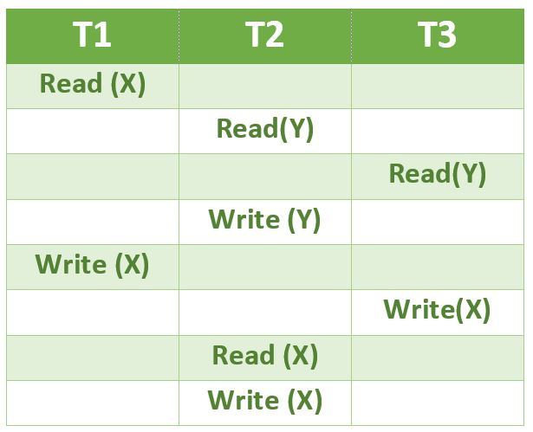

**Write a serial equivalent of the above schedule.**

1. **Consider two transactions T1 and T2, and four schedules S1, S2, S3, S4 of T1 and T2 as given below:**  
   T1 = R1[X] W1[X] W1[Y]  
   T2 = R2[X] R2[Y] W2[Y]  
   S1 = R1[X] R2[X] R2[Y] W1[X] W1[Y] W2[Y]  
   S2 = R1[X] R2[X] R2[Y] W1[X] W2[Y] W1[Y]  
   S3 = R1[X] W1[X] R2[X] W1[Y] R2[Y] W2[Y]  
   S1 = R1[X] R2[Y]R2[X]W1[X] W1[Y] W2[Y]
2. **Consider a relation scheme R = (A, B, C, D, E, H) on which the following functional dependencies hold: {A–>B, BC–> D, E–>C, D–>A}. Find all the candidate keys of R?**