**NESTED SUBQUERIES 23/07/2019**

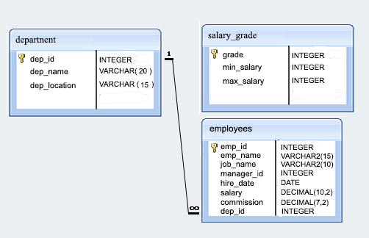

**Employees**

|  |  |  |  |  |  |  |  |
| --- | --- | --- | --- | --- | --- | --- | --- |
| emp_id | emp_name | job_name | manager_id | hire_date | salary | commission | dep_id |
| 68319 | KAYLING | PRESIDENT |  | 18-11-1991 | 6000 |  | 1001 |
| 66928 | BLAZE | MANAGER | 68319 | 01-05-1991 | 2750 |  | 3001 |
| 67832 | CLARE | MANAGER | 68319 | 09-06-1991 | 2550 |  | 1001 |
| 65646 | JONAS | MANAGER | 68319 | 02-04-1991 | 2957 |  | 2001 |
| 67858 | SCARLET | ANALYST | 65646 | 19-04-1997 | 3100 |  | 2001 |
| 69062 | FRANK | ANALYST | 65646 | 03-12-1991 | 3100 |  | 2001 |
| 63679 | SANDRINE | CLERK | 69062 | 18-12-1990 | 900 |  | 2001 |
| 64989 | ADELYN | SALESMAN | 66928 | 20-02-1991 | 1700 | 400 | 3001 |
| 65271 | WADE | SALESMAN | 66928 | 22-02-1991 | 1350 | 600 | 3001 |
| 66564 | MADDEN | SALESMAN | 66928 | 28-09-1991 | 1350 | 1500 | 3001 |
| 68454 | TUCKER | SALESMAN | 66928 | 08-09-1991 | 1600 | 0 | 3001 |
| 68736 | ADNRES | CLERK | 67858 | 23-05-1997 | 1200 |  | 2001 |
| 69000 | JULIUS | CLERK | 66928 | 03-12-1991 | 1050 |  | 3001 |
| 69324 | MARKER | CLERK | 67832 | 23-01-1992 | 1400 |  | 1001 |

**Department**

|  |  |  |
| --- | --- | --- |
| dep_id | dep_name | dep_location |
|  |  |  |
| 1001 | FINANCE | SYDNEY |
| 2001 | AUDIT | MELBOURNE |
| 3001 | MARKETING | PERTH |
| 4001 | PRODUCTION | BRISBANE |
|  |  |  |

**Salary Grade**

|  |  |  |
| --- | --- | --- |
| grade | min_sal | max_sal |
|  |  |  |
| 1 | 800 | 1300 |
| 2 | 1301 | 1500 |
| 3 | 1501 | 2100 |
| 4 | 2101 | 3100 |
| 5 | 3101 | 9999 |

**Write Nested Sub queries**

1. Write a query in SQL to display all the details of managers.
2. Write a query in SQL to display the employee ID, name, job name, hire date, and experience of all the managers.
3. Write a query in SQL to list all the employees of grade 2 and 3.
4. Write a query in SQL to display all the employees of grade 4 and 5 who are working as ANALYST or MANAGER.
5. Write a query in SQL to list the details of the employees whose salary is more than the salary of JONAS.
6. Write a query in SQL to list the employees who works in the same designation as FRANK.
7. Write a query in SQL to list the employees who are senior to ADELYN.
8. Write a query in SQL to list the employees of department ID 2001 who works in the designation same as department ID 1001.

**Sample output**

|  |  |  |  |  |  |  |  |  |  |  |
| --- | --- | --- | --- | --- | --- | --- | --- | --- | --- | --- |
| emp_id | emp_name | job_name | manager_id | hire_date | salary | commission | dep_id | dep_id | dep_name | dep_location |
|  |  |  |  |  |  |  |  |  |  |  |
| 65646 | JONAS | MANAGER | 68319 | ######## | 2957 | | | 2001 | 2001 | AUDIT | MELBOURNE |
| 63679 | SANDRINE | CLERK | 69062 | ######## | 900 | | | 2001 | 2001 | AUDIT | MELBOURNE |
| 68736 | ADNRES | CLERK | 67858 | ######## | 1200 | | | 2001 | 2001 | AUDIT | MELBOURNE |

1. Write a query in SQL to list the employees whose salary is more than the total remuneration of the SALESMAN. (Renumeration=commission+salary)
2. Write a query in SQL to find the highest paid employees in the department MARKETING.