1. A book has a unique ISBN number, a title and one or more authors. The library service may own several copies of a given book, each of which is located in one of the service’s libraries. A given library contains many books, and in order to distinguish different copies of the same book a library assigns a different copy-number to each of its copies of a given book; the price that was paid for each copy is also recorded. Every library has a unique name and is either a main library or a branch library. A main library may have zero or more branch libraries and every branch library is a branch of exactly one main library. A borrower has a name and a unique ID code. A borrower can have many books on loan, but each copy of a book can only be on loan to one borrower. A borrower could borrow the same book on several occasions, but it is assumed that each such loan will take place on a different date. 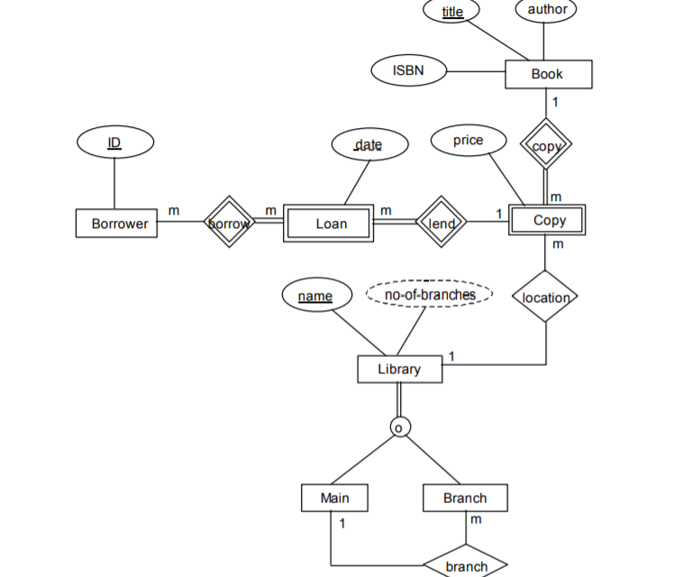

The requirements for the part of the UNIVERSITY database are the following:

1. The database keeps track of three types of persons: employees, alumni, and students. A person can belong to one, two, or all three of these types. Each person has a name, SSN, sex, address, and birth date.

2. Every employee has a salary, and there are three types of employees: faculty, staff, and student assistants. Each employee belongs to exactly one of these types. For each alumnus, a record of the degree or degrees that he or she earned at the university is kept, including the name of the degree, the year granted, and the major department. Each student has a major department.

3. Each faculty has a rank, whereas each staff member has a staff position. Student assistants are classified further as either research assistants or teaching assistants, and the percent of time that they work is recorded in the database. Research assistants have their research project stored, whereas teaching assistants have the current course they work on.

4. Students are further classified as either graduate or undergraduate, with the specific attributes degree program (M.S., Ph.D., M.B.A., and so on) for graduate students and class (freshman, sophomore, and so on) for undergraduates.

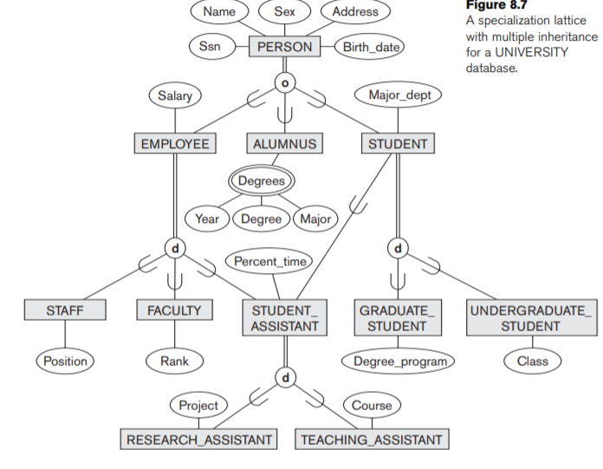

In a database for motor vehicle registration, an owner of a vehicle can be a person, a bank (holding a lien on a vehicle), or a company.