TEAM - 5

(Projects@CyberSecurity)

Mahesh Tanakala

21B21A4661

Git & Github

Git:

Git is a free, open-source version control system (VCS) that helps track and manage code changes

Why git helpful?

1.Git stores source code and its development history in a repository.

2.Git is distributed, so each developer has a local copy of the project’s history.

3.Git allows developers to branch, merge and rewrite repository history.

GitHub:

GitHub is a website that helps developers store,manage,and collaborate on software projects.

Git User Configuration:

Username :

Git config --global user.name “name”

E-mail:

Git config –global user.email “@email.com”

The common commands of Git:

1.Git init:

Use git init to initialize a directory so Git tracks it as a repository.

2.Git add:

It adds files in to the staging area for Git.

3.Git commit:

This command is used to add a commit to the changes made in the files.

4.Git remote:

This command is used to connect GitHub repository to the Git.

5.Git push:

It lets you move a local branch to another repository, which serves as a convenient way to publish contributions.

6.Git rebase:

Rebasing lets you move branches around, which helps you avoid unnecessary merge commits.

7.Git fetch:

It downloads commits,files from the remote repository to the local repository.

8.Git clone:

It clones the files from any public GitHub repository to the local repository.

The process of interaction between Git & GitHub:

Step-1:Creating a folder.

Creates a new folder and open it in the VS Code.

and create any file in that folder to work.

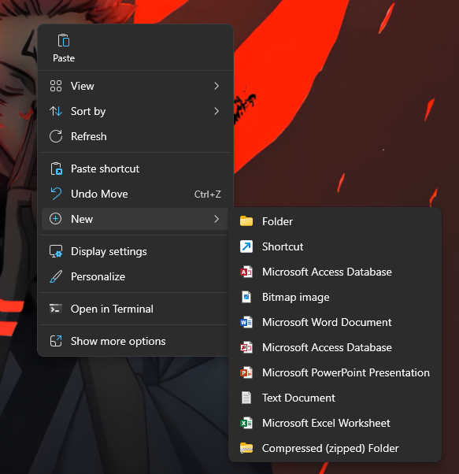

Step-2:Initializing git in the Folder.

Open terminal in VS Code and navigate to the folder where the file is located and run the command below.

>> git init

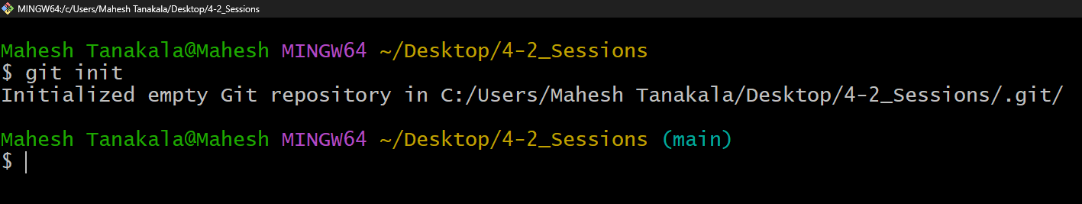

Step-3:Adding files to the staging.

To add files to the staging run the below command in the terminal.

>> git add .

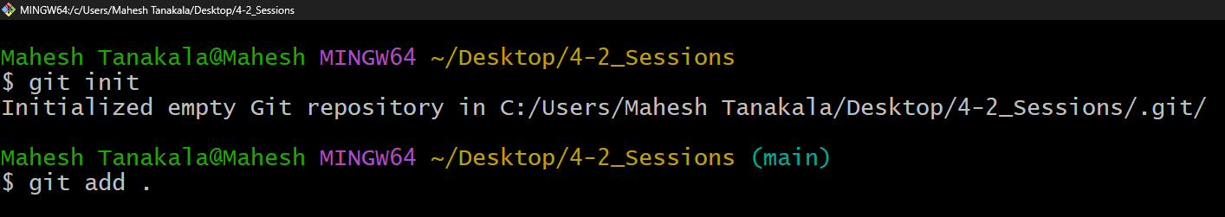

Step-4:Commit the changes.

Commit the changes made in the file so that we can track of it.Run the below command to commit the changes.

>>git commit -m “commit string”

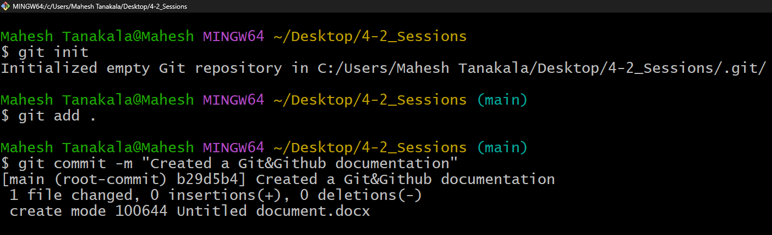

Step-5:Create a GitHub repository.

Open GitHub and login to your account and create a new repository and name it.



Step-6:Link Local repository to GitHub.

Copy the remote repository URL from GitHub and type the following command in the terminal.

>> git remote add origin <repository_URL>

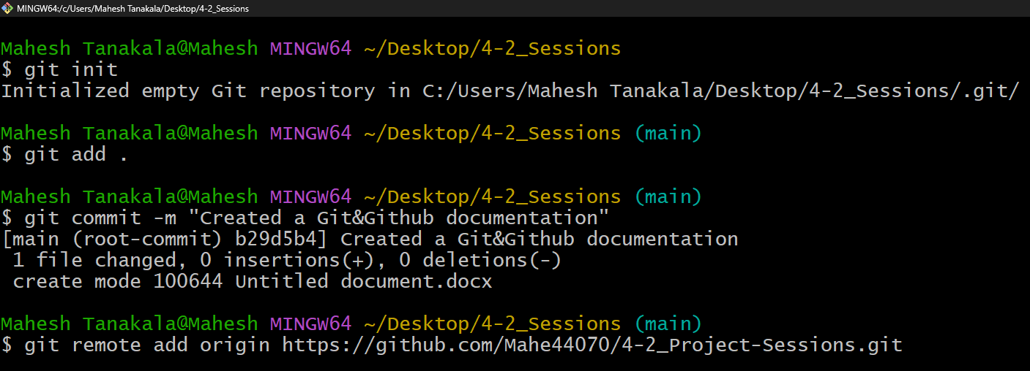

Step-7:Push Changes to GitHub.

Now you can push the changes made in the file to the Github repository to do that type the command below in the terminal.

>> git push origin main

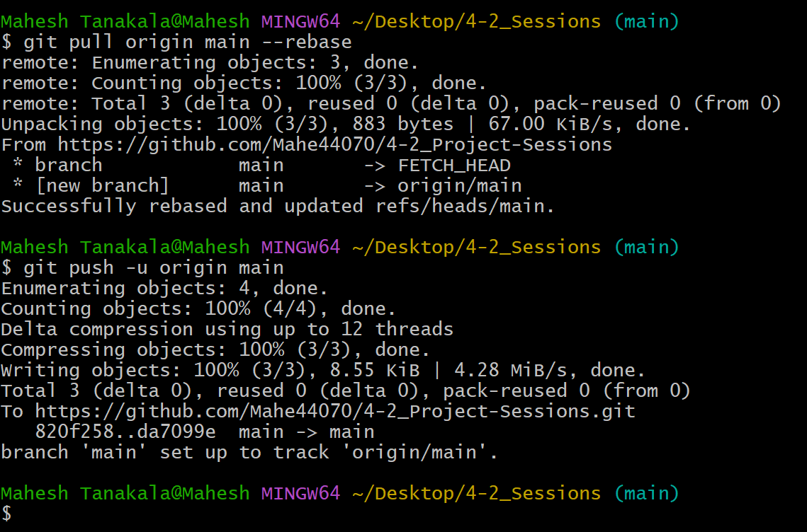

Contact:

Name : MAHESH TANAKALA

E-Mail: [mahe44070@gmail.com](mailto:mahe44070@gmail.com)

THANK YOU