Testcase 1:

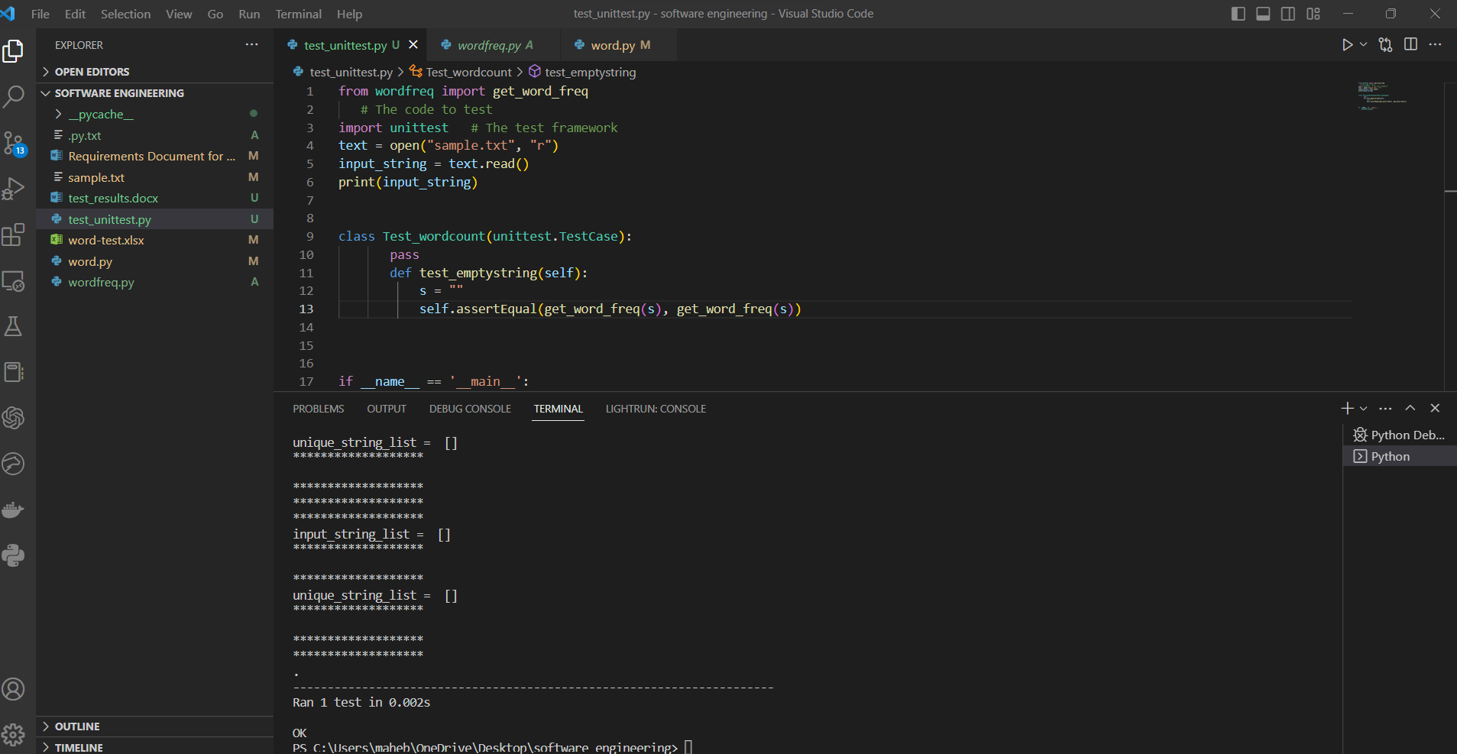

Test case 2:

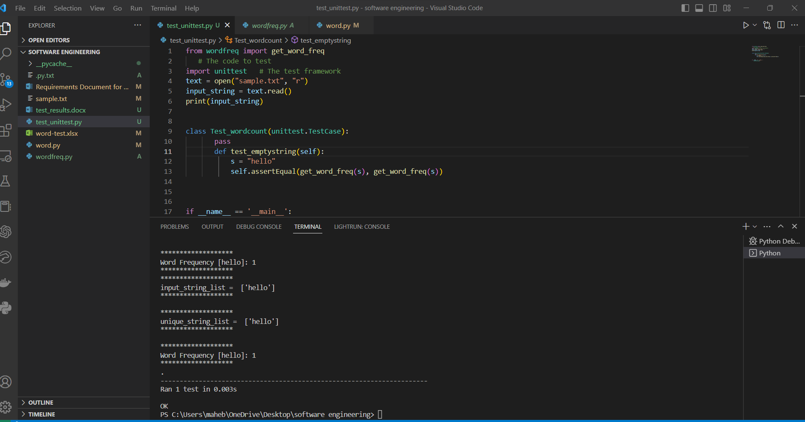

Testcase 3
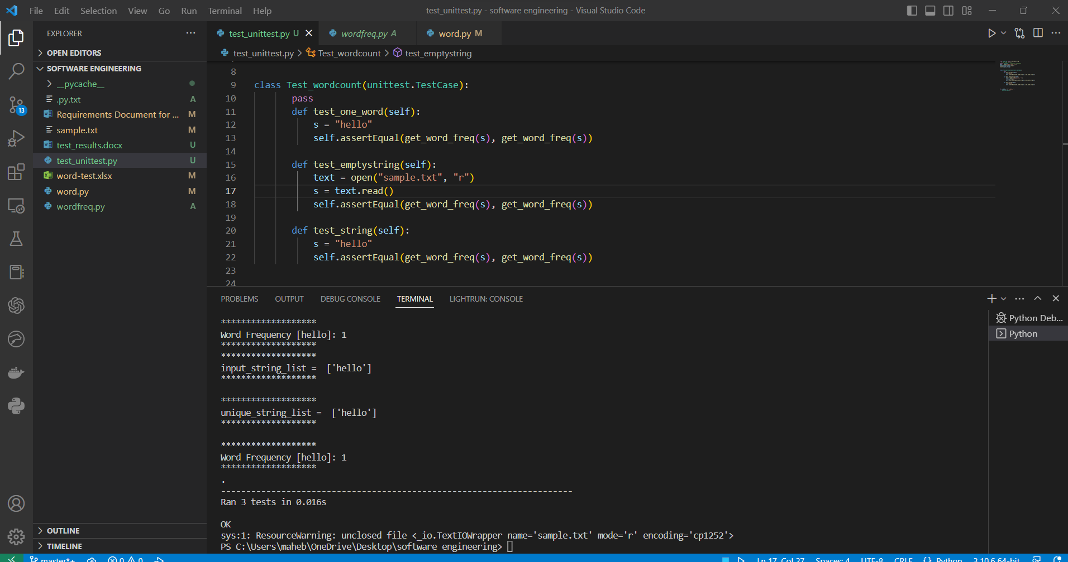

Testcase 4:
Inout :

Hello this is the first file for testing and would you get this
helo this is second line
please find

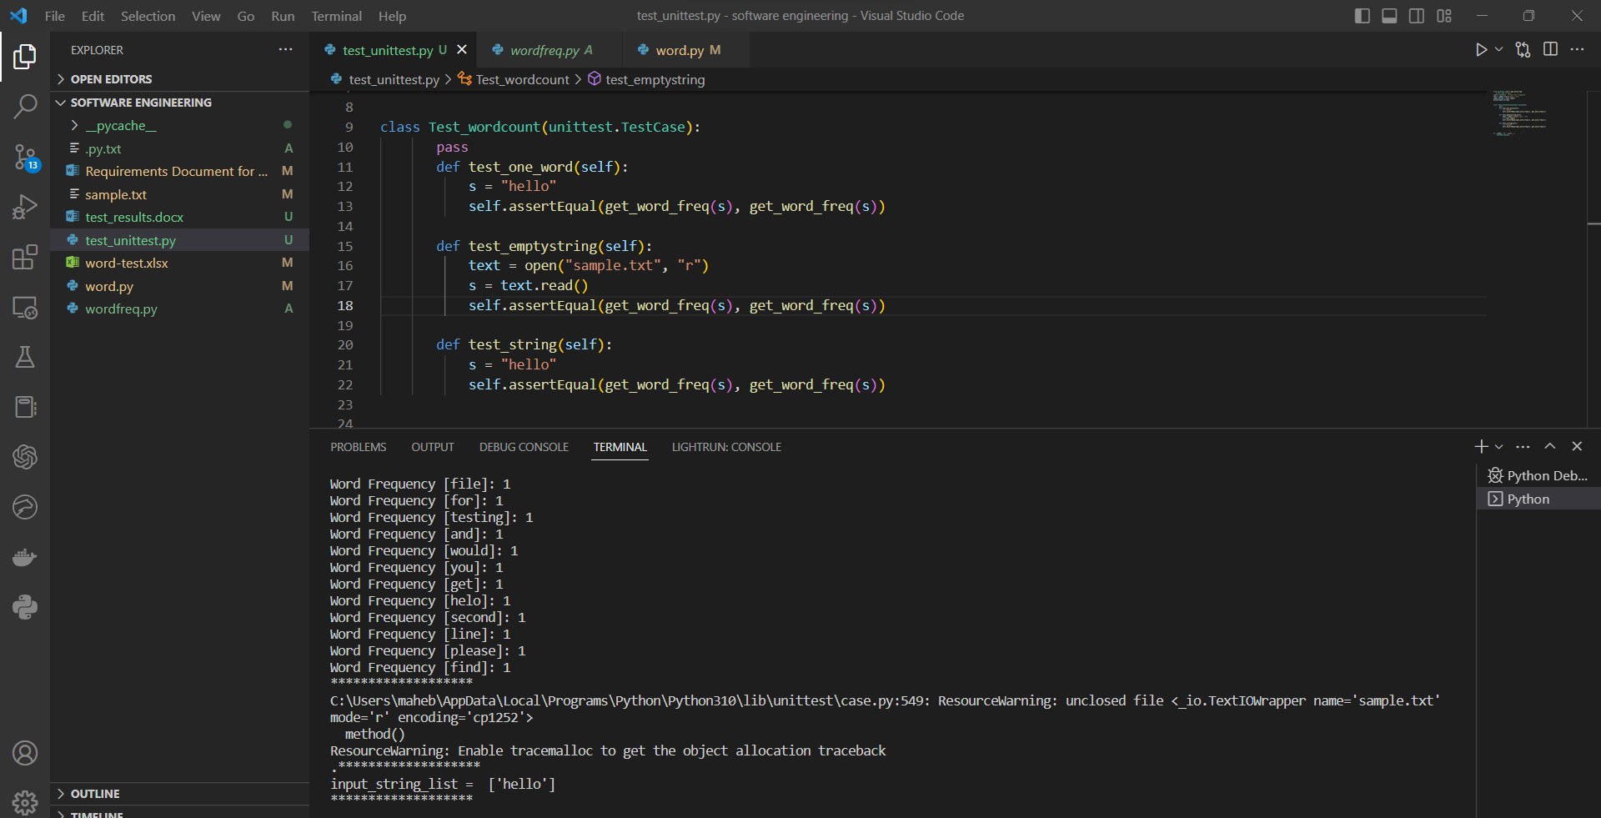

Testcase 5 :
Hello this is the first file for testing and would you get this
helo this is second line
please find

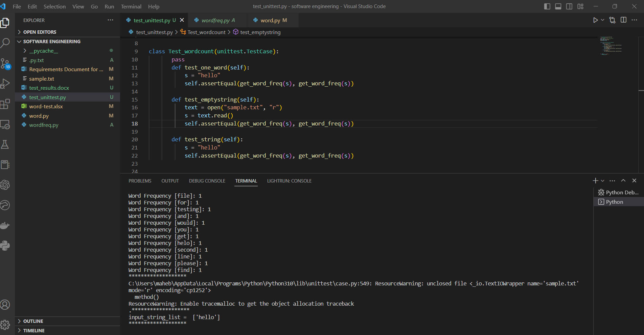
Testcase 6:
Hello this is the first file for testing and would you get this
helo this is second line
please find

Testcase 7:
Hello this is the first file for testing and would you get this
helo this is second line
please find

i) The empty string should give empty list with no words
ii) The string with one word must give one word as output in list
iii) The string with one space between each word should give correct output
iv) The string with double space between each word should give correct output
v) The string with many lines should identify the newline character and give correct word count
vi) The string with a tab between each word should omit the tab , consider it as delimiter
vii) The string with large size should pass too
viii) The string should give correct word count
ix) String with special characters in it’s words should consider characters as characters and print separate words.
x) String with alphanumeric words are considered as unique words such as word12

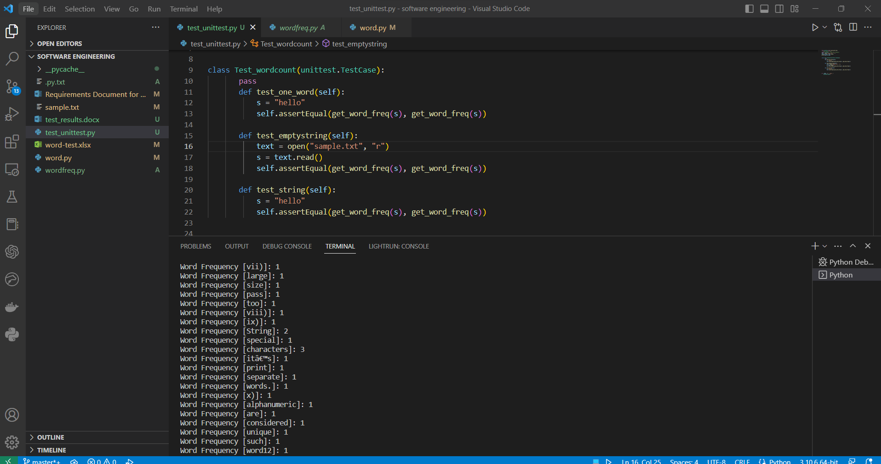

Testcase 8:
Input :

Testcase9 :

Hello this is the first file for testing and would you get this
helo this is second line
please find

i) The empty string should give empty list with no words
ii) The string with one word must give one word as output in list
iii) The string with one space between each word should give correct output
iv) The string with double space between each word should give correct output
v) The string with many lines should identify the newline character and give correct word count
vi) The string with a tab between each word should omit the tab , consider it as delimiter
vii) The string with large size should pass too
viii) The string should give correct word count
ix) String with special characters in it’s words should consider characters as characters and print separate words.
x) String with alphanumeric words are considered as unique words such as word12

hello!! hello!! hello!!

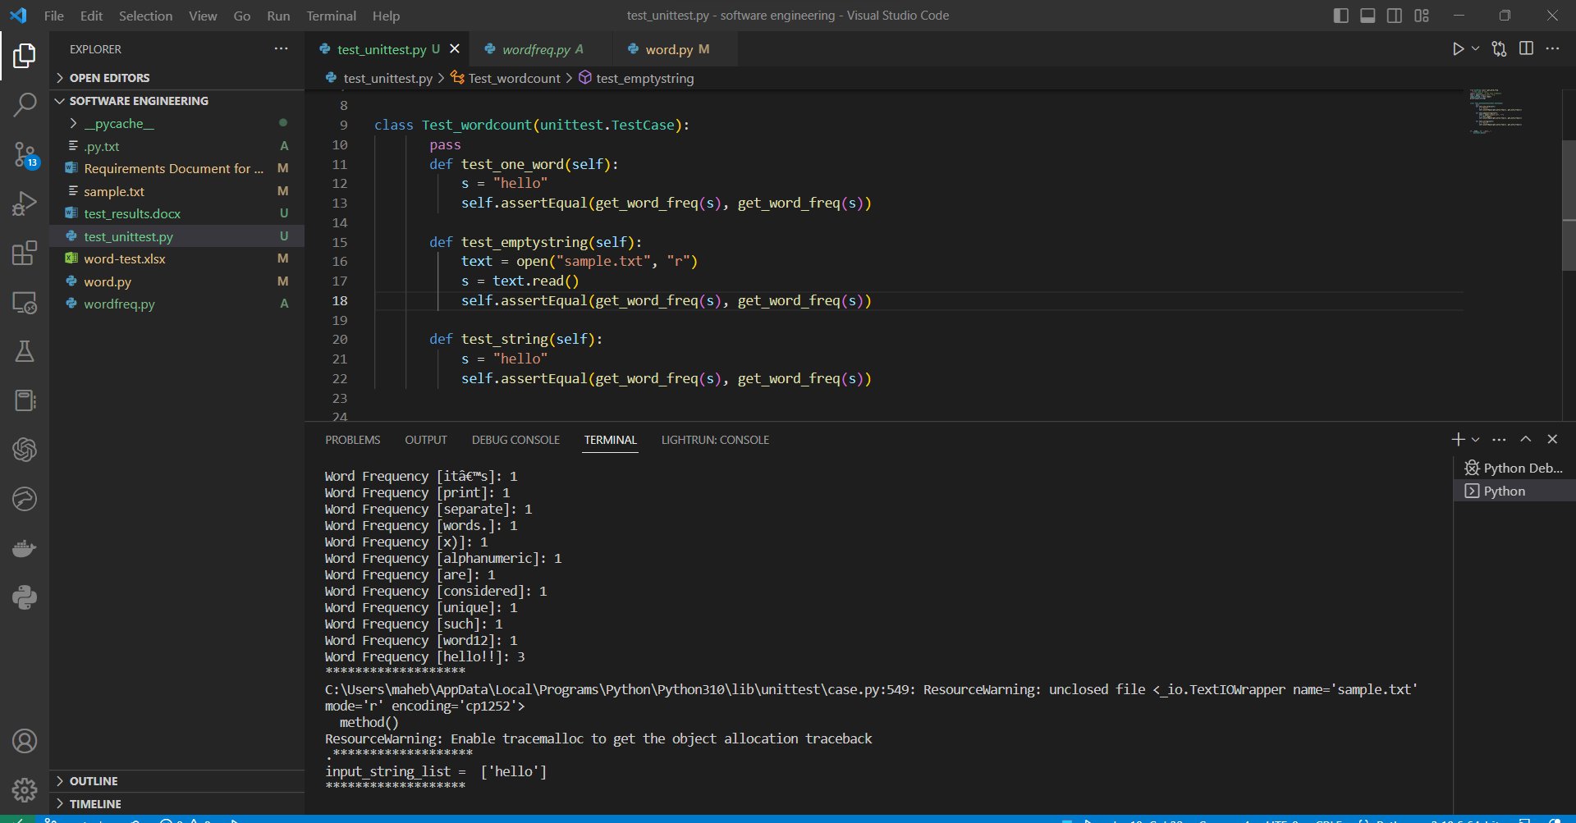

Testcase 10:
Hello this is the first file for testing and would you get this
helo this is second line
please find

i) The empty string should give empty list with no words
ii) The string with one word must give one word as output in list
iii) The string with one space between each word should give correct output
iv) The string with double space between each word should give correct output
v) The string with many lines should identify the newline character and give correct word count
vi) The string with a tab between each word should omit the tab , consider it as delimiter
vii) The string with large size should pass too
viii) The string should give correct word count
ix) String with special characters in it’s words should consider characters as characters and print separate words.
x) String with alphanumeric words are considered as unique words such as word12

hello!! hello!! hello!!
wow*

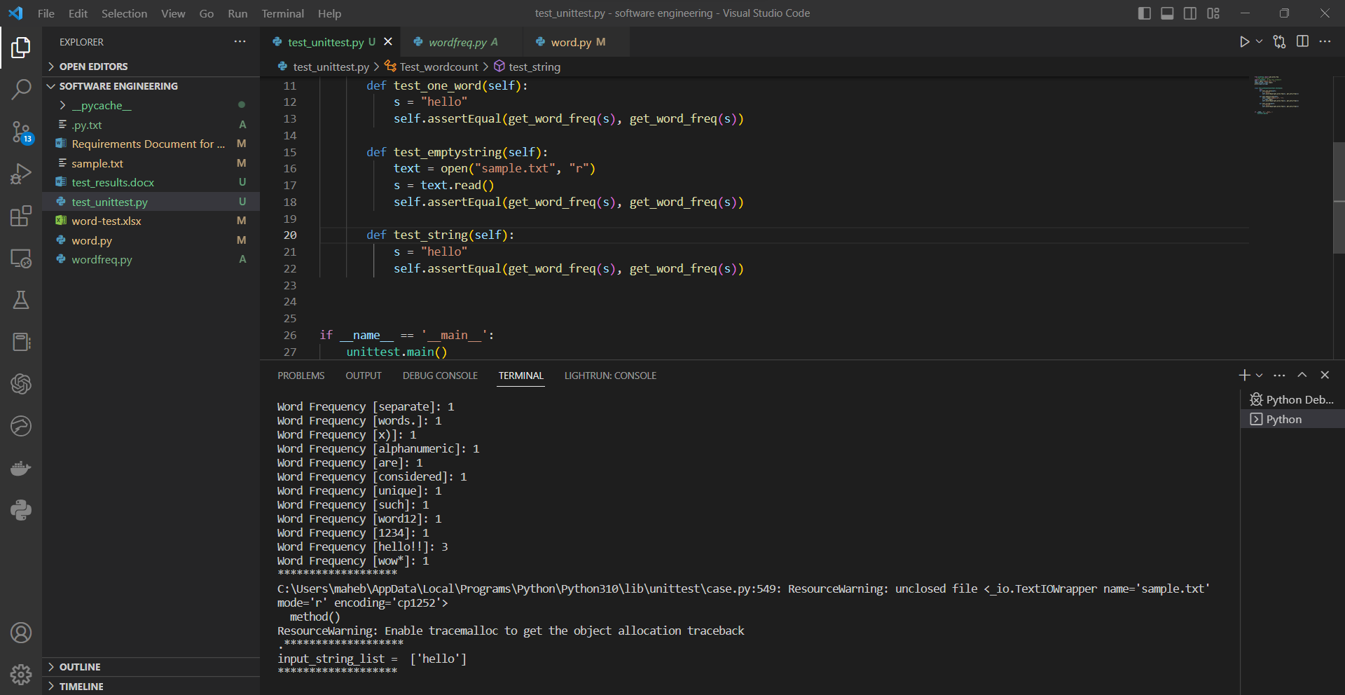

To produce the test results I keep on changing the text file so I didn’t need to write many test cases in the file

The Phase 2 test cases

  - Requirements testing For the word count : all requirements tested here are mentioned with their corresponding number in requirements document , the input passed is also given here along with the actual result(actual result includes the screenshot of the run , test and the output printed by program) and pass/fail status
    - The empty string should give an empty list with no words.
    - The empty string should give the total number of characters as 0.
4.3.1 The empty string should give the total line count as 0.

Input string passed:

Empty string

Status : pass

Actual result:

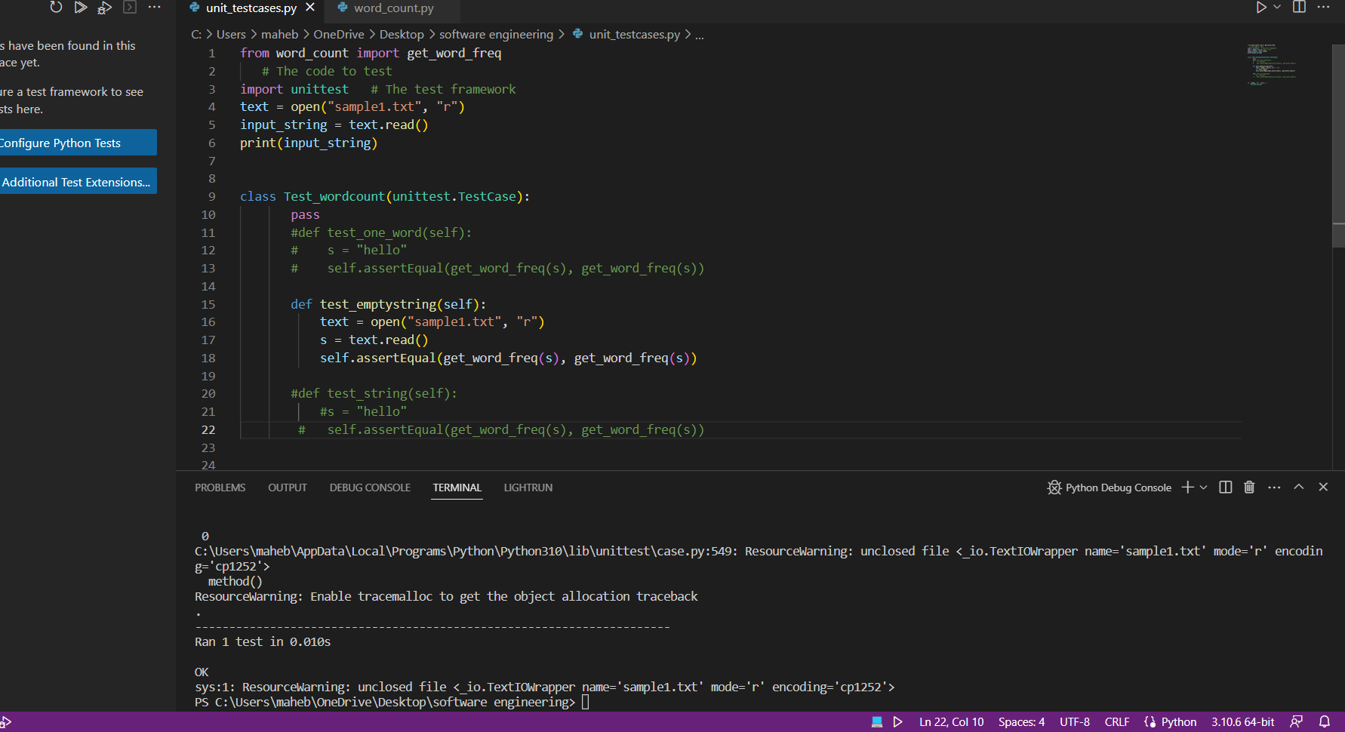

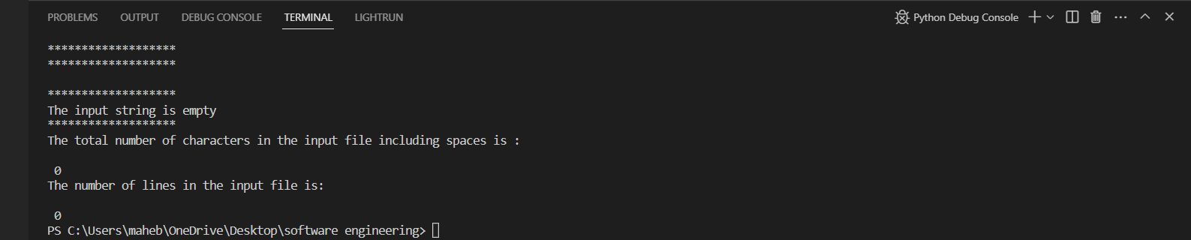

    - The string with all blank spaces should give word count 0
Input string passed:

“ “

Status : pass

Actual result:

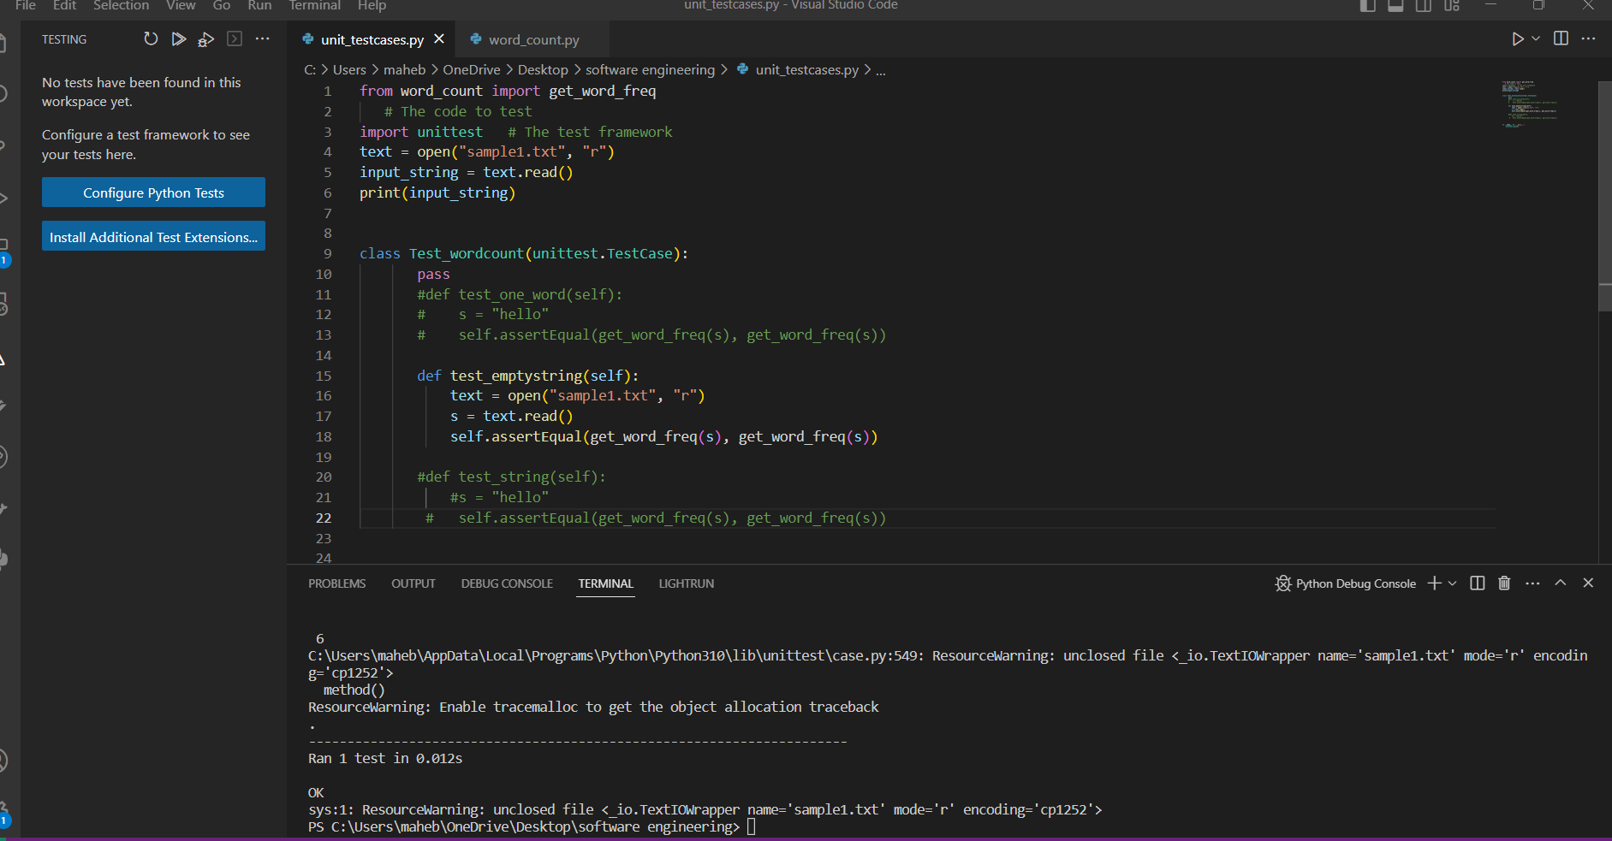

    - The string with just one period (i.e ‘.’) should give correct output as . as a word

Input string passed:

“.”

Status : pass

Actual result:

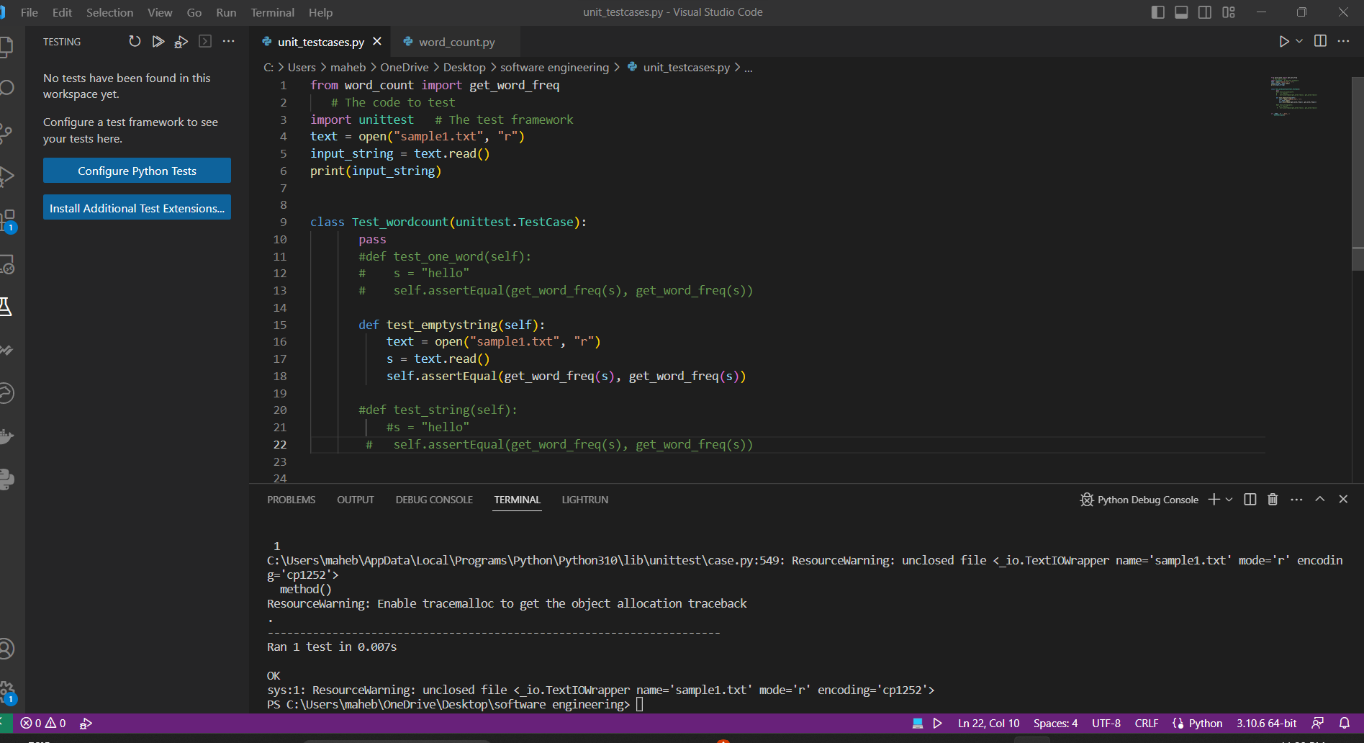

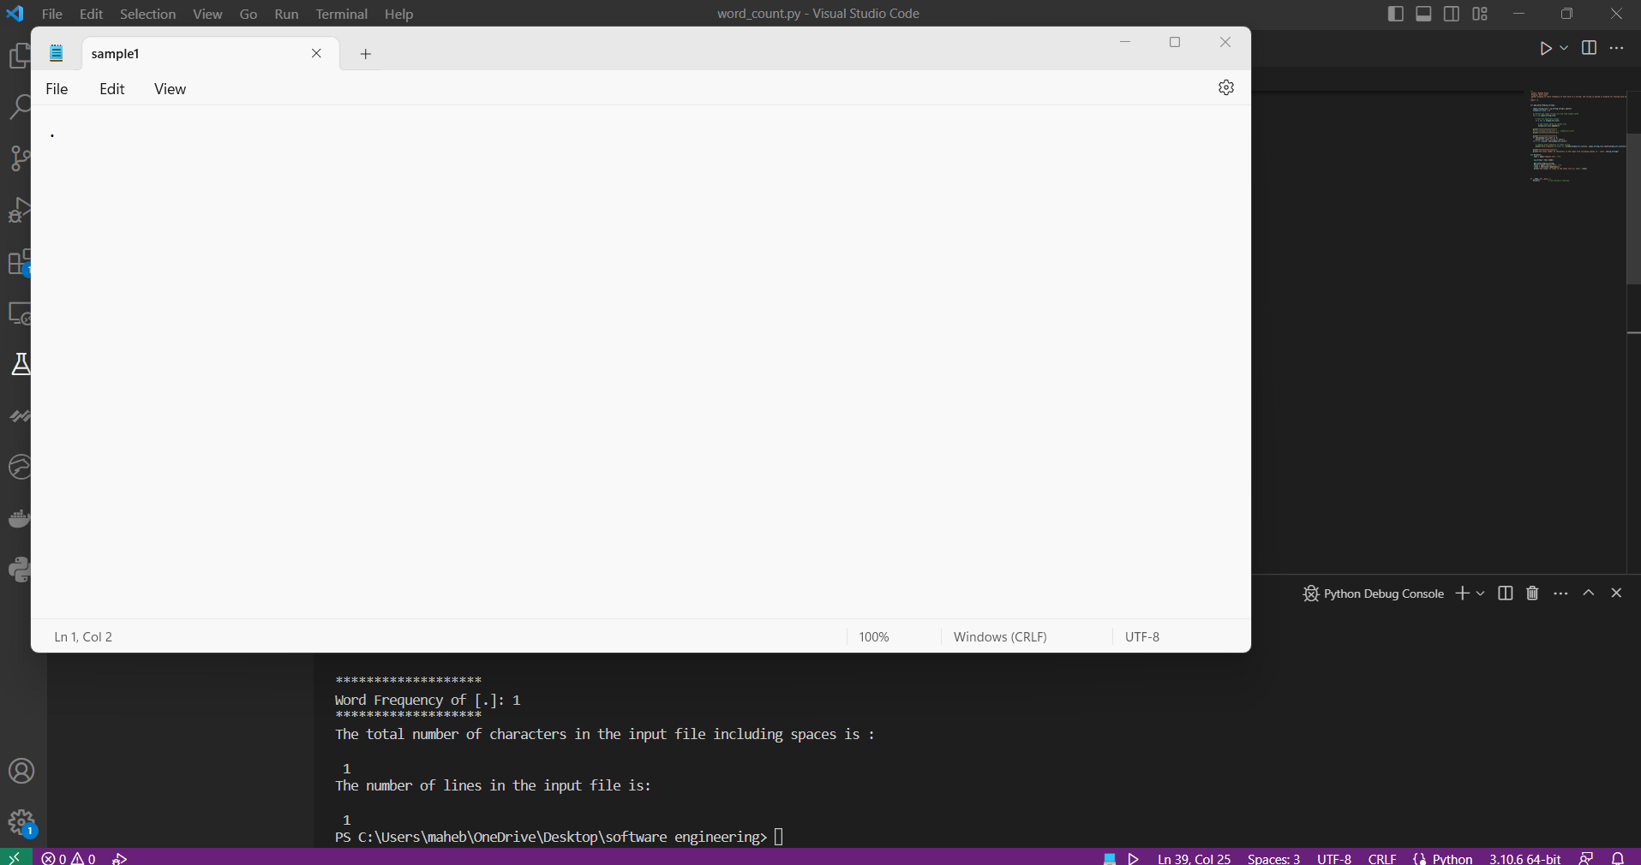

    - The string with one word must give one word as output in list.

Input string passed:

“word”

Status : pass

Actual result:

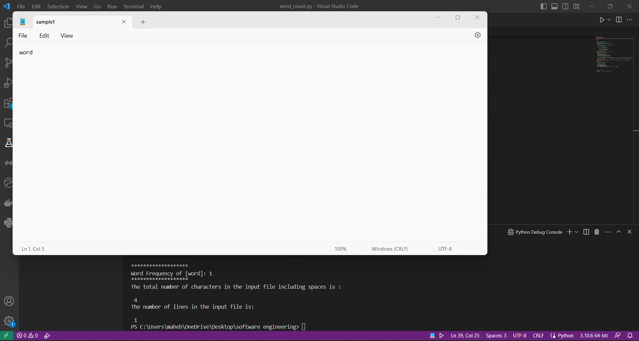

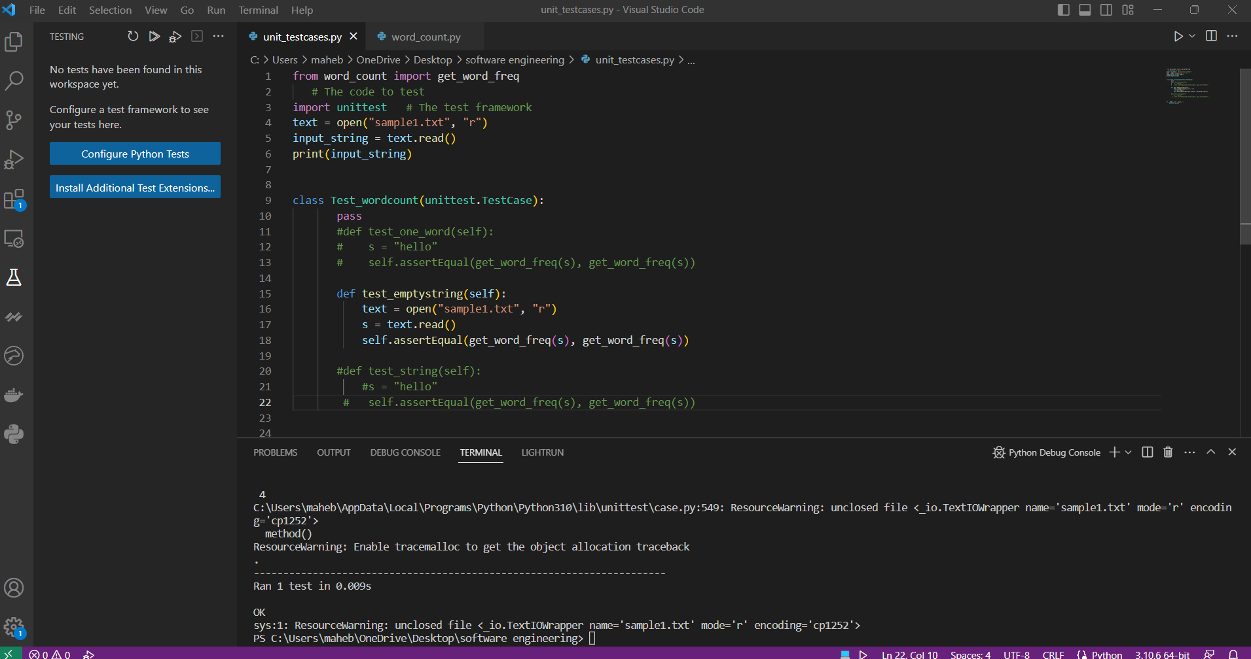

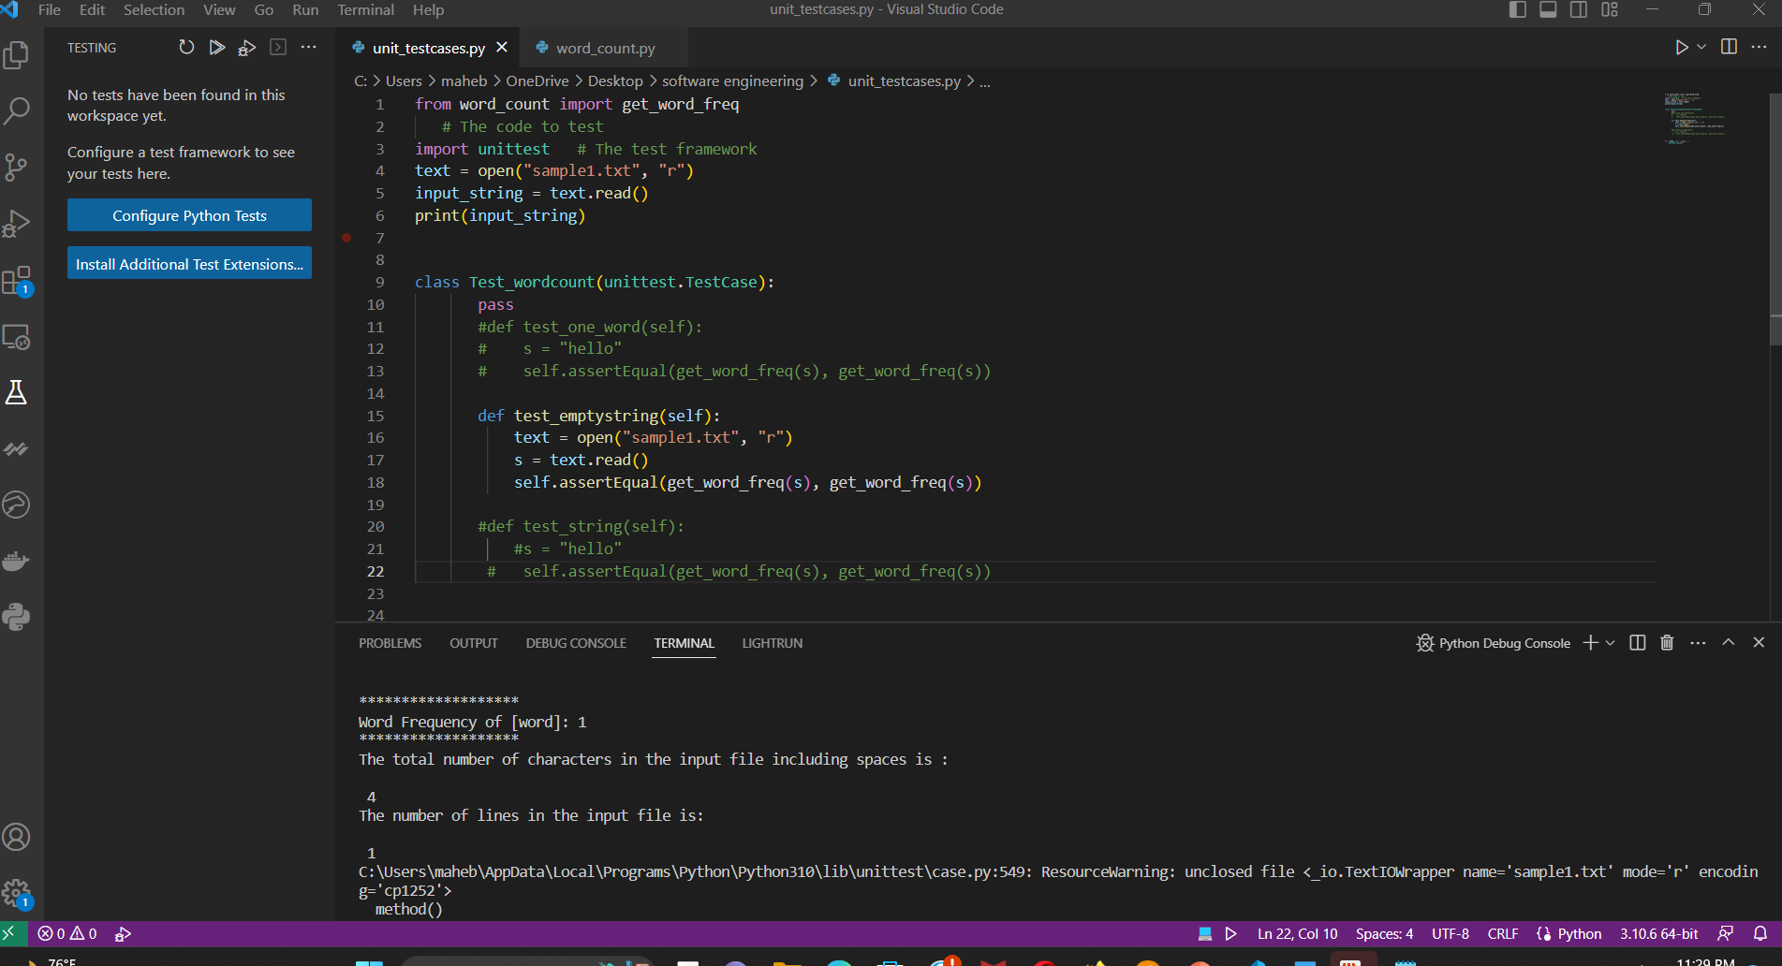

    - The string with one space between each word should give correct output.

Input string passed:

“word word”

Status : pass

Actual result:

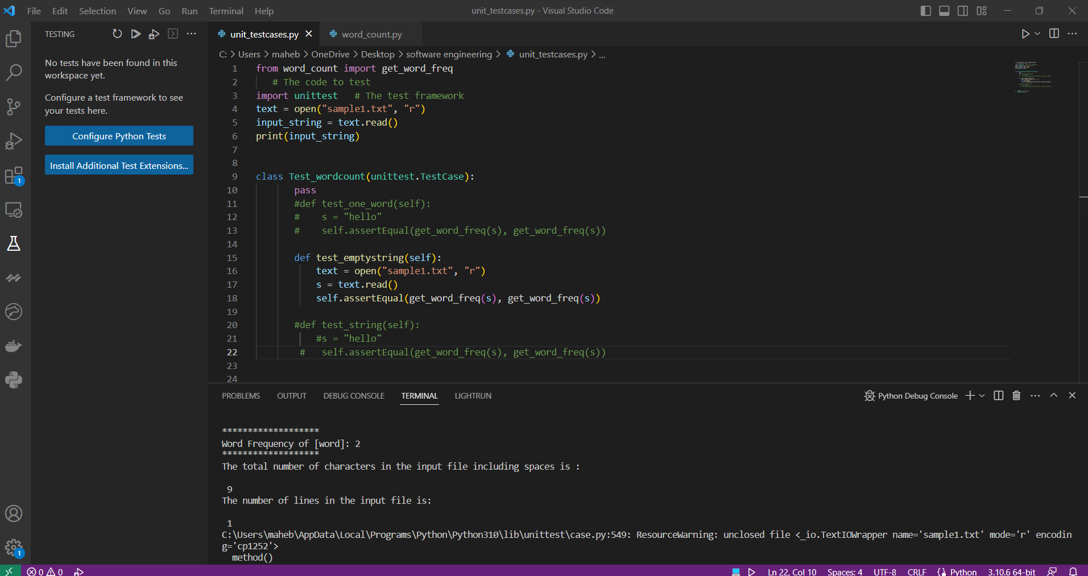

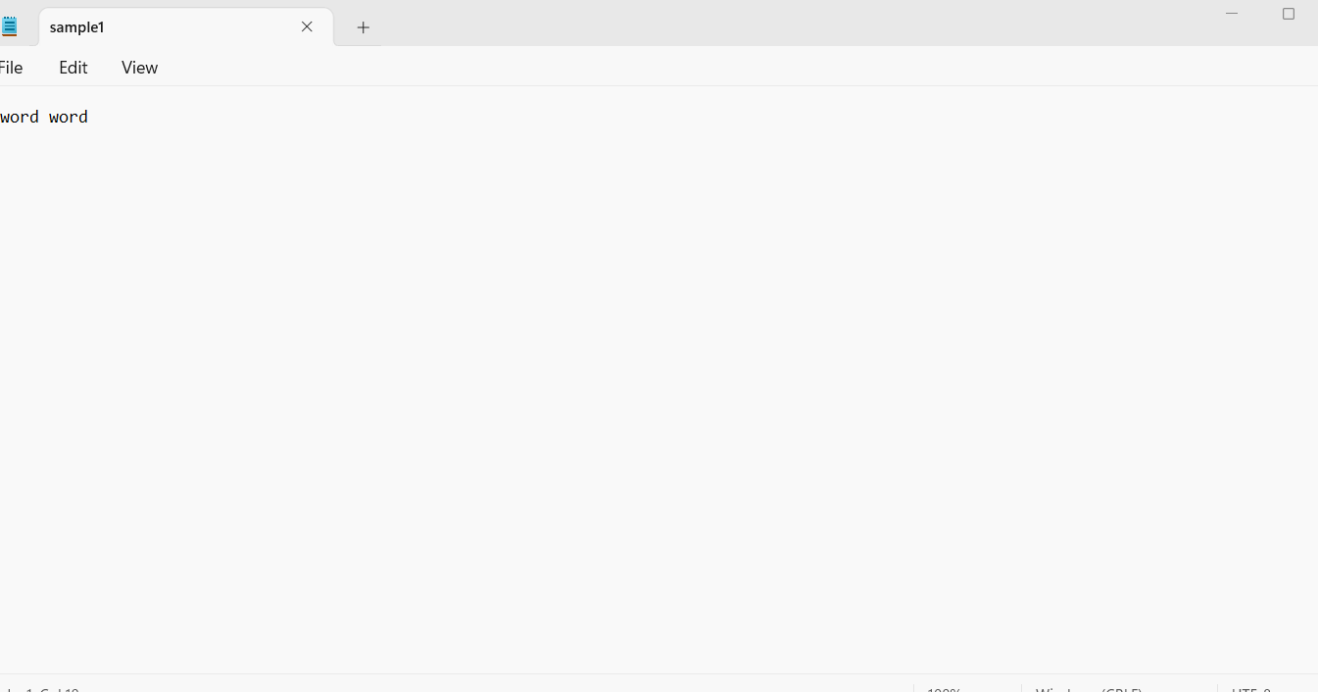

    - The string with double space between each word should give correct output.
Input string passed:
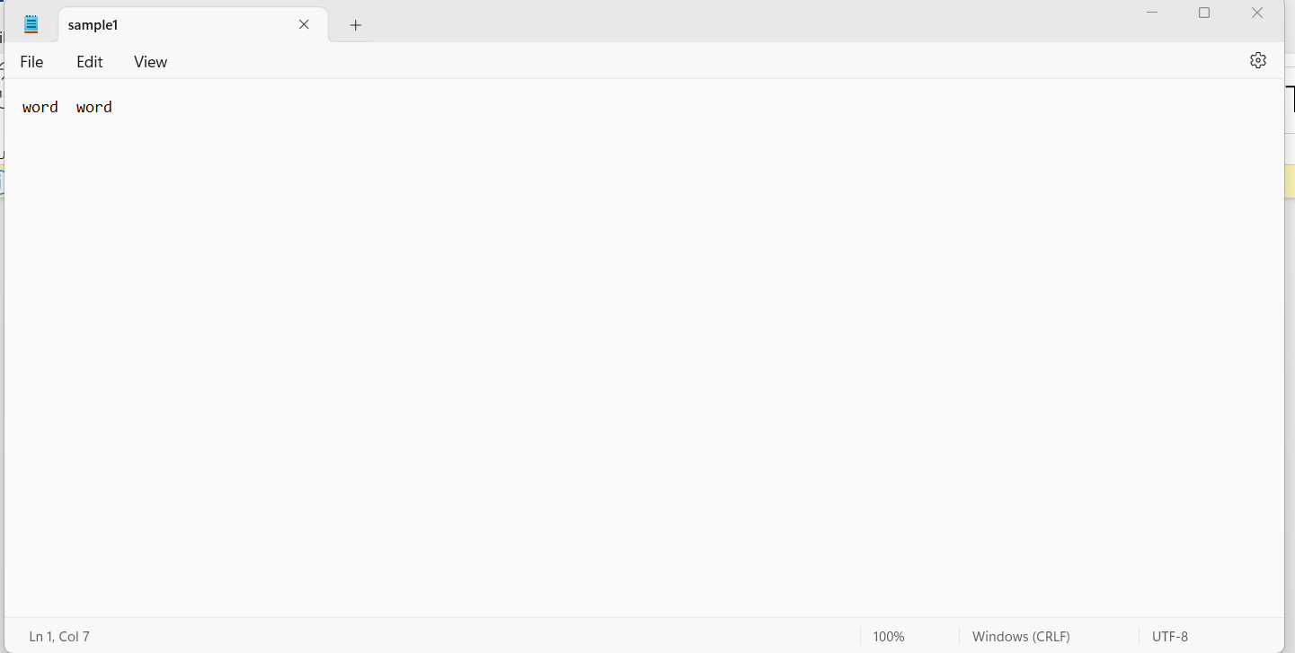

Status : pass

Actual result:
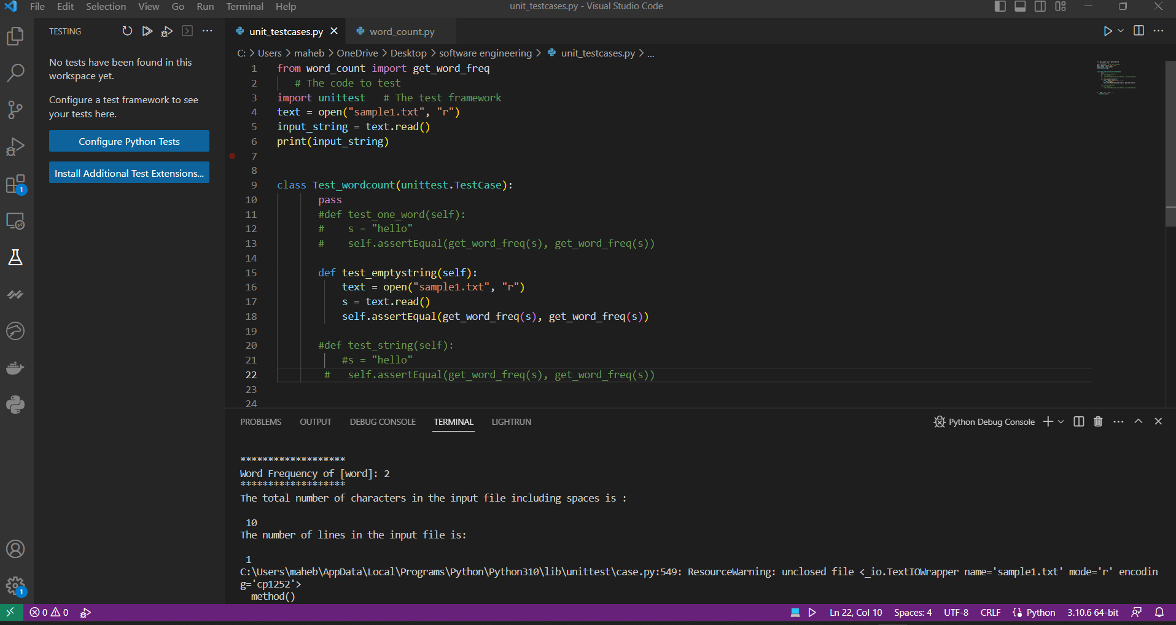
    - The string with many lines should identify the newline character and give correct word count.

Input string passed:
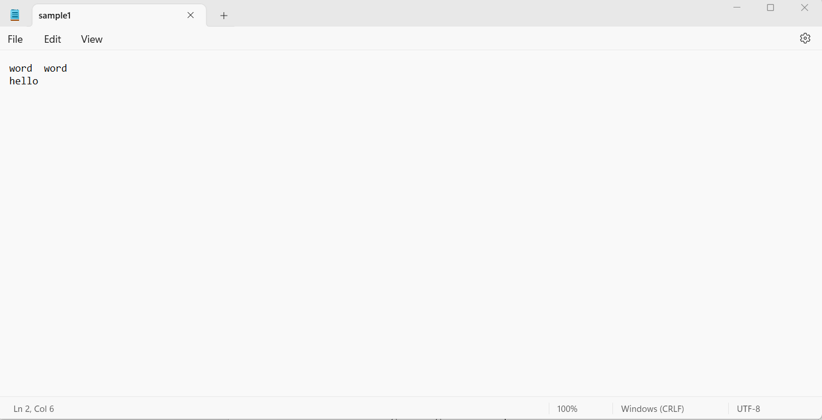

Status : pass

Actual result:
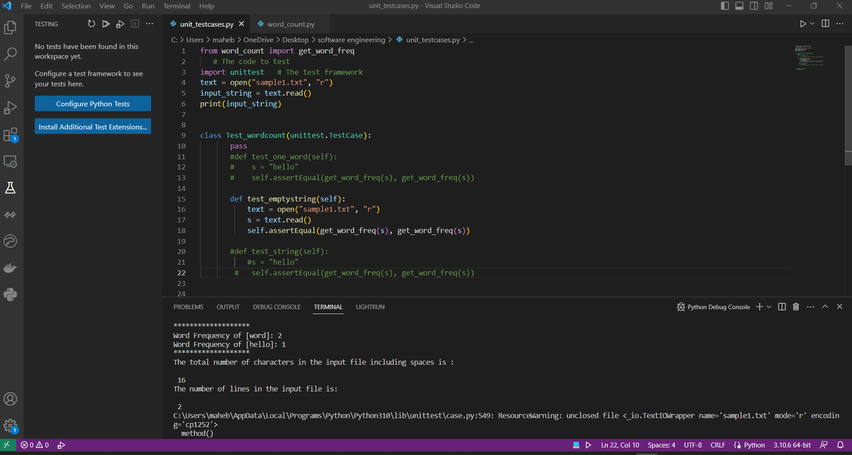

    - The string with a tab between each word should omit the tab, consider it as delimiter.

Input string passed:

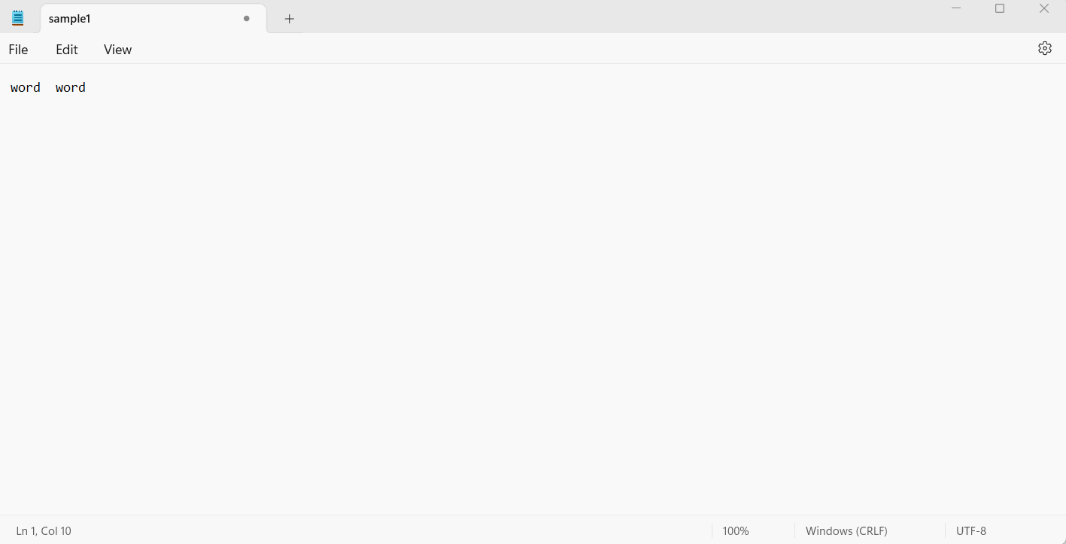

Status : pass

Actual result:

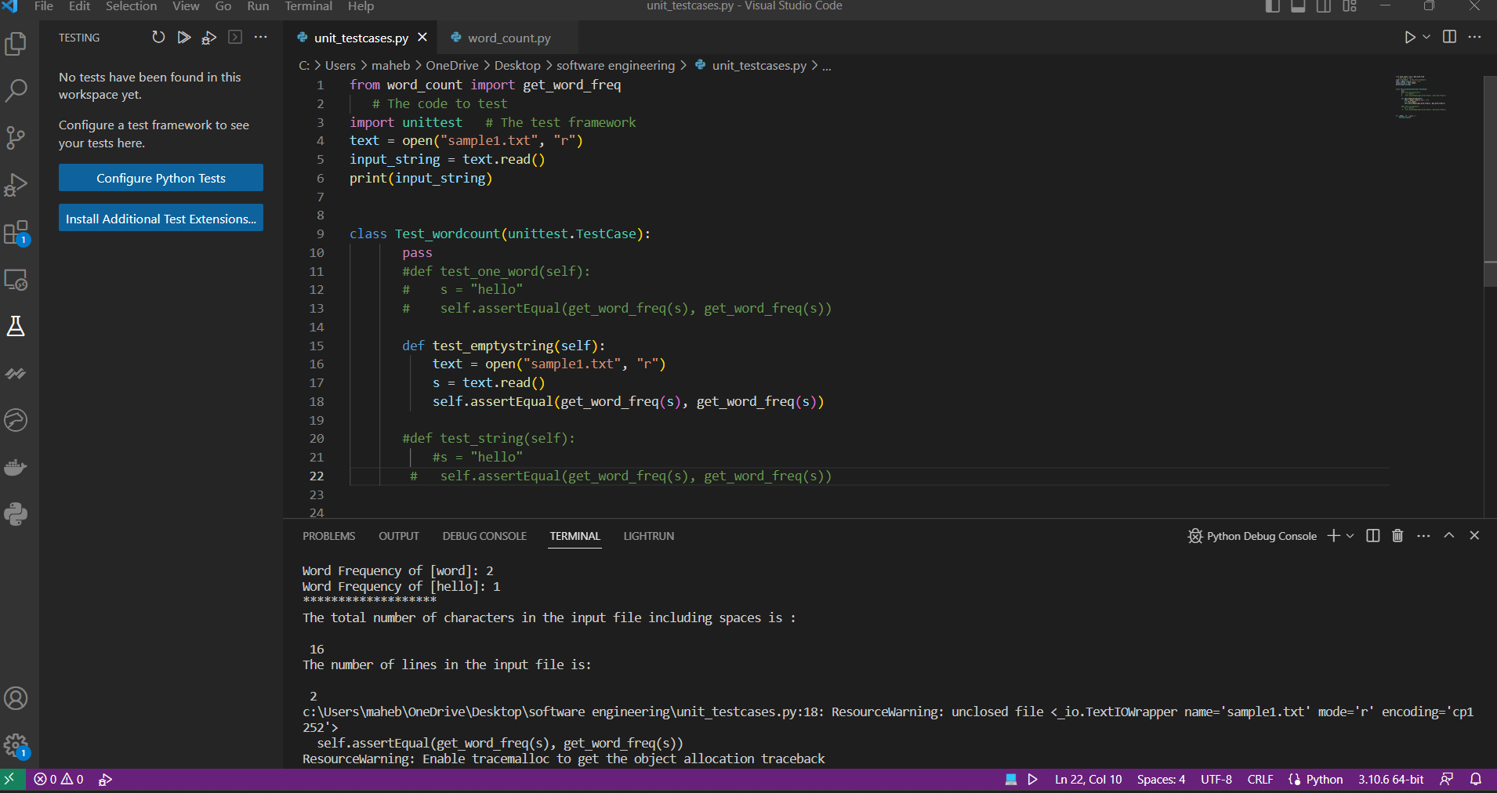

    - The string with large size should pass too.
Input string passed:
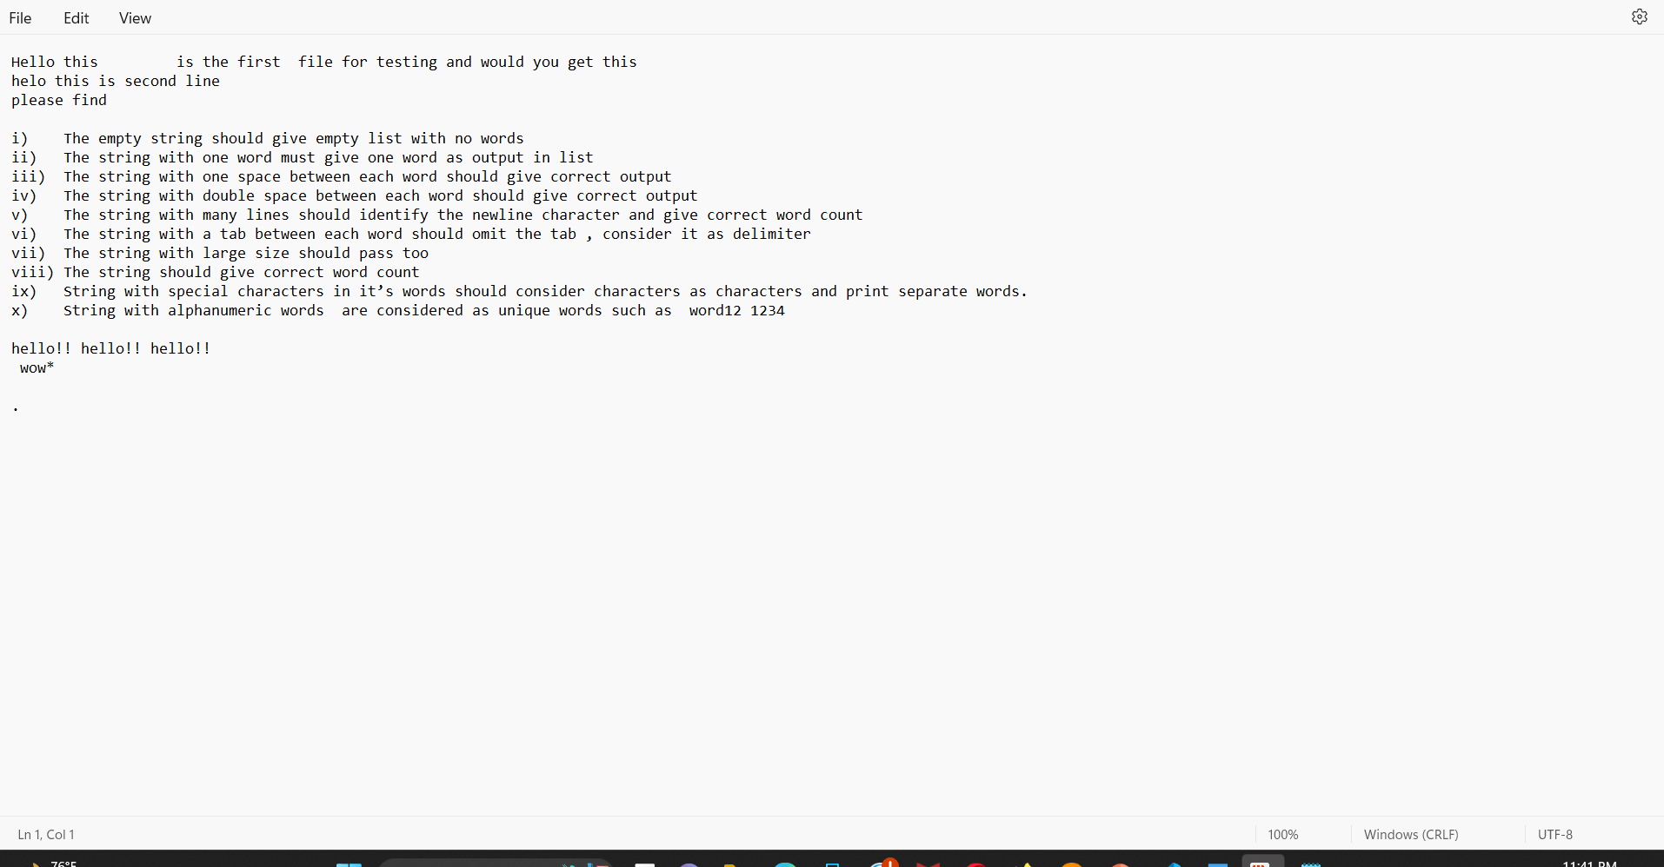

Status : pass

Actual result:

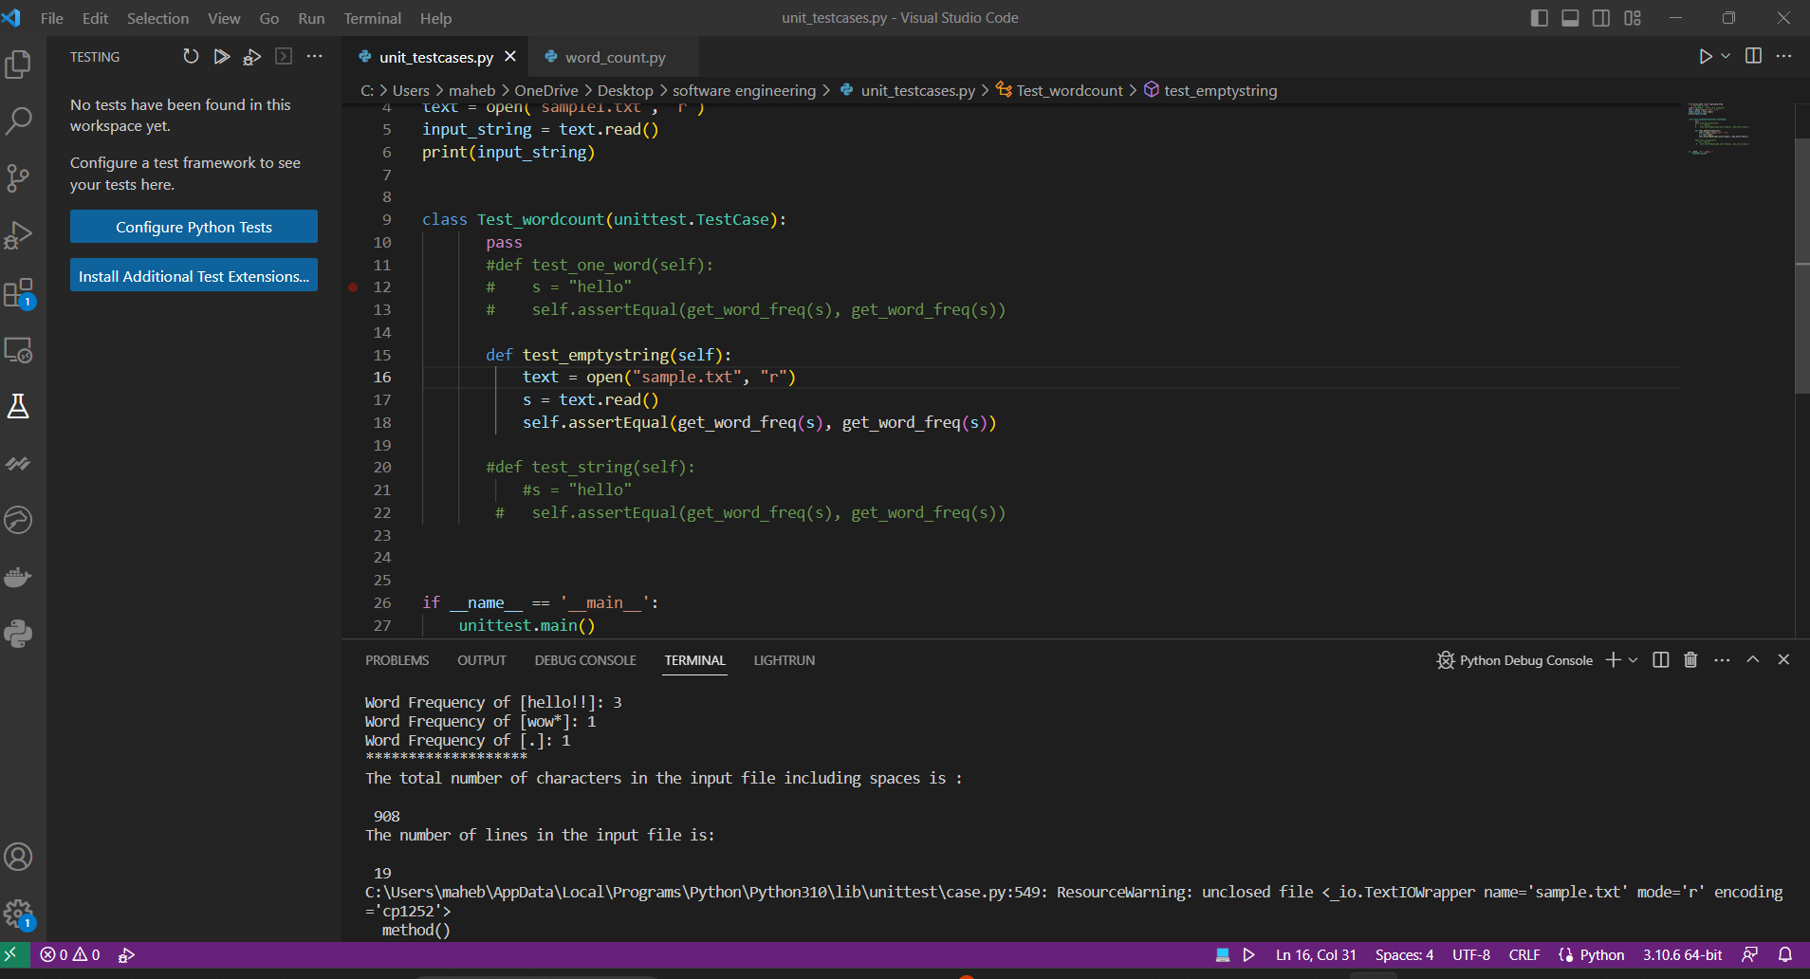
    - The string should give correct word count.
Same as the previous one with large input
    - String with special characters in its words should consider characters as characters and print separate words.
This type of input is covered in the large input test case i.e 4.1.9
    - Strings with alphanumeric words are considered as unique words such as word12.
This one is covered in 4.1.9

  - Requirements testing For the character count:
    - The empty string should give the total number of characters as 0.
Input string passed:

Empty string

Status : pass

Actual result:

    - The string with all blank spaces should give correct character count as many as the number of spaces

Input string passed:

“ “

Status : pass

Actual result:

    - The string with just one period (i.e ‘.’) should give correct output also

Input string passed:

“ . “

Status : pass

Actual result:

    - String with just numbers should consider numbers also as characters
Covered in 4.1.9
    - String with just all special characters is also considered as characters
Covered in 4.1.9
    - The string with one word must give the count of characters correctly.

Input string passed:

“word”

Status : pass

Actual result:

    - The string with one space between each word should give correct output considering the spaces also as characters.

Input string passed:

“word word”

Status : pass

Actual result:

    - The string with double space between each word should give correct output considering double spaces as characters

Input string passed:

Status : pass

Actual result:

    - The string with many lines should identify the newline character and give correct character count

Input string passed:

Status : pass

Actual result:

    - The string with a tab between each word should give the correct character count considering the tab as spaces.
Input string passed:

Status : pass

Actual result:

    - The string with large size should pass too

Input string passed:

Status : pass

Actual result:

    - String with special characters in its words should consider special characters also in it’s total count characters

Covered in 4.2.11
    - String with alphanumeric words are considered as characters as well
Covered in 4.2.11

    - String with First line leading spaces should consider spaces and count them as characters

Input string passed:
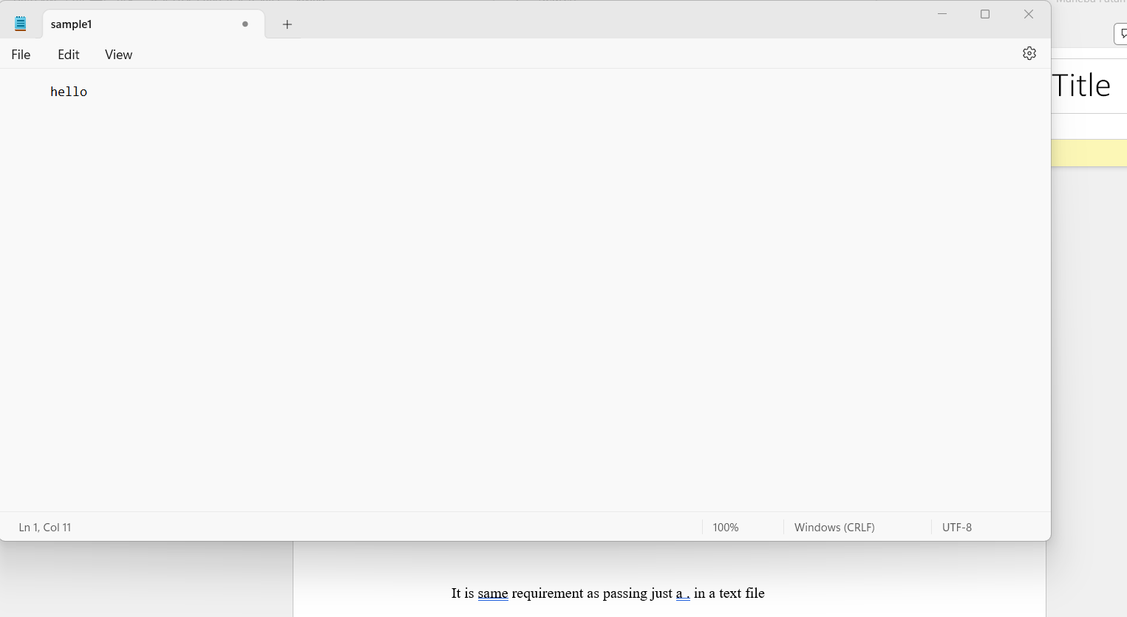

Status : pass

Result :
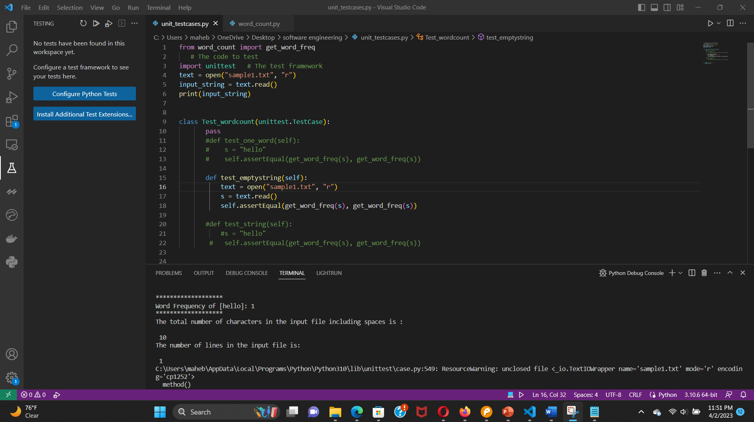

  - Requirements testing For the line count:

    - The empty string should give the total line count as 0.
Input string passed:

Empty string

Status : pass

Actual result:

    - The string with one line and all blank spaces in it should give correct line count as 1 i.e consider the blank line also as a line
Input string passed:

“ “

Status : pass

Actual result:

    - The string with just one period (i.e ‘.’) should give correct output also

Input string passed:

“ “

Status : pass

Actual result:

    - String with just numbers should consider numbers in line1 should give output as 1 line
    - String with just all special characters in a line should give count as 1.
    - The string with one word must give the count of lines as 1

Input string passed:

“word”

Status : pass

Actual result:

    - The string with one space between each word in a line should give correct output as line count 1.

Input string passed:

“word word”

Status : pass

Actual result:

    - The string with double space between each word in a line should give correct output as line count 1

Input string passed:

Status : pass

Actual result:

    - The string with many lines should identify the newline character and give correct line count

Input string passed:

Status : pass

Actual result:

    - The string with a tab between each word in a line should in a line should give the correct line count as 1

Input string passed:

Status : pass

Actual result:

    - The string with large size should pass too

Input string passed:

Status : pass

Actual result:

    - The string with first line as blank and characters in second line should give count as 2.

Input string passed:
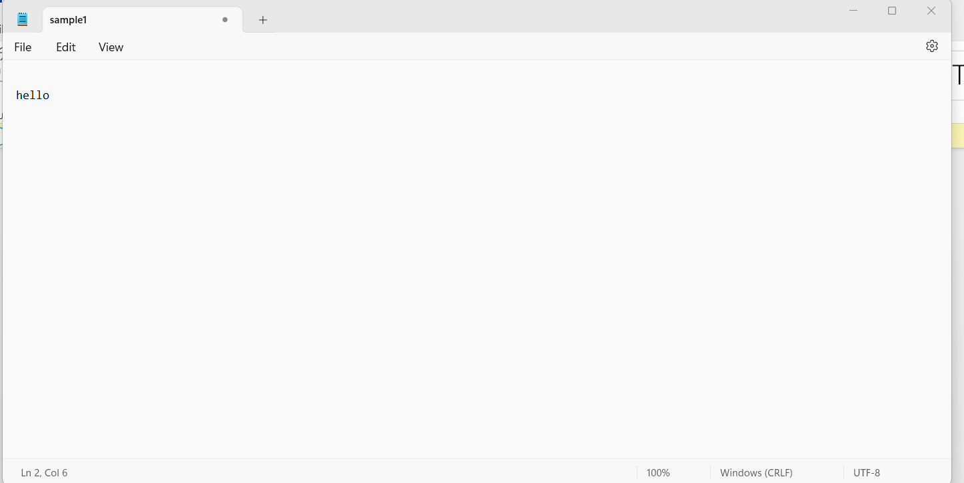

Status : pass

Actual result:

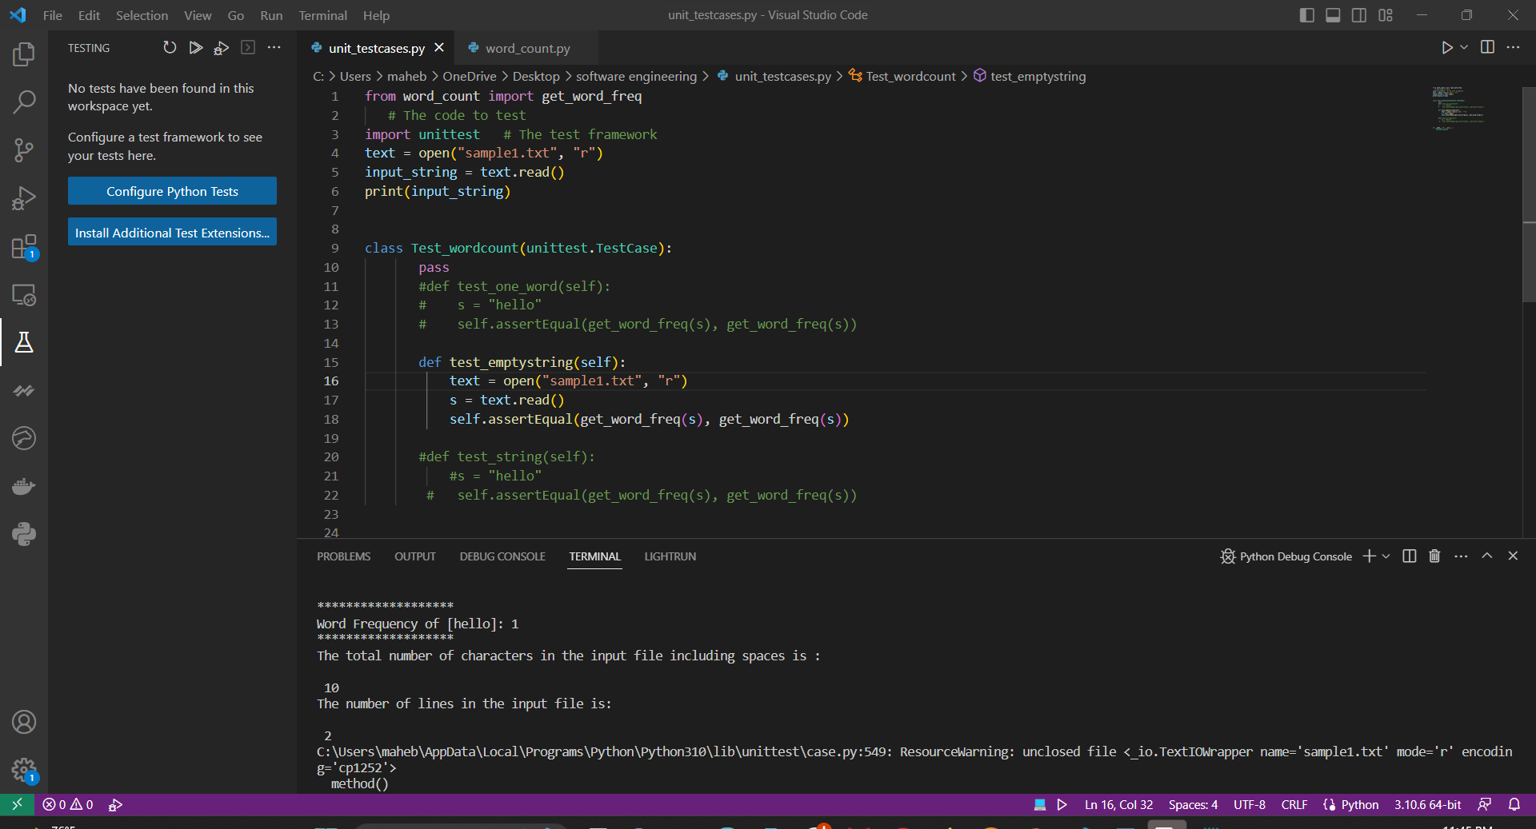
    - The string with characters in first line and Second line blank should give count as 2
Input string passed:

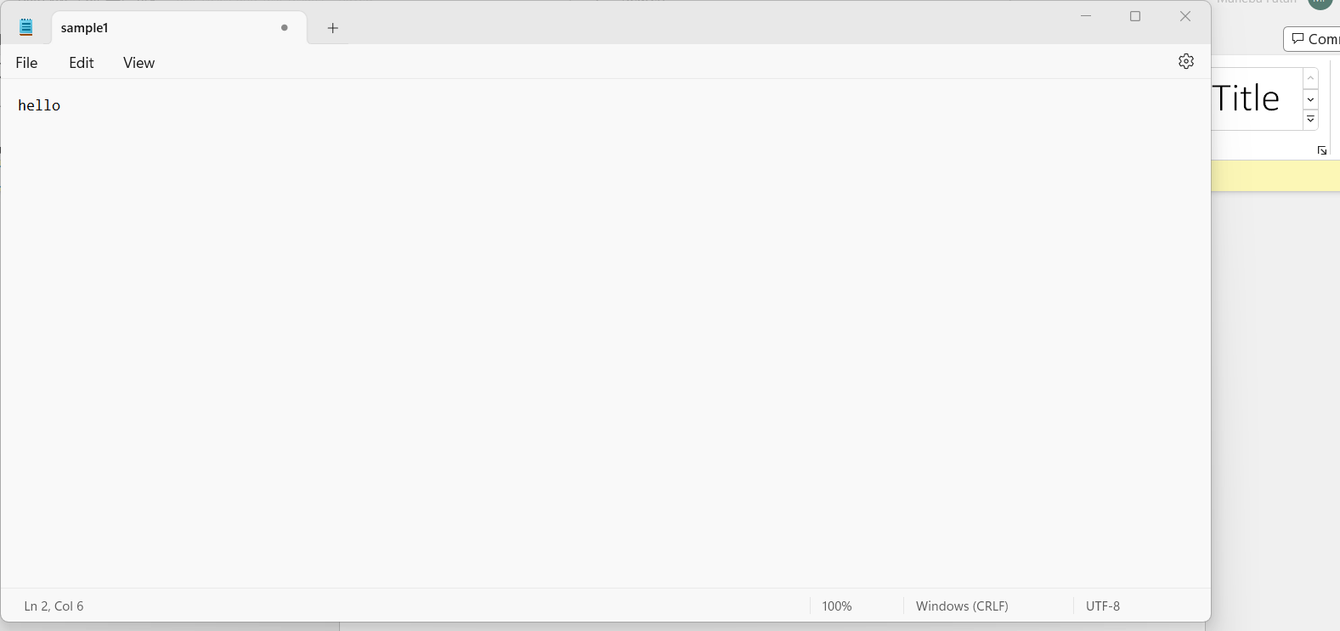

Status : pass

Actual result:
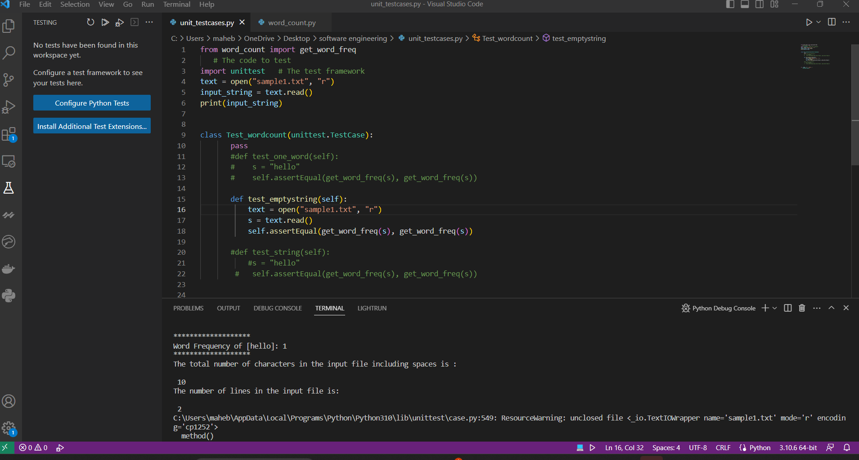

    - The string with First and third line as blank and characters in second line should give count as 3

Input string passed:

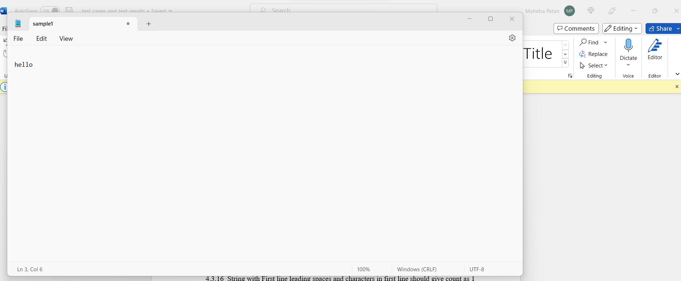

Status : pass

Actual result:

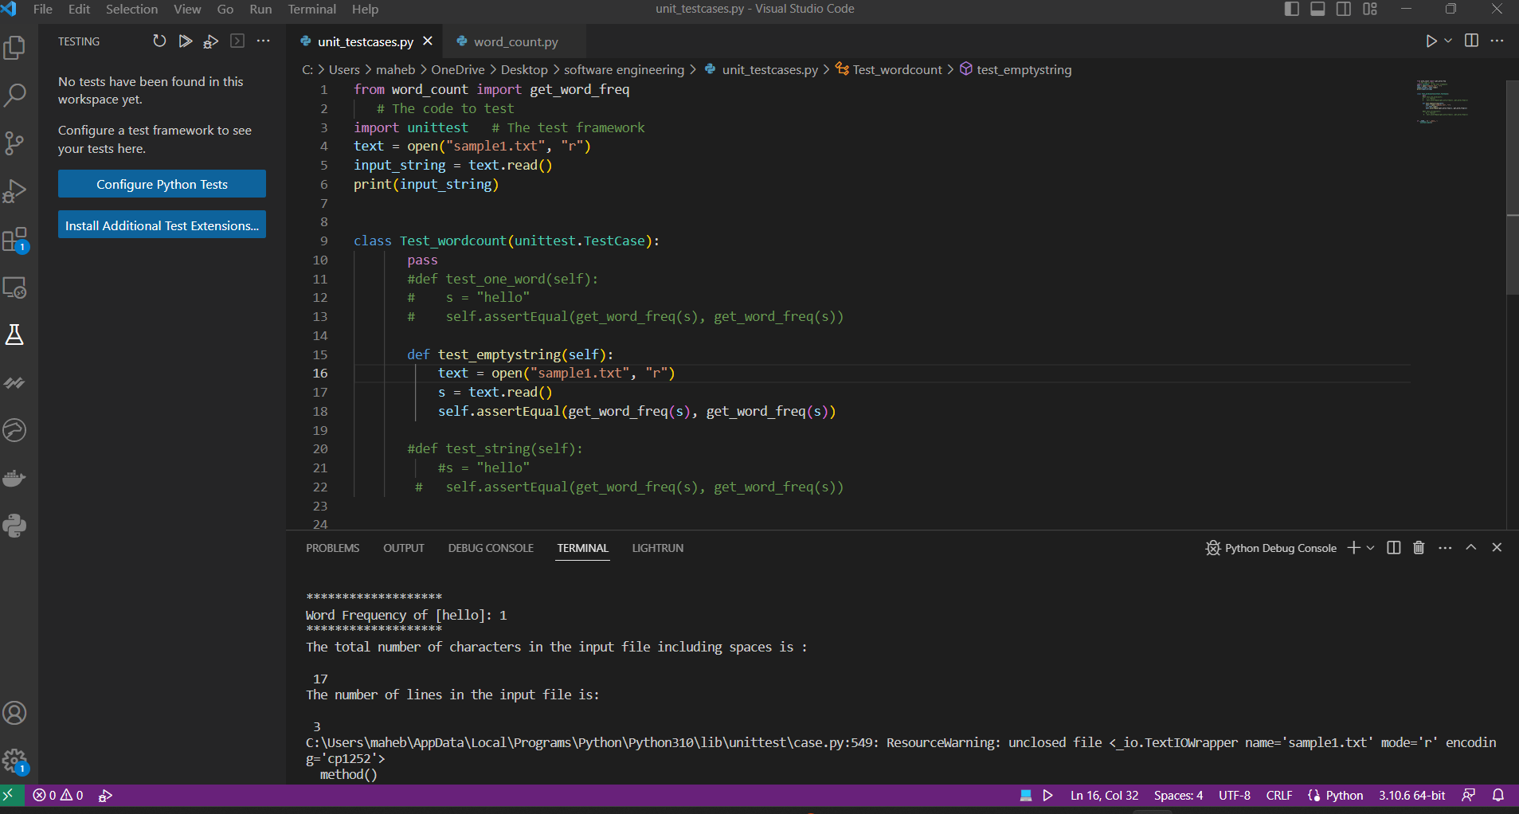

    - String with just One character in a line should give count as 1

Input string passed:

It is same requirement as passing just a . in a text file

Status : pass

    - String with First line leading spaces and characters in first line should give count as 1

Input string passed:

Status : pass

Result :

