Testcase 1:

Test case 2:

Testcase 3

Testcase 4:

Inout :

Hello this is the first file for testing and would you get this

helo this is second line

please find

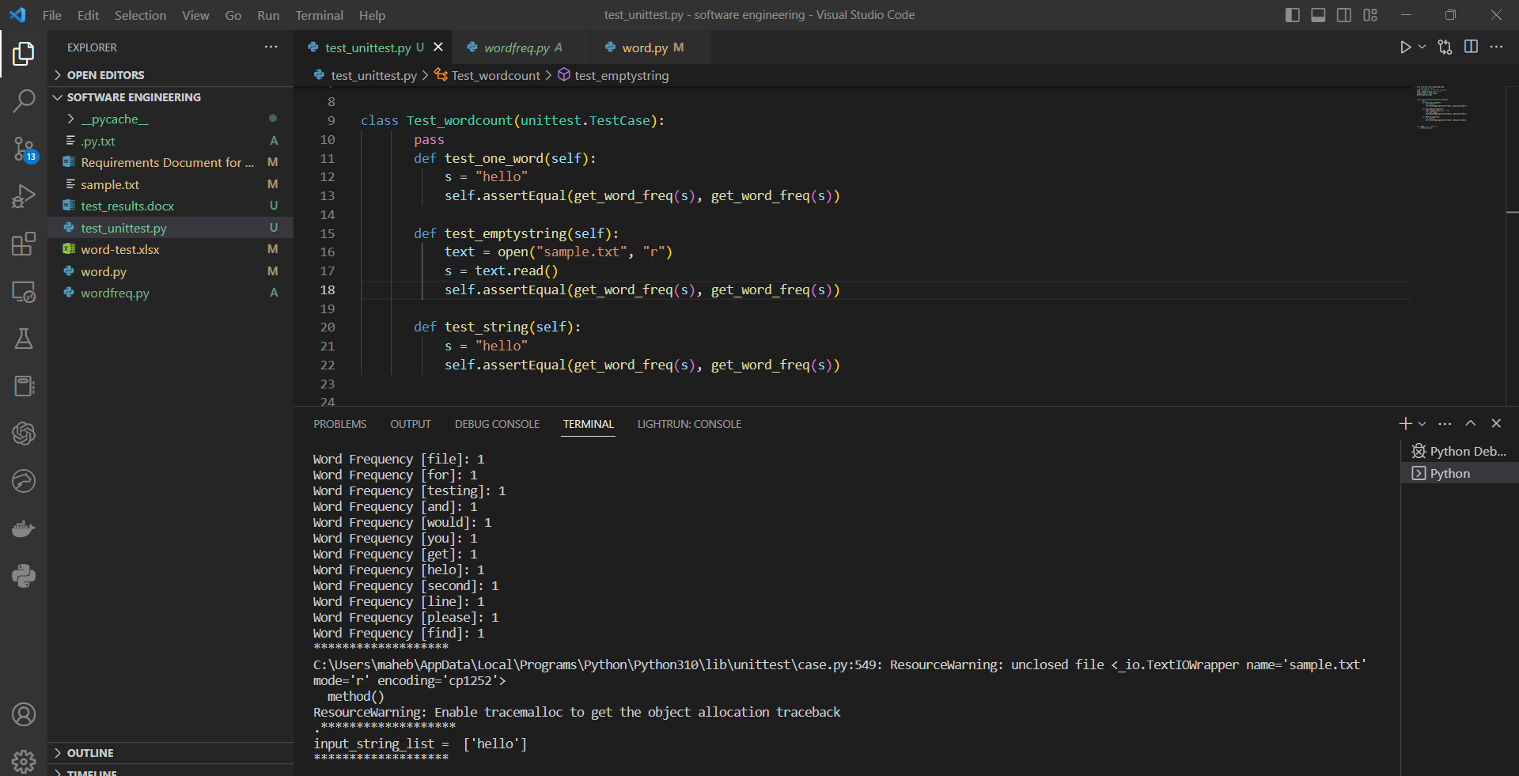

Testcase 5 :

Hello this is the first file for testing and would you get this

helo this is second line

please find

Testcase 6:

Hello this is the first file for testing and would you get this

helo this is second line

please find

Testcase 7:

Hello this is the first file for testing and would you get this

helo this is second line

please find

i) The empty string should give empty list with no words

ii) The string with one word must give one word as output in list

iii) The string with one space between each word should give correct output

iv) The string with double space between each word should give correct output

v) The string with many lines should identify the newline character and give correct word count

vi) The string with a tab between each word should omit the tab , consider it as delimiter

vii) The string with large size should pass too

viii) The string should give correct word count

ix) String with special characters in it’s words should consider characters as characters and print separate words.

x) String with alphanumeric words are considered as unique words such as word12

Testcase 8:

Input :

Testcase9 :

Hello this is the first file for testing and would you get this

helo this is second line

please find

i) The empty string should give empty list with no words

ii) The string with one word must give one word as output in list

iii) The string with one space between each word should give correct output

iv) The string with double space between each word should give correct output

v) The string with many lines should identify the newline character and give correct word count

vi) The string with a tab between each word should omit the tab , consider it as delimiter

vii) The string with large size should pass too

viii) The string should give correct word count

ix) String with special characters in it’s words should consider characters as characters and print separate words.

x) String with alphanumeric words are considered as unique words such as word12

hello!! hello!! hello!!

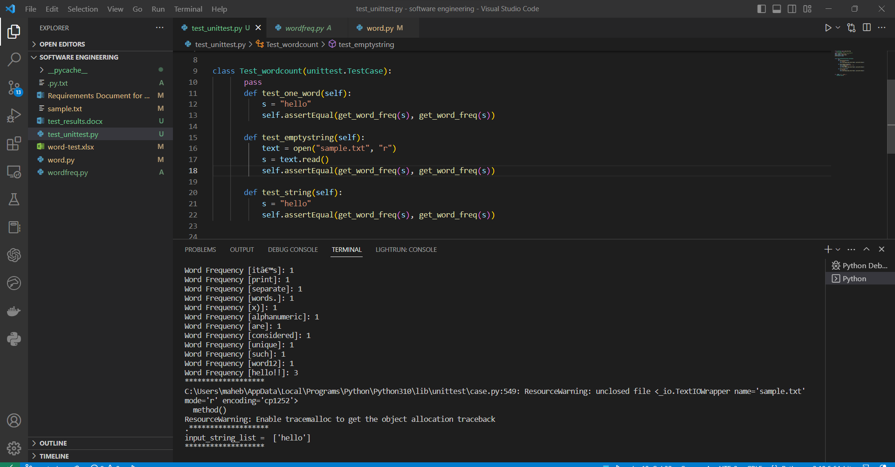

Testcase 10:

Hello this is the first file for testing and would you get this

helo this is second line

please find

i) The empty string should give empty list with no words

ii) The string with one word must give one word as output in list

iii) The string with one space between each word should give correct output

iv) The string with double space between each word should give correct output

v) The string with many lines should identify the newline character and give correct word count

vi) The string with a tab between each word should omit the tab , consider it as delimiter

vii) The string with large size should pass too

viii) The string should give correct word count

ix) String with special characters in it’s words should consider characters as characters and print separate words.

x) String with alphanumeric words are considered as unique words such as word12

hello!! hello!! hello!!

wow\*

To produce the test results I keep on changing the text file so I didn’t need to write many test cases in the file