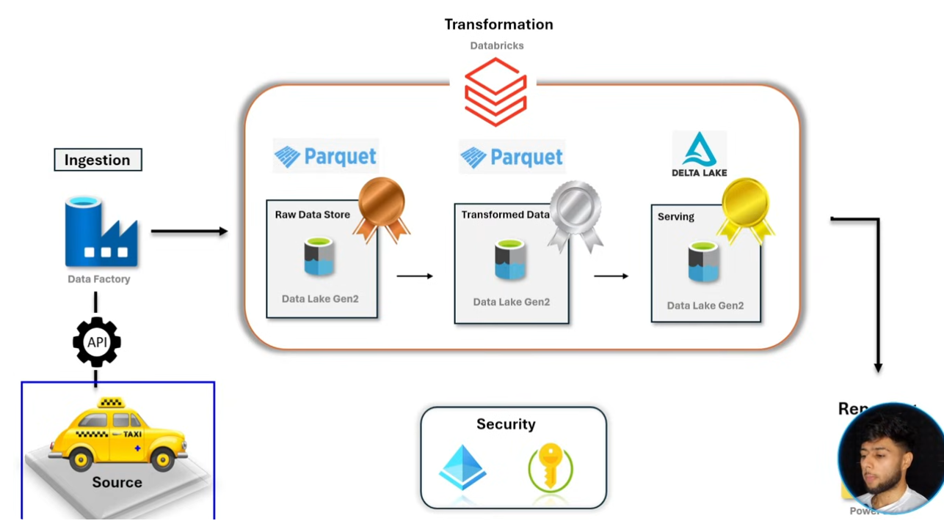

Taxi Data End-to-End Pipeline
An end-to-end pipeline for processing Taxi data using Azure services.
Download Data dynamically
Data Source: https://www.nyc.gov/site/tlc/about/tlc-trip-record-data.page
Green Taxi Trip Data -Parquet format – download dynamically
Taxi Zone lookup Data CSV format – download manually
Trip Type -CSV format -download manuallay
Technologies:
1. Storage Account
Programming language : pyspark, SQL
2. Azure Data Factory –
3. Databricks
4. Microsoft Entra ID – to connect databricks to data lake
Storage Account
Created Data Lake with three folders –
- Bronze
- Directory: trip Type – trip_type.csv
- Directory: taxi_zone_lookup_data.csv
- Directory: Green Taxi Trip Data
- silver
- gold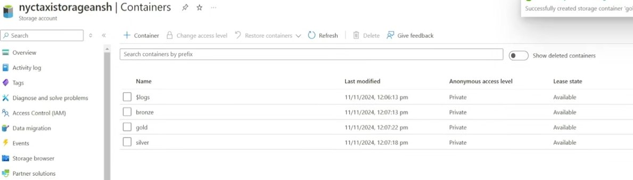
Azure Data Factory
Bronze Layer
Linked Services
- source: http
- destination: azure data lake storage Gen2
Pipeline
- myWebDL : source(http) -> copy data - > sink (ADLS Gen2 Bronze – Green tai trip Data)
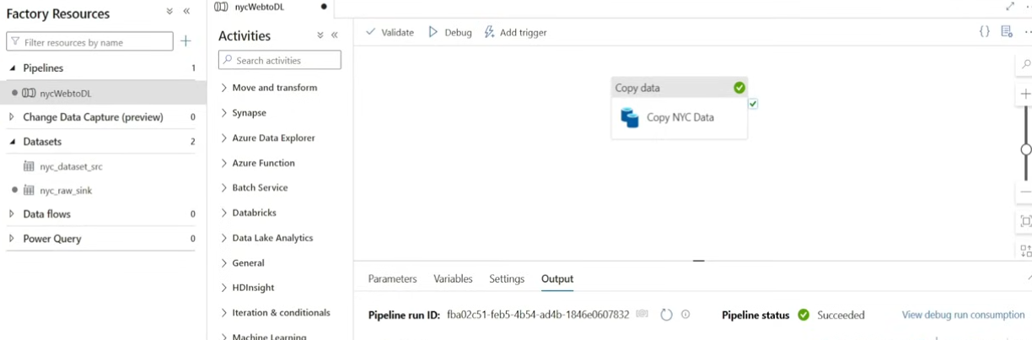
Green_trip_data_01.parquet file has been imported to data lake.
I want files of all months.
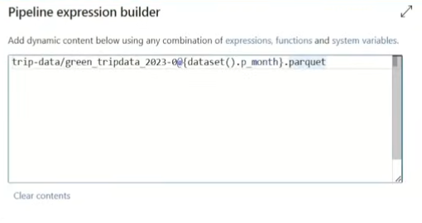
For each activity
IF CONDITION
Copy activity
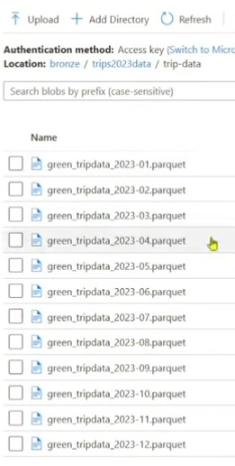

Databricks
Bronze to Silver Layer
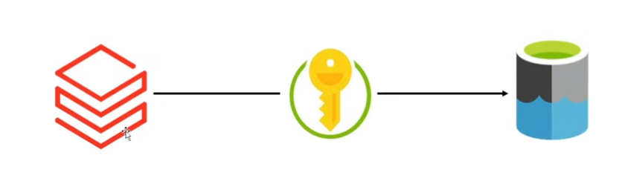
Create a application in microsoft entra id
Create a secret key
Now I have three things to connect to databricks with storage accout
- Application(client) ID
- Directory (tenant) ID
- Secret Key
Add role – storage blob data contributor for storage account
Create a databricks
Compute -> create compute
Workspace - > Create folder - >NYX-Taxi - > Notebook -> Silver_notebook
Trip data columns
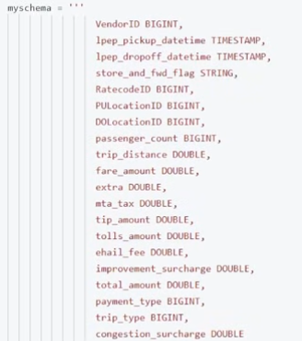
Gold Layer
Storage account(Silver Layer) - > Delta Format -> Gold Layer -> Delta Table
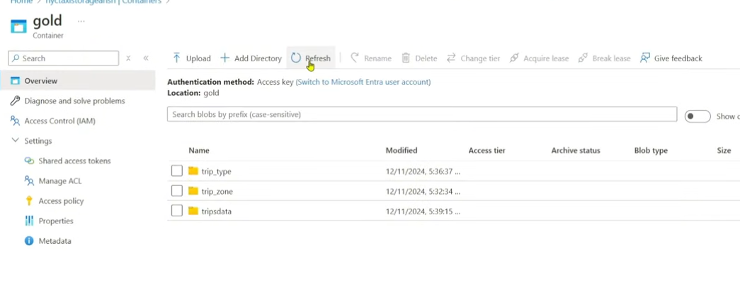

Cnnected final gold layer to poweBi

