Satellite Communication
Introduction

If the communication takes place between any two earth stations through a satellite, then it is called as satellite communication. In this communication, electromagnetic waves are used as carrier signals. These signals carry the information such as voice, audio, video or any other data between ground and space and vice-versa.
Soviet Union had launched the world's first artificial satellite named, Sputnik 1 in 1957.

Need of Satellite Communication
The following two kinds of propagation are used earlier for communication up to some distance.
- Ground wave propagation − Ground wave propagation is suitable for frequencies up to 30MHz. This method of communication makes use of the troposphere conditions of the earth.
- Sky wave propagation − The suitable bandwidth for this type of communication is broadly between 30–40 MHz and it makes use of the ionosphere properties of the earth.
The maximum hop or the station distance is limited to 1500KM only in both ground wave propagation and sky wave propagation. Satellite communication overcomes this limitation. In this method, satellites provide communication for long distances, which is well beyond the line of sight.
Since the satellites locate at certain height above earth, the communication takes place between any two earth stations easily via satellite. So, it overcomes the limitation of communication between two earth stations due to earth’s curvature.

How a Satellite Works
A satellite is a body that moves around another body in a particular path. A communication satellite is nothing but a microwave repeater station in space. It is helpful in telecommunications, radio and television along with internet applications.
A repeater is a circuit, which increases the strength of the received signal and then transmits it. But, this repeater works as a transponder. That means, it changes the frequency band of the transmitted signal from the received one.
The frequency with which, the signal is sent into the space is called as Uplink frequency. Similarly, the frequency with which, the signal is sent by the transponder is called as Downlink frequency. The following figure illustrates this concept clearly.

The transmission of signal from first earth station to satellite through a channel is called as uplink. Similarly, the transmission of signal from satellite to second earth station through a channel is called as downlink.
Uplink frequency is the frequency at which, the first earth station is communicating with satellite. The satellite transponder converts this signal into another frequency and sends it down to the second earth station. This frequency is called as Downlink frequency. In similar way, second earth station can also communicate with the first one.
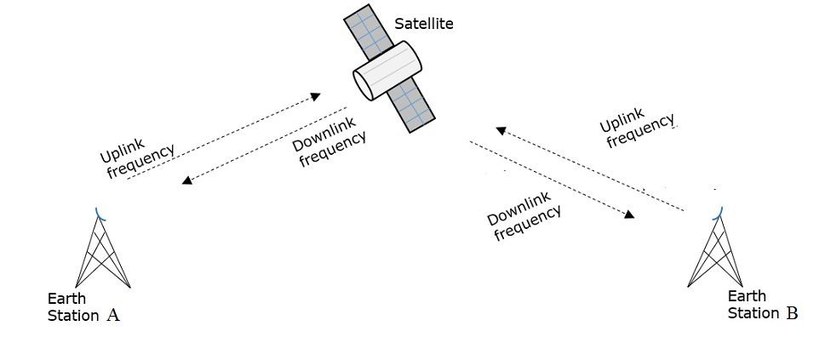
The process of satellite communication begins at an earth station. Here, an installation is designed to transmit and receive signals from a satellite in an orbit around the earth. Earth stations send the information to satellites in the form of high powered, high frequency (GHz range) signals.
The satellites receive and retransmit the signals back to earth where they are received by other earth stations in the coverage area of the satellite. Satellite's footprint is the area which receives a signal of useful strength from the satellite.

Pros and Cons of Satellite Communication
In this section, let us have a look at the advantages and disadvantages of satellite communication.
Following are the advantages of using satellite communication:
- Area of coverage is more than that of terrestrial systems
- Each and every corner of the earth can be covered
- Transmission cost is independent of coverage area
- More bandwidth and broadcasting possibilities

Following are the disadvantages of using satellite communication −
- Launching of satellites into orbits is a costly process.
- Propagation delay of satellite systems is more than that of conventional terrestrial systems.
- Difficult to provide repairing activities if any problem occurs in a satellite system.
- Free space loss is more
- There can be congestion of frequencies.

Applications of Satellite Communication
(a) Weather Forecasting:
Certain satellites are specifically designed to monitor the climatic conditions of earth. They continuously monitor the assigned areas of earth and predict the weather conditions of that region. This is done by taking images of earth from the satellite. These images are transferred using assigned radio frequency to the earth station. These satellites are exceptionally useful in predicting disasters like hurricanes, and for monitor the changes in the Earth's vegetation, sea state, ocean color, and ice fields.
(b) Radio and TV Broadcast:
These dedicated satellites are responsible for making 100s of channels across the globe available for everyone. They are also responsible for broadcasting live matches, news, world-wide radio services. These satellites require a 30-40 cm sized dish to make these channels available globally.
(c) Military Satellites:
These satellites are often used for gathering intelligence, as a communications satellite used for military purposes, or as a military weapon. A satellite by itself is neither military nor civil. It is the kind of payload it carries that enables one to arrive at a decision regarding its military or civilian character.
(d) Navigation Satellites
The system allows for precise localization world-wide, and with some additional techniques, the precision is in the range of some meters. Ships and aircraft rely on GPS as an addition to traditional navigation systems. Many vehicles come with installed GPS receivers. This system is also used for fleet management of trucks or for vehicle localization in case of theft.
(e) Global Telephone:
One of the first applications of satellites for communication was the establishment of international telephone backbones. Instead of using cables it was sometimes faster to launch a new satellite. But, fiber optic cables are still replacing satellite communication across long distance as in fiber optic cable, light is used instead of radio frequency, hence making the communication much faster (and of course, reducing the delay caused due to the amount of distance a signal needs to travel before reaching the destination.).
Using satellites, to typically reach a distance approximately 10,000 kms away, the signal needs to travel almost 72,000 kms, that is, sending data from ground to satellite and (mostly) from satellite to another location on earth. This cause‟s substantial amount of delay and this delay becomes more prominent for users during voice calls.
(f) Connecting Remote Areas:
Due to their geographical location many places all over the world do not have direct wired connection to the telephone network or the internet (e.g., researchers on Antarctica) or because of the current state of the infrastructure of a country. Here the satellite provides a complete coverage and (generally) there is one satellite always present across a horizon.
(g) Global Mobile Communication:
The basic purpose of satellites for mobile communication is to extend the area of coverage. Cellular phone systems, such as AMPS and GSM do not cover all parts of a country. Areas that are not covered usually have low population where it is too expensive to install a base station. With the integration of satellite communication, however, the mobile phone can switch to satellites offering world-wide connectivity to a customer.
Satellites cover a certain area on the earth. This area is termed as a “footprint” of that satellite. Within the footprint, communication with that satellite is possible for mobile users. These users communicate using a Mobile-User-Link (MUL). The base-stations communicate with satellites using a Gateway-Link (GWL). Sometimes it becomes necessary for satellite to create a communication link between users belonging to two different footprints. Here the satellites send signals to each other and this is done using Inter-Satellite-Link (ISL).

Orbital Elements
Orbital elements are the parameters, which are helpful for describing the orbital motion of satellites. Following are the orbital elements.
- Semi major axis (a)
- Eccentricity (e)
- Mean anomaly (M_{o})
- Argument of perigee
- Inclination
- Right ascension of ascending node
The above six orbital elements define the orbit of earth satellites. Therefore, it is easy to discriminate one satellite from other satellites based on the values of orbital elements.

Semi major axis (a)
The length of Semi-major axis (a) defines the size of satellite’s orbit. It is half of the major axis. It is the longest diameter, a line that runs through the center and both foci, its ends being at the widest points of the shapes. Semi-Minor axis (b) is the the line joining the points of perigee.
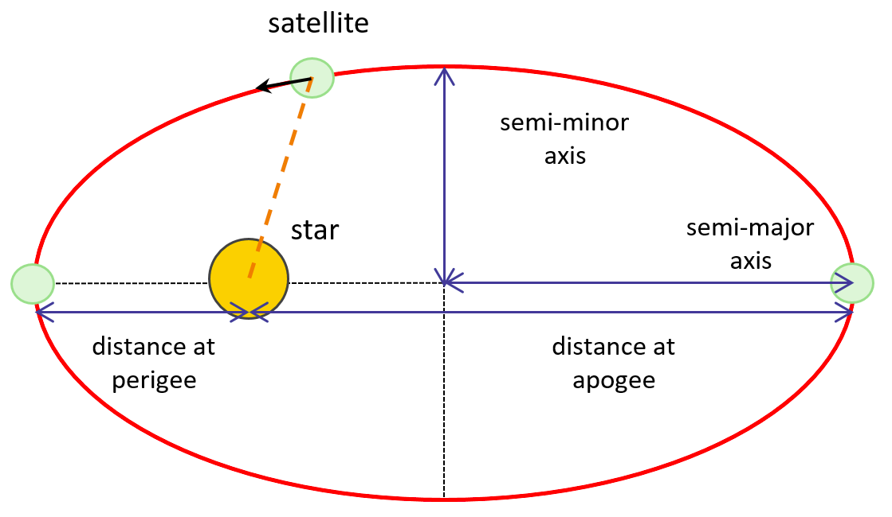
Both semi major axis and semi minor axis are represented in above figure. Length of semi major axis (a) not only determines the size of satellite’s orbit, but also the time period of revolution.
If circular orbit is considered as a special case, then the length of semi-major axis will be equal to radius of that circular orbit.

Eccentricity
The value of Eccentricity (e) fixes the shape of satellite’s orbit. This parameter indicates the deviation of the orbit’s shape from a perfect circle. If the lengths of semi major axis and semi minor axis of an elliptical orbit are a & b, then eccentricity (e) will be

The value of eccentricity of a circular orbit is zero, since both a & b are equal. Whereas, the value of eccentricity of an elliptical orbit lies between zero and one.
The following figure shows the various satellite orbits for different eccentricity (e) values

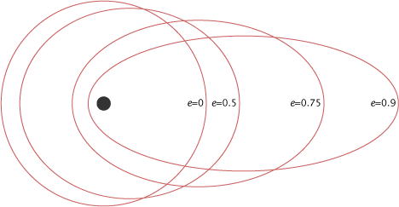

In above figure, the satellite orbit corresponding to eccentricity (e) value of zero is a circular orbit. And, the remaining three satellite orbits are of elliptical corresponding to the eccentricity (e) values 0.5, 0.75 and 0.9.

Mean Anomaly
For a satellite, the point which is closest from the Earth is known as Perigee. Mean anomaly (M) gives the average value of the angular position of the satellite with reference to perigee.
If the orbit is circular, then Mean anomaly gives the angular position of the satellite in the orbit. But, if the orbit is elliptical, then calculation of exact position is very difficult. At that time, Mean anomaly is used as an intermediate step.

Argument of Perigee
Satellite orbit cuts the equatorial plane at two points. First point is called as descending node, where the satellite passes from the northern hemisphere to the southern hemisphere. Second point is called as ascending node, where the satellite passes from the southern hemisphere to the northern hemisphere.
Argument of perigee (ω) is the angle between ascending node and perigee. If both perigee and ascending node are existing at same point, then the argument of perigee will be zero degrees
Argument of perigee is measured in the orbital plane at earth’s center in the direction of satellite motion.

Inclination
The angle between orbital plane and earth’s equatorial plane is known as inclination (i). It is measured at the ascending node with direction being east to north. So, inclination defines the orientation of the orbit by considering the equator of earth as reference.
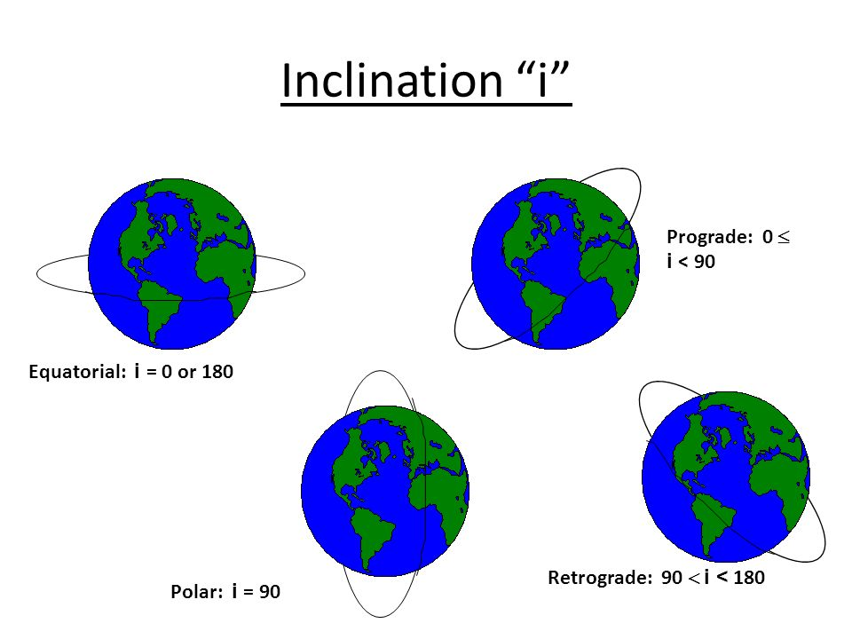

There are four types of orbits based on the angle of inclination.
- Equatorial orbit − Angle of inclination is either zero degrees or 180 degrees.
- Polar orbit − Angle of inclination is 90 degrees.
- Pro-grade orbit − Angle of inclination lies between zero and 90 degrees.
- Retrograde orbit − Angle of inclination lies between 90 and 180 degrees.

Right Ascension of Ascending node
We know that ascending node is the point, where the satellite crosses the equatorial plane while going from the southern hemisphere to the northern hemisphere.
Right Ascension of ascending node (Ω) is the angle between line of Aries and ascending node towards east direction in equatorial plane. Aries is also called as vernal and equinox.
Satellite’s ground track is the path on the surface of the Earth, which lies exactly below its orbit. The ground track of a satellite can take a number of different forms depending on the values of the orbital elements.
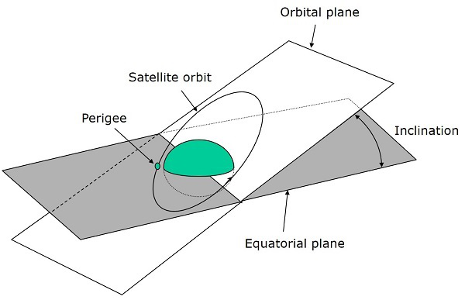 | 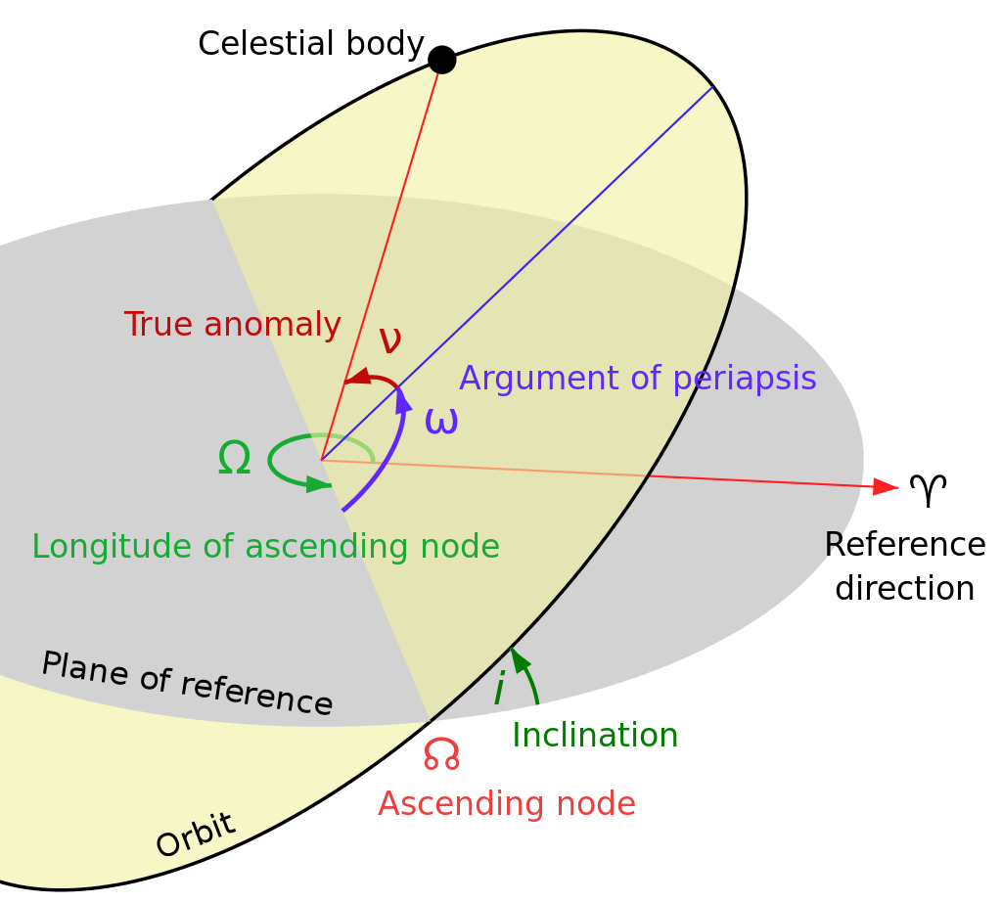

Types of Earth Orbit satellites
We should choose an orbit properly for a satellite based on the requirement. For example, if the satellite is placed in lower orbit, then it takes less time to travel around the earth and there will be better resolution in an onboard camera. Similarly, if the satellite is placed in higher orbit, then it takes more time to travel around the earth and it covers more earth’s surface at one time.
Following are the three important types of Earth Orbit satellites −
- Geosynchronous Earth Orbit Satellites
- Medium Earth Orbit Satellites
- Low Earth Orbit Satellites
- Sun- Synchronous Orbits satellites

Geosynchronous Earth Orbit Satellite
A Geo-synchronous Earth Orbit (GEO) Satellite is one, which is placed at an altitude of 22,400 miles above the Earth. This orbit is synchronized with a side real day (i.e., 23 hours 56 minutes). This orbit can have inclination and eccentricity. The satellites present in these orbits have the angular velocity same as that of earth. Hence, these satellites are considered as stationary with respect to earth since, these are in synchronous with the Earth’s rotation.
It may not be circular. This orbit can be tilted at the poles of the earth. But, it appears stationary when observed from the Earth. These satellites are used for satellite Television. The advantage of Geostationary orbit is that no need to track the antennas in order to find the position of satellites.
Geostationary Earth Orbit Satellites are used for weather forecasting, satellite TV, satellite radio and other types of global communications.
The following figure shows the difference between Geo-synchronous and Geo-stationary orbits. The axis of rotation indicates the movement of Earth.
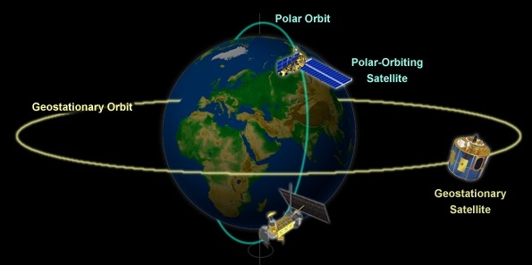
Note − Every Geostationary orbit is a Geo-synchronous orbit. But, the converse need not be true.

Medium Earth Orbit Satellites
Medium Earth Orbit (MEO) satellites will orbit at distances of about 6,000-12,000 miles from earth's surface. Signals transmitted from a MEO satellite travel a shorter distance. Due to this, the signal strength at the receiving end gets improved. This shows that smaller and light weight receiving terminals can be used at the receiving end.
Transmission delay can be defined as the time it takes for a signal to travel up to a satellite and back down to a receiving station. In this case, there is less transmission delay. Because, the signal travels for a shorter distance to and from the MEO satellite.
For real-time communications, the shorter the transmission delay, the better will be the communication system. As an example, if a GEO satellite requires 0.25 seconds for a round trip, then MEO satellite requires less than 0.1 seconds to complete the same trip. MEOs operate in the frequency range of 2 GHz and above.
These satellites are used for High speed telephone signals. Ten or more MEO satellites are required in order to cover entire earth.

Low Earth Orbit Satellites
Low Earth Orbit LEO) satellites are mainly classified into three categories. Those are little LEOs, big LEOs, and Mega-LEOs. LEOs will orbit at a distance of 100 to 500 miles above the earth's surface. These satellites are used for satellite phones and GPS.
This relatively short distance reduces transmission delay to only 0.05 seconds. This further reduces the need for sensitive and bulky receiving equipment. Twenty or more LEO satellites are required to cover entire earth.
Little LEOs will operate in the 800 MHz (0.8 GHz) range. Big LEOs will operate in the 2 GHz or above range, and Mega-LEOs operates in the 20-30 GHz range.
The higher frequencies associated with Mega-LEOs translates into more information carrying capacity and yields to the capability of real-time, low delay video transmission scheme.
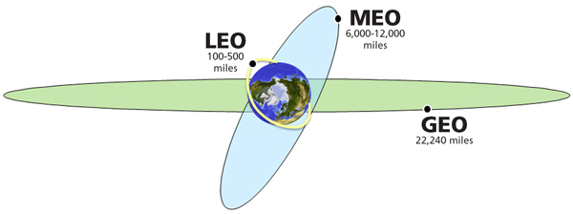
Sun- Synchronous Orbits satellites
These satellites rise and set with the sun. Their orbit is defined in such a way that they are always facing the sun and hence they never go through an eclipse. For these satellites, the surface illumination angle will be nearly the same every time.
Surface illumination angle: The illumination angle is the angle between the inward surface normal and the direction of light. This means that the illumination angle of a certain point of the Earth's surface is zero if the Sun is precisely overhead and that it is 90 degrees at sunset and at sunrise.

Orbital Slots
Here, a question may arise that with more than 450 satellites that are in geosynchronous orbit, how do we keep them from running into each other or from attempting to use the same location in space?
To answer this problem (question), international regulatory bodies like the International Telecommunications Union (ITU) and national government organizations like the Federal Communications Commission (FCC) designate the locations on the geosynchronous orbit, where the communications satellites can be located. These locations are specified in degrees of longitude and are called as orbital slots.

