Digital Communication
CSE-472
Digital Communication
Digital communication is a mode of communication. It occurs when the information or the thought is encoded digitally as discreet signals and then is electronically transferred to the recipients.

Advantages of Digital Communication
As the signals are digitized, there are many advantages of digital communication over analog communication, such as −
- The effect of distortion, noise, and interference is much less in digital signals as they are less affected.
- Digital circuits are more reliable.
- Digital circuits are easy to design and cheaper than analog circuits.
- The hardware implementation in digital circuits, is more flexible than analog.
- The occurrence of cross-talk is very rare in digital communication.
- Signal processing functions such as encryption and compression are employed in digital circuits to maintain the secrecy of the information.
- The probability of error occurrence is reduced by employing error detecting and error correcting codes.
- Digital signals can be saved and retrieved more conveniently than analog signals.
- Many of the digital circuits have almost common encoding techniques and hence similar devices can be used for a number of purposes.
- The capacity of the channel is effectively utilized by digital signals.

Elements of Digital Communication
The elements which form a digital communication system is represented by the following block diagram for the ease of understanding.
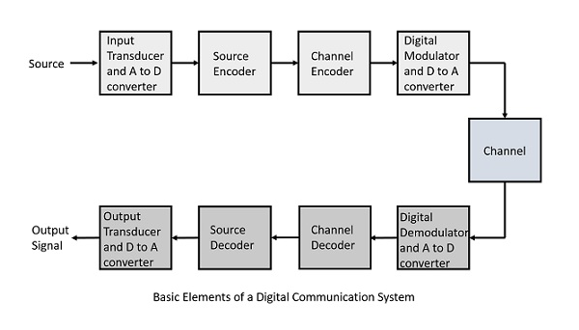
Following are the sections of the digital communication system.

Source: The source can be an analog signal. Example: A Sound signal

Input Transducer: This is a transducer which takes a physical input and converts it to an electrical signal (Example: microphone). This block also consists of an analog to digital converter where a digital signal is needed for further processes.

Source Encoder: The source encoder compresses the data into minimum number of bits. This process helps in effective utilization of the bandwidth. It removes the redundant bits (unnecessary excess bits, i.e., zeroes).

Channel Encoder: The channel encoder, does the coding for error correction. During the transmission of the signal, due to the noise in the channel, the signal may get altered and hence to avoid this, the channel encoder adds some redundant bits to the transmitted data. These are the error correcting bits.

Digital Modulator: The signal to be transmitted is modulated here by a carrier. The signal is also converted to analog from the digital sequence, in order to make it travel through the channel or medium.

Channel: The channel or a medium, allows the analog signal to transmit from the transmitter end to the receiver end.

Digital Demodulator: This is the first step at the receiver end. The received signal is demodulated as well as converted again from analog to digital. The signal gets reconstructed here.

Channel Decoder: The channel decoder, after detecting the sequence, does some error corrections. The distortions which might occur during the transmission, are corrected by adding some redundant bits. This addition of bits helps in the complete recovery of the original signal.

Source Decoder: The resultant signal is once again digitized by sampling and quantizing so that the pure digital output is obtained without the loss of information. The source decoder recreates the source output.

Output Transducer: This is the last block which converts the signal into the original physical form, which was at the input of the transmitter. It converts the electrical signal into physical output (Example: loud speaker).

Output Signal: This is the output which is produced after the whole process. Example − The sound signal received.
Modulation
Modulation is nothing but, a carrier signal that varies in accordance with the message signal. Modulation technique is used to change the signal characteristics. Basically, the modulation is of following two types: Analog and Digital modulation.
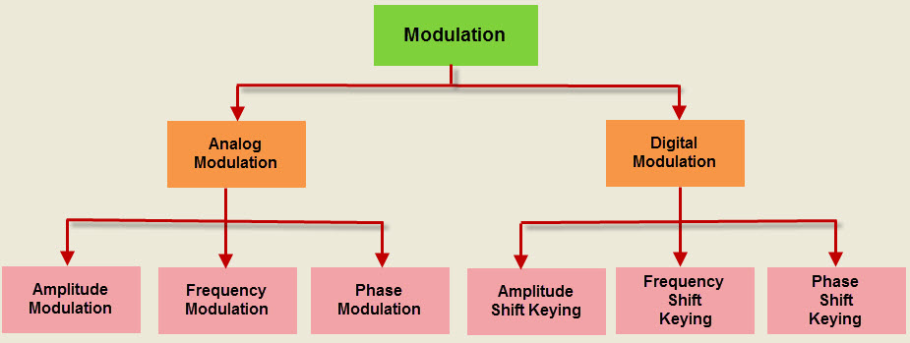
The message signal is the signal which is being transmitted for communication and the carrier signal is a high frequency signal which has no data, but is used for long distance transmission. There are many modulation techniques, which are classified according to the type of modulation employed. Of them all, the digital modulation technique used is Pulse Code Modulation (PCM).
Pulse Code Modulation (PCM)
Pulse code modulation is a method that is used to convert an analog signal into a digital signal, so that modified analog signal can be transmitted through the digital communication network. PCM is in binary form ,so there will be only two possible states high and low(0 and 1). We can also get back our analog signal by demodulation. The Pulse Code Modulation process is done in three steps Sampling, Quantization, and Coding. There are two specific types of pulse code modulations such as differential pulse code modulation(DPCM) and adaptive differential pulse code modulation (ADPCM)
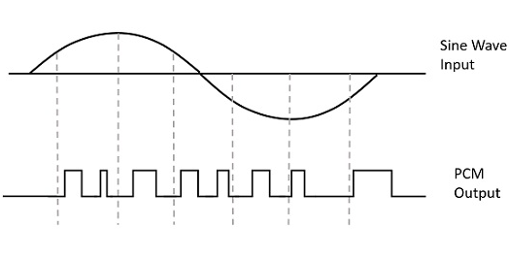
Instead of a pulse train, PCM produces a series of numbers or digits, and hence this process is called as digital. Each one of these digits, though in binary code, represent the approximate amplitude of the signal sample at that instant.
In Pulse Code Modulation, the message signal is represented by a sequence of coded pulses. This message signal is achieved by representing the signal in discrete form in both time and amplitude.

Basic Elements of PCM
The transmitter section of a Pulse Code Modulator circuit consists of Sampling, Quantizing and Encoding, which are performed in the analog-to-digital converter section. The low pass filter prior to sampling prevents aliasing of the message signal.
The basic operations in the receiver section are regeneration of impaired signals, decoding, and reconstruction of the quantized pulse train. Following is the block diagram of PCM which represents the basic elements of both the transmitter and the receiver sections.

Low Pass Filter
This filter eliminates the high frequency components present in the input analog signal which is greater than the highest frequency of the message signal, to avoid aliasing of the message signal.

Sampler
This is the technique which helps to collect the sample data at instantaneous values of message signal, so as to reconstruct the original signal. The sampling rate must be greater than twice the highest frequency component W of the message signal, in accordance with the sampling theorem.
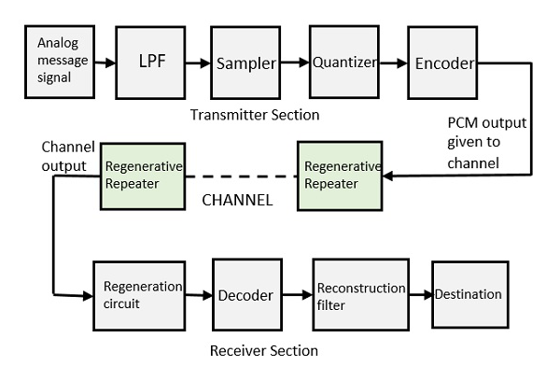

Quantizer
Quantizing is a process of reducing the excessive bits and confining the data. The sampled output when given to Quantizer, reduces the redundant bits and compresses the value.

Encoder
The digitization of analog signal is done by the encoder. It designates each quantized level by a binary code. The sampling done here is the sample-and-hold process. These three sections (LPF, Sampler, and Quantizer) will act as an analog to digital converter. Encoding minimizes the bandwidth used.

Regenerative Repeater
This section increases the signal strength. The output of the channel also has one regenerative repeater circuit, to compensate the signal loss and reconstruct the signal, and also to increase its strength.

Decoder
The decoder circuit decodes the pulse coded waveform to reproduce the original signal. This circuit acts as the demodulator.

Reconstruction Filter
After the digital-to-analog conversion is done by the regenerative circuit and the decoder, a low-pass filter is employed, called as the reconstruction filter to get back the original signal.
Hence, the Pulse Code Modulator circuit digitizes the given analog signal, codes it and samples it, and then transmits it in an analog form. This whole process is repeated in a reverse pattern to obtain the original signal.

Sampling is defined as, “The process of measuring the instantaneous values of continuous-time signal in a discrete form.”
Sample is a piece of data taken from the whole data which is continuous in the time domain.
When a source generates an analog signal and if that has to be digitized, having 1s and 0s i.e., High or Low, the signal has to be discretized in time. This discretization of analog signal is called as Sampling.
The following figure indicates a continuous-time signal x (t) and a sampled signal xs (t). When x (t) is multiplied by a periodic impulse train, the sampled signal xs (t) is obtained.
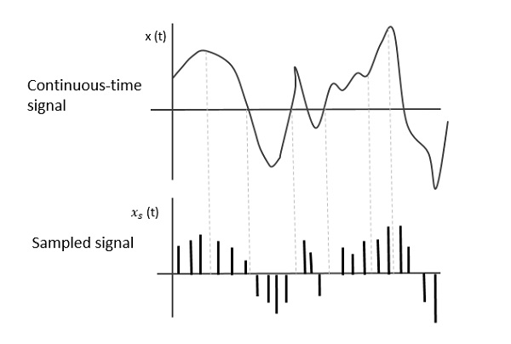

Sampling Rate
To discretize the signals, the gap between the samples should be fixed. That gap can be termed as a sampling period Ts.
Sampling Frequency=1 / Ts = fs
Where,
- Ts is the sampling time
- fs is the sampling frequency or the sampling rate
Sampling frequency is the reciprocal of the sampling period. This sampling frequency, can be simply called as Sampling rate. The sampling rate denotes the number of samples taken per second, or for a finite set of values.
For an analog signal to be reconstructed from the digitized signal, the sampling rate should be highly considered. The rate of sampling should be such that the data in the message signal should neither be lost nor it should get over-lapped. Hence, a rate was fixed for this, called as Nyquist rate.

Nyquist Rate
Suppose that a signal is band-limited with no frequency components higher than W Hertz. That means, W is the highest frequency. For such a signal, for effective reproduction of the original signal, the sampling rate should be twice the highest frequency.
Which means,
f_{S} = 2W
Where,
- f_{S} is the sampling rate
- W is the highest frequency
This rate of sampling is called as Nyquist rate.
A theorem called, Sampling Theorem, was stated on the theory of this Nyquist rate.

Sampling Theorem
The sampling theorem, which is also called as Nyquist theorem, delivers the theory of sufficient sample rate in terms of bandwidth for the class of functions that are bandlimited.
The sampling theorem states that, “a signal can be exactly reproduced if it is sampled at the rate fs which is greater than twice the maximum frequency W.”
To understand this sampling theorem, let us consider a band-limited signal, i.e., a signal whose value is non-zero between some –W and W Hertz.
Such a signal is represented as x(f)=0for|f|>W
For the continuous-time signal x (t), the band-limited signal in frequency domain, can be represented as shown in the following figure.
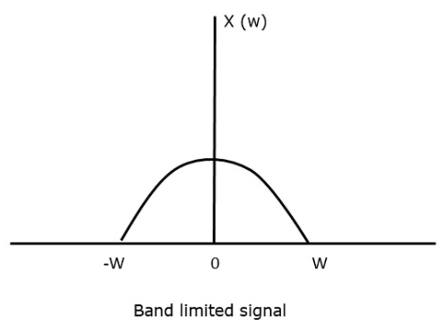
We need a sampling frequency, a frequency at which there should be no loss of information, even after sampling. For this, we have the Nyquist rate that the sampling frequency should be two times the maximum frequency. It is the critical rate of sampling.
If the signal x(t) is sampled above the Nyquist rate, the original signal can be recovered, and if it is sampled below the Nyquist rate, the signal cannot be recovered.
The following figure explains a signal, if sampled at a higher rate than 2w in the frequency domain.
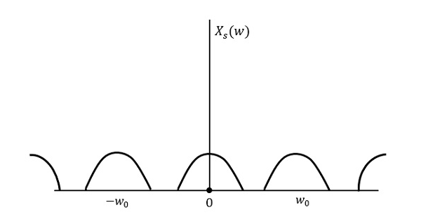
The above figure shows the Fourier transform of a signal xs(t)
. Here, the information is reproduced without any loss. There is no mixing up and hence recovery is possible.
The Fourier Transform of the signal xs(t)
is
Xs(w)=1Ts∑n=−∞∞X(w−nw0)
Where Ts
= Sampling Period and w0=2πTs
Let us see what happens if the sampling rate is equal to twice the highest frequency (2W)
That means,
fs=2W
Where,
- fs
- is the sampling frequency
- W is the highest frequency
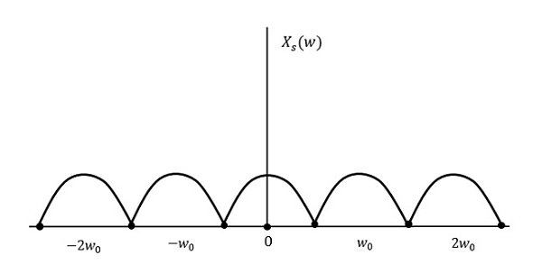
The result will be as shown in the above figure. The information is replaced without any loss. Hence, this is also a good sampling rate.
Now, let us look at the condition,
fs<2W
The resultant pattern will look like the following figure.
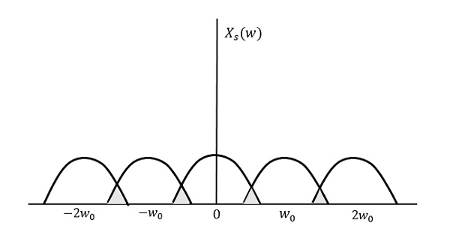
We can observe from the above pattern that the over-lapping of information is done, which leads to mixing up and loss of information. This unwanted phenomenon of over-lapping is called as Aliasing.

Aliasing
Aliasing can be referred to as “the phenomenon of a high-frequency component in the spectrum of a signal, taking on the identity of a low-frequency component in the spectrum of its sampled version.”
The corrective measures taken to reduce the effect of Aliasing are −
- In the transmitter section of PCM, a low pass anti-aliasing filter is employed, before the sampler, to eliminate the high frequency components, which are unwanted.
- The signal which is sampled after filtering, is sampled at a rate slightly higher than the Nyquist rate.
This choice of having the sampling rate higher than Nyquist rate, also helps in the easier design of the reconstruction filter at the receiver.

Scope of Fourier Transform
It is generally observed that, we seek the help of Fourier series and Fourier transforms in analyzing the signals and also in proving theorems. It is because −
- The Fourier Transform is the extension of Fourier series for non-periodic signals.
- Fourier transform is a powerful mathematical tool which helps to view the signals in different domains and helps to analyze the signals easily.
- Any signal can be decomposed in terms of sum of sines and cosines using this Fourier transform.
Quantization
The digitization of analog signals involves the rounding off of the values which are approximately equal to the analog values. The method of sampling chooses a few points on the analog signal and then these points are joined to round off the value to a near stabilized value. Such a process is called as Quantization.

Quantizing an Analog Signal
The analog-to-digital converters perform this type of function to create a series of digital values out of the given analog signal. The following figure represents an analog signal. This signal to get converted into digital, has to undergo sampling and quantizing.
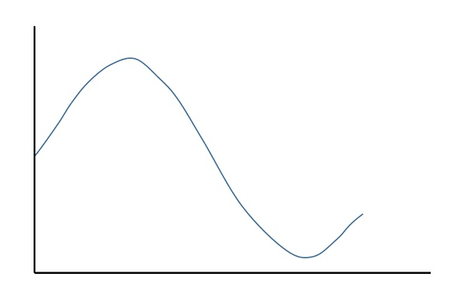
The quantizing of an analog signal is done by discretizing the signal with a number of quantization levels. Quantization is representing the sampled values of the amplitude by a finite set of levels, which means converting a continuous-amplitude sample into a discrete-time signal.
The following figure shows how an analog signal gets quantized. The blue line represents analog signal while the brown one represents the quantized signal.
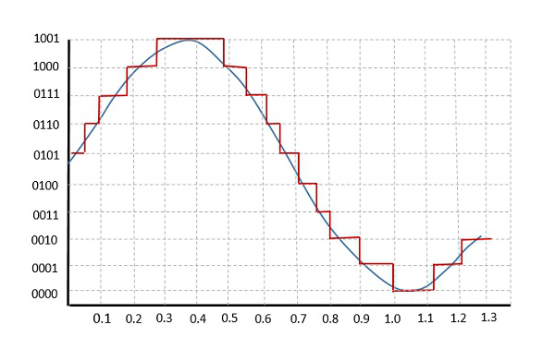
Both sampling and quantization result in the loss of information. The quality of a Quantizer output depends upon the number of quantization levels used. The discrete amplitudes of the quantized output are called as representation levels or reconstruction levels. The spacing between the two adjacent representation levels is called a quantum or step-size.
The following figure shows the resultant quantized signal which is the digital form for the given analog signal.
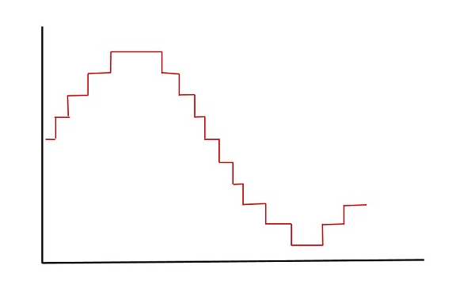
This is also called as Stair-case waveform, in accordance with its shape.

Types of Quantization
There are two types of Quantization - Uniform Quantization and Non-uniform Quantization.
The type of quantization in which the quantization levels are uniformly spaced is termed as a Uniform Quantization. The type of quantization in which the quantization levels are unequal and mostly the relation between them is logarithmic, is termed as a Non-uniform Quantization.
There are two types of uniform quantization. They are Mid-Rise type and Mid-Tread type. The following figures represent the two types of uniform quantization.
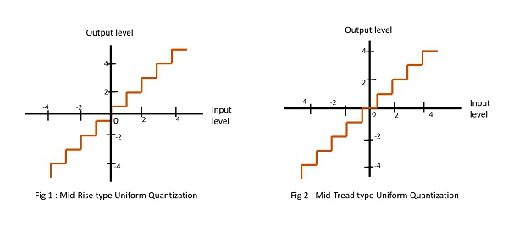
Figure 1 shows the mid-rise type and figure 2 shows the mid-tread type of uniform quantization.
- The Mid-Rise type is so called because the origin lies in the middle of a raising part of the stair-case like graph. The quantization levels in this type are even in number.
- The Mid-tread type is so called because the origin lies in the middle of a tread of the stair-case like graph. The quantization levels in this type are odd in number.
- Both the mid-rise and mid-tread type of uniform quantizers are symmetric about the origin.

Quantization Error
For any system, during its functioning, there is always a difference in the values of its input and output. The processing of the system results in an error, which is the difference of those values.
The difference between an input value and its quantized value is called a Quantization Error. A Quantizer is a logarithmic function that performs Quantization (rounding off the value). An analog-to-digital converter (ADC) works as a quantizer.
The following figure illustrates an example for a quantization error, indicating the difference between the original signal and the quantized signal.
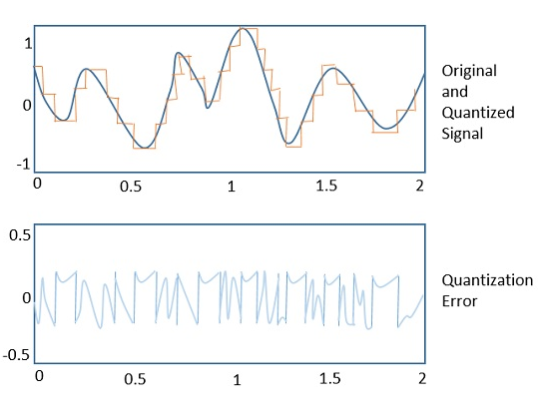

Quantization Noise
It is a type of quantization error, which usually occurs in analog audio signal, while quantizing it to digital. For example, in music, the signals keep changing continuously, where a regularity is not found in errors. Such errors create a wideband noise called as Quantization Noise.

Multiplexing
Multiplexing is the process of combining multiple signals into one signal, over a shared medium. These signals, if analog in nature, the process is called as analog multiplexing. If digital signals are multiplexed, it is called as digital multiplexing.
Multiplexing was first developed in telephony. A number of signals were combined to send through a single cable. The process of multiplexing divides a communication channel into several number of logical channels, allotting each one for a different message signal or a data stream to be transferred. The device that does multiplexing, can be called as a MUX. The reverse process, i.e., extracting the number of channels from one, which is done at the receiver is called as de-multiplexing. The device which does de-multiplexing is called as DEMUX.
The following figures represent MUX and DEMUX. Their primary use is in the field of communications.
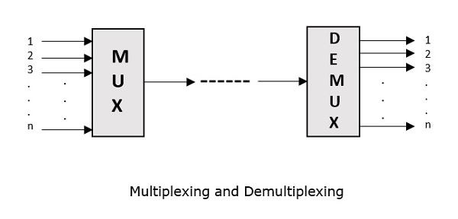

Types of Multiplexers
There are mainly two types of multiplexers, namely analog and digital. They are further divided into FDM, WDM, and TDM. The following figure gives a detailed idea on this classification.
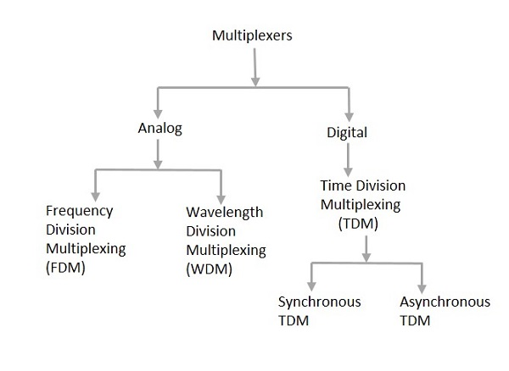
Actually, there are many types of multiplexing techniques. Of them all, we have the main types with general classification, mentioned in the above figure.

Analog Multiplexing
The analog multiplexing techniques involve signals which are analog in nature. The analog signals are multiplexed according to their frequency (FDM) or wavelength (WDM).

Frequency Division Multiplexing (FDM)
In analog multiplexing, the most used technique is Frequency Division Multiplexing (FDM). This technique uses various frequencies to combine streams of data, for sending them on a communication medium, as a single signal. For example: A traditional television transmitter, which sends a number of channels through a single cable, uses FDM.

Wavelength Division Multiplexing (WDM)
Wavelength Division multiplexing is an analog technique, in which many data streams of different wavelengths are transmitted in the light spectrum. If the wavelength increases, the frequency of the signal decreases. A prism which can turn different wavelengths into a single line, can be used at the output of MUX and input of DEMUX. For example: Optical fiber communications use WDM technique to merge different wavelengths into a single light for communication.

Digital Multiplexing
The term digital represents the discrete bits of information. Hence, the available data is in the form of frames or packets, which are discrete.

Time Division Multiplexing (TDM)
In TDM, the time frame is divided into slots. This technique is used to transmit a signal over a single communication channel, by allotting one slot for each message. Of all the types of TDM, the main ones are Synchronous and Asynchronous TDM.

Synchronous TDM
In Synchronous TDM, the input is connected to a frame. If there are ‘n’ number of connections, then the frame is divided into ‘n’ time slots. One slot is allocated for each input line. In this technique, the sampling rate is common to all signals and hence the same clock input is given. The MUX allocates the same slot to each device at all times.

Asynchronous TDM
In Asynchronous TDM, the sampling rate is different for each of the signals and a common clock is not required. If the allotted device, for a time-slot, transmits nothing and sits idle, then that slot is allotted to another device, unlike synchronous. This type of TDM is used in Asynchronous transfer mode networks.

Regenerative Repeater
For any communication system to be reliable, it should transmit and receive the signals effectively, without any loss. A PCM wave, after transmitting through a channel, gets distorted due to the noise introduced by the channel.
The regenerative pulse compared with the original and received pulse, will be as shown in the following figure.
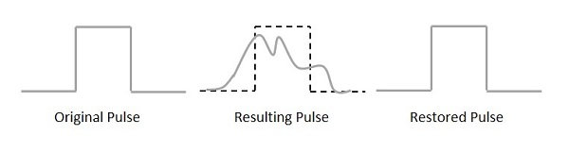
For a better reproduction of the signal, a circuit called as regenerative repeater is employed in the path before the receiver. This helps in restoring the signals from the losses occurred. Following is the diagrammatical representation.
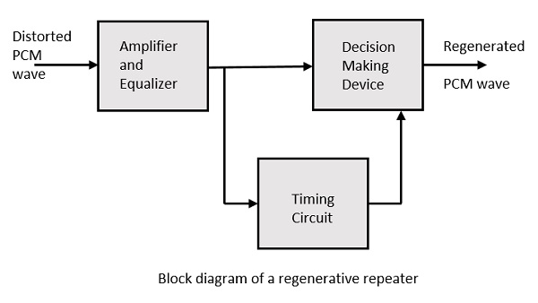
This consists of an equalizer along with an amplifier, a timing circuit, and a decision making device. Their working of each of the components is detailed as follows.

Equalizer
The channel produces amplitude and phase distortions to the signals. This is due to the transmission characteristics of the channel. The Equalizer circuit compensates these losses by shaping the received pulses.

Timing Circuit
To obtain a quality output, the sampling of the pulses should be done where the signal to noise ratio (SNR) is maximum. To achieve this perfect sampling, a periodic pulse train has to be derived from the received pulses, which is done by the timing circuit.
Hence, the timing circuit, allots the timing interval for sampling at high SNR, through the received pulses.

A line code is the code used for data transmission of a digital signal over a transmission line. This process of coding is chosen so as to avoid overlap and distortion of signal such as inter-symbol interference.

Properties of Line Coding
Following are the properties of line coding −
- As the coding is done to make more bits transmit on a single signal, the bandwidth used is much reduced.
- For a given bandwidth, the power is efficiently used.
- The probability of error is much reduced.
- Error detection is done and the bipolar too has a correction capability.
- Power density is much favorable.
- The timing content is adequate.
- Long strings of 1s and 0s is avoided to maintain transparency.

Types of Line Coding
There are 3 types of Line Coding
- Unipolar
- Polar
- Bi-polar

Unipolar Signaling
Unipolar signaling is also called as On-Off Keying or simply OOK.
The presence of pulse represents a 1 and the absence of pulse represents a 0.
There are two variations in Unipolar signaling −
- Non Return to Zero (NRZ)
- Return to Zero (RZ)

Unipolar Non-Return to Zero (NRZ)
In this type of unipolar signaling, a High in data is represented by a positive pulse called as Mark, which has a duration T0 equal to the symbol bit duration. A Low in data input has no pulse.
The following figure clearly depicts this.
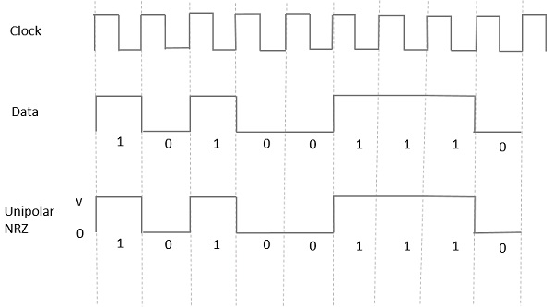
Advantages
The advantages of Unipolar NRZ are −
- It is simple.
- A lesser bandwidth is required.
Disadvantages
The disadvantages of Unipolar NRZ are −
- No error correction done.
- Presence of low frequency components may cause the signal droop.
- No clock is present.
- Loss of synchronization is likely to occur (especially for long strings of 1s and 0s).

Unipolar Return to Zero (RZ)
In this type of unipolar signaling, a High in data, though represented by a Mark pulse, its duration T0 is less than the symbol bit duration. Half of the bit duration remains high but it immediately returns to zero and shows the absence of pulse during the remaining half of the bit duration.
It is clearly understood with the help of the following figure.
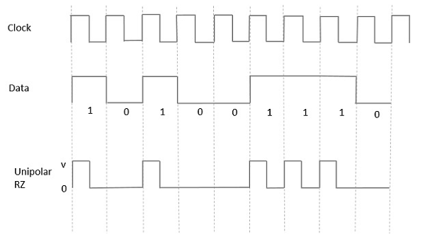
Advantages
The advantages of Unipolar RZ are −
- It is simple.
- The spectral line present at the symbol rate can be used as a clock.
Disadvantages
The disadvantages of Unipolar RZ are −
- No error correction.
- Occupies twice the bandwidth as unipolar NRZ.
- The signal droop is caused at the places where signal is non-zero at 0 Hz.

Polar Signaling
There are two methods of Polar Signaling. They are −
- Polar NRZ
- Polar RZ

Polar NRZ
In this type of Polar signaling, a High in data is represented by a positive pulse, while a Low in data is represented by a negative pulse. The following figure depicts this well.
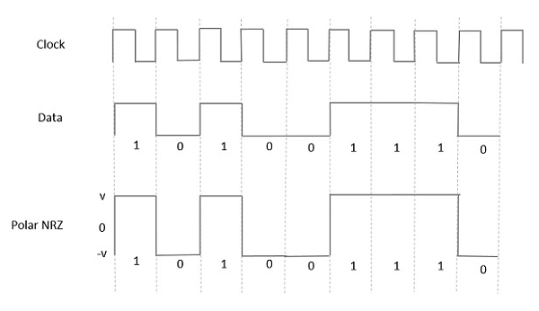
Advantages
The advantages of Polar NRZ are −
- It is simple.
- No low-frequency components are present.
Disadvantages
The disadvantages of Polar NRZ are −
- No error correction.
- No clock is present.
- The signal droop is caused at the places where the signal is non-zero at 0 Hz.

Polar RZ
In this type of Polar signaling, a High in data, though represented by a Mark pulse, its duration T0 is less than the symbol bit duration. Half of the bit duration remains high but it immediately returns to zero and shows the absence of pulse during the remaining half of the bit duration.
However, for a Low input, a negative pulse represents the data, and the zero level remains same for the other half of the bit duration. The following figure depicts this clearly.
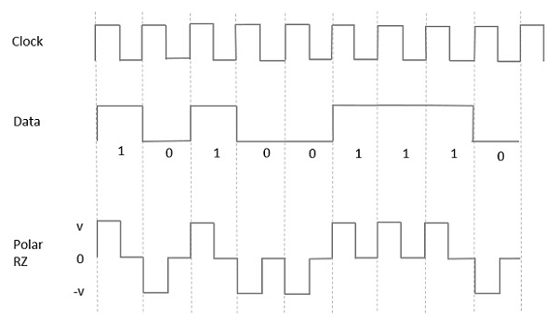
Advantages
The advantages of Polar RZ are −
- It is simple.
- No low-frequency components are present.
Disadvantages
The disadvantages of Polar RZ are −
- No error correction.
- No clock is present.
- Occupies twice the bandwidth of Polar NRZ.
- The signal droop is caused at places where the signal is non-zero at 0 Hz.

Bipolar Signaling
This is an encoding technique which has three voltage levels namely +, - and 0. Such a signal is called as duo-binary signal.
An example of this type is Alternate Mark Inversion (AMI). For a 1, the voltage level gets a transition from + to – or from – to +, having alternate 1s to be of equal polarity. A 0 will have a zero voltage level.
Even in this method, we have two types.
- Bipolar NRZ
- Bipolar RZ
From the models so far discussed, we have learnt the difference between NRZ and RZ. It just goes in the same way here too. The following figure clearly depicts this.
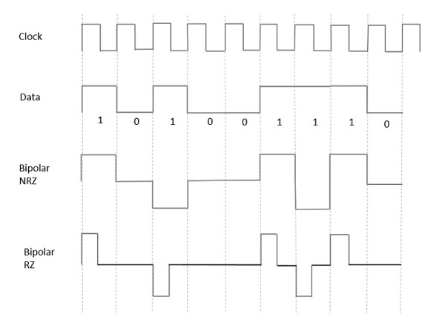
The above figure has both the Bipolar NRZ and RZ waveforms. The pulse duration and symbol bit duration are equal in NRZ type, while the pulse duration is half of the symbol bit duration in RZ type.

Advantages
Following are the advantages −
- It is simple.
- No low-frequency components are present.
- Occupies low bandwidth than unipolar and polar NRZ schemes.
- This technique is suitable for transmission over AC coupled lines, as signal drooping doesn’t occur here.
- A single error detection capability is present in this.

Disadvantages
Following are the disadvantages −
- No clock is present.
- Long strings of data causes loss of synchronization.

Encoding is the process of converting the data or a given sequence of characters, symbols, alphabets etc., into a specified format, for the secured transmission of data. Decoding is the reverse process of encoding which is to extract the information from the converted format.

Data Encoding
Encoding is the process of using various patterns of voltage or current levels to represent 1s and 0s of the digital signals on the transmission link.
The common types of line encoding are Unipolar, Polar, Bipolar, and Manchester.

Encoding Techniques
The data encoding technique is divided into the following types, depending upon the type of data conversion.
- Analog data to Analog signals − The modulation techniques such as Amplitude Modulation, Frequency Modulation and Phase Modulation of analog signals, fall under this category.
- Analog data to Digital signals − This process can be termed as digitization, which is done by Pulse Code Modulation (PCM). Hence, it is nothing but digital modulation. As we have already discussed, sampling and quantization are the important factors in this. Delta Modulation gives a better output than PCM.
- Digital data to Analog signals − The modulation techniques such as Amplitude Shift Keying (ASK), Frequency Shift Keying (FSK), Phase Shift Keying (PSK), etc., fall under this category. These will be discussed in subsequent chapters.
- Digital data to Digital signals − These are in this section. There are several ways to map digital data to digital signals. Some of them are −

Non Return to Zero (NRZ)
NRZ Codes has 1 for High voltage level and 0 for Low voltage level. The main behavior of NRZ codes is that the voltage level remains constant during bit interval. The end or start of a bit will not be indicated and it will maintain the same voltage state, if the value of the previous bit and the value of the present bit are same.
The following figure explains the concept of NRZ coding.
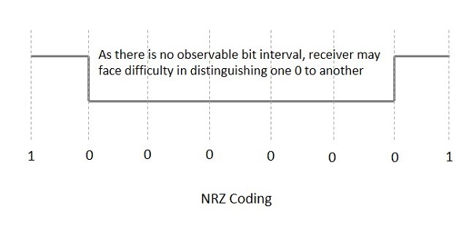
If the above example is considered, as there is a long sequence of constant voltage level and the clock synchronization may be lost due to the absence of bit interval, it becomes difficult for the receiver to differentiate between 0 and 1.
There are two variations in NRZ namely −

NRZ - L (NRZ – LEVEL)
There is a change in the polarity of the signal, only when the incoming signal changes from 1 to 0 or from 0 to 1. It is the same as NRZ, however, the first bit of the input signal should have a change of polarity.

NRZ - I (NRZ – INVERTED)
If a 1 occurs at the incoming signal, then there occurs a transition at the beginning of the bit interval. For a 0 at the incoming signal, there is no transition at the beginning of the bit interval.
NRZ codes has a disadvantage that the synchronization of the transmitter clock with the receiver clock gets completely disturbed, when there is a string of 1s and 0s. Hence, a separate clock line needs to be provided.

Error Probability and Figure-of-merit
The rate at which data can be communicated is called the data rate. The rate at which error occurs in the bits, while transmitting data is called the Bit Error Rate (BER).
The probability of the occurrence of BER is the Error Probability. The increase in Signal to Noise Ratio (SNR) decreases the BER, hence the Error Probability also gets decreased.
In an Analog receiver, the figure of merit at the detection process can be termed as the ratio of output SNR to the input SNR. A greater value of figure-of-merit will be an advantage.

Digital Modulation techniques.
Digital Modulation provides more information capacity, high data security, quicker system availability with great quality communication. Hence, digital modulation techniques have a greater demand, for their capacity to convey larger amounts of data than analog modulation techniques. There are many types of digital modulation techniques and also their combinations, depending upon the need. Of them all, we will discuss the prominent ones.

ASK – Amplitude Shift Keying
The amplitude of the resultant output depends upon the input data whether it should be a zero level or a variation of positive and negative, depending upon the carrier frequency.

FSK – Frequency Shift Keying
The frequency of the output signal will be either high or low, depending upon the input data applied.

PSK – Phase Shift Keying
The phase of the output signal gets shifted depending upon the input. These are mainly of two types, namely Binary Phase Shift Keying (BPSK) and Quadrature Phase Shift Keying (QPSK), according to the number of phase shifts. The other one is Differential Phase Shift Keying (DPSK) which changes the phase according to the previous value.

