Experiment 2
PULSE CODE MODULATION & DEMODULATION
Aim:
To convert an analog signal into a pulse digital signal using PCM system and to convert the digital signal into analog signal using PCM trainer kit
Apparatus:
1. PCM kit,
2. CRO and
3. Connecting probes
Theory:
Pulse code modulation is a process of converting a analog signal into digital. The basic operations performed in the transmitter of a PCM system are sampling, quantizing and encoding. The low pass filter prior to sampling is included to prevent aliasing of the message signal. The incoming message signal is sampled with a train of narrow rectangular pulses so as to closely approximate the instantaneous sampling process. To ensure perfect reconstruction of the message signal at the receiver, the sampling rate must be greater than twice the highest frequency component W of the message signal in accordance with the sampling theorem.
The quantizing and encoding operations are usually performed in the same circuit, which is called an analog-to-digital converter. The same circuit, which is called and analog-to-digital converter. The sampled version of the message signal is then quantized, thereby providing a new representation of the signal that is discrete in both time and amplitude. In combining the process of sampling and quantization, the specification of a continuous message (baseband) signal becomes limited to a discrete set of values, but not in the form best suited to transmission. To exploit the advantages of sampling and quantizing for the purpose of making the transmitted signal more robust to noise, interference and other channel impairments, we require the use of an encoding process to translate the discrete set of sample values to a more appropriate form of signal.
Regeneration: The most important feature of PCM system lies in the ability to control the effects of distortion and noise produced by transmitting a PCM signal through a channel. This capability is accomplished by reconstructing the PCM signal by means of a chain of regenerative repeaters located at sufficiently closed spacing along the transmission route. As illustrated in figure below three basic functions are performed by a regenerative repeater: equalization timing and decision making.
Regeneration Repeater: The equalizer shapes the received pulses so as to compensate for the effects of amplitude and phase distortion produced by the non ideal transmission characteristics of the channel. The timing circuit provides a periodic pulse trainer, derived from the received pulses, for sampling the equalized pulses at the instants of time where the signal to noise ratio is maximum. Each sample so extracted is compared to predetermined threshold in the decision making device. In each bit interval, a decision is then made whether the symbol is 1 or 0 on the basis of whether the threshold is exceeded or not. If the threshold is exceeded, a pulse representing symbol ‘1’ is transmitted.
In the way, the accumulation of distortion and noise in a repeater span is completely removed. The basic operations in the receiver are regeneration of impaired signals, decoding and reconstruction of the train of quantized samples. The first operation in the receiver is to regenerate (i.e., reshape and cleanup) the received pulses one last time. These clean pulses are then regrouped in to code words and decoded into a quantized PAM signal. The decoding process involves generating a pulse, the amplitude of which is the linear sum of all the pulses in the code word. The final operation in the receiver is to recover the message signal by passing the decoder output through a low pass reconstruction filter whose cut-off frequency is equal to the message band width W. Assuming that the transmission path is error free, the recovered signal includes no noise with the exception of the initial distortion introduced by the quantization process.
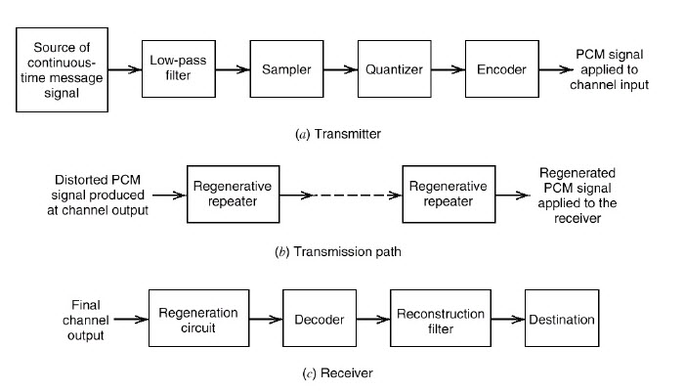
At the demodulator the received bits are first converted into parallel frames and each frame is de-quantized to an equivalent analog value. This analog value is thus equivalent to a sampler output. This is the demodulated signal. In the kit this is implemented differently. The analog signal is passed trough a ADC (Analog to Digital Converter) and then the digital code-word is passed through a parallel to serial converter block. This is modulated PCM. This is taken by the Serial to Parallel converter and then through a DAC to get the demodulated signal. The clock is given to all these blocks for synchronization. The input signal can be either DC or AC according to the kit. The waveforms can be observed on a CRO for DC without problem. AC also can be observed but with poor resolution.
Procedure: The kit is self-explanatory. Identify the blocks according to the theory mentioned and generate a PCM modulated signal and demodulate to check if the same signal is obtained or not. The steps are also given below in a detailed fashion:
1. Switch on Pulse code modulation and demodulation.
2. Connect the variable DC output to the Analog I/P of modulation section.
3. Connect the clock O/P of bit clock generator to the clock I/P of modulation Section.
4. By varying the variable DC O/P observe the PCM O/P on CRO.
5. Connect the AF output to Analog I/P of modulation section by removing variableDC O/P
6. Connect the PCM O/P to PCM I/P of demodulation section.
7. Observe the DAC O/P at channel 1 of CRO and observe the demodulated O/P at channel 2 of CRO.
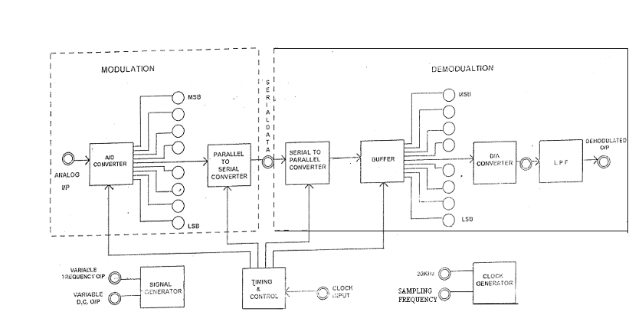
Fig. Block diagram of PCM trainer kit
For model output
