**SECTION: K**



**GROUP 6**

2022

DATABASE

PROJECT

PROJECT

Cricket Team Management System

**Supervised By:**

**SIFAT RAHMAN AHONA**  
***Assistant Professor, AIUB***

**Group members:**

**Name: RAFIUL HASAN SHAFIN ID:22-46663-1**

**Name: MAHEDI HASAN ID:22-46259-1**

**Name: TANJID AHMED TOMAL ID:22-46153-1**

**Name: NUSRAT JAHAN AL-AKSA ID:22-46253-1**

Cricket Team Management System

The Bangladesh Premier League (BPL) is a professional Twenty 20

cricket league in Bangladesh cricket history. The BPL is one of the three

professional cricket leagues in Bangladesh. It is the 16th most attended

premier league in the world. The league of BPL manages this vast

organization with a database. The database usually contains many

tournament T20, Test, ODI. Every match of the tournament has many

coaches by the team by team. The coaches have phone no, agreement.

Coach id, role, name. It has played many leagues contains all league

moderate, team match, contact, league name, league format, league

team. Every league has a board office like board name, contract no,

joining, job. The board appointed a manager for the league. Manager

has a manager id, name, phone, salary, address. The board office

selected stadium. The stadium has stadium id, capacity, place, country,

name. The broad of the league appointed umpire. The umpire has

umpire id, country, date of birth, age, name. The board the umpire

discussing and fixed many matches like match id, date, result, toss. The

board also appointed a doctor. The doctor observes the player and

record player’s condition. The doctor has doctor id, name, appoint, add,

phone. The league participle many players like player name, capital no,

name, skill, date of birth, age, role. The players management has many

selectors. The selectors selected player. The selectors have sectors id,

phone, name. Every league has on or more ticket counter which is

managed by the manager. Ticket counter sells tickets. The database

keeps some record of tickets like ticket number, chair, first class, ticket

prices.

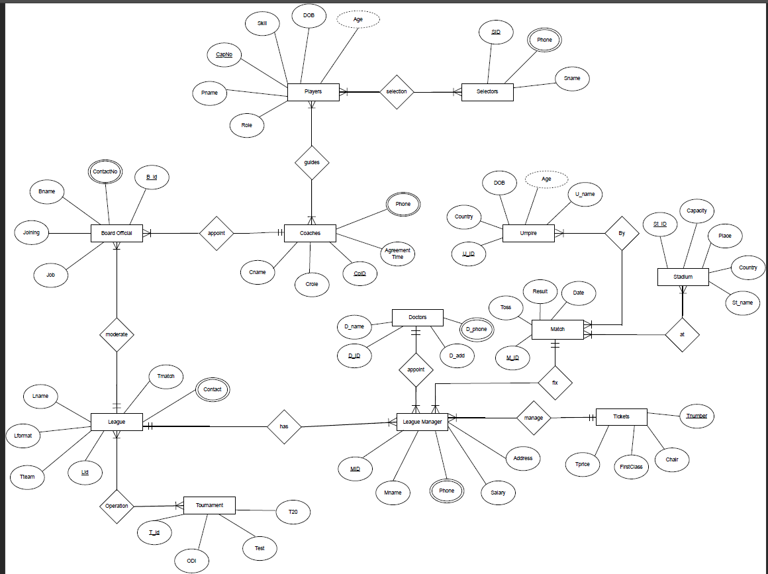

***Normalization:***

**Appoint** (Bid, Job, Joining, Bname, contactNo, Coid, Cname, crole, Agreement Time, Phone)

1NF: Phone, ContactNo Multivalude attributes

2NF: Bid, Job, Joining, Bname, contactNo, Coid

Coid, Cname, crole, Agreement Time, Phone

3NF: Bid, Bname, contactNo, Coid, J_ id

J_ id, Job, Joining

Coid, Cname, crole, Agreement Time, Phone

Table: Bid, Bname, contactNo, Coid, J_ id

J_ id, Job, Joining

Coid, Cname, crole, Agreement Time, Phone

**Moderate** (Bid, Job, Joining, Bname, contactNo, Lid, Tteam, Lformate, Lname, T match, Contact)

1NF: ContactNo, Contact Multivalued attributes

2NF: Bid, Job, Joining, Bname, contactNo, Lid

Lid, Tteam, Lformate, Lname, Tmatch, Contact

3NF: Bid, , Bname, contactNo, Lid, J_id

J_ id, Job, Joining

Lid, Tteam, Lformate, Lname, T match, Contact

Table: Bid, , Bname, contactNo, Lid, J_id

J_ id, Job, Joining

Lid, Tteam, Lformate, Lname, Tmatch, Contact

**Operation** ( Lid, Tteam, Lformate, Lname, Tmatch, Contact, Tid, Odi, test, T20

)

1NF: Contact Multivalued attributes

2NF: Lid, Tteam, Lformate, Lname, Tmatch, Contact

Tid, Odi, test, T20

LTid, Lid, Tid

3NF: Lid, Tteam, Lformate, Lname, Tmatch, Contact

Tid, Odi, test, T20

LTid, Lid, Tid

Table: Lid, Tteam, Lformate, Lname, Tmatch, Contact

Tid, Odi, test, T20

LTid, Lid, Tid

**Guides**( Coid, Cname, crole, Agreement Time, Phone)

, CapNo, Pnamne, Role, Skill, DOB, Age)

1NF: Phone Multivalued attributes

2NF: Coid, Cname, crole, Agreement Time, Phone

CapNo, Pnamne, Role, Skill, DOB, Age

Cid, Coid, CapNo

3NF: Coid, Cname, crole, Agreement Time, Phone

CapNo, Pnamne, Role, Skill, DOB, Age

Cid, Coid, CapNo

Table: Coid, Cname, crole, Agreement Time, Phone

CapNo, Pnamne, Role, Skill, DOB, Age

Cid, Coid, CapNo

**Selection** ( CapNo, Pname, Role, Skill, DOB, Age, SID , Phone, Sname)

1NF: Phone Multivalued attributes

2NF: CapNo, Pname, Role, Skill, DOB, Age

SID , Phone, Sname

CSid, CapNo, SID

3NF: CapNo, Pname, Role, Skill, DOB, Age

SID , Phone, Sname

CSid, CapNo, SID

Table: CapNo, Pname, Role, Skill, DOB, Age

SID , Phone, Sname

CSid, CapNo, SID

**Has** ( Lid, Lteam, Lname, Lformat, Lmatch, contact, Mid, Mname, phone, salary, address)

1NF : contact, phone multivalued attribute

2NF : Lid , Lteam, Lname, Lformat, Lmatch, contact

Mid, Mname, phone, salary, address, LId

3NF : Lid , Lteam, Lname, Lformat, Lmatch, contact

Mid, Mname, phone, salary, address, Lid

Table : Lid , Lteam, Lname, Lformat, Lmatch, contact

Mid, Mname, phone, salary, address, Lid

**Appoints** (Mid, Mname, phone, salary, address, Did, Dname, Dadd, Dphone)

1NF : phone, D_phone multivalued attribute

2NF : Mid, Mname, phone, salary, address, Did

Did, Dname, Dadd, Dphone

3NF : Mid, Mname, phone, salary, address, Did

Did, Dname, Dadd, Dphone

Table : Mid, Mname, phone, salary, address, Did

Did, Dname, Dadd, Dphone

**Manage** ( Mid, Mname, phone, salary, address, Tnumber, Tprice, firstClass, chair)

1NF : phone, multivalued attribute

2NF : Mid, Mname, phone, salary, address, Tnumber

Tnumber, Tprice, firstClass, chair

3NF : Mid, Mname, phone, salary, address, Tnumber

Tnumber, Tprice, firstClass, chair

Table : Mid, Mname, phone, salary, address, Tnumber

Tnumber, Tprice, firstClass, chair

**Fix** ( Mid, Mname, phone, salary, address, M_id, date, result, toss)

1NF : phone multivalued attribute

2NF : Mid, Mname, phone, salary,address, M_id

M_id, date, result, toss

3NF : Mid, Mname, phone, salary,address,M_id

Mid, date, result, toss

Table : Mid, Mname, phone, salary, address, M_id

Mid, date, result, toss

**By** ( Mid, date, result, toss, Uid, country, DOB, age, Uname)

1NF : No multivalued attribute

2NF : Mid, date, result, toss

Uid, country, DOB, age, Uname

MUid, Mid, Uid

3NF :

Mid, date, result, toss

Uid, country, DOB, age, Uname

MUid, Mid, Uid

Table : Mid, date, result, toss

Uid, country, DOB, age, Uname

MUid, Mid, Uid

**At** ( Mid, date, result, toss, St_id ,capacity, place, country, St_name)

1NF : No Multivalued Attribute

2NF : Mid, date, result, toss

St_id ,capacity, place, country, St_name

MSid , Mid, ST_id

3NF : Mid, date, result, toss

St_id,capacity, St_name,CP_id

CP_id, S_country, place

MSid , Mid, ST_id

Table **:**  Mid, date, result, toss

St_id,capacity, St_name,CP_id

CP_id, S_country, place

MSid , Mid, ST_id

***Total Table:***

Bid, Bname, contactNo, Coid

J_ id, Job, Joining

Coid, Cname, crole, Agreement Time, Phone

Bid, , Bname, contactNo, Lid, J_id

J_ id, Job, Joining

Lid, Tteam, Lformate, Lname, T match, Contact

Lid, Tteam, Lformate, Lname, Tmatch, Contact

Tid, Odi, test, T20

LTid, Lid, Tid

Coid, Cname, crole, Agreement Time, Phone

CapNo, Pnamne, Role, Skill, DOB, Age

Cid, Coid, CapNo

CapNo, Pname, Role, Skill, DOB, Age

SID , Phone, Sname

CSid, CapNo, SID

Lid , Lteam, Lname, Lformat, Lmatch, contact

Mid, Mname, phone, salary, address, Lid

Mid, Mname, phone, salary, address, Did

Did, Dname, Dadd, Dphone

Mid, Mname, phone, salary, address, Tnumber

Tnumber, Tprice, firstClass, chair

Mid, Mname, phone, salary, address, M_id

Mid, date, result, toss

Mid, date, result, toss

Uid, country, DOB, age, Uname

MUid, Mid, Uid

Mid, date, result, toss

St_id,capacity, St_name

CPid, country, place

MSid , Mid, ST_id

***Final Table:***

1. Bid, Bname, contactNo, Coid,J_id
2. J_ id, Job, Joining
3. Coid Cname, crole, Agreement Time, Phone
4. Lid, Tteam, Lformate, Lname, T match, Contact
5. Tid, Odi, test, T20
6. LTid, Lid, Tid
7. CapNo, Pnamne, Role, Skill, DOB, Age
8. Cid, Coid, CapNo
9. SID , Phone, Sname
10. CSid, CapNo, SID
11. Mid, Mname, phone, salary, address, Lid
12. Mid, Mname, phone, salary, address, Did
13. Did, Dname, Dadd, Dphone
14. Mid, Mname, phone, salary, address, Tnumber
15. Tnumber, Tprice, firstClass, chair
16. Mid, Mname, phone, salary, address, M_id
17. M_id, MDate, MResult, Toss
18. U_id, country, DOB, age, Uname
19. MUid, M_id, U_id
20. St_id,capacity, St_name,CP_id
21. CP_id, S_country, place
22. MSid , M_id, St_id

***Table Creation (With Screenshot):***

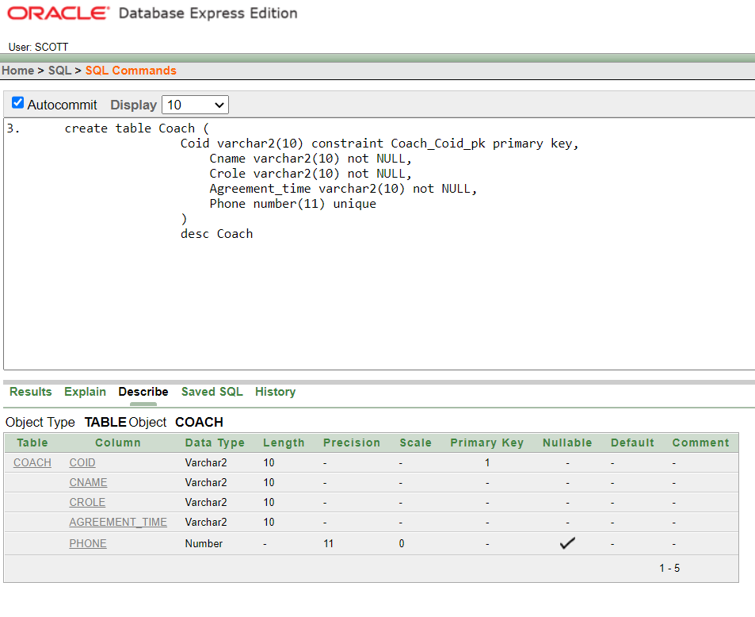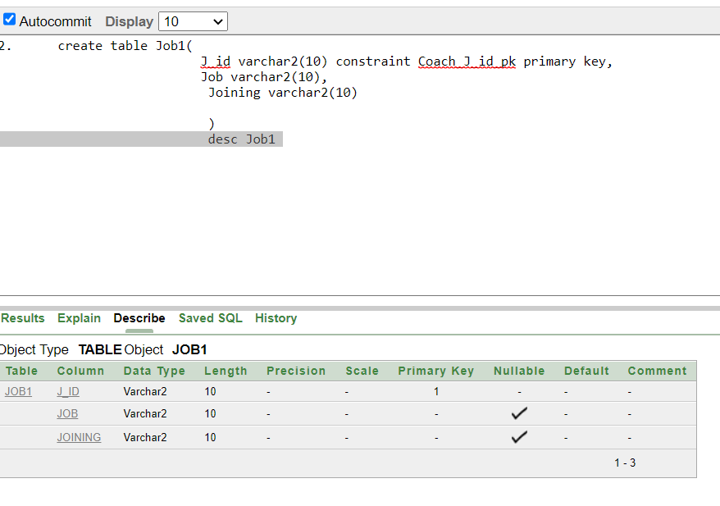

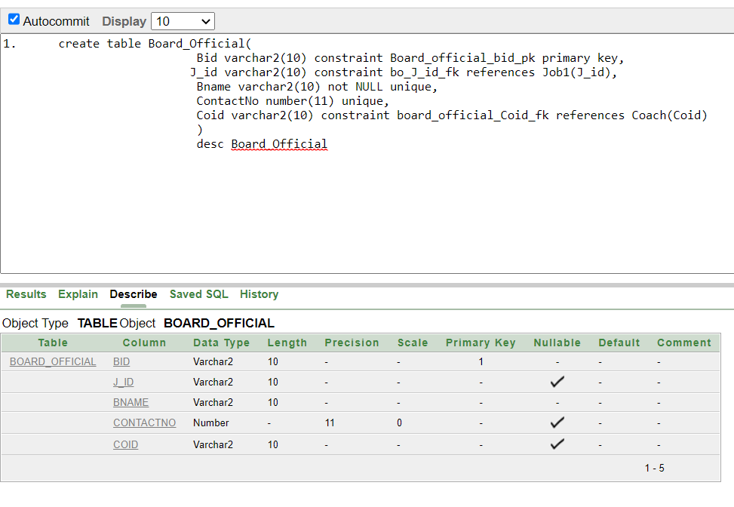

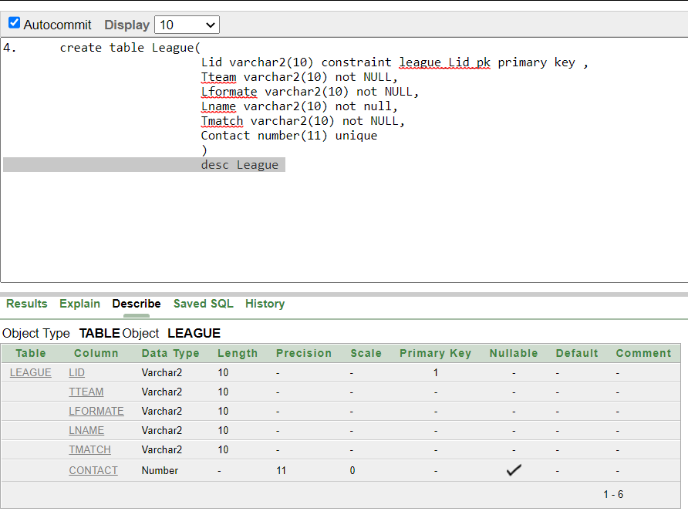

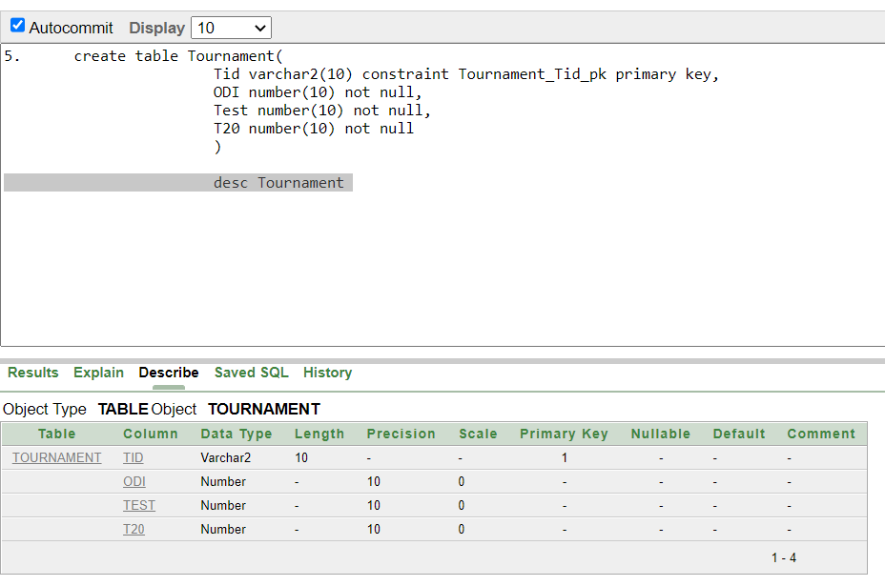

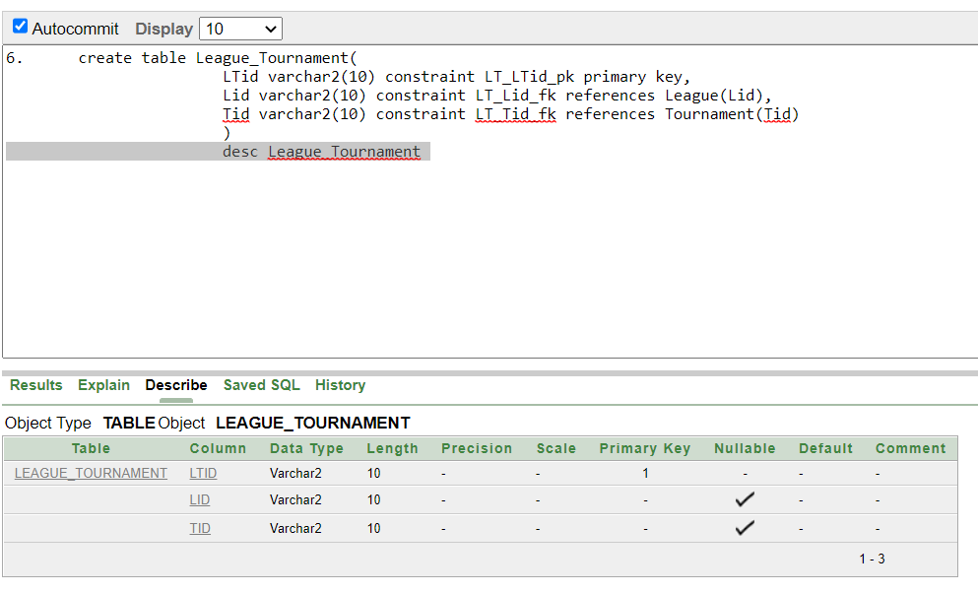

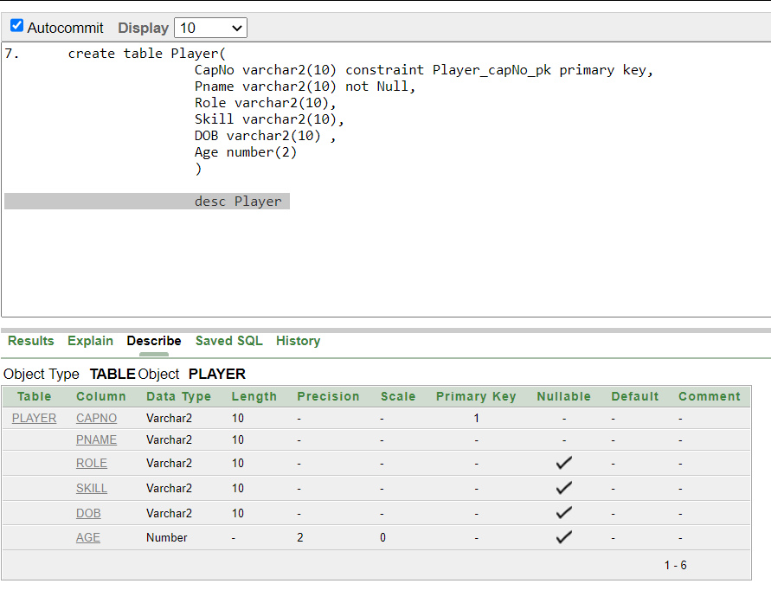

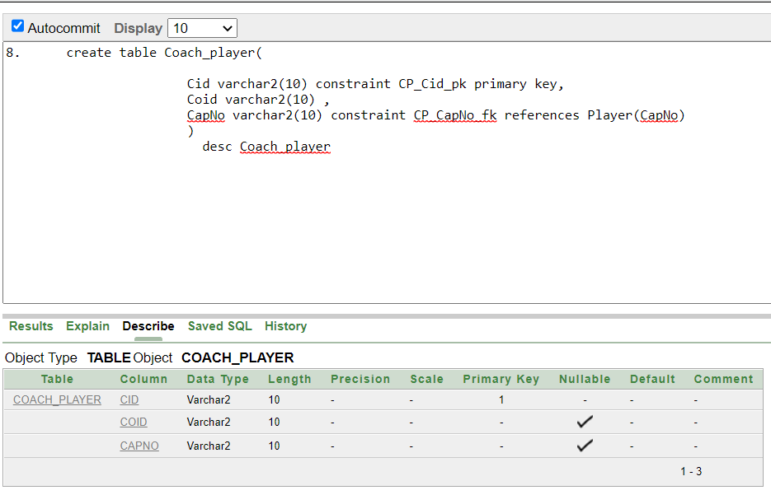

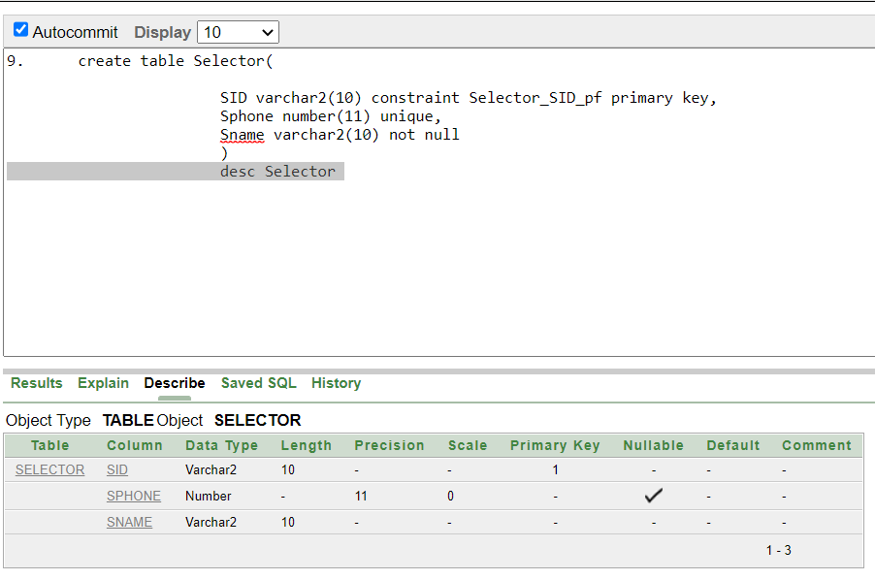

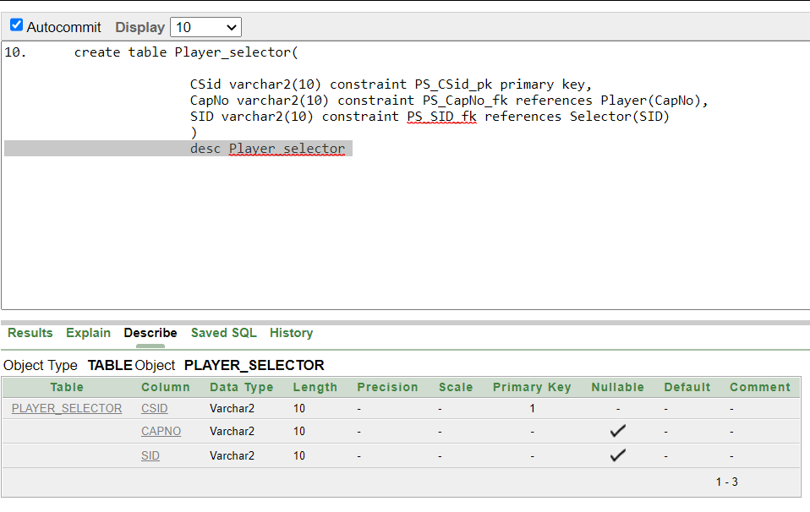

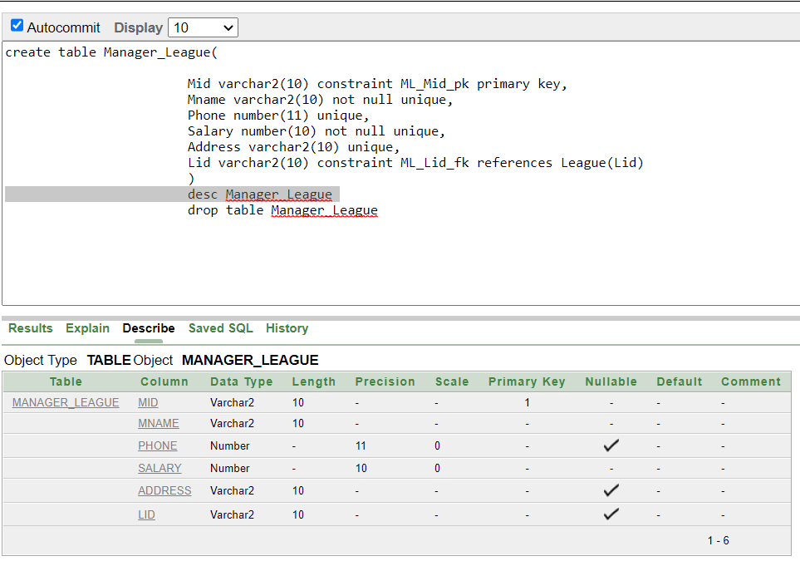

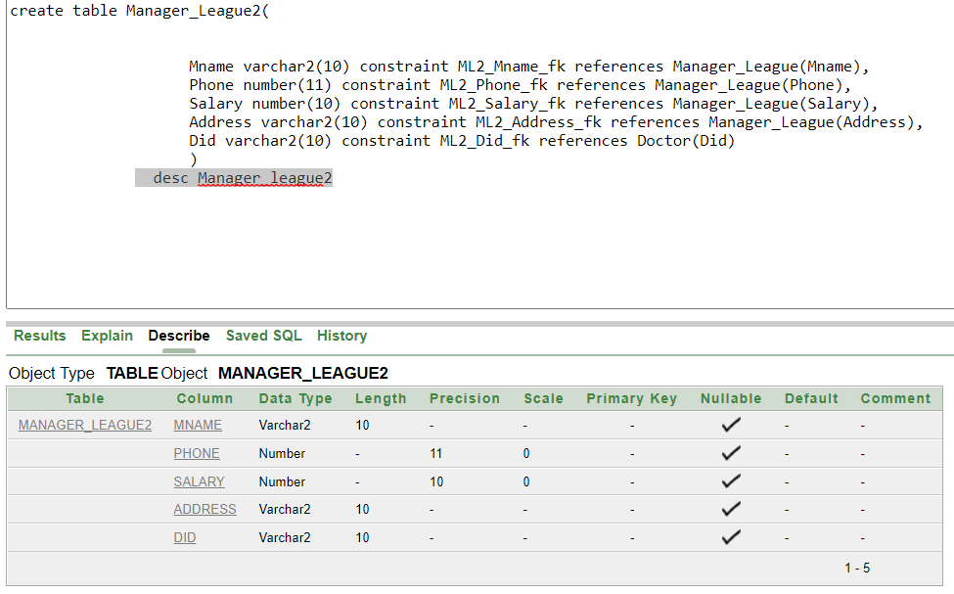

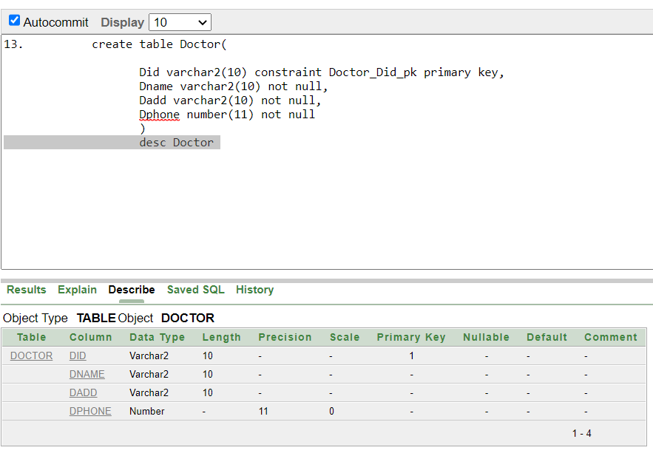

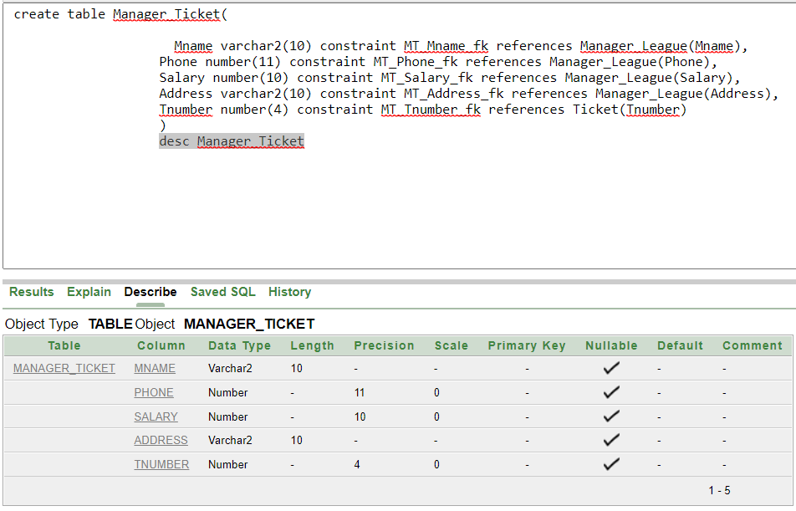

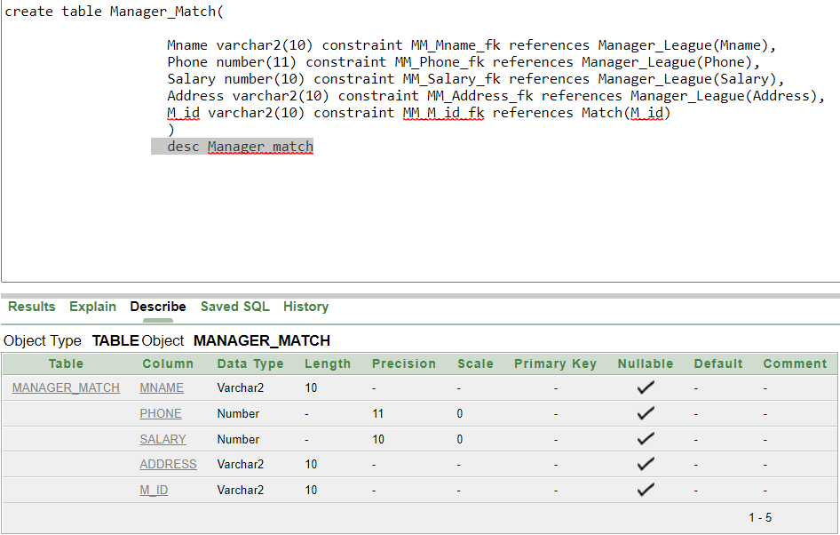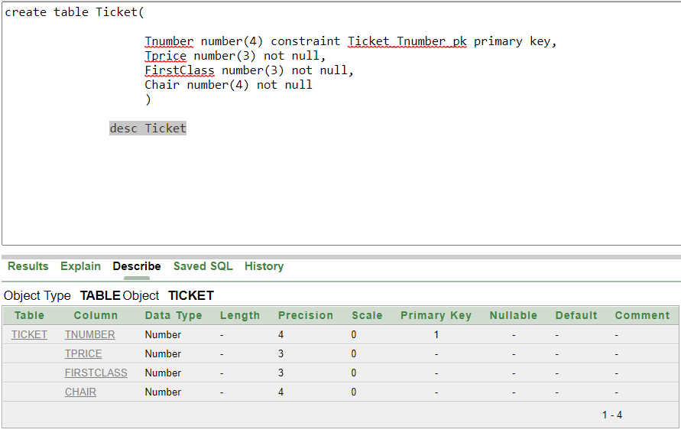

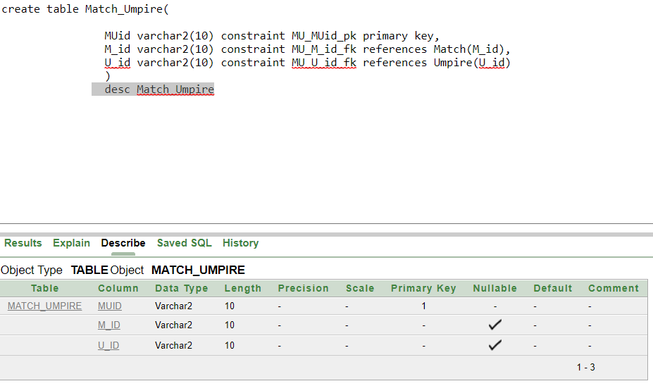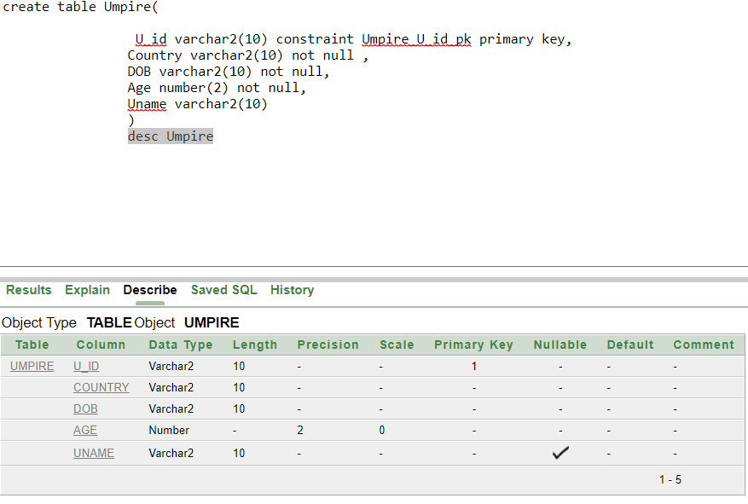

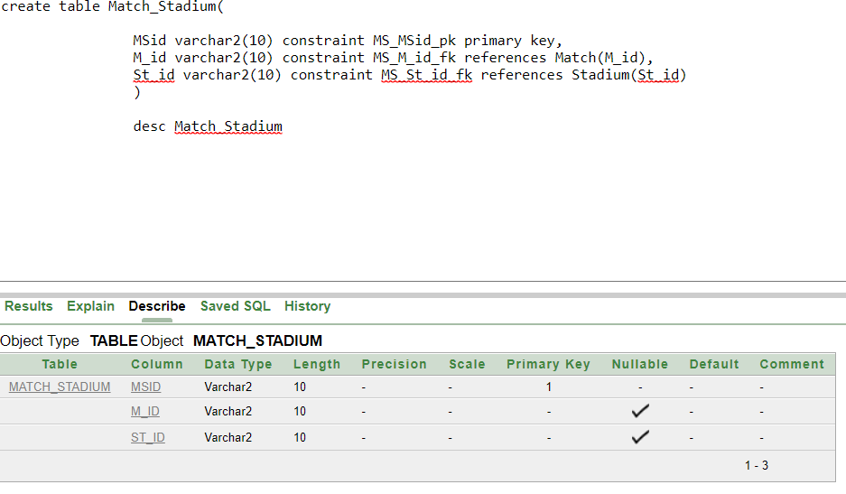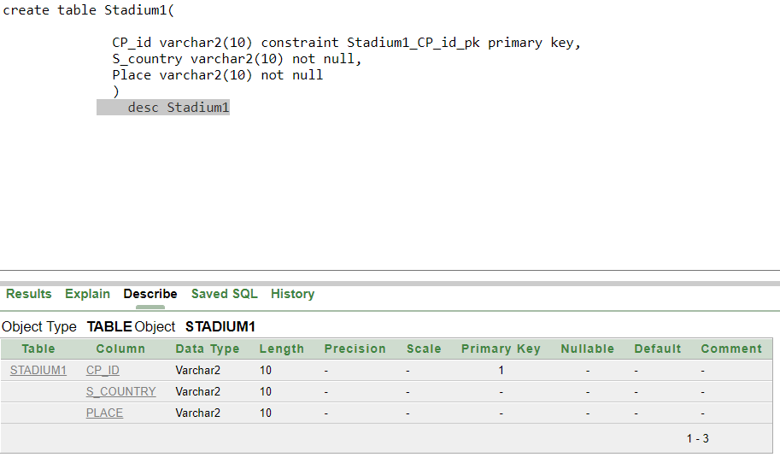

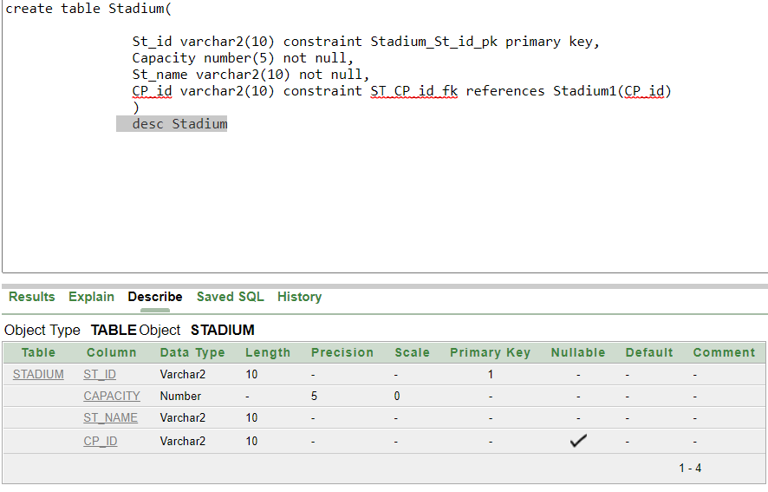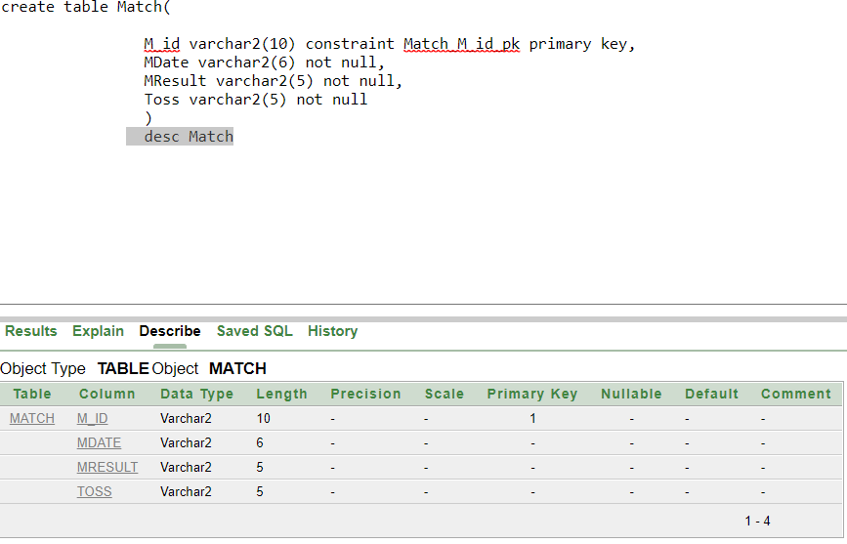

**Data Insertion with Screen Shot:**

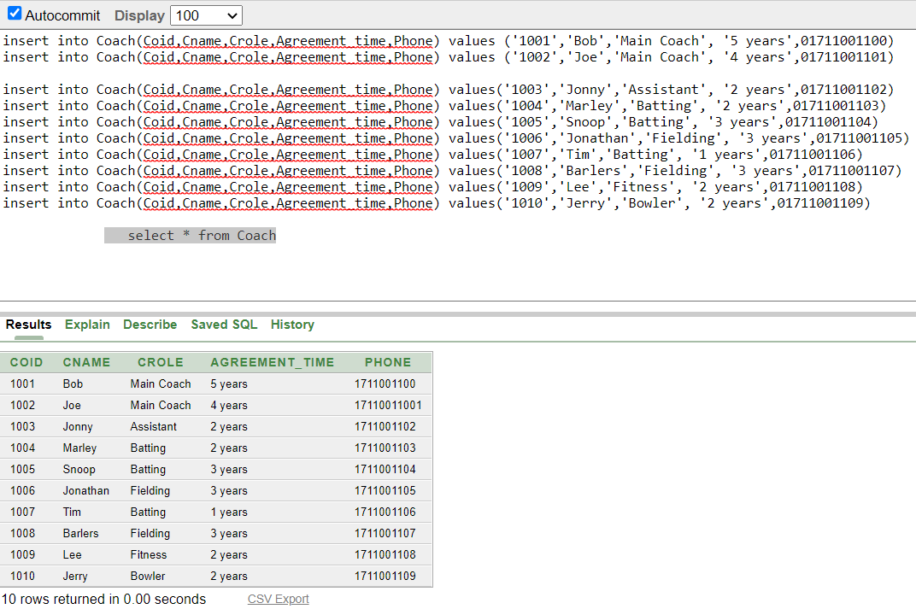

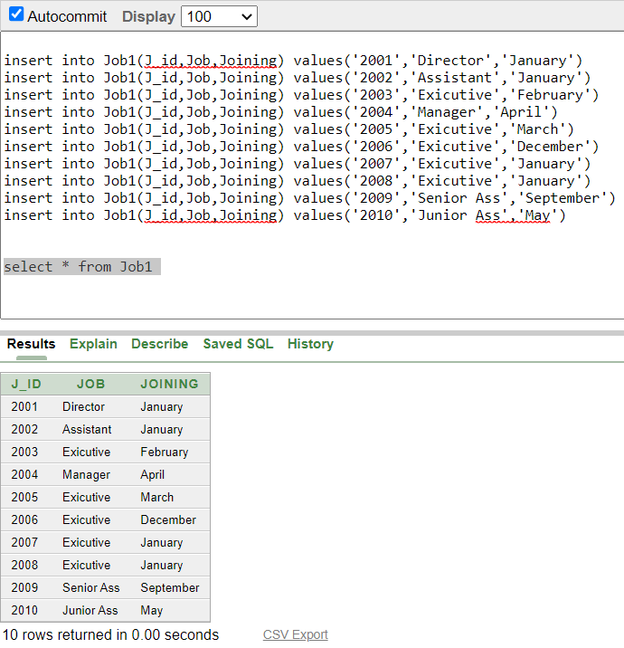

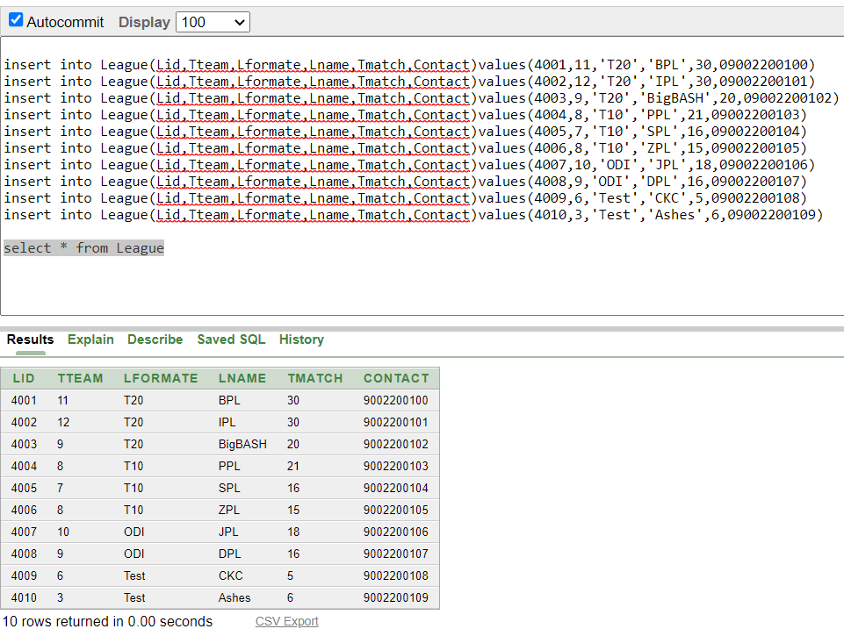

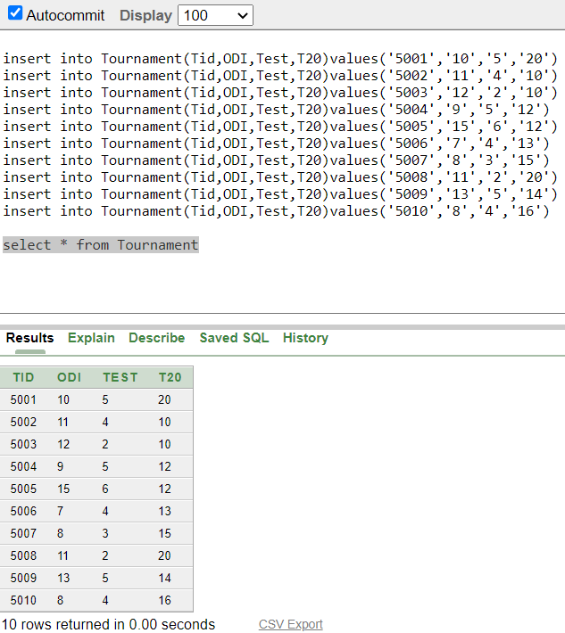

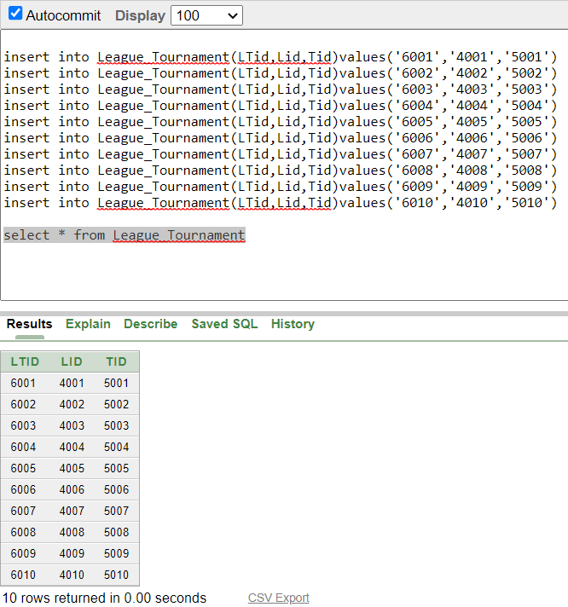

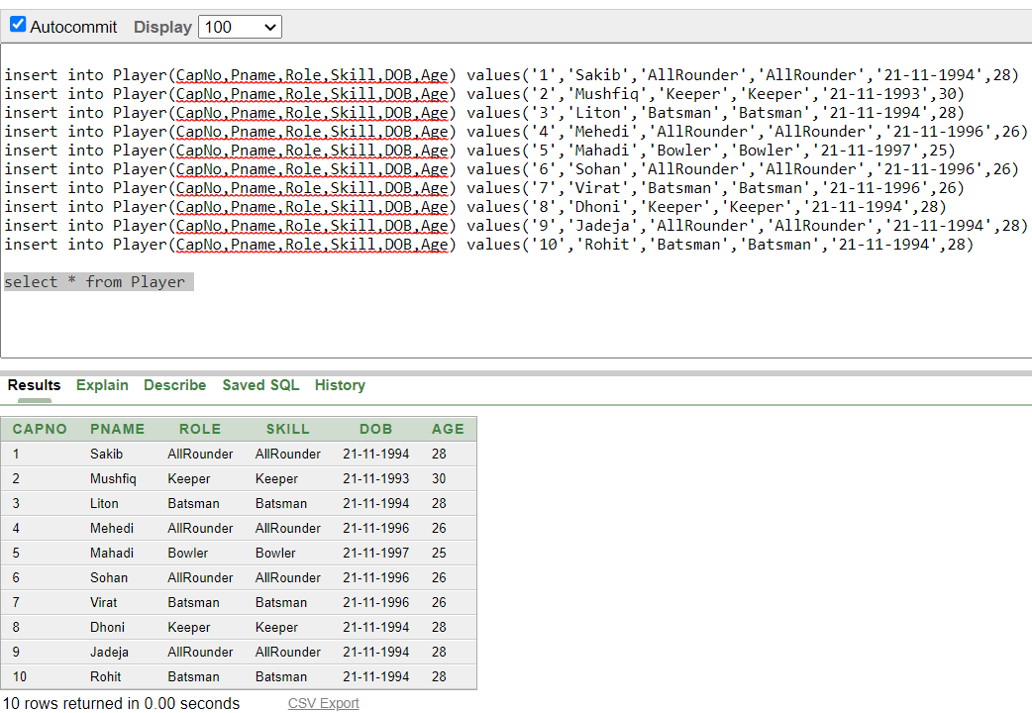

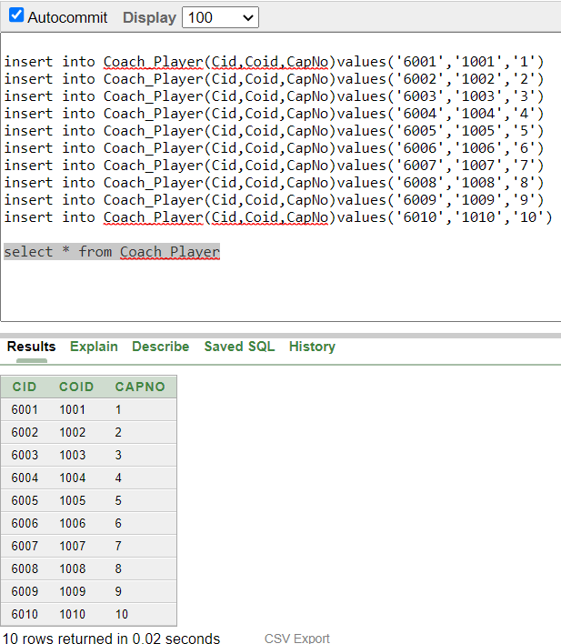

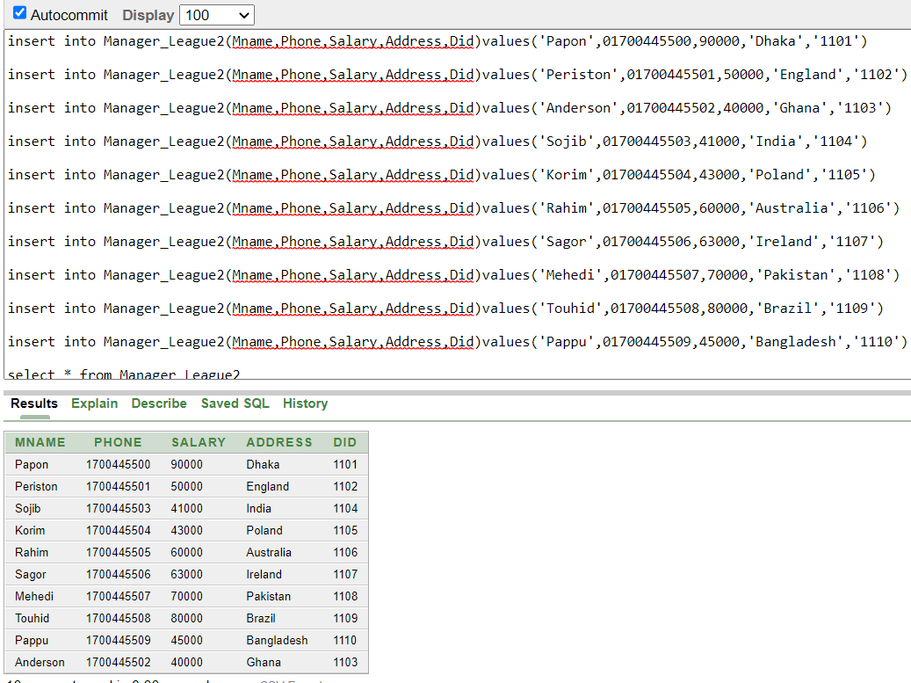

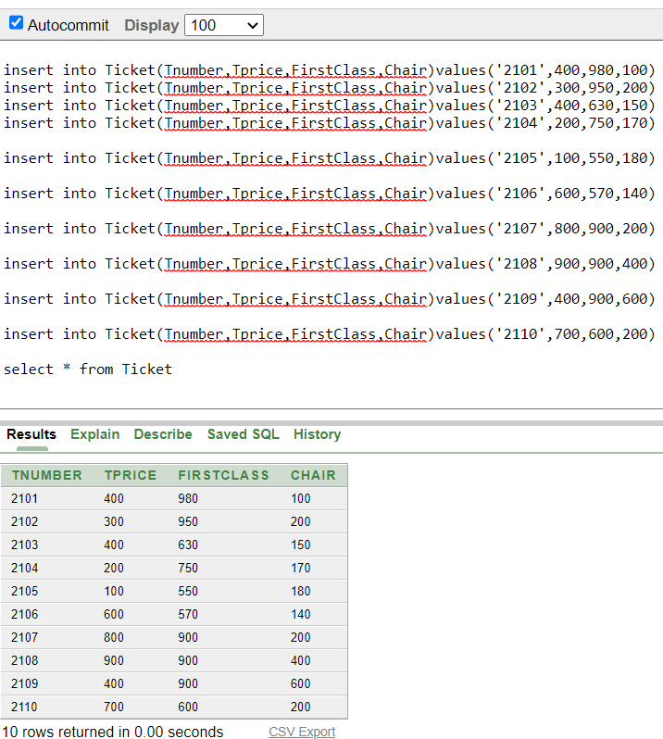

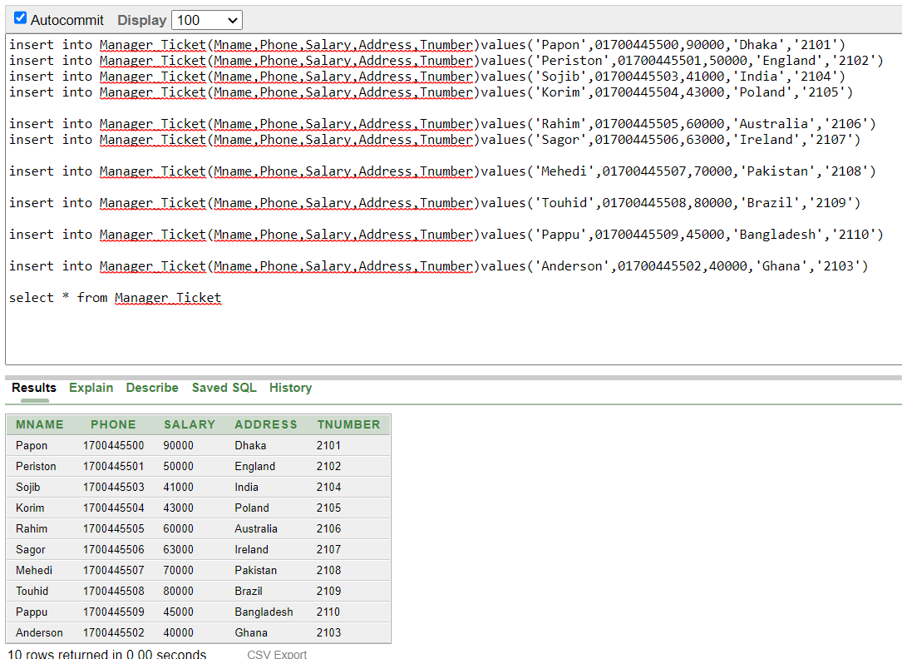

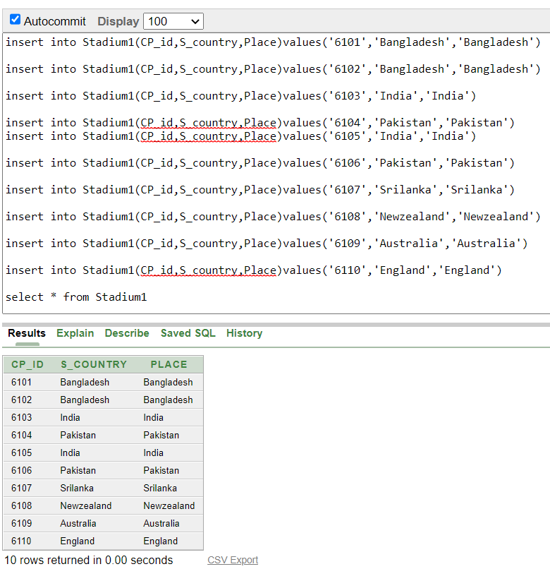

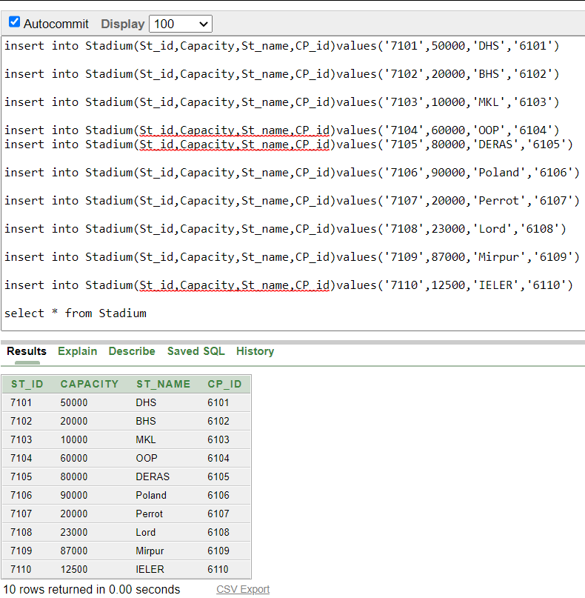

**General Query**

1.Display Coach ID, Coach name, Coach Agreement Time and Coach Phone number?

=>Select Coid,Cname,Agreement_time,Phone from Coach

2.Display Board Official ID,Board Name where Coach ID is 1003?

=> select Bid,Bname from Board_Official where Coid=’1003’

3.Display the number of ODI,Test and T20 series Tournament id is between 5001 and 5004?

=>select ODI,Test,T20 from Tournament where Tid between ‘5001’ and ‘5004’

4)Display Manager name, manager phone number, address and salary in descending order by salary?

=>select Mname,Phone,Address ,salary from Manager_league order by salary desc

5)Display Player name and Date of Birth who have the skill All rounder from age 25 to 26?

=>select Pname,DOB from Player where Skill like ‘%Batsman%’ and Age between 28 and 30

**View**

1.Create a view and display the Coach name,Coach ID,Coach Role and Phone number where agreement time is less than 3 years.

=>

Create or replace view Coach_Details

as

select c.Coid , c.Cname, c.Crole, c.Phone from Coach c where c.Agreement_time <’3 years’

select * from Coach_Details

**Group Function**

1.Display the total salary of the Manager

=>select sum(Salary) from Manager_League

2)Display the lowest and highest ticket price ?

=>select min(Tprice) ,max(Tprice) from Ticket

3)Display the number of League name in which there is at least an ‘L’?

=>select count(Lname) from League where Lname like ‘%L%’

4)Display the maximum capacity where Stadium Id is greater than 7103?

=>select max(Capacity) from Stadium where CP_id>’7103’

5)Display the average ticket price where ticket firstClass ticket in between 550 to 980?

=>select avg(Tprice) from Ticket where FirstClass between 550 and 980

**Single Row Function**

1.Display all the information of the Manager in uppercase where salary>60000?

=>select Mid,UPPER(Mname) , Phone,UPPER(Address) from Manager_League where Salary>60000

2.Display all information about the Doctor whose name is ‘osoa, altaf’

=>select * from Doctor where lower(Dname) =’osoa, altaf’

3.Display the Stadium name and the capacity concataning like ‘StadiumName has Capacity’

Select (ST_name ||’ ‘||’has’||’ ‘||capacity) from Stadium

4.Display the annual salary of the manager who lives in Ireland and also name the table annual salary

Select (salary*12)as Annual_Salary from Manager_Ticket where Address=’Ireland’

5.display the country length, Date of birth ,age and concat the umpire name and id

Select (Uname ||’ ‘||U_ID), length(country) as Country_Length, DOB,Age from Umpire

**Subquery**

1.Display the manager name and salary for all managers who earn more than manager number 9005

Select Mname,salary from Manager_League where salary>(select Mid from Manager_League where Mid=’9005’

2.Display the joining month and job of the Board officials who was joined after job number 2004

Select Job, Joining from Job1 where Joining >(select Joining from Job1 where J_id=’2004’)

3.Display the umpire name ,age ,date of birth for all umpires who lives in the same country whose umpire id is 4101

Select Uname,Age,DOB,U_id from Umpire where country in(select country

from Umpire where u_id=’4101’)

4.Display the Stadium id ,capacity ,stadium name where the capacity is greater than equal to the stadium name DHS,OOP and Lord

select st_id, capacity , st_name from Stadium where capacity>=any(select capacity from Stadium where st_name in ('DHS','OOP','Lord'))

5. Display Mname, phone, salary, address of all managers who have salary less then those managers who have 'P' at first of their name.

Select mname, phone, salary, address from manager_league2 where salary <all (select salary from manager_league2 where mname like 'P%')

**Sequence**

create sequence seriall increment by 1 start with 1111 maxvalue 2100 nocycle

insert into Stadium1(CP_id,S_country,Place)values(seriall.nextval,'Nepal','Nepal')

insert into Stadium1(CP_id,S_country,Place)values(seriall.nextval,'Argentina','Argentina')

select * from Stadium1 where place = ANY('Argentina','Argentina')

**Joining**

**Equivalent Joint:**

1.Display doctors id,dname,phone number along with managers name and phone number?

select d.did,d.dname,d.dphone,m.mname,[m.phone](http://m.phone) from doctor d, manager_league2 m where d.did=m.did

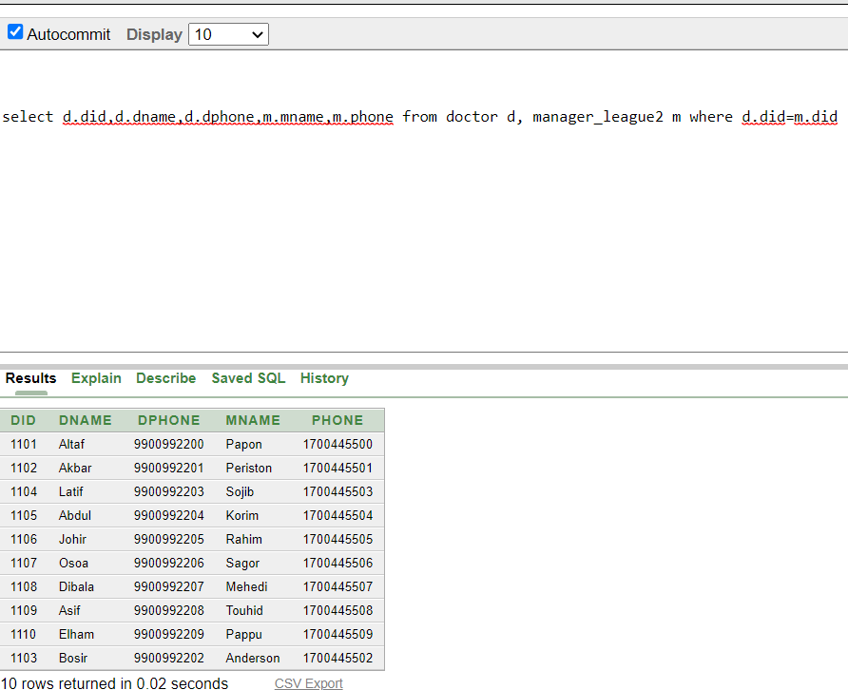

2.Display ticket no ,ticket price along with the manager name of all tickits?

select t.tnumber, t.tprice ,m.mname from ticket t ,manager_ticket m where t.tnumber=m.tnumber

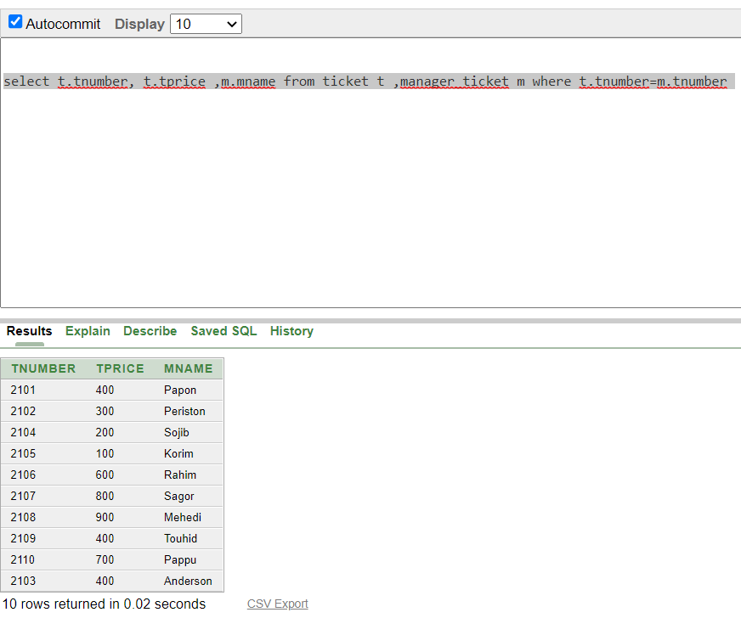

**Non Equivalent Joint:**

1.Display number of odi matches of a tournament where tournment id is more than league id?

select t.odi from tournament t, league_tournament l where t.tid=l.tid and t.tid>l.lid

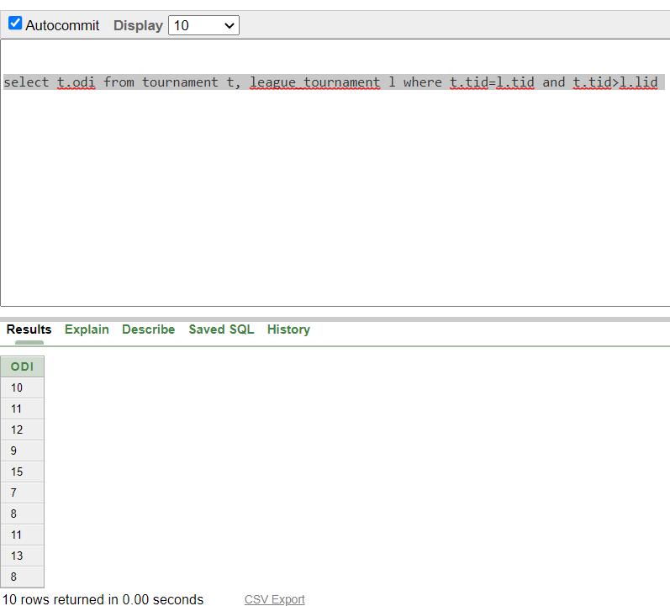

2.display number of captain when PlayerSelector_id is greater than selectors id?

select p.capNo from Player_selector p ,selector s where p.sid=s.sid and p.csid>s.sid

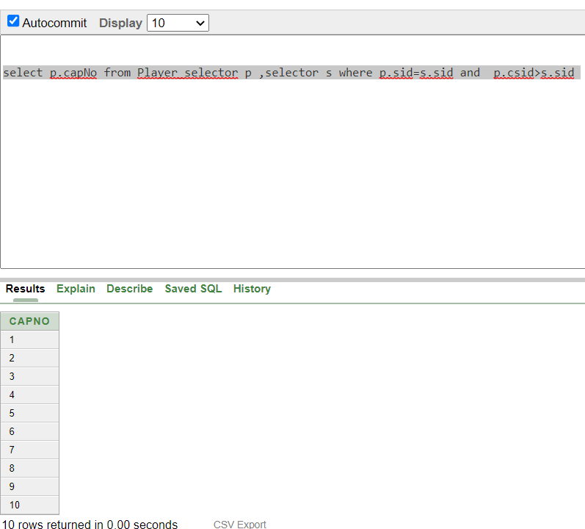

**Self Joint:**

1.display player naame,role and skill of those who has same role and skill?

select p.pname ,p.role, s.skill from player p,player s where p.capno=s.capno and p.role=s.skill

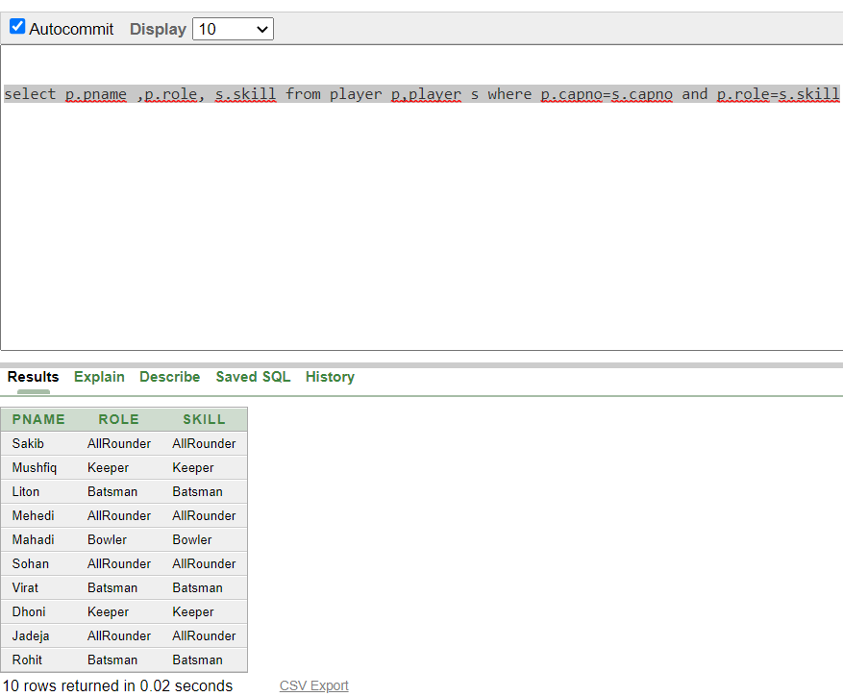

2.Display the match result and toss result of those matches win by winning tosses and lost by lossing tosses?

select a.mresult , b.toss from match a, match b where a.m_id=b.m_id and a.mresult=b.toss

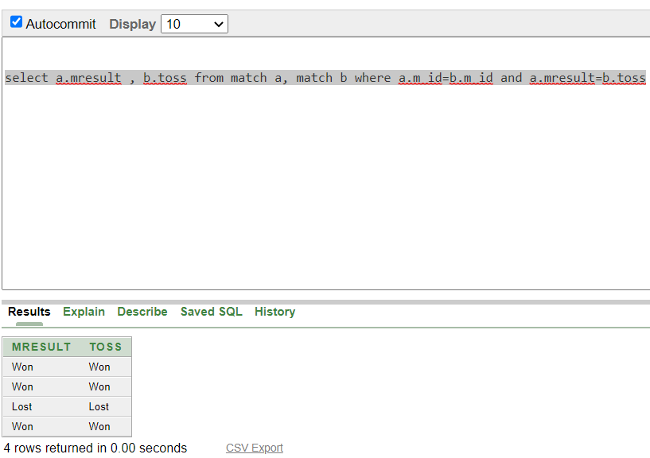

**Outer Joint:**

1.Display ticket number along with all managers name and address where manager salary is greater ticket price ?

select t.tnumber ,m.mname,m.address from ticket t, manager_ticket m where m.tnumber=t.tnumber(+) and m.salary>t.tprice

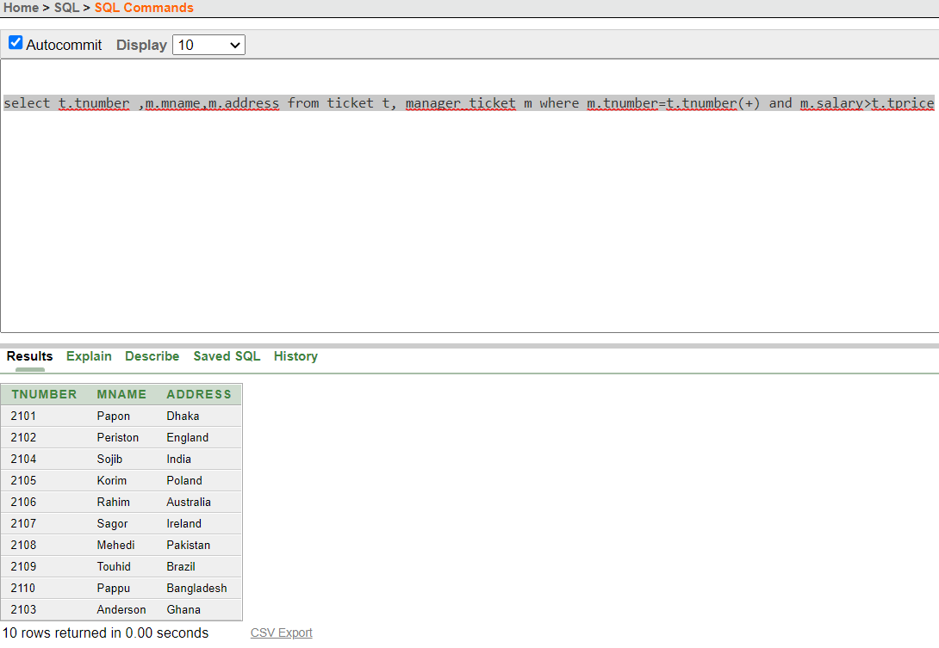

2.display all stadium info with match id?

select m.m_id,s.st_id,s.capacity,s.st_name,s.cp_id from stadium s ,match_stadium m where m.st_id(+)=s.st_id

