QuickDrop Route-Planning Module
Graph Modelling, Minimum Spanning Tree and Connectivity Analysis
Name | MD Hasibul Mahee Chowdhury
Student ID | 2025100000006
Batch / Section | Batch : 70, Section : 7
Course | CSE2417
Submission folder | 006_70
Program file | IsmailSirAssignment.cpp

Overview
QuickDrop delivers packages across a city. The road network is modelled as an undirected weighted graph G = (V, E): every node is a hub or customer location, every edge is a road, and every edge weight is the distance in km. This report covers three tasks: (1) design of a 22-location network, (2) a Minimum Spanning Tree (MST) for fibre-cable layout using Kruskal's algorithm, and (3) a BFS-based connectivity check from the warehouse.

Task 1: City Network Design

1.1 Locations (nodes)
ID | Location | ID | Location
0 | Warehouse | 11 | Mohakhali
1 | Mirpur Hub | 12 | Badda
2 | Gulshan-2 | 13 | Rampura
3 | Banani | 14 | Khilgaon
4 | Uttara | 15 | Jatrabari
5 | Dhanmondi | 16 | Airport Checkpoint
6 | Mohammadpur | 17 | Bashundhara
7 | Farmgate | 18 | Shahbagh
8 | Motijheel | 19 | Malibagh
9 | Old Dhaka | 20 | Lalbagh
10 | Tejgaon | 21 | Gulistan

Node 0 (Warehouse) is the main depot. Airport Checkpoint (16) and Bashundhara (17) act as checkpoints; the remaining nodes are neighbourhood hubs. V = 22.

1.2 Roads (edges) with distances
# | Road | km | # | Road | km
1 | Warehouse – Mirpur Hub | 8 | 23 | Farmgate – Mohakhali | 5
2 | Warehouse – Mohammadpur | 5 | 24 | Farmgate – Shahbagh | 6
3 | Warehouse – Farmgate | 3 | 25 | Motijheel – Old Dhaka | 4
4 | Warehouse – Tejgaon | 4 | 26 | Motijheel – Shahbagh | 3
5 | Mirpur Hub – Uttara | 9 | 27 | Motijheel – Malibagh | 5
6 | Mirpur Hub – Mohammadpur | 4 | 28 | Motijheel – Gulistan | 2
7 | Mirpur Hub – Farmgate | 6 | 29 | Old Dhaka – Lalbagh | 3
8 | Mirpur Hub – Airport Checkpoint | 7 | 30 | Old Dhaka – Gulistan | 3
9 | Gulshan-2 – Banani | 2 | 31 | Tejgaon – Mohakhali | 3
10 | Gulshan-2 – Mohakhali | 3 | 32 | Mohakhali – Rampura | 7
11 | Gulshan-2 – Badda | 5 | 33 | Mohakhali – Airport Checkpoint | 6
12 | Gulshan-2 – Bashundhara | 6 | 34 | Badda – Rampura | 3
13 | Banani – Mohakhali | 2 | 35 | Badda – Bashundhara | 4
14 | Banani – Airport Checkpoint | 4 | 36 | Rampura – Khilgaon | 5
15 | Uttara – Airport Checkpoint | 5 | 37 | Rampura – Malibagh | 4
16 | Uttara – Bashundhara | 8 | 38 | Khilgaon – Jatrabari | 4
17 | Dhanmondi – Mohammadpur | 3 | 39 | Khilgaon – Malibagh | 3
18 | Dhanmondi – Farmgate | 4 | 40 | Jatrabari – Motijheel | 6
19 | Dhanmondi – Shahbagh | 5 | 41 | Jatrabari – Gulistan | 5
20 | Dhanmondi – Lalbagh | 7 | 42 | Airport Checkpoint – Bashundhara | 7
21 | Mohammadpur – Lalbagh | 8 | 43 | Shahbagh – Malibagh | 4
22 | Farmgate – Tejgaon | 2 | 44 | Lalbagh – Gulistan | 4

|E| = 44 roads. The graph is undirected (a road can be driven both ways) and connected, so every location can be reached from every other location.

1.3 Graph representation
- Graph type: undirected, weighted, simple, connected graph. Weights are positive integers (km).
- Adjacency matrix adjM[22][22] — adjM[u][v] = distance, 0 if no direct road. Gives O(1) road lookup and is used by BFS in the program.
- Edge list (eu[], ev[], ew[]) — the natural input for Kruskal because the edges must be sorted by weight.
- Adjacency list (printed by the program) — the compact view of neighbours for each location, shown below for the first few nodes.
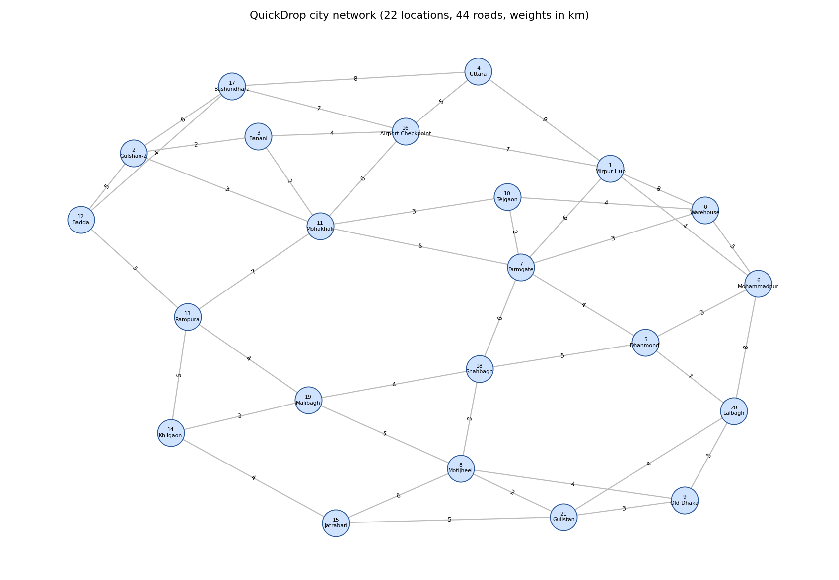
Figure 1: QuickDrop city network

Task 2: Minimum Spanning Tree (Kruskal's Algorithm)
Goal: connect all 22 hubs with the minimum total fibre length, using existing roads as candidate cable routes. A spanning tree of 22 nodes has exactly 21 edges; the MST is the one with the smallest total weight.

2.1 Algorithm
1. Sort all edges by weight in ascending order (stable insertion sort in the program).
2. Make every node its own set (Union-Find: parent[i] = i, rank[i] = 0).
3. Take the next smallest edge (u, v). If find(u) ≠ find(v), ACCEPT it, union the two sets and add the weight to the total. Otherwise REJECT it, because it would form a cycle.
4. Stop when n − 1 = 21 edges are accepted.
Complexity: O(E log E) with efficient sorting (the program uses O(E²) insertion sort, which is fine for E = 44); Union-Find operations are nearly O(1). Space O(V + E).

2.2 Code walkthrough
Code line
int findSet(int x) {
if (dsuParent[x] == x) {
return x;
} else {
dsuParent[x] = findSet(dsuParent[x]);
return dsuParent[x];
bool unionSets(int a, int b) {
int ra = findSet(a); int rb = findSet(b);
if (ra == rb) { return false; }
if (dsuRank[ra] < dsuRank[rb]) dsuParent[ra] = rb;
else if (dsuRank[ra] > dsuRank[rb]) dsuParent[rb] = ra;
else { dsuParent[rb] = ra; dsuRank[ra]++; }
sortEdgesByWeight();
for (i = 0; i < m; i++) {
if (mstCount == n - 1) { ... break; }
int ra = findSet(eu[i]); int rb = findSet(ev[i]);
if (ra != rb) { unionSets(...); ... totalCost += ew[i]; }
else { cout << "REJECT (cycle)"; }

2.3 Step-by-step demonstration
Sorted order (E1…E44) is listed first by the program; the table below shows each decision. "Roots" are the Union-Find representatives of the two endpoints before the decision.
Step | Edge considered | km | Roots | Decision | Running total (km)
1 | Gulshan-2 – Banani | 2 | 2, 3 | Accept | 2
2 | Banani – Mohakhali | 2 | 2, 11 | Accept | 4
3 | Farmgate – Tejgaon | 2 | 7, 10 | Accept | 6
4 | Motijheel – Gulistan | 2 | 8, 21 | Accept | 8
5 | Warehouse – Farmgate | 3 | 0, 7 | Accept | 11
6 | Gulshan-2 – Mohakhali | 3 | 2, 2 | Reject (cycle) | –
7 | Dhanmondi – Mohammadpur | 3 | 5, 6 | Accept | 14
8 | Motijheel – Shahbagh | 3 | 8, 18 | Accept | 17
9 | Old Dhaka – Lalbagh | 3 | 9, 20 | Accept | 20
10 | Old Dhaka – Gulistan | 3 | 9, 8 | Accept | 23
11 | Tejgaon – Mohakhali | 3 | 7, 2 | Accept | 26
12 | Badda – Rampura | 3 | 12, 13 | Accept | 29
13 | Khilgaon – Malibagh | 3 | 14, 19 | Accept | 32
14 | Warehouse – Tejgaon | 4 | 7, 7 | Reject (cycle) | –
15 | Mirpur Hub – Mohammadpur | 4 | 1, 5 | Accept | 36
16 | Banani – Airport Checkpoint | 4 | 7, 16 | Accept | 40
17 | Dhanmondi – Farmgate | 4 | 5, 7 | Accept | 44
18 | Motijheel – Old Dhaka | 4 | 9, 9 | Reject (cycle) | –
19 | Badda – Bashundhara | 4 | 12, 17 | Accept | 48
20 | Rampura – Malibagh | 4 | 12, 14 | Accept | 52
21 | Khilgaon – Jatrabari | 4 | 12, 15 | Accept | 56
22 | Shahbagh – Malibagh | 4 | 9, 12 | Accept | 60
23 | Lalbagh – Gulistan | 4 | 9, 9 | Reject (cycle) | –
24 | Warehouse – Mohammadpur | 5 | 7, 7 | Reject (cycle) | –
25 | Gulshan-2 – Badda | 5 | 7, 9 | Accept | 65
26 | Uttara – Airport Checkpoint | 5 | 4, 9 | Accept | 70

Steps 6, 14, 18, 23 and 24 are rejected because both endpoints are already in the same set. For example, in Step 6, Gulshan-2 – Mohakhali (3 km) is rejected because Gulshan-2 and Mohakhali were already connected via Banani in Steps 1–2. After Step 26 the 21st edge is accepted and the algorithm stops; the remaining 18 edges are skipped.

2.4 Selected edges and total cost
# | From | To | Distance (km)
1 | Gulshan-2 | Banani | 2
2 | Banani | Mohakhali | 2
3 | Farmgate | Tejgaon | 2
4 | Motijheel | Gulistan | 2
5 | Warehouse | Farmgate | 3
6 | Dhanmondi | Mohammadpur | 3
7 | Motijheel | Shahbagh | 3
8 | Old Dhaka | Lalbagh | 3
9 | Old Dhaka | Gulistan | 3
10 | Tejgaon | Mohakhali | 3
11 | Badda | Rampura | 3
12 | Khilgaon | Malibagh | 3
13 | Mirpur Hub | Mohammadpur | 4
14 | Banani | Airport Checkpoint | 4
15 | Dhanmondi | Farmgate | 4
16 | Badda | Bashundhara | 4
17 | Rampura | Malibagh | 4
18 | Khilgaon | Jatrabari | 4
19 | Shahbagh | Malibagh | 4
20 | Gulshan-2 | Badda | 5
21 | Uttara | Airport Checkpoint | 5

Total MST cost = 70 km (21 edges, all 22 hubs connected).
Verification: the same graph was checked independently with a library MST (NetworkX); it also gives 70 km. Because several edges share the same weight, an alternative MST with different edges but the same 70 km total can exist.
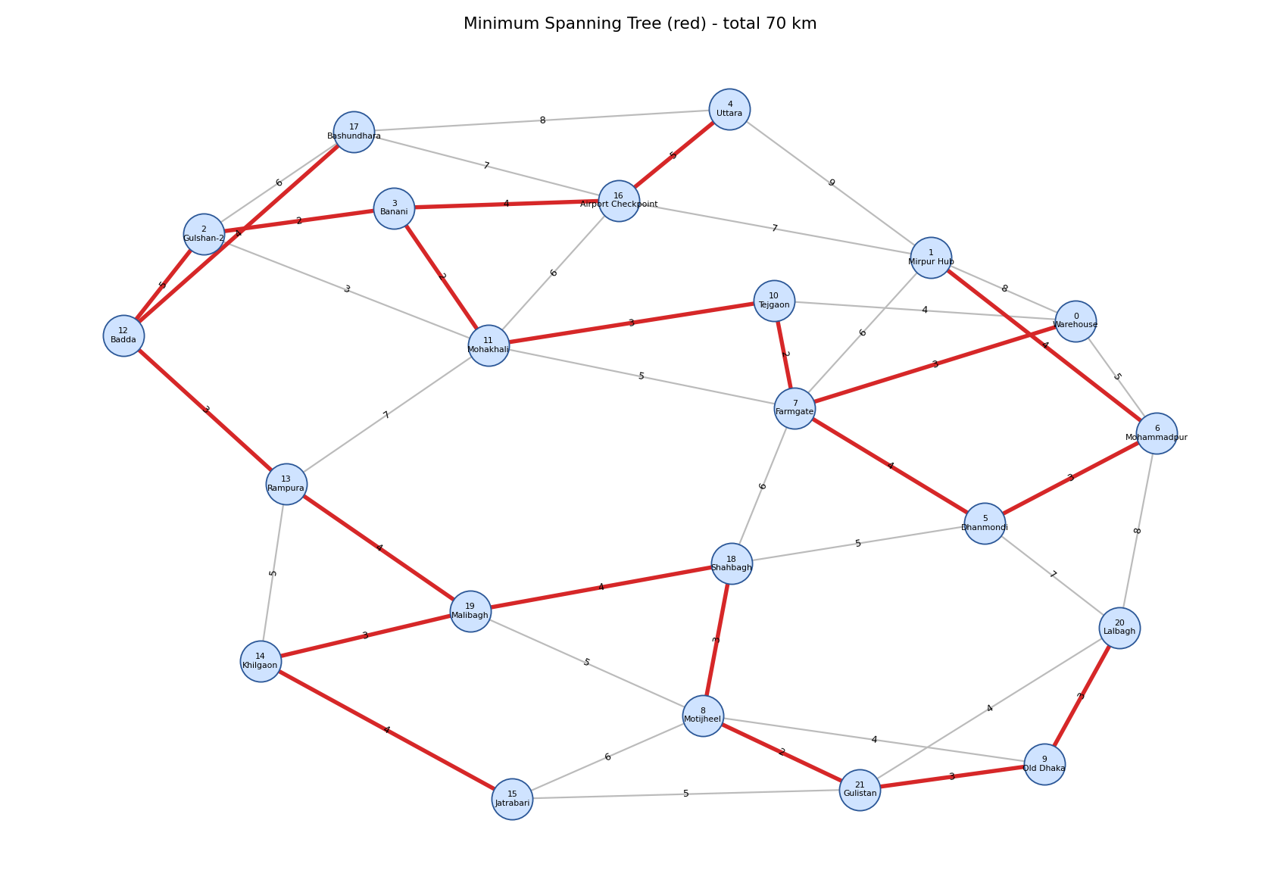
Figure 2: MST edges highlighted in red (total 70 km)

Task 3: Connectivity Check using BFS
Goal: before assigning a new delivery zone, check whether every location is reachable from the Warehouse and report isolated areas. BFS from the Warehouse visits exactly the locations in its connected component; any unvisited node is unreachable. Complexity: O(V²) with the adjacency matrix (O(V + E) with an adjacency list).

3.1 Algorithm
1. Mark all nodes unvisited; dist = −1.
2. Mark the Warehouse visited (dist = 0) and push it into the queue.
3. Pop the front node u. For every neighbour v of u that is unvisited: mark visited, dist[v] = dist[u] + 1, push v.
4. Repeat until the queue is empty.
5. If visited count = n, all locations are reachable. Otherwise print every unvisited node as isolated.

3.2 Code walkthrough (line-by-line, Bengali)
Code line
bool visited[MAXN]; int dist[MAXN]; int q[MAXN];
for (...) { visited[i]=false; dist[i]=-1; }
visited[source]=true; dist[source]=0;
q[back]=source; back++;
while (front < back) {
u = q[front]; front++;
for (v = 0; v < n; v++) {
if (adjM[u][v] != 0) {
if (visited[v] == false) {
visited[v]=true; dist[v]=dist[u]+1; push v
if (visitedCount == n)
else { print every visited[i]==false }

3.3 Test A: current network
Order | Location visited | Hops from Warehouse
1 | Warehouse | 0
2 | Mirpur Hub | 1
3 | Mohammadpur | 1
4 | Farmgate | 1
5 | Tejgaon | 1
6 | Uttara | 2
7 | Airport Checkpoint | 2
8 | Dhanmondi | 2
9 | Lalbagh | 2
10 | Mohakhali | 2
11 | Shahbagh | 2
12 | Bashundhara | 3
13 | Banani | 3
14 | Old Dhaka | 3
15 | Gulistan | 3
16 | Gulshan-2 | 3
17 | Rampura | 3
18 | Motijheel | 3
19 | Malibagh | 3
20 | Badda | 4
21 | Jatrabari | 4
22 | Khilgaon | 4

Result: 22 / 22 locations reachable. All locations can be reached from the Warehouse; the farthest hubs (Badda, Jatrabari, Khilgaon) are 4 hops away. No isolated area exists.

3.4 Test B: two new zones with no connecting road
To demonstrate isolation detection, two candidate zones, Keraniganj Zone and Purbachal Zone, are added with a 6 km road between themselves but no road to the main network (n becomes 24).
The BFS visit order and hop counts for the first 22 nodes are identical to Test A. The program then reports:

So the two new zones form their own connected component and are correctly detected as isolated: QuickDrop must build a road/route link before assigning them as delivery zones.

Conclusion
- Task 1: a connected weighted graph of 22 locations and 44 roads was designed and represented with an edge list, adjacency matrix and adjacency list.
- Task 2: Kruskal's algorithm selected 21 roads for fibre cable, with minimum total length 70 km (verified independently).
- Task 3: BFS from the Warehouse confirmed full reachability (22/22) and detected the two disconnected zones in the test case.

