PREDICTIVE ANALYTICS

For
Bachelor of Technology
In
Computer Science and Engineering

Predicting Building Damage Severity from Earthquakes Using Structural and Geographic Features: A KDD-Based Predictive Analytics Approach

Continuous Assessment 3 (CA3)
End-to-End Predictive Model Development Project Report

Submitted by
MAHEEN RAJESH MESHRAM
PRN : 23070521085
Semester : VII
Year : 4
Section : B

Subject Faculty
Dr. Deepak Asudani
Faculty In-charge

October 2026
ABSTRACT
This project applies the complete Knowledge Discovery in Databases (KDD) process to a disaster-resilience problem: predicting how badly a building will be damaged by a major earthquake using only information that is available before the earthquake strikes. The data comes from the household survey conducted after the Mw 7.8 Gorkha earthquake of 25 April 2015 in Nepal, released through the 2015 Nepal Earthquake Open Data Portal and distributed as the DrivenData Richter's Predictor dataset. It describes 260,601 buildings through 38 attributes covering structure, construction material, land condition, ownership, use and a three-level geographic hierarchy, and labels each building with a damage grade of 1 (low), 2 (medium) or 3 (near-complete destruction).
Every KDD stage is carried out and documented in a reproducible Jupyter notebook. Data understanding revealed an imbalanced target (9.6% / 56.9% / 33.5%), a sentinel age value of 995 years affecting 1,390 buildings, and 3,825 groups of buildings that are identical in all 38 features yet received different damage grades, which places a ceiling on achievable accuracy. Chi-square and Kruskal–Wallis tests, with Cramér's V as the effect size, showed that region, mud-mortar stone construction, foundation, roof and floor types carry the strongest association with damage. Eight domain features were engineered, the data was split 80/20 with stratification before any target-dependent step, and the three high-cardinality region identifiers (31, 1,414 and 11,595 levels) were target-encoded with internal cross-fitting so that no label leaks into its own encoding.
Six models were compared on a held-out test set of 52,121 buildings. Against a majority-class baseline of 0.5689 micro-F1, Logistic Regression reached 0.7392, a Decision Tree 0.7297, and the three tree ensembles — Random Forest, XGBoost and LightGBM — clustered between 0.7513 and 0.7527. LightGBM was tuned in two stages: a randomised search on a 60,000-row sample, followed by confirmation of the leading configurations with 3-fold cross-validation on the full training set. The final model scores 0.7514 micro-F1 and 0.7021 macro-F1 on the test set, an improvement of 18.2 percentage points over the baseline, and only 0.33% of its errors confuse grade 1 with grade 3. Class weighting and SMOTE raised grade-1 recall from 54.5% to as much as 85.1% but lowered micro-F1, a trade-off the report documents rather than hides.
Interpretation with gain importance and SHAP shows that location dominates: the nine target-encoded region columns account for 77.1% of the model's split gain. Mud-mortar stone construction is the most vulnerable common building type, with a 40.5% destruction rate, while engineered reinforced-concrete buildings are destroyed in fewer than 2% of cases. The model's predicted destruction rates match actual rates per construction profile within about one percentage point and correlate at 0.998 with actual rates across regions, so its probabilities are usable for ranking areas and building types for inspection and retrofitting. The report closes with the limitations of the data — most importantly the absence of ground-shaking intensity — and recommendations for its use.
Key figures for the abstract:
Table 1: Key figures of the project
Quantity | Value
Buildings in the dataset | 260,601 (38 features + damage grade)
Target distribution | Grade 1: 9.64% · Grade 2: 56.89% · Grade 3: 33.47%
Train / test split | 208,480 / 52,121 buildings, stratified
Features after transformation | 83 (incl. 9 target-encoded region columns)
Models compared | Dummy, Logistic Regression, Decision Tree, Random Forest, XGBoost, LightGBM
Final model | LightGBM, two-stage tuned (stage-1 rank 2)
Test micro-F1 / macro-F1 | 0.7514 / 0.7021
Gain over majority baseline | +18.2 percentage points
Grade 1 ↔ grade 3 confusions | 173 of 52,121 (0.33%)
Share of gain from region features | 77.1%
Most vulnerable building type | Mud-mortar stone only — 40.5% destroyed

CONTENTS
Sr. No. | Topic | Page No.
 | ABSTRACT | 2
 | TABLE OF FIGURES | 6
 | TABLE OF TABLES | 7
1 | INTRODUCTION | 8
 | 1.1 Domain Context | 8
 | 1.2 Problem Statement | 8
 | 1.3 Objectives | 9
 | 1.4 Scope and Boundaries | 9
 | 1.5 Organisation of the Report | 10
2 | LITERATURE REVIEW | 11
 | 2.1 Conventional Seismic Vulnerability Assessment | 11
 | 2.2 The 2015 Gorkha Earthquake and Its Damage Data | 11
 | 2.3 Machine Learning for Earthquake Damage Prediction | 12
 | 2.4 Techniques Used in This Project | 12
 | 2.5 The KDD Process | 13
 | 2.6 Summary of Literature and Research Gap | 13
3 | WORKFLOW / PREDICTIVE MODELLING PROCESS | 14
 | 3.1 Overview of the KDD Workflow | 14
 | 3.2 Data Selection | 14
 | 3.3 Data Understanding | 15
 | 3.4 Data Preprocessing | 16
 | 3.5 Exploratory Data Analysis and Hypothesis Testing | 17
 | 3.6 Feature Engineering | 20
 | 3.7 Data Partitioning and Transformation | 21
 | 3.8 Model Building | 21
 | 3.9 Class-Imbalance Handling | 22
 | 3.10 Hyperparameter Tuning | 22
 | 3.11 Toolchain and Reproducibility | 22
4 | RESULTS AND DISCUSSION | 24
 | 4.1 Model Comparison | 24
 | 4.2 Effect of Class-Imbalance Handling | 25
 | 4.3 Hyperparameter Tuning Results | 26
 | 4.4 Evaluation of the Final Model | 26
 | 4.5 Generalisation | 27
 | 4.6 Model Interpretation | 27
 | 4.7 Knowledge Discovery | 30
 | 4.8 Discussion and Limitations | 31
5 | CONCLUSION | 33
 | 5.1 Recommendations | 33
 | 5.2 Future Scope | 34
 | REFERENCES | 35
 | APPENDIX A — GITHUB REPOSITORY STRUCTURE | 37
 | APPENDIX B — FEATURE DICTIONARY | 38
 | AI Report | 39
 | Plagiarism Report | 40

TABLE OF FIGURES
Fig No. | Figure Name | Page No.
1 | End-to-end KDD workflow followed in the project, fourteen steps in five stage groups | 14
2 | Distribution of the target variable, damage grade | 16
3 | Box plots of the numeric features before outlier treatment | 17
4 | Share of grade 1 and grade 3 outcomes by superstructure material | 18
5 | Damage grade composition by building age band and by number of floors | 19
6 | Damage grade composition by foundation type and roof type | 19
7 | Mean damage grade by top-level region (geo_level_1_id) | 19
8 | Strength of association with damage grade, Cramér's V from chi-square tests | 20
9 | Micro-F1 and macro-F1 of each model against the majority-class baseline | 25
10 | Confusion matrix of the final model: counts (left) and row-normalised recall (right) | 27
11 | Top fifteen features of the final model by share of total split gain | 28
12 | SHAP summary for the grade 3 (destruction) output of the final model | 29
13 | SHAP summary for the grade 1 (low damage) output of the final model | 29
14 | Predicted against actual destruction risk by construction profile | 30

TABLE OF TABLES
Table No. | Table Name | Page No.
1 | Key figures of the project | 3
2 | Summary of reviewed literature | 13
3 | Mapping of KDD stages to project steps and notebook sections | 14
4 | Dataset description by feature group | 15
5 | Data-quality register: issues, evidence and remediation | 16
6 | Engineered features | 20
7 | Transformation applied to each feature group | 21
8 | Models compared and their key settings | 21
9 | Toolchain and project artefacts | 22
10 | Performance of all models on the held-out test set (52,121 buildings) | 24
11 | LightGBM with and without class-imbalance remedies (test set) | 25
12 | Stage-2 tuning: full-training-set 3-fold cross-validation of the leading configurations | 26
13 | Classification report of the final model on the test set | 26
14 | Predicted and actual destruction rate by construction profile (test set) | 30
15 | Regions with the highest predicted destruction rate (test set) | 31
16 | Original features of the dataset | 38

CHAPTER 1
INTRODUCTION
1.1 Domain Context
Earthquakes are among the most destructive natural hazards because they strike without warning and because most of the loss of life they cause is not due to the shaking itself but to the collapse of buildings. Where a building stands, what it is made of, how old it is and how it was put together decide whether its occupants walk out or are trapped. In countries where most houses are self-built from locally available materials, these factors vary from one house to the next, and so does the risk.
Nepal is one of the most seismically active countries in the world, sitting on the boundary where the Indian plate pushes under the Eurasian plate. On 25 April 2015 the Mw 7.8 Gorkha earthquake struck about 80 km north-west of Kathmandu, followed by a large aftershock on 12 May. Nearly 9,000 people died, and the Government of Nepal's Post Disaster Needs Assessment recorded about half a million houses destroyed and a quarter of a million more damaged [2]. Most of the destroyed houses were rural, low-rise and built of stone or brick laid in mud mortar.
After the earthquake Nepal carried out one of the largest post-disaster household surveys ever conducted, recording the structure, use and damage grade of every building in the affected districts [3]. This record turns a historical disaster into a predictive problem: if the attributes of a building that existed before the earthquake can predict how badly it was damaged, the same relationship can be used to rank buildings and areas for inspection after the next earthquake and for retrofitting before it.
1.2 Problem Statement
Assessing building damage after an earthquake, and screening buildings for vulnerability before one, both depend on trained engineers inspecting buildings one at a time. After the Gorkha earthquake the number of buildings needing assessment ran into the hundreds of thousands, far beyond what survey teams could cover quickly, and the same constraint applies to any pre-earthquake retrofitting programme. The questions that matter to a planner are therefore predictive:
• Which buildings are most likely to be destroyed? — so that rescue and inspection effort goes first where collapse is most likely.
• Which construction types and practices carry the most risk? — so that retrofitting and building-code effort targets the most vulnerable stock.
• Which localities concentrate the risk? — so that resources are allocated across regions in proportion to expected damage.
This project formulates the problem as a three-class supervised classification task. Given a building's pre-earthquake attributes, the model must predict its damage grade: 1 (low damage), 2 (medium damage) or 3 (near-complete destruction). The primary metric is micro-averaged F1, the official metric of the DrivenData competition, which for single-label multi-class classification equals accuracy. Because the minority class (grade 1, 9.6% of buildings) is easy to ignore, macro-F1 and per-class recall are reported alongside it.
1.3 Objectives
1. Apply every stage of the KDD process — selection, preprocessing, transformation, data mining, and interpretation/evaluation — to a real, large-scale post-disaster dataset, and document each stage in a reproducible notebook.
2. Profile the data before modelling and record every data-quality issue found, with the evidence and the remediation applied.
3. Test statistically which building attributes are associated with damage grade, and use effect sizes rather than p-values to rank them.
4. Engineer domain-motivated features and encode the high-cardinality geographic hierarchy without leaking the target.
5. Compare a baseline, a linear model, a single tree and three tree ensembles on an untouched test set, and evaluate the effect of class-imbalance remedies.
6. Tune the strongest model family with cross-validation and select the final model without using the test set.
7. Interpret the final model with feature importance and SHAP, and turn the results into concrete, quantified knowledge for disaster-risk planning.
1.4 Scope and Boundaries
Data scope. The study uses the labelled portion of the Richter's Predictor dataset: 260,601 buildings from the districts surveyed after the Gorkha earthquake. The competition's unlabelled test file is not used, because its labels are not public; a held-out test set is instead carved out of the labelled data.
Feature scope. Only attributes that exist before an earthquake are used. Ground-motion intensity, distance to the epicentre and soil type are not in the dataset, so location stands in for them through the region identifiers. Categorical values are obfuscated as single letters by the data publisher, so the analysis can say that a particular foundation type is risky but not which construction it denotes.
Use scope. The model is a screening and prioritisation tool. It is not a substitute for structural engineering assessment, and the report does not make claims about individual buildings beyond the probabilities the model assigns.
1.5 Organisation of the Report
Chapter 2 reviews the literature on seismic vulnerability assessment and machine learning for damage prediction. Chapter 3 describes the workflow and every stage of the predictive modelling process. Chapter 4 presents the results, compares the models and interprets the final one. Chapter 5 concludes and sets out recommendations and future work. The GitHub repository structure and the full feature dictionary are given in the appendices.
CHAPTER 2
LITERATURE REVIEW
2.1 Conventional Seismic Vulnerability Assessment
Seismic vulnerability assessment has traditionally followed two routes. Empirical methods relate observed damage to shaking intensity for broad building classes, using damage-probability matrices and vulnerability curves; analytical methods model the mechanical response of representative structures. Calvi et al. reviewed thirty years of these methodologies and noted that empirical approaches are only as good as the post-earthquake damage data behind them, while analytical approaches struggle with the variability of non-engineered construction [7]. Damage itself is usually recorded on a graded scale such as the five grades of the European Macroseismic Scale EMS-98, which describes damage from slight non-structural cracking to collapse for each vulnerability class of building [9].
For screening large building stocks, rapid visual screening procedures such as FEMA P-154 score each building from a short list of observable attributes — structural system, height, irregularity, age relative to building codes and soil — to flag those needing detailed evaluation [8]. These procedures are, in effect, hand-built linear scoring models. They are fast and transparent, but their weights are set by expert judgement rather than learned from damage data.
2.2 The 2015 Gorkha Earthquake and Its Damage Data
Field reconnaissance after the Gorkha earthquake documented the failure patterns that the survey data later quantified. Goda et al. reported that damage was concentrated in unreinforced masonry, particularly stone and brick in mud mortar, and that engineered reinforced-concrete buildings generally performed much better, although poorly detailed non-engineered RC frames also failed [5]. Chaulagain et al., in a national seismic risk assessment completed shortly before, had already identified the predominance of low-strength masonry in Nepal's building stock as the main driver of expected loss [6].
The National Planning Commission's Post Disaster Needs Assessment set the scale of the housing loss and the reconstruction need [2]. The subsequent household survey by the Central Bureau of Statistics and Kathmandu Living Labs recorded the structure and damage of each building and was released through the 2015 Nepal Earthquake Open Data Portal [3]. DrivenData selected a subset of this survey for its Richter's Predictor competition, standardising it into 38 features and a three-level damage grade and fixing micro-F1 as the evaluation metric [4]. This standardised release is the dataset used in this project.
2.3 Machine Learning for Earthquake Damage Prediction
Machine learning reframes vulnerability assessment as learning the relationship between building attributes and observed damage directly from data. Mangalathu et al. classified building damage from the 2014 South Napa earthquake into damage categories using tree-based and other classifiers, and found ensemble methods to be the most accurate; they emphasised that such models can support rapid post-earthquake decisions [10]. Working directly on the Gorkha building-damage data, Ghimire et al. tested several machine-learning models for regional-scale damage prediction, studying how performance depends on the features used and on the class imbalance between damage grades [11]. A recurring conclusion across these studies is that damage is only partly predictable from building attributes alone, because the intensity of shaking at each site and the quality of workmanship are not observed.
2.4 Techniques Used in This Project
Tree ensembles. Random Forests average many decorrelated trees grown on bootstrap samples and random feature subsets, reducing variance without much increase in bias [12]. Gradient boosting builds trees sequentially, each correcting the residual errors of the previous ones. XGBoost made gradient boosting scalable through regularised objectives and sparsity-aware split finding [13], and LightGBM accelerated it further with histogram-based splitting and leaf-wise tree growth [14]. On tabular data with many categorical and binary features, tree-based models continue to outperform deep neural networks in benchmark studies [20].
Encoding high-cardinality categoricals. One-hot encoding a variable with thousands of levels produces a very wide, sparse matrix, while integer codes impose a meaningless order. Micci-Barreca proposed replacing each level with a smoothed estimate of the target statistic for that level, blending the level mean with the global mean according to how many observations the level has [15]. Because the encoding uses the target, it must be fitted on training data only and preferably with cross-fitting, otherwise it leaks the label into the features.
Class imbalance. SMOTE generates synthetic minority-class examples by interpolating between a minority example and its nearest minority neighbours [16]; the alternative is to weight the loss so that minority errors cost more. Both remedies must be applied after the train–test split, to training data only.
Tuning and interpretation. Bergstra and Bengio showed that random search finds good hyperparameters with far fewer trials than grid search, because only a few hyperparameters usually matter [19]. For interpretation, SHAP attributes each prediction to the features that produced it using Shapley values from cooperative game theory, giving consistent local and global explanations of tree ensembles [17].
2.5 The KDD Process
Fayyad, Piatetsky-Shapiro and Smyth defined knowledge discovery in databases as the non-trivial process of identifying valid, novel, potentially useful and ultimately understandable patterns in data, and set out its stages: selection, preprocessing, transformation, data mining, and interpretation/evaluation [1]. Their central point is that data mining is one step within a larger process, and that most of the effort and most of the risk lie in the steps around it. This project follows that structure explicitly, and Chapter 3 maps each notebook section to a KDD stage.
2.6 Summary of Literature and Research Gap
Table 2: Summary of reviewed literature
Ref. | Focus | Relevance to this project
[1] | KDD process definition | Structure of the workflow (Chapter 3)
[7], [8], [9] | Conventional vulnerability assessment, RVS, EMS-98 | Domain baseline; damage grades; why learned models help
[2], [5], [6] | Gorkha earthquake damage and Nepal risk | Expected effect of masonry type; validation of findings
[3], [4] | Survey data and Richter’s Predictor release | Dataset and evaluation metric
[10], [11] | ML damage classification (Napa, Gorkha) | Model choice; noise ceiling; imbalance
[12], [13], [14], [20] | Random Forest, XGBoost, LightGBM, tabular benchmarks | Data-mining algorithms
[15], [16] | Target encoding, SMOTE | Transformation and imbalance handling
[17], [19] | SHAP, random search | Interpretation and tuning

The literature shows that tree ensembles are the strongest learners for this kind of data and that damage is only partly predictable. What is less often shown in one place is the complete process: how the data is profiled and cleaned, how the very high-cardinality location hierarchy is encoded without leakage, what class-imbalance remedies actually cost, how tuning on a sample can mislead, and how the final model's outputs translate into quantified, checkable knowledge for planners. This project addresses that gap by documenting every KDD stage end to end on the full Gorkha dataset.
CHAPTER 3
WORKFLOW / PREDICTIVE MODELLING PROCESS
3.1 Overview of the KDD Workflow
The project follows the five KDD stages of Fayyad et al. [1], expanded into fourteen concrete steps. Each step corresponds to a numbered section of the Jupyter notebook, so every number quoted in this report can be traced to the cell that produced it. The ordering contains one deliberate design decision: the train–test split (step 7) is placed before every step that uses the target — target encoding, resampling and tuning — so that the test set remains genuinely unseen.
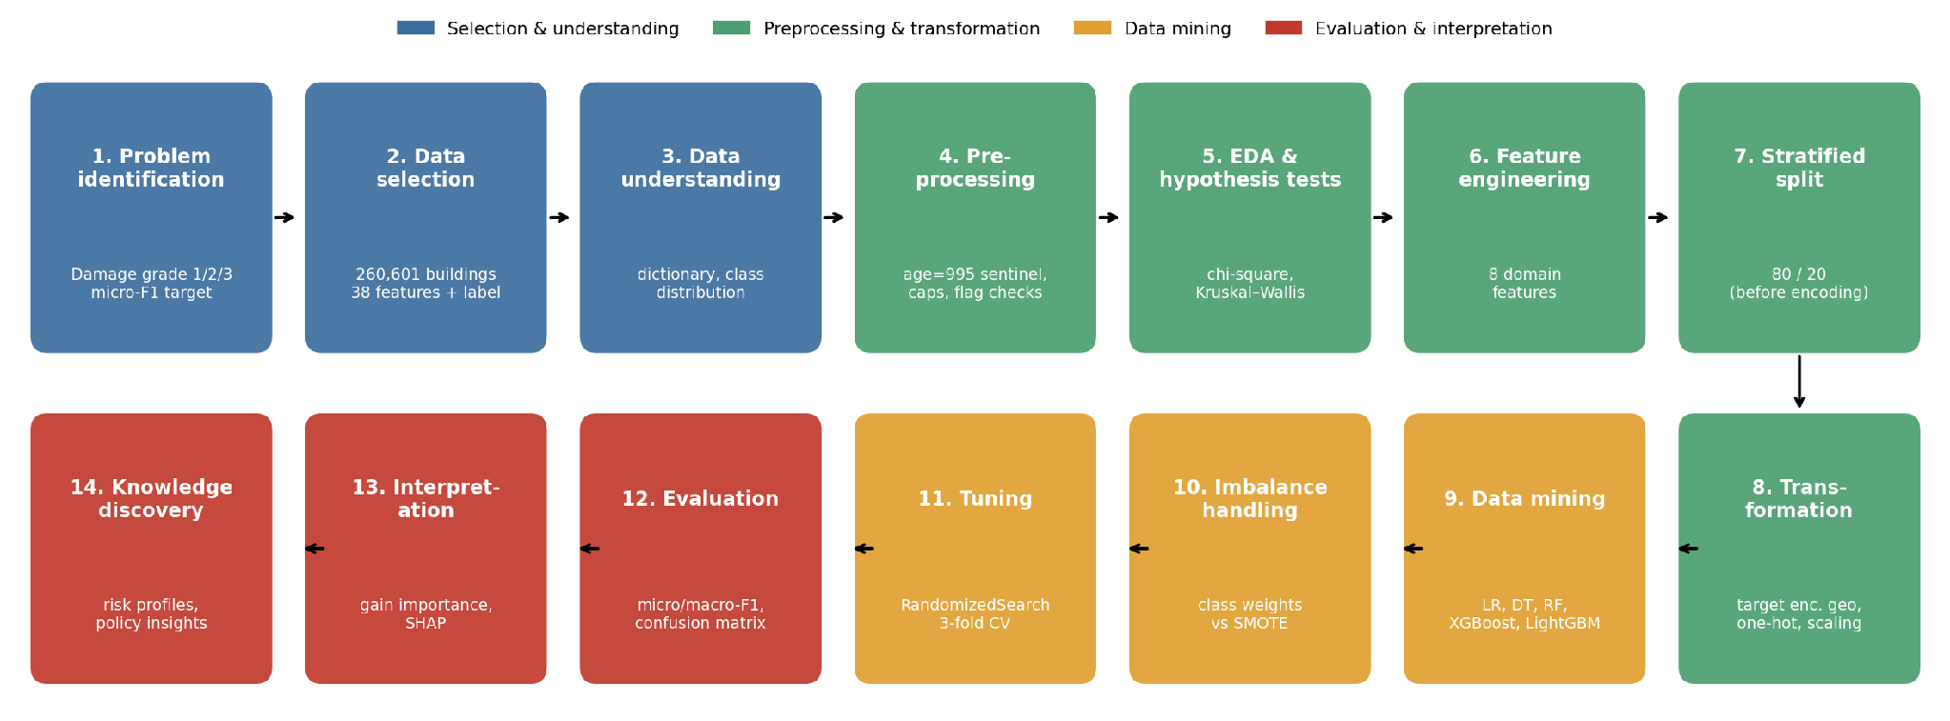
Fig 1: End-to-end KDD workflow followed in the project, fourteen steps in five stage groups.
Table 3: Mapping of KDD stages to project steps and notebook sections
KDD stage [1] | Project steps | Notebook §
Selection | Problem identification; data selection; data understanding | 1–3
Preprocessing | Duplicate, outlier and consistency checks; EDA and hypothesis testing | 4–5
Transformation | Feature engineering; stratified split; encoding and scaling | 6–8
Data mining | Model building; imbalance handling; two-stage tuning | 9–11
Interpretation / evaluation | Evaluation; feature importance and SHAP; knowledge discovery | 12–14

3.2 Data Selection
The dataset is the labelled training portion of DrivenData's Richter's Predictor: Modeling Earthquake Damage [4], derived from the 2015 Nepal Earthquake Open Data Portal [3]. Two files are used — train_values.csv with 38 features per building and train_labels.csv with the damage grade — and they are joined one-to-one on building_id, a random identifier carrying no information. The join was validated as one-to-one and produced 260,601 rows with no missing values.
Table 4: Dataset description by feature group
Feature group | Count | Contents
Geographic | 3 | geo_level_1_id (31 regions) → geo_level_2_id (1,414) → geo_level_3_id (11,595), coarse to fine
Numeric structural | 5 | floors before earthquake, age (years), normalised area and height percentages, number of families
Categorical construction | 8 | land surface, foundation, roof, ground-floor and upper-floor type, position, plan configuration, legal ownership; obfuscated letter codes
Superstructure materials | 11 | binary flags: adobe/mud, mud-mortar stone, stone, cement-mortar stone, mud-mortar brick, cement-mortar brick, timber, bamboo, RC non-engineered, RC engineered, other
Secondary use | 11 | binary flags: any secondary use, agriculture, hotel, rental, institution, school, industry, health post, government office, police, other
Target | 1 | damage_grade: 1 = low, 2 = medium, 3 = near-complete destruction

3.3 Data Understanding
The first finding of data understanding is that the target is imbalanced. Grade 2 accounts for 56.89% of buildings, grade 3 for 33.47% and grade 1 for only 9.64%, a majority-to-minority ratio of 5.9. A model that predicts grade 2 for every building therefore already scores 0.5689 micro-F1, which is the floor every useful model must beat, and its grade-1 recall is zero, which is why macro-F1 and per-class recall are tracked throughout.
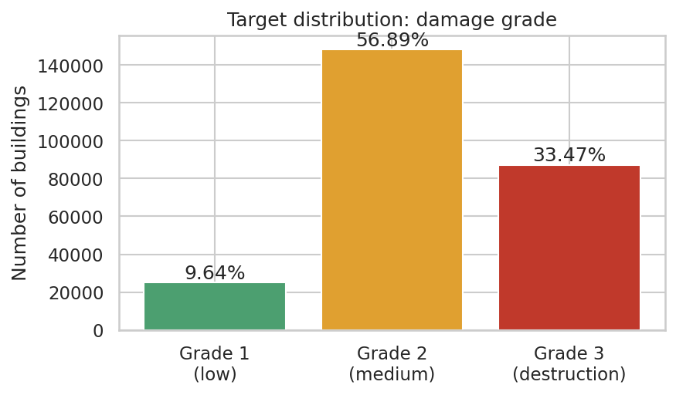
Fig 2: Distribution of the target variable, damage grade.
The numeric features are strongly right-skewed. Median age is 15 years, but the maximum is 995; median normalised area is 7 with a maximum of 100; most buildings have two floors, but some have nine. The categorical features have between 3 and 10 levels each and are obfuscated, while the geographic identifiers range from 31 to 11,595 levels and are effectively high-cardinality nominal variables.
3.4 Data Preprocessing
Preprocessing checked the data for duplicates, outliers and logical inconsistencies. Table 5 is the data-quality register: every issue found, the evidence for it and the action taken.
Table 5: Data-quality register: issues, evidence and remediation
# | Issue | Evidence | Remediation
1 | Duplicate records | 0 exact duplicates; all 260,601 building_id values unique | None needed
2 | Feature-identical buildings | 16,191 rows identical to another row in all 38 features | Kept: similar houses in the same village are real, not data-entry repeats
3 | Label noise | 3,825 feature-identical groups carry different damage grades | Kept; recorded as an accuracy ceiling (§4.8)
4 | Sentinel age value | 1,390 buildings (0.53%) have age = 995; next highest genuine value is 200 | Flag age_unknown_995 created; age capped to 200
5 | Extreme area | area_percentage up to 100 against a median of 7 | Winsorised at 99.5th percentile (28); 1,270 values capped
6 | Extreme height | height_percentage up to 32 against a median of 5 | Winsorised at 99.5th percentile (13); 768 values capped
7 | Binary flag validity | All 22 flag columns contain only 0/1 | None needed
8 | Parent–child flag consistency | has_secondary_use agrees with every specific-use flag in both directions | None needed
9 | Missing material | Every building has at least one superstructure material flagged | None needed
10 | Floors vs height | Correlation 0.79 between floor count and height percentage | Consistent; no action

Issue 3 deserves emphasis because it limits every model in Chapter 4. When thousands of buildings that are identical in every recorded attribute end up with different damage grades, no model using those attributes can classify all of them correctly. The variation is real: neighbouring identical houses experience different shaking and were built with different care. The winsorising thresholds in issues 5 and 6 are simple percentiles that use no target information, so applying them before the split does not leak the label.
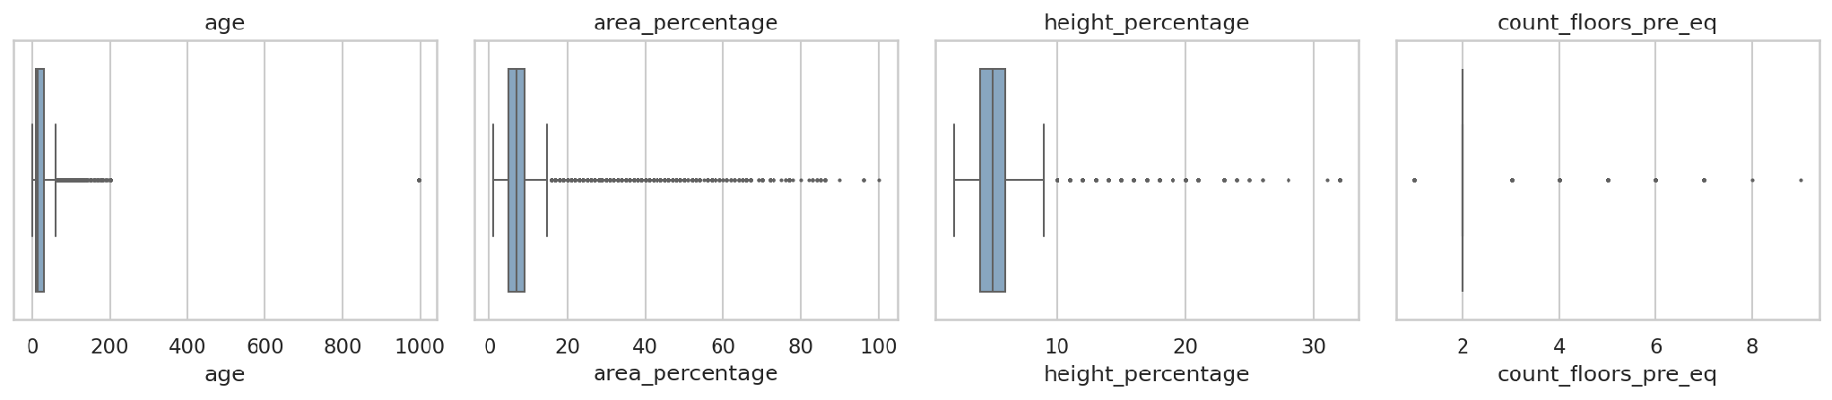
Fig 3: Box plots of the numeric features before outlier treatment.
3.5 Exploratory Data Analysis and Hypothesis Testing
Exploratory analysis examined how damage varies with each group of attributes. Superstructure material shows the clearest gradient (Fig 4). Stone, mud-mortar stone and adobe/mud buildings have the highest destruction rates, between 37% and 47%, while engineered reinforced-concrete buildings are destroyed in only 1.8% of cases and escape with grade 1 in 64.3%. Mud-mortar stone is also by far the most common material, present in 198,561 buildings (76%), so its vulnerability dominates the overall picture.
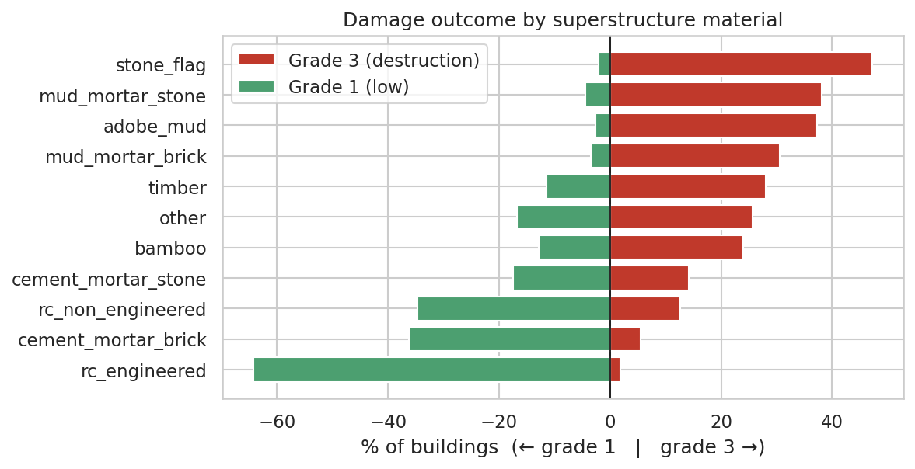
Fig 4: Share of grade 1 and grade 3 outcomes by superstructure material.
Damage increases with building age and, up to a point, with the number of floors (Fig 5). Foundation and roof types also separate the grades sharply (Fig 6): for some foundation types almost no building was destroyed, for others well over a third were. Location has the largest effect of all (Fig 7). Mean damage grade across the 31 top-level regions ranges from 1.73 to 2.79, reflecting distance from the epicentre, local geology and local building practice.
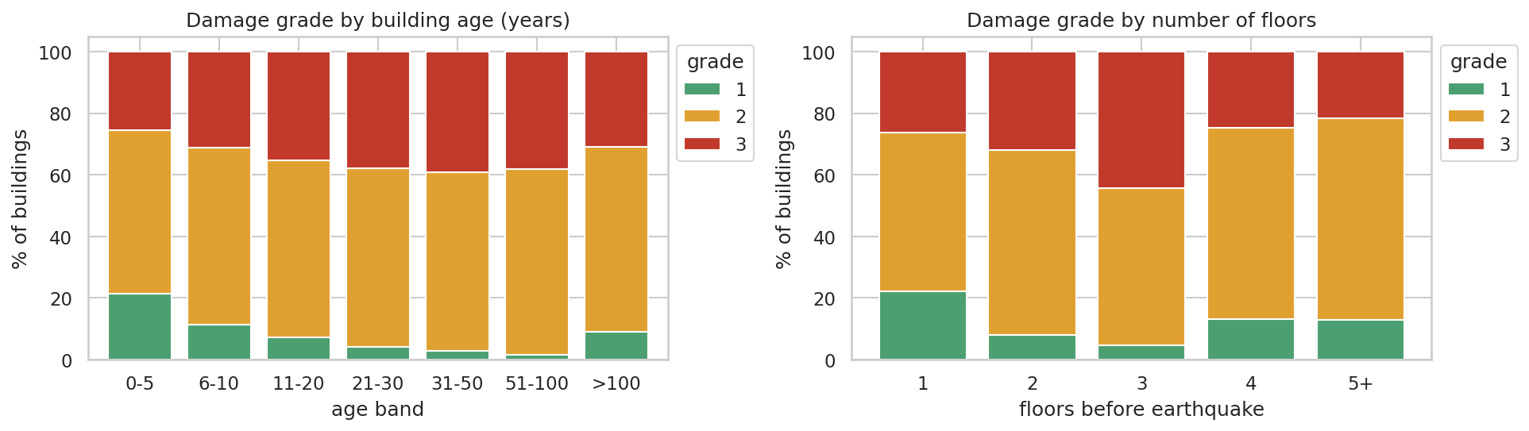
Fig 5: Damage grade composition by building age band and by number of floors.
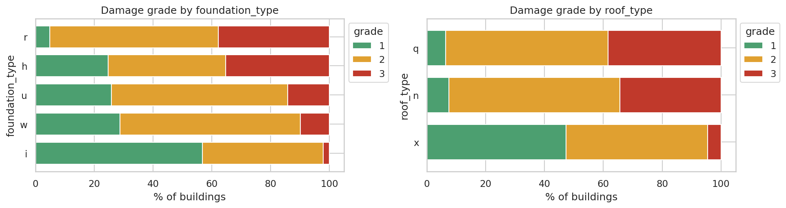
Fig 6: Damage grade composition by foundation type and roof type.
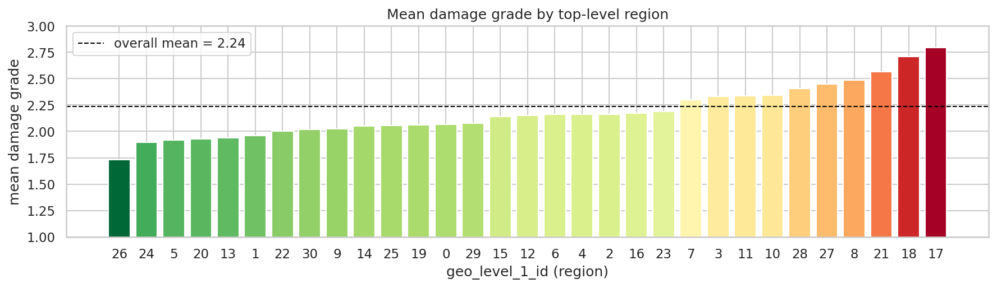
Fig 7: Mean damage grade by top-level region (geo_level_1_id).
These visual impressions were tested formally. For each categorical and binary feature a chi-square test of independence was run against damage grade, with the null hypothesis that the feature and the grade are independent; Cramér's V was computed as the effect size. For each numeric feature a Kruskal–Wallis test was used, because the distributions are skewed and a non-parametric test of equal distributions across the three grades is more appropriate than ANOVA.
With 260,601 observations every test rejected its null hypothesis at α = 0.05, so significance alone does not discriminate between features; the effect size does. Region (geo_level_1_id), mud-mortar stone superstructure, foundation type, cement-mortar brick superstructure, ground-floor type, other-floor type and roof type show the strongest associations (Fig 8). This ranking anticipates the model's feature importance in Chapter 4.
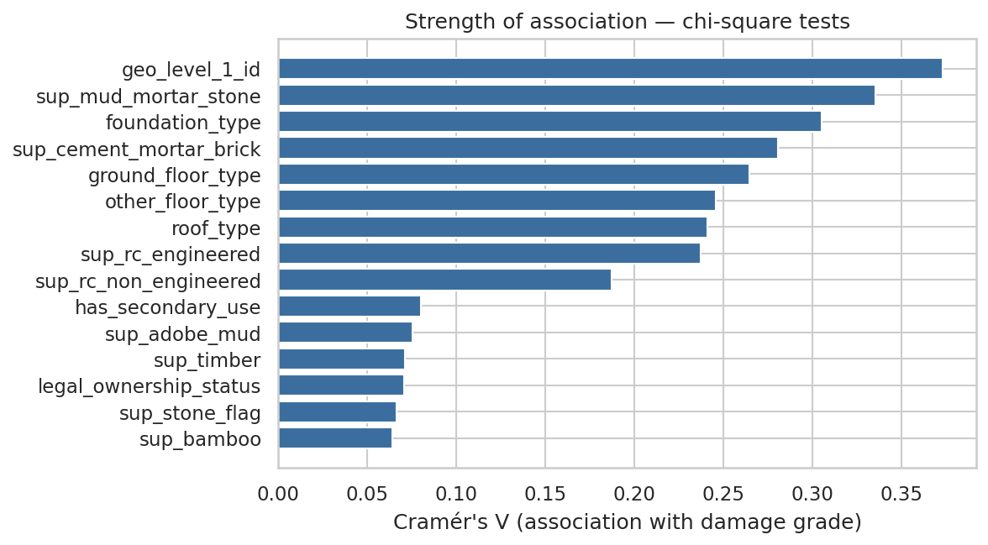
Fig 8: Strength of association with damage grade, Cramér's V from chi-square tests.
3.6 Feature Engineering
Eight features were derived from domain reasoning about why buildings fail. All of them use only pre-earthquake attributes and no target information. Table 6 lists them; the two material flags behaved exactly as expected, with buildings that contain any weak material destroyed in 36.2% of cases against 4.2% for buildings with none, and buildings with an RC frame escaping with grade 1 in 42.6% of cases against 7.6% for those without.
Table 6: Engineered features
Feature | Definition | Rationale
volume_proxy | area_percentage × height_percentage | Overall size and mass of the building
area_per_floor | area_percentage / floors | Footprint per storey
height_per_floor | height_percentage / floors | Storey height; tall, slender storeys are weaker
age_band | Ordinal bins: 0–5, 6–10, 11–20, 21–30, 31–50, 51–100, >100 | Captures the non-linear effect of ageing
n_materials | Count of superstructure flags | Mixed construction
weak_material | Any of adobe/mud, mud-mortar stone, stone, mud-mortar brick, bamboo, timber | Low-strength, non-engineered materials
has_rc | RC engineered or RC non-engineered | A reinforced-concrete frame is present
families_per_floor | count_families / floors | Occupancy density

3.7 Data Partitioning and Transformation
The data was split into 80% training (208,480 buildings) and 20% test (52,121 buildings) with stratification on damage grade, so both parts have exactly the 9.64 / 56.89 / 33.47% class composition. The split precedes every target-dependent step. Transformation was then implemented as a single scikit-learn ColumnTransformer [18], fitted on the training data only and applied unchanged to the test data, so the same object can later score new buildings.
Table 7: Transformation applied to each feature group
Feature group | Transformation | Output columns
Region IDs (3 columns) | Multiclass target encoding with smoothing and internal 5-fold cross-fitting [15] | 9 (one per grade per level)
Categorical construction (8) | One-hot encoding; unseen levels ignored | 42
Numeric and ratio features (9) | Standard scaling (z-score) | 9
Binary flags and ordinal features (23) | Passed through unchanged | 23
Total |  | 83

The encoding of the region hierarchy was the most consequential transformation decision. One-hot encoding the 11,595 village-level identifiers would have produced more than 13,000 mostly empty columns, and treating the identifiers as integers would have imposed an order that means nothing. Target encoding replaces each region with the smoothed share of each damage grade among training buildings in that region; regions with few buildings are pulled towards the overall mean. Because the encoder uses the label, it was fitted with internal cross-fitting: each training building's encoding is computed from the other folds, so a building never sees its own label. Without this, the model would learn from leaked labels and its training score would be meaningless.
3.8 Model Building
Six models of increasing capacity were trained on the same transformed training matrix and evaluated on the same untouched test set. Table 8 lists them and the settings used.
Table 8: Models compared and their key settings
Model | Family | Key settings
Dummy classifier | Baseline | Always predicts the majority class (grade 2)
Logistic Regression | Linear | Multinomial, L2, C = 1.0, max_iter = 1000
Decision Tree | Single tree | max_depth = 14, min_samples_leaf = 20
Random Forest | Bagging ensemble [12] | 150 trees, min_samples_leaf = 3, max_features = √p
XGBoost | Gradient boosting [13] | 400 trees, depth 8, learning rate 0.1, histogram method
LightGBM | Gradient boosting [14] | 500 trees, 63 leaves, learning rate 0.05, row and column subsampling

3.9 Class-Imbalance Handling
Two remedies were compared on LightGBM: class weights inversely proportional to class frequency, and SMOTE oversampling [16], which grew the training set from 208,480 to 355,821 rows with 118,607 buildings in each grade. Both were applied to training data only, after the split. Their effects are reported in Section 4.2.
3.10 Hyperparameter Tuning
LightGBM was tuned in two stages, entirely on the training set. Stage 1 ran RandomizedSearchCV [19] over seven hyperparameters (number of trees, learning rate, leaves, minimum child samples, row and column subsampling and L2 regularisation), with 10 configurations scored by 3-fold stratified cross-validation on a stratified 60,000-row sample. Stage 2 took the three best stage-1 configurations and the default configuration of Section 3.8, and re-scored each with 3-fold cross-validation on all 208,480 training rows. The configuration with the highest full-data cross-validated micro-F1 was refitted on the whole training set and became the final model. In both stages the complete preprocessing pipeline sat inside the cross-validation, so the target encoder was refitted on each training fold.
The second stage exists because of a lesson learned during development. The configuration that wins on a 60,000-row sample tends to be the more regularised one — fewer leaves, stronger L2 penalty — because that suits a smaller dataset. Refitted on 3.5 times more data, it can under-fit. Confirming candidates on the full training data, rather than trusting the sample winner, guards against this without ever consulting the test set.
3.11 Toolchain and Reproducibility
Table 9: Toolchain and project artefacts
Layer | Tool | Artefact
Language and environment | Python 3, Jupyter Notebook | Earthquake_Damage_Prediction_KDD.ipynb
Data handling | pandas, NumPy | data/train_values.csv, data/train_labels.csv
Statistics | SciPy (chi-square, Kruskal–Wallis) | Hypothesis-test table in §5.5
Preprocessing and models | scikit-learn, imbalanced-learn, XGBoost, LightGBM | models/final_lightgbm_pipeline.joblib
Interpretation | SHAP | figures/fig11, fig12
Visualisation | Matplotlib, Seaborn | figures/fig01–fig13
Version control | Git, GitHub | Repository with README.md and requirements.txt

A single random seed (42) is fixed for the split, every model, the search and SMOTE, so the notebook reproduces the same numbers on every run. The saved pipeline contains the fitted preprocessing and the model together, so it takes raw building attributes and returns a predicted grade and the probability of each grade.
CHAPTER 4
RESULTS AND DISCUSSION
4.1 Model Comparison
Table 10: Performance of all models on the held-out test set (52,121 buildings)
Model | Micro-F1 | Macro-F1 | Recall G1 | Recall G2 | Recall G3 | Train (s)
Dummy (majority) | 0.5689 | 0.2417 | 0.0000 | 1.0000 | 0.0000 | 0
Logistic Regression | 0.7392 | 0.6763 | 0.4697 | 0.8493 | 0.6298 | 28
Decision Tree | 0.7297 | 0.6722 | 0.5095 | 0.8342 | 0.6156 | 3
Random Forest | 0.7527 | 0.6998 | 0.5194 | 0.8575 | 0.6418 | 59
XGBoost | 0.7513 | 0.7027 | 0.5489 | 0.8503 | 0.6415 | 53
LightGBM | 0.7513 | 0.7024 | 0.5449 | 0.8497 | 0.6434 | 42
LightGBM – tuned (final) | 0.7514 | 0.7021 | 0.5445 | 0.8503 | 0.6430 | 77

Every model clears the majority baseline by a wide margin (Table 10, Fig 9). Logistic Regression, the only linear model, reaches 0.7392, which shows that much of the signal is captured by the target-encoded regions and the material flags even without interactions. The single Decision Tree is slightly worse at 0.7297: it captures interactions but has high variance. The three ensembles form a clear top group between 0.7513 and 0.7527 micro-F1, a spread of only 0.14 percentage points, which is within the run-to-run variation one would expect from a different split. The ensembles' advantage over the linear model is about 1.3 points of micro-F1 and 2.5 points of macro-F1, mostly from better recall on grades 1 and 3.
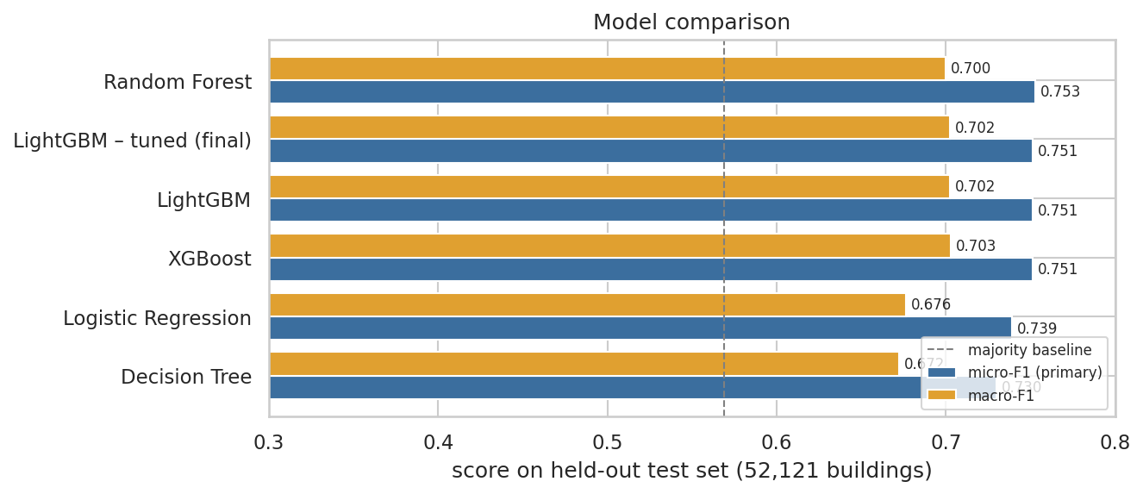
Fig 9: Micro-F1 and macro-F1 of each model against the majority-class baseline.
LightGBM was taken forward as the final model family. Random Forest, XGBoost and LightGBM perform almost identically, but LightGBM trains fastest at this scale, produces well-calibrated class probabilities, and is supported directly by SHAP's exact tree explainer, which matters for the interpretation stage.
4.2 Effect of Class-Imbalance Handling
Table 11: LightGBM with and without class-imbalance remedies (test set)
Variant | Micro-F1 | Macro-F1 | Recall G1 | Recall G2 | Recall G3
LightGBM – no rebalancing | 0.7513 | 0.7024 | 0.5449 | 0.8497 | 0.6434
LightGBM – class weights | 0.7110 | 0.6860 | 0.8513 | 0.6686 | 0.7425
LightGBM – SMOTE | 0.7048 | 0.6791 | 0.7787 | 0.6620 | 0.7561

Both remedies do what they are designed to do. Class weights raise grade-1 recall from 54.5% to 85.1% and grade-3 recall from 64.3% to 74.2%; SMOTE has a similar but slightly weaker effect on grade 1. The cost is paid by the majority class: grade-2 recall falls from 85.0% to about 66.9%, and overall micro-F1 falls by about 4.0 points. Macro-F1 also falls slightly, because precision on grade 1 drops faster than its recall rises.
Which variant is better depends on what an error costs. For the competition metric, and for estimating the total number of buildings in each grade, the unweighted model is best. For a triage tool in which failing to flag a destroyed building is far more costly than sending an inspector to a building that turns out to be fine, the class-weighted model gives a more useful error profile. The final model in this report optimises micro-F1, in line with the stated objective, and the class-weighted variant is retained in the notebook as an alternative operating point.
4.3 Hyperparameter Tuning Results
Table 12: Stage-2 tuning: full-training-set 3-fold cross-validation of the leading configurations
Candidate | Trees | LR | Leaves | L2 | Col. sample | CV micro-F1
stage-1 rank 2 | 800 | 0.05 | 31 | 5 | 0.6 | 0.7438 ± 0.0013
default (§9) | 500 | 0.05 | 63 | 0 | 0.8 | 0.7437 ± 0.0008
stage-1 rank 3 | 300 | 0.03 | 127 | 5 | 1 | 0.7433 ± 0.0014
stage-1 rank 1 | 300 | 0.05 | 31 | 5 | 0.6 | 0.7427 ± 0.0013

In stage 1 the best configuration on the 60,000-row sample reached 0.7264 cross-validated micro-F1. Its score is lower than the full-data figures in Table 12 simply because a smaller training fold gives the target encoder and the trees less data, which is the reason a second stage was needed. Re-scored on the full training set, the ranking of the candidates changed, and stage-1 rank 2 was selected with a cross-validated micro-F1 of 0.7438 ± 0.0013. The small standard deviations show that the estimate is stable across folds and that the differences between the leading configurations are small: the ensembles are close to the ceiling that the features allow.
4.4 Evaluation of the Final Model
Table 13: Classification report of the final model on the test set
Class | Precision | Recall | F1-score | Support
Grade 1 (low) | 0.6895 | 0.5445 | 0.6085 | 5,025
Grade 2 (medium) | 0.7514 | 0.8503 | 0.7978 | 29,652
Grade 3 (destruction) | 0.7684 | 0.6430 | 0.7001 | 17,444
Macro average | 0.7364 | 0.6793 | 0.7021 | 52,121
Weighted average | 0.7511 | 0.7514 | 0.7468 | 52,121

The final model achieves 0.7514 micro-F1 (accuracy), 0.7021 macro-F1 and 0.7468 weighted F1 on 52,121 test buildings it never saw during training or tuning. Grade 2 is recognised best, as the majority class; grade 3 is predicted with the highest precision, meaning that when the model says a building will be destroyed it is usually right; grade 1 is the hardest class, as expected for the smallest and most heterogeneous group.
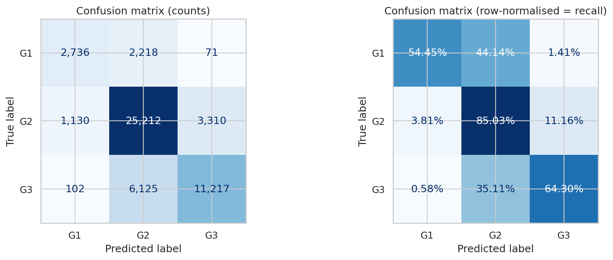
Fig 10: Confusion matrix of the final model: counts (left) and row-normalised recall (right).
The confusion matrix shows that the model's errors are almost entirely between adjacent grades. Only 173 test buildings (0.33%) are confused between grade 1 and grade 3, the error that would matter most in practice. The remaining errors are grade 1 or grade 3 buildings predicted as grade 2, which is consistent with the ordinal nature of the target and with the label noise documented in Section 3.4.
4.5 Generalisation
The final model scores 0.7726 micro-F1 on the training set and 0.7514 on the test set, a gap of 2.12 percentage points. The full-data cross-validated estimate of 0.7438 is slightly lower than the test score, as expected, because each cross-validation model is trained on only two-thirds of the training data. A small train–test gap and close agreement between cross-validation and test indicate that the model is not over-fitting and that the test score is a reliable estimate of performance on new buildings from the same population.
4.6 Model Interpretation
Fig 11 shows the fifteen most important features by LightGBM split gain. The nine target-encoded region columns together account for 77.1% of the total gain, led by the village-level (geo_level_3) and municipality-level (geo_level_2) encodings. Among the structural features, the mud-mortar stone flag, age, area and height, the foundation and roof types and the engineered features are the most used. This ranking agrees with the effect sizes from the chi-square tests in Section 3.5.
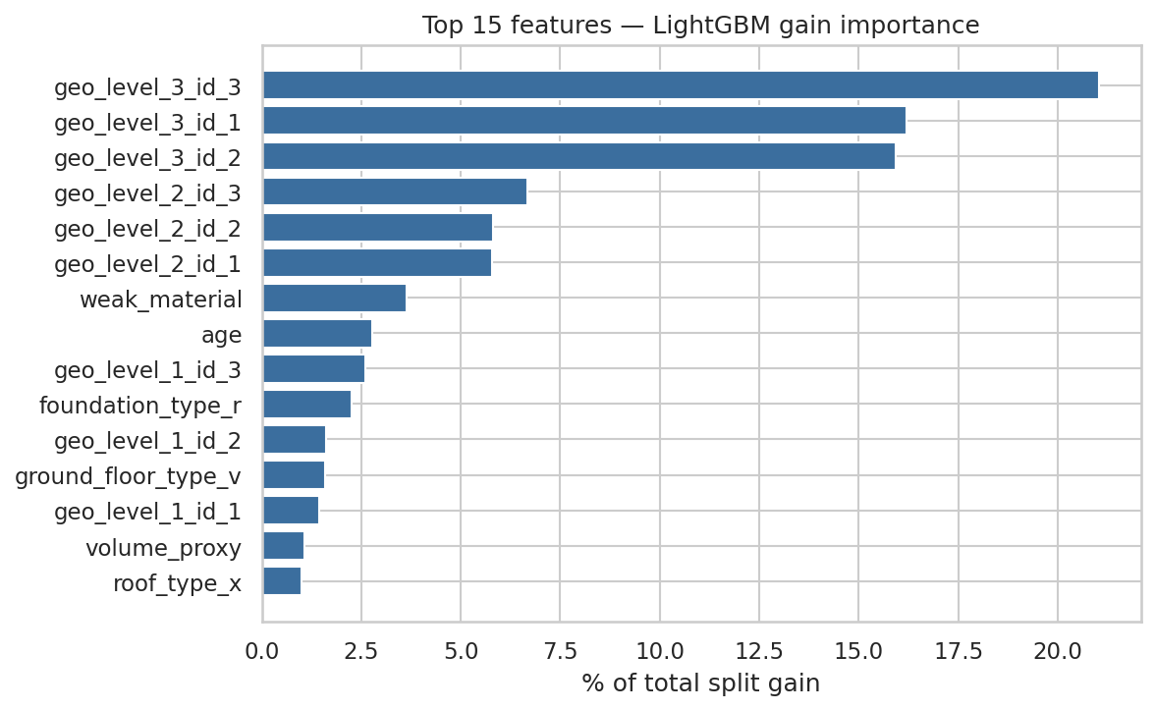
Fig 11: Top fifteen features of the final model by share of total split gain.
Gain importance says which features the model uses, but not in which direction they push. SHAP values [17] answer that. Figs 12 and 13 show the SHAP summary for the grade-3 and grade-1 outputs on a sample of 3,000 test buildings. A high share of destroyed buildings in a building's region pushes its prediction strongly towards grade 3 and away from grade 1. A mud-mortar stone superstructure pushes towards grade 3. Reinforced-concrete and cement-mortar construction, lower age and particular foundation and roof types push towards grade 1. Larger footprints per floor are mildly protective, while tall, slender storeys are not.
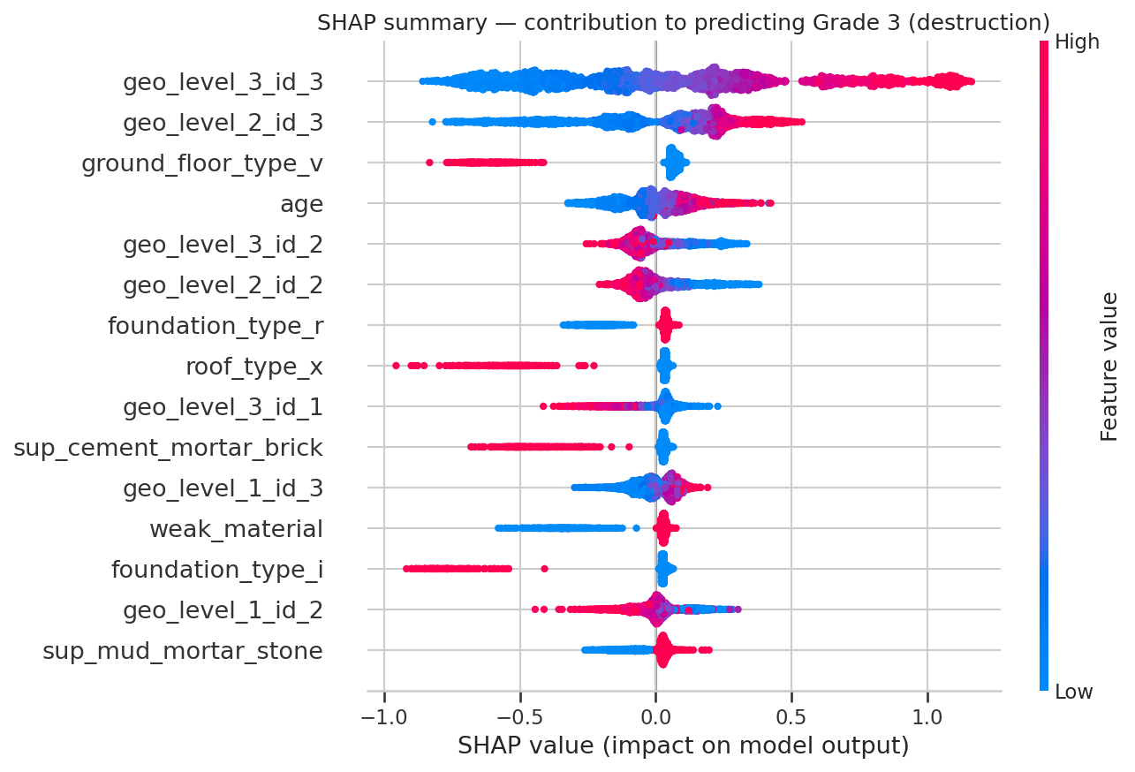
Fig 12: SHAP summary for the grade 3 (destruction) output of the final model.
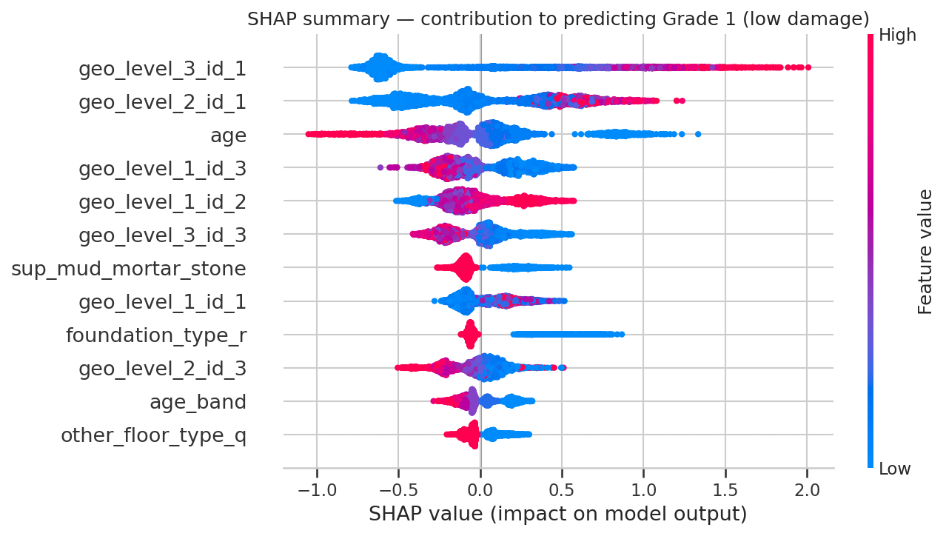
Fig 13: SHAP summary for the grade 1 (low damage) output of the final model.
4.7 Knowledge Discovery
The final stage of KDD turns the model into knowledge a planner can act on. The model's predicted probability of destruction was averaged over buildings of each construction profile in the test set and compared with the actual destruction rate (Table 14, Fig 14).
Table 14: Predicted and actual destruction rate by construction profile (test set)
Construction profile | Buildings | Mean predicted P(G3) | Actual G3 rate
Mud-mortar stone only | 29,354 | 40.6% | 40.5%
Adobe / mud | 2,889 | 38.8% | 38.8%
Mud-mortar stone + timber | 9,349 | 32.3% | 31.9%
Other | 4,367 | 21.4% | 21.9%
RC non-engineered | 2,210 | 12.8% | 13.3%
Cement-mortar brick | 3,141 | 5.9% | 5.8%
RC engineered | 811 | 2.0% | 1.6%

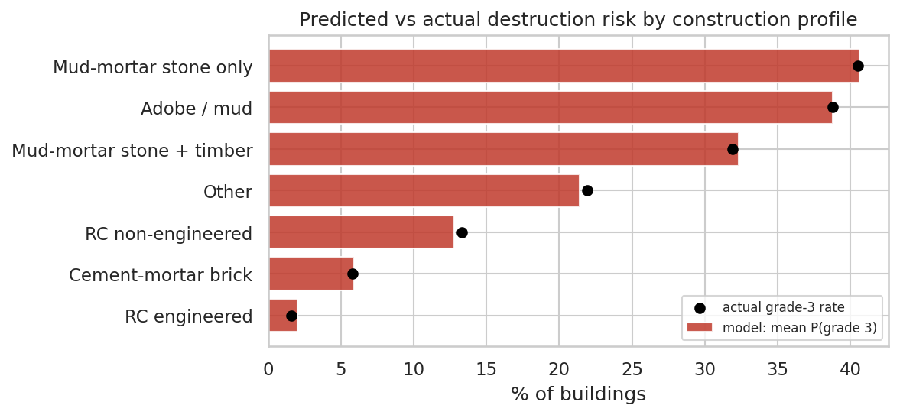
Fig 14: Predicted against actual destruction risk by construction profile.
Two findings follow. First, the model's probabilities are well calibrated at the level of building types: predicted and actual destruction rates agree within about one percentage point for every profile, so the probabilities can be used directly for planning, not only the predicted labels. Second, the profiles span a twenty-five-fold range of risk. A building of mud-mortar stone alone has about a 41% chance of destruction; adding a timber frame lowers this to about 32%; cement-mortar brick lowers it to about 6%; and engineered RC to about 2%.
Table 15: Regions with the highest predicted destruction rate (test set)
Region (geo_level_1) | Buildings | Mean predicted P(G3) | Actual G3 rate | Weak-material share
17 | 4,386 | 81.1% | 81.2% | 94.9%
18 | 653 | 73.0% | 73.2% | 94.8%
21 | 2,938 | 59.1% | 59.2% | 96.8%
8 | 3,775 | 51.7% | 52.7% | 93.8%
27 | 2,561 | 47.5% | 49.4% | 89.2%
10 | 4,430 | 40.0% | 39.4% | 92.6%
28 | 44 | 39.6% | 43.2% | 100.0%
11 | 1,611 | 38.2% | 39.4% | 91.7%

At the regional level the model's predicted destruction rate correlates at 0.998 with the actual rate across the 31 regions. In the highest-risk region about four in five test buildings were destroyed, and in every one of the top regions more than 89% of buildings contain a weak material. Region and material therefore compound each other: the most damaged areas are those where strong shaking met a building stock that was almost entirely unreinforced masonry.
4.8 Discussion and Limitations
Comparison with the literature. The ranking of models — ensembles ahead of linear models and single trees, with little to separate the ensembles — matches the findings of earlier damage-classification studies [10], [11] and of tabular-data benchmarks [20]. The ranking of risk factors matches field reconnaissance after the earthquake, which singled out stone and brick masonry in mud mortar as the most vulnerable construction and reinforced concrete as the least [5], [6].
The accuracy ceiling. About one building in four is misclassified even by the best model. Section 3.4 showed why: 3,825 groups of buildings identical in all 38 features received different grades. The dataset does not record the intensity of shaking at each building, soil conditions or workmanship, and these vary between neighbouring buildings. The ensembles all stopping at about 0.75 suggests that the remaining error is largely irreducible with these features rather than a failure of modelling.
Obfuscated categories. The publisher replaced the categorical values with letters. The model can identify a foundation type as high-risk but the report cannot say which construction it denotes, which limits the specificity of recommendations.
Transferability. The model learned the relationship between building attributes and damage for one earthquake. Its region encodings in particular describe where the Gorkha earthquake shook hardest. Applied to a future earthquake with a different epicentre, the structural part of the model would transfer better than the regional part, and the region encodings would need to be replaced by a measure of expected shaking.
CHAPTER 5
CONCLUSION
This project carried out the complete KDD process on 260,601 buildings surveyed after the 2015 Gorkha earthquake, from problem identification to quantified, checkable knowledge for disaster-risk planning. Its deliverables are:
1. A reproducible notebook that implements all fourteen workflow steps with fixed random seeds, from data loading to knowledge discovery.
2. A documented data-quality register of ten checks, including the age-995 sentinel, outlier treatment and the label-noise ceiling.
3. A leakage-safe transformation pipeline that target-encodes an 11,595-level location hierarchy with cross-fitting and is fitted on training data only.
4. A tuned LightGBM model scoring 0.7514 micro-F1 and 0.7021 macro-F1 on 52,121 unseen buildings, 18.2 points above the baseline, saved as a single pipeline that scores raw building records.
5. Interpretation and knowledge discovery through gain importance, SHAP, and calibrated risk tables by construction profile and region.
6. A GitHub repository containing the notebook, dataset, README, requirements and saved model.
The analytical conclusions are clear. Location is the strongest single predictor of damage, carrying 77.1% of the model's gain, because it stands in for the unrecorded intensity of shaking. Among building attributes, construction material dominates: mud-mortar stone buildings, which make up three-quarters of the stock, were destroyed at about 41%, while engineered reinforced-concrete buildings were destroyed at about 2%. Tree ensembles predict damage grade substantially better than a linear model, but all of them reach the same ceiling of about 0.75 micro-F1, set by noise that the available features cannot explain.
5.1 Recommendations
• Post-earthquake triage. Use the model's grade-3 probability to rank localities and buildings for the first round of inspection, and use the class-weighted variant where missing a destroyed building is the costliest error.
• Retrofitting priority. Target mud-mortar stone and adobe buildings first; the model attributes the highest risk to them independently of region.
• Reconstruction codes. The twenty-five-fold difference in destruction risk between mud-mortar stone and engineered RC supports enforcing cement-mortar or engineered construction in rebuilding.
• Use as screening, not verdict. Predictions should direct inspectors, not replace them.
5.2 Future Scope
Three extensions would raise the accuracy ceiling. First, joining the survey with ground-motion data, such as the USGS ShakeMap intensity at each village, would replace the region encodings with a physical measure of shaking and make the model transferable to future earthquakes. Second, treating the target as ordinal, through ordinal regression or by optimising thresholds on a continuous prediction, would exploit the order of the grades. Third, the trained pipeline could be deployed as a simple web form so that engineers and local authorities can score buildings in the field.
REFERENCES
[1] U. Fayyad, G. Piatetsky-Shapiro and P. Smyth, “From data mining to knowledge discovery in databases,” AI Magazine, vol. 17, no. 3, pp. 37–54, 1996.
[2] National Planning Commission, Nepal Earthquake 2015: Post Disaster Needs Assessment, Vol. A: Key Findings. Kathmandu: Government of Nepal, 2015.
[3] Central Bureau of Statistics and Kathmandu Living Labs, 2015 Nepal Earthquake Open Data Portal. National Planning Commission Secretariat, Government of Nepal. [Online]. Available: https://eq2015.npc.gov.np
[4] DrivenData, “Richter’s Predictor: Modeling Earthquake Damage,” practice competition. [Online]. Available: https://www.drivendata.org/competitions/57/nepal-earthquake/
[5] K. Goda, T. Kiyota, R. M. Pokhrel et al., “The 2015 Gorkha Nepal earthquake: insights from earthquake damage survey,” Frontiers in Built Environment, vol. 1, art. 8, 2015.
[6] H. Chaulagain, H. Rodrigues, V. Silva, E. Spacone and H. Varum, “Seismic risk assessment and hazard mapping in Nepal,” Natural Hazards, vol. 78, no. 1, pp. 583–602, 2015.
[7] G. M. Calvi, R. Pinho, G. Magenes, J. J. Bommer, L. F. Restrepo-Vélez and H. Crowley, “Development of seismic vulnerability assessment methodologies over the past 30 years,” ISET Journal of Earthquake Technology, vol. 43, no. 3, pp. 75–104, 2006.
[8] Federal Emergency Management Agency, FEMA P-154: Rapid Visual Screening of Buildings for Potential Seismic Hazards: A Handbook, 3rd ed. Washington, DC: FEMA, 2015.
[9] G. Grünthal (ed.), European Macroseismic Scale 1998 (EMS-98). Cahiers du Centre Européen de Géodynamique et de Séismologie, vol. 15. Luxembourg, 1998.
[10] S. Mangalathu, H. Sun, C. C. Nweke, Z. Yi and H. V. Burton, “Classifying earthquake damage to buildings using machine learning,” Earthquake Spectra, vol. 36, no. 1, pp. 183–208, 2020.
[11] S. Ghimire, P. Guéguen, S. Giffard-Roisin and D. Schorlemmer, “Testing machine learning models for seismic damage prediction at a regional scale using building-damage dataset compiled after the 2015 Gorkha Nepal earthquake,” Earthquake Spectra, vol. 38, no. 4, 2022.
[12] L. Breiman, “Random forests,” Machine Learning, vol. 45, no. 1, pp. 5–32, 2001.
[13] T. Chen and C. Guestrin, “XGBoost: a scalable tree boosting system,” in Proc. 22nd ACM SIGKDD Int. Conf. Knowledge Discovery and Data Mining, 2016, pp. 785–794.
[14] G. Ke, Q. Meng, T. Finley et al., “LightGBM: a highly efficient gradient boosting decision tree,” in Advances in Neural Information Processing Systems 30, 2017, pp. 3146–3154.
[15] D. Micci-Barreca, “A preprocessing scheme for high-cardinality categorical attributes in classification and prediction problems,” ACM SIGKDD Explorations Newsletter, vol. 3, no. 1, pp. 27–32, 2001.
[16] N. V. Chawla, K. W. Bowyer, L. O. Hall and W. P. Kegelmeyer, “SMOTE: synthetic minority over-sampling technique,” Journal of Artificial Intelligence Research, vol. 16, pp. 321–357, 2002.
[17] S. M. Lundberg and S.-I. Lee, “A unified approach to interpreting model predictions,” in Advances in Neural Information Processing Systems 30, 2017, pp. 4765–4774.
[18] F. Pedregosa et al., “Scikit-learn: machine learning in Python,” Journal of Machine Learning Research, vol. 12, pp. 2825–2830, 2011.
[19] J. Bergstra and Y. Bengio, “Random search for hyper-parameter optimization,” Journal of Machine Learning Research, vol. 13, pp. 281–305, 2012.
[20] L. Grinsztajn, E. Oyallon and G. Varoquaux, “Why do tree-based models still outperform deep learning on typical tabular data?” in Advances in Neural Information Processing Systems 35 (Datasets and Benchmarks Track), 2022.
APPENDIX A — GITHUB REPOSITORY STRUCTURE
The repository submitted with this report has the following structure. The README describes the problem statement, dataset, methodology and how to run the notebook.
earthquake-damage-prediction-kdd/
├── Earthquake_Damage_Prediction_KDD.ipynb # complete KDD notebook (executed)
├── README.md # project overview and instructions
├── requirements.txt # Python dependencies
├── data/
│ ├── train_values.csv # 260,601 buildings x 39 columns
│ └── train_labels.csv # building_id, damage_grade
├── figures/ # 13 figures produced by the notebook
├── models/
│ └── final_lightgbm_pipeline.joblib # preprocessing + tuned LightGBM
├── results_model_comparison.csv
├── results_imbalance.csv
└── results_tuning_stage2.csv

To reproduce the results: clone the repository, install the dependencies with pip install -r requirements.txt, and run all cells of the notebook. On a single CPU core the full run takes about 45 minutes, most of it in the two tuning stages.
APPENDIX B — FEATURE DICTIONARY
Table 16: Original features of the dataset
Feature | Type | Description
geo_level_1_id, _2_id, _3_id | int (nominal) | Geographic region, from largest (31) to most specific (11,595) sub-region
count_floors_pre_eq | int | Number of floors before the earthquake
age | int | Age of the building in years (995 = sentinel)
area_percentage | int | Normalised footprint area
height_percentage | int | Normalised height
land_surface_condition | categorical (3) | Surface condition of the land the building stands on
foundation_type | categorical (5) | Type of foundation
roof_type | categorical (3) | Type of roof
ground_floor_type | categorical (5) | Type of ground floor
other_floor_type | categorical (4) | Type of construction of floors above ground
position | categorical (4) | Position of the building
plan_configuration | categorical (10) | Building plan configuration
has_superstructure_* (11) | binary | Superstructure material: adobe/mud, mud-mortar stone, stone, cement-mortar stone, mud-mortar brick, cement-mortar brick, timber, bamboo, RC non-engineered, RC engineered, other
legal_ownership_status | categorical (4) | Legal ownership status of the land
count_families | int | Number of families living in the building
has_secondary_use* (11) | binary | Any secondary use, and specific use: agriculture, hotel, rental, institution, school, industry, health post, government office, police, other
damage_grade | ordinal target | 1 = low damage, 2 = medium damage, 3 = near-complete destruction

AI REPORT
[Attach AI-detection report screenshot here]
PLAGIARISM REPORT
[Attach plagiarism report screenshot here]

