FLIPKART SALES
& PROFIT ANALYSIS
A simple report explaining what the sales data tells us—and what it cannot tell us

What I did
I used SQL to answer questions about sales, products, regions, discounts and customer ratings. I used Power BI to show the main results in a dashboard.
.

One important thing to remember
The dataset calculates profit as exactly 20% of sales for every order. So I can explain the profit values in the file, but I cannot claim they are the real profit the business earned. To calculate real profit, I would need costs and fees too.
Project report • 30 October 2026
1. Project at a glance
The file has 1,000 order records and 15 columns. It includes product, category, price, quantity, sales, date, payment method, customer rating, discount, customer segment and region.
■7.52 crore | 1,000 | ■75,213 | 3,097 | 3.01/5
Total sales | Orders | Average sales per order | Units sold | Average rating

Main findings
- Electronics has the highest sales of all categories, at ■1.73 crore.
- North has the highest sales among the four regions; East has the lowest.
- The top five products make up 26.7% of total sales, so sales are spread across many products.
- 238 orders (23.8%) have a rating below 2 out of 5, which is worth investigating.
- Discounts and sales do not show a strong straight-line relationship in this dataset.
In simple words: the project helps describe what was sold, where sales came from, which products sold most, and where customer ratings may need attention.
2. Understanding and checking the data
Before analysing the numbers, I checked the basic structure of the file and a few common data-quality issues.
What I checked | What I found | What it means
Number of records | 1,000 | The file contains 1,000 order records.
Number of columns | 15 | Each row has 15 fields.
Blank values | 0 | No blank cells were found in the CSV.
Repeated Order IDs | 0 | Each Order ID appears once in this file.
Sales calculation | Price × Quantity | The Total_Sales values match Price multiplied by Quantity.
Profit calculation | 20% of sales | Profit is set to a fixed share of sales, not calculated from costs.

Date range
The dates in the file run from 03 January 2024 to 01 December 2025. January 2025 is only part of the overall time period, so it should not be compared with a complete month without care.

- Which categories and regions made the most sales?
Category means the type of product, such as Electronics, Books or Clothing.
Category | Total sales | Share of all sales | Average rating
Electronics | ■1.73 crore | 23.0% | 2.99/5
Clothing | ■1.51 crore | 20.1% | 2.97/5
Books | ■1.48 crore | 19.7% | 3.08/5
Beauty | ■1.47 crore | 19.5% | 2.87/5
Home & Kitchen | ■1.33 crore | 17.7% | 3.14/5
Electronics is the top category, with ■1.73 crore in sales. Home & Kitchen has the lowest sales, but it still contributes a meaningful part of the total. This means sales are not coming from only one category.
Region means the area listed in the dataset. North has the highest sales, at ■2.03 crore, while East has the lowest, at ■1.67 crore. This is a difference worth exploring, but the data alone does not explain why it exists.
Region | Total sales | Share of all sales
North | ■2.03 crore | 27.0%
South | ■1.99 crore | 26.4%
West | ■1.84 crore | 24.5%
East | ■1.67 crore | 22.2%
How I would explain it: “I compared sales by category and region. Electronics was the strongest category and North was the strongest region. These are results from this dataset; more information would be needed to explain the reasons.”
- Which products sold the most?
I added up sales for each product and sorted the results from highest to lowest. This shows which products contributed the most sales.
Rank | Product | Total sales | Share of total sales
1 | Educational Book | ■45.22 lakh | 6.0%
2 | Laptop | ■41.33 lakh | 5.5%
3 | Table Lamp | ■39.87 lakh | 5.3%
4 | Headphones | ■37.23 lakh | 4.9%
5 | Jeans | ■36.85 lakh | 4.9%
6 | Smartwatch | ■36.80 lakh | 4.9%
7 | Face Cream | ■36.47 lakh | 4.8%
8 | Perfume | ■32.67 lakh | 4.3%
9 | Fiction Novel | ■31.73 lakh | 4.2%
10 | Jacket | ■31.61 lakh | 4.2%
The top five products together make up 26.7% of all sales, and the top ten make up 49.2%. This means no small group of products accounts for most of the sales.
Why this matters: a business could use this list to decide which products deserve closer attention. But sales alone do not tell us which products make the most real profit, because product costs and other expenses are missing.
How I would explain it: “I used SQL to group orders by product, add up sales, and rank products from highest to lowest. This helped me identify the top-selling products and see how much of total sales they represent.”
5. What did I learn about discounts?
I compared the average order sales at different discount levels. Average order sales means the average sales amount for orders in that discount group.
Discount group | Orders | Average sales per order
0–10% | 244 | ■77,400
Over 10–20% | 348 | ■76,553
Over 20–30% | 408 | ■72,762
The correlation between Discount and Total_Sales is -0.016, which is close to zero. In simple terms, this dataset does not show a strong straight-line relationship between discount size and sales amount.
Important: this does not prove discounts do not work. It only describes the records we have. To test whether a discount increases sales, a business would need more context, such as product prices, campaign details and a fair comparison between orders with and without a discount.
How I would explain it: “I compared order sales across discount levels. I found no strong relationship in this dataset, so I would not claim that bigger discounts cause higher or lower sales.”
6. What do customer ratings tell us?
The average customer rating is 3.01 out of 5. There are 238 orders rated below 2 out of 5, which is 23.8% of all records.
This is a signal to investigate, not proof of a specific problem. The file does not explain why customers gave low ratings.
A useful next step would be to check whether low ratings are more common for certain products, categories or regions. If review comments or complaint reasons were available, they could help explain what customers disliked.

Customer segments
The dataset also separates orders into Wholesale, Online and Retail segments. Their total sales are fairly close, so no single segment dominates the recorded sales.
Segment | Total sales | Share of sales
Wholesale | ■2.57 crore | 34.2%
Online | ■2.52 crore | 33.5%
Retail | ■2.43 crore | 32.3%
How I would explain it: “I calculated the average rating and counted orders rated below 2. Almost one quarter of the records had a very low rating, so I would investigate those orders rather than guess the reason.”
7. My Power BI dashboard
The dashboard puts the main results in one place. It shows key numbers, monthly sales, category and region comparisons, and the top products. The Year, Category and Customer Segment filters let a viewer narrow the results.
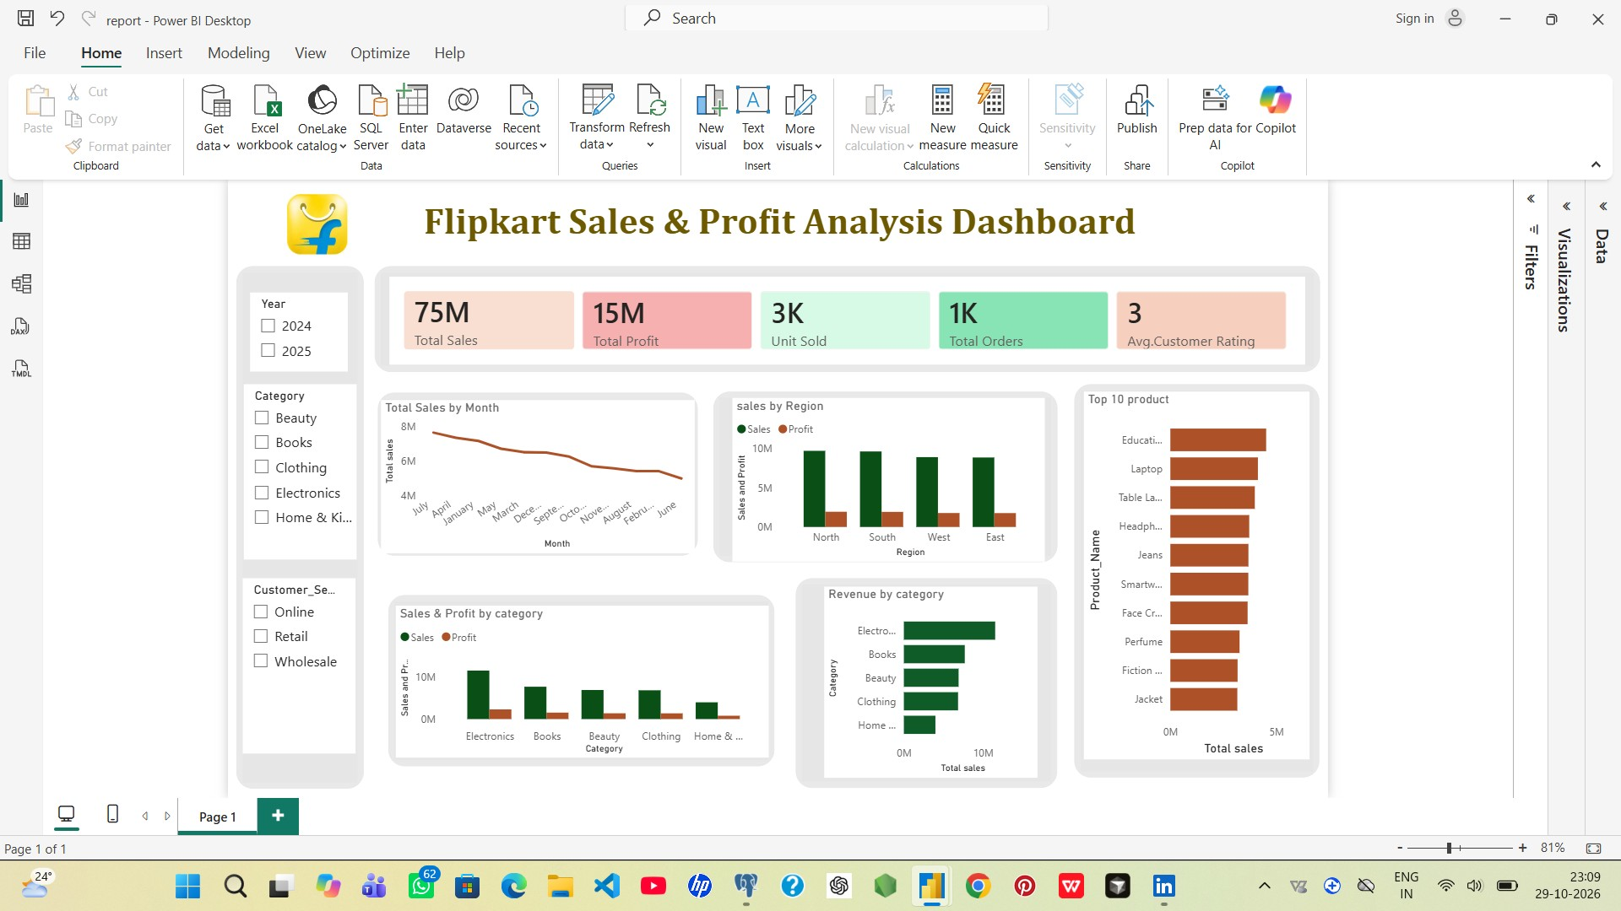
- What SQL skills does this project show?
The project uses SQL to answer business questions. Here is what the main techniques mean in plain language:
SQL technique | Simple meaning | How I used it
SUM / AVG / COUNT | Add values, find averages, count records | Sales, profit, order counts and ratings
GROUP BY | Put records into groups | By category, region, month and segment
ORDER BY / LIMIT | Sort results and keep the first few | Top products and lowest recorded profit
CASE WHEN | Create groups using a condition | Group discounts into bands
CTE | Give a temporary name to a query result | Keep multi-step analysis easier to read
DENSE_RANK +  PARTITION BY | Rank items inside each group | Rank products within their own category
How I would explain it: “I used SQL to summarise sales, compare groups, find top and bottom products, and rank products within categories. I used Power BI to turn the results into a dashboard.”

What information is missing?
The file does not include enough information to calculate true profit, understand repeat customers, measure delivery speed, or check returns and cancellations. It also does not tell us why customers gave low ratings.

