FAST National University Islamabad Campus
Digital Logic Design – EL1005
Three-Gate Parking Lot with Gate Priority System

Members
Bareerah Haroon (25i-0061), Arisha Mohsin (25i-0065), Maheen Furqan (25i-0073)

Instructor
Sir Ammar Masood

Date of Submission: 6th May 2026

Abstract
Our project tests the logic-building and implementation of a priority-based counting system. Three gates are controlled by buttons, each with a different level of priority. If the button with the least priority will be clicked along with the buttons with greater priorities, the least priority input will be ignored; the system will, in any case, try to choose the button with the greatest priority. Each press of a button increments a counter, and this count is displayed using a 7-segment display. We tested the physical implementation, and the Proteus simulation of this circuit to the best of our abilities.
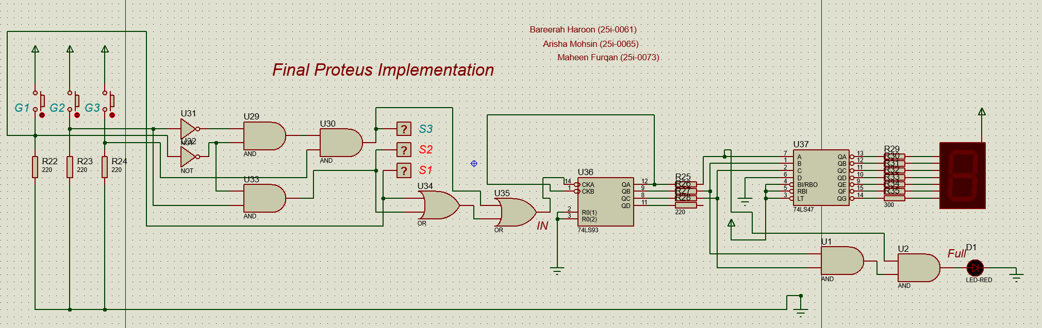
Introduction
The project features a fully functional priority-based input selection system; gates with higher priority are always considered above lower priority gates. In our circuit, the highest priority has been given to Gate 1 (G1), followed immediately by Gate 2 (G2), with the least priority gate being Gate 1 (G1). Each gate is controlled by buttons, and each push of a button increments the counter by one. After the counter reaches 7, it resets to 0; this is because the maximum capacity for the parking is 7. If more than 7 cars park, the red LED turns on immediately, and the following increments restart the counter from 0 again. We successfully implemented this exact functionality using common gates and ICs on Proteus.
The project demonstrates in-depth logic-building skills, as we build a complete system using only rudimentary operations; these skills teach us to think about the very basics of computing and circuitry, and help develop our skills from the ground up.

Design and Methodology
The first task we overtook, naturally, was the proteus implementation. And after further dividing the circuit into parts/blocks of logic, we decided that the easiest and best place to start would be the priority-based input selection system; this would not only fulfil a requirement of the project but it would allow us to get off to a good start with our project.
The priority system uses basic AOI (AND, OR, INVERT/NOT) gates. To create the logic for its implementation, we first thought of a simple truth table.
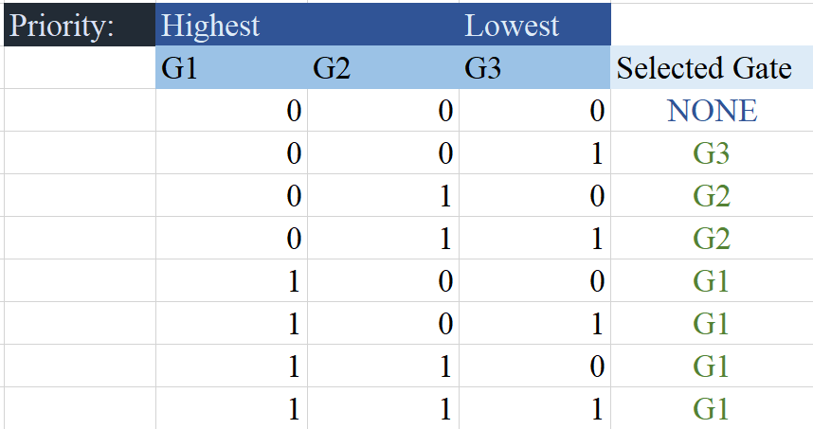
Now, to individually find the required inputs for each gate to be selected.
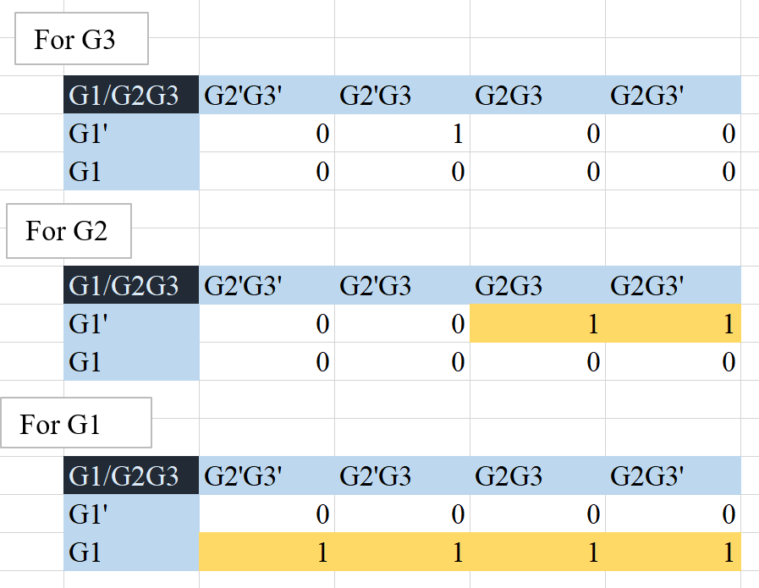
Now that we have mapped each selected gate’s inputs to a K-MAP, we can easily deduce their Boolean expressions by making groups of 2^n with the min-terms. The resulting equations are the following:
G1 = G1
G2 = G1’.G2
G3 = G1’.G2’.G3
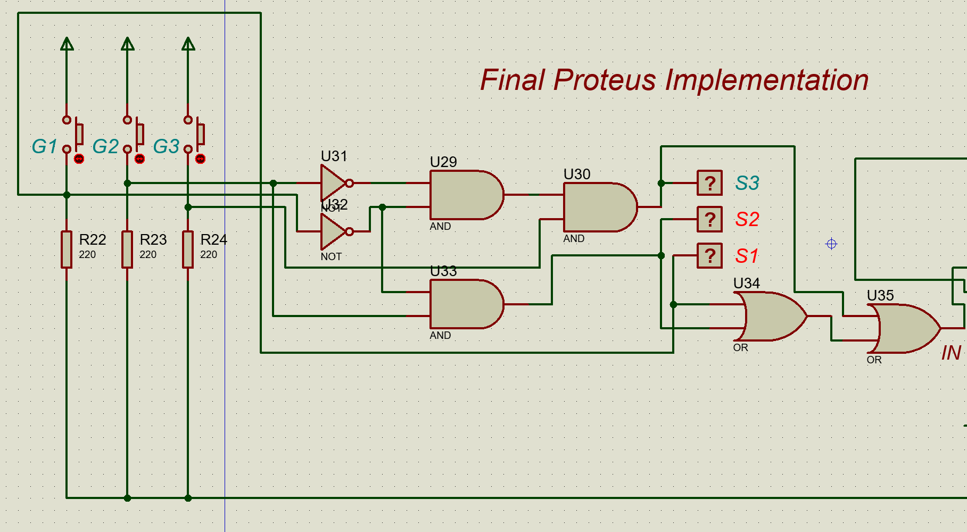
Now we know which gate needs to be opened when multiple gates are triggered together. Before moving on, it is important to remember that our counter counts the opening of each gate; it does not care about whether the gate triggered is G1, G2, or G3. This means that we need to activate the counter when any one of these gates is open, and the gate to handle this condition is the OR-gate. The final value that our counter will require is:
IN = G1 + G2 + G3
Next comes the actual counting. We have decided to use a very widely available and supported counter: the 74LS93 4-bit binary counter.
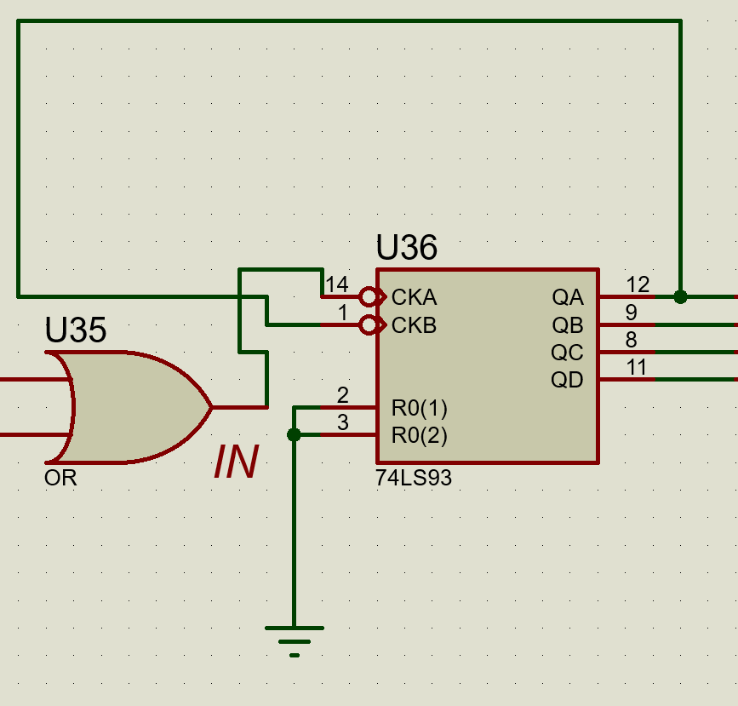
Pin 14 (CKA) will be connected to IN which we just calculated above, and pin 1 (CKB) will be connected to the least significant output – output QA (pin 12) as shown. Pins 12, 8, and 9, will be the binary representation of numbers 0-7, which we must now represent with the help of an ANODE 7-segment display. However, outputs can not be fed into the display directly; they need to pass through a BCD to 7-segment driver (74LS47).
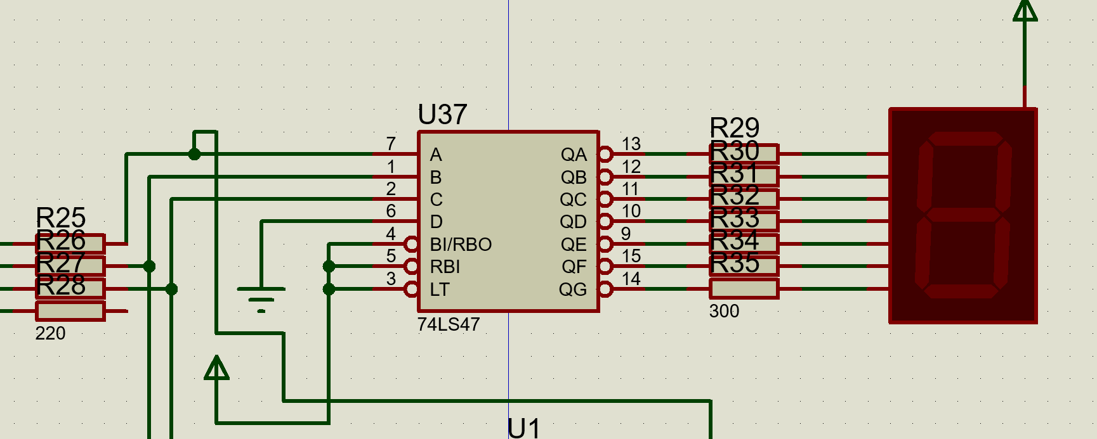
We connect only the 3 inputs we need to the 74LS47, while connected the most significant input (D) to ground. Each output from the 74LS47 is then fed to an ANODE 7-segment display, which is activated with a power source.
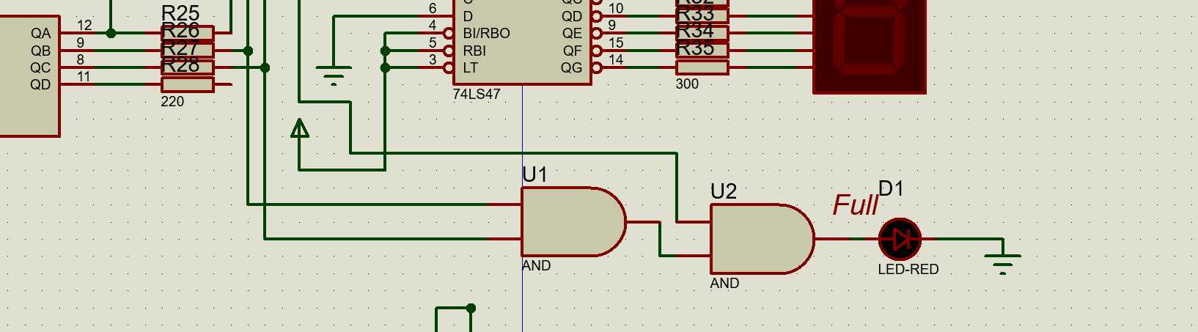
Finally, the FULL check is implemented.
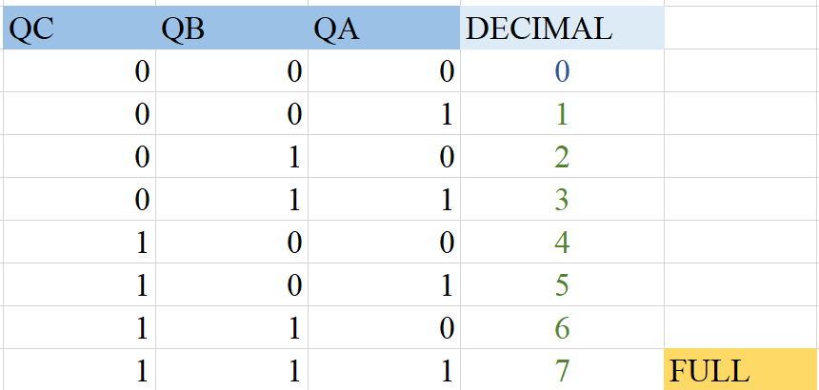
By the truth table it is evident that the FULL LED must only be switched on if all QC, QB, and QA are active, as this is the only condition where the decimal representation is a 7.
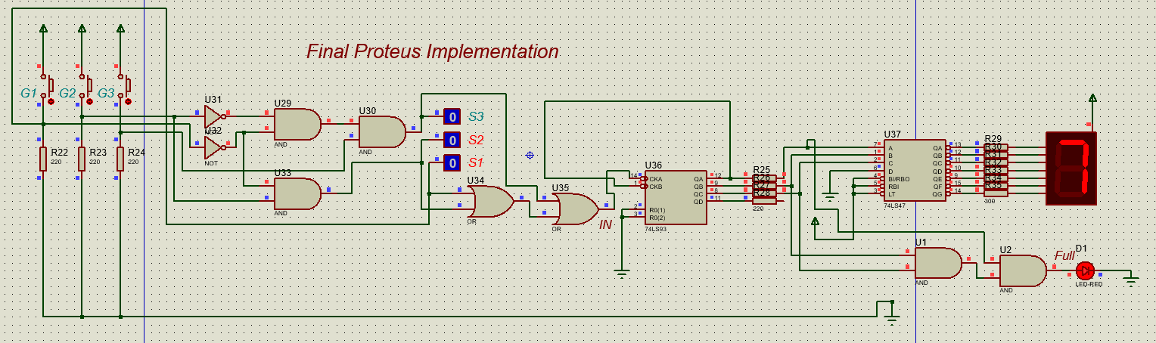
If we press one more button, the system will reset and the counter will start from 0 again.
We tried using other 7-segment drivers, but each came with increasingly confusing functions and complications; we even tried using 7447 – Common anode 7-seg decoder. Same was the case with the counters; after trying out multiple counters, we conclusively decided to use the 74LS93 – 4-bit binary counter, considering its simplicity and understandability.
Here’s a complete list of all the components we used to simulate the circuit:
- OR Gate
- AND Gate
- NOT Gate
- Buttons
- 220 Ohm Resistors
- 74LS93
- 74LS47
- Red LED
- ANODE 7-Segment display
It is to be noted that the resistors are added in order to help us understand the working of proper realistic circuitry; many display components like LEDs and 7-segment displays require the connection of resistors at times.

Testing and Results
First of all, we needed to test whether priority-based selection is handled correctly. For that, we connected logic probes to the end of each gate’s selection circuit (S1, S2, S3).
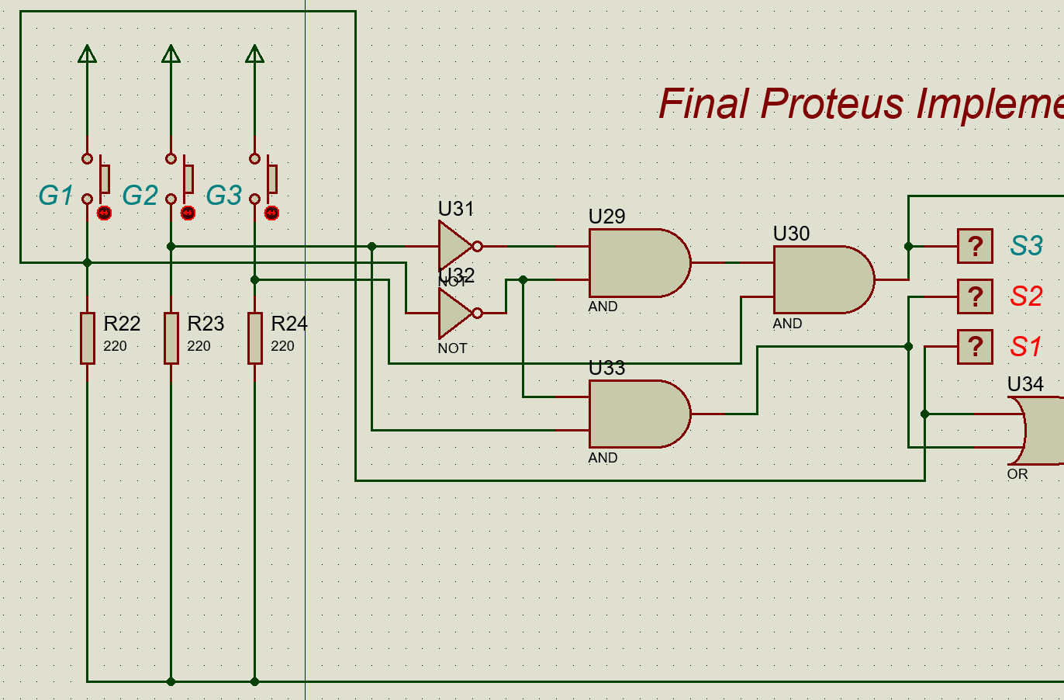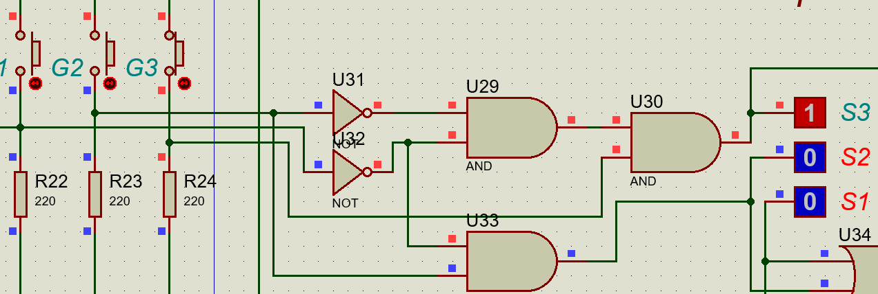
Once we were certain that only the desired gates are activated, we continued implementing the circuit.
Other than the first bit, the testing for the circuit was very straightforward. We simply pressed the buttons and noted the reading on the 7-segment display and the LED.
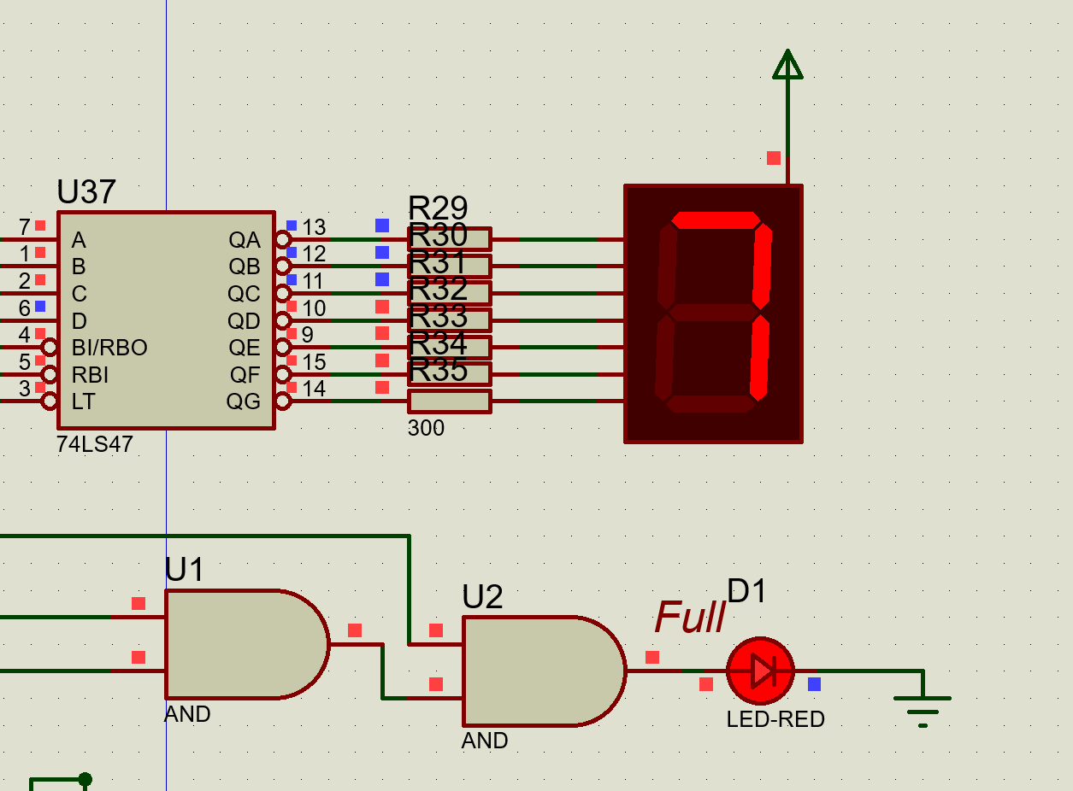

Conclusion
The project solidified our understand of digital logic design, and helped us implement our concepts, translating standalone logic and structured thinking to real life solutions to problems. We learned new things, especially about counters and decoders, and applied this knowledge in real-world context problems. The simulation ran perfectly, demonstrating the reliability of the design.

Thank you.

