Maheen Khan
30021268 Henley Business School
Financial Analysis Project: Investigating Speculative Bubbles

Contents
From Dotcom to AI: Investigating speculative bubbles through monthly volume traded using Google Trends data 2
1. Introduction 2
2. Literature Review 2
3. Data Collection 4
4. Methodology 4
i. Converting Daily Volume to Monthly Volume 4
ii. Normalised Z-Volume Scores 4
iii. Indexing 5
iv. Multicollinearity 5
v. Principal Component Analysis Indexing 6
5. Analysis 7
i. Plotting 7
ii. Summary Statistics 8
iii. Fitted Models 9
a. Nasdaq-100 Companies 9
b. FTSE – 100 Companies 10
iv. Residual Analysis 10
6. Conclusion 11

From Dotcom to AI: Investigating speculative bubbles through monthly volume traded using Google Trends data
  - Evidence from Nasdaq-100 & FTSE-100

Introduction
Speculative trading is defined as the buying or selling of financial assets, commodities or currencies to generate short-term profits from price fluctuations (Chen, 2023). It is a high-risk, high-return and volatility-focused trading strategy derived from market news and investor euphoria. The dot-com bubble was a period of speculative trading in US-based technology stocks in the late 1990s, driven by the rapid rise of internet-based companies with the “.com” suffix (Hayes, 2024). This created investor euphoria about profits based on “anticipated future growth” rather than on fundamental analysis of the companies, creating an overvaluation “bubble”. The bubble burst in 2000, collapsing unprofitable firms and wiping out trillions in investment.
This project investigates the emergence of a contemporary speculative bubble associated with AI, drawing inspiration from the dot-com era. This report aims to analyse the trading volumes of the high-tech index, Nasdaq-100, and the non-tech index, FTSE-100, against Google Trends data on AI-related keywords. This aims at understanding the specific pattern of speculative behaviours associated with bubble dynamics.

Literature Review
Baker and Wurgler (2007) classified six proxies to measure investor sentiment. Trading volume is often seen as a measure of market liquidity. When short selling is more costly or constrained relative to long positions, investors are more inclined to trade during periods of future stock price appreciation, thereby increasing market liquidity (Baker and Stein, 2004). Moreover, an unusually liquid market is indicative of heightened participation of irrational investors who underreact to order flow information (Baker and Stein, 2004), prompting temporarily inflated asset pricing, hence arising speculative trading, conditions that are often associated with the emergence of asset price bubbles within a sector.
Similarly, rationalist economists would argue that high trading volume reflects greater market efficiency and reduces volatility by facilitating price discovery (Raza et al., 2025). This suggests that stocks with higher trading volume may have more stable prices and liquidity, but it still indicates a symmetrical relationship between investor attention and market behaviour. These perspectives suggest that trading volume captures both efficiency-driven and sentiment-driven trading activity, making it a valuable indicator for examining the interaction between investor attention, market behaviour and speculative dynamics.
The current AI hype exhibits the classic signature of a technology bubble, echoing observed patterns of the “Dotcom bubble” in four dimensions: technological promise and overgeneralisation, capital flows, market narratives and commercial viability (Floridi, 2024). This means that hype of AI applications faces accelerated capital inflows, investments and tech -equity trading mirroring a growing “speculative bubble”. However, these market patterns are mostly associated few companies earning heightened stock prices of top tech companies like Nvidia, which has seen exponential growth after 2024 (See Figure 1).
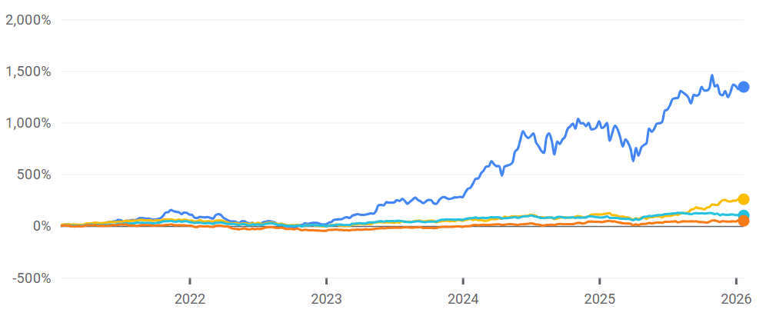
Nvidia Corp
Alphabet Inc
Amazon.com
Microsoft Corp

Figure 1: Stock Prices of Nvidia Corp, Alphabet Inc (Google), Amazon and Microsoft Corp (Google Finance, 2025)
A study written by Jang (2025) concluded that the AI bubble is selective in nature, only notable in Nvidia Corp and Tesla due to their explosive price behaviour and volatility pattern consistent with bubble dynamics. In contrast, other major AI-associated companies like Alphabet, Meta and Microsoft display no speculative trading patterns (Jang, 2025). This concludes that AI hype is firm-specific rather than systematic.
The empirical evidence highlights the investor sentiment around tech companies and the use of volume trading as investor sentiment. However, behavioural economists have also identified Google Search Volume Index as a proxy to measure investor attention influencing stock market behaviour (Raza et al., 2024). Da, Engelberg and Gao (2011) studied the implications of investor attention and stock prices using Google search frequency. The authors found that the search volume index is correlated with existing investor sentiment proxies like volume traded and turnover. Hence, an increase in SVI is linked to higher prices over the 2 weeks, indicating temporary price pressure and capturing attention-related trading.
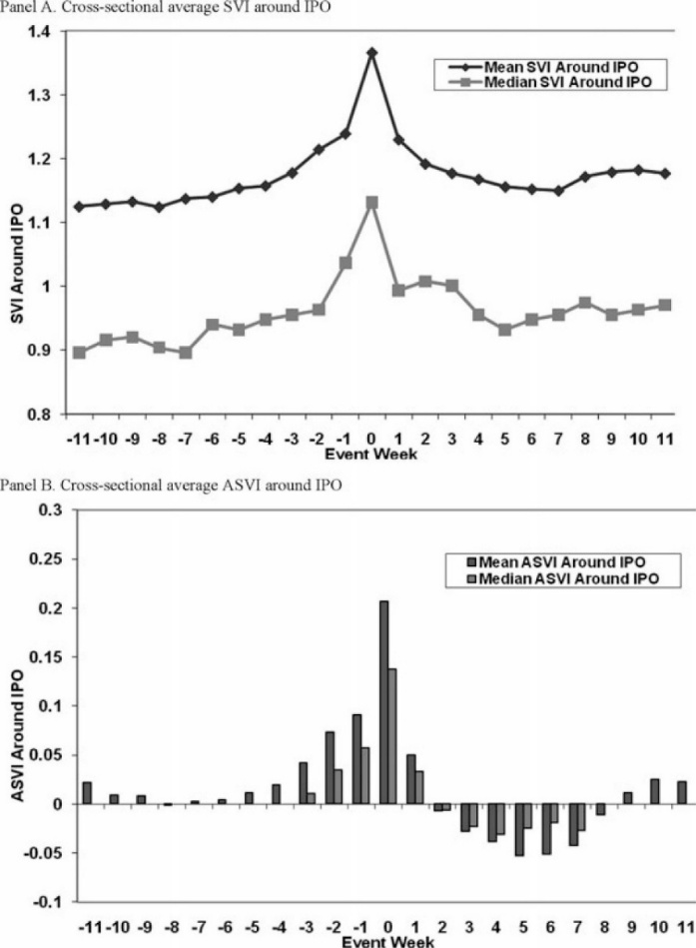
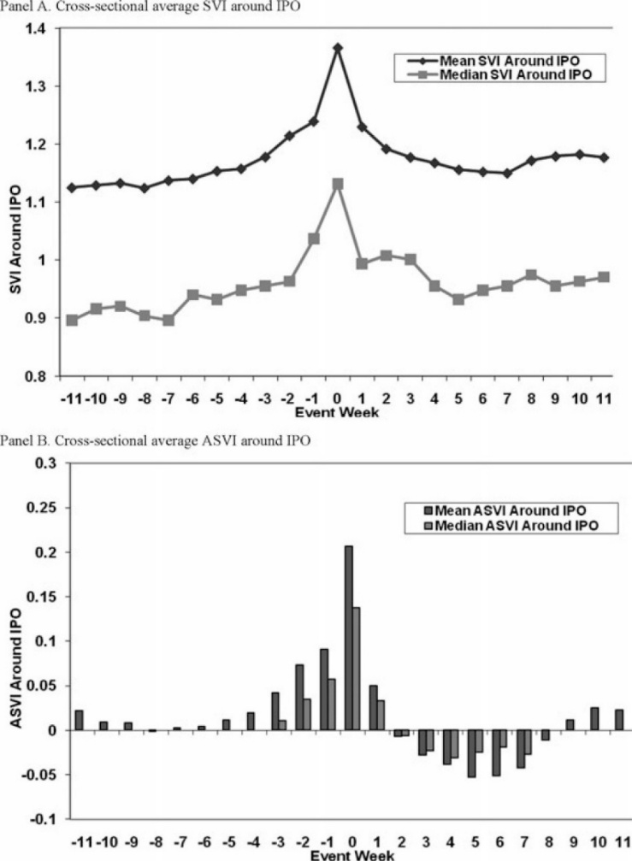
Figure 2 shows that normal and abnormal SVI increase around IPO (Initial Price Offering) event sharply with heightened trading volume, turnover and media coverage (Da et al., 2011). Collectively, the above literature underscores the relevance of trading volume and online search behaviour in explaining investor sentiment and attention influence market dynamics.
Figure 2: Normal and Abnormal Search Volume Intensity (SVI) around (Initial Public Offering) IPO events (Da et al., 2011)

Data Collection
This study uses a quantitative approach to investigate how investor attention influences speculative trading during the period of technological hype from January 2019 to December 2024. It uses the daily volume of firms listed on the Nasdaq-100 and the FTSE-100, sourced from the London Stock Exchange Group via the Eikon API. The Nasdaq-100 serves as a technology-focused index with AI exposure, while the FTSE-100 act as a diversified control group. Only firms continuously listed throughout the sample period are included. Investor attention is measured using region-specific Google Trends data on AI-related Keywords, ensuring geographic alignment across markets.
Dependent Variables: ${Monthly_Volume}_{NAS100} and {Monthly_Volume}_{^FTSE}$
Independent Variables:
$$β_{1}$$ | $$β_{2}$$ | $$β_{3}$$ | $$β_{4}$$ | $$β_{5}$$ | $$β_{6}$$
AI Bubble | Artificial Intelligence | Generative AI | Tech Companies | AI trade | Tech Bubble
Table 1: Google Trends Keywords

Methodology
H1: Are the Monthly Volume of Nasdaq-100 companies influenced more by Google Trend Data than FTSE-100 companies
The hypothesis evaluates whether AI-related Google tends reflect data effects in Nasdaq-100 trading volume more than FTSE-100.

Converting Daily Volume to Monthly Volume
Firstly, the data obtained for 75 Nasdaq-100 companies is in daily frequency, and the data obtained from Google Trends is in monthly frequency. Hence, before fitting the model, the financial variables are first summed across the tickers for days in each month, i.e., the January 2019 observations for each company are added up for every company.
Let:
(4.1)
$$i=1, …, N index firm \left(N=75\right)$$
$$d∊D_{m}index trading days with month m$$
$$V_{i,d}denote the daily volume of firm i on day d$$
$${Vol}_{m}=Monthly Aggregated Volume= \sum_{i=1}^{N}{\sum_{d∊D_{m}}{V_{i,d}}}$$

Normalised Z-Volume Scores
After the monthly aggregation of volume, rather than using the natural logarithm of volume across the firm, normalised volume z-scores are used. Log-transformed trading volume captures overall market liquidity but does not distinguish normal from speculative trading (Karpoff et al., 2008). As the aim of the study is understand abnormal trading activity influenced by AI hype, deriving a bubble formation or speculative trading.
(4.2)
$$Z-{Vol}_{m}=\frac{{Vol}_{m}-μ}{σ},$$
$where μ= \frac{1}{T}\sum_{m=1}^{T}{{Vol}_{m}},$ $σ=\sqrt{\frac{1}{T-1}\sum_{m=1}^{T}{{{(Vol}_{m}-μ)}^{2}}}$
Interpretation:
Date | Z-score of NAS100 Firms | Interpretation
2019-01-31 | 2.67 | Abnormal trading compared to the sample mean
2019 -02-28 | 0.33 | Moderately above the normal sample mean
2019-04-30 | -0.03 | Less than the normal trading volume
Table 2: Monthly Z-Scores of NASDAQ-100 aggregated firms and interpretation

Indexing
The normalised z-scores are computed for both indices; however, the dimensions of the financial panel dataset and the non-financial dataset remain inconsistent. Hence, the monthly Normalised Z-scores are aggregated across the months. This means it assumes equal weight to all the firms' volume z-scores across the same months.
Let:
(4.3)
$$i=1, …, N_{t} index firms at month t \left(N=75\right)$$
$$t=1, …, T index months$$
$$Z_{i,t }denote Volume Z-scores for stock i in month t$$
$${Volume_Index}_{t}=\frac{1}{N}\sum_{i=1}^{N_{t}}{Z_{i,t }}$$
The volume index is created for the FTSE-100 stocks as well.

Multicollinearity
Testing for multicollinearity is essential for model fitting, as my time series regression uses OLS estimation (Ordinary Least Squares). I computed the Pearson Correlation coefficient for every pair of regressors$x_{j}, x_{k}$:
(4.4)
$$ρ_{jk}=\frac{Cov\left(x_{j},x_{k}\right)}{\sqrt{Var(x_{i})Var(x_{k)}}}$$
Correlation matrices (see tables 3 &4) for both the USA and UK Google Trends datasets reveal strong correlation among keywords: Artificial Intelligence, AI bubble, AI Trade, and Generative AI, indicating substantial multicollinearity, reflecting overlap of informational content. Multicollinearity inflates the standard errors of the estimators, giving misleading p-values (Brookes, 2019). To address this, a composite AI index for non-financial data is constructed.

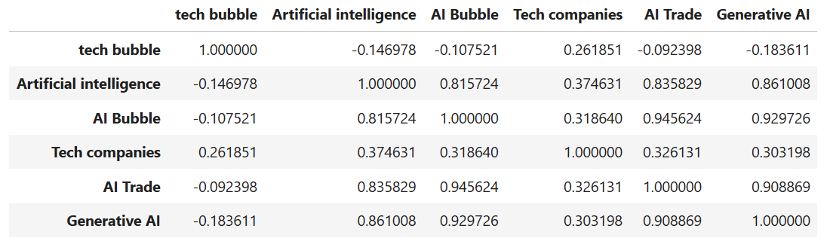
Table 3: Correlation Matrix of Google Trends Data on AI keywords from the USA
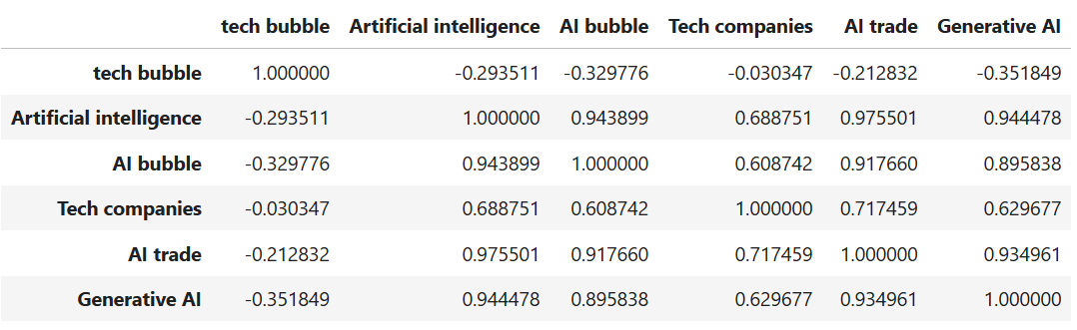
Table 4: Correlation Matrix of Google Trends Data on AI keywords from the UK

Principal Component Analysis Indexing
The above correlation in the non-financial data are supressed following Broker (2019), Principal Component Analysis.
Let $A$ denote the standard AI keywords data. Firstly, a covariance matrix is computed
(4.5)
$$\sum{\frac{1}{n-1}A^{T}A,} (n=months)$$
Then the principal component is obtained by the eigenvalue problem
(4.6)
(4.7)
$$\sum{v_{k}=λ_{k}v_{k},}$$
$λ_{k}$measure variance. The AI index is defined as the first principal component,
$${AI}_{t}=\sum_{j=1}^{p}{A_{tj}v_{1j}}$$
This basically captures the underlying common variance among the AI keywords and puts it in one single index that explains as much variation as possible across all original AI-related variables.
To ensure that the PCA captures the underlying structure of AI‑specific dynamics rather than broader technology‑sector movements, the ‘Tech companies’ variable is excluded from the PCA computation.

Analysis
The methodology structures the data cleaning and manipulation process to engage in model formation between volume Z-Scores of both indices against their respective AI Indices. Firstly, plotting the aggregated monthly volume helps understand the difference between the companies listed on the Nasdaq-100 and the FTSE-100.

Plotting
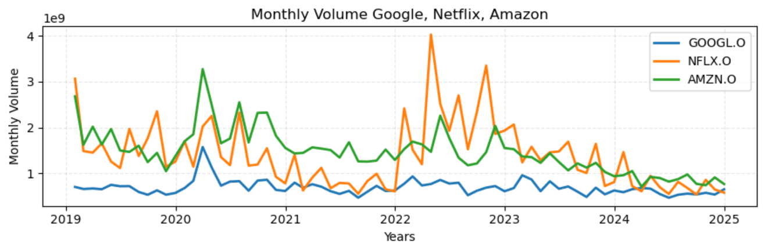
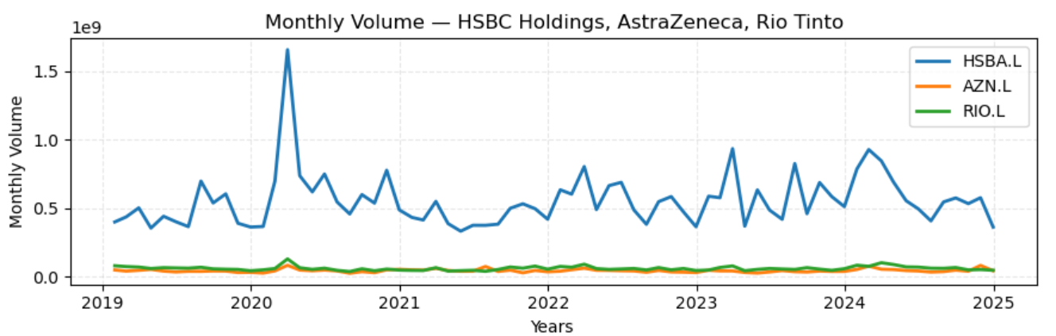
Figure 3: Monthly Volume of Respective Indices
The above figures highlight the difference between the three top-performing companies in both indices. As Nasdaq-100 is a technology-centred index, its top performers are recipients of the tech and entertainment industry, and the constituents of the FTSE-100 are from diverse sectors, the top performers vary from banking, pharmaceutical, and basic material sectors. The volume for the Nasdaq-100 companies reaches above $1 billion; however, UK companies mostly remain below £1 billion.
The following figures show the interest of the AI-related words in the USA and the UK, respectively. It’s clear to see that after 2023, the rise of AI-related words like Generative AI, Artificial Intelligence, and AI Bubble occurred in both regions. This sparked interest is driven by the exposure of investors to ChatGPT in 2022 when it was first introduced (Jang, 2025). The co-movement, as illustrated in the plots, also supports the choice of creating a PCA index for AI-related words.
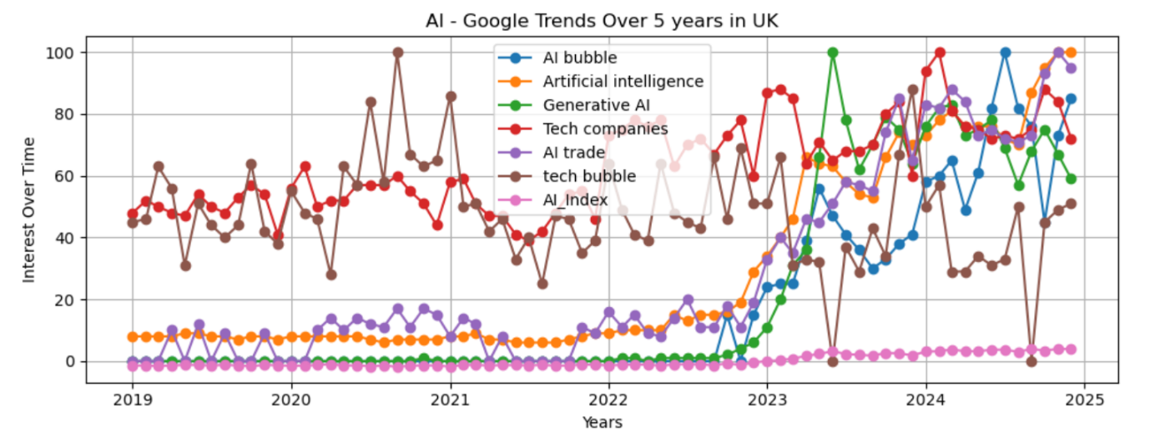
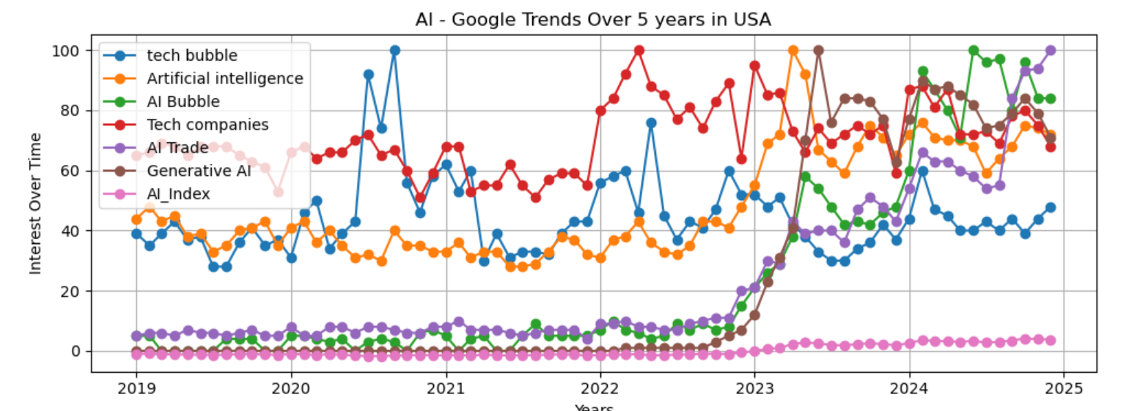
Figure 4: Google Trends Data across the USA and the UK region

Summary Statistics
Summary Statistics of Volume Z-Scores
Statistics | FTSE-100 | Nasdaq-100 | Interpretation
Mean ($μ)$ | -7.40 | -1.36 | A negative mean indicated that, on average, the entire market (75 companies in each index ) traded below its long-run norm  FTSE-100 has a more negative mean than Nasdaq-100, indicating it's experienced even lower trading volume than the norm.
Standard Deviation ($σ)$ | 1 | 1 | The standard deviation of 1 indicated normal dispersion of deviations from the mean.
Skew | 5.80 | 3.84 | High positive skewness shows the presence of extreme values; as such, some months had a surge in trading volume  FTSE-100 had a heavily right-skewed distribution, meaning a small number of months saw a surge when compared to the Nasdaq-100 companies.
Kurtosis | 1.88 | 1.34 | Positive kurtosis confirms that extreme volume spikes occurred more often than in a normal distribution. Nasdaq-100 showed occasional high volume traded with rarer dominance of extreme bursts of high trading volume
Table 5: Summary Statistics of Volume Z-Scores
Summary Statistics of AI Index
Statistics | UK | USA | Interpretation
Mean ($μ)$ | -9.87 | -1.48 | The UK saw below-average interest in AI-related keywords compared to the USA.
Standard Deviation ($σ)$ | 1.10 | 1.93 | The UK have low volatility, meaning across 5 years AI interest remained modest as compared to the USA, which shows a dynamic public shift towards AI.
Skew | -0.84 | -0.87 | Both have a negative low skew, indicating less presence of high AI interest-based surge across months.
Kurtosis | 0.96 | 0.94 | Similarly, positive kurtosis indicated occasional extreme deviation across months in AI interest.
Table 6: Summary Statistics of AI Index

Fitted Models

Nasdaq-100 Companies
$${Volume_Index}_{t}=-2.62+0.037 Tech Companies-0.25{AI}_{t}+ε_{t}$$
Nasdaq-100 Volume Z-Scores Dependent Variable
Variable | Coefficient | T-ratio | P-value | Interpretation
Constant | -2.62 | -3.755 | 0.00*** | High significance
Tech Companies | 0.037 | 3.796 | 0.00*** | High significance increased public interest is associated with higher trading volume across Nasdaq-100 companies.
AI Index | -0.247 | -4.381 | 0.00*** | High significance, the greater AI-related public attention correlated with lower overall trading volume, possibly reflecting investor caution.  Interesting to note that this result confirms the literature on Jang (2025) that AI speculation is more firm-specific than systematic.
Table 7: Fitted Model Summary of Volume Z-Scores of Nasdaq-100 against the USA AI Index
Diagnostic Testing
R-squared | 0.269 = 27% | Only 27% of the variation in Volume Z-scores is illustrated by the regressors, but as they were significant, the fitted model is okay.
F-statistic | 12.70 | Overall, the variables are statistically significant, hence the variables jointly explain a meaningful portion of the variation
Durbin-Watson Test Statistics | 1.030 | Positive Correlation, indicating errors are not independent over time, giving me biased estimators, hence indicating the need to use HAC (heteroskedasticity autocorrelation consistent errors)
Jarque-Bera Test Statistics | 202.422 | The residuals are not normally distributed as indicated by skewness and kurtosis. This affects the robustness of standard errors.
Table 8: Diagnostic Testing

FTSE – 100 Companies
$${Volume_Index}_{t}=-1.68+0.03 Tech Companies{-0.05AI}_{t}+ε_{t}$$
FTSE-100 Volume Z-Scores Dependent Variable
Variable | Coefficient | T-ratio | P-value | Interpretation
Constant | -1.68 | -2.49 | 0.015 | Not significant
Tech Companies | 0.03 | 2.52 | 0.014 | Not statistically significant, although it carries a weak association of public interest in Tech companies with higher FTSE-100 trading volume.
AI Index | -0.05 | -0.72 | 0.475 | Not statistically significant. This implies AI-related public attention does not influence trading activity in the FTSE100 index.
Diagnostic Testing
R-squared | 0.103= 10.3% | Weak explanatory power of regressors in explaining the variation of trading volume
F-statistic | 3.96 | Suggests evidence that variables are jointly significant, but only to some extent
Durbin-Watson Test Statistics | 1.37 | Positive Autocorrelation violated the OLS assumption of independent errors
Jarque-Bera Test Statistics | 298.9 | Highly non-normal error distribution, this also supports that HAC standard errors are more appropriate
Table 9: Fitted Model Summary of Volume Z-Scores of FTSE-100 against the UAI Index
Table 10: Diagnostic Testing
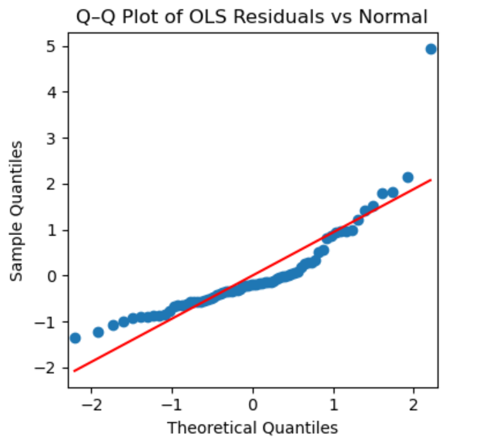
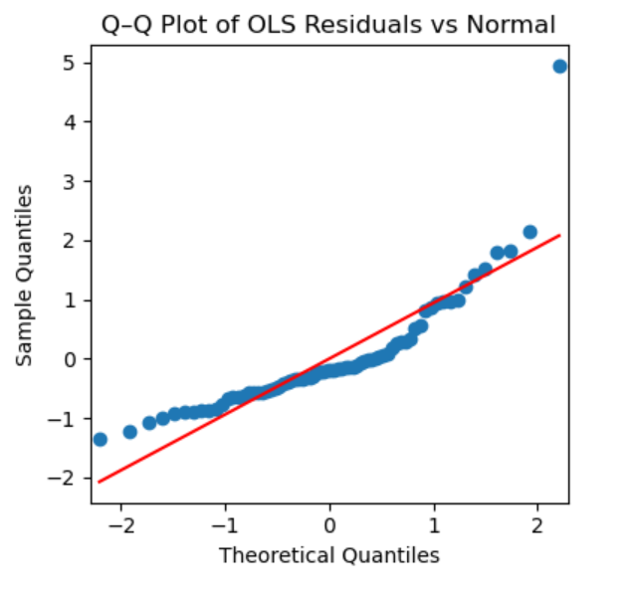
- Residual Analysis
Figure 5: QQ-Plot of FTSE-100 and Nasdaq-100 Fitted Model Residuals
The QQ-plot shows that most residuals lie close to the theoretical normal line, but the deviations suggest the presence of non-normality and outliers. This undermines the reliability of standard OLS estimators and suggests the use of HAC errors. However, the normalisation of Volume and PCA-derived AI index exhibits non-Gaussian features, meaning it does not follow a normal distribution(Brookes, 2019). These characteristics can propagate into regression residuals even with corrected robust errors. The normality fails due to dependent and independent variables containing extreme values.

Conclusion
In conclusion, the findings show that AI-related investor attention influences trading behaviour unevenly across the indices. It is weakly negative influence on Nasdaq-100 but no significant influence on FTSE-100 companies. These findings suggest that Nasdaq-100 volumes have a significant relationship between tech sector interest and PCA-derived AI index, weakly suggesting speculative dynamics, but the investor focus is heavier due to interest in the Technological Sector. This also iterated the literature represented by Jang (2025) that a few firms with explosive volatility, like Nvidia, possess speculative and AI bubble dynamics rather than the market collective. In contrast, FTSE-100 volumes show no sensitivity to AI attention, reinforcing the view that current AI hype is selective to specific firms. Although diagnostic tests highlight the limitation in the model precision, the plotting and summary statistics support the hypothesis that AI-driven speculation is stronger in a tech-centric market than in diversified indices.

References:
Baker, M. & Wurgler, J. (2007). ‘Investor Sentiment in the Stock Market’. Journal of Economic Perspectives, 21(2), 129–151.
Baker, M. and Stein, J.C. (2004). ‘Market liquidity as a sentiment indicator’. Journal of Financial Markets, 7(3), pp.271–299. Available at: HTTPs://doi.org/10.1016/j.finmar.2003.11.005.
Chen, J. (2023). ‘Speculation: Trading with High Risks, High Potential Rewards’. [online] Investopedia. Available at: https://www.investopedia.com/terms/s/speculation.asp.
Da, Z., Engelberg, J. and Gao, P. (2011). ‘In Search of Attention’. The Journal of Finance, 66(5), pp.1461–1499. Available at: HTTPs://doi.org/10.1111/j.1540-6261.2011.01679.x
Floridi, L. (2024). Why the AI Hype is Another Tech Bubble. Philosophy & Technology, 37(4). Available at: HTTPs://doi.org/10.1007/s13347-024-00817-w.
Google (2023). Google Finance - Stock Market Prices, Real-time Quotes & Business News. www.google.com. Available at: https://www.google.com/finance/?hl=en.
Hayes, A. (2024). ‘Dotcom Bubble Definition’. [online] Investopedia. Available at: https://www.investopedia.com/terms/d/dotcom-bubble.asp.
Jung, W. (2025). Is the AI bubble Real? A Time Series Analysis on Unit Root Process and Volatility of Financial Bubble Dynamics. Available at: HTTPs://doi.org/10.2139/ssrn.5340813
Karpoff, J.M. and Walkling, R.A. (1988). Short-term trading around ex-dividend days. Journal of Financial Economics, 21(2), pp.291–298. Available at: https://doi.org/10.1016/0304-405x(88)90063-3
Raza, S., Baiqing, S., Soltani, H. and Ben-Salha, O. (2025). ‘Investor Attention, Market Dynamics, and Behavioural Insights: A Study Using Google Search Volume’. Systems,13(4), p.252. Available at: HTTPs://doi.org/10.3390/systems13040252.

