# Assignment # 02

## Scenario: Web Development Team Management

## Name Maheen Abdul Razzaq

# **Task 01**

**mkdir /var/www/ProjectX**  
➤ Creates a new directory for ProjectX at the specified path.

**cd /var/www/ProjectX**  
➤ Navigates into the newly created ProjectX directory.

**touch index.html app.py README.md**  
➤ Creates empty frontend and backend files for the project.

**pwd**  
➤ Displays the current working directory path.

**ls -l**  
➤ Lists files with detailed info like permissions, owner, size, and modification time.

**df -h**  
➤ Shows disk space usage in human-readable format (e.g., GB, MB).

**echo "Welcome to ProjectX" > README.md**  
➤ Writes the welcome message into the README.md file (overwriting any existing content).

**cat README.md**  
➤ Displays the contents of the README.md file in the terminal.

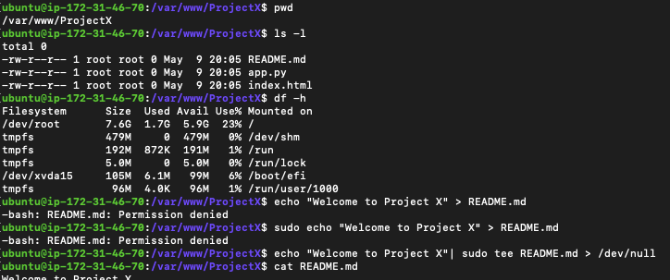

# **Task 02**

**User and Group Permission**

**Management**

**groupadd devteam**  
➤ Creates a new group named devteam.

**useradd bhatti and useradd malik**  
➤ Adds new users bhatti and malik to the system.

**usermod -aG devteam bhatti and usermod -aG devteam malik**  
➤ Adds bhatti and malik to the devteam group without removing them from other groups.

**chgrp -R devteam /var/www/ProjectX**  
➤ Changes the group ownership of the ProjectX directory and its contents to devteam.

**chmod -R 770 /var/www/ProjectX**  
➤ Gives read/write/execute permission to owner and group, and no permission to others.

**ls -ld /var/www/ProjectX**  
➤ Lists directory details to verify permissions and group ownership.

**groups bhatti**  
➤ Displays the groups the user bhatti belongs to.

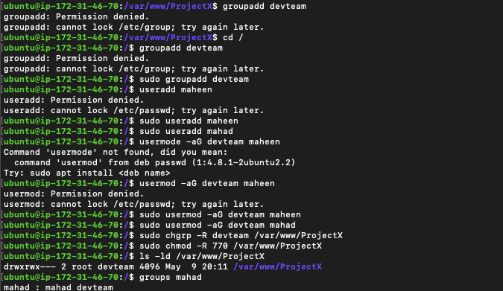

# **Task 03**

**Change Ownership**

**chown -R bhatti:devteam /var/www/ProjectX**  
➤ Makes bhatti the owner and devteam the group of all files and folders in ProjectX.

**ls -l /var/www/ProjectX**  
➤ Shows updated ownership and permissions for each file in the directory.

**su - bhatti**  
➤ Switches to the user account bhatti (requires password).

**cd /var/www/ProjectX**  
➤ Moves into the project directory as user bhatti.

**touch config.yaml**  
➤ Creates a new configuration file in the project directory.

**ls -l**  
➤ Confirms the file creation and ownership under user bhatti.

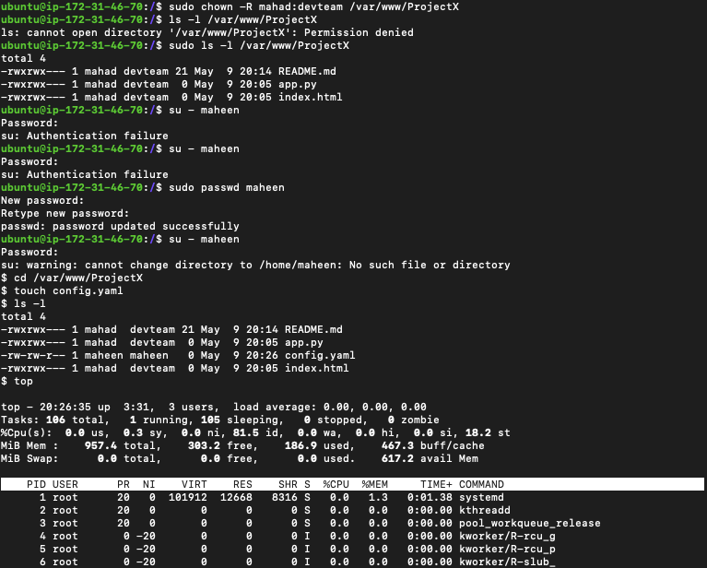

# **Task 04**

**System-Level Commands**

**top**  
➤ Continuously displays real-time system performance including CPU and memory usage.

**ps aux | grep ProjectX**  
➤ Searches and lists any running processes related to ProjectX.

**tail -n 50 /var/log/syslog**  
➤ Displays the last 50 lines of the system log for troubleshooting purposes.