Netflix: case study

**Netflix** was originally a DVD shipping business where they would send out DVDs of your chosen programs to you. This was going well until 2008 where they experienced a major database loss and for 3 days could not ship out any DVDs to their customers.

**They chose Amazon Web Services despite having Amazon as a competitor (Amazon has their own streaming service known as Amazon Prime) because AWS provided them with the greatest scaling capabilities and the biggest set of available features.** It took 7 years of migration for Netflix to shut down their last remaining data centers and move completely to the cloud.

**Netflix has expanded into 130 new countries.**It uses multiple AWS Cloud regions which are spread all over the world to create a better and more enjoyable streaming experience for Netflix members wherever they are.

Netflix relies on Cloud for all its **scalability**, **computing**, and **storage needs** (not only video streaming) — Netflix **business logic**, **distributed databases**, **big data processing**, **analytics**, **recommendations**, **transcoding**, and hundreds of other functions that are used by Netflix all go through their Cloud infrastructure. Netflix also has its own Content Delivery Network (CDN) known as Netflix Open Connect which is used to deliver videos globally in an efficient manner.

[Netflix](http://www.netflix.com/) is the world’s leading internet television network, with more than**100 million members**in more than **190 countries** enjoying **125 million hours of TV shows and movies each day**. Netflix uses AWS for nearly all its computing and storage needs, including databases, analytics, recommendation engines, video transcoding, and more — hundreds of functions that in total use more than **100,000 server instances on AWS.**

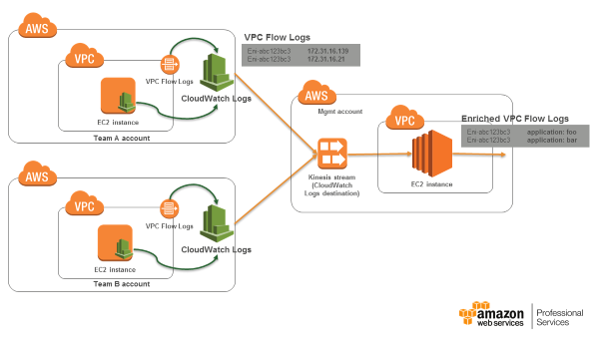

(Netflix Uses NICE DCV on AWS to Build VFX Studio in the Cloud for Artists Globally)

Netflix and AWS

Netflix revealed it would spend over [$1 billion](https://www.sec.gov/ix?doc=/Archives/edgar/data/1065280/000106528020000155/form10qq120.htm) on “streaming services and cloud computing costs” through 2023. That would average Netflix’s AWS cloud services costs at over $27.78 million per month.

It is no wonder Amazon boasts Netflix as its [biggest AWS customer](https://aws.amazon.com/solutions/case-studies/netflix-case-study/) regularly, despite owning a competing service in Amazon Prime. In comparison, [Airbnb plans](https://www.businessinsider.com/airbnb-ipo-amazon-web-services-cloud-computing-spending-2020-11) to spend $1.2 billion on AWS web services before 2027, which averages out to $16.67 million per month.

Netflix uses AWS for almost everything cloud computing. That includes online storage, [recommendation engine](https://neilpatel.com/blog/how-netflix-uses-analytics/), video transcoding, databases, and analytics. So most of the $1 billion Netflix plans to spend on cloud services will go to Amazon Cloud Services.

How much Netflix's AWS bill costs reflects its utilization of [over 100,000 server instances](https://aws.amazon.com/solutions/case-studies/netflix/), according to Amazon Web Services.

To process the colossal traffic, its global subscribers generate, Netflix uses over 1,000 Amazon Kinesis shards in parallel.

`