Project Title: Student Learning Activity and Course Relationship Tracker Using Neo4j
Project will be a web application where students can:
- Add and manage their courses.
- Record daily study activities.
- Track the time spent studying each course.
- View their study history.
- See relationships between students, courses, and learning activities.
- Update or delete study records.
Component | Technology
Frontend | HTML, CSS, JavaScript
Backend | Python with Flask
Database | Neo4j
Query Language | Cypher
Database Management | Neo4j Browser
Development Tool | VS Code
Version Control | Git and GitHub

Graduate NoSQL Database Project – Progress Report

1. Project Title
Student Learning Activity and Course Relationship Tracker Using Neo4j

2. List of Group Members
- Mahek Patel
- Yashvi Patel
- Rishikesh Pathak

3. Database in Use
Neo4j – Graph-Based NoSQL Database

4. Summary of Project
Our project aims to develop a web-based Student Learning Activity and Course Relationship Tracker using Neo4j. The application will allow students to manage their courses, record daily learning activities, track study duration, and monitor their academic progress. Neo4j will store students, courses, and learning activities as nodes connected through relationships. We plan to use Python and Flask for backend development and HTML, CSS, and JavaScript for frontend development. The application will demonstrate database operations such as creating, retrieving, updating, and deleting records using Neo4j’s Cypher query language.

5. NoSQL Use Case
Neo4j is a graph-based NoSQL database that stores information using nodes, relationships, and properties. In our project, Student, Course, and LearningActivity will be represented as nodes. Relationships such as ENROLLED_IN, COMPLETED, and FOR_COURSE will connect these nodes.
Neo4j is beneficial for our project because it allows us to represent and retrieve connections between students, courses, and learning activities efficiently. Its graph structure makes it easier to explore relationships and analyze learning patterns without requiring complex relational joins. We will use Cypher queries to create, retrieve, update, and delete student learning records.

6. Member Roles
Member 1: Mahek Patel – Backend Development and Database Integration
Responsible for developing the Python Flask backend, integrating Neo4j, implementing Cypher queries, and assisting with frontend development.
Member 2: Yashvi Patel– Frontend Development
Responsible for developing the user interface using HTML, CSS, and JavaScript, implementing course management features, and assisting with Flask backend and Neo4j database operations.
Member 3: Rishikesh Pathak – Database Design, Testing, and Documentation
Responsible for designing Neo4j nodes and relationships, implementing Cypher queries for learning activity tracking, assisting with frontend and backend development, and testing.
All group members will collaborate on application integration, testing, GitHub documentation, and the final presentation.

7. Current Project Progress
We have completed the initial setup and configuration of Neo4j Desktop on macOS. A local Neo4j instance named StudentLearningTracker has been created successfully.
We have also implemented the initial graph database structure using Cypher queries.
The database currently contains:
- 3 nodes: Student, Course, and LearningActivity.
- 3 relationships: ENROLLED_IN, COMPLETED, and FOR_COURSE.
We successfully executed Cypher queries to create nodes, establish relationships, and retrieve the connected graph.
The initial graph visualization confirms that the database structure is working correctly.
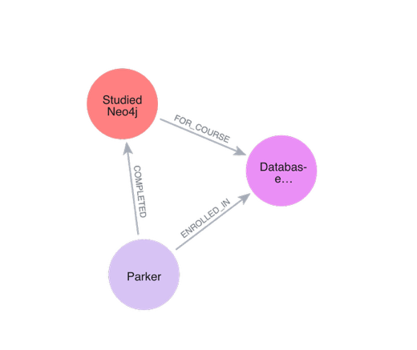
Our next steps include developing the frontend and backend, integrating Python Flask with Neo4j, implementing CRUD operations, and testing the complete application.

