Symbiosis Institute of Technology, Nagpur
PREDICTIVE ANALYTICS PROJECT REPORT
for
Bachelor of Technology
in
Computer Science and Engineering
Batch 2023-27
on

An End-to-End Predictive Analytics Model for E-Commerce Purchase Intention Prediction
Submitted by
Name: Mahek Shah
PRN: 23070521086
Semester: VII
Course: Predictive Analytics
Institute Guide
Dr. Deepak Asudani


Symbiosis International (Deemed University), Pune

Chapter 1: Introduction

1.1 Background
E-commerce platforms log every visitor interaction during a browsing session, pages viewed, time spent, bounce and exit behavior, and traffic source. These session-level attributes contain latent signals about a visitor's purchase intent, but that intent is not directly observable until a transaction occurs or the session ends. Manually identifying which sessions are likely to convert is infeasible at scale, which motivates a predictive, data-driven approach.
Global e-commerce retail sales have grown to represent a substantial and still-rising share of total retail trade, and this growth has been accompanied by an equally large expansion in the volume of behavioral data that online retailers collect. Every click, scroll, page view, and pause is, in principle, a data point; in practice, the overwhelming majority of this data goes unused for decision-making because it is unstructured in intent, noisy, and collected at a scale that exceeds manual or rule-based analysis. Traditional business intelligence approaches, dashboards, fixed-rule segmentation, simple funnel reports, summarize what happened in aggregate but cannot, on their own, estimate the likelihood that a specific, currently active session will convert. This is precisely the gap that predictive, machine-learning-based analytics fills: by learning statistical regularities from historical sessions whose outcomes are already known, a model can generalize those regularities to new, in-progress sessions and output a probability of purchase, which downstream systems can act on immediately.

1.2 Problem Statement
E-commerce websites generate large amounts of visitor browsing and session data, but it is difficult to determine which browsing sessions are likely to result in a purchase.
The difficulty is threefold. First, purchase intent is latent, it is a mental state of the visitor that is never directly observed, only inferred from indirect behavioral proxies such as dwell time or page-value accumulation. Second, the signal is imbalanced: the overwhelming majority of browsing sessions, across virtually every e-commerce vertical, do not end in a purchase (15.6% of sessions in one dataset used here and only 4.2% of users in the other), so any naive analysis is dominated by the non-converting majority and risks overlooking the comparatively rare but commercially important converting minority. Third, the relationship between browsing behavior and purchase outcome is non-linear and interactive, for instance, a long session duration is a positive signal only when combined with meaningful product engagement (high PageValues), but on its own can equally indicate a confused or lost visitor. These three properties together place purchase-intent prediction squarely in the domain of supervised machine learning rather than simple rule-based heuristics or descriptive statistics.

1.3 Objectives
The primary objective of this project is to develop an end-to-end predictive analytics model to predict whether an e-commerce browsing session will result in a purchase based on visitor behavior and session-level attributes. The study follows the Knowledge Discovery in Databases (KDD) process to develop a reliable classification model and tests it on two independent datasets with very different class imbalance.
The specific objectives of the study are:
• To analyze and preprocess two e-commerce datasets, a clickstream purchase-propensity dataset (Dataset 1) and the Online Shoppers Purchasing Intention dataset (Dataset 2), by handling duplicates, checking for missing values, and performing exploratory data analysis.
• To engineer meaningful behavioral features and apply appropriate encoding and scaling techniques for model development.
• To develop and compare five classifiers, Logistic Regression, Random Forest, Gradient Boosting, Support Vector Machine (SVM), and XGBoost, while addressing class imbalance through cost-sensitive class weighting.
• To select the decision threshold of every model on a separate validation set and to select the final model for each dataset by validation F1-score, keeping the test set untouched until final reporting.
• To evaluate the final models using classification metrics, compare all models across both datasets, and identify the important factors influencing purchase intention.

1.4 Scope of the Study
The study uses two datasets. Dataset 1 is a clickstream purchase-propensity dataset of 455,401 users with 25 columns, whose target variable ordered records whether the user placed an order. Dataset 2 is the publicly available Online Shoppers Purchasing Intention Dataset (UCI Machine Learning Repository), consisting of 12,330 sessions and 18 attributes collected over one year from a shopping portal. The scope covers the full predictive analytics lifecycle, from raw data to an evaluated classification model, and is restricted to session-level, tabular behavioral features.
This boundary is intentional rather than a weakness of design: it allows the study to establish a rigorous, reproducible baseline using only the attributes a typical web-analytics platform (e.g., Google Analytics) already captures by default, without requiring custom event-tracking infrastructure. The 18 raw attributes of Dataset 2 span four conceptual groups, page-interaction counts and durations across three page categories (Administrative, Informational, Product-Related), aggregate engagement-quality metrics (BounceRates, ExitRates, PageValues), temporal/seasonal context (Month, SpecialDay, Weekend), and visitor/technical context (VisitorType, OperatingSystems, Browser, Region, TrafficType). Its target variable, Revenue, is a Boolean flag recording whether the session culminated in a completed transaction. The predictors of Dataset 1 are mostly binary and count indicators of on-site actions, for example basket clicks, delivery and returns information checks, sign-in, checkout and device type.

1.5 Significance of the Study
An accurate purchase-intent model lets an e-commerce business prioritize marketing spend, trigger real-time interventions for high-intent sessions, and understand which browsing behaviors most strongly precede a purchase, turning raw session logs into actionable business intelligence.
Beyond the immediate use cases already noted, a validated purchase-intent model has three further practical implications. First, it enables dynamic personalization: sessions scored as high-intent can be shown different content (urgency messaging, simplified checkout) than low-intent sessions, without requiring a human analyst to define these segments manually. Second, it supports resource allocation: customer-support or live-chat capacity, which is finite, can be routed preferentially toward high-probability-of-purchase visitors who are struggling (e.g., high ExitRates combined with high PageValues). Third, the feature-importance analysis performed as part of model interpretation (Section 4.7) itself constitutes a business deliverable independent of the predictive model, it tells a product or UX team which aspects of the site experience most strongly precede a sale, informing where design and content investment should be prioritized. Evaluating the same workflow on two datasets additionally shows how far the conclusions generalise beyond a single data source.

Chapter 2: Literature Review

2.1 Purchase Intention Prediction
Sakar et al. (2019) introduced the Online Shoppers Purchasing Intention dataset used in this study as Dataset 2, combining a multilayer perceptron with a Long Short-Term Memory (LSTM) architecture to model session sequences, and reported that PageValues, ExitRates and session duration were the strongest predictors of purchase. This finding is consistent with the feature-importance results obtained in the present study (Chapter 4), where PageValues and the engineered PageValuePerProductPage feature dominate the ranking for Dataset 2.
Their study is notable for being the origin of the dataset used here, and for an early empirical demonstration that deep sequential models (LSTM) offer only marginal improvement over simpler feed-forward architectures on this particular feature set, a result that foreshadows a central finding of the present study (Section 4.8): once the signal available in session-level aggregate features is exhausted, additional model complexity yields diminishing returns, regardless of architecture. This suggests the binding constraint on achievable performance for this dataset is the information content of the features themselves, not the sophistication of the learning algorithm applied to them.

2.2 Classical Machine Learning Approaches
Subsequent work on the same dataset has largely relied on classical supervised learning: Logistic Regression as an interpretable baseline, Support Vector Machines (Cortes & Vapnik, 1995) for margin-based non-linear classification, Decision Trees and Random Forests for non-linear, rule-based splits, and Gradient Boosting variants (Friedman, 2001; XGBoost, LightGBM, CatBoost) for state-of-the-art tabular performance. Across this literature, tree-ensemble and boosting methods consistently outperform linear models on this type of imbalanced, mixed-type session data, typically achieving ROC-AUC in the 0.90-0.94 range and F1-scores of 0.60-0.70 on the minority (purchase) class.
The theoretical basis for this consistent advantage is well understood: purchase decisions depend on interactions between behavioral signals (for example, high engagement duration matters differently depending on whether PageValues is also high), and tree-based methods partition the feature space recursively, naturally capturing such interactions without requiring them to be hand-engineered as polynomial or cross-product terms, as a linear model would. Logistic Regression, by contrast, remains valuable in this literature not for raw predictive power but for its coefficient interpretability and its function as a sanity-check baseline: if a complex ensemble fails to meaningfully outperform logistic regression, that is itself diagnostic evidence that the available features carry limited additional non-linear signal.

2.3 Class Imbalance in E-commerce Data
A recurring challenge in this literature is severe class imbalance, purchases typically represent only 10-20% of sessions, and far less in user-level propensity data. Commonly applied remedies include cost-sensitive learning (class weighting), threshold moving, and synthetic oversampling methods such as SMOTE (Chawla et al., 2002; He & Garcia, 2009). Comparative studies generally find that SMOTE and its variants (Borderline-SMOTE, ADASYN) provide modest but consistent improvements to recall and F1-score over doing nothing, while class weighting and threshold moving often achieve comparable results at lower cost.
A further recurring theme in this literature is the distinction between data-level interventions (resampling: SMOTE, undersampling) and algorithm-level interventions (cost-sensitive learning: class weights, scale_pos_weight in XGBoost). Theoretically, both approaches aim to counteract the same underlying problem, a loss function that, left uncorrected, is dominated by the majority class and so drives the decision boundary toward classifying everything as the majority outcome, but they intervene at different points in the pipeline. Data-level methods reshape the training distribution the model ever sees; algorithm-level methods leave the distribution untouched but reweight how costly each class's errors are treated during optimisation. This study adopts the algorithm-level route, because every one of the five model families used here supports it natively (class_weight in scikit-learn, scale_pos_weight in XGBoost), it generates no synthetic records and scales to the 455,401-user Dataset 1, and it is combined with explicit threshold tuning on a validation set. Precision-recall based measures are reported alongside ROC-AUC, since PR curves are more informative than ROC curves on highly imbalanced data (Saito & Rehmsmeier, 2015).

2.4 Comparison of Existing and Proposed Solutions
Table 2.1 compares common approaches reported in existing purchase-intention research with the integrated workflow adopted in this project. The comparison highlights the project's implementation choices rather than claiming that individual techniques are entirely new.
Table 2.1: Comparison of Existing and Proposed Solutions
Comparison factor | Existing solutions | Proposed solution
Prediction models | Prior studies have explored classifiers such as Logistic Regression, Random Forest, support vector machines, neural networks, and gradient-boosting methods. | Compares Logistic Regression, Random Forest, Gradient Boosting, SVM, and XGBoost using one consistent evaluation workflow on two datasets.
Data preprocessing | Preprocessing, encoding, feature selection, and feature construction vary across studies. | Performs duplicate handling, missing-value checks, exploratory data analysis, behavioural feature engineering, one-hot encoding (Dataset 2), and standardisation for the scale-sensitive models.
Class imbalance | Research has investigated approaches such as class weighting, resampling, and SMOTE. | Uses cost-sensitive class weighting inside each model (class_weight / scale_pos_weight), so no synthetic data is created and the same strategy works on 12 thousand and 455 thousand rows.
Model optimisation | Studies use different validation strategies and hyperparameter-tuning methods; decision thresholds are not always calibrated explicitly. | Uses a stratified 60/20/20 train/validation/test split; the decision threshold of every model is tuned on the validation set (maximum F1) and the final model is the one with the best validation F1.
Evaluation | Common evaluation measures include accuracy, precision, recall, F1-score, and ROC-AUC. | Reports accuracy, precision, recall, F1-score, ROC-AUC, PR-AUC, and the confusion matrix on a test set used once, plus a validation-versus-test generalisation check.
Interpretation | Many studies aim to identify likely purchasers and derive insights that may support marketing decisions. | Examines permutation feature importance of the final model on each dataset to identify behavioural and session-level factors associated with purchase intention.

The proposed contribution is the integration of these steps in one reproducible workflow, including cost-sensitive learning, explicit validation-based threshold optimization and a two-dataset comparison, rather than the introduction of a new classification algorithm.

2.5 Research Gap
Most published work evaluates a single modelling strategy on a single dataset rather than systematically comparing model families and decision-threshold calibration together under the same protocol. This study addresses that gap by empirically comparing five model families on two datasets with very different class balance (15.6% and 4.2% positives) under an identical, leakage-free evaluation protocol, and selecting the final model on validation performance rather than on the test set.
A second gap concerns decision-threshold calibration. The great majority of published studies on this dataset report metrics at the conventional 0.5 probability threshold without examining whether that threshold is appropriate given the severe class imbalance and the asymmetric real-world cost of false negatives versus false positives. This study closes that gap by explicitly optimizing the decision threshold on a held-out validation set (Section 4.5), rather than treating 0.5 as a fixed convention, and by reporting the resulting shift in the precision-recall trade-off transparently.

Chapter 3: Predictive Modelling Process
The project follows the standard Knowledge Discovery in Databases (KDD) process shown in Fig 3.1, adapted into nine concrete stages for this predictive analytics task. The same nine stages are applied to both datasets.

3.1 Overall KDD Workflow
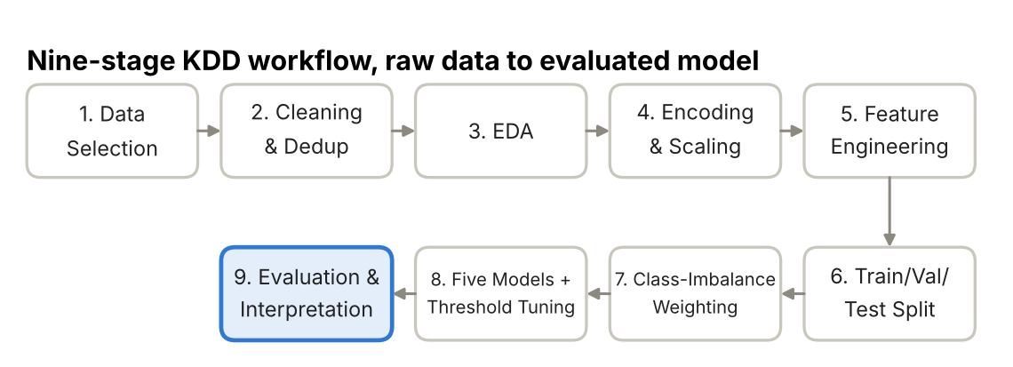
Fig 3.1: KDD workflow · 9 stages, raw data to evaluated model

3.2 Stage Details
1. Data Selection and Understanding. Dataset 1 (455,401 users, 25 columns) and Dataset 2, the Online Shoppers Purchasing Intention dataset (12,330 sessions, 18 attributes), were loaded and profiled: data types, missing values, and the target class distribution were examined.
This stage exists to answer a foundational question before any modelling is attempted: is each dataset actually fit for the stated objective? Profiling confirmed that Dataset 1 consists of numeric and binary action indicators and that Dataset 2 has mixed types (numeric, Boolean, categorical string), that neither has structural anomalies such as impossible negative durations, and that both have a usable sample size for a train/validation/test strategy. The target class distribution check is particularly critical, since it determines, from the outset, that this is an imbalanced-classification problem (4.2% positives in Dataset 1, 15.6% in Dataset 2) requiring the dedicated remedial stages (Stage 7) built into the rest of the pipeline.
2. Data Cleaning and Duplicate Handling. No missing values were found in either dataset. In Dataset 1 no duplicate users were found (checked on UserID), so all 455,401 users were kept. In Dataset 2, 125 exact duplicate rows (1.0% of records) were identified and removed, leaving 12,205 sessions.
Duplicate rows arise in web-analytics exports for several plausible reasons, repeated logging on page refresh, export-pipeline retries, or genuinely identical anonymous sessions from automated traffic, and if left in place, they would cause the same session to appear in both the training and test partitions after a naive random split, silently inflating the apparent test-set performance (a specific form of data leakage). Removing exact duplicates before the data split, rather than after, is therefore a necessary precaution, not merely a cosmetic cleaning step.
Figure 3.2 below details Stages 1-5 as implemented for both datasets, including the exact missing-value and duplicate-handling checks and the final engineered feature sets.
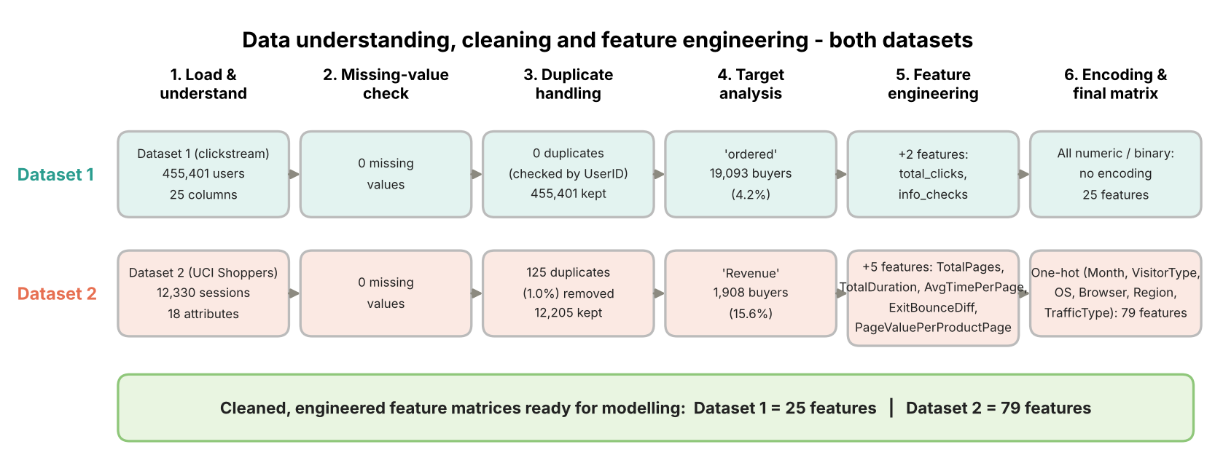
Fig. 3.2: Data understanding, cleaning, exploratory analysis, and feature engineering workflow for both datasets

3. Exploratory Data Analysis (EDA). Class balance, the train/validation/test partition, and the correlation of each feature with the target were visualised for both datasets (Section 4.1).
EDA serves two purposes here: it validates assumptions the later feature-engineering and modelling stages depend on (for instance, confirming that PageValues in Dataset 2 and checkout and delivery-information actions in Dataset 1 are visibly associated with the target, which justifies treating them as primary predictive signals), and it surfaces potential preprocessing concerns such as the strong correlation between BounceRates and ExitRates in Dataset 2 (r = 0.90), which informs how those features are later combined.
4. Categorical Encoding and Numerical Preprocessing. Dataset 1 contains only numeric and binary columns, so no encoding was needed. In Dataset 2 the Weekend flag was converted to 0/1 and six categorical features (Month, VisitorType, OperatingSystems, Browser, Region, TrafficType) were one-hot encoded, giving 79 model inputs. Standardisation with StandardScaler is applied inside the Logistic Regression and SVM pipelines.
Standardisation (zero mean, unit variance) is necessary for these two models because Logistic Regression's gradient-based optimiser converges faster and more reliably when features share a comparable scale, and because the SVM's RBF kernel is distance-based, so features with large raw magnitudes would otherwise dominate (SpecialDay ranges 0-1, while ProductRelated_Duration can run into the thousands of seconds). Tree-based models (Random Forest, Gradient Boosting, XGBoost) are scale-invariant and receive the unscaled features. One-hot encoding is required for the categorical features because these models cannot interpret an arbitrary integer code (e.g., Month = 3) as carrying a meaningful ordinal relationship; one-hot encoding represents each category as an independent binary indicator, removing any spurious ordinality.
5. Feature Engineering. For Dataset 2, five derived features were constructed: TotalPages, TotalDuration, AvgTimePerPage, ExitBounceDiff (ExitRates − BounceRates), and PageValuePerProductPage. For Dataset 1, two aggregate features were constructed: total_clicks (the sum of ten click and action counters) and info_checks (the sum of the delivery-detail, returns-detail, size-chart and delivery-page indicators).
Each engineered feature encodes a specific behavioural hypothesis the raw columns do not directly express: TotalPages and TotalDuration aggregate engagement across all three page categories into single scalars, capturing overall session depth independent of which page type dominated; AvgTimePerPage normalises duration by page count, distinguishing a visitor who browsed quickly across many pages from one who lingered on few; ExitBounceDiff isolates sessions where the exit rate substantially exceeds the bounce rate; and PageValuePerProductPage (PageValues divided by the number of product-related pages, set to 0 when there are none) normalises the strongest raw predictor by browsing breadth, surfacing sessions with unusually concentrated, high-value engagement relative to how many product pages were viewed. In Dataset 1, total_clicks summarises overall on-site activity and info_checks summarises whether the user looked for delivery, returns or sizing information, a behaviour typical of a user close to purchase. Feature selection was performed implicitly through this process: no raw feature was dropped (other than the UserID identifier), since tree-based ensembles naturally assign near-zero importance to uninformative features without being misled by their presence.
6. Train-Validation-Test Split. A stratified 60/20/20 split was used for both datasets: 273,240 / 91,080 / 91,081 users for Dataset 1 and 7,323 / 2,441 / 2,441 sessions for Dataset 2, preserving the original purchase rate (about 4.2% and 15.6% respectively) in every partition.
Stratification matters specifically because of the imbalance identified in Stage 1: a non-stratified random split risks producing a validation or test set with a meaningfully different purchase rate than the training set purely by chance, which would bias the reported evaluation metrics. A separate validation set is needed because the decision threshold and the final model are selected from data the models were not trained on; this leaves the test set (91,081 users with 3,819 purchases in Dataset 1, and 2,441 sessions with 382 purchases in Dataset 2) completely untouched until the final evaluation.
7. Class-Imbalance Handling. Imbalance is handled natively inside each model through cost-sensitive class weighting: class_weight="balanced" for Logistic Regression, Gradient Boosting and SVM, class_weight="balanced_subsample" for Random Forest, and scale_pos_weight (the ratio of negative to positive training samples) for XGBoost. The weights are computed from the training partition only.
The theoretical justification for this approach is that re-weighting the loss makes each purchase example count as much as many non-purchase examples during optimisation, which counteracts the majority-class bias without altering the data. No synthetic records are created, so no information from validation or test sessions can leak into training, and the same mechanism is available in all five model families, which keeps the comparison between models fair. The side effect is that predicted probabilities are shifted upward, so the default 0.5 cut-off is no longer appropriate; this is corrected by the validation-based threshold tuning of Stage 8.
Figure 3.3 traces this leakage-prevention logic end-to-end: the stratified split producing the 60/20/20 partition, class weighting applied to the training side only, threshold and model selection performed on the validation set, and the untouched test set flowing directly to final evaluation.
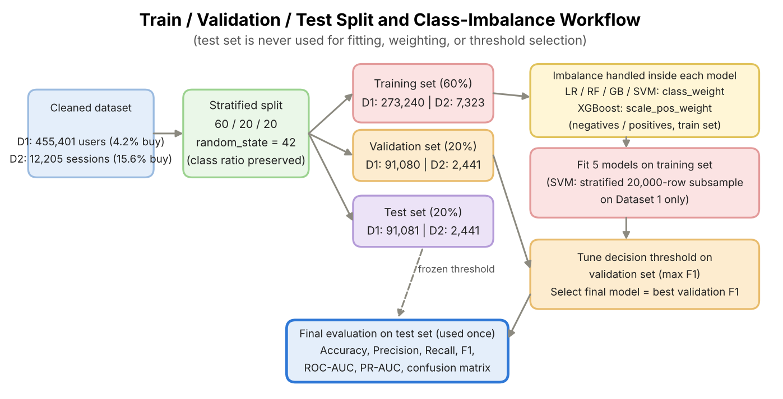
Fig. 3.3: Train/validation/test split and class-imbalance workflow to prevent data leakage

8. Model Building, Threshold Tuning and Model Selection. Five models, Logistic Regression, Random Forest, Gradient Boosting, SVM and XGBoost, were trained on the training partition of each dataset. For every model the decision threshold was tuned on the validation set by scanning thresholds from 0.05 to 0.99 and keeping the value that maximises F1-score. The final model of each dataset is the model with the highest validation F1 at its tuned threshold.
F1-score was chosen as the model-selection and tuning criterion, rather than accuracy, specifically because of the class imbalance characterised in Stages 1 and 7: accuracy would reward a model for correctly classifying the easy majority class while providing no signal about performance on the commercially important minority (purchase) class, whereas F1-score is computed on the positive class directly and penalises models that achieve a high score on one of precision or recall only by sacrificing the other. Because the SVM does not scale to hundreds of thousands of rows, on Dataset 1 it was trained on a stratified 20,000-row subsample of the training set (evaluation still uses the full validation and test sets); on Dataset 2 it uses the full training set.
9. Model Evaluation and Interpretation. The final models were evaluated once on the held-out test set using Accuracy, Precision, Recall, F1-score, ROC-AUC, PR-AUC and a confusion matrix, followed by permutation feature-importance analysis (Section 4.7) and a cross-dataset comparison (Section 4.8).
Evaluation is deliberately performed exactly once, on the test set, after all model selection and threshold optimisation decisions have already been finalised using only the training and validation partitions; this ordering is what makes the reported test-set metrics (Section 4.6) an honest, leakage-free estimate of how the models would perform on genuinely new, future sessions, rather than an optimistic estimate inflated by indirect exposure to the test data during development.

3.3 Theoretical Background
Predictive analytics uses historical data to predict unknown outcomes. The Knowledge Discovery in Databases (KDD) process, introduced by Fayyad, Piatetsky-Shapiro, and Smyth (1996), provides a structured framework for data selection, preprocessing, transformation, modelling, and evaluation. This project applies KDD to predict whether an e-commerce browsing session results in a purchase.
Logistic Regression: A linear classification algorithm that estimates purchase probability using a sigmoid function. It provides an interpretable baseline but has limited ability to capture complex non-linear relationships.
Decision Tree: Classifies sessions using feature-based rules and captures non-linear patterns. However, a single tree may overfit the training data.
Random Forest: Combines multiple decision trees using bagging and random feature selection, improving stability and reducing overfitting compared with a single tree (Breiman, 2001).
Gradient Boosting and XGBoost: Gradient Boosting builds trees sequentially to correct previous errors (Friedman, 2001); this study uses scikit-learn's histogram-based implementation. XGBoost adds regularisation and efficient optimisation, making it suitable for structured data (Chen & Guestrin, 2016).
Support Vector Machine (SVM): Finds the maximum-margin separating boundary and, with an RBF kernel, can model non-linear class boundaries (Cortes & Vapnik, 1995). Its training cost grows quickly with the number of samples, which is why it is trained on a subsample for Dataset 1.
Class Imbalance and Class Weighting: Purchase sessions represent only 15.6% of Dataset 2 and 4.2% of Dataset 1. Cost-sensitive class weighting increases the penalty for misclassifying the minority class so that the model does not simply favour the majority class. Resampling methods such as SMOTE (Chawla et al., 2002) are the main alternative; they were not used in this study.
Train/Validation/Test Protocol: Models are fitted on the training set, the decision threshold and the final model are chosen on the validation set, and the test set is used once for reporting, so that no tuning decision is made with knowledge of the test data.
Decision Threshold Optimisation: The default threshold of 0.5 is not always ideal for imbalanced data, and it is particularly inappropriate once class weights have shifted the predicted probabilities. This project selects a threshold on the validation set to maximise the F1-score and improve the precision-recall balance.
Evaluation Metrics: Accuracy measures overall correctness, while precision measures the reliability of purchase predictions. Recall measures how many actual purchases are identified, F1-score balances precision and recall, ROC-AUC measures the model's ability to distinguish between classes, and PR-AUC (average precision) summarises the precision-recall curve, which is more sensitive to performance on the rare positive class. The confusion matrix summarises correct and incorrect predictions.

Chapter 4: Results and Discussion

4.1 Exploratory Data Analysis
Fig 4.1 shows that Dataset 1 is strongly imbalanced: 95.8% of users (436,308) did not order and 4.2% (19,093) ordered, a ratio of about 23 to 1. Fig 4.2 shows that Dataset 2 is imbalanced too, but less severely: 84.4% of sessions (10,297) end with no purchase and 15.6% (1,908) end with a purchase, a ratio of about 5.4 to 1.
These ratios are textbook cases of imbalance: a classifier optimised purely for accuracy would be strongly incentivised to under-predict the purchase class (always predicting 'no purchase' would already be 95.8% accurate on Dataset 1 and 84.4% on Dataset 2), motivating the class weighting applied from Stage 7 onward and the use of F1 and PR-AUC rather than accuracy. The stratified 60/20/20 split shown in the middle panel of each figure preserves these proportions in the training, validation and test partitions.
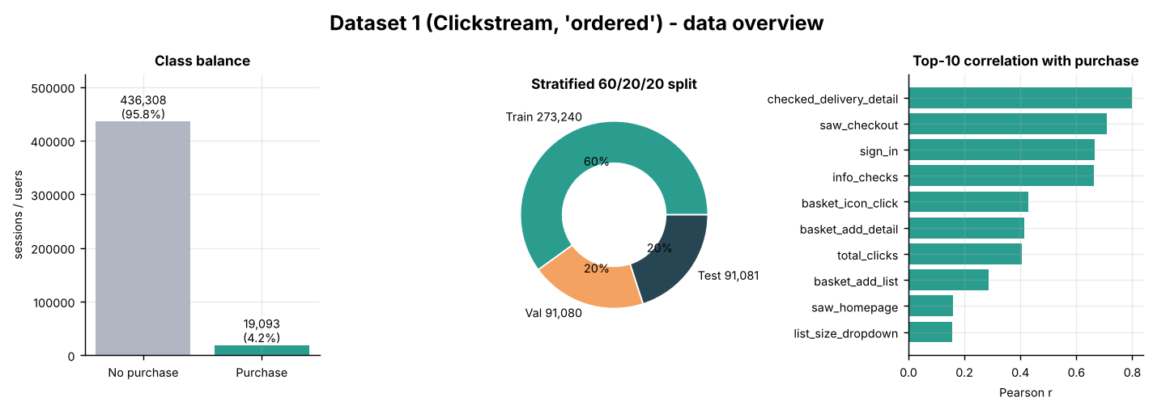
Fig. 4.1: Dataset 1 (clickstream) overview: class balance, 60/20/20 split and top-10 correlations with purchase

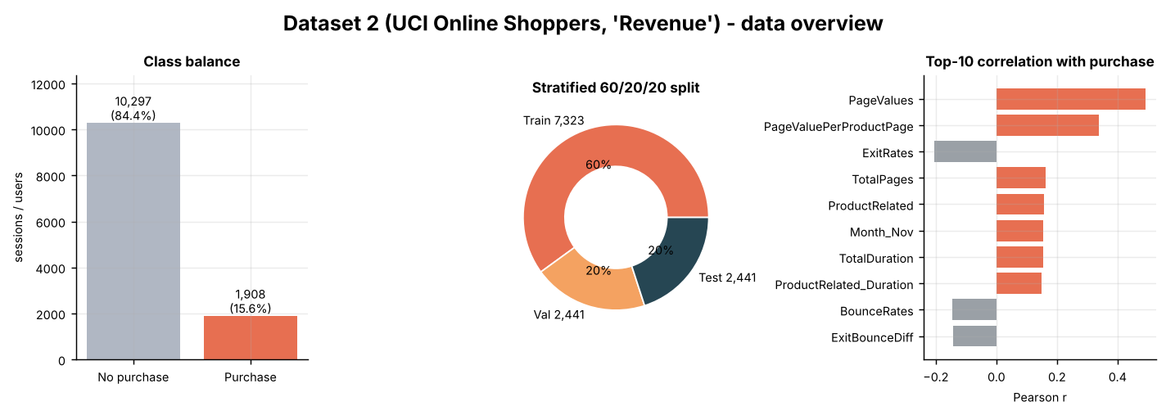
Fig. 4.2: Dataset 2 (Online Shoppers) overview: class balance, 60/20/20 split and top-10 correlations with purchase

The correlation panel of Fig 4.1 shows that in Dataset 1 the features most associated with ordering are late-funnel actions: checked_delivery_detail (r = 0.80), saw_checkout (0.71), sign_in (0.67) and the engineered info_checks (0.66), followed by basket interactions such as basket_icon_click (0.43). In Dataset 2 (Fig 4.2), PageValues has the strongest correlation with Revenue (r = 0.49), followed by the engineered PageValuePerProductPage (0.34), while ExitRates (−0.20), BounceRates and ExitBounceDiff are negatively correlated with purchase, as expected for disengagement measures.
This observation has a direct, practical consequence for model-building. In Dataset 2, BounceRates and ExitRates are strongly correlated with each other (r = 0.90), so they convey substantially overlapping information and a linear model (Logistic Regression) would need to split predictive weight across two near-redundant features, slightly diluting the interpretability of either coefficient. Tree-based ensembles are far less sensitive to this redundancy, since a tree only ever splits on one feature at a time. In Dataset 1, the very high correlation of a few late-funnel indicators with the target (0.7-0.8) already suggests that this dataset will be easy to classify, a point that is confirmed by the model results in Section 4.3 and discussed as a limitation in Section 5.3.

4.2 Data Cleaning Summary
Table 4.1: Data summary and cleaning for both datasets
Check | Dataset 1 (Clickstream) | Dataset 2 (Online Shoppers)
Raw rows / columns | 455,401 / 25 | 12,330 / 18
Missing values | 0 | 0
Duplicate rows removed | 0 (checked by UserID) | 125 (1.0%)
Rows after cleaning | 455,401 | 12,205
Model inputs after engineering | 25 | 79 (after one-hot encoding)
Purchases (positive class) | 19,093 (4.2%) | 1,908 (15.6%)
Train / Validation / Test | 273,240 / 91,080 / 91,081 | 7,323 / 2,441 / 2,441
Purchases in test set | 3,819 | 382

Figure 4.3 summarises the end-to-end decision logic connecting Sections 4.3-4.6: how the models were trained, threshold-optimised, the final model chosen, and finally evaluated.

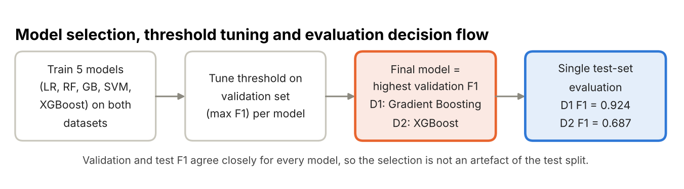
Fig 4.3: Model selection, threshold tuning and evaluation decision flow

4.3 Model Comparison (Validation-Tuned Threshold, Held-Out Test)
Five classifiers were trained on each dataset with identical preprocessing and class weighting. Table 4.2 and Table 4.3 report their performance on the held-out test set at the threshold tuned on the validation set; Fig 4.4 and Fig 4.5 show the same results graphically together with the ROC curves.
Table 4.2: Dataset 1 (Clickstream) - test-set performance of all models at the validation-tuned threshold
Model | Threshold | Precision | Recall | F1 | ROC-AUC | PR-AUC
Logistic Regression | 0.95 | 0.870 | 0.986 | 0.925 | 0.997 | 0.900
Random Forest | 0.83 | 0.868 | 0.989 | 0.924 | 0.997 | 0.897
Gradient Boosting | 0.95 | 0.870 | 0.984 | 0.924 | 0.997 | 0.902
SVM | 0.31 | 0.864 | 0.964 | 0.911 | 0.996 | 0.885
XGBoost | 0.95 | 0.873 | 0.981 | 0.924 | 0.997 | 0.899

Table 4.3: Dataset 2 (Online Shoppers) - test-set performance of all models at the validation-tuned threshold
Model | Threshold | Precision | Recall | F1 | ROC-AUC | PR-AUC
Logistic Regression | 0.66 | 0.647 | 0.657 | 0.652 | 0.910 | 0.675
Random Forest | 0.72 | 0.709 | 0.599 | 0.650 | 0.931 | 0.736
Gradient Boosting | 0.73 | 0.678 | 0.678 | 0.678 | 0.933 | 0.740
SVM | 0.22 | 0.595 | 0.691 | 0.639 | 0.894 | 0.641
XGBoost | 0.72 | 0.699 | 0.675 | 0.687 | 0.928 | 0.731

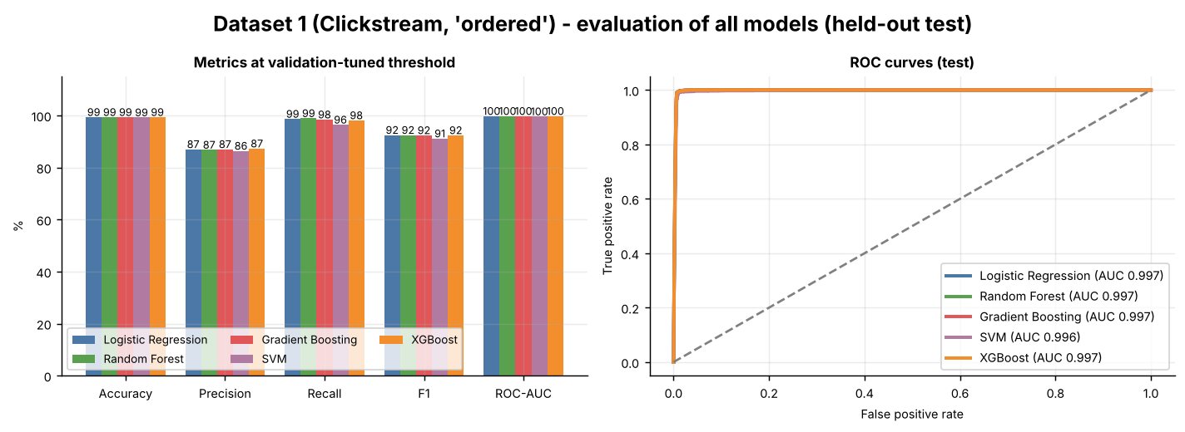
Fig 4.4: Dataset 1 - evaluation of all models (held-out test): metrics and ROC curves

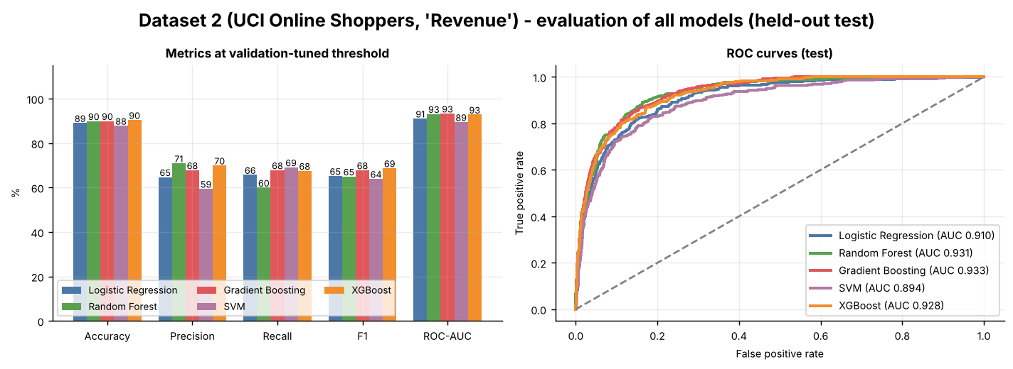
Fig 4.5: Dataset 2 - evaluation of all models (held-out test): metrics and ROC curves

On Dataset 1 all five models are almost indistinguishable: test F1 lies between 0.911 (SVM) and 0.925 (Logistic Regression), the four strongest models differ by less than 0.001 F1, and every ROC-AUC is 0.996-0.997. The ROC curves in Fig 4.4 are visually superimposed against the top-left corner. This pattern is the signature of a dataset in which a few very informative features (Section 4.1) make the problem nearly linearly separable, so that model complexity adds nothing. The weakest result belongs to the SVM, which is also the only model trained on a 20,000-row subsample.
On Dataset 2 the models separate more clearly. XGBoost has the highest test F1 (0.687), followed by Gradient Boosting (0.678), Logistic Regression (0.652), Random Forest (0.650) and SVM (0.639). By ROC-AUC and PR-AUC the two boosting models and Random Forest form a leading group (ROC-AUC 0.928-0.933, PR-AUC 0.731-0.740), clearly ahead of Logistic Regression (0.910 / 0.675) and the SVM (0.894 / 0.641). This is consistent with the literature reviewed in Section 2.2: tree-ensemble and boosting methods outperform the linear model and the SVM on this type of imbalanced, mixed-type session data, and the F1 and ROC-AUC values fall within the 0.60-0.70 and 0.90-0.94 ranges reported there.
Note that Random Forest has a strong ROC-AUC on Dataset 2 (0.931) but the lowest recall (0.599): its ranking quality is high, but at its validation-tuned threshold it favours precision (0.709). The difference between ranking quality (AUC) and the hard classification at one threshold is examined further in Section 4.5.

4.4 Model Configuration and Hyperparameters
The five models were trained with the fixed configurations shown in Table 4.4, identical for both datasets except for the class-weight value of XGBoost, which is computed from each training set (about 22.9 for Dataset 1 and 5.4 for Dataset 2). No grid search or cross-validation was run; the configurations were set a priori to be reasonable, moderately regularised settings, and the only quantity tuned on validation data is the decision threshold of each model (Section 4.5).
Table 4.4: Model configurations (identical for both datasets)
Model | Main settings | Imbalance handling
Logistic Regression | StandardScaler + LogisticRegression, max_iter = 2000 | class_weight = balanced
Random Forest | 200 trees, max_depth = 14, min_samples_leaf = 5 | class_weight = balanced_subsample
Gradient Boosting | HistGradientBoosting, max_iter = 250, learning_rate = 0.06, max_depth = 5 | class_weight = balanced
SVM | StandardScaler + SVC, RBF kernel, C = 1.0, probability = True (Dataset 1: 20,000-row training subsample) | class_weight = balanced
XGBoost | 250 trees, learning_rate = 0.08, max_depth = 5, subsample = 0.9, colsample_bytree = 0.9 | scale_pos_weight = negatives / positives

Because no hyperparameter search was run, the results in Section 4.3 should be read as the performance of sensible default-style configurations, not as the best achievable by each algorithm. Given how closely the models agree on both datasets, further tuning is unlikely to change the main conclusions, but it could change the exact ordering of the models on Dataset 2 (Section 5.3).

4.5 Threshold Tuning
Fig 4.6 and Fig 4.7 (middle panels) show that the default 0.5 probability cut-off is not optimal once class weights have been applied. For each model, thresholds from 0.05 to 0.99 were scanned on the validation set and the value maximizing F1-score was kept. For the final models this gave 0.95 for Gradient Boosting on Dataset 1 (0.955 before rounding) and 0.72 for XGBoost on Dataset 2.
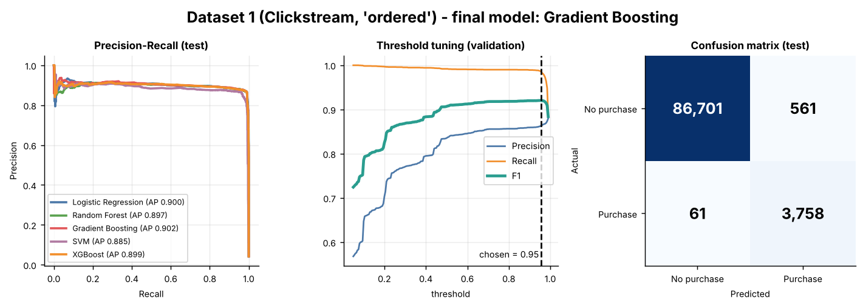
Fig 4.6: Dataset 1 - final model (Gradient Boosting): precision-recall curves, threshold tuning on validation, and test confusion matrix

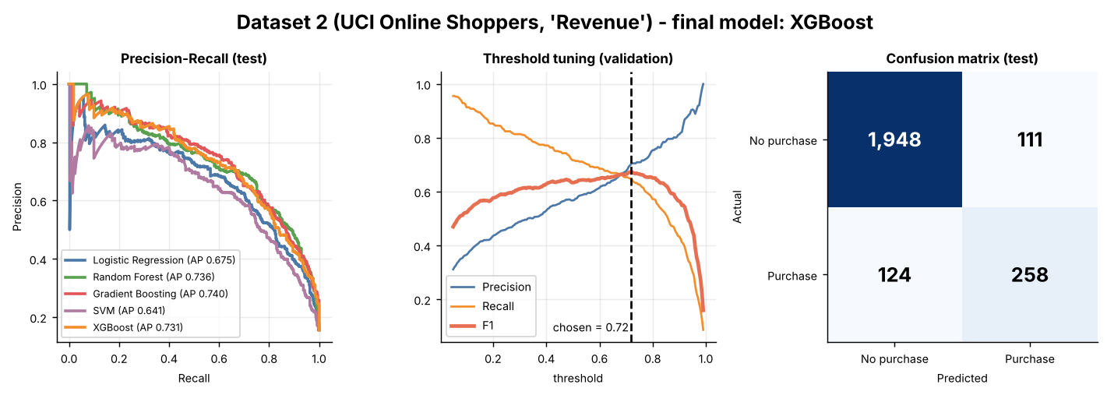
Fig 4.7: Dataset 2 - final model (XGBoost): precision-recall curves, threshold tuning on validation, and test confusion matrix

Table 4.5: Effect of validation-tuned threshold on test F1-score
Model | D1 threshold | D1 F1 @ 0.50 | D1 F1 @ tuned | D2 threshold | D2 F1 @ 0.50 | D2 F1 @ tuned
Logistic Regression | 0.95 | 0.912 | 0.925 | 0.66 | 0.629 | 0.652
Random Forest | 0.83 | 0.919 | 0.924 | 0.72 | 0.670 | 0.650
Gradient Boosting | 0.95 | 0.910 | 0.924 | 0.73 | 0.672 | 0.678
SVM | 0.31 | 0.904 | 0.911 | 0.22 | 0.565 | 0.639
XGBoost | 0.95 | 0.910 | 0.924 | 0.72 | 0.668 | 0.687

Table 4.5 shows that tuning the threshold improves test F1 for nine of the ten model-dataset combinations, by 0.006-0.014 on Dataset 1 and by up to 0.074 for the SVM on Dataset 2. The single exception is Random Forest on Dataset 2, where the validation-tuned threshold of 0.72 lowers test F1 from 0.670 to 0.650, which shows that a threshold chosen on 2,441 validation sessions (382 purchases) is itself subject to sampling noise and does not always transfer perfectly to the test set.
The direction of the shift is the opposite of what a pipeline without class weighting would produce: thresholds are above 0.5 for the logistic, tree and boosting models (0.66-0.73 on Dataset 2 and up to 0.95 on Dataset 1). This is the expected consequence of class weighting: re-weighting the loss inflates predicted purchase probabilities, so a higher cut-off is needed to restore a good balance between precision and recall. The SVM is the exception (0.22 and 0.31) because its probabilities come from Platt scaling and are calibrated differently from the other models.
It is worth making explicit that the F1-optimal threshold treats false positives and false negatives as equally costly in the precision/recall sense. In practice a false negative (a real buyer the model fails to flag) represents fully forgone revenue and a missed opportunity for timely intervention, whereas a false positive (a non-buyer flagged as likely-to-purchase) typically costs only a modest, scalable marketing action, a retargeting impression, a chat prompt, or an email. A business with this cost structure would rationally select a lower threshold from the precision/recall curve in Fig 4.6 or Fig 4.7 and favour recall, while a business where the intervention is expensive (a human sales call) would select a higher one and favour precision; the threshold-tuning methodology used here supports either adjustment without retraining the underlying model.

4.6 Final Model Evaluation
The final model of each dataset is the model with the highest validation F1 at its tuned threshold: Gradient Boosting (threshold 0.95) for Dataset 1 and XGBoost (threshold 0.72) for Dataset 2. Their test-set results are shown in Table 4.6 and Table 4.7. On Dataset 1 the selection between Gradient Boosting, XGBoost and Random Forest was decided by a validation-F1 margin of only 0.0001-0.0006 (0.9203, 0.9202 and 0.9197), so the choice is effectively a tie.
Table 4.6: Final model evaluation on the held-out test sets
Metric | Dataset 1: Gradient Boosting | Dataset 2: XGBoost
Decision threshold | 0.95 | 0.72
Accuracy | 0.993 | 0.904
Precision (Purchase) | 0.870 | 0.699
Recall (Purchase) | 0.984 | 0.675
F1-score (Purchase) | 0.924 | 0.687
ROC-AUC | 0.997 | 0.928
PR-AUC | 0.902 | 0.731

Classification report:
Table 4.7: Final model classification report (test set)
Dataset | Class | Precision | Recall | F1-score | Support
Dataset 1 | No Purchase | 1.00 | 0.99 | 1.00 | 87,262
 | Purchase | 0.87 | 0.98 | 0.92 | 3,819
 | Accuracy |  |  | 0.99 | 91,081
 | Macro avg | 0.93 | 0.99 | 0.96 | 91,081
 | Weighted avg | 0.99 | 0.99 | 0.99 | 91,081
Dataset 2 | No Purchase | 0.94 | 0.95 | 0.94 | 2,059
 | Purchase | 0.70 | 0.68 | 0.69 | 382
 | Accuracy |  |  | 0.90 | 2,441
 | Macro avg | 0.82 | 0.81 | 0.82 | 2,441
 | Weighted avg | 0.90 | 0.90 | 0.90 | 2,441

Of the 3,819 actual purchasers in the Dataset 1 test set, 3,758 (98.4%) were correctly identified; of the users flagged as likely purchasers, 87.0% did order, and 99.4% of non-purchasers were correctly left unflagged (561 false positives and 61 false negatives, Fig 4.6). On Dataset 2, of 382 actual purchase sessions 258 (67.5%) were correctly identified; of the sessions flagged as likely purchases, 69.9% converted; and 94.6% of non-purchase sessions were correctly classified (111 false positives and 124 false negatives, Fig 4.7).
Cross-referencing the confusion matrices: on Dataset 2, of the 2,059 true non-purchase sessions about 5% (111) are incorrectly flagged as likely purchases, and of the 382 true purchase sessions about 32% (124) are missed. Because the F1-optimal threshold weights precision and recall about equally, the final Dataset 2 model is deliberately balanced (precision 0.699, recall 0.675); a lower threshold would trade some precision for a higher recall if the business cost structure described in Section 4.5 calls for it. On Dataset 1 the very high recall (0.984) with a precision of 0.870 reflects the strong late-funnel signals discussed above.
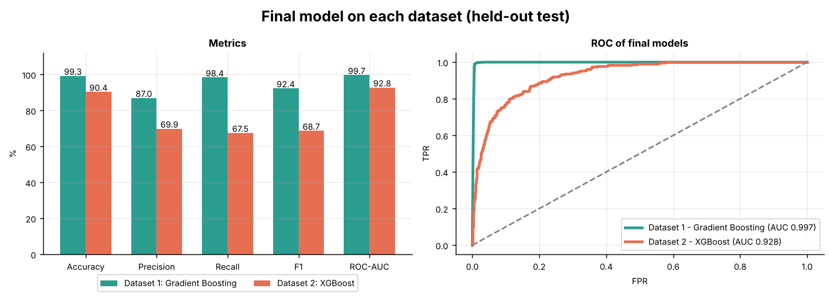
Fig 4.8: Final model of each dataset on the held-out test set: metrics and ROC curves

Fig 4.8 shows ROC-AUC values of 0.997 (Dataset 1) and 0.928 (Dataset 2). The Dataset 2 value means that the model ranks a randomly chosen purchase session above a randomly chosen non-purchase session about 93% of the time, substantially better than a random classifier (AUC = 0.50).
It is important to note that ROC-AUC, being threshold-independent, is unaffected by the Section 4.5 threshold-tuning decision, it summarizes the model's underlying discriminative quality across every possible threshold simultaneously. The fact that ROC-AUC (0.928) is considerably higher than F1-score (0.687) on Dataset 2 is not a contradiction: it reflects that the model's probability ranking is strong, while the hard classification at any single threshold is necessarily constrained by the genuine overlap between the two classes' feature distributions. The PR-AUC values (0.731 for Dataset 2, 0.902 for Dataset 1), which focus on the positive class, give a more sober picture than ROC-AUC. This distinction matters for deployment: if the downstream system can consume a continuous probability score rather than a binary label, the model's practical value is better reflected by its strong ROC-AUC than by the F1-score alone.

4.7 Feature Importance
Fig 4.9 and Fig 4.10 show the twelve most important features of the final model of each dataset, measured by permutation importance on the test set (the drop in ROC-AUC when a feature's values are shuffled).
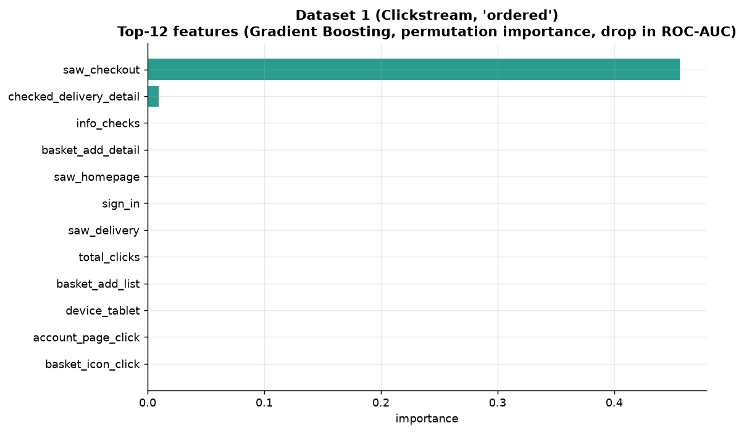
Fig 4.9: Dataset 1 - top 12 important features (Gradient Boosting)

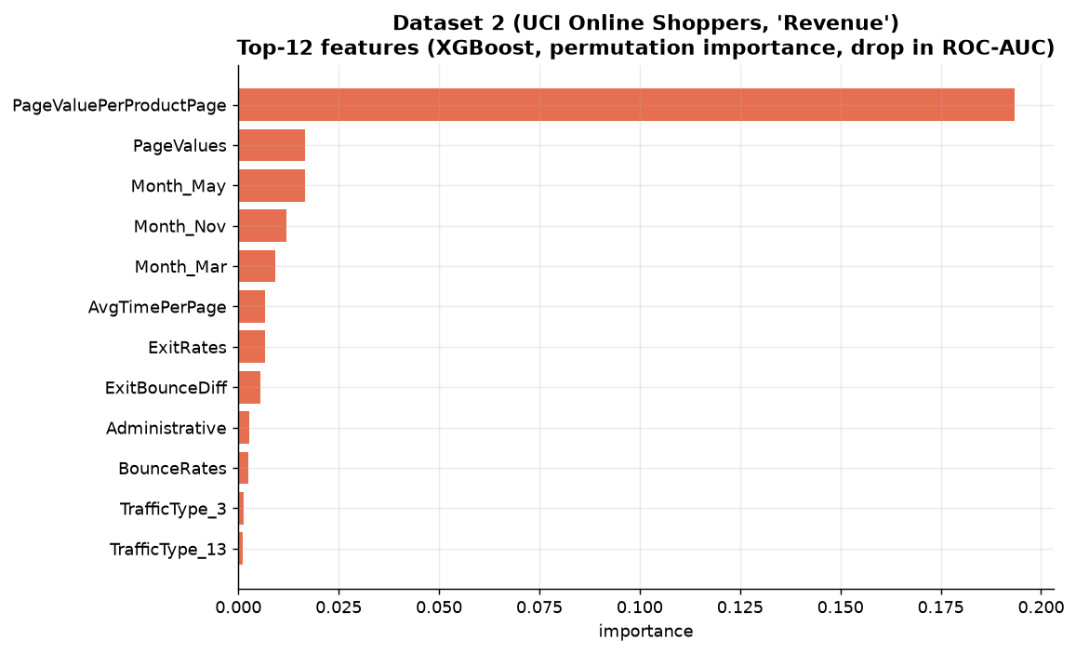
Fig 4.10: Dataset 2 - top 12 important features (XGBoost)

In Dataset 2, the engineered PageValuePerProductPage feature is overwhelmingly the dominant predictor (a ROC-AUC drop of about 0.19, more than ten times that of any other feature), followed by PageValues, the seasonal indicators Month_May, Month_Nov and Month_Mar, and then AvgTimePerPage, ExitRates and ExitBounceDiff. This is consistent with the literature (Section 2.1): PageValues directly measures how much value Google Analytics assigns a page based on historical conversions, and normalising it by the number of product pages viewed turns it into an even stronger signal. Three of the top eight features (PageValuePerProductPage, AvgTimePerPage, ExitBounceDiff) are engineered, confirming that the engineered features carry real predictive signal. The month effects indicate that purchase propensity varies strongly with the season.
This ranking also has a direct business interpretation: because PageValues is itself a historically-derived, page-level conversion-attribution metric rather than a raw behavioural count, its dominance means the single highest-leverage lever available to a business is ensuring high-PageValues pages (typically specific high-converting product or landing pages) are surfaced prominently and early in the customer journey, for instance, through on-site search ranking, recommendation placement, or paid-traffic landing-page selection. The importance of what a visitor does during a session (PageValues, AvgTimePerPage, ExitRates) alongside seasonality, rather than technical attributes such as traffic type, which appear only at the bottom of the ranking, is consistent with the behavioural, within-session nature of purchase intent discussed in Chapter 1.
In Dataset 1, saw_checkout is by far the most important feature (a ROC-AUC drop of about 0.46), followed at a distance by checked_delivery_detail (about 0.01); all remaining features contribute almost nothing individually. Two cautions apply. First, permutation importance understates features that are strongly correlated with a more informative one: info_checks, sign_in and checked_delivery_detail are all correlated with saw_checkout (Section 4.1), so shuffling any one of them costs little. Second, reaching the checkout page is a late-funnel behaviour that sits very close to the act of ordering itself, so the Dataset 1 model is mostly recognising users who are already at the end of the purchase journey. Its excellent scores should therefore not be read as evidence that early purchase intent is easy to predict.

4.8 Cross-Dataset Comparison and Generalisation Check
To confirm that the model choices are not an artefact of one dataset or one lucky split, all five models were compared across both datasets. Table 4.8 averages each model's test F1, ROC-AUC and PR-AUC over the two datasets; the overall score is the mean of those three averages. Fig 4.11 shows the same comparison graphically.
Table 4.8: Overall model ranking across both datasets (test set, tuned threshold)
Model | Mean F1 | Mean ROC-AUC | Mean PR-AUC | Overall score | Chosen as final model for
Gradient Boosting | 0.801 | 0.965 | 0.821 | 0.862 | Dataset 1
XGBoost | 0.805 | 0.963 | 0.815 | 0.861 | Dataset 2
Random Forest | 0.787 | 0.964 | 0.816 | 0.856 | -
Logistic Regression | 0.788 | 0.954 | 0.788 | 0.843 | -
SVM | 0.775 | 0.945 | 0.763 | 0.828 | -

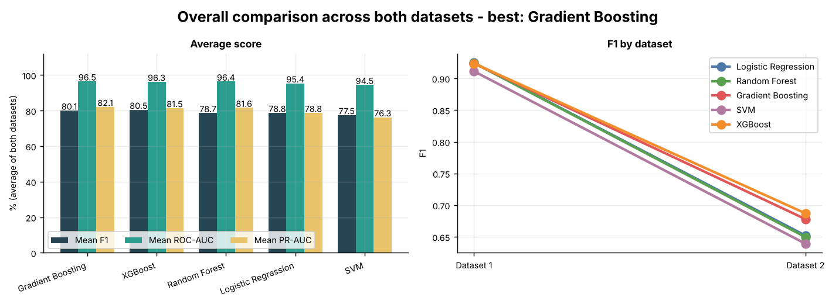
Fig 4.11: Overall comparison across both datasets: average score and F1 by dataset

Gradient Boosting obtains the highest overall score (0.862), but its lead over XGBoost (0.861) is only 0.001, which is practically a tie; XGBoost has the highest mean F1 (0.805) and is the final model for Dataset 2. Random Forest and Logistic Regression follow closely on F1 (0.787-0.788), and the SVM is consistently last (overall 0.828), although it was also the only model trained on a subsample for Dataset 1. The two boosting methods therefore emerge as the most reliable choice across datasets, with the remaining differences smaller than would justify strong claims.
Fig 4.11 (right) also shows the dominant effect in the study: whichever model is used, F1 drops from about 0.92 on Dataset 1 to about 0.64-0.69 on Dataset 2. The difference between datasets is far larger than the difference between models. On Dataset 2, the full range of test F1 across all five models is only 0.048 (0.639 to 0.687) and, among the four best models, 0.037, which is of the order of the sampling noise expected from a test set with 382 purchases. This convergence is itself evidence that F1 of about 0.65-0.69 represents a practical ceiling for this feature set, rather than a shortfall specific to one modelling choice: a meaningful share of Purchase and No-Purchase sessions are not separable on session-level browsing features alone.
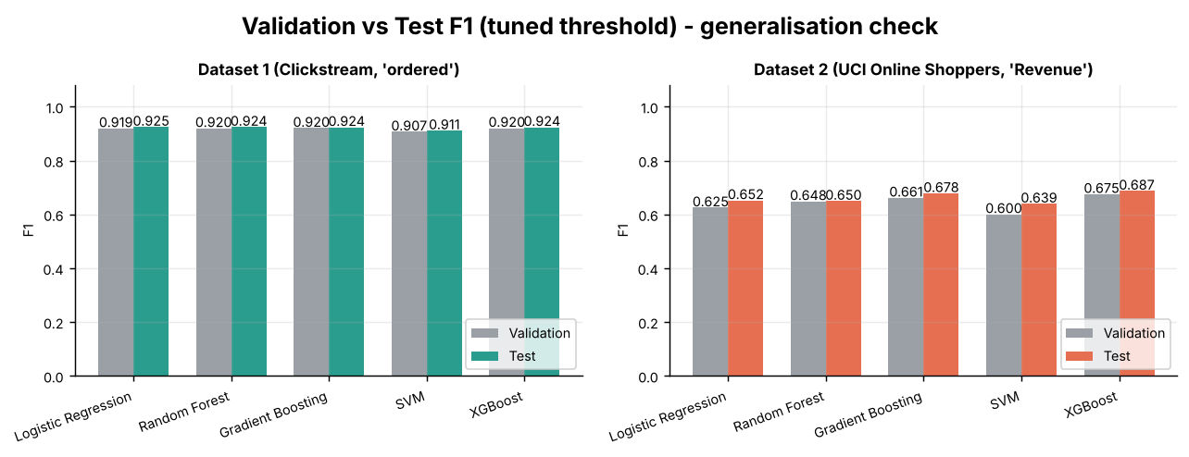
Fig 4.12: Validation versus test F1 (tuned threshold): generalisation check

Fig 4.12 compares validation and test F1 for every model. On Dataset 1 the two agree to within 0.006 for all models. On Dataset 2 the test F1 is slightly higher than the validation F1 for every model (by 0.001 for Random Forest and up to 0.039 for the SVM), and XGBoost is first, Gradient Boosting second and the SVM last on both splits. There is no sign that the thresholds or the final models were over-fitted to the validation set. Because the models differ by so little, and differences of 0.01-0.02 F1 are comparable to the sampling noise of a 2,441-session split, further gains from algorithmic experimentation alone appear limited, and genuine future improvement (Section 5.4) would require additional or richer input features rather than further model-side engineering.

Chapter 5: Conclusion

5.1 Summary
This study implemented a complete predictive analytics pipeline, following the KDD process end-to-end, to predict e-commerce purchase intention on two datasets: a clickstream purchase-propensity dataset (455,401 users, 4.2% purchasers) and the UCI Online Shoppers Purchasing Intention dataset (12,205 sessions after removing 125 duplicates, 15.6% purchasers). Data was cleaned, explored, encoded, and enriched with engineered features (two for Dataset 1, five for Dataset 2). Class imbalance was addressed with cost-sensitive class weighting inside each model. Five classifiers, Logistic Regression, Random Forest, Gradient Boosting, SVM and XGBoost, were trained on a stratified 60/20/20 split; the decision threshold of each model was optimised on the validation set and the final model of each dataset was selected by validation F1.
Throughout, the methodological emphasis was on rigour as much as raw performance: every weighting, threshold-selection and model-selection decision was made using only the training and validation partitions, with the held-out test set touched exactly once, for final reporting, ensuring the results presented in Chapter 4 are an honest estimate of generalisation rather than an artefact of indirect test-set exposure during development.

5.2 Key Findings
The final model for Dataset 1, Gradient Boosting with a threshold of 0.95, achieved an accuracy of 0.993, precision of 0.870, recall of 0.984, F1-score of 0.924, and ROC-AUC of 0.997 on the held-out test data. The final model for Dataset 2, XGBoost with a threshold of 0.72, achieved an accuracy of 0.904, precision of 0.699, recall of 0.675, F1-score of 0.687, and ROC-AUC of 0.928. Feature importance analysis identified PageValuePerProductPage, PageValues and seasonal (month) indicators as the dominant predictors on Dataset 2, and the checkout page visit (saw_checkout) as the dominant predictor on Dataset 1. All five models performed almost identically on Dataset 1 (F1 0.911-0.925) and within a narrow band on Dataset 2 (F1 0.639-0.687), with the boosting methods slightly ahead (Gradient Boosting has the best overall score across the two datasets, XGBoost the best mean F1), suggesting that predictive performance is limited by the information available in the features rather than by the choice of algorithm. Tuning the decision threshold on the validation set improved test F1 in nine of ten model-dataset combinations, and since class weighting shifted the optimal thresholds above 0.5, relying on the default cut-off would have under-used the models. Overall, the findings address the problem statement by demonstrating that session-level behavioural data can identify a substantial proportion of purchase-intent sessions, with PageValues-based and late-funnel engagement signals providing the strongest information, although perfect separation between purchasing and non-purchasing sessions remains difficult.

5.3 Limitations
Dataset 2 contains only aggregated session-level statistics, not raw clickstream sequences, cart events, or returning-customer history, which likely limits the achievable separability between classes, and it reflects a single e-commerce portal over one year, which may limit generalisability to other platforms or time periods. Dataset 1 is dominated by late-funnel indicators (checkout and delivery-information views) that sit very close to the act of ordering, so its near-ceiling scores overstate how well purchase can be predicted early in a session; its original source and collection period are also not documented in this study.
A further limitation concerns the evaluation protocol itself. Models were trained with fixed hyperparameters, with no grid search and no cross-validation, and results come from a single stratified split with one random seed, so small differences between models (especially on Dataset 1 and among the top models on Dataset 2) are within the noise level and should not be over-interpreted. On Dataset 1 the SVM was trained on a 20,000-row subsample, which may understate its performance, and SMOTE or other resampling approaches were not tested against class weighting. Permutation importance can understate correlated features. True deployment validation (monitoring live model performance against actual subsequent purchases, and watching for concept drift as shopping behaviour evolves seasonally or in response to site redesigns) has not been performed, since this study is confined to offline, retrospective evaluation. The one-year collection window of Dataset 2 also captures only a single seasonal cycle, so the model's robustness to multi-year trends or unprecedented events is untested.

5.4 Future Scope
Future work could add stratified cross-validation and hyperparameter search (for example GridSearchCV) for the boosting models, compare class weighting with SMOTE-based resampling, calibrate the predicted probabilities, and train the SVM on the full Dataset 1. Further directions include sequential clickstream modelling, returning-visitor purchase history, real-time session features, and online/incremental learning to adapt to seasonal shopping behaviour. Training Dataset 1 models on early-session features only, excluding checkout and delivery-page indicators, would show how well purchase can be predicted early enough to intervene. Deployment as a real-time scoring service integrated with marketing automation would convert this model into direct business value.
More immediately, A/B testing the deployed model's threshold against the current intervention strategy would provide the causal evidence needed to justify further investment in this direction, the offline metrics reported in Chapter 4, while rigorous, are necessarily correlational and should be validated against actual incremental revenue lift before being treated as a final business case.

Chapter 6: References
- Sakar, C.O., Polat, S.O., Katircioglu, M., Kastro, Y. (2019). Real-time prediction of online shoppers' purchasing intention using multilayer perceptron and LSTM recurrent neural networks. Neural Computing and Applications, 31, 6893-6908.
- Chawla, N.V., Bowyer, K.W., Hall, L.O., Kegelmeyer, W.P. (2002). SMOTE: Synthetic Minority Over-sampling Technique. Journal of Artificial Intelligence Research, 16, 321-357.
- Chen, T., Guestrin, C. (2016). XGBoost: A Scalable Tree Boosting System. Proceedings of the 22nd ACM SIGKDD International Conference on Knowledge Discovery and Data Mining, 785-794.
- Breiman, L. (2001). Random Forests. Machine Learning, 45(1), 5-32.
- Fayyad, U., Piatetsky-Shapiro, G., Smyth, P. (1996). From Data Mining to Knowledge Discovery in Databases. AI Magazine, 17(3), 37-54.
- UCI Machine Learning Repository: Online Shoppers Purchasing Intention Dataset. Dua, D. and Graff, C. (2019). University of California, Irvine, School of Information and Computer Sciences.
- Pedregosa, F. et al. (2011). Scikit-learn: Machine Learning in Python. Journal of Machine Learning Research, 12, 2825-2830.
- He, H., Garcia, E.A. (2009). Learning from Imbalanced Data. IEEE Transactions on Knowledge and Data Engineering, 21(9), 1263-1284.
- Cortes, C., Vapnik, V. (1995). Support-vector networks. Machine Learning, 20(3), 273-297.
- Friedman, J.H. (2001). Greedy function approximation: A gradient boosting machine. The Annals of Statistics, 29(5), 1189-1232.
- Saito, T., Rehmsmeier, M. (2015). The precision-recall plot is more informative than the ROC plot when evaluating binary classifiers on imbalanced datasets. PLoS ONE, 10(3), e0118432.

