In this practical we will learn how to create update select delete the data

1. Create A database: 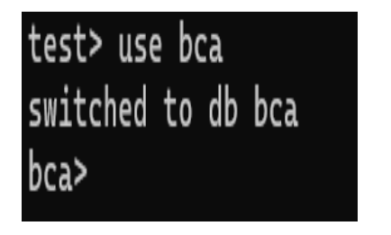

2. Create A Collection 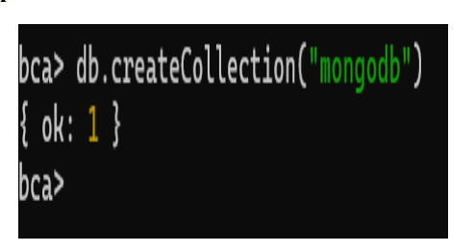

3. Insert into the collection There are Two ways to insert the data into the collection

i. insertOne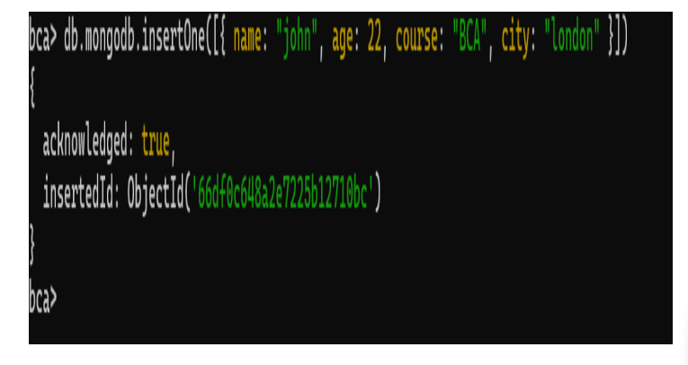

ii. insertMany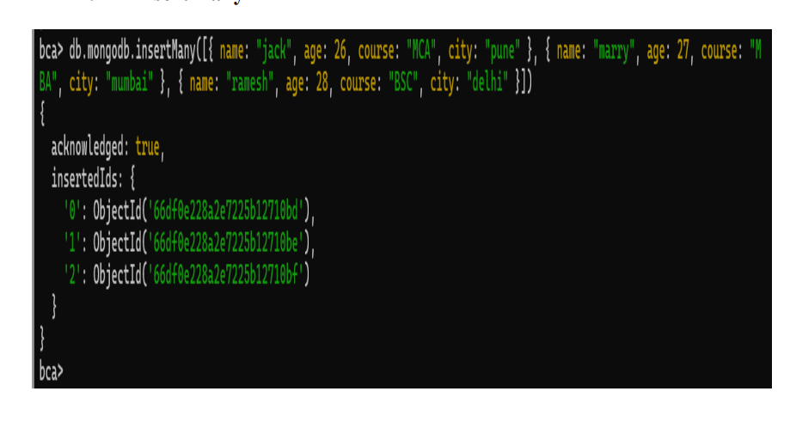

4. Update the data that we inserted There are Two ways to update a data i. updateOne 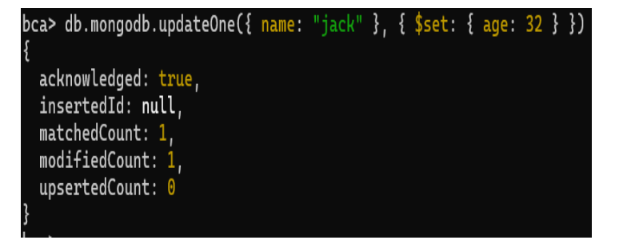

ii. updatemany 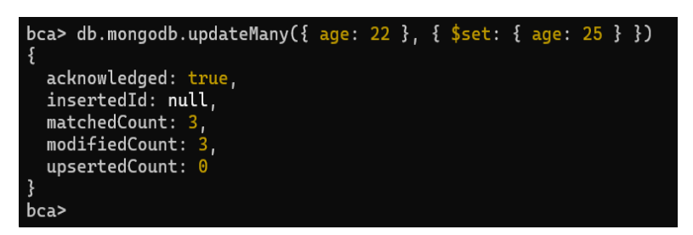

5. Select the data 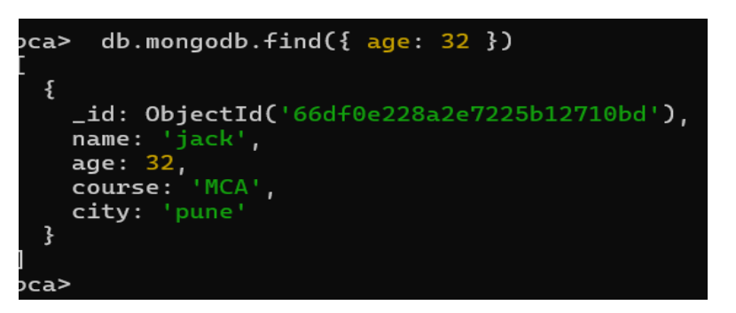

6. Delete the data There are Two ways to delete the data

i. deleteOne 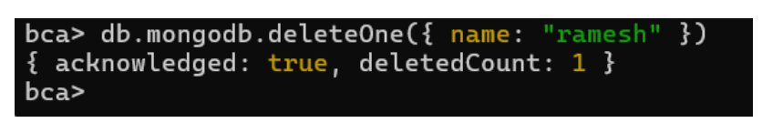

ii. deleteMany